10/24/2021
BMSW4005 - professional career development TASK 3
Shazia Cousear Ayub (2008734)
RICHMOND LAMPTEY
REFLECTIVE PORTFOLIO
CONTENTS
INTRODUCTION 2
OWN SKILLS AND COMPETENCIES 3
Higher Awareness Test 3
Learning Style 4
16Personality Test Conclusion 5
Swot 6
Personal Development Plan 7
PDP/SWOT Definition 8
Interview Results 9
EFFECTIVE IT MANAGER SKILLS 11
Manager Role 12
ASSESSING LEARNED OUTCOME 13
Smart Goals 13
Johari Window 14
UK Employment laws 15
Learning Theories 16
Self-Awareness 17
My Assessment 18
CONCLUSION 19
REFERENCES 20

INTRODUCTION
In the modern world skills, experience and qualifications are needed to thrive in every aspect of life. Getting to know your strengths, weaknesses and having the abilities to overcome them can help you achieve your goals. To do this, a personal analysis needs to be carried out using a swot analysis (Strengths, Weaknesses, Opportunities and Threats), PDP (personal development plan) which include Smart goals (Specific, Measurable, Achievable, Realistic and Timely). By identifying the weaknesses, a plan can be put into place as to how to improve and get the required outcome. Whether that is getting the qualifications/skills required for a job, improving oneself to do better or communicating effectively. A 16personality test is available online, which gives you an idea of what personality type you are. These will be used for my analysis and the kind of skills required for an effective manager in my chosen career.
.
- Swot Analysis, Personal Development Plan and Interview Results.
- Analyse skills to be an ‘Effective Manager’ in IT.
- Smart / Johari window and results from above are used to reflect and assess what has been learned, what to improve on, self-awareness and UK law.
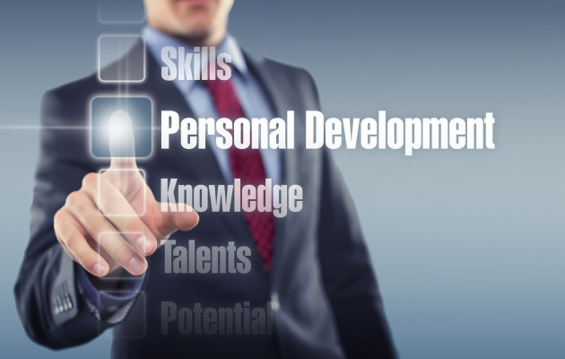
This Photo by Unknown Author is licensed under CC BY
(Unknown, 2013)

OWN SKILLS AND COMPETENCIES

To analyse my skills and competencies I have used SWOT, PDP tools, and also taken an online personality, awareness test. The results are shown below with their conclusion of me.

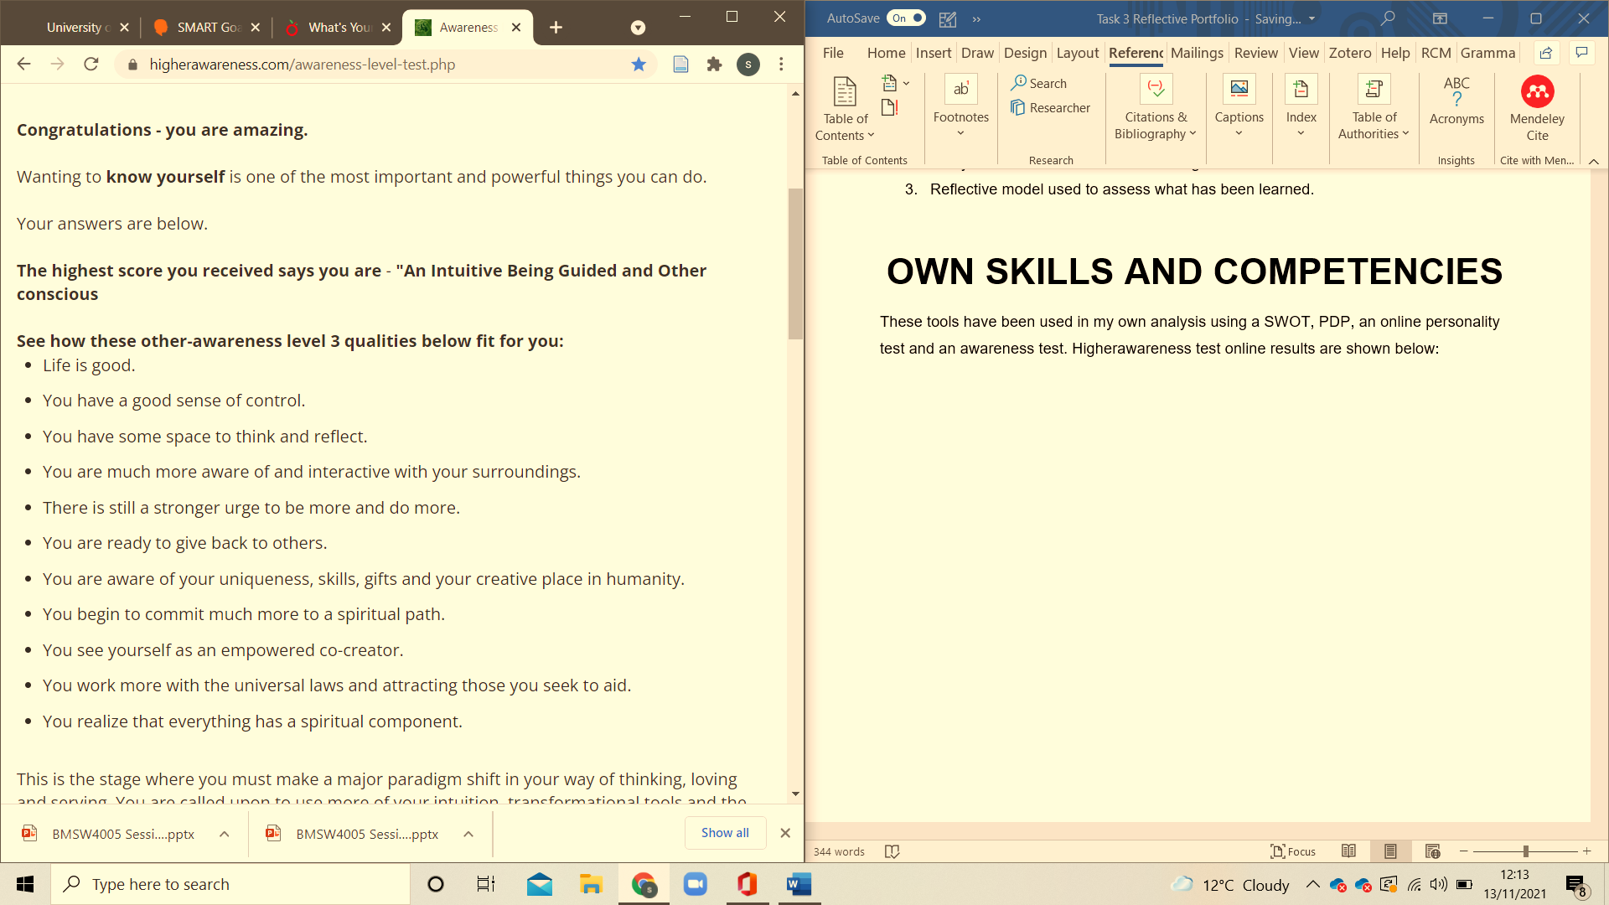
Higher Awareness Test
(Robson, 2019)

Learning Style

My results for the learning style Higher awareness and Personality test are correct because I do need to see to picture it in my head to remember. I like to go over rewrite watch tutorials, find visual information. My main goal is to help people overcome their problems, help them excel and to achieve what they believe that they are not capable of. As I am very motivated and do not give up until I get the outcome I’m aiming for.

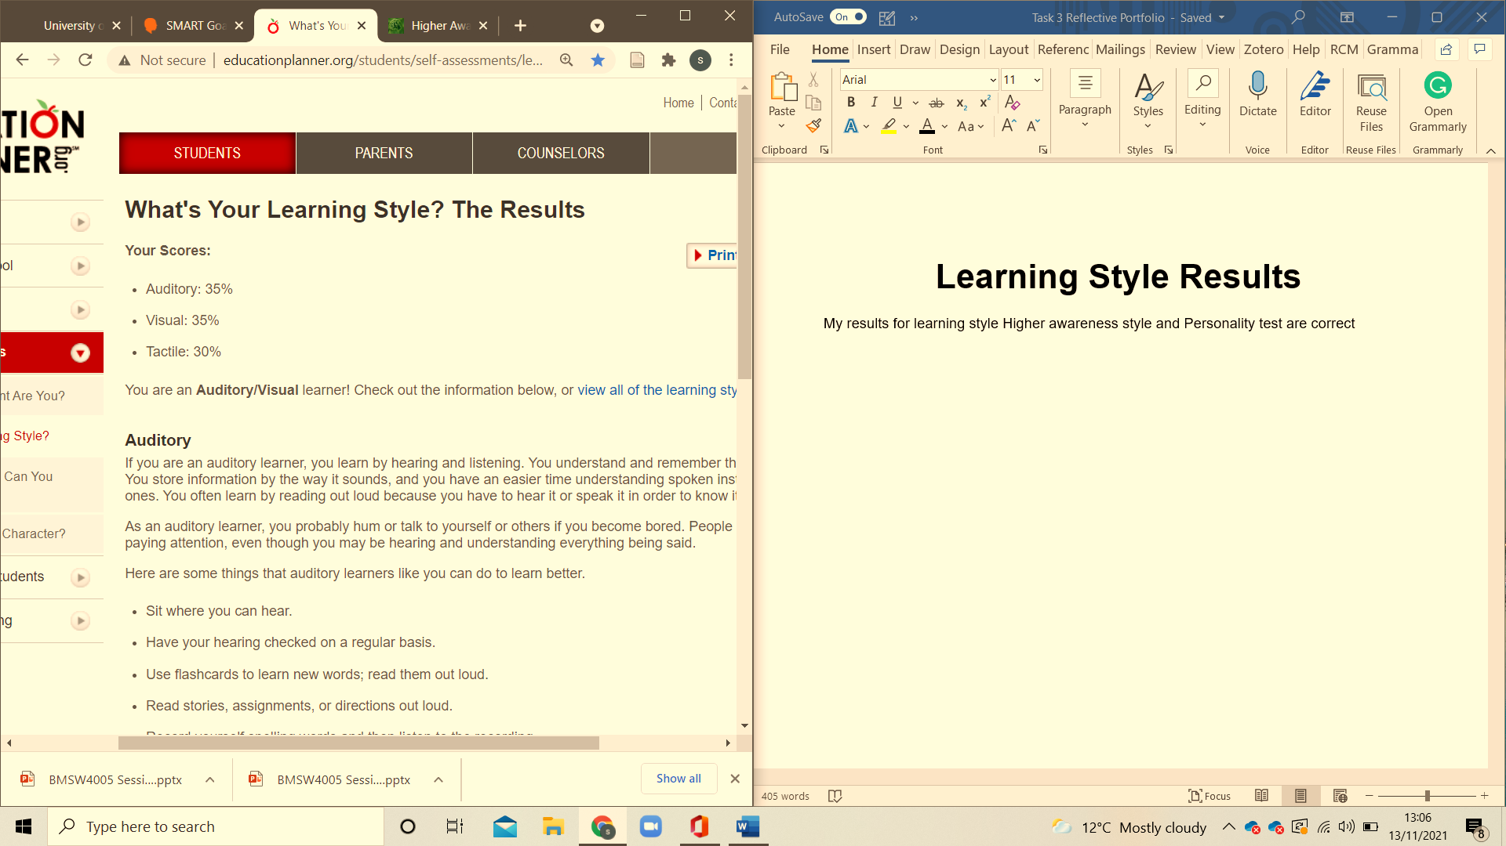
(Planner, 2011-2021)

16Personality Test Conclusion

The results reflect my personality its true as I don’t like conflicts but I do stand my ground where I feel I need to. As to career decisions I have always been clear as to what I want to achieve and always worked hard to get it. Getting back into education was one of my goals it took me longer than I would have wanted, but as I got into it I realised I still have the passion I always did. I'm gaining confidence as I continue to achieve the steps needed to get to my final goal of getting a degree and going on to do masters. I'm am very determined and will reach my goals someday even if it takes longer than expected.
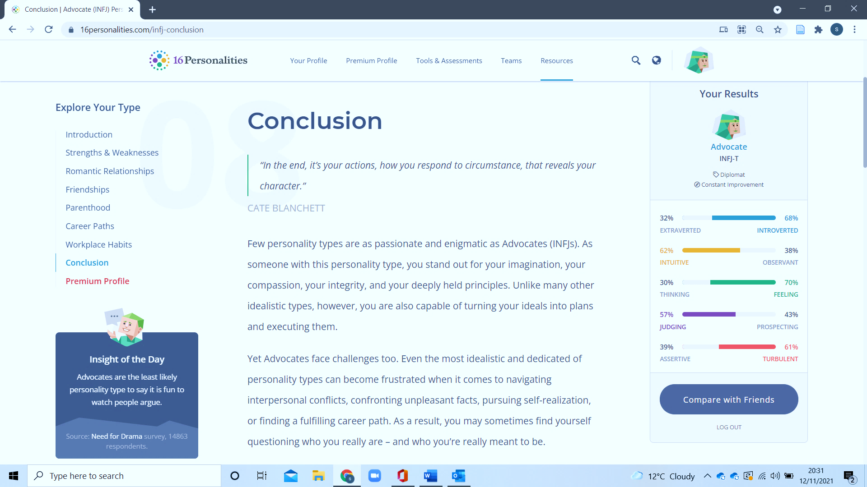
The conclusion states that I'm an Advocate. (16personalities, 2021)

Swot
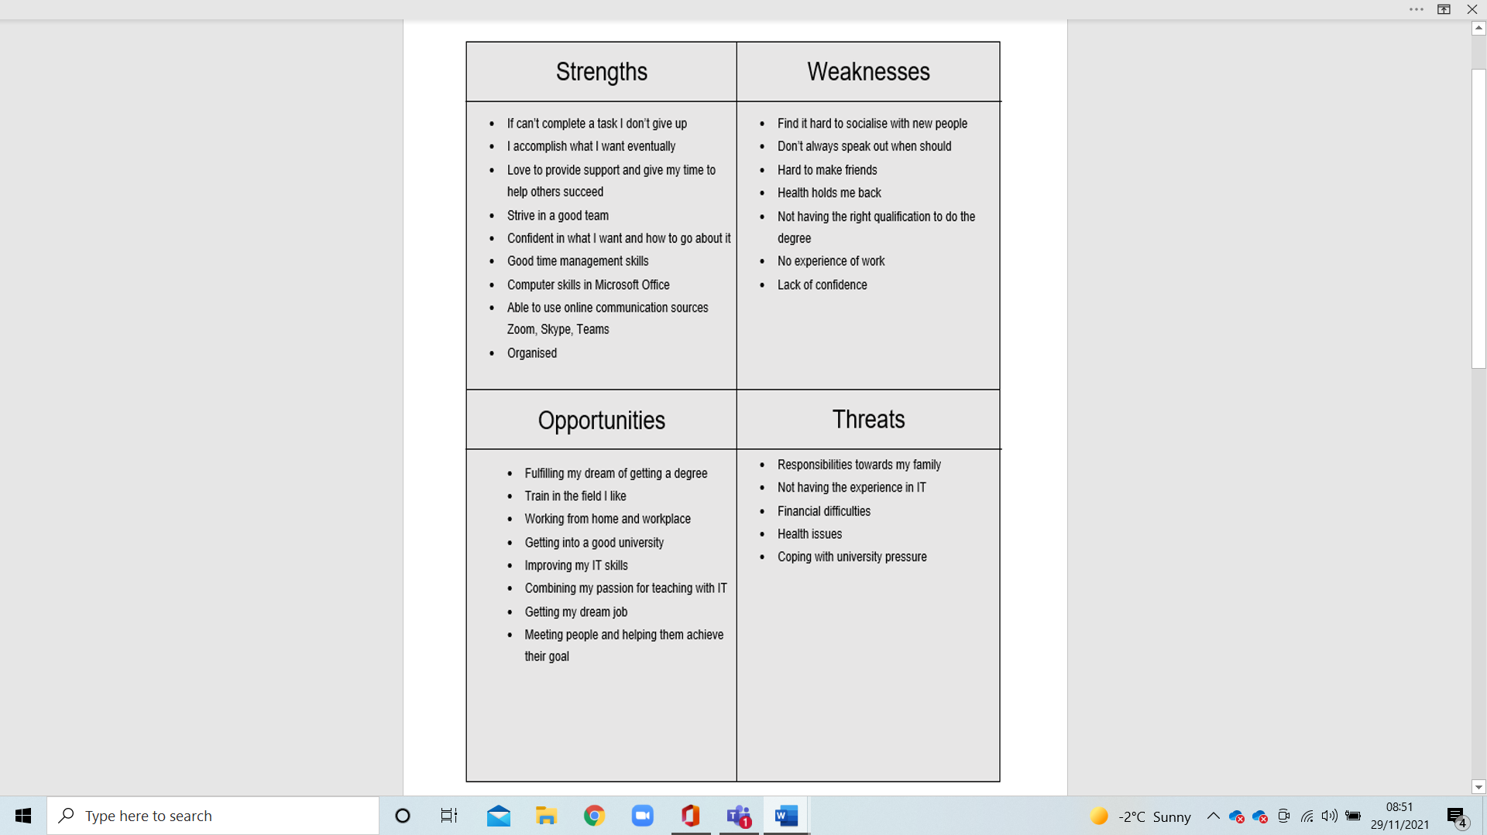
A SWOT analysis “is a strategic analysis tool focussed on achieving change and can be utilised to help understand complex predefined concepts while focussing on identifying changes and strategies which improve the concept.” (Schupp, 2021)

Personal Development Plan
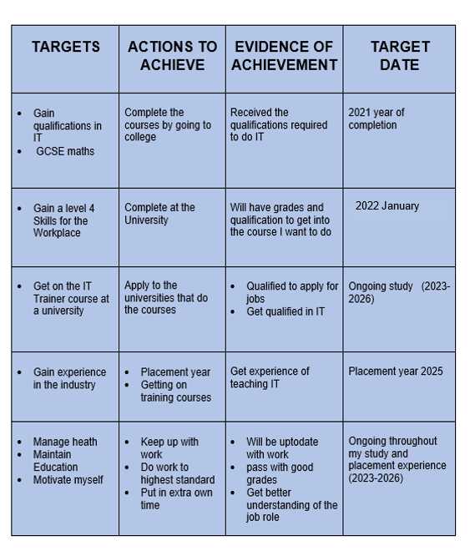
PDP stands for Personal Development Plan. “A PDP is a form of self-evaluation and self-reflection that is typically used in higher education and the workplace. However, it can also be a beneficial exercise in your personal life”. (Putter, 2021)

PDP/SWOT Definition
PDP
As shown in the above diagram, “There are typically 5 sections in a PDP:

  - Evaluate current situation
  - Identify career goal(s)
  - Identify skills, knowledge and resources required
  - Determine actions to achieve a goal(s)
  - Determine evaluation frequency” (Hill, 18 June)

This analysis tool helps you to determine what you want to achieve by evaluating your current situation, stating your goals, identifying existing qualifications, skills and experiences. Then put a plan into action on how to go about achieving it using realistic methods and time to complete.

SWOT
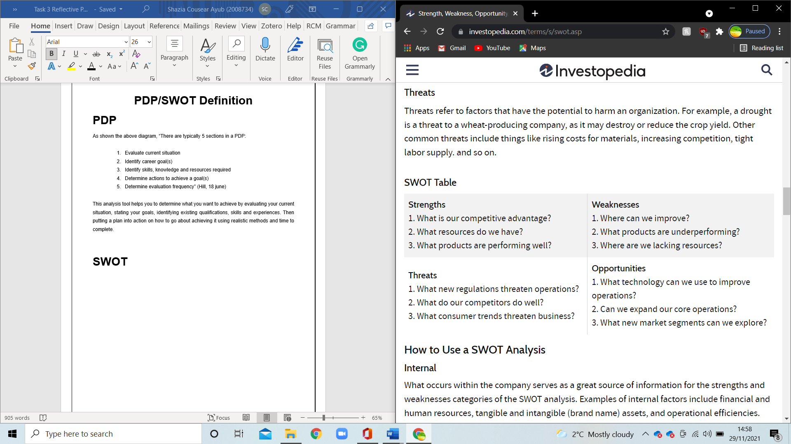
(Kenton, 2021)

Interview Results
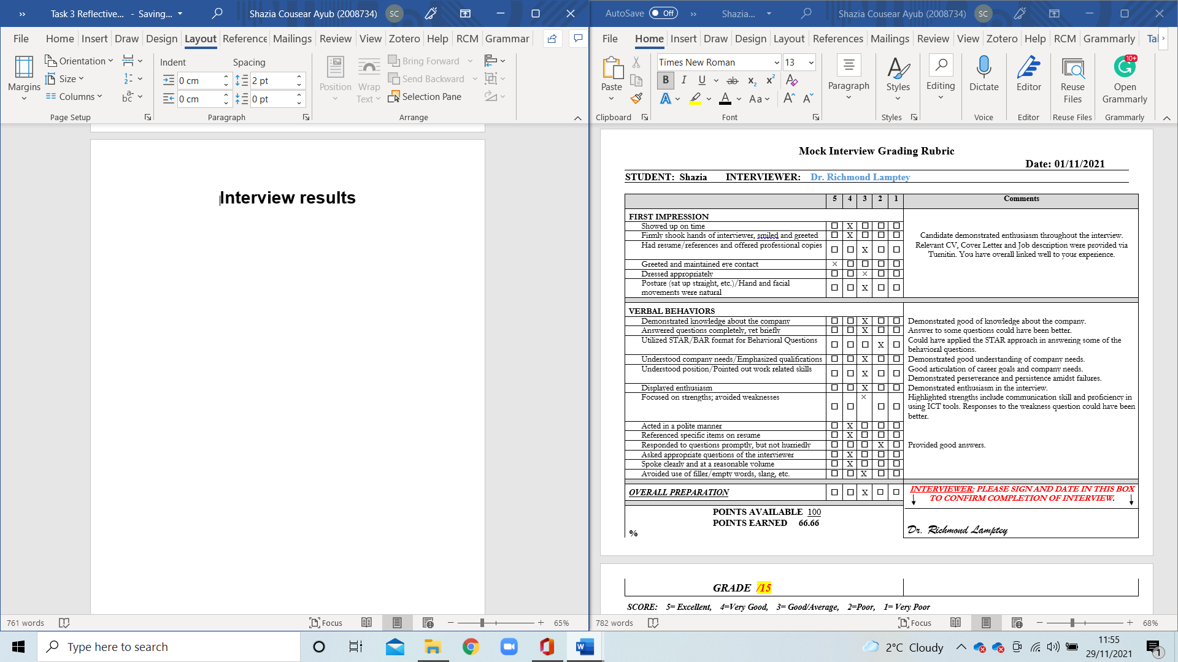
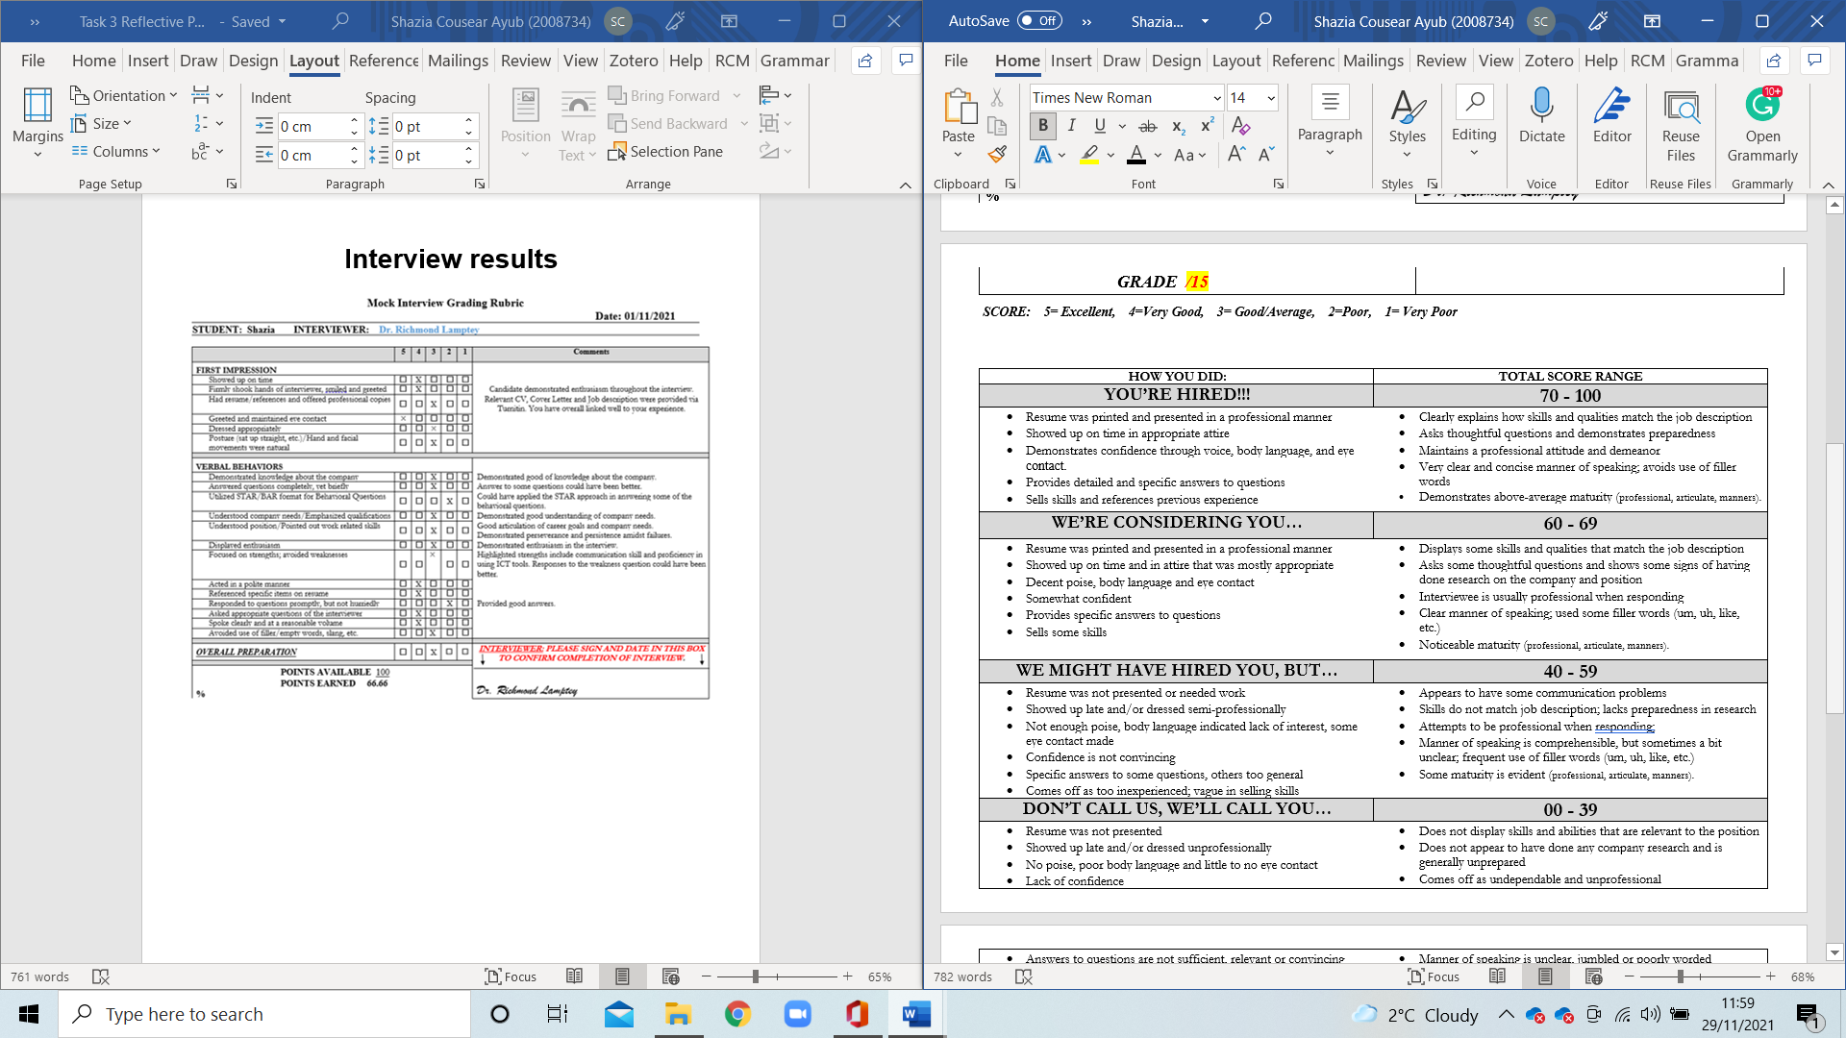

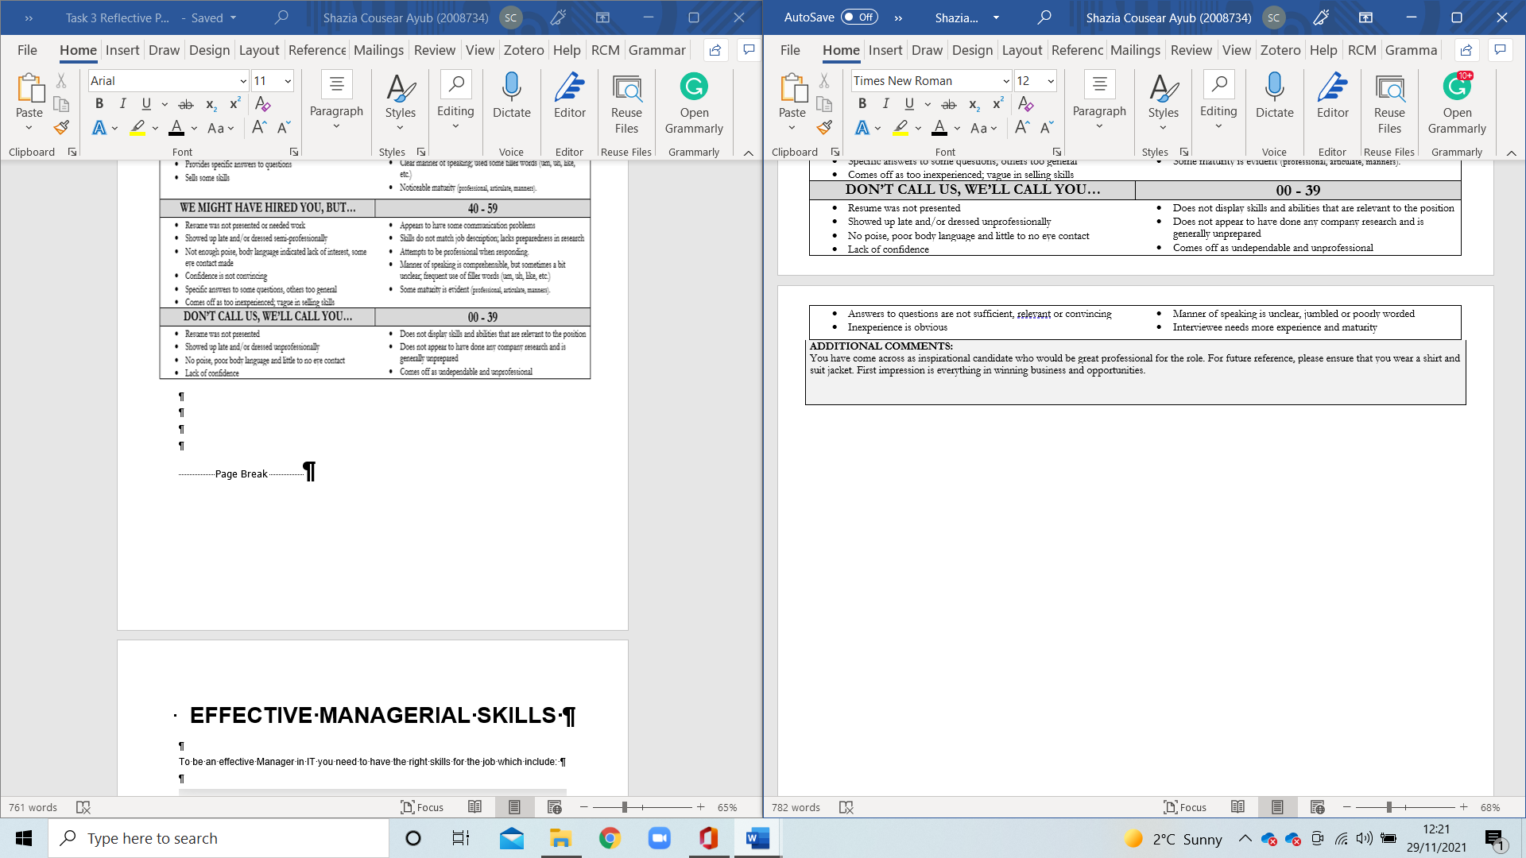
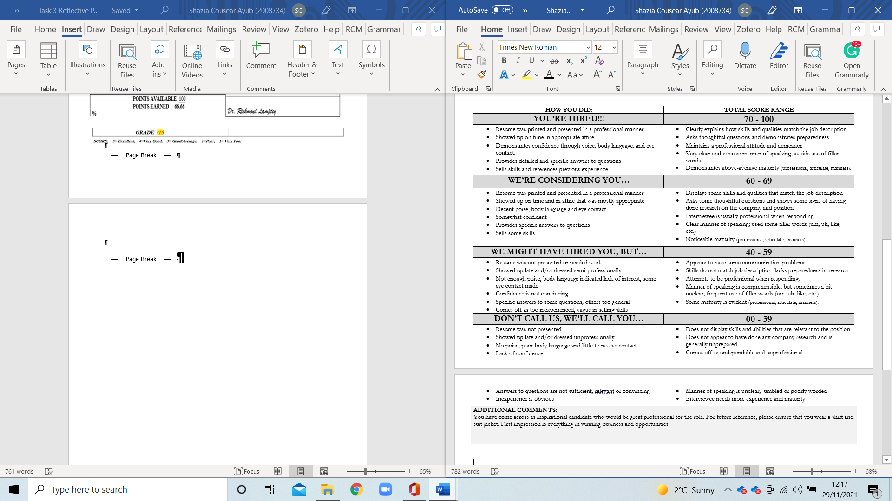

EFFECTIVE IT MANAGER SKILLS

To be an effective Manager in IT you need to have the right skills for the job which include:

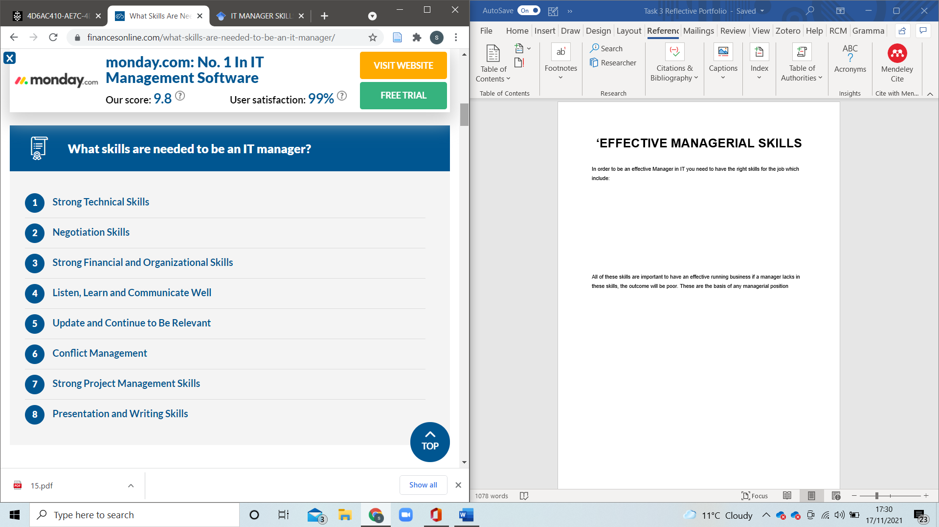
(business, 2021)

Manager Role
All of the above skills are important to be a successful manager, If the manager lacks these skills, it would be difficult to run a successful business. One of the main skills an IT manager needs is to be qualified and have knowledge in the field known as Hard Skills. This is obtained through college, University, certified programs or training.
Another main attribute of a manager should be his soft skills be able to motivate, communicate, instruct, be able to time keep and have good leadership.
The role of a manager is to make sure everyone does their jobs to a good standard, understands the work set, completed on time without any issues. To be able to accomplish this the manager needs to be able to solve problems that may occur due to staff or production.
Companies may offer managerial courses to advance within the workplace if they see potential, but some qualification, experience, knowledge is needed to progress hence the need to go back and study to progress. (Team, 2021)

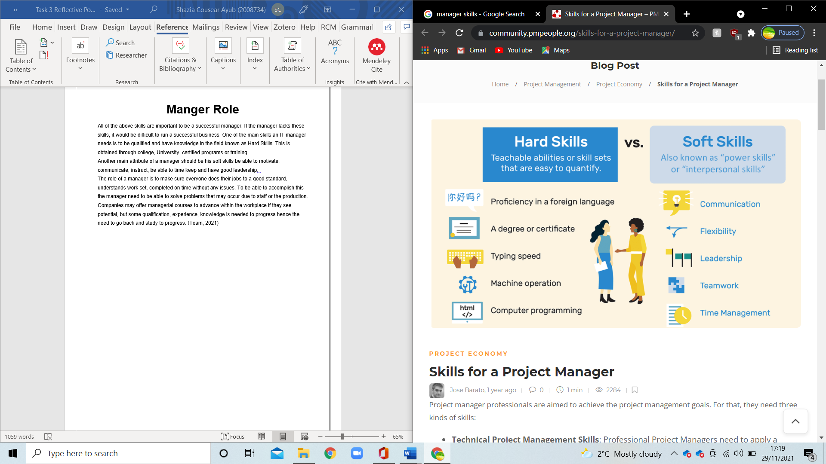
(Barato, 2020)

ASSESSING LEARNED OUTCOME

Smart Goals
Sour text here
R
M text here

T
A

S- Specific
Know what your goals are and what you want to achieve
M-Measurable
To complete the task you need need to be clear on what the issue is.
A-Achievable
Setting realistic goals within a timeframe is important it shouldn’t be too easy as it will lack the motivation to achieve better and if not achievable then causes low self-esteem.
R-Realistic
The goals need to be realistic so it achievable otherwise waste of time, with no results.
T-Timely
There needs to be a timeframe in which to complete the task whether education, qualification/certificates or training. (A.J.Janabergenova, 2021)
This method helps with putting down realistic goals within a timeframe because it has a time limit it pushed the individual to work hard and gain the required results.

Johari Window
A Johari Window Model has four sections and is a tool that helps in creating a better understanding between two or more people. Two psychologists Joseph Luft and Harry Ingram used a diagram with four sections 2 parts are about what you do and don’t know about yourself, two what others do and know about you. (coach, 2020). Leadership roles require a person who can understand himself/herself as well as understand what others think. This tool is a good place to start when evaluating.
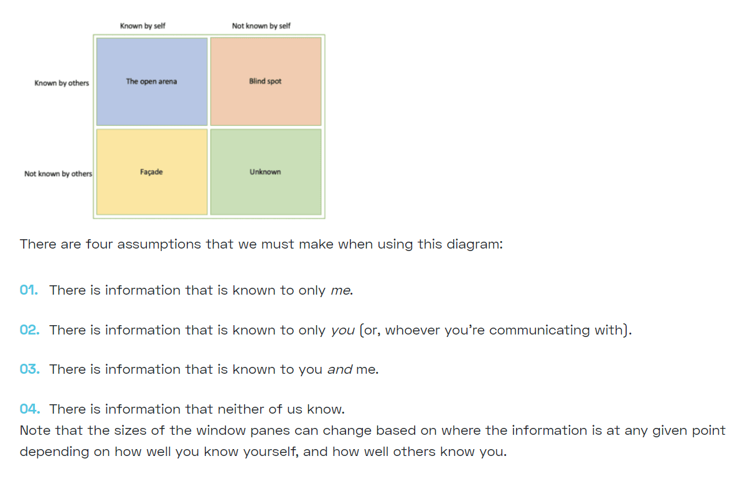

(coach, 2020)
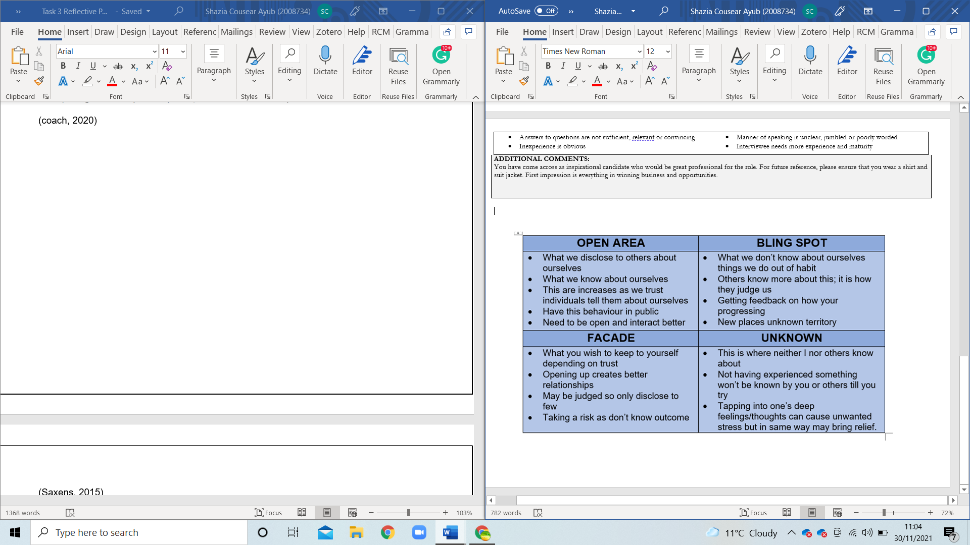

(Saxens, 2015).
These sections can be increased as knowledge increases. How that can be achieved is by getting feedback from others and asking questions about what people think of you. Also trying new things opens up to making friendships. This can be risky as the other person reaction is unknown. This tool is great for getting to know yourself and your flaws.

UK Employment laws
All employers are required by law to follow the UK Employment Laws these are:
- Minimum wages as of April 2021 are £8.91 an hour which increases on 22nd April 2022 to £9.50 an hour.
- Holiday pay is paid holiday 28 days a year for full-time employment. Plus, public holidays
- Statuary sick pays up to 28 weeks in any 3 years.
- Working hours are restricted to 48 hours a week but employers can opt-out.
- Equal pay for men and women if doing the same job.
- Maternity leave for 52 weeks with 39 weeks paid with the right to return to work.
- Paternity leave for 2 weeks with paid leave.
- Adoption leaves for 52 weeks with 38 weeks pay, Appointment leave to 5 for the main adopter and 2 for the second parent.
- Shared parental leave is 52 weeks with mothers 2 weeks compulsory, shared pay for 39 weeks.
- Unpaid leave in the first 18 years of a child’s life.
Employers are required to have a contract of employment which includes names of the employer and employee, the start date of employment, Job description, place of work, hours of work, pay details, detail of pension, holiday entitlement. The workplace should have policies in place for discipline and grievance procedures of which copies can be found around the workplace.
It is against the law to discriminate against sex, race, disability, maternity leave, sexual orientation, pregnancy, religious beliefs, marital or civil partnership or gender reassignment. There are the same rules whether you are a part-time employee or full time. If this is the case the employers face lawsuits. However, unfair dismissal within the workplace requires a minimum of 2 years of continuous employment. Workers made redundant in large numbers require notice otherwise employers will have to pay 90 days to pay and if employed for more than 2 years will have to give redundancy pay. The retirement age limit is no reason to dismiss an employee either, but this is where the policies of the workplace need to be clear. (David, 2021)

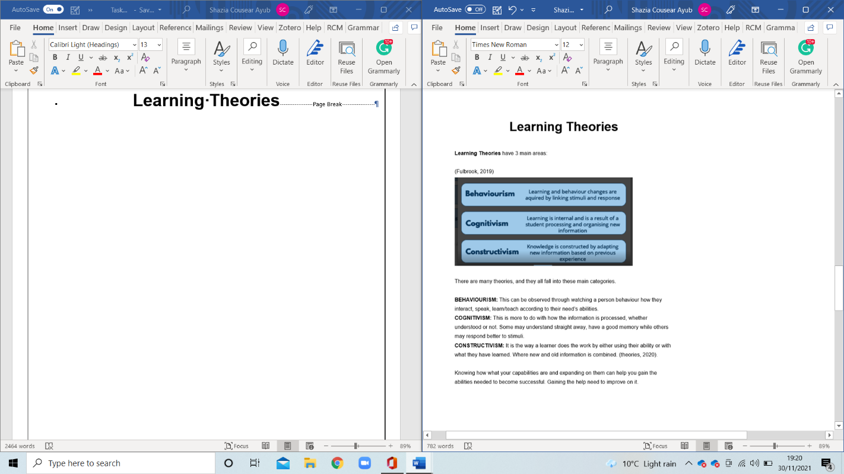
Learning Theories

Self-Awareness
When a person can assess themselves and improve on it, their level of understanding increases and work output is better. Gibbs Reflective cycle has 6 stages:

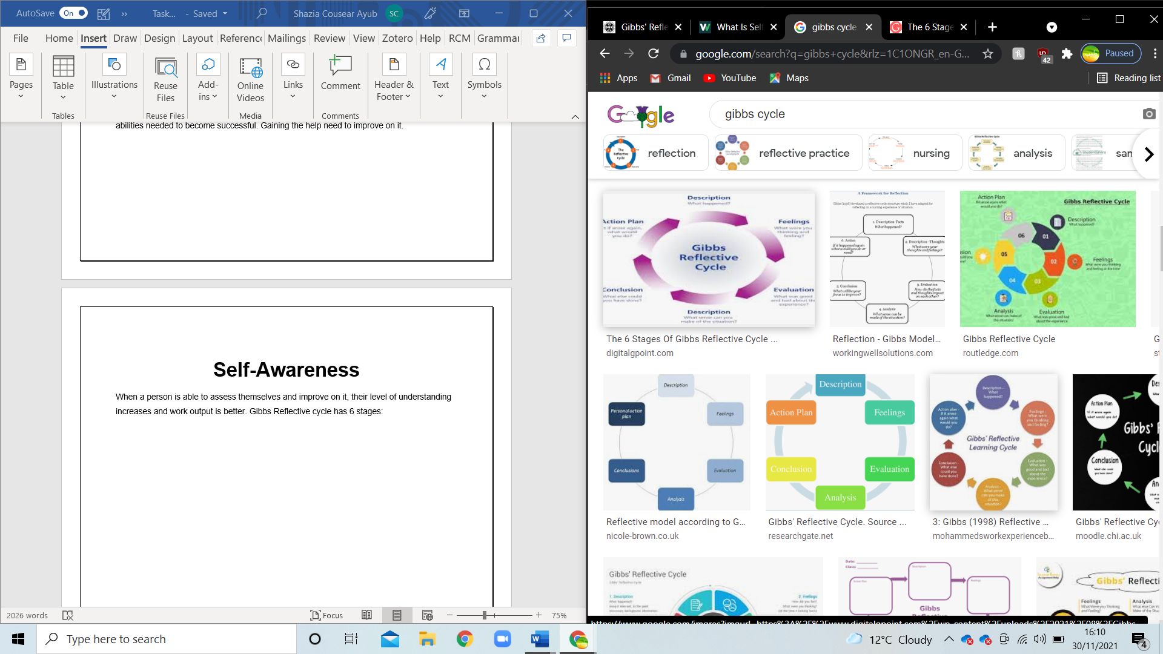

(Smith, 2020)

“Gibbs' Reflective Cycle was developed by Graham Gibbs in 1988 to give structure to learning from experiences. It offers a framework for examining experience”. (EDINBURGH, 2021). This tool like the PDP is another tool to analyse an issue and solve it. Going through these stages will give you a clear path to follow the one you decide on a route.

My Assessment
In my time at the university, I have learned a lot made friends but most of all I have been able to understand myself better. Although I was aware of my abilities and how I wanted to achieve them I never really thought in the depth of what I was going to do and give myself a time limit or thought I was capable of achieving my goal to graduate. This now feels like I’m a step closer and having completed my first year at a good level I’m confident in my ability to achieve what I want.
- HIGHER AWARENESS TEST: It explains to me exactly I like to finish what I start. Try to achieve the best I can, helping others too. My abilities are known to me, but I have less confidence.
- LEARNING STYLE: The learning style for me shows that I am a visual learner which is correct as I love to watch tutorials and YouTube videos to help me understand. This way I don’t need to try it comes naturally I picture and I rewatch it if I need to. Listening is also a good way for me to learn I keep listening and learn off by heart. If I try to learn it, I find it difficult.
- PERSONALITY TEST: This test also is accurate as I do have a good imagination, good at solving problems. Not liking confrontations and like to set high standards and try to achieve.
- SWOT: This is quite explanatory as I had to think hard about myself to fill in this. I found strengths I thought I never had.
- PERSONAL DEVELOPMENT PLAN: This was a challenge to write down what I wanted out of life, how I was going to do and by when. I have set myself realistic targets which I now believe I can do. This has put things into perspective after a hard year, it is written down has made it seem achievable even when I faced hardship, I accomplished my goals a step closer to my dream of graduating.
- INTERVIEW RESULTS: I was a bit disappointed, to say the least in my interview I was expecting more but I see where I need to improve so when I get out into the world, I will be ready. I was under the required mark to be fully considered but I don’t have the experience yet even though have qualifications. This was an eye-opener for me thought would do better in a real one I think now. I do feel like I lacked in the questions, but I did answer with a good response which I thought I wouldn’t be able as was nervous. Overall, a great experience I didn’t enjoy but I learned a lot.

CONCLUSION
As there are many tools available to help with self-awareness it is easy to evaluate yourself and come to a good conclusion as to where improvement is needed. It is quite scary to see how accurate these tests are. My test results changed my opinion of myself, and I learned that I have confidence in the wrong places and none where I should. Even though it was not a favourite module I am happy with what I learned and achieved. Creating a PDP was the best part, it’s like putting my dream on paper was bringing me closer to it and I will complete it within a few years. The responsibility to be in a high post is not something for me. I might have thought about it before but not now. This was a great experience for a job interview as I never had one before. Maybe that’s why I didn’t do as well as I would have wanted, but you learn through experience.

REFERENCES
16personalities, 2021. Advocate (INFJ) personalities/ 16personalities. [Online]
Available at: https://www.16personalities.com/infj-conclusion
[Accessed 12 11 2021].
A.J.Janabergenova, 2021. Setting Goals on Smart Techniques and Affecting Student Motivation. Annals of the Romanian Society for Cell Biology, 25(4), p. 23.
Barato, J., 2020. Skills for a project manager pm people. [Online]
Available at: https://community.pmpeople.org/skills-for-a-project-manager/
[Accessed 29 11 2021].
business, F. o. r. f., 2021. What Skills Are Needed To Be An IT Manager?. [Online]
Available at: https://financesonline.com/what-skills-are-needed-to-be-an-it-manager/
[Accessed 17 11 2021].
coach, u., 2020. The Johari Window Model – How To Become A Great Communicator. [Online]
Available at: https://upskillcoach.com/blog/what-is-the-johari-window/
[Accessed 30 11 2021].
David, U. o. W. T. S., 2021. moodle. [Online]
Available at: https://moodle.uwtsd.ac.uk/course/view.php?id=5908
[Accessed 30 11 2021].
EDINBURGH, U. o., 2021. Reflective Toolkit, Gibbs Reflective Cycle. [Online]
Available at: https://www.ed.ac.uk/reflection/reflectors-toolkit/reflecting-on-experience/gibbs-reflective-cycle
[Accessed 30 11 2021].
Fulbrook, P., 2019. 15 Learning Theories in Education (A Complete Summary). [Online]
Available at: https://teacherofsci.com/learning-theories-in-education/
[Accessed 30 11 2021].
Hill, T., 18 June. Professional Development Plan Template (with Completed Examples). [Online]
Available at: https://www.seoptimer.com/blog/professional-development-plan-template/
[Accessed 03 10 2021].
Kenton, W., 2021. Investopedia Strength, Weakness, Opportunity, and Threat (SWOT) Analysis. [Online]
Available at: https://www.investopedia.com/terms/s/swot.asp
[Accessed 29 11 2021].
Planner, E., 2011-2021. What's your learning style? The Results. [Online]
Available at: http://www.educationplanner.org/students/self-assessments/learning-styles-quiz.shtml?event=results&A=7&V=7&T=6
[Accessed 13 11 2021].
Putter, M., 2021. CPD Online College knowledge base. [Online]
Available at: https://cpdonline.co.uk/knowledge-base/business/what-are-personal-development-plans/
[Accessed 03 10 2021].
Robson, J., 2019. Higher Awareness programs - Raise Consciousness. [Online]
Available at: https://www.higherawareness.com/johnrobson.html
[Accessed 13 11 2021].
Saxens, P., 2015. Academia Accelerating the world's research. JOHARI WINDOW: An Effective, 5(2), pp. 4-5.
Schupp, M. K. G. O. V. e. a., 2021. Dissecting the offshore wind and mariculture multi-use discourse: a new approach using targeted SWOT analysis. Springerlink, 10 03, pp. 127-140.
Smith, C., 2020. The 6 Stages Of Gibbs Reflective Cycle- A Complete Guide. [Online]
Available at: https://www.digitalgpoint.com/the-6-stages-of-gibbs-reflective-cycle-a-complete-guide/
[Accessed 30 11 2021].
Team, I. E., 2021. Management Skills: Definitions and Examples. [Online]
Available at: https://uk.indeed.com/career-advice/career-development/management-skills
[Accessed 29 11 2021].
theories, T. l., 2020. 15 learning theories in education (A complete summary). [Online]
Available at: https://www.learning-theories.com/
[Accessed 30 11 2021].
Unknown, 2013. EMPLOYER-PERSONAL-DEVELOPMENT-E13. [Online]
Available at: https://atabsh.files.wordpress.com/2013/07/employer-personal-development-e1365297431711.jpg?w=809
[Accessed 17 11 2021].

