Kai Barker
2307670

Advanced Coaching and Mentoring Assignment (BMSM5007)

Contents…
Contents.. PG. 2
In-Class Test (Semester 1).. PG.3/4/5
Academic Journal Review 1.. PG.6
1 x Lesson Plan from LC Delivery.. PG.7
Academic Journal Review 2.. PG.8
Mentoring Assessment 1.. PG.9
Mentoring Assessment 2.. PG.10
In-Class Test Coach Education Pathway (Semester 2).. PG11/12/13/14

In-Class Test (Semester 1)
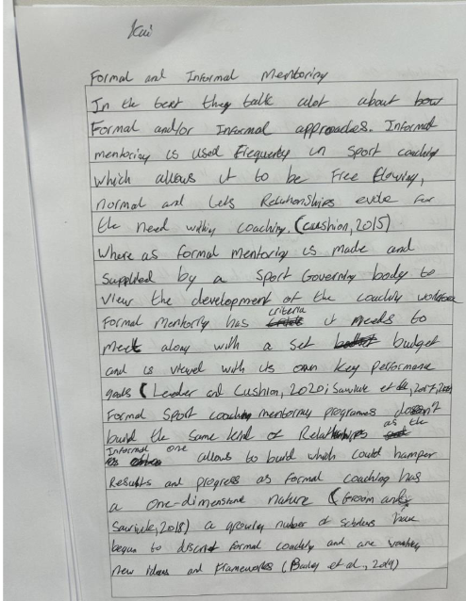

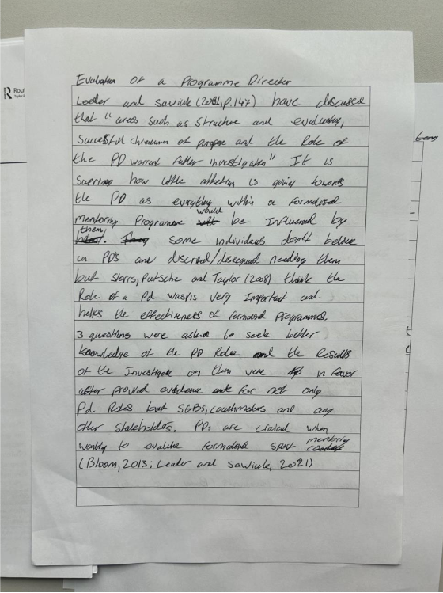

Academic Journal Review 1
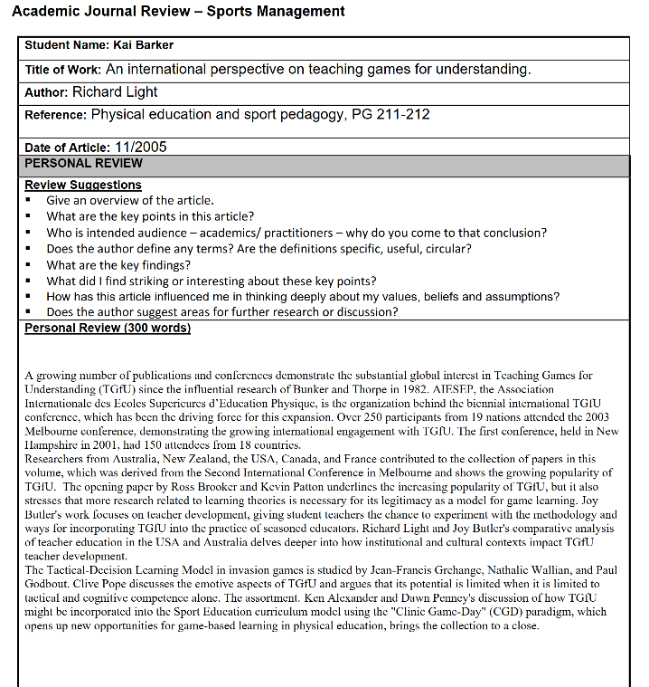

1 x Lesson Plan from LC Delivery..

Academic Journal Review 2
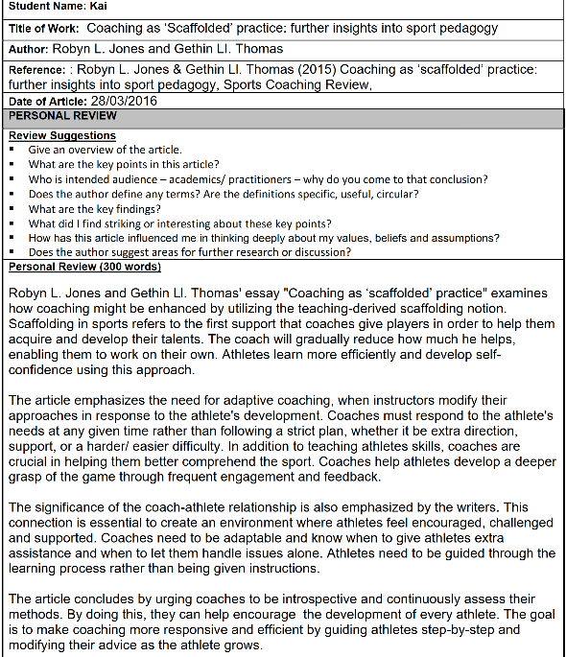

Mentoring Assessment 1

Mentoring Assessment 2
In-Class Test Coach Education Pathway (Semester 2)

Time frame –
If you can get access to all the courses and complete them all on the first try, then it will take you
Intro to coaching football course – 4 weeks
UEFA C licence –16-20 weeks
UEFA B licence – 9-12 months
UEFA A licence – 12 months
UEFA Pro Licence – 18 months
Which in total takes 3 years and 8 months
Pre entry requirements –
To become an elite status football coach, you will need to a UEFA pro licence, which you can get through the doing a course but to be accepted on the course, you will need to have your UEFA C, B and A licences along with a good amount of time coaching football at a very high level
You will also need to be 16 or older and have a guarding check along with a DBS check
Then to complete all the courses, you will need Intro to coaching football course
UEFA C licence – intro course complete
UEFA B licence – UEFA C + minimum one year coaching
UEFA A licence – UEFA B + experience at a competitive level
UEFA Pro Licence – UEFA A + elite level coaching experience
Essential skills –
The essential skills you will need to achieve elite status are:
Technical – you will need to be able to design your own sessions, tactical analysis and position-specific coaching
Soft skills – you will need to be good at communication, motivating your players and being able to handle and resolve conflicts
Leadership – good team management and be able to do performance reviews
Digital – be able to use video analysis tools and data analytics
Reflective practice – be able to give peer feedback, be able to be a good mentor
Work experience –
Year 1 – Start coaching at a local club as an assistant youth coach while completing your intro to coaching course that will take 4 weeks; you can then go on to complete your UEFA C licence that will take you a maximum of 20 weeks. You will be coaching at grassroot clubs or a local academy
Year 2 – this is when you will apply to complete your UEFA B licence. For this, it will benefit you more to become a head coach for U12-U16 at a semi-pro academy; this will be a regional club such as….
Year 3 – start coaching as an assistant coach for U18-U23 for a pro academy. While completing your UEFA A licence, this will take up all your 3rd year coaching and maybe some 4th year coaching, but you will gain loads of experience
Year 4 – you will now want to start coaching at a higher level than you are at. Start to apply and land a job at a club in the national league as a head coach.
Year 5 – once you’ve held your UEFA A licence for 12 months and have gained enough experience, you can apply for your UEFA PRO licence; this will take 18 months to complete. You will need to apply to work as an assistant coach in professional clubs in either the Championship or Premier League academy teams.
Location –
Wales, Swansea
UEFA C- Dragon Park, Newport
UEFA B – dragon park, Newport
UEFA C- Dragon Park, Newport
UEFA Pro – Dragon Park, Newport
Certification –
Intro to coaching football course
UEFA C licence
UEFA B licence
UEFA A licence
UEFA pro licence
Safeguarding
First aid

Costs
Intro to coaching football course – £100 (4 weeks)
UEFA C licence – £650 (16-20 weeks)
UEFA B licence – £1200 (9-12 months)
UEFA A licence – £4000 (12 months)
UEFA pro licence – £13,700 (18 months)
Safeguarding – £50
First aid – £50

Works Cited
Association, The Football. “Introduction to Coaching Football | England Football Learning.” Https://Learn.englandfootball.com, 2023, learn.englandfootball.com/courses/football/introduction-to-coaching-football.
---. “Safeguarding Children Course | England Football Learning.” Https://Learn.englandfootball.com, learn.englandfootball.com/courses/safeguarding/safeguarding-children-course.
---. “UEFA a Licence | England Football Learning.” Https://Learn.englandfootball.com, 2023, learn.englandfootball.com/courses/football/uefa-a-licence.
---. “UEFA B Licence | England Football Learning.” Https://Learn.englandfootball.com, 2024, learn.englandfootball.com/courses/football/uefa-b-licence.
---. “UEFA pro Licence | England Football Learning.” Https://Learn.englandfootball.com, 2023, learn.englandfootball.com/courses/football/uefa-pro-licence.

