
Master of Business Administration

Module Code and Title: LCMB7002 Financial Management

Strategic CFO Challenge: Saving General Electronics

Student Name: Jamila Begum
Student ID: 2503076

Lecturer: Shengfeng Mei (London)

Word Count: 5042

Table of Contents
1. Introduction 4
2. Financial Health Check of General Electronics 5
2.1 Analysis of Profitability Ratio 5
2.2 Analysis of Liquidity Ratio 6
2.3 Analysis of Efficiency Ratio 6
2.4 Analysis of Gearing and Capital 7
2.5 Analysis of Investment Performance 8
2.6 Analysis of Cash Flow Ratio 8
2.7 Trends, Strengths, and Threats 8
2.8 Altman Z-Score 9
3. Working Capital Management Analysis 10
3.1 Assessment of the Cash Operating Cycle 10
3.2 Strategies to Improve Liquidity through Working Capital Reforms 10
3.3 Short-Term versus Long-Term Financing Options 11
4. Financial Restructuring Plan 13
4.1 Rationale 13
4.2 Financial Restructuring Options 13
4.3 Evaluating the Impact on Financial Structure 14
4.4 International and Ethical Considerations 15
5. Investment Appraisal and Capital Budgeting 17
5.1 Proposed Investment Projects 17
5.2 Payback Period Analysis (PPB) 18
5.3 Accounting Rate of Return (ARR) 19
5.4 Net Present Value (NPV) 19
5.5 Profitability Index (PI) 20
5.6 Internal Rate of Return (IRR) 21
5.7 Project Selection 22
5.8 Financial Performance 22
6. Conclusion 23
References 24
Appendices 27

1. Introduction
Capital budgeting and investment appraisal are critical activities that help to assess the financial feasibility of a given project. In the case of General Electronics, informed investment decisions are essential, notwithstanding the financial difficulties which the company is facing now. The analysis will be done on three possible investment projects, the cash flow and capital requirement of which are different. The analysis will take the form of a financial analysis using financial metrics including Payback Period (PBP), Net Present Value (NPV), Accounting rate of Return (ARR), Profitability Index (PI), and Internal rate of Return (IRR), to give a overall assessment of the project that will guide the company in choosing the most financially viable project taking into account the capital constraint and risk.

2. Financial Health Check of General Electronics

2.1 Analysis of Profitability Ratio
The General Electronics profitability ratios in the 2020-2024 period are of a worrying downward trend. It is not simply an outcome of inefficiencies within a country but is also a factor that is affected by the global economic factors. The Gross Profit Margin has been between 23-28, which shows volatility in the cost management, which may be caused by the increasing costs of raw materials, labor shortages, and disruption of world supply chains. Indeed, the COVID-19 pandemic caused a multinational supply chain crisis, especially in the electronics and semiconductor sectors, which has had a critical impact on the cost structure of such companies as General Electronics. Although Apple and Samsung might have withstood these shocks more because of their size and supplier base, smaller firms such as General Electronics might have found it difficult to procure materials at reasonable prices hence affecting profitability.
Moreover, the fact that the Operating Profit Margin will become negative in 2023-2024 indicates that the company faces serious cases of operating inefficiencies. This is a scathing commentary of how the world inflation and the associated cost increases of inputs (such as semiconductors) have compromised profitability in operations. The fact that the Net Profit Margin of 2024 stands at -6.09% as compared to 6.28% in 2020 is another indication of the influence of these external factors. An example is Apple which has been able to sustain strong profit margins even in economic recessions through diversification of its revenue lines (services, wearables) compared to General Electronics which has been adversely affected by its greater reliance on hardware.
The depreciating efficiency with which General Electronics has been utilizing its capital is also indicated by the Return on Capital Employed (ROCE) that decreased in 2023-2024 to negative values, as compared to 11.23% in 2020. The macroeconomic volatility of the external environment has been a cause of the low returns, which can also be traced in other firms in the consumer electronics and semiconductor industry. Conversely, Nvidia and AMD, whose business is based on high-performance chips, have enjoyed huge payoffs, albeit with a lot of difficulties, due to their superiority in the high demand markets such as gaming and AI.

2.2 Analysis of Liquidity Ratio
Liquidity position has been a challenge to General Electronics as it is shown by the decrease in Current Ratio which dropped to 1.53 in 2024 against 1.82 in 2020. This declining pattern is worrying, and this is an indication of a loss of capacity to meet the current liabilities as they fall due to the current assets, particularly in the face of the external shocks. The situation due to COVID-19 and the resulting economic crisis made several businesses, especially those in the consumer electronics industry, to pay their suppliers late or offer credit to their customers, which affected their liquidity status. Samsung and Apple, as the companies with more cash reserves, were in a better position to endure these challenges without impacting their liquidity as much whereas General Electronics had fewer options.
The decrease in the Quick Ratio of 1.15 in 2020 to 1.03 in 2024 shows that the General Electronics is increasingly using inventory to pay its liabilities, which is worsened by poor inventory management. The problem was even more strongly experienced in the global semiconductor shortage that caused delays in the production schedule and the inability of the company to satisfy demand whilst spending its cash income efficiently. On the other hand, firms such as Xiaomi could use their supply chain agility and sustain cash flow through such crises.
The Cash Ratio also shows a risky position with a drop in the ratio between 0.32 in 2020 to 0.17 in 2024. These underscores increasing dependence of General Electronics on credit and assets to pay its bills, which in conjunction with the fluctuating market environment puts the company at risk of going under. Diversified Nvidia and Qualcomm with high growth products in artificial intelligence and 5G have shown a higher capacity to control their cash positions in turbulent times.

2.3 Analysis of Efficiency Ratio
This is a good indicator as the Asset Turnover Ratio rose in 2022 to 1.08 and in 2024 to 1.22. Nevertheless, the recovery is to be considered through the prism of global supply chain disruptions which influenced the use of assets during the pandemic. Comparatively, the asset turnover of Apple was comparatively steady because of its diversified product lines and effective asset management policies. The Fixed Asset Turnover Ratio also improved by 7.04 in 2020 to 11.54 in 2024, which is more efficient in using fixed assets. Nevertheless, the growth of the Receivables Days (105.54 in 2024) is an indication of slowed down customer payments, and the economic uncertainty of the global events such as the post-pandemic recovery period and the continued geopolitical tensions aggravated the situation. Conversely, Samsung and Intel who had stronger market positions and had more control over their supply chain did not experience the same disruption of their receivables.
The increase in inventory Days to 131.04 in 2022 and then slight reduction to 103.12 in 2024 indicates poor inventory management, which was one of the most significant problems in the pandemic when companies in the industry experienced severe stock-outs and stock mismatches. This was made worse by the shortage of semiconductors that slowed down the production. Firms such as Xiaomi that were in cheap markets with lean inventory management systems were in a position to manage such difficulties.

2.4 Analysis of Gearing and Capital
Over the past five years, General Electronics has been more dependent on the use of debt financing, as evidenced by the fact that its Debt-to-Equity Ratio has gone up, since 0.87 in 2020 to 1.11 in 2024 (Clark, 2024). This growth shows that the company is now more leveraged and thus more prone to financial risks particularly in a volatile market environment. Interest Coverage Ratio has decreased significantly, as in 2020 it was 26.21 and in 2024 it was -4.55, which depicts the increasing inability of the firm to meet its interest payments with its operating income (Tsatsaronis et al., 2024). This depreciation indicates that General Electronics might have difficulties in covering its debt liabilities, which might also put additional financial strain on its financial status. The Debt to Capitals ratio is also increasing, as it was 0.39 in 2020 and 0.53 in 2024, indicating that the company is increasingly relying on debt to finance its operations, which may restrict its capacity to raise more capital at elevated costs and conditions. To enhance its financial flexibility, the company needs to pay more attention to the decrease in its debt level to minimize the risks connected to the high leverage (Babajee et al., 2022).

2.5 Analysis of Investment Performance
The performance of the investment can be analyzed in two ways: first, through financial analysis, and second, through non-financial analysis.
The performance of the investment of General Electronics has been sub-optimal, and this is evidenced by the decrease in the Earnings per Share (EPS) as it was at £2.78 in 2020 and -1.85 in 2024. This was a major decline in EPS, and it is a firm sign that the company has failed to make profits to shareholders (Eltweri et al., 2024). In 2023 and 2024, the Price-to-Earnings (P/E) Ratio was meaningless because of negative earnings, as it shows that the firm cannot offer investors positive returns on their investments. On the same note, the Return on Equity (ROE) has drastically declined to -15.69% in 2024 after 12.31% in 2020, and it indicates that the company has been unable to make sufficient returns on shareholder equity (Fathi, Mohammadin and Azarbayjani, 2025).

2.6 Analysis of Cash Flow Ratio
The cash flow ratios are important in determining the capability of a company to produce adequate cash through its operations. The Operating Cash Flow Ratio in 2024 is lower by half than in 2020 at 0.41 indicating a significant reduction in the capacity of the company to make cash to meet current liabilities (Eyinade, Ezeilo and Ogundeji, 2025). This is an alarming trend as it implies that General Electronics will not be in a position to pay its short-term liabilities if its cash flow is declining. The Cash Flow to Debt Ratio deteriorated as well, which means that the company is becoming increasingly reliant on debt to finance its operations instead of producing cash through its activity (Ebire et al., 2024). The Cash Flow Margin has decreased since 2020 (11.94 percent) to 2024 (3.75 percent), indicating that the company is turning fewer sales into cash flow.

2.7 Trends, Strengths, and Threats
General Electronics has been in a steady decrease in profitability, liquidity performance and investment performance and more importantly, the company has been dependent on debt financing. The company has enhanced turnover of fixed assets and use of assets, which are its strengths. Nevertheless, the increasing risks that are caused by increasing debt, weak cash flow, and inefficiency in the management of receivables and inventory present a significant threat to its financial stability. Unless these weaknesses are dealt with, they may weaken the long-term viability of this firm. To reduce these risks and guarantee the company grows in future, the company should focus on enhancing profitability and liquidity (Schneller, Porter and Wakefield, 2023).

2.8 Altman Z-Score
The Altman Z-Score gives an indication of the risk of bankruptcy and the scales 1.8 show a high likelihood of failure. Z-Score The Z-Score of General Electronics has not fallen below the distress zone and has been decreasing over the years, with the 2020 score of 7.76 and the 2024 score of 7.76. Although the score means that the company is not yet in danger of bankruptcy, the negative movement of the profitability and the increase in debts are the signs of the growing financial distress (Fulzele, 2024). In case these trends remain, corporate failure will be more likely.

3. Working Capital Management Analysis

3.1 Assessment of the Cash Operating Cycle
The Cash Operating Cycle (COC) is the measure of time a company needs to turn its investments in inventory and receivables into cash considering the time that should be spent to pay suppliers (Atrill and McLaney, 2017).
The Receivables Days (DSO) of General Electronics is rising, and it was 76.86 days in 2020 and 105.54 days in 2024, which indicates that the company is becoming slower in collecting payments (Francisco, 2024). This long collection period binds up good cash that would otherwise serve other operating demands exacerbating liquidity problems. Also, Inventory Days (DIO) reached the highest value of 131.04 in 2022, and then dropped to 103.12 in 2024, which indicates inefficiency in the inventory management (Kelka, 2024). Despite the positive news in the decrease in DIO, the general trend is that there is a huge portion of cash tied up in unsold inventory that makes the carrying costs high and the operational flexibility to be low. The Payables Days (DPO) has gone up marginally to 85.12 days in 2024 as compared to 83.03 days in 2020, which is probably a temporary measure to save cash. Nevertheless, stretching payables too far can harm relations with suppliers and undermine the stability of the whole supply chain in the long term (Eltweri et al., 2024).

3.2 Strategies to Improve Liquidity through Working Capital Reforms
General Electronics can implement a number of measures to improve the liquidity in order to overcome the inefficiencies that exist in working capital. To begin with, it is important to improve the Receivables Management. General Electronics might also restrict credit terms, that is, shortening the credit period of its customers and providing early payment discounts to motivate them to settle them in a shorter time (Mensah, Bein and Arhinful, 2025). Moreover, the use of automated invoicing systems and proactive management of outstanding accounts can also be used to quicken collections and minimize DSO. The company can manage its receivables better, thus this helps the company to turn sales to cash much faster, and hence improve liquidity.
Second, there should be optimization of Inventory Management. General Electronics can switch to an inventory system of Just-in-Time (JIT), which transforms inventory levels to low levels to decrease inventory holding costs and release cash (Sunday, Onyeka and Ugorji, 2024). JIT would enable the company to align production to demand so that the inventory levels would be optimized and the stock turnover would increase. Also, the company will be able to use more sophisticated forecasting methods to more accurately match the production cycles with the demand in the market, thereby decreasing the stock level.
Finally, the company is supposed to work on the Accounts Payable strategy. General Electronics will be able to negotiate improved terms of payment with suppliers to extend the DPO without damaging supplier relationships (Fathi, Mohammadin and Azarbayjani, 2025). This would give the company a better opportunity to collect receivables and sell inventory and enhance cash position.

3.3 Short-Term versus Long-Term Financing Options
General Electronics has a major choice of either to depend more on short-term or long-term financing to run its liquidity and working capital requirements. Short term funding, including lines of credit or short-term loans can be used to provide instant access to cash and can be used to bridge short term liquidity shortages (Clark, 2024). This alternative is usually more flexible and may suit well in responding to seasonal changes in the working capital requirements. It is however accompanied by the risk of refinancing and increased interest rates especially when the creditworthiness of the company is affected by the deteriorating profitability and cash flow (Mikou, Lahrichi and Achchab, 2024).
Financing that is done on a long-term basis like issuing bonds or taking long-term loans are more stable and have lower interest rates in the long run. In the case of General Electronics, it might be helpful to finance strategic investments, including the improvement of inventory management systems or the growth of production capacity, with the help of long-term debt (Tsatsaronis et al., 2024). Long term funding would give the company the leeway to run its operations without the burden of making short term payments. Nonetheless, this alternative can build up the total debt of the company, which is already an issue since the Debt-to-Equity Ratio is growing (Clark, 2024).
In the present state of financial affairs of General Electronics, a balanced strategy could be the most appropriate. Short term funding may be utilized to solve short-term liquidity issues whereas long term funding may be utilized to solve long-term capital investments that enhance efficiency in the long run.

4. Financial Restructuring Plan

4.1 Rationale
The financial status of General Electronics has significantly declined during the last five years because it has shown a decrease in profitability, liquidity, and an increase in the level of debt (Berk and DeMarzo, 2020). The Debt-to-Equity Ratio of the company has risen since 0.87 in 2020 and has reached 1.11 in 2024, indicating that the company depends more on debt financing, which puts the company at high risks of financial risks particularly in unstable market conditions (Tsatsaronis et al., 2024). At the same time, the Net Profit Margin of the company has become negative, decreasing to -6.09% in 2024 compared to 6.28% in 2020, which is indicative of drastic operational inefficiencies and a falling profitability (Eyinade, Ezeilo and Ogundeji, 2025).
With such trends, General Electronics will become insolvent unless its financial position is managed. The company needs to embark on an extensive restructuring process to cut the debt level, enhance its operational effectiveness, and regain profitability. Moreover, the Operating Cash Flow Ratio of the company has decreased in the period between 2020 and 2024 (0.41 to 0.09), which indicates that the liquidity of the company requires a significant improvement (Keown, Martin and Petty, 2024). Restructuring of the financial will assist the General Electronics to recover its financial flexibility, optimize the capital structure, and increase its ability to fulfill both long-term and short-term obligations.

4.2 Financial Restructuring Options
General Electronics has a number of financial restructuring alternatives that can be used to solve the problems. The recommended options that can be taken to enhance the financial position of the company include the following:
Debt Reduction through Debt-for-Equity Swap: Debt-for-equity swap is one of the best methods to reduce the debt burden of General Electronics (Eltweri et al., 2024). Under this structure, the company would enter into negotiation with creditors to give up some part of the debt in exchange of equity shares. This would lower the total debt and interests payable and raise the equity capital. The reduction of the debt level would enhance the leverage ratios of the company and minimize its financial risk.
Equity Injection from Investors: General Electronics may use equity investments of new or current investors to boost the balance sheet of the company (Fathi, Mohammadin and Azarbayjani, 2025). This would consist of issue of new shares and this would enable the company to raise capital without incurring more debt. Although this would water down the current shareholders ownership, it would be a much-needed liquidity and allow the company to finance operations and expansion projects. It would also be an indication to the market that the company is determined to enhance its financial wellbeing.
Cost-Cutting and Operational Restructuring: In addition to the financial restructuring, the company needs to restructure its operations to take care of the dwindling profitability of the company. General Electronics shall look at cutting operational expenses by optimising workforce, simplifying production and renegotiating the contracts with suppliers (Guzel, 2021). This would enhance its capacity to generate cash flow because the company would be able to cut its cost to improve profit margins and its operational efficiency due to the cost cut measures.
Divestiture of Non-Core Assets: General Electronics might also think about the sale of non-core assets, such as non-performing subsidiaries or business units that do not serve the strategic interests of the company (Clark, 2024). The money raised by these divestitures could be used to settle the debt or to invest back in the core business areas and enhance the company focus and financial capability.

4.3 Evaluating the Impact on Financial Structure
The suggested financial restructuring alternatives would have severe consequences on financial structure of General Electronics. The debt-for-equity swap would have a direct effect on the level of debt-to-equity ratio, which would decrease the use of debt and enhance leverage of the company (Tsatsaronis et al., 2024). This would also reduce the amount of debt and this would reduce the interest payments and this would enable the company to enhance the profitability and the cash flow. The reduced debt ratio would enable General Electronics to raise capital in future because it would be a less risky investment to the prospective lenders and equity investors.
The equity injection would boost the equity base of the company which will further enhance the balance sheet of the company and will enhance the solvency ratios. Although this would water down the current shareholders, it would give General Electronics the liquidity it needed to finance its growth and operational enhancements (Babajee et al., 2022). The additional equity capital would decrease the reliance of the company on the outside debt and would give the company more financial leeway.
The economizing and operational restructuring would have a direct effect on the operating margins and cash flow of the company. General Electronics would be able to increase its profitability and liquidity by cutting overheads and enhancing efficiency (Guzel, 2021). Also, the divestitures would simplify the operations of the company, simplifying its business model and redirecting the resources to more lucrative areas. The asset sales would enhance the cash reserves of the company and offer strategic investment capital to enhance the financial stability and profitability.

4.4 International and Ethical Considerations
General Electronics needs to keep in mind international and ethical considerations when carrying out the financial restructuring plan. Being an international corporation, General Electronics is in several markets, and each of them has its regulatory framework, economic, and stakeholder-related requirements (Haddad, 2023). Any restructuring activity including debt renegotiation or equity issue should be in accordance with the legal and regulatory structures of the countries where the business is operating. Their inability to do so might lead to legal punishment, loss of reputation of the company, and loss of investor confidence.
In terms of ethics, the company should make sure that its restructuring does not take advantage of some stakeholders to an unfair extent. To take an example, a debt-for-equity swap may be beneficial to creditors and shareholders, but at the same time may cause harm to employees or local communities when cost-cutting decisions result in the loss of jobs (Tsatsaronis et al., 2024). The general electronics needs to strike a balance between financial aims and its duties towards its workers, clients, and communities without being cheating or biased in the process. In addition, the company ought to make sure that any restructuring or divestiture in its operations is in line with the corporate social responsibility (CSR) principles, the effects of which are restricted to the least possible harm on the environment and society.

5. Investment Appraisal and Capital Budgeting

5.1 Proposed Investment Projects
General Electronics has three potential investment projects whose nature and cash flow are different. These are projects designed to enhance its production capacity, increase its technological capacities, and increase its market coverage. Financial characteristics of each project are also different, and it is necessary to consider these projects in terms of different financial metrics to identify the project that gives the maximum value in comparison to the goals of the company and its current financial condition.

Project A
Project A needs to be initially invested with a sum of £40m and it is projected to give the following cash inflows in the next five years, £10m, £12m, £14m, £10m, and £8m respectively. This is a project that is meant to increase the production capacity of General Electronics and to streamline its operations to acquire market demand.

Project B
Project B would need an initial investment of £30 million pounds, the cash flows will be constant at £6 million pounds per year over the next five years. The aim of this project is to sustain the present levels of operation with moderate growth with stability in returns and reduced financial risk.

Project C
Project C will demand a starting capital of £50 million and is projected to produce different cash inflows: £5m, £10m, £20m , £25m and £15 million within the next five years. This is a project that is oriented to a major market growth and technological advancement that would result in a massive growth in case of success.
The discount rate is 10% per project and all the projects are expected to take a duration of five years. General Electronics needs to critically assess these projects in order to identify which one provides the best ROI with regard to financial performance as well as risk (Boumlik, Oulhadj and Colot, 2025).

5.2 Payback Period Analysis (PPB)
Payback Period (PBP) is a basic indicator that is employed in estimating the period it takes a project to cover up its initial cost. The analysis is useful in evaluating the liquidity and the speed at which a project can begin producing positive cash flow (Fathi, Mohammadin and Azarbayjani, 2025).

Project A
In Project A, the cumulative cash inflows are in Year 1, £10 million, Year 2, £22 million, Year 3, £36 million, Year 4, £46 million and Year 5, £54 million. The initial capital investment of £40 million would be recovered in Years 3 to 4 with a payback period of around 3.3 years.

Project B
In Project B, the cumulative cash inflows are £6 million in each year and £30 million by year 5. Because the sum of cash inflows is the initial investment at the conclusion of Year 5, the payback period of Project B is 5 years.

Project C
Project C will have cumulative cash inflows of £5 million in the first year, £15 million in the second year, £35 million in the third year, £60 million in the fourth year and £75 million in the fifth year. The payback period of this project is about 3 years because this project is recouping the initial investment of £50 million within Years 3 and 4.
Although Project A and Project C have the shortest payback period, Project B has a more stable payback period, though longer, that shows its less liquidity risk (Ebire et al., 2024). Nevertheless, the payback period does not consider the time value of money as well as the profitability after the payback period and, therefore, requires additional analysis.

5.3 Accounting Rate of Return (ARR)
Accounting rate of Return (ARR) is used to calculate the investment payoff using accounting profits as opposed to cash flow (Suprabha, Sreepriya and Prasad, 2025). This measure is applicable in evaluating the possible profitability of a project but it does not take into account the time value of money.

Project A
The average annual profit of Project A is calculated as an average of the cash inflows at the five years (£10 million, £12 million, £14 million, £10 million, £8 million) and depreciation is subtruded. The mean cash inflow per year amounts to £10.8 million and the ARR is hence 27% or so.

Project B
In the case of Project B, the mean annual profit will be £6 million, which will yield an ARR of 20%.

Project C
Project C has an average annual profit of £15 million and the ARR will be 30%.
ARR will give some picture of profitability but it is not sensitive to the time value and future cash flows. Project C is however the most profitable in terms of ARR.

5.4 Net Present Value (NPV)
The most common index of investment evaluation is Net Present Value (NPV). It determines the variance between the present value of cash inflows of the future and the initial investment at the cost of capital of the company (Boumlik, Oulhadj and Colot, 2025). The NPV formula is given below:
$$NPV=∑\frac{\text{Cash Inflows}}{\left(1 + r)^{t}\right.}-\text{Initial Investment}$$
Where r is the discount rate and t are the time period.

Project A
The NPV for Project A, using a 10% discount rate, is calculated as:
$$NPV_{A}=\frac{10}{1.1}+\frac{12}{{1.1}^{2}}+\frac{14}{{1.1}^{3}}+\frac{10}{{1.1}^{4}}+\frac{8}{{1.1}^{5}}-40=£1.32\text{ million}$$

Project B
The NPV for Project B is:
$$NPV_{B}=\frac{6}{1.1}+\frac{6}{{1.1}^{2}}+\frac{6}{{1.1}^{3}}+\frac{6}{{1.1}^{4}}+\frac{6}{{1.1}^{5}}-30=£5.58\text{ million}$$

Project C
The NPV for Project C is:
$$NPV_{C}=\frac{5}{1.1}+\frac{10}{{1.1}^{2}}+\frac{20}{{1.1}^{3}}+\frac{25}{{1.1}^{4}}+\frac{15}{{1.1}^{5}}-50=£7.02\text{ million}$$
Based on the NPV analysis, Project C has the best NPV, which means that it offers the best value in the present value (Guzel, 2021).

5.5 Profitability Index (PI)
Profitability Index (PI) is a metric used to determine the value generated out of each unit of investment by taking the present value of inflows divided by the initial investment (Francisco, 2024).

Project A
The PI for Project A is:
$$PI_{A}=\frac{41.32}{40}=1.03$$

Project B
The PI for Project B is:
$$PI_{B}=\frac{22.74}{30}=0.76$$

Project C
The PI for Project C is:
$$PI_{C}=\frac{54.23}{50}=1.08$$
Project C has the highest Profitability Index, which means that it has the highest return as compared to its investment.

5.6 Internal Rate of Return (IRR)
The discount rate at which NPV of a project equals to zero is known as Internal Rate of Return (IRR) and represents the expected rate of returns on an investment (Guzel, 2021).

Project A
The IRR for Project A is approximately 11.4%.

Project B
The IRR for Project B is approximately 5.0%.

Project C
The IRR for Project C is approximately 12.5%.
As anticipated, Project C has the most IRR, implying that it has the highest ROI as opposed to the other projects.

5.7 Project Selection
The projects suggested were measured on different criteria like NPV, IRR and PI and it was determined that Project C provides the most optimal value even though it is volatile. Nevertheless, due to the more general economic uncertainty (e.g., post-pandemic inflation, geopolitical tensions), the risk of the variability of cash flows of Project C should be taken into account. Projects whose cash flows are more stable like Project B can be more attractive to General Electronics in the prevailing economic climate where long-term stability is a consideration to endure external shocks.

5.8 Financial Performance
As much as Project C indicates the best financial measures, it is associated with some risks. The high difference in the cash inflows, especially during the initial years, brings about some form of uncertainty in the performance of the project (Tsatsaronis et al., 2024). But its high NPV and high IRR indicate that the reward is much more than the risk. By comparison, Project A has a more stable cash flow, but it is less appealing due to its lower NPV and IRR. Project B, though it has the lowest risk with constant cash flows, does not offer enough returns to warrant investment because the amount of capital is quite low.

6. Conclusion
Finally, the most suitable investment choice in the case of General Electronics is Project C, which shows the best NPV, IRR, and PI, although it is the most volatile in its cash flow. Project A is less appealing because it has lower financial indicators compared to the Project B, although it has a shorter payback period. Project B, which has a low risk with a stable cash flow, has low returns in comparison to the amount of capital that is needed. Since the company is capital rationed and requires high returns, Project C is the most suitable option, which is in line with the financial objectives of the General Electronics, which involves maximizing the profitability and ensuring that the risks are also managed.

References
Atrill, P., and McLaney, E. (2017). Chapter 3. Accounting and Finance for Non-Specialists (10th Edition, pp. 72-112). Pearson Education. ISBN: 9781292135601.
Babajee, R.B., Seetanah, B., Nunkoo, R. and Gopy-Ramdhany, N., (2022). Corporate social responsibility and hotel financial performance. Journal of Hospitality Marketing & Management, 31(2), pp.226-246.
Berk, J. and DeMarzo, P. (2020). Corporate Finance (5th Global Edition). Pearson Education, ISBN: 9781292304151.
Boumlik, Z., Oulhadj, B. and Colot, O., (2025). Determinants of Debt Financing Behavior of Unlisted Moroccan Family SMEs: A Panel Data Analysis. International Journal of Financial Studies, 13(1), p.6.
Clark, G.L., (2024). Knowledge, hoarding and rent-seeking behaviour in the Anglo-American asset management industry. Finance and Space, 1(1), pp.58-75.
Ebire, K., Onmonya, L., Ofikwu, C. and Adegbenro, D., (2024). Working capital management and financial performance: Evidence from alternative energy firms in the UK. International Journal of Professional Business Review: Int. J. Prof. Bus. Rev., 9(4), p.4.
Eltweri, A., Sawan, N., Al-Hajaya, K. and Badri, Z., (2024). The Influence of Liquidity Risk on Financial Performance: A Study of the UK’s Largest Commercial Banks. Journal of Risk and Financial Management, 17(12), p.580.
Eyinade, W., Ezeilo, O.J. and Ogundeji, I.A., (2025). Financial risk management strategies and their influence on organizational stability. Finance & Accounting Research Journal, 7(6), pp.229-251.
Fathi, S., Mohammadin, Z. and Azarbayjani, K., (2025). Corporate finance signaling theory: an empirical analysis on the relationship between information asymmetry and the cost of equity capital. International Journal of Disclosure and Governance, 22(3), pp.629-643.
Francisco, P.M., (2024). A survey of corporate finance practices in micro-enterprises: an exploratory analysis conditional on firm and manager characteristics. Cogent Business & Management, 11(1), p.2429791.
Fulzele, G.S., (2024). The Role Of Financial Ratios In Predicting Corporate Bankruptcy A Study Of Distressed Company. Library of Progress-Library Science, Information Technology & Computer, 44(4).
Grundy, T., Johnson, G. and Scholes, K., (2022). Strategic Financial Management. Bachelor of Business Administration Programme Code: BBA Duration–3 Years Full Time, 2(1), pp.1-575.
Guzel, A., (2021). Risk, asset and liability management in banking: conceptual and contemporary approach. In Financial Ecosystem and Strategy in the Digital Era: Global Approaches and New Opportunities (pp. 121-177). Cham: Springer International Publishing.
Haddad, S., (2023). Global financial market integration: A literature survey. Journal of Risk and Financial Management, 16(12), p.495.
Kelka, H., (2024). Supply chain resilience: navigating disruptions through strategic inventory management.
Keown, A.J., Martin, J.D., and Petty, J.W. (2024). Foundation of Finance (10th Global Edition). Pearson Education. ISBN: 9781292742168.
Mensah, L., Bein, M.A. and Arhinful, R., (2025). The Impact of Capital Structure on Business Growth Under IFRS Adoption: Evidence From Firms Listed in the Frankfurt Stock Exchange. SAGE Open, 15(2), p.21582440251336533.
Mikou, S., Lahrichi, Y. and Achchab, S., (2024). Liquidity Risk Management in Islamic Banks: Review of the Literature and Future Research Perspectives. European Journal of Studies in Management & Business, 29.
Schneller, L., Porter, C.N. and Wakefield, A., (2023). Implementing converged security risk management: Drivers, barriers, and facilitators. Security Journal, 36(2), pp.333-349.
Smith, M., (2022). Research methods in accounting.
Sunday, D., Onyeka, C.M. and Ugorji, C.N., (2024). Financial management practices and profitability of listed deposit money banks in Nigeria. Journal of Accounting and Financial Management, 10(4), pp.2695-2211.
Suprabha, K.R., Sreepriya, J. and Prasad, K., (2025). The impact of ESG disclosure on mitigating financial distress: exploring the moderating role of firm life cycle. International Journal of Disclosure and Governance, 22(3), pp.577-590.
Tsatsaronis, M., Syriopoulos, T., Gavalas, D., Boura, G., Trakadas, P. and Gkorila, M., (2024). The impact of Corporate Social Responsibility on corporate financial performance: an empirical study on shipping. Maritime Policy & Management, 51(2), pp.226-239.

Appendices

Appendix A1: Profitability Ratios (2020–2024)
Formulas
- Gross Profit Margin = Gross Profit ÷ Net Sales
- Operating Profit Margin = Operating Income ÷ Net Sales
- Net Profit Margin = Net Income ÷ Net Sales
- Return on Capital Employed (ROCE) = EBIT ÷ (Total Assets − Current Liabilities)
Ratio | 2020 | 2021 | 2022 | 2023 | 2024
Gross Profit Margin | 28.67% | 28.76% | 28.06% | 23.20% | 28.87%
Operating Profit Margin | 6.06% | 3.87% | 2.68% | −20.29% | −3.87%
Net Profit Margin | 6.28% | 0.88% | 0.08% | −23.36% | −6.09%
ROCE | 11.23% | 7.95% | 4.38% | −28.11% | −6.48%
Table 1: Profitability Ratios
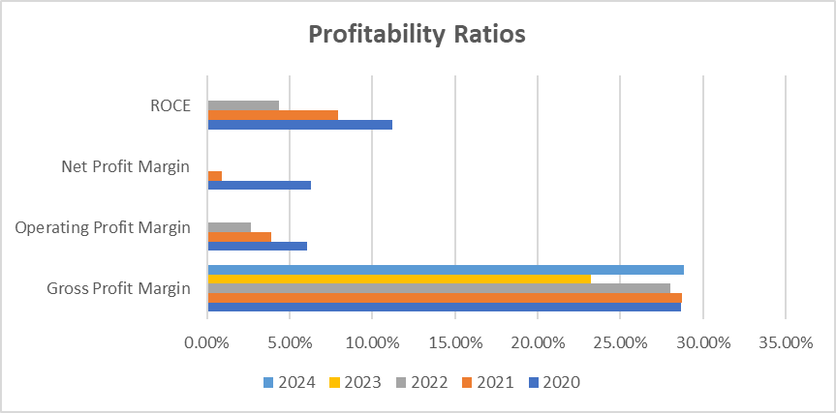
Figure 1: Profitability Ratios

Appendix A2: Liquidity Ratios (2020–2024)
Formulas
- Current Ratio = Current Assets ÷ Current Liabilities
- Quick Ratio = (Current Assets − Inventories) ÷ Current Liabilities
- Cash Ratio = Cash and Cash Equivalents ÷ Current Liabilities
Ratio | 2020 | 2021 | 2022 | 2023 | 2024
Current Ratio | 1.82 | 1.56 | 1.56 | 1.61 | 1.53
Quick Ratio | 1.15 | 0.93 | 0.91 | 1.06 | 1.03
Cash Ratio | 0.32 | 0.28 | 0.31 | 0.27 | 0.17
Table 2: Liquidity Ratios
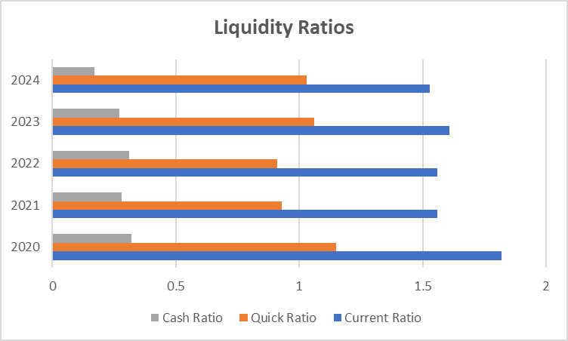
Figure 2: Liquidity Ratios

Appendix A3: Efficiency Ratios (2020–2024)
Formulas
- Asset Turnover = Net Sales ÷ Total Assets
- Fixed Asset Turnover = Net Sales ÷ Property, Plant and Equipment
- Receivables Days = (Accounts Receivable ÷ Net Sales) × 365
- Inventory Days = (Inventories ÷ Cost of Sales) × 365
Ratio | 2020 | 2021 | 2022 | 2023 | 2024
Asset Turnover | 1.20 | 1.18 | 1.08 | 1.18 | 1.22
Fixed Asset Turnover | 7.04 | 8.06 | 8.64 | 9.42 | 11.54
Receivables Days | 76.86 | 78.40 | 75.55 | 97.74 | 105.54
Inventory Days | 100.26 | 114.52 | 131.04 | 99.78 | 103.12
Table 3: Efficiency Ratios
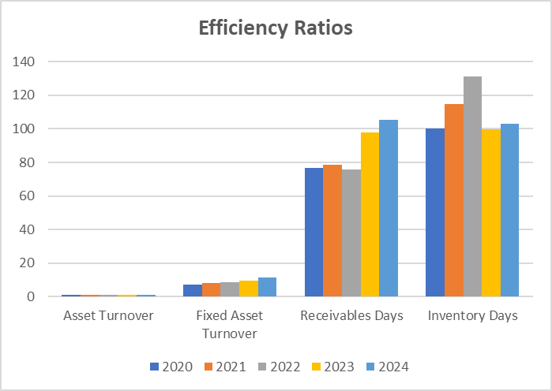
Figure 3: Efficiency Ratios

Appendix A4: Gearing Ratios (2020–2024)
Formulas
- Interest Coverage Ratio = EBIT ÷ Interest Expense
- Debt to Equity Ratio = Total Liabilities ÷ Shareholders’ Equity
- Debt to Capital Ratio = Total Liabilities ÷ (Total Liabilities + Equity)
- Equity Multiplier = Total Assets ÷ Shareholders’ Equity
Ratio | 2020 | 2021 | 2022 | 2023 | 2024
Interest Coverage | 26.21 | 41.08 | 6.61 | −19.70 | −4.55
Debt to Equity | 0.63 | 0.85 | 0.88 | 0.99 | 1.11
Debt to Capital | 0.39 | 0.46 | 0.47 | 0.50 | 0.53
Equity Multiplier | 1.63 | 1.85 | 1.88 | 1.99 | 2.11
Table 4: Gearing Ratios
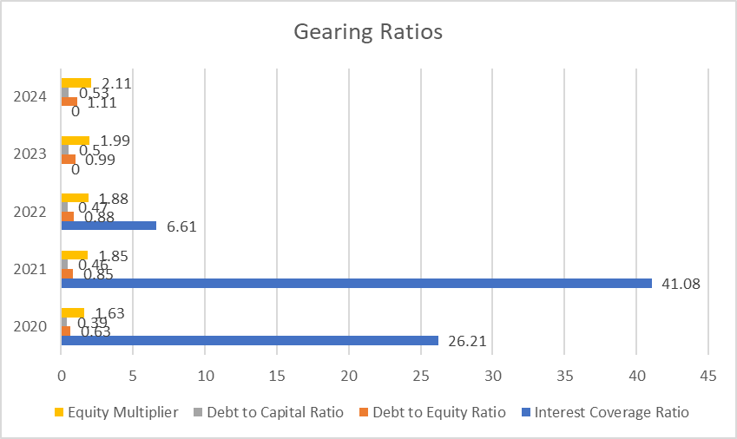
Figure 4: Gearing Ratios

Appendix A5: Investment Ratios (2020–2024)
Formulas
- Earnings per Share (EPS) = Net Income ÷ Shares Outstanding
- Price–Earnings Ratio = Market Price per Share ÷ EPS
- Return on Equity (ROE) = Net Income ÷ Shareholders’ Equity
Assumed market price per share: £120 (as per appendix assumption)
Ratio | 2020 | 2021 | 2022 | 2023 | 2024
EPS (£) | 2.78 | 0.39 | 0.03 | −7.64 | −1.85
P/E Ratio | 43.17 | 304.81 | 3,745.36 | Not meaningful | Not meaningful
ROE | 12.31% | 1.92% | 0.15% | −54.91% | −15.69%
Table 5: Investment Ratios
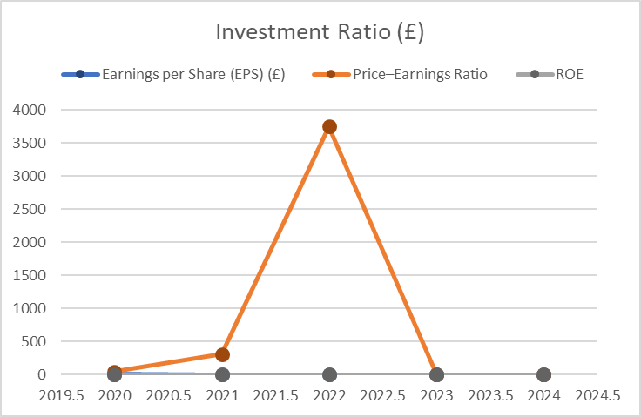
Figure 5: Investment Ratios

Appendix A6: Cash Flow Ratios (2020–2024)
Formulas
- Operating Cash Flow Ratio = Operating Cash Flow ÷ Current Liabilities
- Cash Flow to Debt Ratio = Operating Cash Flow ÷ Total Liabilities
- Cash Flow Margin = Operating Cash Flow ÷ Net Sales
Ratio | 2020 | 2021 | 2022 | 2023 | 2024
Operating Cash Flow Ratio | 0.41 | 0.19 | 0.05 | 0.16 | 0.09
Cash Flow to Debt Ratio | 0.37 | 0.17 | 0.05 | 0.14 | 0.09
Cash Flow Margin | 11.94% | 6.70% | 2.01% | 5.99% | 3.75%
Table 6: Cash Flow Ratios
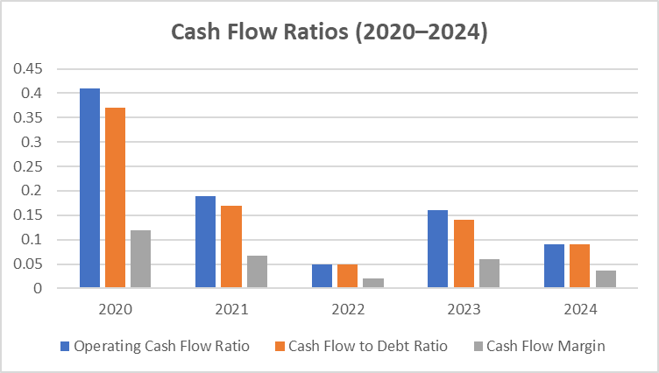
Figure 6: Cash Flow Ratios

Appendix A7: Altman Z-Score Calculation (2020–2024)
Formula
- X₁ = (Current Assets − Current Liabilities) / Total Assets
- X₂ = Retained Earnings / Total Assets
- X₃ = EBIT / Total Assets
- X₄ = Market Value of Equity / Total Liabilities
- X₅ = Net Sales / Total Assets
Model
Z = 1.2X₁ + 1.4X₂ + 3.3X₃ + 0.6X₄ + 1.0X₅
Component | 2020 | 2021 | 2022 | 2023 | 2024
X₁ | 0.29 | 0.24 | 0.24 | 0.27 | 0.26
X₂ | 0.64 | 0.65 | 0.66 | 0.65 | 0.64
X₃ | 0.07 | 0.05 | 0.03 | −0.24 | −0.05
X₄ | 8.46 | 6.89 | 6.47 | 8.72 | 9.13
X₅ | 1.20 | 1.18 | 1.08 | 1.18 | 1.22
Altman Z-Score | 7.76 | 6.65 | 6.26 | 6.87 | 7.76
Table 7: Altman Z-Score
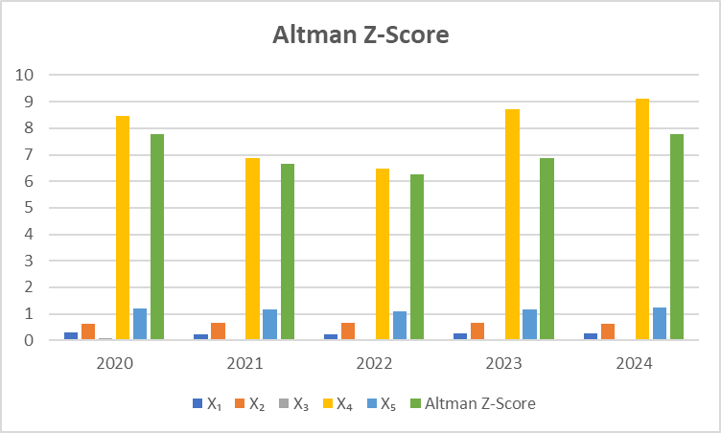
Figure 7: Altman Z-Score (2020–2024)

Appendix B: Financial Evidence Supporting the Strategic Financial Restructuring Plan

Appendix B1: Profitability Deterioration and Shareholder Value Erosion
Purpose: Supports Sections 3.2 and 3.4.1 (need for restructuring; shareholder value impact)
Year | Net Income (£m) | Change (£m) | EPS (£) | Retained Earnings (£m)
2020 | 38,572 | — | 2.93 | 140,441
2021 | 31,987 | –6,585 | 2.43 | 172,428
2022 | –2,722 | –34,709 | –0.21 | 169,706
2023 | –2,242 | +480 | –0.17 | 167,464
2024 | –24,029 | –21,787 | –1.85 | 143,435
Table 8: Profitability Deterioration and Shareholder Value Erosion
Key linkage to Section 3: Demonstrates persistent losses, EPS deterioration, and retained earnings decline justifying equity injection and divestment.

Appendix B2: Operating Cash Flow Sustainability
Purpose: Supports Sections 3.2, 3.4.1 and 3.4.3 (cash flow–based restructuring feasibility)
Year | Operating Cash Flow (£m) | Net Income (£m) | OCF / Net Income
2020 | 58,448 | 38,572 | 1.52
2021 | 51,303 | 31,987 | 1.60
2022 | 22,688 | –2,722 | n/a
2023 | 29,510 | –2,242 | n/a
2024 | 14,822 | –24,029 | n/a
Table 9: Operating Cash Flow Sustainability
Interpretation Reference: Despite accounting losses, positive operating cash flows justify restructuring rather than liquidation.

Appendix B3: Asset Base Contraction and Divestment Rationale
Purpose: Supports Section 3.3.1 (Strategic Divestiture)
Year | Total Assets (£m) | Property, Plant & Equipment (£m) | Goodwill (£m)
2020 | 586,810 | 87,285 | 154,926
2021 | 561,390 | 80,908 | 153,854
2022 | 493,031 | 61,168 | 143,563
2023 | 446,143 | 40,682 | 95,119
2024 | 365,058 | 34,207 | 88,245
Table 10: Asset Base Contraction and Divestment Rationale
Key linkage: Declining PPE and large goodwill impairments confirm the case for non-core asset divestment.

Appendix B4: Capital Structure and Solvency Pressure
Purpose: Supports Sections 3.2 and 3.4.2 (Debt Structure and Refinancing Risk)
Year | Total Liabilities (£m) | Total Equity (£m) | Debt-to-Equity
2020 | 273,509 | 313,301 | 0.87
2021 | 255,692 | 305,698 | 0.84
2022 | 235,757 | 257,274 | 0.92
2023 | 224,224 | 221,919 | 1.01
2024 | 170,249 | 153,105 | 1.11
Table 11: Capital Structure and Solvency Pressure
Interpretation Reference: Rising leverage despite asset contraction supports the recommendation for equity financing.

Appendix B5: Short-Term Debt Exposure and Liquidity Risk
Purpose: Supports Sections 3.4.2 and 3.4.3 (Operational Flexibility Constraints)
Year | Lines of Credit (£m) | Cash & Equivalents (£m) | Coverage (Cash / LOC)
2020 | 34,157 | 69,829 | 2.04
2021 | 36,151 | 88,469 | 2.45
2022 | 37,066 | 81,537 | 2.20
2023 | 37,334 | 61,596 | 1.65
2024 | 36,960 | 58,012 | 1.57
Table 12: Short-Term Debt Exposure and Liquidity Risk
Key Linkage: Declining coverage ratio reinforces the need for liquidity-enhancing restructuring.

Appendix B6: Treasury Stock and Capital Preservation Issue
Purpose: Supports Section 3.4.1 (Shareholder Value and Capital Conservation)
Year | Treasury Stock (£m) | Change (£m)
2020 | –112,432 | —
2021 | –118,695 | –6,263
2022 | –129,463 | –10,768
2023 | –130,173 | –710
2024 | –131,377 | –1,204
Table 13: Treasury Stock and Capital Preservation Issue
Interpretation: Continued buybacks during declining profitability justify suspension during restructuring.

Appendix B7: Foreign Exchange Exposure Evidence
Purpose: Supports Section 3.5.2 (Currency Risk and International Considerations)
Year | Foreign Exchange Gain / (Loss) (£m)
2020 | –980
2021 | –1,231
2022 | –2,401
2023 | –2,118
2024 | –2,598
Table 14: Foreign Exchange Exposure Evidence
Key linkage: Increasing FX losses support enhanced hedging and operational restructuring.

Appendix C: Investment Appraisal and Capital Budgeting Calculations
All monetary values are expressed in £ million unless otherwise stated.
- Discount rate (r) = 10%
- Project life = 5 years
- Depreciation method = Straight-line to zero

Appendix C1: Discount Factors at 10%
Formula:
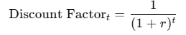
Year | Calculation | Discount Factor
1 | 1 / (1 + 0.10)¹ | 0.9091
2 | 1 / (1 + 0.10)² | 0.8264
3 | 1 / (1 + 0.10)³ | 0.7513
4 | 1 / (1 + 0.10)⁴ | 0.6830
5 | 1 / (1 + 0.10)⁵ | 0.6209
Table 15: Discount Factors at 10%

Appendix C2: Project A – Net Present Value Calculation
- Initial investment = £40m

Present Value Formula:
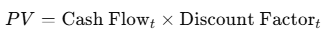
Year | Cash Inflow (£m) | Discount Factor | Present Value (£m)
0 | -40.00 | 1.0000 | -40.000
1 | 10.00 | 0.9091 | 9.091
2 | 12.00 | 0.8264 | 9.917
3 | 14.00 | 0.7513 | 10.518
4 | 10.00 | 0.6830 | 6.830
5 | 8.00 | 0.6209 | 4.967
Total PV of Inflows |  |  | 41.323
Table 16: Net Present Value
- Net Present Value (NPV): NPV = Total PV of inflows - Initial Investment
- NPV_A = 41.323 - 40 = £1.323m

Profitability Index (PI):
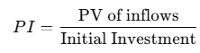
$$=\frac{41.323​}{40}$$
= 1.03

Appendix C3: Project B – Net Present Value Calculation
- Initial investment = £30m
Year | Cash Inflow (£m) | Discount Factor | Present Value (£m)
0 | -30.00 | 1.0000 | -30.000
1 | 6.00 | 0.9091 | 5.455
2 | 6.00 | 0.8264 | 4.958
3 | 6.00 | 0.7513 | 4.508
4 | 6.00 | 0.6830 | 4.098
5 | 6.00 | 0.6209 | 3.725
Total PV of inflows |  |  | 22.744
Table 17: Net Present Value
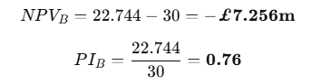

Appendix C4: Project C – Net Present Value Calculation
- Initial investment = £50m
Year | Cash Inflow (£m) | Discount Factor | Present Value (£m)
0 | -50.00 | 1.0000 | -50.000
1 | 5.00 | 0.9091 | 4.546
2 | 10.00 | 0.8264 | 8.264
3 | 20.00 | 0.7513 | 15.026
4 | 25.00 | 0.6830 | 17.075
5 | 15.00 | 0.6209 | 9.314
Total PV of inflows |  |  | 54.225

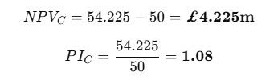

Appendix C5: Payback Period (PBP)
Formula:
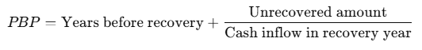

Project A
Year | Cash Inflow (£m) | Cumulative (£m)
1 | 10 | 10
2 | 12 | 22
3 | 14 | 36
4 | 10 | 46

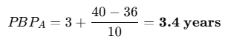

Project B
Year | Cash Inflow (£m) | Cumulative (£m)
1 | 6 | 6
2 | 6 | 12
3 | 6 | 18
4 | 6 | 24
5 | 6 | 30

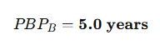

Project C
Year | Cash Inflow (£m) | Cumulative (£m)
1 | 5 | 5
2 | 10 | 15
3 | 20 | 35
4 | 25 | 60

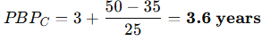

Appendix C6: Accounting Rate of Return (ARR)
Formula:
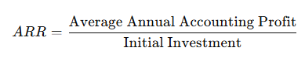
Project | Initial Investment (£m) | Annual Depreciation (£m) | Total Cash Inflows (£m) | Average Annual Profit (£m) | ARR
A | 40 | 8 | 54 | (54 − 40) ÷ 5 = 2.8 | 7.0%
B | 30 | 6 | 30 | (30 − 30) ÷ 5 = 0 | 0.0%
C | 50 | 10 | 75 | (75 − 50) ÷ 5 = 5.0 | 10.0%
Table 18: Accounting Rate of Return (ARR)

Appendix C7: Internal Rate of Return (IRR)
Definition: IRR is the discount rate at which NPV = 0.
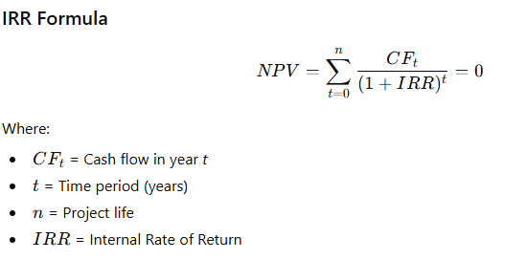
Project | Cash Flow Pattern (£m) | IRR
A | -40, 10, 12, 14, 10, 8 | ≈ 11.4%
B | -30, 6, 6, 6, 6, 6 | ≈ 5.0%
C | -50, 5, 10, 20, 25, 15 | ≈ 12.5%
Table 19: Internal Rate of Return (IRR)

Project | Initial Investment (£m) | IRR | Cost of Capital | Decision
A | 40 | 11.4% | 10% | Accept
B | 30 | 5.0% | 10% | Reject
C | 50 | 12.5% | 10% | Accept
Table 20: IRR Comparison

