This document contains the evidence and a reflection of my welsh used both within my microteach and within my PTE1 Experience.

Micro Teach:

Lesson Plan Phase 1

Lesson Plan – Step 1 Cynllun Gwers – Cam 1

Student-teacher | Jordan Nasser. | Class: | Year 7.
AoLE or Subject | Drama. | Date:
Lesson Focus: | Exploring Stereotypes in relation to Genre.
Meaningful links to Curriculum | Linking to unit 1 (Devising Theatre) and Unit 2 (Performing Theatre) further on at GCSE, teaching transferrable skills for devising and performing.
Meaningful links to:  Cross Curricular Responsibilities | -Linking directly to curriculum Cymreig.
Personal Targets (Linked to QTS and identifed in weekly review)

Learning Objectives (focus on Learning- use accessible vocabulary):
The pupils will learn to:

-Identify the different steretypes that famoud faces and job roles carry.
-Pupils will increase their welsh language competency by learning key subject specific vocabulary in welsh.
-Pupils will use their welsh language skills to respond to basic commands and questions.
-Some pupils will begin to recognise the changes in nouns based on gender.

Success Criteria (clearly linked to each Learning Objective and related to the process and/or product of learning) | Assessment of Pupils’ Learning  Evidence  (What have the learners to say/write/do/produce – to demonstrate learning)
-Pupils should respond to the Welsh being used using welsh.  -Pupils should be able to engage with basic commands and questions directed at them that are not the focus of the lesson. | -All pupils attempt to verbally contribute to the questions being asked. Most pupils will verbally contrubte to the questions using the correct Welsh. Some Pupils will consitantly respond to the questions using the correct welsh and offering more based on previous learning.  -All Pupils should be able to respond to basic greetings and commands “Bore da” “prynhawn da” “dim siarad” etc. Most pupils should verbally respond to the greetings using a more ambitious vocabulary. Some pupils will be able to engage fully with basic commands and be able to formulate responses to these commands that contiurbute to a basic conversation.

Time | Activities/Methodology/Key Concepts  (Teacher’s Role – including key teaching points, differentiation strategies and key questions) | Pupil Tasks  (Pupils’ role –including differentiation, engagement in formative assessment and homework) | Resources  (Including Health and Safety requirement)
Opening phase (with links to prior learning) | Phase 1) Open with basic greetings to model the proper use of the Welsh Language. Pupils should be encouraged to respond to the language being used using Welsh. | Phase 1) Pupils should interact with the teacher using the Welsh language. All pupils should be able to contirbute. | N/A
Teaching & Core Learning | Phase 2) Teacher led game based on different famous faces and job roles that the pupils are familiar with. “Pwy Yw Hwnna/Honna>” This should be highlighted throughout how to properly use these words based on the gender of the person on the screen. It is important to model the correct language in this and correct pupils without embarrassing them.  -This is followed by “Pa sterioteip mae nhw'n ffitio/which stereotype do they fit?” to further challenge pupils and relate this back to the topic. | Phase 2) Pupils should actively participate within the game. As the game goes on Most pupils should start to use the correct nouns based on masculine and feminine lanuage. Pupils should get used to the removal of English as the game progresses and respond to the Welsh Questions and respond only in Welsh.  -Pupils should respond using “yw hi or yw e”. | Powerpoint.
Plenary | Finally, as a challenge, pupils should attempt to answer “Pa Stereoteip wyt ti'n ffitio?” this should not be translated at first to test pupil’s knowledge of what they have learnt in the session. This should only be translated in no pupil understands (try to translate as little as possible). | -Pupils should all attempt to work out and answer the final question. Pupils may have the opportunity to ask a partner if they are stuck. | Powerpoint.

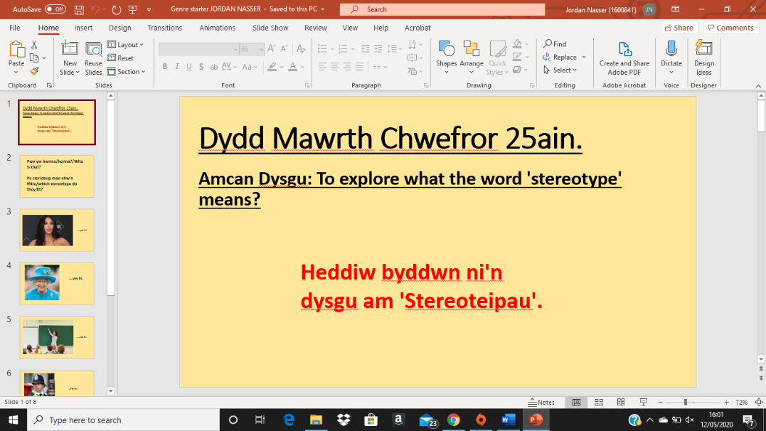
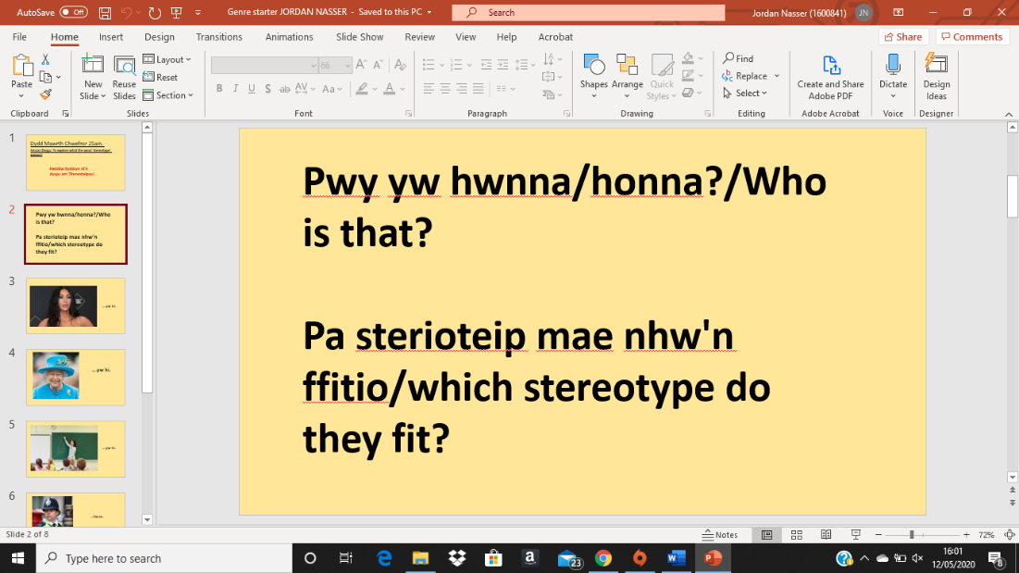

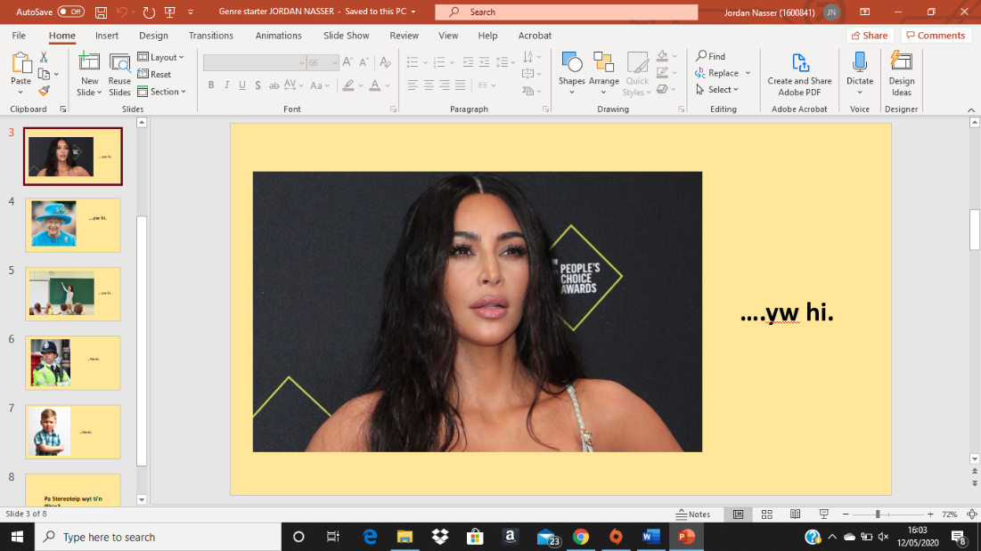

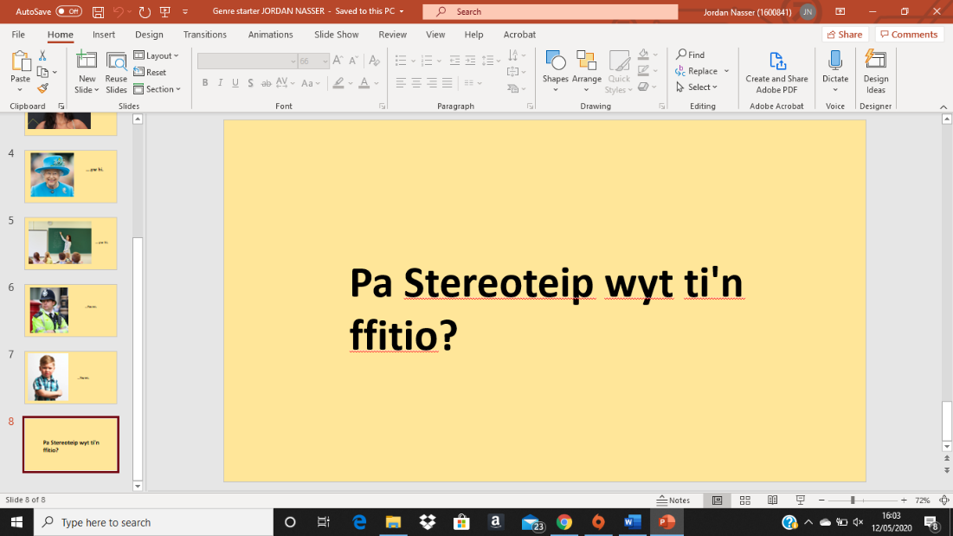

Lesson Example 1:
This lesson was used for four different year 7 classes and differentiated.

Lesson Plan – Step 1 Cynllun Gwers – Cam 1

Student-teacher | Jordan Nasser | Class: | 7B
AoLE or Subject | Drama | Date: | 15/11/2019
Lesson Focus: | Introduction to Genre.
Meaningful links to Curriculum | Literacy, Oracy and Curriculum Cymraeg.
Meaningful links to:  Cross Curricular Responsibilities | Curriculm Cymraeg and Literacy.
Personal Targets (Linked to QTS and identifed in weekly review)

-Behaviour management (Classroom control/leadership).
-Questioning (Pose, Pause, Pounce and Bounce).

Learning Objectives (focus on Learning- use accessible vocabulary):
The pupils will learn to:

-Pupils will consolidate new knowledge of this genre by creating a new concept for a soap opera targeted at their own age group.

-Pupils will develop their understanding of a new devising technique 'Cross-Cutting'

-PSE link: Pupils will discuss and create scene based upon topic that are appropriate to their age group. Also linking to curriculum Cymraeg pupils are making a soap in their local area.

Success Criteria (clearly linked to each Learning Objective and related to the process and/or product of learning) | Assessment of Pupils’ Learning  Evidence  (What have the learners to say/write/do/produce – to demonstrate learning)
-Pupils should be able to understand what genre is.  -Pupils should understand what stereotypes are and be able to apply these to genre.  -Pupils should be able to understand what cross cutting is and be able to apply this to their performances. | -Learners must contribute to all tasks.  -Pupils will be observed with teacher circling.  -Pupils must be able to answer teacher led questioning.  -Pupils must be involved in the performance.

Time | Activities/Methodology/Key Concepts  (Teacher’s Role – including key teaching points, differentiation strategies and key questions) | Pupil Tasks  (Pupils’ role –including differentiation, engagement in formative assessment and homework) | Resources  (Including Health and Safety requirement)
Opening phase (with links to prior learning) | - 1. Starter activity: One word story task (linked to literacy/oracy) Put pupils into groups of 5 upon entry.  Extension:  -Add different Genre’s to the game but don’t mention genre yet (Scary story, Romantic story, Funny Story, etc).  -Add level of difficulty and a higher level of literacy (no “Once upon a time will be allowed” pupils must provide punctuation: Commas, full stops, exclamation marks) Pupils must start story from the middle of the story using sentence starters using fronted adverbials such as Suddenly, Although, etc.  -One round of just telling a story.  -One round adding a genre (Comedy)  -two rounds split in half competition (Horror and Romance). - Introduce pupils to subject specific terminology in Welsh “Comedi”, “Arswyd” and “Rhamant” (use throughout the lesson when using the English terminology”.  Mini plenary:  - Discuss with the group that they had put their stories into groups based on genre.  Discuss with pupils what genre is “a style or category of art, music, or literature.” give examples  2) Play “Who is that?/Pwy yw Hwnna/Honna?”  Where in groups the first group to mould one person in the group to mould someone into the group into that person. (20 Seconds to do so) and ask “Who are they?”, “What do we expect them to be like?”, and then “Why do we expect them to be like?”. | 1)Pupils will sit in their groups and contribute one word to the class story and when working just in their groups will contribute two words to their group story. This will have strong literacy links including: Punctuation, Grammar and fronted adverbials. Including application of genre.  2) Pupils will also contribute in groups to the stereotype activity. | -Presentation.
Teaching & Core Learning | 1)Pupils will be asked to go into groups and have 2 minutes to discuss “What is a soap opera?” (taking into consideration what characters and storyline’s they would see) and examples of soap operas. Show a video of eastenders and the show a video of Pobl Y Cwm to bring the ideas of soap opera back to Wales (make it relevant) and contextualise the use of the Welsh language in today’s society.  -One pupil from each group will feedback to the class what the group has discussed.  Mini plenary:  -sum up the ideas of the class and discuss what naturalism is.  2)Pupils will then be introduced to cross cutting where the group will be split in half and they will have to create two two minute scenes (One dramatic scene and one every day scene).  -Pupils will then be asked to show these back to their bigger groups (offering feedback to eachother) Pupils will then be asked to split their pieces both of their pieces in half and decide where they need to freeze their pieces to cross cut to the next scene and then back. | 1)Pupils should have student led discussion in their groups and be able to feedback/share the mainpoints of their discussions to the class.  2)Pupils should split from one group into two groups and create a two minute piece (one dramatic and one normal scenario.  -Pupils should show these back to their larger group and as a group offer feedback and decide where the to freeze the pieces in order to jump to the next and back.
Plenary | 1)Spotlighting performances with peer feedback at the end.  -Questions “Why is it important to add genre Stereotypes into a genre?”  “What would happen if we added too many Stereotypes into our pieces?”  “What is naturalism?”  “Why is it important to use naturalism in performing our soap opera pieces?” | 1)Pupils should offer feedback and be able to answer questions when asked.

Example 2:
Within my phase swap I had the opportunity to teach some Welsh within a Primary school environment as this fell close to St David's Day. Within this I looked at a Welsh Poem with the pupils and we first read this in English and discussed what this meant. Pupils were then shown a poem in Welsh (supplied by their main teacher). The pupils were able to understand a lot of the terminology as they had previously studied sentence structure. The pupils were then given the opportunity to create a word bank of nouns, verbs and adjectives that they could use in creating their own poems. Pupils then discussed what a noun a verb and an adjective was to cement this and used this structure (using the same colour pens as the colours shown). To write their own poems. Pupils were able to do this successfully and this was a way of pupils transferring the skills they had been taught to practical work. Some pupils even attempted to read out their poems which assisted in pupils improving their spoken welsh competency.
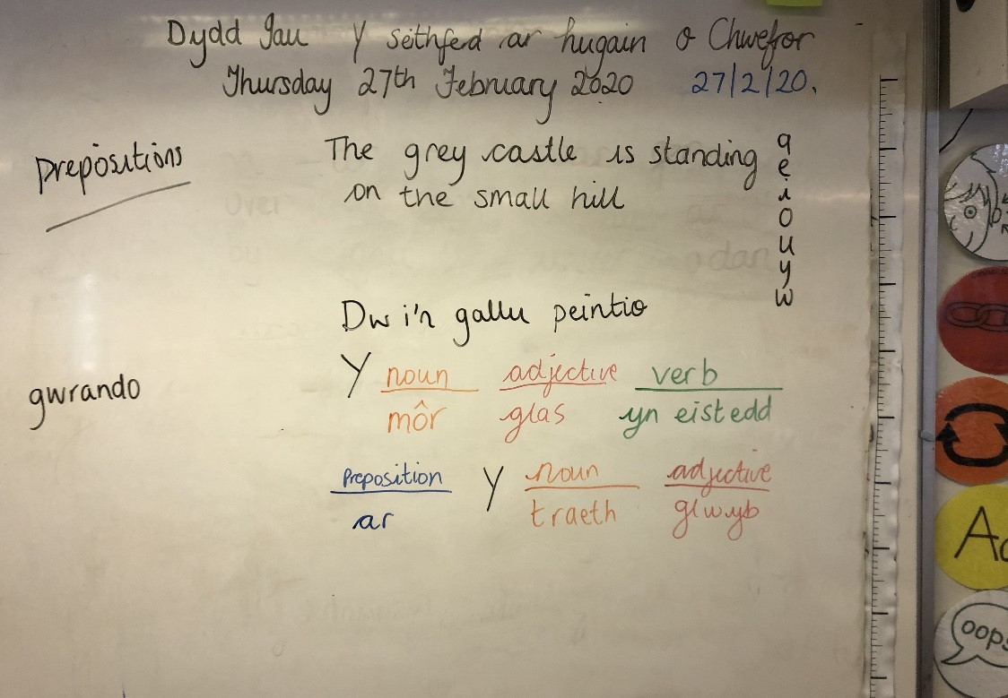

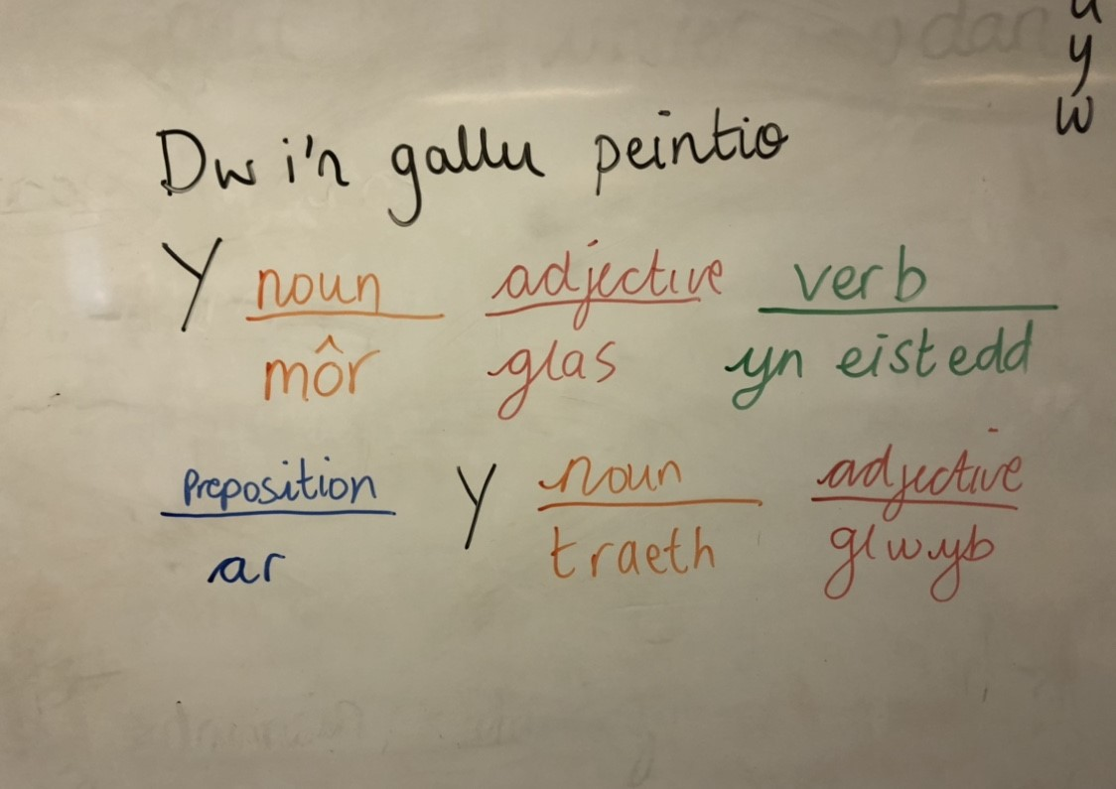

Example 3:
Also, within my phase swap I taught a lesson that was similar to my microteach lesson and that taught to my year 7 on Genre, this was however broken down and made more relevant to the pupils in year 6. However, I found within this that these pupils were actually more able and had a better grip of the Welsh Language than my year 7’s did. Therefore, this lesson progressed in allowing the pupils to describe the people that they were seeing on the slide and creating their own characters and using adjectives to describe their characters fully in welsh. Pupils then completed a hot seating activity where they answered questions about their characters. Some pupils even asked each other questions in Welsh (without encouragement) but as this was praised this started to become more popular with pupils using welsh to ask basic questions and give basic responses based on name, age, what they looked like, etc. This experience taught me that I would need to find new ways of challenging more able pupils in Welsh by having back up challenges. This shows my ability to use the welsh language with different levels and ability of pupils and shows a competence in differentiating the welsh language and promoting this within different environments. Examples 2 and 3 display that I can use both written and spoken welsh within the classroom and able to understand this enough to respond verbally and have an understanding to respond to welsh written tasks to a basic level.
Welsh dates and titles always used throughout lessons.
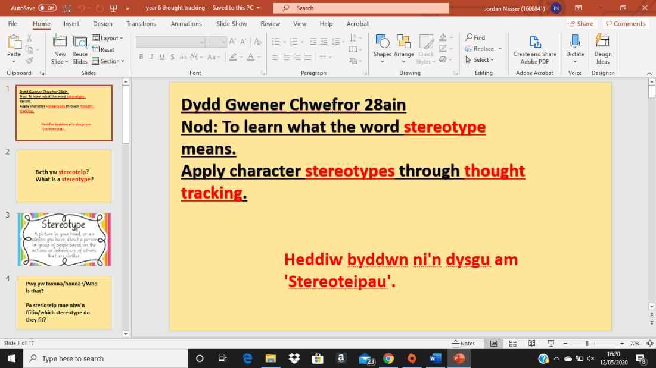

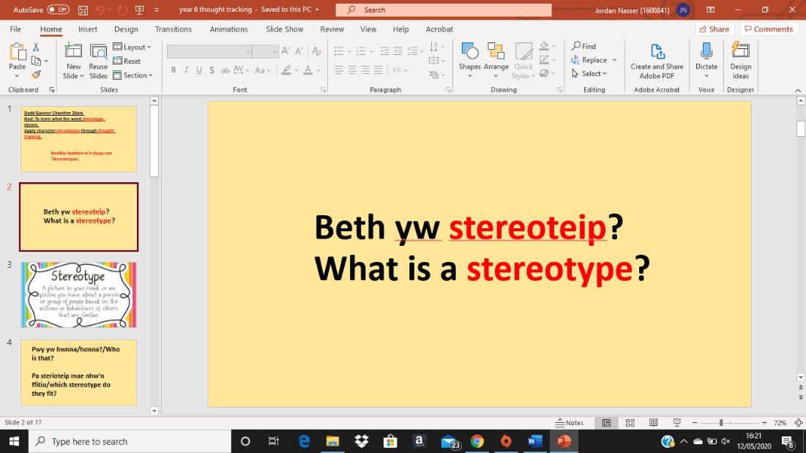

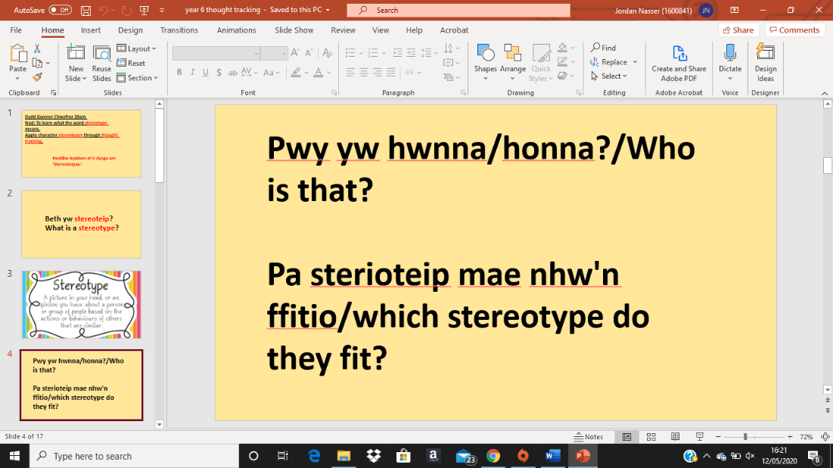

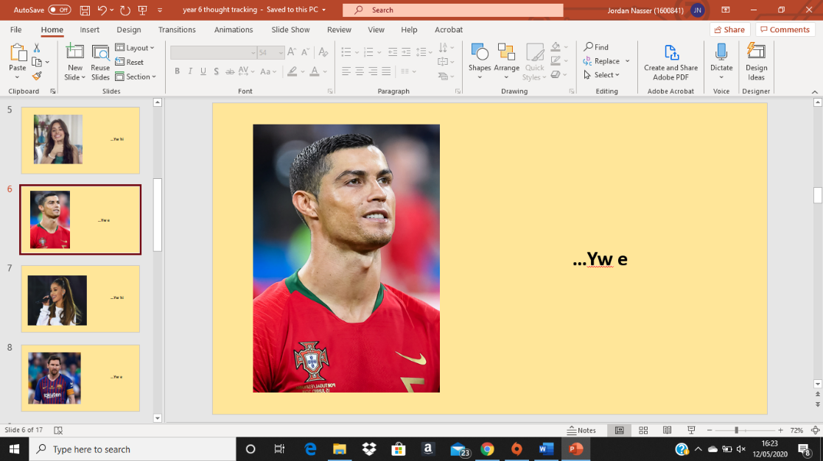
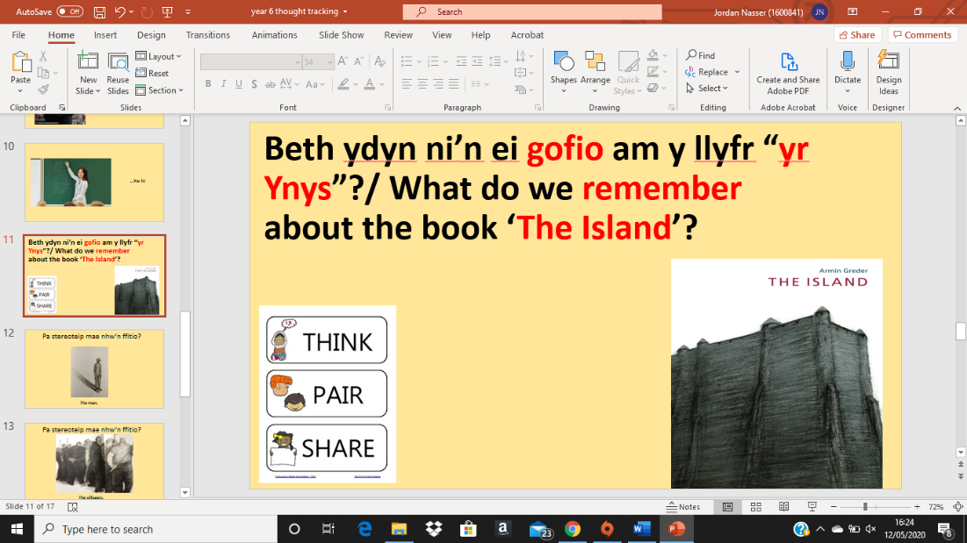
The welsh language is placed first and key terms are highlighted to encourage engaging with the Welsh before the English.

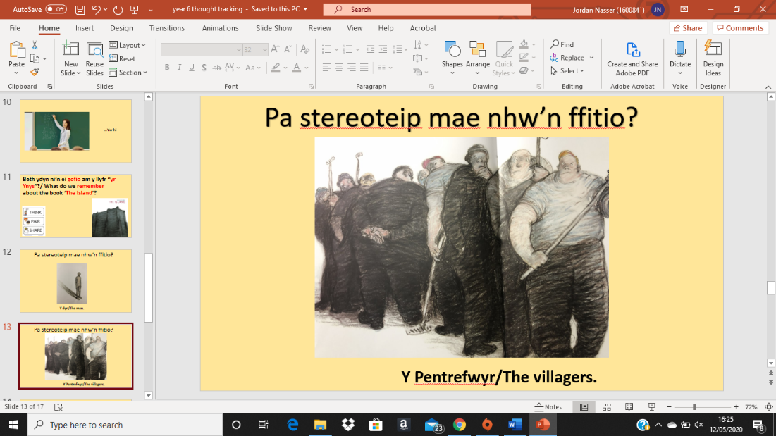

Example 4:
Lesson Plan – Step 1 Cynllun Gwers – Cam 1

Student-teacher | Jordan Nasser. | Class: | 10C.
AoLE or Subject | Drama. | Date: | 01/12/2019.
Lesson Focus: | Creating a devised piece in the style of Brecht.
Meaningful links to Curriculum | Linking to Unit 1 (Devising theatre).
Meaningful links to:  Cross Curricular Responsibilities | Literacy (LNF):  - Present ideas and issues to meet the demands of different audiences.  - Speak fluently, using a range of techniques, expressions and gestures.  - Confidently explore challenging or contentious issues through sustained role play.
Personal Targets (Linked to QTS and identifed in weekly review)

Learning Objectives (focus on Learning- use accessible vocabulary):
The pupils will learn to:

-Apply Brechtian techniques to their devising process and be able to justify their decisions by considering the purpose and effect of apply techniques to their work.

-Discuss and critically evaluate their own and other pieces in accordance to the brief given at the start of the devising process (create a Brechtian piece with a moral message).

-Start to consider playing with the structure of their piece to remove essences of naturalism; Understanding the purposes and effects of playing with their episodic structure.

Success Criteria (clearly linked to each Learning Objective and related to the process and/or product of learning) |  | Assessment of Pupils’ Learning  Evidence  (What have the learners to say/write/do/produce – to demonstrate learning)
-All pupils should be able to discuss their devised pieces in accordance to Brecht and Epic Theatre within groups and be able to feed this back to the class being able to justify their decisions.  -All pupils should have written evidence of their group work in their work book answering the following:  - What is the piece about?  - What is their moral message?  - What Brechtian techniques have they used and why?  -Most pupils should have produced a piece with clear links to Brechtian theatre including: Gestus, Placards and breaking the fourth wall.  -Some pupils should produce a piece having considered their episodic structure and a clear moral message visable. |  | -All Pupils must produce verbal feedback of their work throughout the lesson using subject specific terinology in accordance to Brechtian theatre.  -All pupils must have written evidence of their group work in their work book.  -Most pupils should have a rough first draft of their piece as a whole that can be observed upon teacher observation.
Time | Activities/Methodology/Key Concepts  (Teacher’s Role – including key teaching points, differentiation strategies and key questions) |  | Pupil Tasks  (Pupils’ role –including differentiation, engagement in formative assessment and homework) | Resources  (Including Health and Safety requirement)
Opening phase (with links to prior learning) | 1)Watch the two remaining groups perform and give feedback as a group.  (10 mins). |  | 1) Pupils should watch eachother perform their devised piece with a critical eye and offer the group suggestions linked to the chosen practitioner (Brecht). | -N/A
Teaching & Core Learning | 1) A brief discussion of Episodic structure (What is means, what it does within a piece, and then ask pupils to apply this to their pieces). (5 mins max)  -Most pupils will be asked to start finishing off their pieces and consider the placing of their scenes to make their pieces ‘Epic Theatre’ pieces. (25 minutes)  2) Pupils will have ten minutes to collate their ideas and write a scene by scene breakdown in their books including:  - Title of the scene (A one line max description of what it’s about).  - What is the moral message (how have you made this clear?).  - What Brechtian techniques they’ve applied to their scenes and why? |  | 1) Pupils should contribute to the based on their previous knowledge and with new information should consider, discuss and feedback how they can apply this (transferable learning, turning theory into practice). * Speak fluently, using a range of techniques, expressions and gestures.*  -Most pupils should start to understand that their pieces should not have to follow a linear narrative and move their scenes around accordingly using their placards to clarify this.  2)Pupils will record information in their books in order for them to refer back to this information in coming lessons and also will act as a refresher further on down along the GCSE course. This will also encourage pupils to consider why they are using techniques and the effect that they have on an audience. | -Powerpoint.  -Workbooks.
Plenary | 1) Pupils will be asked to feedback as a group (all members contributing) feeding back. Pupils should ask each other questions and ask their audience questions and attempt to use the Welsh sentence structures previously learnt “Beth wyt ti’n feddwl?” “Dwi’n meddwl bod..”, etc. |  | 1) Pupils should feedback to the class: What their piece is about and what techniques they have used to highlight their moral message and why they’ve used the techniques. Pupils are encouraged to use incidental welsh here.  Questioning was used here as a method of formative assessment and was used throughout year groups.

Example 5:
This contains feedback that I had received from my mentor in both my mid placement and end of placement reviews in regard to my Welsh language competency within the classroom as an evidence base of my spoken welsh language (which was difficult to evidence within lesson plans).

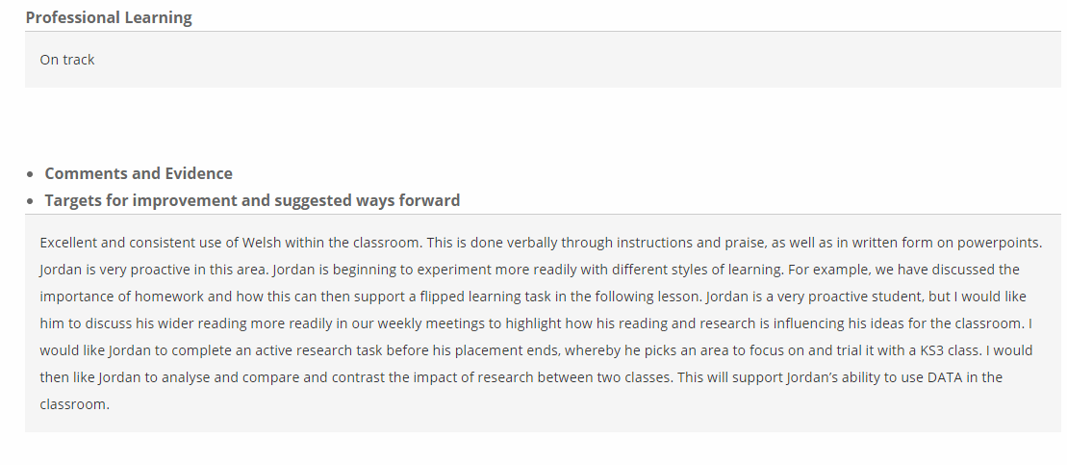
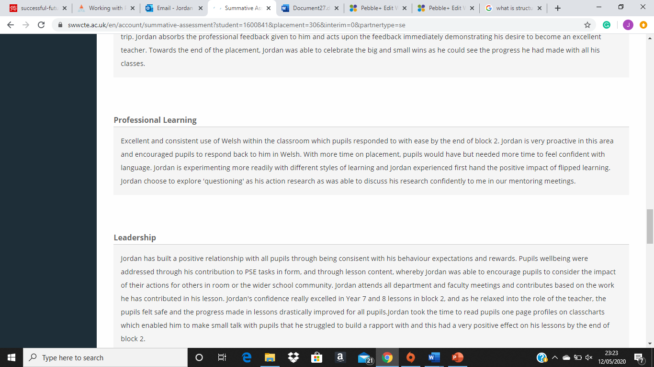
Reflection of my Welsh Progression – 1387 words:

The purpose of this evaluation is to discuss my own performance whilst teaching a ten-minute Drama lesson aimed at a year 7 class. I will also further evaluate my Welsh language development skills as a whole and evaluate if this has been successful in transferring to my practise. I aimed to place myself on the Welsh language scale as entry level, due to the fact that before starting my teacher training, I was unfamiliar with classroom-based Welsh and my Welsh was more conversational and slightly colloquial.
Firstly, I feel that my taught lesson was well pitched to the year group that it was aimed at, this being evidenced as when used within my PTE1 placement school the pupils responded positively to this. I also feel that this supplied pupils with a good blend of challenge and applying prior knowledge which is important in making connections from what they know to newly taught skills. I feel a positive element within the planning of this lesson was the content being relevant to the pupils’ scheme of work (Genre) which in accordance to Donaldson (2015) when embedding cross-curricular themes, these should be embedded naturally and not as an add on. I feel the relevance of this was also backed up by creating that authentic context by linking the content to people that the pupils would know, which contextualised the language use and subject content.
I feel my spoken literacy skills were a positive element within this lesson as I was able to confidently introduce myself and the lesson, displaying that I can open and close a lesson in Welsh. There were elements of the lesson where I displayed that I can interact with a class appropriately using the correct pronouns and second-person plural pronouns when addressing an individual or the class (ti and chi) and through my use of commands, praise and discipline. With moments being unplanned, this displayed a knowledge and an element of confidence in the language that I was using. Particularly, the interactions between myself and my audience which displayed what was being pitched was understood displaying that I am able to respond appropriately to learners as they are developing their welsh language skills. Another positive element of this session was the use of masculine and feminine terminology such as “hwnna” and “honna” which I feel that I was able to use confidently within the teaching session, displaying an understanding and control of the terminology that I was using and my knowledge of this. I feel that I was able to use notes from the board prompts, however, I feel I was not reliant on these to teach the lesson. There were also clear interactions between myself and my audience which displayed what was being pitched was understood displaying that I am able to respond appropriately to learners as they are developing their welsh language skills. There was also evidence of the fact that I can write sentences and sentence patterns correctly through my use of bilingual PowerPoints with a heavier Welsh influence to add challenge.
There were however areas within my session that could be improved such as, the nerves that I felt when being recorded. This I feel could be due to the Pygmalion effect in which the teacher is affected by the knowledge that they are being observed. In improving this I would need to increase the frequency that I am using Welsh outside of the classroom to gain further confidence. To improve I would also need to ensure that I am always using the correct language as on one occasion within my recorded lesson I taught an incorrect term. I would avoid this by ensuring that I address mistakes rather than skipping over them. I would also need to ensure I concentrate on my diction when introducing new terms as these need to be understood by pupils to be used in the future. As addressed previously within my recorded lesson I used a mix of masculine and feminine terminology, to further develop within teaching I would need to address this with the learners, ensuring that they understand why without going into this with too much depth. Within my use of this type of terminology I would need to develop my understanding in order to help with my written skills which will allow me to write compound and complex sentences for educational purposes.
I feel that on my placement I feel my welsh language skills were appropriate and I was successfully able to engage pupils by using everyday greetings and was successful in gaining a response from pupils. I found part of the success of my welsh within my placement was allowing pupils to become familiar with subject specific terms and simple instructions and using the English words after as a scaffold and eventually removing these in order for pupil's reactions becoming a natural response and to me this highlighted pupils ability to understand basic welsh terms. This displays that in accordance with the Welsh language criteria supplied that I was able to present commands, questions and instructions in a simple way also being able to respond appropriately to learners as they develop their language skills. I feel I excelled within practice with incidental welsh and spoken welsh rather and I have identified speaking and reading welsh as my strengths within this. I do however feel that there were elements of the criteria where I was meeting foundation level as I feel I was able to interact with learners and offer extended feedback, this I feel is evident within the supported evidence. I also feel that I can open and close lessons by setting aims and objectives and summarise clearly for the learner with quite clear and meaningful pronunciation. However, I feel within an English medium secondary school this can only be practical to a certain extent based on the pupil’s understanding and the importance of pupil understanding the learning from the lesson.
Within PTE1 there were some areas that I feel I needed to improve. The first area being not being too full on with the language right at the beginning of my teaching experience and not using too complex terms with pupils as these pupils (based on the location of the school had very limited experience of using the welsh language). I feel I would need to approach my use of the welsh language little by little with the pupils in order for them to become used to the basics and become familiar with these and assess their progress as I would with my own subject and add challenge based on this. To improve I feel I would also need to encourage more written welsh within the classroom as my younger years do not participate in many writing activities this severely lacked within my teaching. I feel that I would need to also improve my own personal Welsh writing skills by practicing the spelling of words and ensuring these are written correctly at all times and within this ensuring that I am mutating correctly and not writing down incorrect mutations as this models incorrect language for pupils.
To improve my competence whilst using the Welsh language I would need to ensure that I am able to differentiate accordingly and further what I have already done regarding differentiation whilst using Welsh. In doing this, I would need to provide visual prompts to assist the Welsh words to cater for the lower ability pupils within my classes. I would also ensure that I am using spoken language that will benefit the pupils and not have spoken welsh language within my lessons just for the sake of speaking welsh. I would ensure I was doing this by speaking formally rather than colloquially as this type of language could transfer incorrectly to their welsh lessons such as always ensure that I am using “Sut ydych chi?” rather than “Ti’n iawn?” etc. I would also need to ensure as a whole I am encouraging more Welsh language writing and also ensure that I am working on my understanding of spoken language as this is the area I feel I am weakest in as I feel misconceptions are important to avoid within the speaking and listening element of language use. Furthermore, I feel I feel that although my implementations have been successful, there is significant area for improvement.

