Data Mining
4/21/2026

2313748@student.uwtsd.ac.uk
Module NaMe: Data Warehousing & Data Mining
Module Code: ACCA6026_LON
Lecturer: Balendran Kandasamy

University of Wales Trinity saint david (London Campus)

STUDENT NAME: Mariana Lupu
STUDENT ID: 2313748


Table of Contents
1.1 Purpose and Practice of Data Mining 3
1.2 Dataset Description and Exploration 3
1.3 Data Preprocessing and Data Quality Analysis 10
1.4 Sample Runs and Analysis Methods 11
1.5 Model Development and Evaluation 13
1.6 Discussion and Conclusion 13
References 15

Purpose and Practice of Data Mining
Data mining is the process of analysing large amounts of data to discover meaningful patterns and relationships. In practice, it transforms raw data into useful information that can be used to make decisions. This is especially important in the business and healthcare sectors, where organisations rely on data to improve efficiency and plan future activities. [1]
In healthcare, data mining plays an important role in predictive analysis. By examining factors such as age, medical history, and lifestyle, it becomes possible to identify individuals who may be at risk of developing serious conditions such as stroke. This type of analysis supports early intervention and can significantly improve patient outcomes. [2]
Data mining also helps businesses optimise resources and improve service delivery. Techniques like classification make it easier to organise and interpret large datasets, allowing for more informed decision-making in real-world scenarios. [3]

Dataset Description and Exploration

Attributes and Data Types
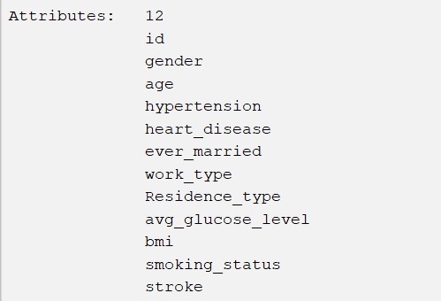
Figure 1 Attributes
The dataset used in this analysis includes a variety of attributes that describe people from demographic, medical, and lifestyle perspectives. These characteristics provide the foundation for identifying patterns associated with stroke risk.
The data set contains both numerical and categorical variables. Numerical attributes such as age, body mass index (BMI), and average glucose level facilitate statistical analysis and the identification of trends in the dataset. In contrast, categorical variables such as gender, work type, residence type, and smoking status classify people and provide context about their lifestyle and background.
Additionally, several variables are binary, which means they have only two possible values: 0 or 1. These include hypertension, heart disease, and a target variable stroke. Binary attributes are especially useful in classification tasks because they clearly show the presence or absence of a condition. [1]

Number of instances
The dataset contains 5,110 instances, each representing an individual. This figure is sufficient to conduct meaningful data analysis and apply data mining techniques. A dataset of this size enables models to detect patterns and relationships between variables while retaining a reasonable level of reliability. Furthermore, having a large number of instances improves the generalisation ability of classification models, because they are trained on more diverse data.

Missing values
The dataset has a small number of missing values, specifically in the bmi attribute. There are approximately 201 instances (around 4% of the dataset) with missing BMI values. Missing data can have a negative impact on machine learning models' performance and accuracy, as incomplete information can lead to incorrect patterns or biased outcomes. As a result, missing values must be handled during the preprocessing stage. In this case, the missing values were addressed using a replacement technique, ensuring that the dataset remained consistent and appropriate for analysis.

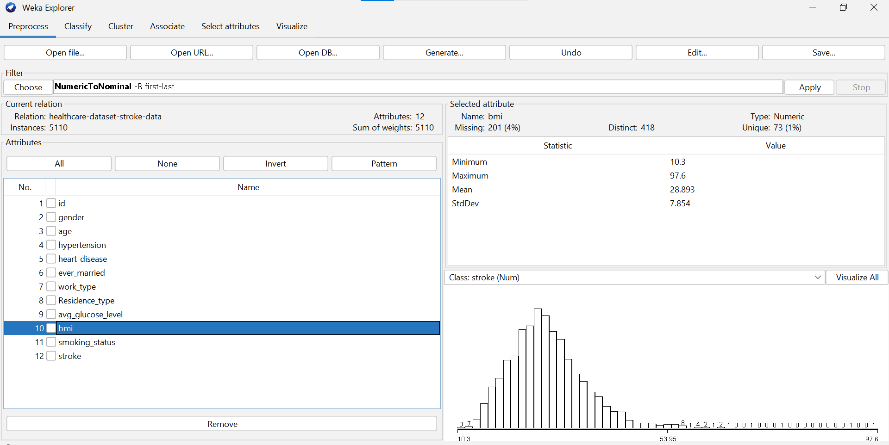
Figure 2 Missing values

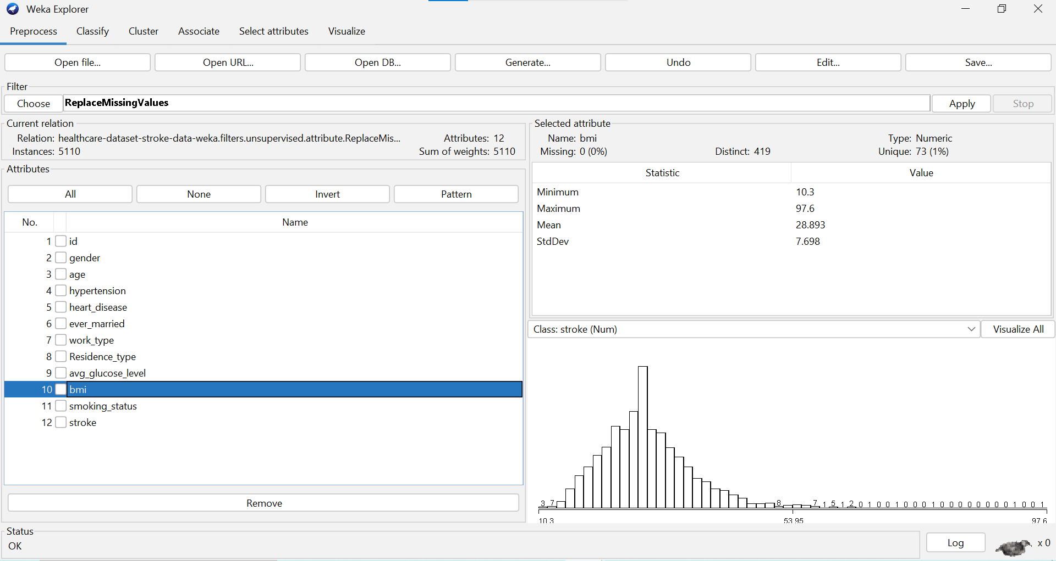
Figure 3 BMI Attribute After Handling Missing Values in Weka

Summary statistics and distributions
To better understand the dataset, several visualisations were created that examined the distribution of each attribute individually. [2]No table of figures entries found.
The stroke variable demonstrates a clear class imbalance, with most people classified as non-stroke (0) and a small proportion as stroke cases (1). This imbalance is significant because it has the potential to affect classification model performance.

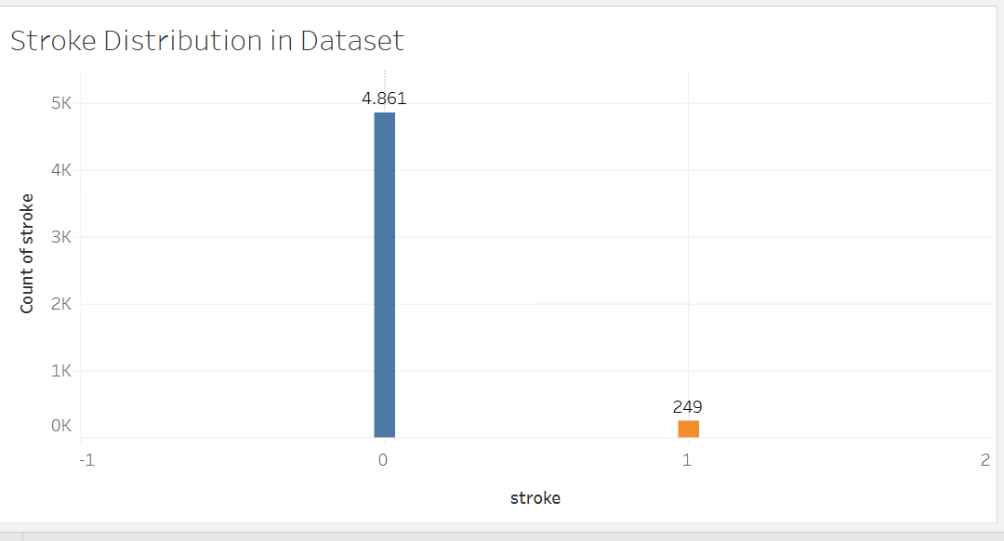
Figure 4 Stroke Distribution in the Dataset

There are fewer cases at younger ages, and the age distribution is concentrated in the adult population. Age is a major risk factor, as evidenced by the higher frequency of stroke cases in older populations.

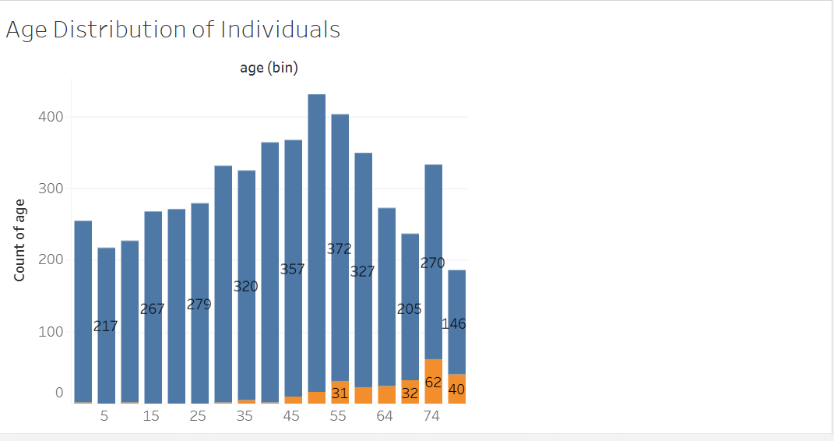
Figure 5 Age Distribution of Individuals

The BMI attribute indicates that most values are concentrated within a typical range, with a peak in the overweight category. However, a small number of extreme values indicate the presence of outliers, which could sway the analysis.

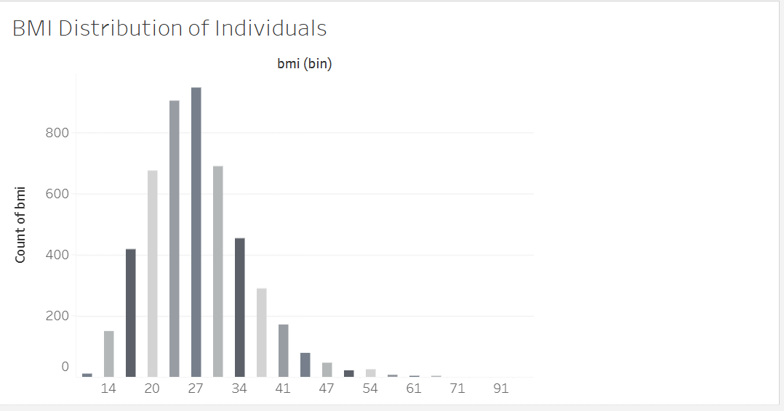
Figure 6 Distribution of Body Mass Index (BMI) in the Dataset

In terms of categorical variables, the gender distribution shows that there are more females than males, with the "Other" category being minimal.

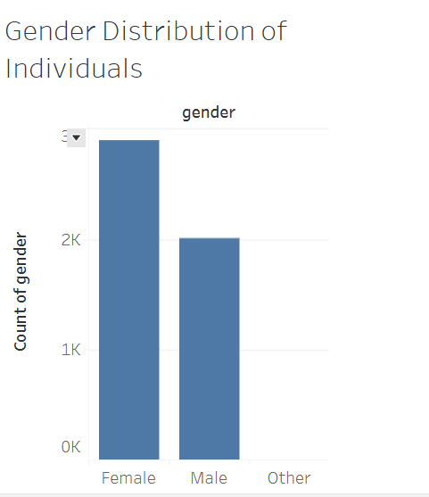
Figure 7 Distribution of Individuals by Gender

The "ever_married" attribute indicates that the majority of the people in the dataset have married, while a smaller proportion have not. This suggests a demographic trend toward married people, which may be related to age and lifestyle choices.

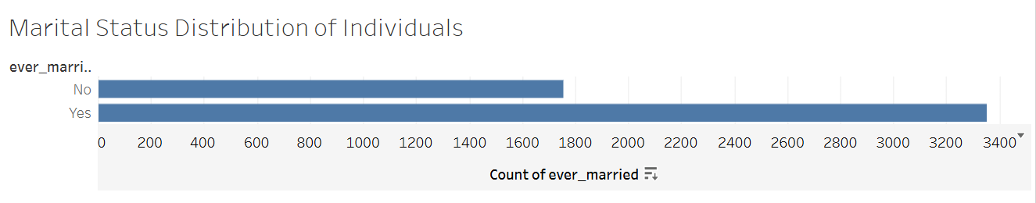
Figure 8 Distribution of Individuals by Marital Status
Binary attributes such as hypertension demonstrate that the majority of people do not have these conditions, while a small proportion do. Despite their lower frequency, these variables are still significant due to their association with stroke risk.

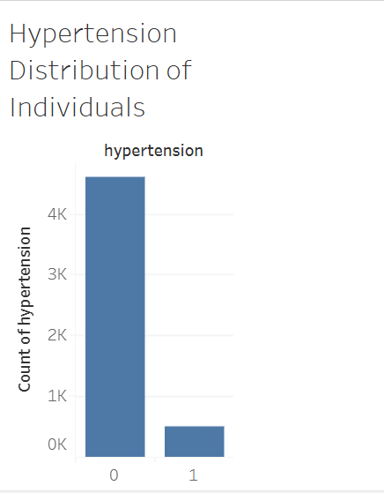
Figure 9 Hypertension Distribution of Individuals

The heart disease variable is binary and indicates whether a person has cardiovascular disease. The distribution indicates that the vast majority of people do not have heart disease, with only a small percentage of cases being positive. This disparity indicates that heart disease is relatively uncommon in the dataset, but it remains an important factor in health-related analysis.

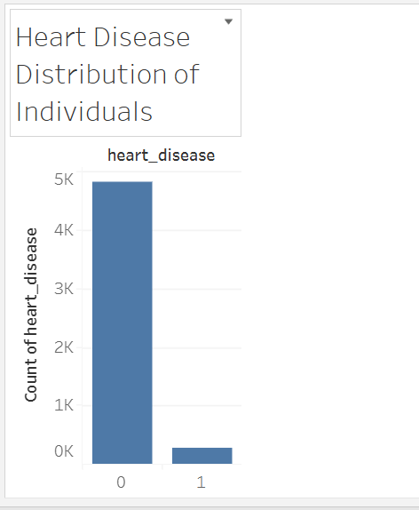
Figure 10 Heart Disease Distribution of Individuals

The work type distribution reveals that the majority of people work in the private sector, followed by self-employment and government jobs. A small percentage of people have never worked, indicating a significant imbalance in employment categories. This suggests that the dataset is primarily made up of economically active individuals.

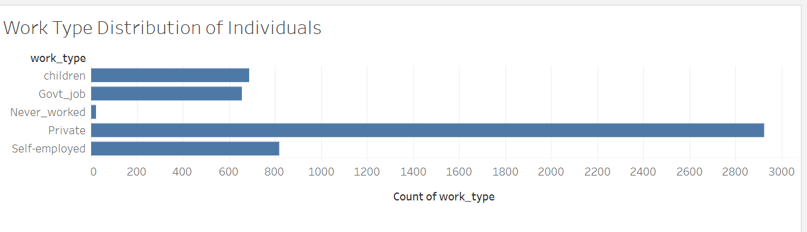
Figure 11 Work Type Distribution of Individuals

The residence type distribution is nearly balanced, with a slightly higher proportion of people living in cities compared to rural areas. This indicates that the dataset represents both environments fairly evenly, allowing for more balanced analysis.

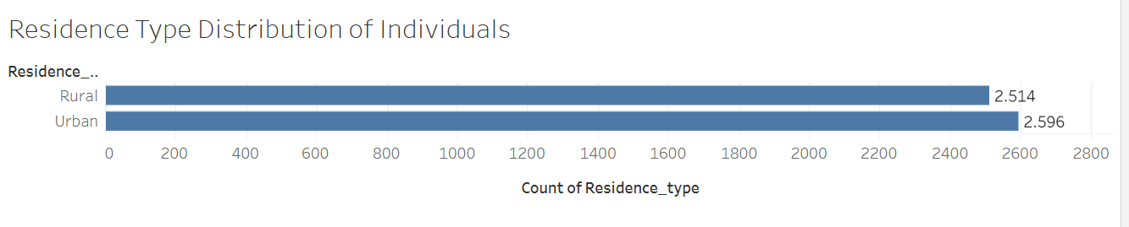
Figure 12 Residence Type Distribution of Individuals

The average glucose level distribution shows that most people fall into the moderate range, with the highest concentrations between 70 and 100. The distribution is slightly skewed to the right, indicating that fewer people have higher glucose levels. This suggests that glucose levels vary and that there may be outliers.

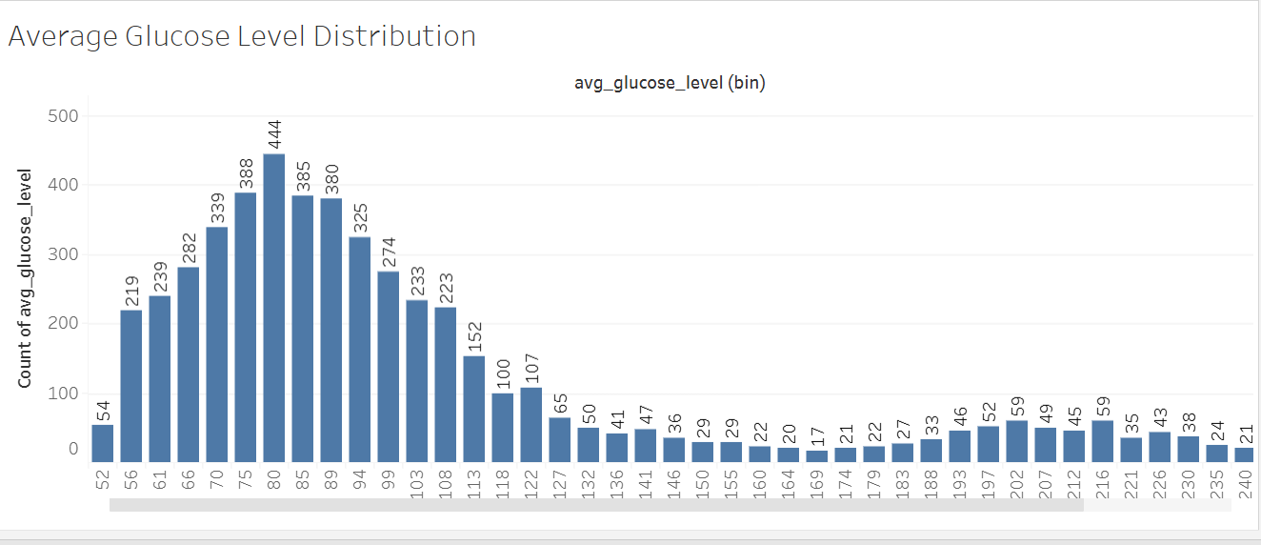
Figure 13 Average Glucose Level Distribution

The smoking status distribution shows that the majority of people have never smoked, with a significant proportion of cases having unknown smoking status. A smaller group of people are classified as current or former smokers. The presence of a large "Unknown" category indicates potential data quality limitations, which may influence the interpretation of smoking-related risk factors.

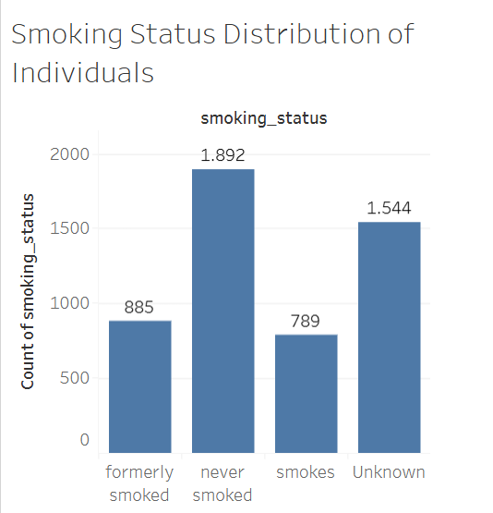
Figure 14 Smoking Status Distribution of Individuals

Data Preprocessing and Data Quality Analysis

Before additional analysis and modelling, the dataset needed to undergo a number of preprocessing steps to guarantee data quality and dependability. Weka's initial inspection showed the existence of missing values, problems with data formatting, and class imbalance, all of which, if left unchecked, could have a detrimental impact on model performance.
The BMI attribute's missing values, which accounted for about 4% of the dataset, were one of the main problems found. The BMI variable originally had incomplete data, as seen in the figure below, which may have an impact on statistical analysis and model accuracy. Additionally, formatting errors prevented the attribute from being correctly identified. By cleaning and fixing the dataset in Excel and making sure that all numerical values were formatted correctly, this problem was fixed. The dataset's consistency and usability were then enhanced by reloading it into Weka. [1]
Additionally, there are a lot of "Unknown" values in the smoking_status attribute, which denotes missing or insufficient data. Although these values were kept, they constitute a dataset limitation because they could make conclusions about lifestyle and health risk factors less reliable.
To guarantee compatibility with classification algorithms, categorical variables were appropriately encoded. The NumericToNominal filter in Weka was used to transform binary attributes like heart disease, stroke, and hypertension into nominal format. In order to improve interpretability and classification performance, this step makes sure that the model treats these variables as categories rather than continuous values.
The significant class imbalance in the target variable (stroke), where the majority of cases belong to the non-stroke class and only a small percentage represent stroke cases, is another significant issue that has been noted. Weka's Resample filter was used to apply data balancing techniques in order to solve this problem. By increasing the minority class's representation, this strategy improved the model's ability to identify patterns linked to stroke cases. Consequently, the model's capacity to identify stroke cases was enhanced. [2]
The relevance of attributes to the prediction task was taken into consideration when selecting features. Due to their strong correlation with the risk of stroke, important factors like age, BMI, average blood sugar, hypertension, and heart disease were kept. Since irrelevant characteristics like ID don't affect predictive performance, they were left out of the analysis. The dataset was meticulously prepared to guarantee meaningful input for machine learning models, but no sophisticated feature engineering techniques were used.
Overall, Weka was used for the preprocessing stage, which involved analysing, validating, and transforming attributes as needed. By taking these actions, the dataset was made more reliable, accurate, and appropriate for machine learning applications. Preprocessing enhancements decreased possible sources of error and led to more trustworthy modelling outcomes. [3]

1.4 Sample Runs and Analysis Methods
The WEKA tool was used in this analysis to apply classification techniques to predict stroke risk based on dataset attributes. Because of its interpretability and efficiency in handling both numerical and categorical data, the J48 decision tree was the main algorithm utilised. [1]
First, 10-fold cross-validation was used to apply the J48 model to the original dataset. A high overall accuracy of 95.12% was revealed by the results. But additional investigation uncovered a crucial problem. For the minority class (stroke = 1), the recall was 0.000, indicating that no stroke cases were correctly identified by the model. All cases were categorised as non-stroke, according to the confusion matrix. This suggests that the dataset's imbalance caused the model to be biased in favour of the majority class. [2]
The WEKA Resample filter with bias towards a uniform class distribution was used as a resampling technique to solve this problem. The objective of this step was to balance the dataset and enhance the model's capacity to identify instances of minority classes.
The J48 model was reassessed using the same cross-validation method after resampling. The overall accuracy dropped to 84.87% in the results, which is to be expected when dealing with unbalanced datasets. Nonetheless, the model's capacity to identify stroke cases significantly improved. All stroke cases were correctly identified, as evidenced by the minority class recall rising to 1.000. The majority of the predicted stroke cases were accurate, as evidenced by the stroke class's precision of 0.768.
This improvement is further supported by the confusion matrix, which demonstrates that while some non-stroke cases were mistakenly predicted as stroke, the model successfully classified all stroke instances. In healthcare settings, where identifying every possible stroke case is more crucial than maintaining high overall accuracy, this trade-off is acceptable. [3]
In summary, the model's ability to identify stroke cases was greatly enhanced by the use of resampling. The findings emphasise how crucial it is to address class imbalance in classification issues, especially in healthcare applications where the minority class is crucial.

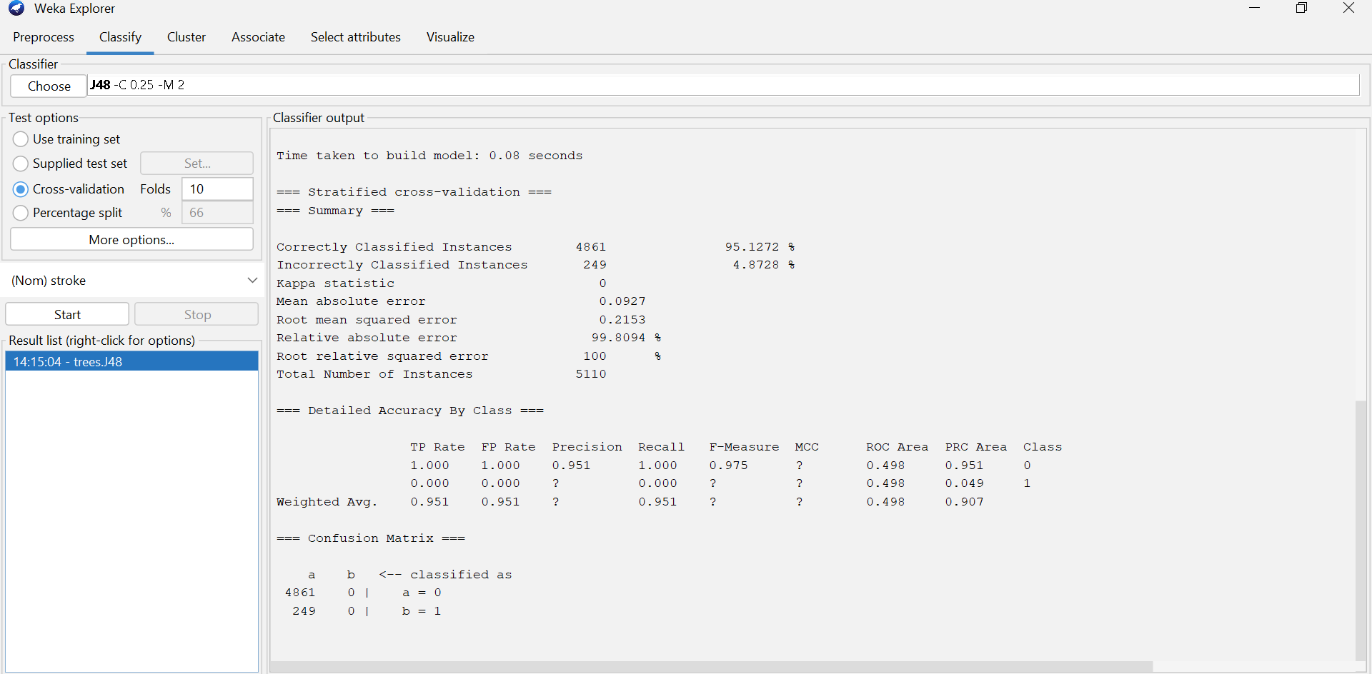
Figure 15 J48 Classification Results in Weka

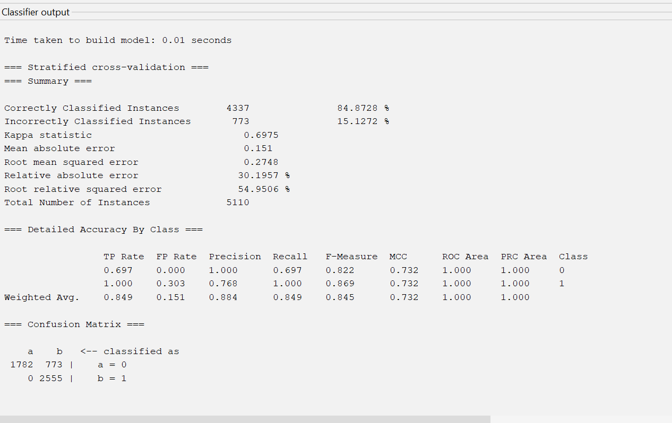
Figure 16 Improved J48 Classification Results After Data Preprocessing in Weka

Model Development and Evaluation
At this point, several classification models were created using Weka to forecast the incidence of stroke. Comparing various algorithms and assessing their effectiveness, especially about the minority class, was the primary goal.
Initially, 10-fold cross-validation was used to apply the J48 decision tree algorithm. Although the model's overall accuracy was high, the results showed that it had trouble accurately identifying stroke cases. The confusion matrix revealed that the majority of cases were categorised as non-stroke, which is a typical problem when working with datasets that are unbalanced.
Weka's Resample filter was used to apply data resampling techniques to enhance performance. This made the dataset more balanced and improved the model's ability to identify patterns related to the minority class. Although there was a minor drop in overall accuracy, the recall for the stroke class greatly improved after resampling.
Furthermore, the Random Forest algorithm's performance was evaluated in comparison to the decision tree model. Random Forest produced more balanced results across classes and showed enhanced robustness and generalisation. Nonetheless, comparable issues with class disparity continued to be noted.
Key performance metrics, such as accuracy, precision, recall, and the confusion matrix, were used to evaluate the model. Since recall is the most crucial component in identifying stroke cases, special attention was paid to it for the minority class. The findings demonstrated that balancing the dataset is essential for enhancing model performance and guaranteeing more accurate predictions.

1.6 Discussion and Conclusion
The classification models' outcomes demonstrate the difficulties posed by unbalanced datasets in medical prediction tasks. Even though early models like J48 had high overall accuracy, they were unable to correctly identify stroke cases, proving that accuracy is insufficient in this situation.
The model's capacity to identify the minority class was greatly enhanced by the use of data resampling techniques. This demonstrates that when dealing with skewed data distributions, preprocessing procedures are crucial. However, increasing recall frequently results in decreased precision or overall accuracy, highlighting the need for a balanced strategy.
Because Random Forest is an ensemble model, it outperformed the decision tree in terms of stability and dependability. Although it still needed balanced data for best results, it was better able to manage dataset variability and lessen overfitting.
Overall, the study shows that preprocessing methods and data quality both significantly affect model performance. Achieving significant results requires addressing class imbalance, handling missing values, and fixing data formats. The use of more sophisticated balancing methods, like SMOTE, and parameter tuning to further improve model performance could be future developments.
This analysis concludes that careful consideration of both data preparation and model selection is necessary for the detection of stroke cases. Predictive results are more accurate and dependable when robust algorithms are combined with suitable preprocessing.

References

[1] | M. K. J. P. J. Han, Data Mining: Concepts and Techniques, Burlington, MA: Morgan Kaufmann, 2011.
[2] | I. H. Witten, E. Frank, M. A. Hall and C. J. Pal, Data Mining: Practical Machine Learning Tools and Techniques, Cambridge, UK: Morgan Kaufmann, 2016.
[3] | F. Provost and T. Fawcett, Data Science for Business: What You Need to Know about Data Mining and Data-Analytic Thinking, Sebastopol,CA: O’Reilly Media, 2013.

