BMSW 5102
HALEMA KHATUN 1808827

DEVELOPING RELATIONSHIPS AND WORKPLACE ACHIEVMENT

LECTURER: ISIAH OINO
CONTENTS PAGE
INTRODUCTION……………………………………………………………………………….3
EMPLOYEE ENGAGEMENT…………………………………………………………………4-5
FEEDBACK AND REWARD………………………………………………………………….6-7
MANAGEMENT DEVELOPMENT……………………………………………………………8
IMPACT OF DEVELOPMENT VEHICLES USED BY
THE CARPHONE WAREHOUSE……………………………………………………………9-11
DEVELOPMENT PLAN………………………………………………………………………12-13
CONCLUSION…………………………………………………………………………………14
REFERENCE LIST……………………………………………………………………………15-16
APPENDIX ONE………………………………………………………………………………17

INTRODUCTION
This is a report based on developing relationships and workplace achievement for employees. In every organization it is very important to develop relationship between employer and employees, so they feel connected and motivated due to which there is enhance in achievements at the workplace (Dries and Pepermans, 2012). I will critically evaluate three development vehicles that are used by organisations to develop employees, these development vehicles are: -
- Employee Engagement
- Feedback and Reward
- Management Development
Following that an assessment has been done on The Carphone Warehouse on how these development vehicles can benefit the organisation by having employees that are engaged. Finally, as a manager I have drawn up a plan to identify the needs and expectations of an employee in a company.

EMPLOYEE ENGAGEMENT
Wiley (2012) identifies employee engagement as ‘the extent to which employees are motivated to contribute to organisational success and are willing to apply discretionary effort to accomplishing tasks important to the achievement of organisational goals.’ Baumruk (2006) found that companies that have a higher engagement in the organisation are more likely to have lower employee turnover, better financial performance and higher productivity. Disengaged employees are not loyal or committed to their work or company, this might be because they are not happy in their roles or with pay therefore tend to leave. Pech and slade (2006) claim that 20% of employees are disengaged at work in the U.K.
Gallup conducted a survey which identified that there are three types of employees which are Engaged employees who work with passion and feel a profound connection to their company. They drive innovation and move the organisation forward. The second is not-engaged employees who are essentially checked out. They’re sleepwalking through their workday, putting time but not energy or passion into their work. The last on which is actively disengaged employees who aren’t just unhappy at work, they’re busy acting out their unhappiness. Every day, these workers undermine what their engaged co-workers accomplish (Kreuger & Killham, 2005). To improve employee engagement, it is important to find out how engaged your employees are, this can be done by measuring it through surveys or monthly appraisals as I had when working for The Carphone Warehouse. As Jim Harter (2013) says, “measurement is one thing, what you measure is another.”
Applying employee engagement to develop individuals is important and beneficial for both the company and employee. There are many factors that influence employee engagement such as workplace culture and organisational communication. There are several ways to keep individuals engaged at work such as highlighting the organisations values and goals and making it clear how employees can contribute to achieve these, making the employee feel valued and important, (Carbonara, 2012).
Also giving employees opportunities to progress in their own career paths by offering development and training programs will show that the company cares about its employees and their future. It is also important for managers to build good working relationships with their staff, if they feel that they are respected and listened to this will further engage them and drive them to be more productive. Ultimately pay and reward is a huge aspect of employee engagement, this can sometimes be the main motivator of an employee being dedicated to their workplace, (Choudhary et al, 2019).
However, disengaged employees are not happy to be at their workplace and will not perform as well as they should which will have a huge impact on the company. According to Branham (2005) disengaged workers can negatively influence morale and revenues of the company. These types of employees often are negative in the way they work and behave, they also tend to complain and cause trouble, (Kahn, 1990). This is why it is important to put in practices to keep employees engaged so that they will give one hundred percent to the company which will benefit both the individual as well as the company and stop the organisation losing staff and money. Managers play important roles in ensuring the success of the organisation’s employee engagement initiatives (Gleeson, 2017).

FEEDBACK AND REWARD
Feedback is important to receive for individuals to know how they are performing at work whether this is positive or negative. London (2013) explains that feedback guides, motivates, and reinforces effective behaviours. It is beneficial to individuals to be provided with feedback as part of their learning process, (Shute, 2008). Effective feedback may motivate employees to perform well to gain rewards and avoid penalties (Latting, 1992). However negative feedback can make employees feel down and not appreciated especially if they take it the wrong way and do not like to be criticised. If this is the case, they will not feel motivated to perform well, there are several motivation theories that support that positive feedback is more effective than negative feedback. Hertzberg has identified the needs of employees in to two categories which are hygiene and motivating factors shown in figure 1.
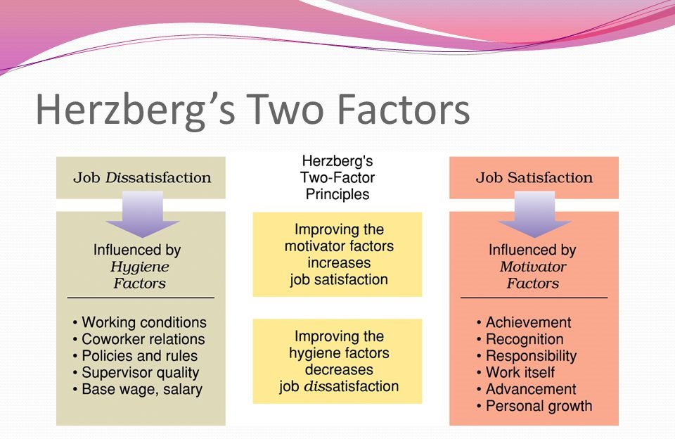
(Figure 1, Zhou, 2017)

As well as receiving honest feedback as a motivator, reward is also welcomed by employees to perform well. Reward can be used as a motivator to get the best out of employees and have a good impact on how they perform. Many organisations nowadays reward employees for performance as means to achieve organisational goals (Mulins, 2005). There are several types of rewards which are classified as intrinsic and extrinsic which can be of a financial and non-financial method. According to Elton Mayo’s theory of Human Management, monetary rewards, job promotions and specific benefits are not enough to most employees today. Managers need to place importance on recognition, appreciation and support for employees as these rewards keep employees loyal to the organisation and not just pay and holiday. No matter what the feedback or reward is they are all used to control behaviour and performance of employees.

MANAGEMENT DEVELOPMENT
According to Allen and Gilmore (1993) a manager is a person who gets things done through other people and is responsible for carrying out the activities required to reach organisational goals. For the success of any organisation there must be effective leadership therefore it is crucial to develop managers and give them the right skills and knowledge to lead their teams to gain organisational success. Management development is a planned process of continuous learning to perform their roles better. According to Molander (1986) “management development is a conscious and systematic process to control the development of managerial resources in the organisation for the achievement of goals and strategies.” However, individuals need to take responsibility to take it upon themselves to do some self-development.
The organisation must provide opportunities for development of its managers through on the job or off the job methods. On the job methods such as coaching and mentoring can be cost effective as there are no external costs, whereas off the job can be costly as it is away from the location and would mean you lose the manager from the company for as long as the training may be. Managers can be sent on development programmes such as courses, training programmes, coaching, guiding and mentoring. For a manager to be successful they are required to have certain basic management skills such as leadership, communication, decision-making skills and project management. In order to do this, they must go through training and development programs to prepare and develop the skills they already possess. All the training should be done by professionals to ensure that these managers get the best out of these courses. Development of these managers gives them better job opportunities for growth and success for themselves and the organisations they work for (Maxwell, 1993).

IMPACT OF DEVELOPMENT VEHICLES USED BY THE CARPHONE WAREHOUSE
In this section I will be analysing the development vehicles that I talked about previously and how these can benefit my organisation The Carphone Warehouse. They offer all colleagues company benefits to retain and attract employees to the business. They also give us the options to buy shares into the company as part of the Sharesave scheme. This makes employees feel like they are part of the organisation and have a personal stake in the business.
To engage with their employees The Carphone Warehouse have an annual survey for employees to take part in and gives every colleague to express their views. It is an external survey done in confidence, it gauges how employees feel about working for the company and is used to improve performance, make decisions and recognise success. In 2017/2018 CPW recorded an 85% response rate, with engagement the same year-on-year at 61% (The Carphone Warehouse, 2020). As a successful organisation the Carphone Warehouse realise that their employees must be engaged with the vision, culture and values and put in practices to achieve this. Successful organisations know that employee satisfaction, performance and employee engagement are crucial (Shmailan, 2016).
Engaged employees have a level of commitment and emotional attachment to the organisation (Paul, 2017). Employees develop a bond with an organisation and that creates better business. If that emotional connection to their career, relationships with other employees and the organisation are present, they perform better. According to Gallup (2006) employees who are highly engaged in their organisation produce high levels of customer care, retention, productivity and generate higher profits (Peterson, 2004).
Organisational commitment has a significant impact on overall employee engagement, as this type of commitment increases so does employee engagement (Schaufeli & Bakkor, 2004). My organisation understands that in keeping staff engaged leads to job satisfaction, therefore people wanting to be at work which in turn less employee turnover. Whereas poor employee engagement can cause organisations to have lower profit margins, poor customer service, high employee turnover and decreased competitive edge. All this can have a detrimental impact on the organisation and production; therefore, it is important to have high quality leaders because poor management leads to disengaged employees and a lack of commitment.
At the Carphone Warehouse we are given monthly appraisals, where our targets and future goals are discussed. This is an opportunity for my manager to express her concerns and a chance for me to discuss mine, communication in these meetings can help to improve performance and individuals to work on criticisms. Employees who receive regular, scheduled feedback together with training, coupled with increased expectations always have a higher level of worker output (Shields, 2007). Having these ongoing meetings with our line manager makes my colleagues and I feel like we are listened to and motivates us to perform better and achieve these set goals. According to Isaac et al (2001) Vrooms Expectancy theory of motivation is not about self interest in rewards but about the associations people make towards expected outcomes and the contribution they feel they can make towards these outcomes.
As well as having your basic pay the Carphone Warehouse reward employees with bonuses for exceeding targets, this encourages employees who like the financial gains to produce more. Which of course benefits the company as they will see this in their profits. For some employee’s recognition was seen as a reward and my manager would give me extra responsibilities which made me feel proud to do. But this saved money for the company as they didn’t have to take on someone extra to do these tasks which I was happy to do because I was given the authority to tell others what to do. Other non-financial rewards that were given to motivate employees were birthday holidays, access to free on-site gym, Christmas and birthday gifts and discounts on mobile phone contracts. These were all applied to enhance the quality of working life and to rewards efforts and make employees feel valued. Which of course in turn benefits the organisation as employees are motivated to perform well to achieve the organisations objectives.
The final vehicle development, management development is needed for all managers to be on top of their game. According to Werner and Desimone (2008) management development is an organisations conscious effort to provide its managers with opportunities to learn, grow and change, in hopes of producing over the long term a managers with the skills necessary to function effectively in that organisation. Therefore, the necessary training must be given to all managers so that they are fully trained to do their roles. At the Carphone Warehouse managers are sent on training courses done by experts to improve their skills and knowledge so that they can then pass this on to their teams. Training gives employees a greater understanding of what is expected of them and builds their confidence which in turn can only benefit the company with less employee turnover. Having the best managers who can achieve their goals using their teams puts the company in a position to lead and be a strong competitor in the industry.
Management development is important in preparing an organisation for the next generation of leadership. Werner and Desimone (2006) also indicate that management development is made of three components, which are management education, management training and on the job training. My manager noticed potential in myself to become a supervisor so she would increase my responsibilities and mentor me to learn specific management tasks as she wanted to mould me into a manager, for instance if she was off I could step in to her shoes so to speak. This is where a good management plan needs to be put in place to identify any deficiencies and what skills and knowledge are needed to learn and improve, she put in all three management components that I discussed earlier so that I could become an effective manager. Management development influences engagement for employees and providing opportunities for personal development (Mumford & Gold, 2004).

DEVELOPMENT PLAN
In this section as a manager I am going to create a development plan for my employee after identifying there needs and expectations and what myself and the company can do to achieve these. An employee development plan is used by companies to provide their employees a guideline of the items that they need to follow to attain growth and improvement in the work environment (Daft & Marcic, 2008). It is very important for the employees to feel that they are growing in the company for them to function more efficiently and for their productivity to increase also. This plan will be done using SMART objectives, which stands for specific, measurable, achievable, realistic and time-based. Using SMART will enable us to have clear and concise objectives to work towards. SMART goals are also easy to use by anyone, anywhere, without the need for specialist tools or training (Hughes, 2018). I will draw up a development plan (see appendix one) for my employee to fill in so that we can have something to look back at and review.
As a manager in the logistics department of Carphone Warehouse I deal with mobile phones that come in for repair and have a turnover of 7 days to get them back to the customer. Following the companies core values of always keeping the customer in mind and giving them the best service, I also must instil this into my staff. There is protocol that must be adhered to and have several departments that the phone goes through before it is delivered back to the customer. However, I can’t be everywhere at the same time therefore I have identified one of my staff who wants to progress from their role on the shop floor to supervisor. I want to help them to achieve this as this will help me on the shop floor and my organisation will benefit because they will not have to advertise the role externally. By training someone with knowledge and potential internally will be cost effective saving the costs of advertising the job and going through the interview process which is costly and needs time.
The following are the steps that will be taken to complete the development plan: -
- IDENTIFY DEVELOPMENT NEED - The first thing to assess when creating a development plan will be to identify the needs of my employee which will be done in a one-to-one meeting. This is where we will talk about the strengths and weaknesses about the individual and will set out clear expectations for the short term and long term and how these can be achieved by both parties.
- DEVELOPMENT OPPORTUNITIES – the development opportunity that has been identified here is that there is a shortage of managers on the shop floor and this employee wants to progress to this role. This has given the employee a chance to come forward for this role and take the opportunity to further their career.
- IDENTIFYING LEARNING OPPORTUNITIES – This is where we will discuss the necessary skills and knowledge that is needed by the individual to improve on. As everyone’s learning styles are different this might be on the job training or could be that I need to send the employee on a training course to acquire the skills and knowledge to fulfil this role.
- ACTION PLAN – This is where I have drawn up an action plan for the individual (see appendix 1) on paper so that it is clear to what exactly needs to be done. This will be done using SMART objectives to make specific goals for the employee to work towards. The set goals will be a challenge for the individual but must be realistic so that the goals can be attained within a realistic time frame.
- RECORD OUTCOMES – Activities and the action taken will be recorded to see what has been achieved through the plan, this will be monitored throughout. The date, the development need identified, the result will all be recorded and then we can discuss how they are getting on and if any further action or changes are required.
- REVIEW AND EVALUATE – it is important to evaluate and review the success of the individual which we will be done with another planned meeting. This is where feedback can be given and see if any amendments are needed and we can go on to set new goals to work towards.
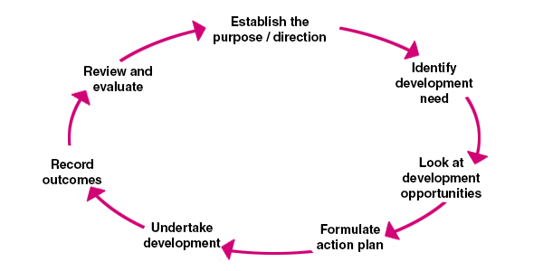
(Chartered Management Institute, n.d)
The goals in the development plan will only be achieved by both of us working together. As a manager it will be my job to put all the processes in place for the individual to have a chance of achieving the goals. However, the individual will need to put in one hundred percent effort in working towards the goals and take the opportunity that has been given to them otherwise it will be a huge waste of money and time.
CONCLUSION
On conclusion it is certain that high levels of employee engagement will lead to improved commitment from employees and will motivate them to work hard and produce more therefore profits for organisations will increase. It is not always financial gain that employees are looking for, but sometimes just simple recognition or appreciation can go along way to have a satisfied workforce. All the areas that have been discussed should be put in place for employees to feel like they count which makes them feel satisfied with their job roles, this will create a happy workplace with employees who are loyal to the company. All these aspects develop good working relationships and achieve goals. Of course, this in turn should generate engaged, motivated staff who are willing to work and produce well for their managers and organisations increasing their profits and this way they will be able to retain employees so will have a low employee turnover. Also having a development system is important in an organisation, the career development system is an everyday activity which shows how the organisation needs are linked with the individuals needs so when the employees are satisfied with their career, the organisation will achieve its goals and objectives (Jackson, 2000).

REFERENCE LIST
- Allen, W. R. & Gilmore, H. L., 1993. What Managers Do. 4 ed. s.l.:American Management Association.
- Baumruk, R., 2006. Why Managers are crucial to increasing engagement. Strategic HR review, 5(2).
- Branham, L., 2005. The 7 Hidden Reasons Employees Leave. New York: American Management Association.
- Carbonara, S., 2012. Managers Guide to Employee Engagement. s.l.:McGraw Hill Professional.
- Chaudhary, N., Sharma, N. & Singh, V. K., 2019. Managment Techinques for Employee Engagement in Contemporary Organisations. Hershey: IGI Global.
- Daft, R. L. & Marcic, D., 2008. Understanding Management. 6 ed. Mason: Cengage Learning.
- Dries, N. & Pepermans, R., 2012. The role of learning & career variety in the identification and development of high potential employees. Personnel Review, 41(3), pp. 340-358.
- Gleeson, B., 2017. 5 Powerful Steps to Improve Employee Engagement. [Online]
Available at: http://forbes.com/sites/brentgleeson/2017/10/15/5-powerful-steps-to-improve-employee-engagement//
[Accessed 20 March 2020].
- Hughes, J., 2028. How to get SMART goals. [Online]
Available at: https://www.elegantthemes.com/blog/business/smart-goals
[Accessed 24 March 2020].
- Jackson, T., 2000. Career Development. London: Institute of Personal & Development.
- Kahn, W. A., 1990. Pschological conditions of personal engagement and disengagement at work. Academy of Management , 33(4), pp. 692-724.
- Krueger, J. & Killham, E., 2005. Feeling Good Matters. [Online]
Available at: https://news.gallup.com/businessjournal/20311/work-feeling-good-matters.aspx
[Accessed 21 March 2020].
- Latting, J. K., 1992. Giving coorective Feedback: A Decisional Analysis. Social Work, 37(5), p. 424.
- London, M., 2003. Jod Feedback:Giving, Seeking and Using Feedback for Performance. Englewood Cliffs: NJ.
- Maxwell, J., 1993. Developing the Leader WithinYou. Nashville: s.n.
- Molander, C., 1986. Management Development. Bromley: Chartwell Bratt.
- Mullins, S., 2004. Organisational Behaviour. 6 ed. Boston: PPalgrave Macmillan.
- Mumford, A. & Gold, J., 2004. Management Development Strategies for Action. 4 ed. London: CIPD.
- Paul, E., 2017. Effective Ways to Improve Employee Engagement. [Online]
Available at: https://www.emptrust.com/blog/employee-engagement-a-key-hr-strategy
[Accessed 26 March 2020].
- Pech, R. & Slade, B., 2006. Employee disengagement: Is there evidence of a growing problem?. In Handbook of Business Strategy, 7(1), pp. 21-25.
- Peterson, D., 2004. The Relationship between perceptions of corporate citizenship and Organisationam Commitment. Business and society, Volume 43, pp. 296-319.
- Schaufeli, W. & Bakker, A., 2004. Job demands, job resources and thier relationship with burnout and engagement. A multi sample study, Volume 25, pp. 293-315.
- Shields, J., 2007. Managing Employee Performance and Reward. Cambridge: Cambridge University Press.
- Shmailan, A. S. B., 2016. Issues in Business Management and Economics. [Online]
Available at: https://journalissues.org/ibme/
[Accessed 28 March 2020].
- Shute, V. J., 2008. Focus on Formative Feedback Review of Educational Research. 78(1), pp. 153-159.
- Werner, J. M. & Desimone, R. L., 2008. Human Resource Development. 5 ed. s.l.:Cengage Learning.
- Zhou, Z., 2017. Herzbergs two Factors Theory. [Online]
Available at: http://blogs.ubc.ca/comm292zigingzhou//
[Accessed 25 March 2020].

APPENDIX ONE
EMPLOYEES NAME: Kelly Hill |  | MANAGERS NAME: Halema Khatun
POSITION: Product Support |  | POSITION: Line Manager
CONTACT INFO: 07789456623 |  | CONTACT INFO: 07793493498
OBJECTIVES FOR CURRENT ROLE: To progress to supervisor role
SHORT TERM GOALS  Be mentored at work and shadow my manager  Learn all the specific skills |  | LONG TERM GOALS  Enrol on to management course at college to gain management qualification  Get management employment
GOALS FOR DEVELOPMENT  Become a manager | ACTION PLAN  Further education  Training | PLANNED DATE  10/04/20  15/05/20 | COMPLETION DATE  10/07/21  28/08/20
COMMENTS/NOTES  Go to college with relevant documents to enrol on to course.  Review in 6 months’ time |  | EMPLOYEE SIGNATURE & DATE:  MANAGER SIGNATURE & DATE:

