Contents
a. Calculate the resistance of E and H for the circuit’s configuration. [3] 1
b. B and C are identical and the current passing through A is 0.5A, calculate the current passing through B and C. [2] 1
c (i) The Resistance of A. [2] 1
c (ii) The Resistance of B and C [3] 1
c (iii) The potential difference across A, B and C [1] 1
c (iv) Since the total potential difference across L to M is 6V, calculate the potential difference across D and find its Resistance. [2] 1
d. The ‘lost volts across one of the cells in the parallel arrangement is 2 V. Calculate r and hence the total resistance of the parallel combination of cells. [3] 1

e. Given that the resistance F is 6Ω, calculate the voltage drop across it. [2] 1
f. Calculate the total resistance of the circuit, this includes total internal and the resistance cause by the reverse polarity battery and the open diodes in given scenario (ignore any “non-open diodes”). [2] 1
g. Calculate the emf of each of the cells in the parallel combination. [3] 1

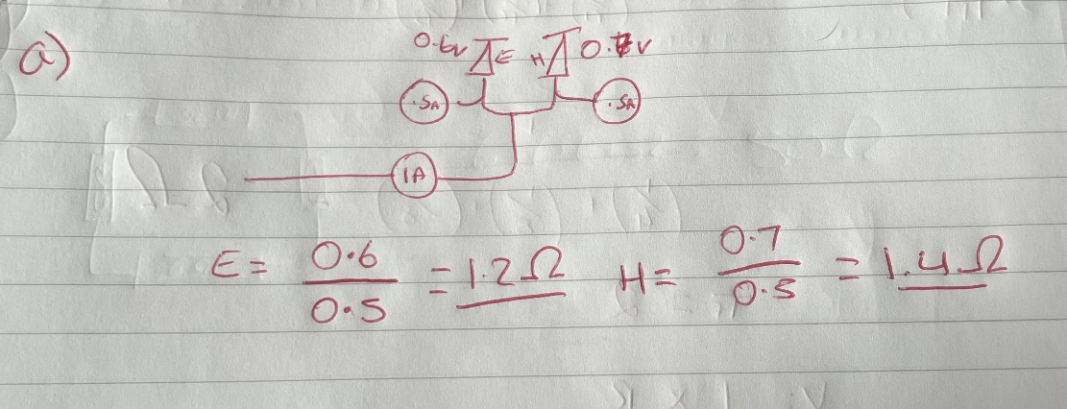
a. Calculate the resistance of E and H for the circuit’s configuration. [3]

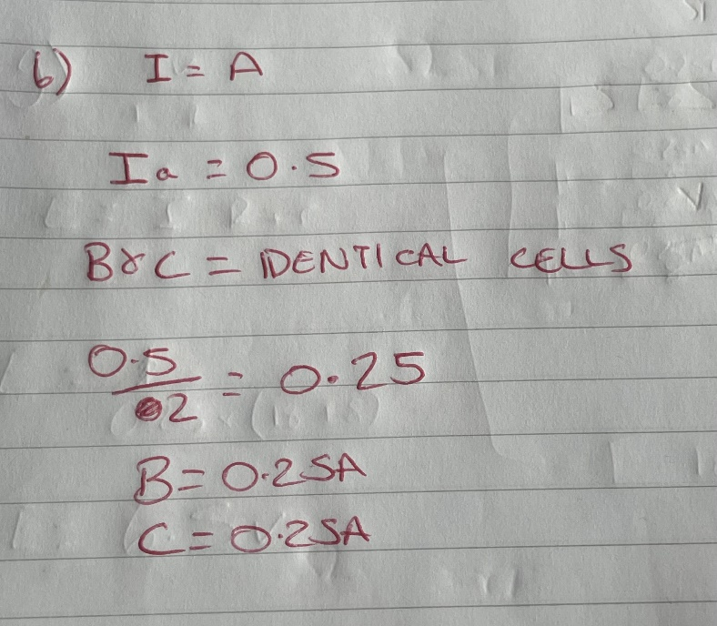
b. B and C are identical and the current passing through A is 0.5A, calculate the current passing through B and C. [2]

c (i) The Resistance of A. [2]

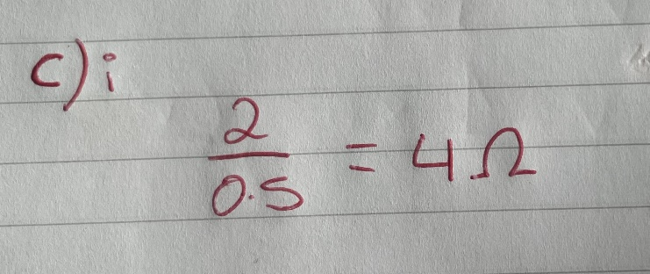

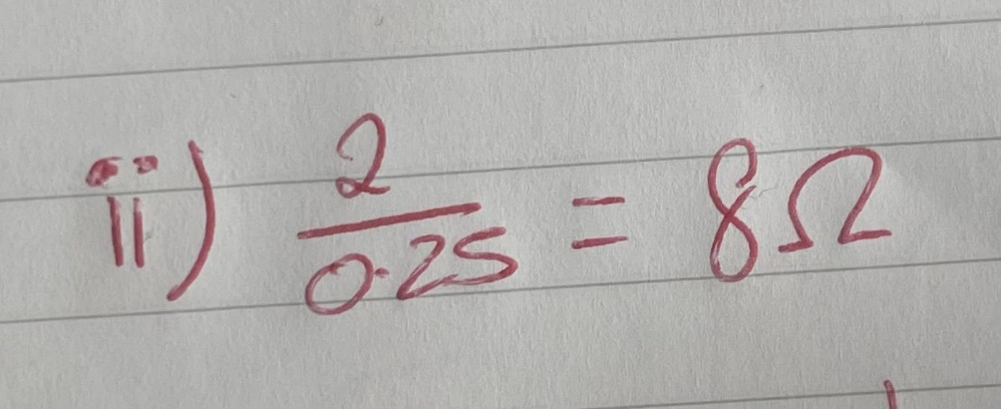
c (ii) The Resistance of B and C [3]

c (iii) The potential difference across A, B and C [1]
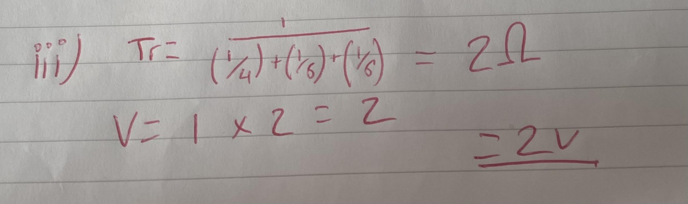

c (iv) Since the total potential difference across L to M is 6V, calculate the potential difference across D and find its Resistance. [2]
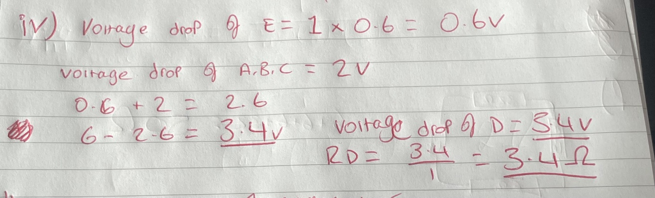

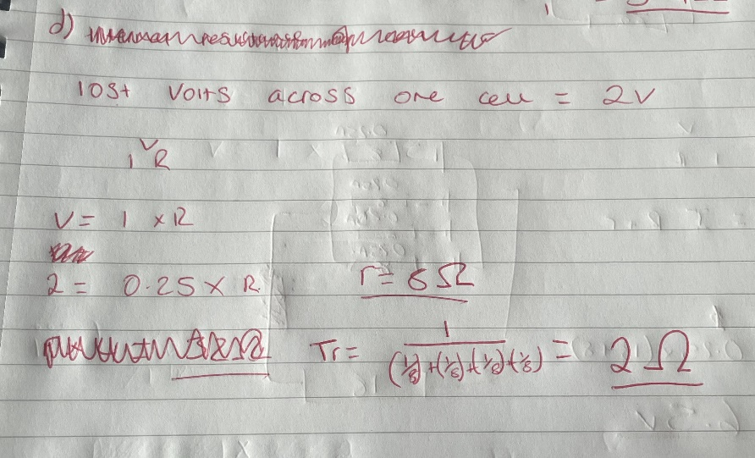
d. The ‘lost volts across one of the cells in the parallel arrangement is 2 V. Calculate r and hence the total resistance of the parallel combination of cells. [3]

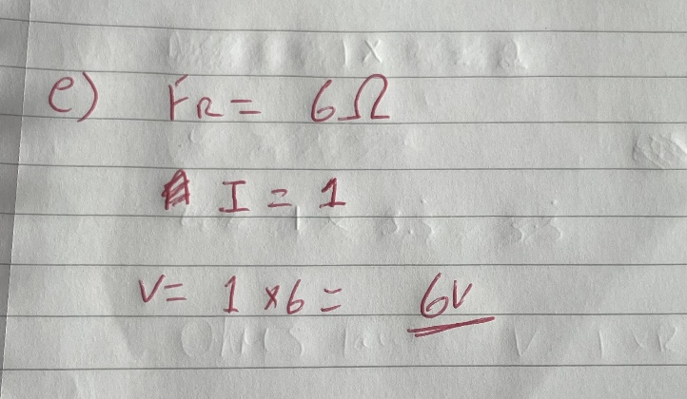
e. Given that the resistance F is 6Ω, calculate the voltage drop across it. [2]

f. Calculate the total resistance of the circuit, this includes total internal and the resistance cause by the reverse polarity battery and the open diodes in given scenario (ignore any “non-open diodes”). [2]
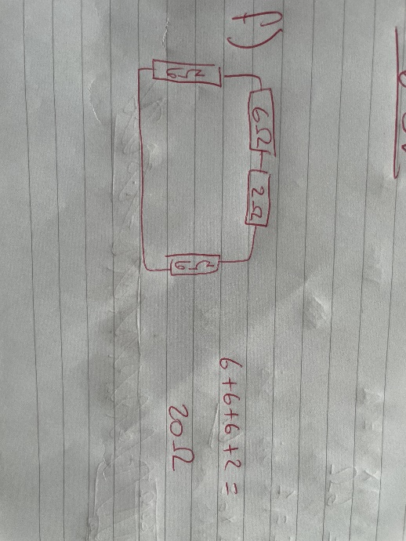

g. Calculate the emf of each of the cells in the parallel combination. [3]



