Introduction
This chapter presents and analyses findings from a survey exploring police officer responses to mental health-related incidents, with a particular focus on Crisis Intervention Team (CIT) training, officer confidence, and perceived effectiveness of current practices. A total of 53 valid responses were collected from serving police officers across a range of roles and experience levels. The findings are analysed thematically to identify key patterns relating to confidence, training effectiveness, attitudes, and organisational barriers. This approach enables a structured interpretation of how officers perceive their role in responding to mental health crises.

Participant Characteristics
Respondents represented a range of operational roles, including response officers, investigators, and supervisory ranks, with varying levels of experience. A large proportion reported regular exposure to mental health-related incidents, reinforcing existing evidence that such calls form a significant and increasing component of police demand (Rees et al., 2023).

**Figure 1: Frequency of police attendance at mental health-related incidents**

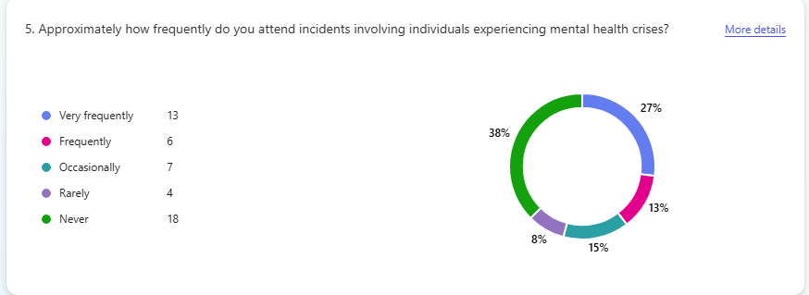

As shown in Figure 1, most officers reported frequent exposure to mental health-related incidents, highlighting the scale of demand placed on frontline policing.
In relation to training, 29 officers reported completing CIT training, while 19 reported no formal CIT training, demonstrating variation in preparedness across the sample. This distinction provides a useful basis for exploring differences in confidence and perceived effectiveness of response strategies.

**Figure 2: Proportion of officers who have completed Crisis Intervention Training (CIT)**

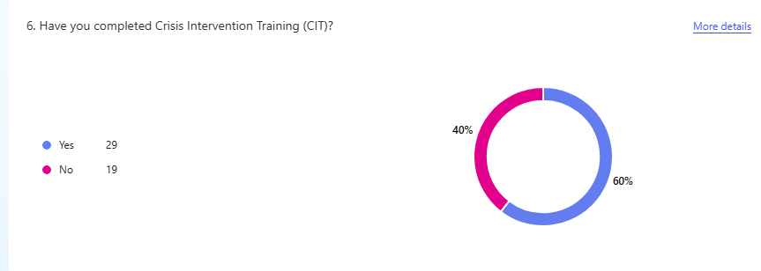

Figure 2 illustrates variation in training exposure, which is important in understanding differences in confidence and perceived effectiveness of responses.

Theme 1: Officer Confidence in Responding to Mental Health Incidents
The findings indicate moderate but inconsistent levels of confidence among officers when responding to mental health crises. While many respondents reported confidence in communication and de-escalation, a notable proportion expressed neutrality or lack of confidence. This variation suggests that confidence is not consistently distributed across the workforce.
This aligns with recent research indicating that mental health incidents continue to present uncertainty for officers, despite increased exposure and training (Dyer, Steer and Biddle, 2023). The presence of neutral responses is particularly significant, as it may reflect uncertainty rather than competence, highlighting a potential gap in preparedness.
Furthermore, confidence does not necessarily equate to effective performance. Research suggests that while officers may feel confident, complex and unpredictable mental health crises require specialised skills that are not always fully developed through standard training (Wood and Watson, 2017).
Overall, the findings suggest that while some officers report confidence, this is not sufficiently consistent to ensure effective responses across all incidents. This variability is significant, as inconsistent confidence may lead to differences in decision-making and outcomes depending on the attending officer. It also highlights a potential gap between perceived competence and actual capability, particularly in complex and high-risk situations. As a result, confidence alone cannot be considered a reliable indicator of preparedness, reinforcing the need to examine wider structural and organisational influences on police response.

**Figure 3: Officer confidence across key mental health response tasks**

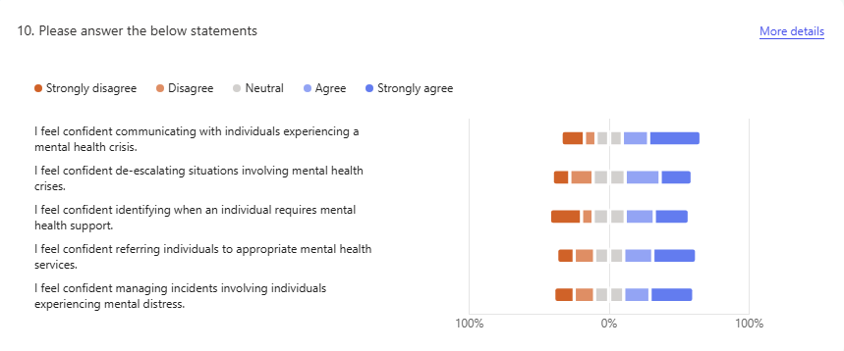
As illustrated in Figure 3, confidence varies across different aspects of response, with higher confidence in communication compared to more complex tasks such as referral and decision-making.

Theme 2: Effectiveness of Crisis Intervention Training (CIT)
The data indicates that while CIT training is present among respondents, its effectiveness is not consistently reflected in operational confidence or perceived outcomes. Despite over half of respondents reporting CIT training, a significant proportion still reported challenges in managing mental health incidents.
This finding reflects recent systematic reviews suggesting that CIT training improves knowledge and attitudes but has a more limited and inconsistent impact on behavioural outcomes, such as use of force or arrest rates (Kane, Evans and Shokraneh, 2018; Arias, Arango and Gutiérrez-Rojas, 2022).
The results also suggest that CIT may be applied inconsistently in practice. While training may enhance theoretical understanding, its practical application appears to depend on experience, situational context, and organisational support. This supports the argument that training alone is insufficient without reinforcement through operational structures and access to mental health services (Compton and Broussard, 2019).
Therefore, while CIT contributes positively to officer preparedness, its effectiveness appears to be partial and context-dependent rather than universally transformative. This suggests that training alone is insufficient to address the complexities of mental health-related incidents, and that its impact is ultimately constrained by organisational and systemic factors beyond the control of individual officers.
Theme 3: Attitudes Towards Mental Health
The findings suggest generally positive attitudes towards individuals experiencing mental illness, with most respondents recognising the importance of respect, fairness, and community support. This reflects broader developments in policing, where awareness of mental health issues has improved significantly.
However, the presence of disagreement and neutral responses indicates that attitudes are not entirely uniform, and elements of stigma may still exist. Contemporary research supports this finding, suggesting that although overt stigma has reduced, underlying biases can still influence police perceptions and decision-making (Corrigan, 2021; Stuart, 2016).
This variation in attitudes may contribute to inconsistencies in police responses, particularly in high-pressure situations where assumptions about risk or behaviour may influence decision-making.
Overall, while attitudes appear broadly positive, the persistence of variation highlights the need for continued focus on mental health awareness and cultural change within policing. This is particularly important given that even subtle biases can influence discretionary decision-making, especially in high-pressure environments. Consequently, improving attitudes is not only a matter of education but also requires ongoing cultural reinforcement within policing organisations.

**Figure 4: Officer attitudes towards individuals experiencing mental illness**

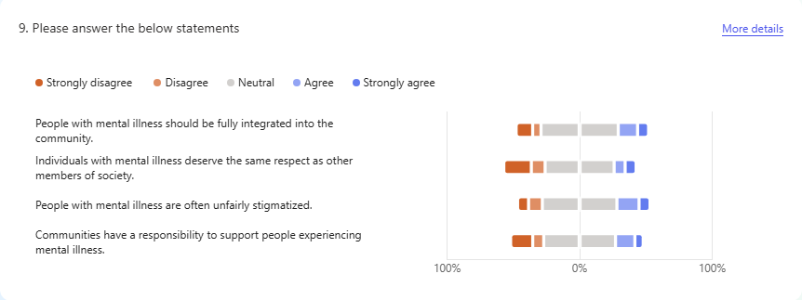
Figure 4 demonstrates generally positive attitudes among officers, although some variation remains, indicating that stigma has not been entirely eliminated.

Theme 4: Organisational and Structural Barriers
A key finding of this study is the identification of significant structural barriers affecting police responses to mental health incidents. Respondents frequently reported challenges related to limited access to services, delays in support, and inadequate referral pathways.
This finding is strongly supported by recent research, which highlights that police are increasingly required to manage mental health crises due to gaps in healthcare provision and limited availability of specialist services (Rees et al., 2023).
Furthermore, the effectiveness of CIT and similar interventions is heavily dependent on the availability of external support. Without appropriate services to refer individuals to, officers are often left managing situations beyond the traditional scope of policing (Kane et al., 2018).
These findings suggest that organisational and structural factors play a critical role in shaping police responses, often limiting the effectiveness of training and individual capability. This highlights that the challenges associated with mental health-related policing are not solely operational but are rooted in wider systemic limitations, reinforcing the argument that effective responses require coordinated multi-agency solutions rather than isolated police interventions.

Theme 5: Perceptions of Training Adequacy
One of the most significant findings is that most respondents indicated that additional training would not improve police responses to mental health incidents. This suggests that officers perceive the challenges they face as systemic rather than skill based.
**Figure 5: Officer perceptions of whether additional training would improve responses**

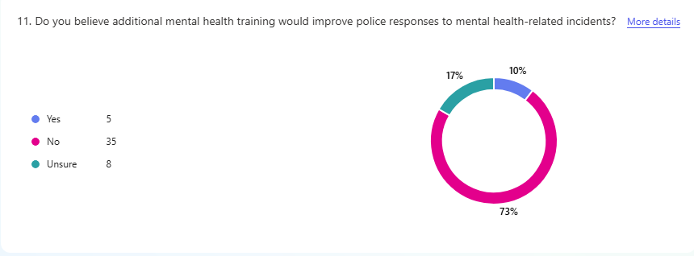
As shown in Figure 5, most officers do not believe that additional training would significantly improve outcomes, suggesting that perceived barriers are structural rather than skill based.
This finding challenges the assumption that increased training is the primary solution to improving police responses. Instead, it indicates that officers recognise the limitations imposed by external factors, such as resource constraints and service availability.
This aligns with research suggesting that while training improves knowledge and awareness, it does not address broader systemic issues that impact outcomes (Livingston, 2016; Dyer et al., 2023).
Therefore, the findings indicate that improving police responses requires a broader approach that extends beyond additional training. While training may enhance knowledge and awareness, it does not address the structural constraints that limit effective practice. This suggests that meaningful improvement depends on increased organisational capacity, improved access to mental health services, and stronger multi-agency collaboration, rather than solely focusing on individual officer development.
Overall Analysis
Overall, the findings highlight a clear disconnect between training, confidence, and operational effectiveness. While CIT training and generally positive attitudes towards mental health are evident, these factors do not consistently translate into effective practice.
A key pattern across the data is the influence of structural and organisational constraints, which limit the ability of officers to apply training effectively. This supports recent literature suggesting that CIT is most effective when implemented alongside strong organisational support and accessible mental health services (Arias et al., 2022; Compton and Broussard, 2019).
Additionally, the variation in confidence and attitudes suggests that preparedness is uneven across the workforce, which may contribute to inconsistent responses depending on individual officers and situational context.
The finding that most officers do not believe additional training would improve responses is particularly significant, as it highlights a recognition that systemic issues, rather than knowledge gaps, are the primary barrier to effective policing in mental health contexts.
Overall, the findings suggest that while CIT training and generally positive attitudes towards mental health are evident, these factors do not consistently translate into effective operational practice. A key pattern across the data is the influence of structural and organisational constraints, which limit the ability of officers to apply training effectively in real-world situations. This reinforces the argument that police responses to mental health crises are shaped as much by systemic factors as by individual capability.
The finding that most officers do not believe additional training would improve responses is particularly significant, as it challenges traditional assumptions that training is the primary solution. Instead, it highlights a recognition among officers that the main barriers to effective response lie in resource limitations, service availability, and inter-agency coordination.
Consequently, these findings support a shift away from training-focused solutions towards a more integrated and system-wide approach to mental health crisis management. This includes greater investment in mental health services, improved partnership working, and clearer role boundaries between policing and healthcare. Without addressing these broader structural issues, the effectiveness of initiatives such as CIT will remain inherently limited.
(Word Count – 1129)

Bibliography:
Arias, E., Arango, C. and Gutiérrez-Rojas, L. (2022) ‘Police responses to mental health crises: A systematic review’, International Journal of Law and Psychiatry, 81, 101784.
Compton, M.T. and Broussard, B. (2019) The Crisis Intervention Team (CIT) model of collaboration between law enforcement and mental health. New York: Oxford University Press.
Corrigan, P.W. (2021) The stigma of mental illness: End of the story? Washington: American Psychological Association.
Dyer, W., Steer, K. and Biddle, P. (2023) ‘Police officer experiences of mental health-related calls’, Policing and Society, 33(6), pp. 715–730.
Kane, E., Evans, E. and Shokraneh, F. (2018) ‘Effectiveness of police crisis intervention teams’, Campbell Systematic Reviews, 14(1), pp. 1–26.
Livingston, J.D. (2016) ‘Contact between police and people with mental disorders’, Journal of Psychiatric and Mental Health Nursing, 23(5), pp. 330–340.
Rees, N., et al. (2023) ‘Policing and mental health demand’, Policing and Society, 33(2), pp. 150–165.
Stuart, H. (2016) ‘Reducing stigma in mental health’, World Psychiatry, 15(1), pp. 3–4.
Wood, J.D. and Watson, A.C. (2017) ‘Improving police interventions during mental health crises’, Police Quarterly, 20(4), pp. 392–419.

