TITLE PAGE:

A CRITICAL PERSPECTIVE OF THE IMPACT ORGANISATIONS ‘QUALITY’ PROCESSES HAVE ON CUSTOMER RELATIONSHIP MANAGEMENT
SENIOR RESEARCHER 1709566
CUSTOMER RELATIONSHIP MANAGEMENT JOURNAL
5 TH JULY 2019

EXECUTIVE SUMMARY:

In the report the researcher has got beneficial and valuable information about Customer relationship management, about Ethics and their importance within the organisations, Sustainability and Quality from the advantages to improvements, gaps and recommendations. The researcher used organisations such as banks, John Lewis and Audi, car manufacturing, how they used CRM system and how that impact to their customer relationship management. Also, the researcher has given an examples of a ‘good practice’ of CRM system.

CONTENTS PAGE:

CONTENT PAGE NO.
- TERMS OF REFERENCE 2
- PROCEDURE 3
- FINDINGS 4-9
- CONCLUSION 10
- RECOMMENDATIONS 11
- APPENDICES 12
- REFERNCE LIST 13-14

1.0 TERMS OF REFERENCE

THE REPORT IS BEING REQUESTED BY THE EDITOR OF’ CUSTOMERS RELATIONSHIP MANAGEMENT ‘ AN ONLINE JOURNAL AT 18.06.2019 AND HAS GOT AS A DETERMINATION THE CRITICAL PERSPECTIVE OF THE IMPACT ORGANISATIONS ‘QUALITY’ PROCESSES HAVE ON CUSTOMER RELATIONSHIP MANAGEMENT, THE RESEARCHER, ANGELA ANDRADA VISCIUN CONTRIBUTE TO THIE RESEARCH BY COMPILING THE REPORT BASED ON THE THREE ISSUES SUCH AS CUSTOMER EXPERIENCE OF ORGANISATIONS BASED ON ETHICAL AND SUSTAINABILITY,AS A FIRST TASK, THE DEMONSTRATION OF A ‘CRITICAL’ DISCUSSION OF A VARIETY OF QUALITY MODELS AND THEORIES THAT MAY ASSIST IN A ORGANISATIONS TO IMPROVE CUSTOMERS RELATIONSHIP MANAGEMENT, AS SECOND TASK AND LAST ISSUE THAT THE RESEARCHER CONTRIBUTE TOWARDS COMPILISHING THE REPORT IS THE CONCLUSION ON THE IMPACT OF ETHICAL AND SUSTAINABILITY POLICIES ON THE QUALITY OF CRM WITHIN THE ORGANISATIONS. THE DATE OF SUBMISSION FOR THE REPORT REQUESTED IS FIFTH JULY 2019 AT 15:00 PM.

- PROCEDURE

TO PREPARE THE REPORT THE RESEARCHER INCLUDE SOURCES OF INFORMATIONS SUCH AS websites, online journals such as google scholar, and Harvard business review, MOODLE, in class notes.

- FINDINGS

  - ETHICS – “Ethics” can be defined as the critical, structured examination of how people should behave — in particular, how we should constrain the pursuit of self-interest when our actions affect others, sourced from (The Business Ethics Blog, 2019)

According to John Donaldson (1989), ‘Business ethics in short can be described as a systematic study of moral (ethical) matters pertaining to business, industry or related activities, institutions or practices and beliefs’, sourced from (Shodhganga.inflibnet.ac.in, 2019)

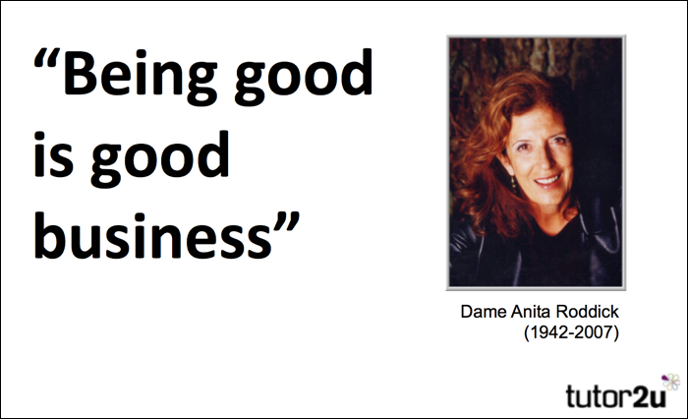 Sourced from (tutor2u, 2019)
In the apparent lack of a code of ethics, there is generally a lack of certainty on suitable ethical conduct; and distinguishable individuals use distinct ethical requirements to determine whether a practice or conduct is ethical or unethical. Business ethics are not the same as legislation.
Two Key Branches of Ethics are: descriptive Ethics which involve describing, characterizing and studying morality, what is the organization's CRM policy and normative ethics includes providing and justifying moral systems, inspired from MOODLE, in class lecture.
The researcher believes that ‘ETHICS’ mean interacting with good and bad and moral duty and obligation within the organisation, people acting different, depending on their previous experiences and how they behave as an individual or working as a team, depending on their value or culture, basically what is right or wrong, what is good or what is bad in term of human behaviour.
The researcher believes they should follow the business ethics to get far beyond staff allegiance and morality or the strength of a leadership team bond, obviously as all the business it may increase profitability as a long term or short term period, also companies have an increasing incentive to be ethical as the region of socially responsible and ethical investment continues to grow. The growing amount of investors wishing to invest in ethically operating businesses is driving more firms to take this problem more seriously, sourced from (Investopedia, 2019)
  - Sustainability- ‘Sustainability’ is the ability to continue a defined behaviour indefinitely.
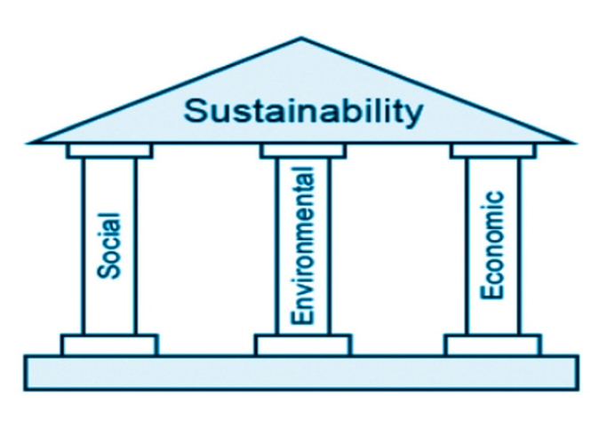
Sustainability is defined as: a requirement of our generation to manage the resource base such that theaverage quality of life that we ensure ourselves can potentially be shared by all future generations. ... Development is sustainable if it involves a non-decreasing average quality of life. [Geir B. Asheim,"Sustainability," The World Bank, 1994]
Firstly, the triple bottom line affirms that a company needs to reach a balance among its economic, environmental and social bottom lines to be sustainable [Elkington, 1998]. Sourced from (Citeseerx.ist.psu.edu, 2019) It is thought that the current definition of sustainability rooted in modern company instruments does not translate the complete obligation and capacity of companies to transform the world in which we reside by responsibly generating new values and cultures, affecting governments, politics and people's behaviour, and construction competitiveness in a country by translating the notion of sustainability into responsible actions [Secretan, 1997; Roddick, 2001; Holliday et al., 2002; Morsing & Thyssen, 2003]
Environmental sustainability is the capacity to sustain permanently ongoing levels of renewable resource harvesting, pollution generation and non-renewable resource depletion.
Economic sustainability is the capacity to sustain a specified level of financial manufacturing indefinitely.
Social sustainability is the capacity of a social system, such as a country, to function indefinitely at a defined level of social well-being. Sourced from (Thwink.org, 2019)
In large and small businesses, corporate sustainability has become a buzzword. Wal-Mart Stores, Inc. (WMT), McDonald's Corporation (MCD) and many of the real corporate giants have identified sustainability as a main priority for going forward. Sourced from (Investopedia, 2019)
Sustainability, seeing from the researcher point of view is the expansion of the people’s needs in the present without compromising the future needs, as an example, looking after the planet, the resources or the natural resources (environmental sustainability), using resources responsibly and efficient ( economic sustainability) and determinedly accomplish a good social wellbeing( social sustainability). The researcher inspired from (Circular Ecology, 2019)

3.3 QUALITY
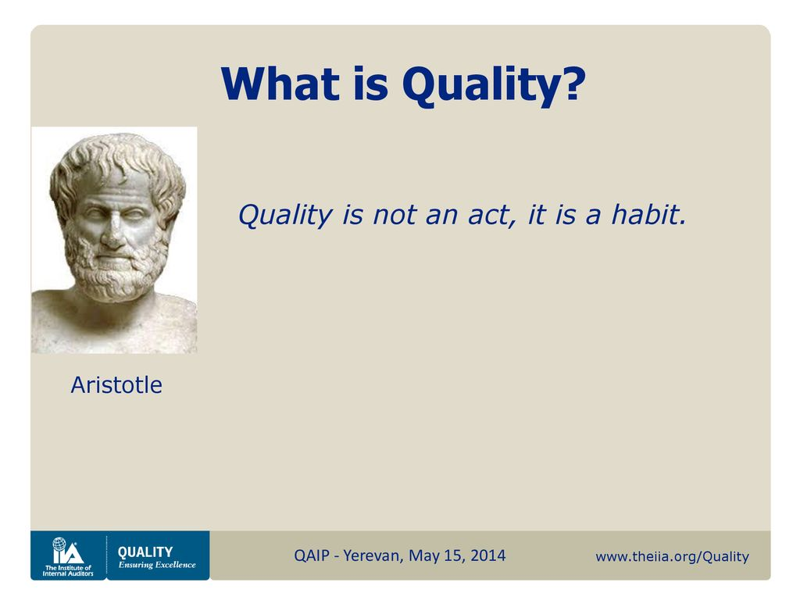
‘Quality’ means that the organization's culture is defined by and supports the constant attainment of customer satisfaction through an integrated system of tools, techniques, and training. (Sashkin & Kiser, 1993)
From the researcher point of view, ‘quality‘s is a "system" that provides a service, product, information or delivery on goal with limited variability that meets or exceeds customer needs, now and in the future, a whole satisfaction to retained for common benefits, sourced from (Qualitydigest.com, 2019)
For quality GURUS, the researcher choose to use DR. JOSEPH JURAN model, being born in Romania, same where the researcher come from, Juran's teaching and consulting career encompassed more than seventy years, known as one of the world's leading quality experts. The ideas of Juran are used to create a traditional quality system as well as to promote tactical quality management. Juran's philosophy involves, among other things, the Quality Trilogy and the Quality Planning Roadmap. Sourced from (Referenceforbusiness.com, 2019)

Juran’s 10 steps to quality improvement are:
Shape mindfulness of opportunity to improve, set-goals for improvement, organize to reach goals, provide training, take-out projects to solve problems, report progress, show recognition, and communicate results, keep score and maintain momentum by making annual improvement part of the regular systems and processes of the company, according to (Total Quality Management, 2019)
“Juran trilogy:” They parallel the processes long used to manage for finance. These financial processes comprise of financial planning and organises the annual financial budget. It defines the performances to be done in the year ahead and translates those performances into money. It determines the financial consequences of doing all those performances. The final result establishes the financial goals for the organization and its various divisions and units. Financial control: This process consists of evaluating actual financial performance, comparing this with the financial goals, and taking action on the difference—the accountant’s “variance.” There are numerous sub processes for financial control: cost control, expense control, inventory control, and so on. Financial improvement: This process aims to improve financial results. It takes many forms: cost-reduction projects, new facilities to improve productivity, new product development to increase sales, acquisitions, joint ventures, and so on, according to (Dump.bitcheese.net, 2019)
Juran's 'Quality Planning Road Map' consists of identifying who are the customers, define the needs of those customers, and interpret those needs into our language. Develop a product that can respond to those needs and optimise the product features so as to meet our needs as well as customer needs. Develop a process which is able to produce the product. Enhance the process and prove that the process can produce the product under operating conditions and the last one transfer the process to operations, briefly overviewed the quality road map from the research, state by (Adamm62.tripod.com, 2019)
  - Impact on CRM system -“CRM is a customer-focused business strategy that aims at increasing customer satisfaction and customer loyalty by offering more responsive and customized services to each customer” (Croteau and Li 2003)
Customer relationship management can be beneficial to customers and suppliers in the same time. First the suppliers can reduce the costs by offering products that are only wanted and when they are wanted and passing the save costing on the customers who choose up the company’s CRM system. All the information’s about customers must be collected and well stored for the future references. In regard with CRM system, in general, in an organisation, ethical businesses guarantee that sensitive data such as credit card numbers or medical history is gathered in a safe setting and safely transferred back to databases. It is also critical to check the identity of the client and the precision of the information presented during data collection. High safety for these tasks is expensive but ethically necessary, the data being stored only with the customer agreement and belongs to customer, the person being able to control his data. Sourced from (Bizfluent.com, 2019) Sustainability provides the basic values and strategic problems that are rarely addressed within CRM, which adds to defined procedures and structures (Ruhwinkel 2013). Therefore, sustainability-oriented CRM means considering financial, ecological and social goals when creating and maintaining lucrative long-term client relationships. More specifically, sustainability-oriented CRM aims to raise customer understanding of corporate sustainability problems and attract and maintain sustainability-conscious clients. Consumer-focused sustainability issues are: sustainable consumption, customer-centric sustainability, market-based sustainability, and market focused sustainability and sustainable marketing, referring to the impact of marketing actions on the environmental, personal, and economic wellbeing of the consumer, sourced from (Fim-rc.de, 2019)
Quality management of an organization is successful adding a plus point to the organizational customer relationship management.
As everyone knows, in UK, one of the most successful company in regard to relationship marketing, is TESCO PLC, there are a number of reasons for this that would include loyalty programs, constantly adding value at every client touchpoint, and making it hard for clients to effectively end the relationship. The Tesco loyalty scheme or loyalty program is called the Tesco Clubcard. Everyone knows what club card are used for and data is kept and stored from each customer. Tesco has got a large and highly developed customers data base, customers are sent coupons that are heavily linked to their purchasing habits, depending on Tesco's understanding of other clients. Essentially, consumers become loyal to a brand which has meaning to them in relation to a product, service, solution or experience, according to (Friesner, 2019)
Best practice CRM system: why to use it?
This is why CRM system should be used:
More optimized marketing strategies, increase workflow efficiency, improved customers data analysis, better customers relationships, easier customer data access, improved cross selling and up selling, sourced from (Financesonline.com, 2019)

  - Organisations CRM system

As an example, the researcher start with a service sector, such a bank, and how ethic and sustainability helped to improve the quality of CRM system.
CRMs help cut costs by minimizing repetitive administrative tasks, streamlining proposals, and keeping sales team in the loop with just a few clicks. With the right technology, bankers are capable of handling more accounts in less time. More efficient communication, CRM can help track last and first interaction with customers, as a result easy pick up a conversation and deliver a level of service that will exceed customer expectation, can help drive a digital transformation, mean that banks can create a digital experience that will consist with what customers would expect from meeting their banker in person. Also, strengthen customer experience, all the departments are kept on the same page so customer won’t need to move from one department to other, according to (Salesforce.com, 2019)
As a manufacturer sector, the researcher used as an example AUDI Company, from researcher’s point of view Audi is a leading manufacturer in the prestige automotive market and Audi's Customer Relationship Management (CRM) initiative began as a result of changes in client purchasing conduct, improvements in customer relationships in other sectors. Also, competitor pressure, especially in Europe by the impending block exemption regulations and difficulties in handling client interactions in a dealer-oriented, multi-sales organisation. Audi considers CRM as a strategic marketing discipline to systematically acquire and retain clients. Audi's strategy can be described using the CRM Framework's Eight Building Blocks from Gartner model. Audi’s CRM process now is very improved and is working very well to maintain a close relationship with its customers, becoming ‘loyal’ to the brand. Audi looked at what it does for its clients (value), how it does it (procedures), and then what instruments could enhance it. The inquiry procedures ("Can I have a brochure for the fresh A4?") and complaint governance ("My tire has broken, my loan is low and I'm on holiday overseas") were recognized as important customer experience factors, sourced from (Bus.umich.edu, 2019) this is why CRM SYSTEM should be used by every company, make it a framework for the company and became o top brand in a manufacture sector.
Moving to retail sector, the researcher choose to go with John Lewis, and trying to define what’s actually working for the company CRM system, ethically and sustainability, to actually improve quality. John Lewis introduced its CRM-based' my John Lewis ' program with the objective of establishing a seamless customer experience across online and offline platforms and acquiring a deeper understanding of client preferences. Chris Bates, Head of Customer Marketing, describes that what they purchase and what they might like to purchase in return for clients who they are, the company provides a more personalized service in the form of relevant, curated content and access to an exclusive event and rewards what they buy and what they can like to buy. Bates claims John Lewis is "considerably ahead of the prediction" in terms of client registration for the project, as well as surpassing its aim for incremental purchases and visits to shops guided by my John Lewis affiliation, sourced inspired from (Smith, 2019)
  - ‘GAPS’ WITHIN THE ORGANISATION BASED AROUND ETHICS AND SUSTAINABILITY

Based on previous saying about the CRM system, the researcher also found some issues, by implementing a good customer relationship management, is crucial those days to making the most of the business advantage, but problems in implementing CRM system can be dangerous for the business. One of the biggest problem in implementing CRM system, based on the previous information’s (3.1 – 3.5) is the CRM cost, other variables such as data migration and performance and the conversion of company activities may also influence the overall cost of implementing CRM. Proper scheduling and thorough evaluation of any possibly concealed expenses should assist to create a reasonable budget for the business CRM venture.
Business culture and poor communication, is also an issues at the CRM, an absence of engagement or opposition from individuals within the business to cultural shift can trigger significant problems with the application of CRM. Customer interactions may break down and result in income loss, unless everyone in the company is dedicated to watching their activities from the customer's view, according to (nibusinessinfo.co.uk, 2019)

- CONCLUSION
To conclude the researcher is going to briefly highlight the main issues or areas for CRM system in regard to Ethics, Sustainability and quality within the retail sector( John Lewis), service sector(a bank) and manufacturing, the researcher using as an example Audi’s company. Starting from the very beginning with the ethics, 3.1, people’s behaviours are critical for the CRM system and most of the investors those days are looking for a CRM system where actually works in ethically operating businesses. In big and small companies, corporate sustainability has become a motto. Sustainability, is the capacity to maintain a specified behaviour forever and it represent a vital and crucial problem to the organisations to make sure customers’ expectations are going to be achieved in the present and nobody is going to have something to lose in the future. The quality has got a big impact to the CRM system, considering to keep same quality products and services and make sure the customer satisfaction being attained. Companies use them to provide the ultimate in customer service by ensuring that all feasible data about each client is available to customers on assistance and sales teams. The businesses generate a CRM database with a whole background so that customers have a complete perspective of all the job that has been accomplished with the client over time, sourced from (Zendesk, 2019)

- RECOMMENDATIONS

The researcher is going to make few recommendations to help the organisations to improve them customer relationships. The main issue that the researcher recommend to take in consider is the Cost of the CRM system, analysing, training and storage are some of the expensive costs to set up the CRM system, but most of the companies are ready to spend when it comes to improvement and their benefits. Customer’s relationship, from the researcher point of view is the key of the business, the opportunity to grow is partially customers experience and the experience that they enhance during their time visit, online or not only, represent vitality to the business. Improve customer retention, visibility across all businesses interactions can assist employees proactively solve at-risk accounts and present fresh possibilities at the correct time to satisfied clients. With transparency in client history, active campaigns, or open instances, you can provide more satisfactory acquisitions and service experiences to maintain them coming home for more. This is what the researcher is expected from John Lewis to offer to their shareholders, also car manufacturing needs to keep their CRM and data up to date and make sure customer retention and grow won’t discontinue. The service sector is in a continued growth and a lot of banks started to spend money on their CRM system to keep their customers happy and employees motivated. Investing in CRM is definitely an increasing profit and offer customers the threats that they deserve.

- Appendices :

https://www.youtube.com/watch?v=AwM_tuO8apE&ab_channel=ExpertMarket the researcher got attached a video that helped and gives the researcher an idea where to start off
https://www.youtube.com/watch?v=dCQdHpjZKE8&ab_channel=DwayneBaraka

7.0 REFERENCE LIST:
- Shodhganga.inflibnet.ac.in. (2019). [online] Available at: https://shodhganga.inflibnet.ac.in/bitstream/10603/148478/10/10_chapter%201.pdf [Accessed 1 Jul. 2019].
- The Business Ethics Blog. (2019). Ethics: Definition. [online] Available at: https://businessethicsblog.com/2010/03/21/ethics-definition/ [Accessed 1 Jul. 2019].
- tutor2u. (2019). Business Ethics - Introduction | Business | tutor2u. [online] Available at: https://www.tutor2u.net/business/reference/business-ethics-introduction [Accessed 2 Jul. 2019].
- Investopedia. (2019). Why is business ethics important? [online] Available at: https://www.investopedia.com/ask/answers/040815/why-are-business-ethics-important.asp [Accessed 4 Jul. 2019].
- Citeseerx.ist.psu.edu. (2019). [online] Available at: http://citeseerx.ist.psu.edu/viewdoc/download?doi=10.1.1.585.5811&rep=rep1&type=pdf [Accessed 4 Jul. 2019].
- Thwink.org. (2019). Definition of Sustainability. [online] Available at: https://www.thwink.org/sustain/glossary/Sustainability.htm [Accessed 4 Jul. 2019].
- Investopedia. (2019). the 3 Pillars of Corporate Sustainability. [online] Available at: https://www.investopedia.com/articles/investing/100515/three-pillars-corporate-sustainability.asp [Accessed 4 Jul. 2019].
- Circular Ecology. (2019). Sustainability and Sustainable Development. [online] Available at: http://www.circularecology.com/sustainability-and-sustainable-development.html#.XR3D7OhKjIU [Accessed 4 Jul. 2019].
- Qualitydigest.com. (2019). Definition of Quality | Quality Digest. [online] Available at: https://www.qualitydigest.com/magazine/2001/nov/article/definition-quality.html [Accessed 4 Jul. 2019].
- Referenceforbusiness.com. (2019). Quality Gurus - strategy, organization, levels, system, style, examples, manager, school, company, workplace. [online] Available at: https://www.referenceforbusiness.com/management/Pr-Sa/Quality-Gurus.html [Accessed 4 Jul. 2019].
- Total Quality Management. (2019). Dr. Joseph Juran. [online] Available at: https://totalqualitymanagement.wordpress.com/2009/06/07/dr-joseph-juran/ [Accessed 4 Jul. 2019].
- Dump.bitcheese.net. (2019). [online] Available at: http://dump.bitcheese.net/files/yhyjyvy/juran.pdf [Accessed 4 Jul. 2019].
- Adamm62.tripod.com. (2019). Joseph M Juran. [online] Available at: http://adamm62.tripod.com/sitebuildercontent/sitebuilderfiles/josephmjura [Accessed 4 Jul. 2019].
- Bizfluent.com. (2019). [online] Available at: https://bizfluent.com/info-8384284-ethical-issues-crm.html [Accessed 4 Jul. 2019].
- Fim-rc.de. (2019). [online] Available at: https://www.fim-rc.de/Paperbibliothek/Veroeffentlicht/465/wi-465.pdf [Accessed 4 Jul. 2019].
- Financesonline.com. (2019). Why Use CRM Software? 10 Reasons to Get One for Your Company - Financesonline.com. [online] Available at: https://financesonline.com/use-crm-software-10-reasons-get-one-company/ [Accessed 4 Jul. 2019].
- Salesforce.com. (2019). The Benefits of CRM for Business Banking. [online] Available at: https://www.salesforce.com/solutions/industries/financial-services/resources/banking-crm/ [Accessed 4 Jul. 2019].
- Friesner, V. (2019). Loyalty Ladder. [online] Marketingteacher.com. Available at: https://www.marketingteacher.com/the-loyalty-ladder/ [Accessed 4 Jul. 2019].
- Bus.umich.edu. (2019). [online] Available at: https://www.bus.umich.edu/KresgePublic/Journals/Gartner/research/119300/119310/119310.pdf [Accessed 5 Jul. 2019].
- Smith, N. (2019). Customer relationship management (CRM) is gaining momentum – Marketing Week. [online] Marketing Week. Available at: https://www.marketingweek.com/customer-relationship-management-crm-is-gaining-momentum/ [Accessed 5 Jul. 2019].
- nibusinessinfo.co.uk. (2019). Potential drawbacks of CRM systems. [online] Available at: https://www.nibusinessinfo.co.uk/content/potential-drawbacks-crm-systems [Accessed 5 Jul. 2019].
- Zendesk. (2019). Customer Relationship Management Systems | Zendesk. [online] Available at: https://www.zendesk.co.uk/support/features/customer-relationship-management-systems/?utm_source=google&utm_medium=Search-Paid&utm_network=g&utm_campaign=SE_AW_EM_UK_ENB_N_Sup_NB_DSA__D_H&matchtype=b&utm_term=&utm_content=274658167843&utm_adgroup=Support_%5BGROUP%5D&gclid=EAIaIQobChMIherx5bGd4wIVRvhRCh3BiwAAEAAYAiAAEgKsw_D_BwE&gclsrc=aw.ds [Accessed 5 Jul. 2019].

