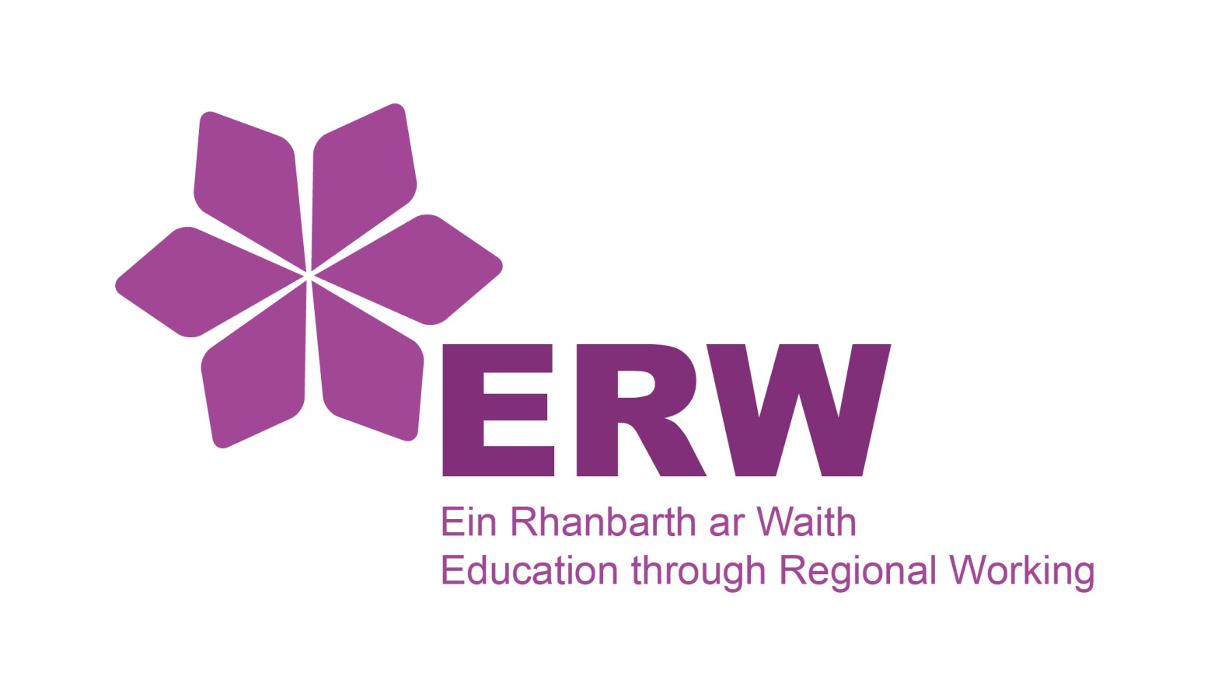 | GCSE Mathematics &  Numeracy Scheme of Work
Intermediate Tier
Scheme of Work Overview

KS3 | Topic: | Numeracy: | Mathematics:
 | Whole Numbers
 | Multiples and Factors
 | Shapes, solids and constructions* (basic congruence)
 | Decimal Numbers
 | Estimation and Using a Calculator 1
 | Fractions 1
 | Graphs and Charts
 | Negative Numbers
 | Fractions, Decimals and Percentages 1 - Equivalence
 | Indices, Standard Form and Using a Calculator 2
 | Basics of Algebra
 | Units of Measure
 | Equations
 | Length and Area
 | Fractions, Decimals and Percentages 2
 | Angles
 | Surface Area and Volume
 | Ratio, Proportion and (basic similar shapes B grade)
 | Bounds of Measurement and Dimensions of Formulae
 | Fractions 2
 | Scale Diagrams and Maps
 | Averages
 | Time, Timetables and Travel
 | Real Life Finances
 | Graphs and Proportion
 | Pythagoras’ Theorem and Trigonometry 1
 | Graphs and Compound Measures
 | Scatter diagrams, Cumulative Frequency and Box plots
 | Sampling Investigation
 | Loci
 | Probability 1 – Theoretical Probability
 | Angles of Polygons
 | Probability 2 – Relative Frequency
 | Simultaneous Equations
 | Transformations
 | Non-linear Graphs
 | Circle Theorems *
 | Solution of Non-linear Equations
*check if has been removed from examinations for 2021

