

University of Wales Trinity Saint David

School of Engineering

Vehicle Structures: Past, Current & Future

Evan Morcom (1802426)

BEng Automotive Engineering

April 2020

Engineering Management (ACHA5012)

Contents
1.0 - Development of Vehicle Structures (Task 1)
1.1 - Body on Frame
1.2 - Backbone structure
1.3 - Triangle tube structure
1.4 - Pure Monocoque
1.5 - Punt and Platform Structure
1.6 – Birdcage Structure
1.7 - Unitary body structure or Integral Structure
1.8 - How EV and other non-ICE Powered vehicles will change the structures

2.0 - Crash requirements (Task 2)
2.1 - Developments in manufacturing technology
2.2 - Developments in materials

3.0 – Simple Structural Surfaces (Task 3)
3.1 – Torsional Load

4.0 – Implications of Access (Task 4)

5.0 – References

1.0 - Development of Vehicle Structures
Vehicle structures have developed rapidly within the last century, a greater understanding of the importance of certain characteristics have made the current structures much safer, durable and stronger compared to the first iterations made in the 1920’s.
1.1 - Body on Frame
Body on frame was one of the very first structure types, this consisted of a flat carriage with the body placed on top as seen in figure 01.
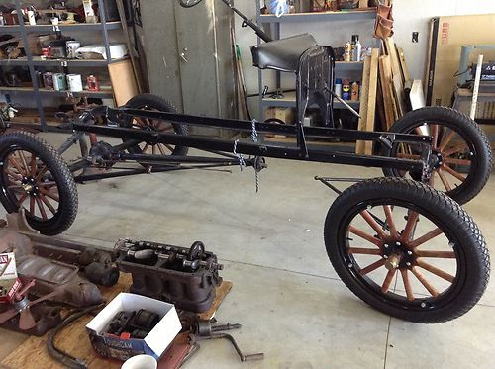

Figure 01 – Ford Model T

The chassis seen in figure 01 is a remake of a Ford Model T Turtle Deck which was manufactured in 1918 and uses steel to construct the framework. Though steel was only used on the higher models and the budget models used wood as the building material. It sounds strange however wood was used for centuries to build wheels, carts and chariots. These first vehicles were built by trades that were already around in the era such as boat builders and carpenters or also known as coachbuilders.
Due to the chassis’ being built by different job types, the opportunities to have a body or chassis company became available.
Although these were the first vehicle structures of their kind, the structures had no torsional rigidity considered into the designs, as the chassis where usually constructed of two open c-sections and were connected by open lateral cross sections riveted together forming a ladder shape frame.
As these vehicles were all mainly roadsters with no roofs, there was no loadbearing points, as more companies were getting involved and a more vehicles were wanted, vehicles were being produced with roofs and ended up acting as two separate springs, the body being one and the chassis being the other. As they were placed on top, they acted in parallel but depending on which spring was stiffer would result in which the torque would pass through.
The first bodies were made using wood and steel cladding, usually the body ended up being softer compared to the chassis. Until manufacturers started to increase the stiffness of the body, this resulted in a lot of squeaks and bangs as the two springs moved with each other and allowed for slight movement resulting in load transfer between the body and chassis. (Wand, 2017)
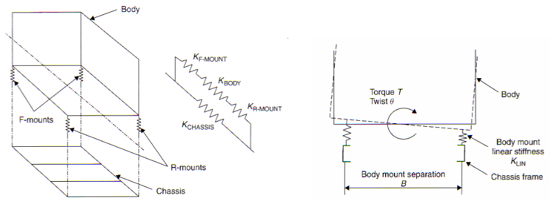
To try and reduce the undesirable squeaking and rattling, springs were placed in series between the body and chassis as seen in figure 02 below.
Figure 02 – Body on Chassis Springs

The introduction of cruciform bracing allowed for the chassis to become lighter and just diagonal members to withstand bending forces however, the frame still used large open sections. In the 1930’s designers
Even though this vehicle structure was designed over 90 years ago, it is still used on many commercial vehicles such as buses and lorries but also on SUV vehicles. The materials have improved however this design is one of the cheapest to manufacture and it gives the manufacturer flexibility to use the same chassis but use a different body to appeal to larger target groups.

1.2 - Backbone structure
The backbone structure was also around the same time as the ladder vehicle structure previously spoken about. The two use the same method by using a separate body to the chassis and fastening method however this type of structure is shaped as a “backbone” as seen in figure 03 below.
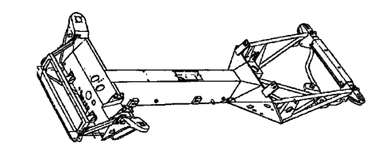

Figure 03 – Backbone Chassis
The first production car to use this vehicle structure was the Rover 8hp model in 1904. It was made up of steel sheet and bar. Due to the different angles being implemented, torsional stiffness was increased over the ladder chassis. (W, 2018)
The chassis developed over the years and became common with use on trucks due to all the mechanical components being able to be positioned below whilst the bodywork mounts on top. Though this vehicle structure became popular with “Kit Car” enthusiasts as the body can be easily removed and replaced with the different fiberglass shaped body.
Also in the 1930s, manufacturers became aware that if the springs were removed between the body and frame and instead hard-mounted, the whole vehicle became stiffer in bending and torsion. The understanding that torsion was proportional to the area enclosed squared. As well as this advancement, the vehicles suspension was improving greatly however the overall stiffness of the vehicle need to increase. This was to control the wheel travel and steering via the suspension arms and dampers and not from the chassis twisting or bending.
The backbone structure used large tube with the steel walls to act in shear, however backbone chassis can also be built with a triangulated tube structure which leads onto the next chassis type.

1.3 - Triangle tube structure
Triangle tube structures or also known as space frame are made up of multi interconnecting tubes that join via welding or bolting. The space frame has much greater chassis stiffness compared to the previous vehicle structures mentioned due to the new chassis type being much wider and having more depth. The tubes are placed to interlock in triangle shapes which has large support from directional forces. Due to the nature of how these chassis are built, manufacturing is very slow but is heavily used in the motorsport discipline as it lightweight, and strong enough to withstand the forces the cars get out through. One of the first was the Mercedes W194 300SL racing coupe in 1952 which then later evolved into the road car in the later years.
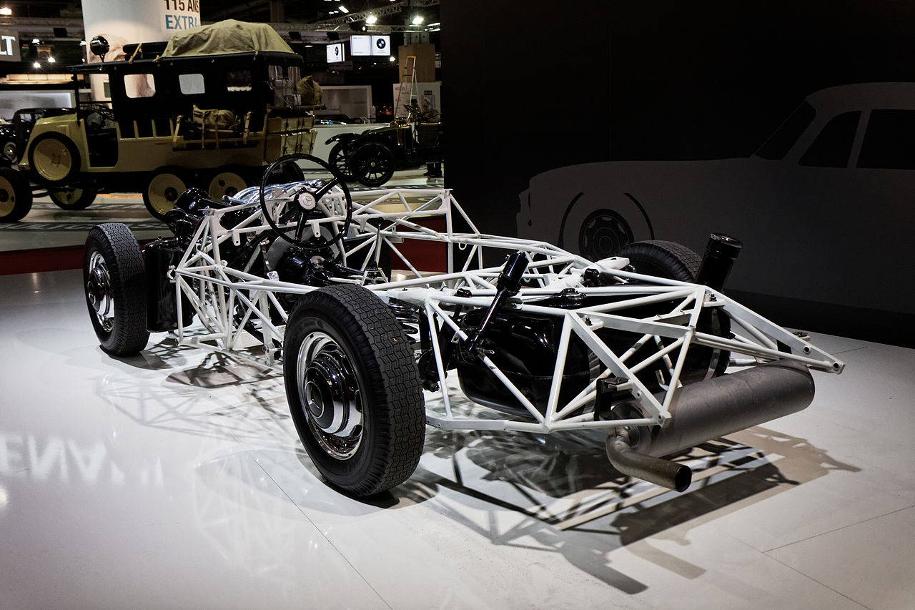

Figure 04 – Mercedes W194 300SL racing coupe
The tube structure surrounds the outside of the body, this allows for the body work to be non-structural unlike the backbone where ribs or other methods would be implemented into the bodywork. However, there is a disadvantage as where the tubes are placed it can make entering and exiting the vehicle a struggle. There are road cars which do use a space frame chassis however they are still quite specialist vehicles such as a lotus or a TVR.
The next logical step that was taken was the incorporation of roll cage into structure. This uses the roll cage to extend the tube structure to incorporate the whole body. Once again, the torsional stiffness has been increased again due to the larger enclosed cross-sectional area. This can be easily seen as the tube now continues all the way up to and over the roof instead of just only coming to the door height. The contribution of the roll cage relies on the triangulation in the bars and the connections between the body and the roll cage itself.
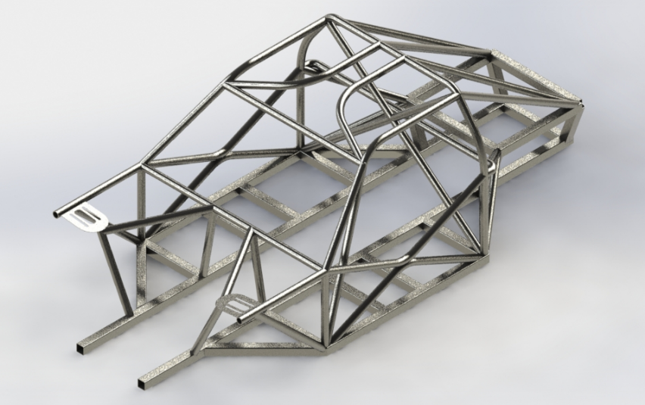

Figure 05 – Triangle tube structure with roll cage incorporated

1.4 - Pure Monocoque
Monocoque is derived from the Greek word mono for single and French word coque which translates to shell. The monocoque chassis is a singular piece built from thin membrane or a shell of material, rather than the previous methods using beams. This now allows the panel that were once to cover up the chassis to be structural and act in shear.
The same vehicle structure technique is used heavily in aerospace, due to the lightweight and high torsional stiffness and bending stiffness. Apart from aerospace it is mainly used on just race vehicles, although it has been seen on a select amount of high-end hyper-cars. When being used in race vehicles, the structure must be able to meet the ingress and egress regulations as well as keeping good visibility for the driver. The vehicle structure requires shell reinforcement to prevent buckling and out of plane loads, this is done by having reinforcements down by the peddle box area etc. as seen in figure 06 however it is common to see the engine and gearbox also used as stressed members within the chassis.
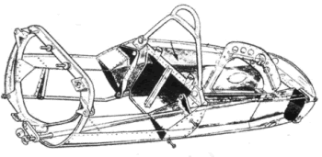

Figure 06 – Monocoque Chassis

1.5 - Punt and Platform Structure
A platform structure is a chassis which is predominately flat with large closed sections. It uses rockers and cross members to gain its structural stiffness in torsion and bending. The chassis has familiar traits to the first mentioned in the report as it is also a body on frame chassis however is has a much higher stiffness rating compared to the first iterations. However, like its first similar chassis, the body is often considered to be non-structural.
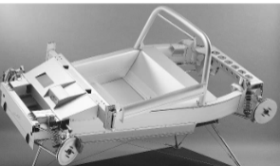
The chassis in figure 07 is from a Lotus Elise which uses a fiberglass composite body, this is habitually deemed a weekend sports car which suits this vehicle structure due to being a low production type chassis.

Figure 07 – Platform Structure
Although sounding contradicting, this type of chassis has become ever more popular with electric vehicle manufacturers as is can give ample amounts of room to store the large batteries., the tesla model s and other similar models use a platform structure.

1.6 – Birdcage Structure
The birdcage structure takes traits from the unibody, however its members are thinner which have ring beams which are attached together by nodes and small section tubular structures. These nodes need to stiff enough to pass the forces rom one ring beam to the next, if the node is not stiff enough, it would have the same effect as the old chassis from the 1930s where there would be squeaks and rattles coming from the joint as an affect of low structural stiffness.
Though when body panels are added to the structure, there is a considerable increase in torsional rigidity. These panels are acting in shear and almost replicating an integral body. A well-known birdcage structure vehicle is the Maserati Tipo 61’ as seen in figure 07.
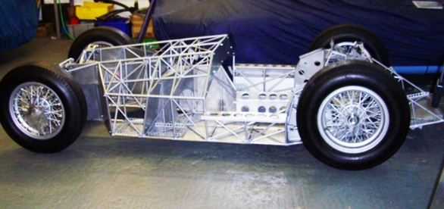

Figure 08 – Maserati Tipo 61’
1.7 - Unitary body structure or Integral Structure
The unitary body or integral structure is the combination of the monocoque chassis and a birdcage chassis, they are main manufactured using pressed sheet metal steel and attached by spot welding. The body is self-supporting so there is no need for a separate chassis.
This type of vehicle structure is the most common used in modern cars due to the process being very well suited to mass production, including the use of robotics.
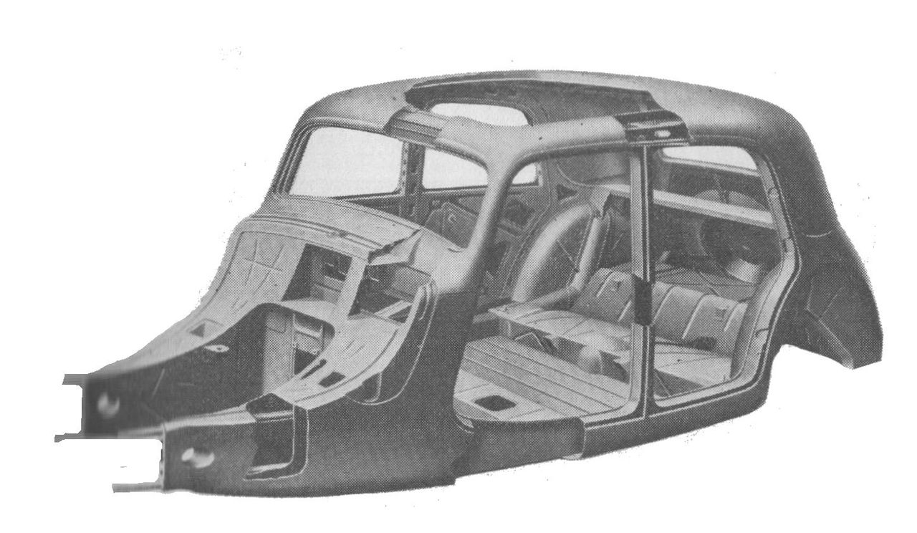
The first unibody vehicle was the Citroen 11CV first built in 1934 until 1956. It is one of the first mass produced vehicles and saving 70kg in steel in each car. An image of the chassis can be seen in figure 09.
Figure 09 – Citroen 11CV 1934

The chassis as previously mentioned is the combination of a monocoque and birdcage chassis where the body forms a closed box where the roof, floor and bulkhead skins as well as the open bay rings which can be seen in the side frame and windscreen frame make up the surfaces of the box. As with the monocoque, the beam members carry the out of plane loads.
Although in the 1930’s, the first chassis were built by stamped sheet steel and spot welded, manufacturing methods have improved and now the use of hydroforming, laser welded blanks, laser welding, adhesives and the user of lighter materials have made the integral body much lighter and stiffer.

1.8 - How EV and other non-ICE Powered vehicles will change the structures
The structures of vehicles powered by EV and non-ICE devices will be different to what is the norm in 2021. The structures will not have to carry an engine and gearbox in the chassis but instead motors and batteries. As batteries in the current state weigh a tremendous amount, weight displacement is a big issue to overcome, and most manufacturers will out the batteries either in the center of the vehicle or slightly rearward for ease of access.

Bodies will also change shape due to ICE engines needing vents for cooling in the front of the vehicle. Batteries also need cooling but the introduction of vents in newer places is a possibility. However, these changes will not happen overnight due to the public being used to seeing a normal ICE vehicle and have gained an idea of what looks good on said chassis. If manufacturers change this, they may struggle initially to their models.
Figure 10 – Tesla Cybertruck
2.0 - Crash requirements
Euro NCAP was introduced in 1997 and tested vehicles in multiple crash scenarios to try and aid with making vehicles safer for occupants and pedestrians.
They now test for adult occupant safety, child occupant safety, vulnerable road users and safety assists on vehicles.
The first test that was introduced in 1997 was the offset-deformable barrier aka the ODB. The test is performed at 40mph with 40% overlap with the car being tested and the ODB. This simulates 2 vehicles of the same weight with 2 average male occupants in the front and it tests the integrity of the body-in-white. The reason and push for the offset-deformable barrier test is because this kind of accident is responsible for most deaths whilst on the road.
Also, in 1997 the side mobile barrier test was created which uses a small crush space and the vehicle is tested side on at 90°. This tests the strength and safety of the b-pillar and sill. A similar test called the side pole was launched in 2001 which also tests via localised loading but simulates a tree or telegraph pole.
The most recent test brought into the program is the full width rigid barrier aka FFB. The test began in 2015 and uses a small female occupant in the front. This test utilizes stiff structures to stop intrusion for ODB meaning high decelerations. The reason for this test is to analyse the restraint system in the vehicle.
2.1 - Developments in manufacturing technology
The manufacturing process developed heavily from the 1920’s to the current day. From starting coachbuilders, boat builders and carpenters building chassis from wood and studs all by hand to moving to steel. The steel has developed in its own area from becoming lighter stiffer and stronger, also the fastening methods increased from replacing the body spring mounts to hard mounting to eliminate any movement.
As cars became more mainstream and the need for cars increased, manufacturers increased production time by employing many people which were then later replacing by robotics which had much less contingencies and repeatable accuracy.
As previously mentioned, whilst talking about unibodies. Manufacturing methods have improved and now the use of hydroforming, laser welded blanks, laser welding, adhesives and the user of lighter materials have made the integral body much lighter and stiffer.
2.2 - Developments in materials
Materials have also developed from the early 1920s developing from wooden structures which had little to no crash safety and would rot when coming into contact with wood. The industry then moved to steel which was much stiffer however followed the same feat as wood with corrosion. This could be prevented however galvanizing costs a lot and would not be cost effective on a production line. The fiberglass bodies used had no structural integrity and would almost explode on contact but made created intricate shapes possible. The most recent material to be used on chassis is carbon fiber however this is still very expensive and is only seen on high end cars or race vehicles even though it is only strong in one axis therefore needing reinforcement beams within the chassis.

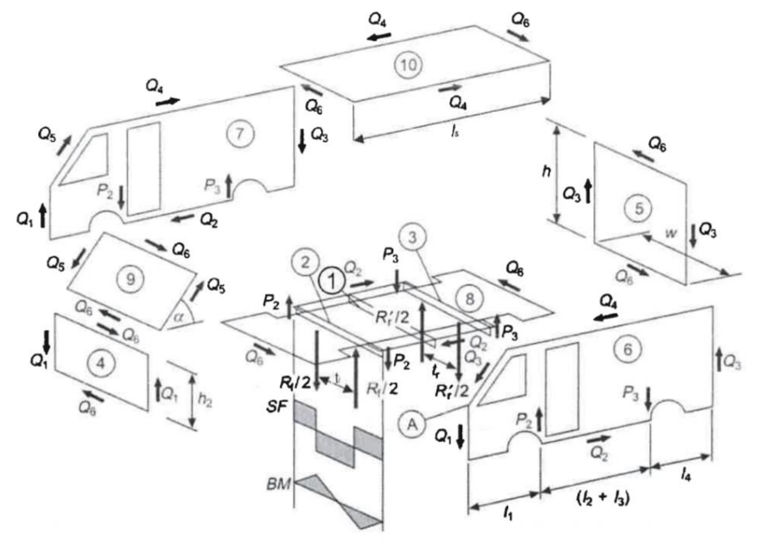
3.0 – Simple Structural Surfaces
w=2m
h1=2m
h2=1m
l1=2m
l2+l3=3m
l4=1m
l5=3m
Overall weight = 3000kg
Weight distribution = 50:50
tf=1.5m
tr=1.5m
alpha=45o
Rr=Rf=5kN

$$P2=\frac{Rf×tf}{2W}= \frac{5000×1.5}{2×2}=1875N$$

$$P3=\frac{Rr×tr}{2W}= \frac{5000×1.5}{2×2}=1875N$$

$$Q6=\frac{W[P3\left(l1+l2+l3\right)-P2×h1]}{h1\left(l1+l2+l3+l4\right)+l5\left(h1-h2\right)+h2(l1+l2+l3+l4)}$$

$$Q6=\frac{2[1875\left(2+3\right)-1875×2]}{2×\left(2+3+1\right)+3\left(2-1\right)+1(2+3+1)}$$

$$Q6=\frac{2(1875×5-1875×2)}{2×6-3×1+1×6}$$

$$Q6=\frac{2(1875×3)}{12-3-6}$$

$$Q6=\frac{2(1875×3)}{15}$$

$$Q6=750N$$

Now to use Q6 to find Q1 to Q5
$$Q1=\frac{Q6×h2}{2}=\frac{750×1}{2}=375N$$

$$Q2=\frac{Q6\left(l1+l2+l3+l4\right)}{W}=\frac{750×6}{2}=2250N$$

$$Q3=\frac{Q6×h1}{W}=\frac{750×2}{2}=750N$$

$$Q4=\frac{Q6×l5}{W}=\frac{750×3}{2}=1125N$$

$$Q5=\frac{Q6(h1-h2)}{W×Sin(α)}=\frac{750(2-1)}{2×Sin(45)}=530.33N$$
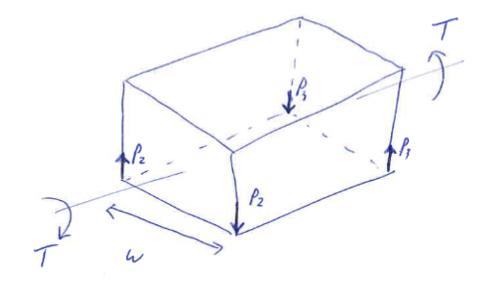
3.1 – Torsional Load

$$T=P2×W=P3×W$$
$$P2=P3$$
$$P2×W=1875×2$$
$$T=3750N$$

4.0 – Implications of Access
In order from highest shear load to lowest shear load, the panel with the greatest magnitude of the shear load that is carries is panel 6 with 9000N. This is the offside side panel. Next is panel 7 with 8780.33N in the nearside side panel. Panel 8 which is the floor comes in next at 6000N followed by 2,3 and 10 which all had 3750N being the floor supports and roof. The rear panel 5 had 3000N of load. The windscreen panel 9 had 2560.33N and front bumper panel 4 calculated at 2250N.
The implications caused by improving access the rear panel on the van by introducing a large opening, results in that panel no longer acting as a shear panel. This means the full body is compromised by this decision and the van structure much more flex in it and spread the load in a different manner. To ensure this does not deduct from the integrity of the body, a thicker, stronger metal will have to be used but then the overall weight is increased.

5.0 – References
Wand, G., 2017. How automobile bodies evolved through history. [online] Autoblog.com. Available at: <https://www.autoblog.com/2017/03/09/evolution-auto-bodies-wood-carbonfiber/> [Accessed 11 April 2021].
W, S., 2018. Backbone Chassis. [online] Motoring Weekly. Available at: <https://www.motoringweekly.com.au/2018/07/02/backbone-chassis/> [Accessed 12 April 2021].

