Zara James P150964 Surface Pattern Design

I am going to be discussing how people in different cultures live in their homes and how has it become more the same over these cultures in recent years due to technology. Interior Design is changing as are people and cultures are becoming less obvious. This is due to the internet and the technology in a whole. For example, people in China in 1918 lived very differently in their homes and cultures to how people in the UK lived in 1918. However today people live in their homes very similarly to people in the UK. We might eat different foods and speak different languages but we all have a living room and a kitchen, and those are the places we relax and centre our lives. The internet has enabled us to see how other people/cultures are living their lives and merge that into our everyday. I will be looking mostly at Edward T Halls Cross Cultural theory and Proxemic Theory, and discussing that with my thought gathered by other books and articles I have read over the past months.
Interior design is changing, as are people and cultures are becoming less obvious. I feel that this is because of the internet. Edward t hall’s Cross-cultural theory states that culture isn’t just what we see from the behaviours of that specific society, there is a lot more that goes deeper into how we think and our beliefs. ‘we become aware of it by exposure to a different culture. Members of a certain society internalise the cultural components of that society and act within the limits as set out by what is ‘culturally acceptable’ (Hall, 1983, 230)
Proxemics is the study of Humans use of space. Edward T. Hall, the cultural anthropologist who coined the term in 1963, defined proxemics as "the interrelated observations and theories of humans use of space as a specialized elaboration of culture"(Hall 1966) Proxemics literally means the study of space and how we use it. To understand the personal territory part of proxemics you need to know the four different kinds of spaces. These vary by place and cultures have different standards of space. It looks at public space, which is how close you stand next to someone you don’t really know like a lecturer for example which would be about twelve to twenty-five feet away. Social space is a little bit closer its four to twelve feet away, so how close you’d stand next to a customer at work. Personal space which is even closer this is reserved to two to four feet away and is for family and friends. And then there is intimate space which is probably less than a foot away or even touching the other person for example your romantic partner. Physical territory is a bit different to personal territory, it’s about the ways we arrange objects within a space and ourselves within that space. A good example of this is that if you go somewhere every day or every week, for example a lecture you might have a specific seat that you sit in every time or maybe even just an area that you and all you friends gravitate towards. However, if one day your late and someone’s in your seat your lost and it takes you a minute to think about where to sit. Or the fact usually we put the bed so that it faces the centre of your bedroom and not the wall, or all your living room furniture and your television or fireplace. This will be shown in my exhibition.
In my exhibition, I want to be able to clearly show how we have changed how we live within our homes. I will be exhibiting in the Mission Gallery because it is local to me, however this exhibition could be reproduced anywhere around the world and it would still have the same meaning to every culture. In my Exhibition, however will be clearly split down the middle and on one side of the room I will have a Victorian style living room or parlour as it would have been called then, with a piano a fire place and the usual sofas and chairs. On the other side of the room will be a modern day living room with all the furniture centred around the television. In the back of the mission Gallery there is a smaller room this is where I will have photographers works that show how people in different cultures live. Such as Elliot Erwitt, who’s work shows the lives of people in America around the time of the 1950’s. Also, Jacob James who is an international Travel and cultural photographer, I love his work and his images are very personal.
I decided to show photography for this exhibition because you see the truth within the photographs. I wanted people visiting this exhibition to be able to really understand culture and for it to be easy for them to visualise. Obviously, the best way to do this is through photography. I really like all the images from both Elliot Erwitt and Jacob James and I would like to have a lot of their work in the exhibition.
I think that Edward T Hall’s theory’s and my thoughts through my own research and opinions, will be shown in my exhibition in The Mission Gallery. As I mentioned before I feel this exhibition could be shown anywhere around the world. It could even be changed so that the ‘living room’ would be native to that culture in the place where exhibition is being shown. For example, if the exhibition was being shown in Japan then you would have an old-fashioned Japanese living room or kitchen and then the modern day to compare. All the modern day living rooms should really all look the same, a sofa facing the television.

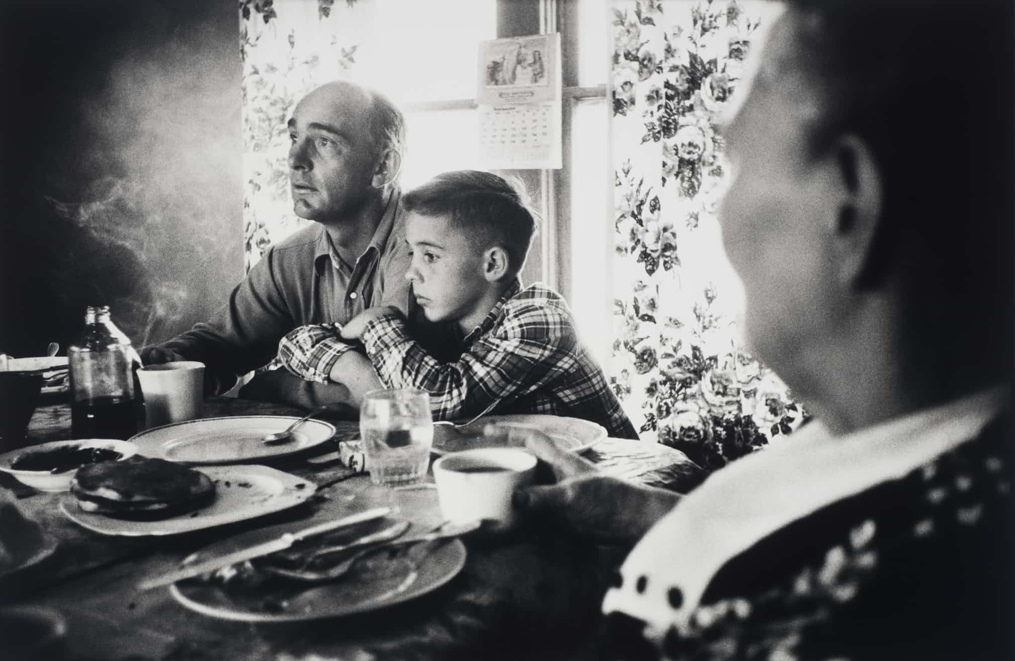

‘Douglas, Wyoming, 1954’
(theguardian.com, 2018)


‘Maramures, Romania’ (Resources, 2018)

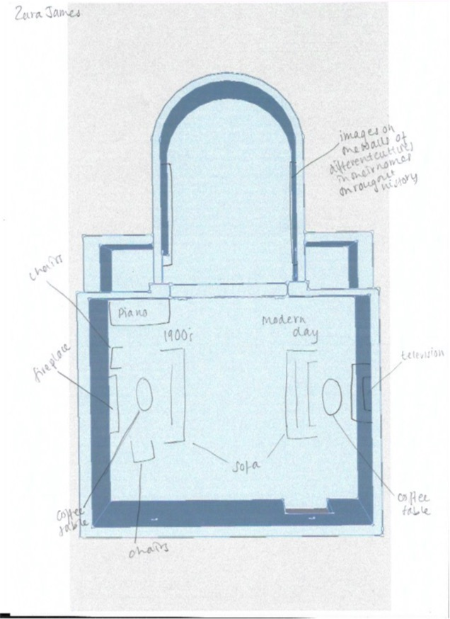

Mission Gallery Floorplan

Bibliography

Augé, M. (2006). Non-places. London: Verso.

Bachelard, G. (1971). The poetics of reverie. Boston: Beacon Press.

Cieraad, I. (1999). At home. Syracuse: Syracuse University Press.

Hall, E. (1992). The hidden dimension. [Gloucester, MA]: Peter Smith Pub.

Hall, E. (1989). The dance of life. New York: Anchor Books.

Hall, E. (1974). Handbook for proxemic research. Washington, D.C.: Society for the Anthropology of Visual Communication.

Hubbard, P. (2011). Key thinkers on space and place. London: SAGE.

Resources, F. (2018). Faces - Jacob James. [online] Jacob James. Available at: http://jacobjamesphotography.co.uk/images/faces/ [Accessed 13 Mar. 2018].

Study.com. (2018). What is Proxemics? - Definition & Examples - Video & Lesson Transcript | Study.com. [online] Available at: https://study.com/academy/lesson/what-is-proxemics-definition-examples.html [Accessed 4 May 2018].

Theguardian.com. (2018). [online] Available at: https://www.theguardian.com/culture/gallery/2016/aug/14/elliott-erwitt-photographer-home-around-the-world-pictures [Accessed 12 Mar. 2018].

