

Digital Skills and Research Methods

Assessment 2

Student Name: Bogdan Dumitru Mesch
Student ID: 2030724

Table of Contents
1. Introduction 1
2. Rationale of the Research 1
3. Research Aim and Objectives 1
4. Literature review 2
5. Research Methodology 3
6. Primary data analysis 4
7. Secondary data analysis 21
8. Conclusion and Recommendation 21
Reference 22
Appendix 24
Google Survey Form 24
Questionnaire 24

Table of Figures

Figure 1 Experiences of learner 4
Figure 2 Thinking of learner 5
Figure 3 Faculty values VLE learning in the course 6
Figure 4 VLE enhances learning strategy of students 7
Figure 5 VLE has benefitted everyone in the teaching system 8
Figure 6 Virtual Learning Environment (VLE) is an effective learning system 9
Figure 7 VLE has an impact on the learning and experiences of the students 10
Figure 8 Moodles has prioritised the benefits of students in education 11
Figure 9 VLE system has fulfilled the expectations and preferences of the learner 12
Figure 10 The learning needs are fulfilled and managed by VLE. 13
Figure 11 The students are way more engaged within VLE 14
Figure 12 The blended learning approach has been effective within VLE 15
Figure 13 VLE enhances 16
Figure 14 Virtual learning environment helps the teacher in managing 17
Figure 15 VLE has reduced the 18
Figure 16 VLE has limitation such as 19
Figure 17 VLE is supported with 20

Title: “Impact of Virtual Learning Environment (VLE) – Moodle on students’ learning experience at the University of Wales Trinity Saint David London Campus (UWTSD)”

1. Introduction
Technologies and the internet have enhanced the system and planning of education in the educational organisation (O’Connor and Larkin, 2019). The students are experiencing a virtual learning environment for education, even within this pandemic situation. A virtual learning environment (VLE) represents the system used in the educational sector which is a web-based platform in order to digitise education, course planning, and lesson planning. Within a virtual learning environment, Moodle software has been used in educational organisation in the UK (Abdullah et al., 2019). This research study will investigate the impacts of VLE on student’s learning experience in UWTSD and the influences on student’s satisfaction with the education system.

2. Rationale of the Research
The virtual learning environment in the education sector has helped the teachers and students to improve their lesson planning and learning systems (Rokibul Kabir, 2020). VLE helps the teachers for the engagement of the students, flexibility and safety in learning, and learner-centred classrooms. However, there are barriers related to VLEs where the students often miss the effectiveness of the traditional approach of learning and teaching (Yuhanis Omar, 2021). The students of UWTSD have been mixed emotions and reactions towards the virtual learning environment. In this situation, the study has chosen to investigate the impacts of Virtual Learning Environment (VLE) in (UWTSD) students of the London Campus.

3. Research Aim and Objectives
The research paper aims at investigating the impact of the Virtual Learning Environment (VLE) on students’ learning experience in the students of (UWTSD), in London Campus.
The research objectives of the paper are:
- To assess the usages and benefits of Virtual Learning Environment in (UWTSD).
- To investigate the necessity for the student’s learning experience in (UWTSD).
- To analyse the impacts of Virtual Learning Environment (VLE) or Moodle on student’s learning experience in (UWTSD).
- To recommend strategies for managing the usages of VLE for students’ learning experience in (UWTSD).

4. Literature review
Crane et al (2012) stated that the virtual learning environment has gained its popularity based on the benefits and application in the educational organisation. On the other hand, Hu and Tian (2012) responded that, for handling distance learning and education, the organisations have applied virtual learning environments. Also, educational organisations tend to look for ways of handling learner’s progress through a virtual learning environment. But, Kilcoyne and Habig (2016) argue that that the organisations are working for the engagement of the students in lesson planning and course study where the virtual learning environment has been adopted in education.
According to Raftery and Risquez (2018), the environment and learning plan influence the student’s learning experiences in the educational organisation. But, O’Connor and Larkin (2019), on the contrary, responded that, for student satisfaction, the motivation and educational plan are necessary to be effective. On the other hand, Cross et al (2019) argued that the proper lesson planning, engagement of the students, and teacher’s teaching styles contribute to the student’s learning experiences and satisfaction in the education sector.
According to Abdullah et al (2019), the application of virtual learning environments allows the educational organisation to improve the engagement and lesson planning for the students. Hence, the learning experiences and satisfaction are developed by the students. On the other hand, Rokibul Kabir (2020) argued that the virtual learning environment in the educational organisation cannot give the same impacts likewise the traditional approach. On the other hand, Yuhanis Omar (2021) responded that the virtual learning environments have benefitted the teacher and students to continue distance learning.

5. Research Methodology
To accomplish the aim and research objectives, in this research paper, qualitative and quantitative data have been chosen. The mixed research design has been adopted to approve the mixed data collection method. For the collection of factual and social data, positivism research philosophy has been adopted.
Positivism research philosophy is the type of philosophy that values the collection of data from sources without judgement, biasness and the own participation of the researcher (Madsen and Aagaard, 2020). Also, a deductive research approach has been chosen to test the available objectives of the paper. Within the deductive research approach, the researcher uses known theories and existing journals.
Data Collection and Sampling Method
Within this investigation, the mixed research design has been applied for the primary and secondary data collection tools. An online survey has been adopted under primary research to collect numerical data from the respondents. The respondents have been communicated for their consent and participation within the online survey as pandemic reduces the scope for the direct survey. For the selection of the respondents, the purposive sampling method has been adopted. The purposive sampling method helps in distance sample collection for easier accessibility to the sources and respondents (D'Esposito et al., 2012). 20 students of the London branch of (UWTSD) have been communicated and they have participated in an online survey. A desk research strategy has been adopted for the detailed discussion. The secondary data collection method has been chosen for the desk research strategy. Available and relevant journals and articles published after 2011 have been selected for this section.

6. Primary data analysis
MS Excel has been used for evaluating numerical data and primary data analysis. A basic qualitative data analysis tool has been approached for the secondary data analysis. These are as follows:
1. Did you ever experience virtual learning?
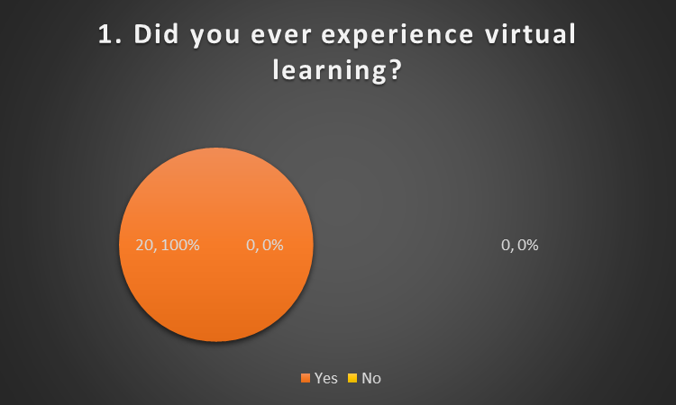
Figure 1 Experiences of learner
Every respondent has confirmed that they have experienced technology-based and virtual learning environments in their course.

2. If you did, what was the first thought of you regarding VLE?
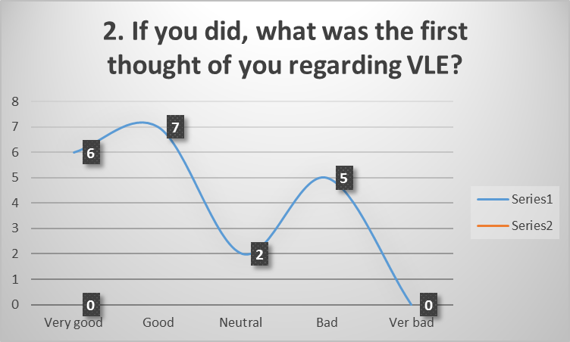
Figure 2 Thinking of learner
13 of the respondents have agreed that they have felt good while experiencing a virtual learning environment in their course. 2 of them have been neutral and the rest of them have disagreed with the fact.

3. Did your faculty value VLE learning in the course?
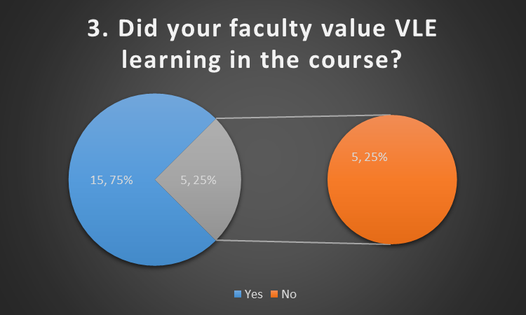
Figure 3 Faculty values VLE learning in the course
The figure represented that 15 of the respondents have agreed that their teachers and faculty valued the virtual learning environments while planning for learning and course study.

4. Do you agree that the learning strategy of students is enhanced within VLE and Moodle?
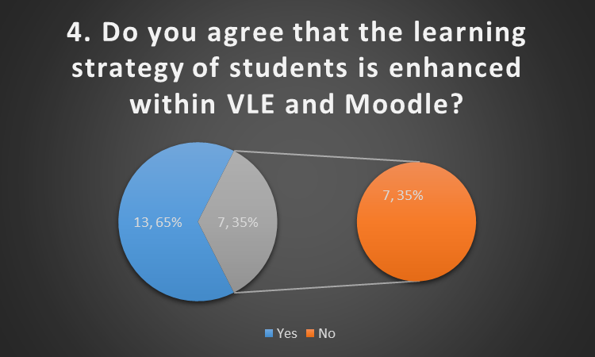
Figure 4 VLE enhances the learning strategy of students
65% of the respondents have agreed that the learning strategy of students is enhanced within VLE and Moodle and 35% of them have not agreed to the given statement.

5. The students and teachers have been benefitted under the VLE system.
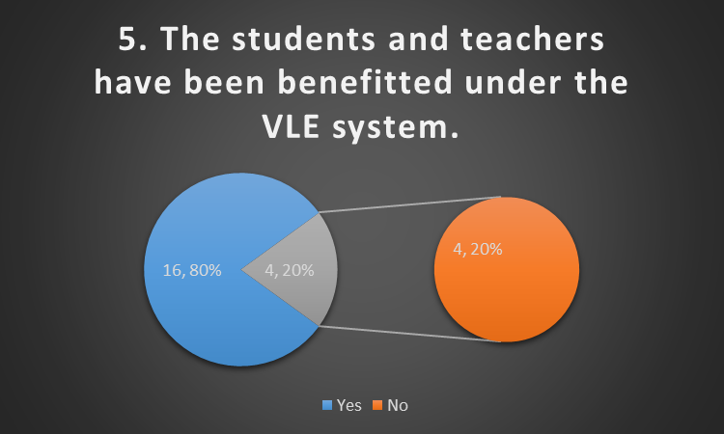
Figure 5 VLE has benefitted everyone in the teaching system
16 of the respondents have agreed that the students and teachers have been benefitted under the VLE system. 4 of them have not agreed to the fact.

6. In the education sector, Virtual Learning Environment (VLE) is an effective learning method.
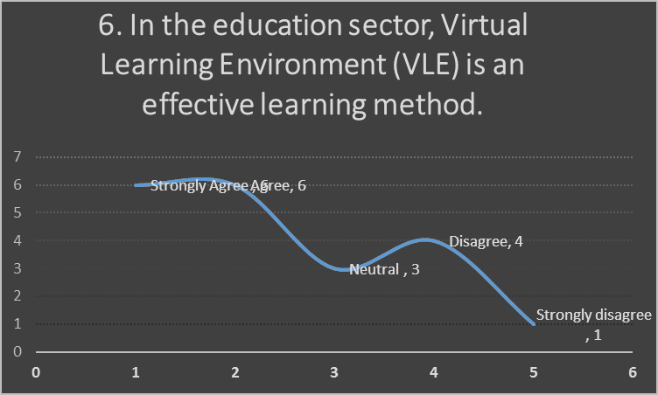
Figure 6 Virtual Learning Environment (VLE) is an effective learning system
60% of the respondents have agreed that in the education sector, Virtual Learning Environment (VLE) is an effective learning method. 3 of them have been neutral and 5 of them have not agreed to the fact.

7. VLE has an impact on the learning and experiences of the students.
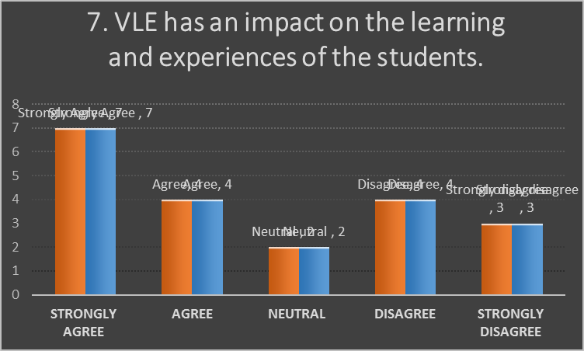
Figure 7 VLE has an impact on the learning and experiences of the students
11 of the respondents have agreed that VLE has an impact on the learning and experiences of the students. 2 of them have been neutral and 7 of them disagreed with the fact.

8. Moodles has prioritised the benefits of students in education.
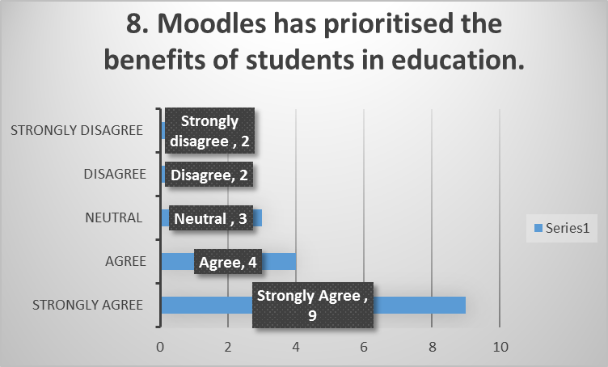
Figure 8 Moodles has prioritised the benefits of students in education
13 of the respondents have agreed that Moodle has prioritised the benefits of students in education. 3 of them have been neutral and 4 of them have disagreed with the fact.

9. VLE system has fulfilled the expectations and preferences of the learner.
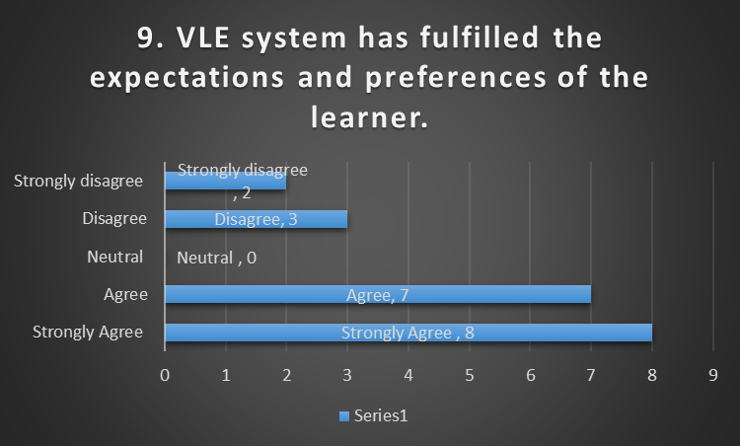
Figure 9 VLE system has fulfilled the expectations and preferences of the learner
15 of the respondents have agreed that the VLE system has fulfilled the expectations and preferences of the learner. 5 of them disagreed with the fact.

10. The learning needs are fulfilled and managed by VLE.
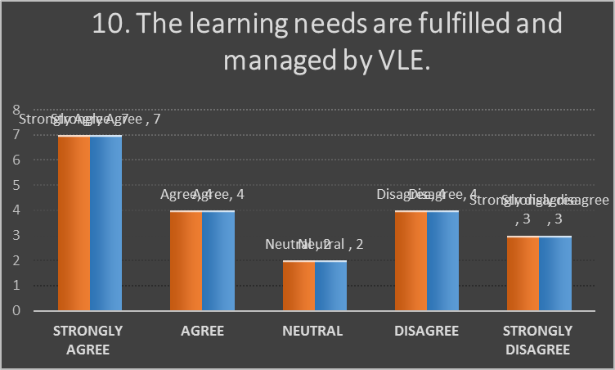
Figure 10 The learning needs are fulfilled and managed by VLE.
55% of the respondents have agreed that the learning needs are fulfilled and managed by VLE. 10% have been neutral and 35% have disagreed with the fact.

11. The students are way more engaged within VLE.
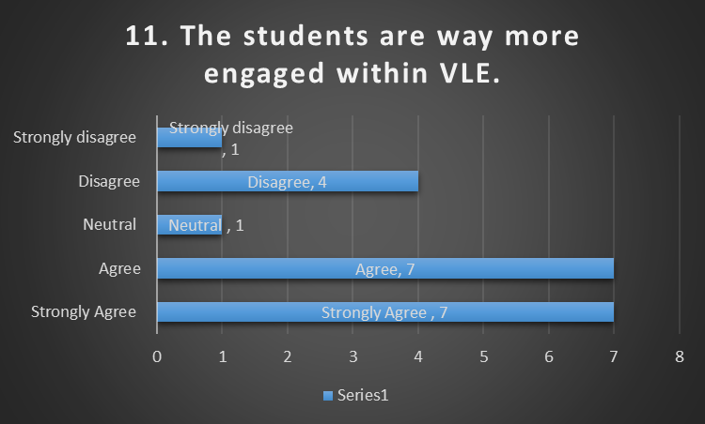
Figure 11 The students are way more engaged within VLE
The figure represented that 14 of the respondents have agreed that the students are way more engaged within VLE. 1 of them has been neutral and 5 of them disagreed with the fact.

12. The blended learning approach has been effective within VLE.
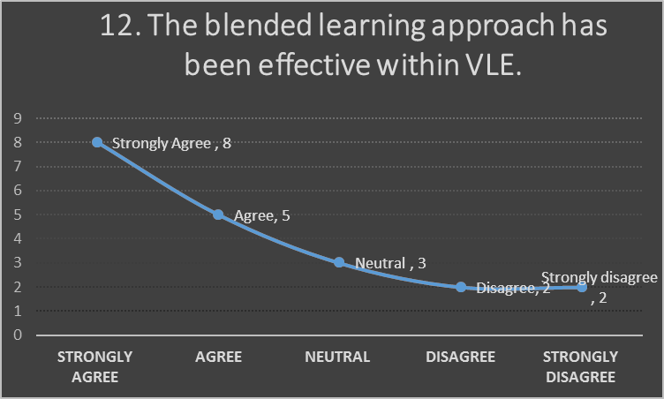
Figure 12 The blended learning approach has been effective within VLE
13 of the respondents have confirmed that the blended learning approach has been effective within VLE. 3 of them have been neutral and the rest of them were not supporting the fact.

Multiple Choice Questions:
13. VLE enhances:
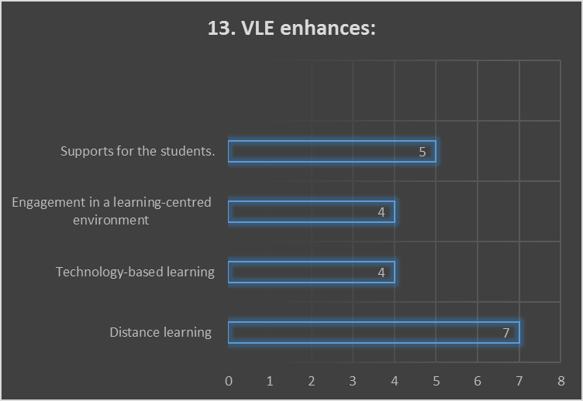
Figure 13 VLE enhances
7 of the respondents have confirmed that VLE enhances distance learning, 4 have confirmed about technology-based learning, 4 of them have confirmed engagement in a learning-centred environment and 5 of them have confirmed about supports for the students.

14. Virtual learning environment helps the teacher in managing:
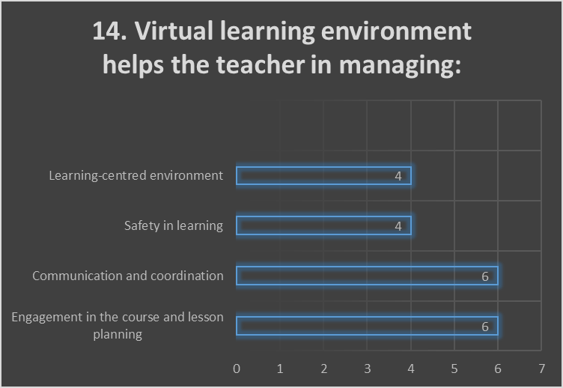
Figure 14 Virtual learning environment helps the teacher in managing
6 of them confirmed that a Virtual learning environment helps the teacher in managing engagement in the course and lesson planning, 6 of them agreed to the communication and coordination, 4 of them added the safety in learning, and 4 of them have confirmed a learning-centred environment.

15. VLE has reduced the:
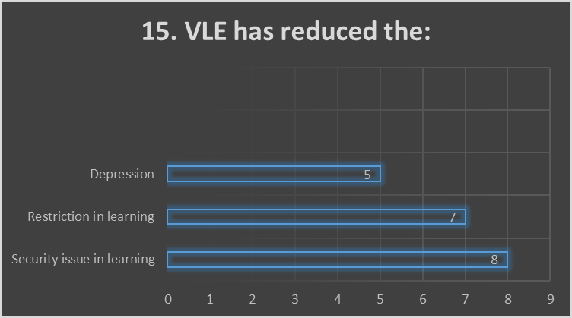
Figure 15 VLE has reduced the
8 of them confirmed that VLE has reduced the security issues in learning, 7 of them confirmed that VLE reduces the restriction in learning, and 5 of them agreed that VLE reduces depression.

16. VLE has limitation such as
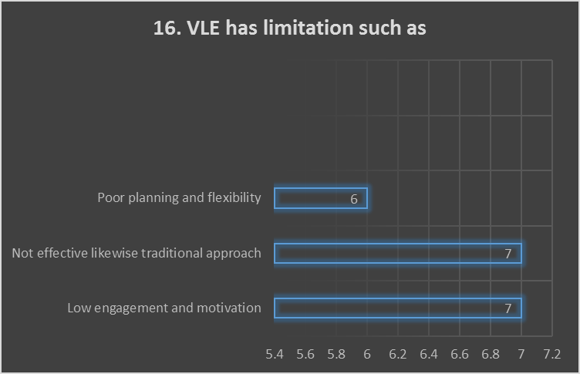
Figure 16 VLE has limitations such as
7 of the students have confirmed that VLE has limitations such as low engagement and motivation. 7 of them agreed that VLE has not been effective than the traditional approach and 6 of them have confirmed that VLE has poor planning and flexibility.

17. VLE is supported with

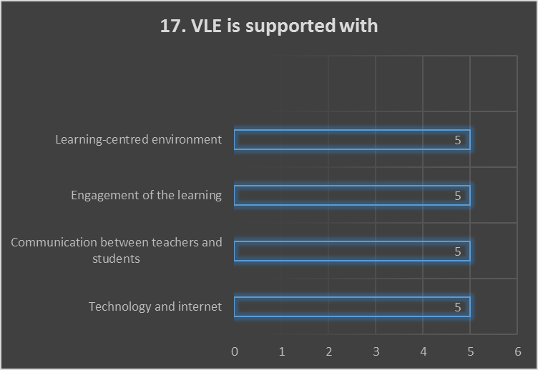
Figure 17 VLE is supported with
5 of them confirmed that VLE is supported by technology and the internet, 5 of them confirmed about communication between teachers and students supports VLE, 5 of them confirmed that engagement of the learners can support VLE, and the rest of them confirmed that a learner-centred environment can support VLE.
Open-ended Questions
18. Does VLE gain the trust of the students?
Within this modern era and pandemic situation, VLE definitely helps the students to complete their learning. Hence, it is pretty confirmed that VLE has gained the trust of the students.
19. Does VLE gain effectiveness compared to the traditional approach?
VLE brings support for the engagement of the students and technology-based learning. But, in some cases, VLE has not been able to gain the same effectiveness as likewise traditional approach of learning.
20. Does the weakness of VLE affect its performance?
VLE has some weaknesses and limitation and in some points, these affect the learning plan and engagement of the students.

7. Secondary data analysis
Day-by-day, educational organisations are using various approaches and technologies to improve education and a learner-centred environment. For developing and using a virtual learning environment, different software and tools are used for enhancing student’s experiences and learning progress. The benefits of a virtual learning environment are higher for the students, teachers, and educational organisation which influence the satisfaction and experiences of the students. But, in some cases, the student’s experience has been affected by the weakness and limitations of the virtual learning environment in the educational organisation.

8. Conclusion and Recommendation
The aim and research objectives of the paper have been accomplished with the findings that a virtual learning environment has positive and slightly negative impacts on the student’s learning experience. The educational organisation can easily improve its impacts with more supports towards the student’s mental health and learning. Also, the organisation can think of a better engagement process within Moodle in the virtual learning environment.

Reference
Abdullah, J., Mohd-Isa, W. and Samsudin, M., 2019. Virtual reality to improve group work skill and self-directed learning in problem-based learning narratives. Virtual Reality, 23(4), pp.461-471.
Crane, L., Benachour, P. and Coulton, P., 2012. Student Experiences with Mobile Electronic Updates from a Virtual Learning Environment. International Journal of Mobile and Blended Learning, 4(3), pp.16-33.
Cross, J., Nyland, R. and Lerchenfeldt, S., 2019. Comparing Student Satisfaction with Traditional and Modular Group Peer-Tutoring Session. Medical Student Research Journal, 7(0).
D'Esposito, M., Palumbo, F. and Ragozini, G., 2012. Interval Archetypes: A New Tool for Interval Data Analysis. Statistical Analysis and Data Mining, 5(4), pp.322-335.
Hu, B. and Tian, L., 2012. Do teachers and students share similar beliefs about teaching and learning strategies?. System, 40(2), pp.237-254.
Kilcoyne, M. and Habig, W., 2016. Online Learning – Learning Styles in a Virtual World Addressing student learning styles in a virtual class focusing on the ability to enhance the learning experience for students in the online learning environment. International Journal for Innovation Education and Research, 4(12), pp.144-153.
Madsen, E. and Aagaard, K., 2020. Concentration of Danish research funding on individual researchers and research topics: Patterns and potential drivers. Quantitative Science Studies, 1(3), pp.1159-1181.
O’Connor, K. and Larkin, L., 2019. Making a Better Student Learning Experience for Virtual Learning Environment Users. International Journal for Digital Society, 10(2), pp.1489-1496.
Raftery, D. and Risquez, A., 2018. Engaging students through the VLE: comparing like with like using the #VLEIreland student survey. Irish Journal of Technology Enhanced Learning, 3(2), p.24.
Rokibul Kabir, M., 2020. Impact of Faculty and Student Readiness on Virtual Learning Adoption amid Covid-19. Revista Internacional de Educación para la Justicia Social, 9(3), pp.387-414.
Yuhanis Omar, A., 2021. Enhancing Student Engagement in VLE Platform: Student Perceptions Towards Programming Course Learning Resources. Psychology and Education Journal, 58(1), pp.5607-5612.

Appendix

Google Survey Form
Student Name: ____________________________ Student ID: ____________________
Module Name: Digital Skills and Research Methods Term 2 Group: _____________
TITLE OF THE RESEARCH: “Impact of Virtual Learning Environment (VLE) – Moodle on students’ learning experience at the University of Wales Trinity Saint David London Campus.”
Dear participant,
This is an academic research project regarding “Impact of Virtual Learning Environment (VLE) – Moodle on students’ learning experience at the University of Wales Trinity Saint David London Campus.” The information of the respondents will be protected.
Thank You

Questionnaire
Yes/No Option:
1. Did you ever experience virtual learning?
i. Yes, ii. No
2. If you did, what was the first thought of you regarding VLE?
- Very good
- Good
- Neutral
- Bad
- Very bad
3. Did your faculty value VLE learning in the course?
- Yes
- No
4. Do you agree that the learning strategy of students is enhanced within VLE and Moodle?
- Yes
- No
5. The students and teachers have been benefitted under the VLE system.
- Yes
- No
Likert Scale:
- Questions | Strongly agree | Agree | Neutral | Disagree | Strongly disagree
In the education sector, Virtual Learning Environment (VLE) is an effective learning method.
VLE has an impact on the learning and experiences of the students.
Moodles has prioritised the benefits of students in education.
VLE system has fulfilled the expectations and preferences of the learner.
The learning needs are fulfilled and managed by VLE.
The students are way more engaged within VLE.
The blended learning approach has been effective within VLE.

Multiple Choice Questions:
13. VLE enhances:
- Distance learning
- Technology-based learning
- Engagement in a learning-centred environment
- Supports for the students.
14. Virtual learning environment helps the teacher in managing:
- Engagement in the course and lesson planning
- Communication and coordination
- Safety in learning
- Learning-centred environment
15. VLE has reduced the:
- Security issue in learning.
- Restriction in learning
- Depression
16. VLE has limitation such as
- Low engagement and motivation
- Not effective likewise traditional approach.
- Poor planning and flexibility
17. VLE is supported with
- Technology and internet
- Communication between teachers and students
- Engagement of the learning
- Learning-centred environment
Open-ended Questions
18. Does VLE gain the trust of the students?

19. Does VLE gain effectiveness compared to the traditional approach?

20. Does the weakness of VLE affect its performance?

