Construction Materials

Introduction
This paper will compare concrete and steel as a framing material for habitable structures. This will be done through selecting two pre-existing buildings and researching them as a desk study looking at the design and planning stage, construction, and the potential impact of the structure coinciding with sustainability. When considering materials, three points of interest will be addressed, including durability and climate resistance, considering the environmental conditions experienced at the site. The potential impact that the material has on environment through its original production, and the ease of assembly on site including potential for the building to be adapted within its life cycle, considering shape and designated use.

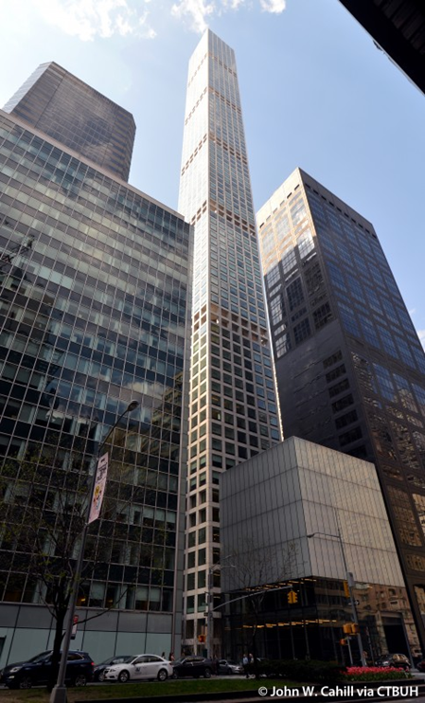
432 Park Avenue - Concrete Frame
Design
432 Park Avenue is the tallest residential concrete building in the western hemisphere at 426m, a footprint of 28.5m x 28.5m (Marcus et al, 2018). The design selected for this site was that of Rafael Vinoly, based on the purest geometric form, a square. With the design having a girth to hight ratio of 1:15, this resulted in many interesting challenges which concluded in the pioneering of engineering solutions (Marcus et al, 2018).

The idea for the project was that of developers Macklowe Properties and CIM Group, with a build time of just over two years and a final construction cost of $1.25 billion (Nasvik, 2016). Consideration needed to be made towards the zoning restrictions and conditions in the area. Aspects that need to be included to make the project financially viable included maximising the possibility of view, and ceiling height (Macklowe, 2015).
Figure 1, photo of 432 Park Avenue J.Cahill, (2020) via CTBUH. http://www.skyscrapercenter.com/building/432-park-avenue/13227
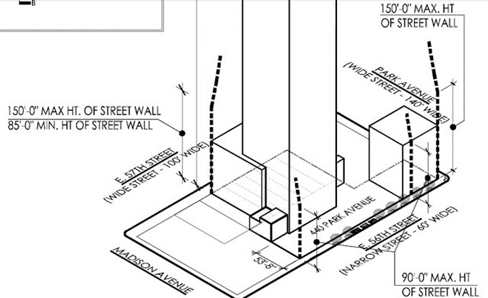
Zoning guidelines for the area state that, if a building is to be built up to the street edge there would need to be ‘setbacks’ at specified points as height increases (figure 2) (Macklowe, 2015). Meaning that the support for upper floor plates would not be substantial enough to contain marketable units (Macklowe, 2015).

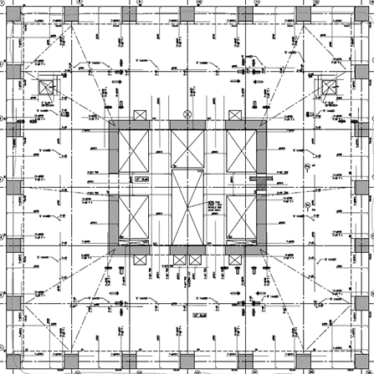
Rafael Vinoly Architects developed software based on a concept called ‘Waldrum Points’, by plotting lines to every possible view point of the site, thus allowing the team to design a building that allowed certain sky exposure in relation to building mass (Macklowe, 2015). The 3m² windows that these views are accessed from form the rigid exoskeleton which bears the vertical load, thus no columns are needed to support the floors between core and façade, allowing any configuration of apartments that the client requires (figure 3) (Macklowe, 2015).
Figure 2, World of Architecture, 432 Park Avenue Floor Plan. Picture of planning site restrictions incorporated into design (2013) https://www.worldofarchi.com/2012/12/432-park-avenue-floor-plans-and.html

Construction
Figure 3, picture showing open floor plan of 432 Park Avenue, (2015), https://www.skyscraper.org/EXHIBITIONS/SKY_HIGH/sky_high.htm
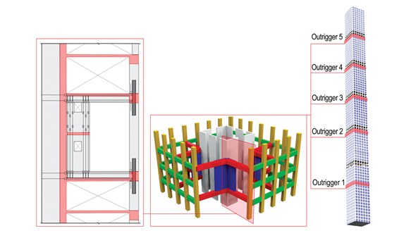
The solution is a duel tube-in-tube system, consisting of, five two-story open mechanical floors, outriggers, core shear walls and mass dampeners (Marcus et al, 2018). The shear walls of the central core are 61cm thick reinforced concrete, this houses the lifts and emergency stairs, while also distributing utilities supplying the building (Marcus et al, 2018). The core is connected to the exoskeleton by using outriggers every twenty floors, plus 25.5cm thick floors also adding rigidity, the upper floor plates thickness is increased to 45.75cm to meet the required mass-to-limit displacement, with the total concrete to complete this amounting to 53,520mᶟ (Marcus et al, 2018).
Figure 4, picture showing out riggers and their location in the construction of 432 Park Avenue, Marcus et al, (2018), Structure Magazine, https://www.structuremag.org/?p=13350
Constructing building of this height and slender design means wind factors are increased, open floors allows wind to pass easily through, reducing pressure, thus, eliminating vortex shedding (Marcus et al, 2018). Also, to combat any sway and vibrations, two 660-ton pendulum mass dampeners were installed (figure 4) (Marcus et al, 2018).Rebar selected was upgraded to gauge 97, reducing congestion when pouring the concrete, these were delivered pre-cut and thread patterned (Nasvik, 2016).
The concrete mix used overcame many variables, requiring to be structurally strong and appliable, while also being the finish. Specification requirements considered were, compressive strength of 14,000psi, modulus of elasticity (MOE) of 7.7msi, self-consolidating with a spread of 76cm, mass pour temperatures ‘heat of hydration’ not exceeding 71ºc, while allowing for two-hour workability (Nasvik, 2016). During winter periods temperatures dropped to -2.8ºc, to ensure consistency of cure time and quality, the floors below were enclosed and heated (Nasvik, 2016).

Sustainability of construction
This concrete development included an Eco Efficiency Analysis, measuring the water emissions, transport impact, and its overall impact on the environment (Nasvik, 2016). By the end of development more than 70% of the Portland cement was replaced by supplementary pozzolans, not only reducing the cost and added strength but also are by-products of other processes, thus environmental impact is reduced (Nasvik, 2016). This is one of the precursors to achieving ‘LEED’ certification.

The Leadenhall Building - Steel Frame
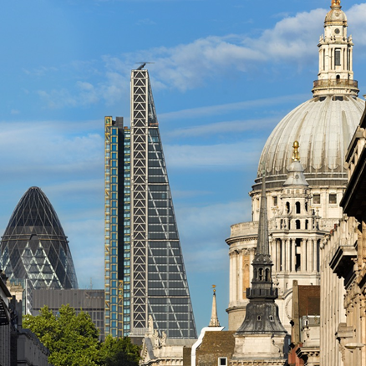
Figure 5, picture of the Leadenhall Building and St Pauls, (2020) https://www.theleadenhallbuilding.com/building/gallery/?tab=2
Design
The iconic sloped shape originates from Rogers Stirk Harbour and Partners. Considering the impact on London’s skyline, a ‘townscape’ approach was implemented, targeting maximum flexible office space, the final design was integrated with a solution to structural problems (Annereal, Eley & Thonger, 2012). A conventional tower was scrapped as key views of St Pauls Cathedral were kept, though for the structure to work this meant that it would have to occupy the entirety of the footplate (Davies, 2013).
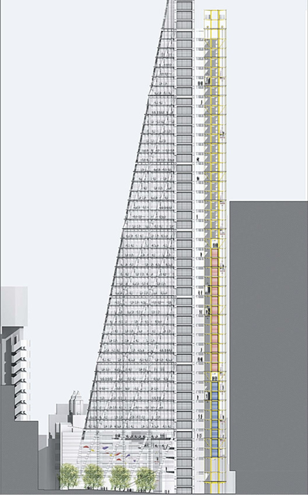
Due to its shape, and to maximise office space, there is no central core to support or service the utilities to the building. Instead the building has a supporting spine on the north side (figure 6 &7) (Davies, 2013). This doesn’t just support the mega-frame, as all amenities, including toilets and lifts, are located here. Designing the building in this way enabled for a gross rentable space to be 71% (Davies, 2013).
Figure 6, design of the Leadenhall building as a cross section, (2020) https://www.archdaily.com/547041/the-leadenhall-building-rogers-stirk-harbour-partners/54109be1c07a807972000068-the-leadenhall-building-rogers-stirk-harbour-partners-section?next_project=no
Figure 7, picture of the north side of the Leadenhall building showing the supporting spine, T. Muliani, (2020) http://www.skyscrapercenter.com/building/the-leadenhall-building/1194
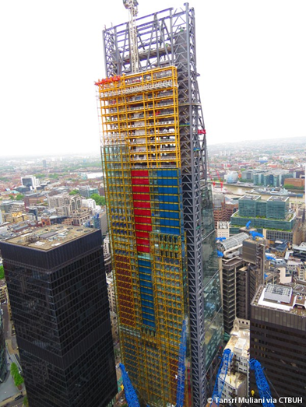

With a building hight of 225m and site conditions that had to be considered, engineers used Early System Design software to simulate a prototype for variables. These analyse using an automated optimisation process giving results for the preferred geometry, the process used was a ‘Best of Breed’ approach, this resulted in the pioneering of design verification (Krolikowski & Eley, 2017).
Construction
As site was tight for space, 85% of the building was fabricated and manufactured off site, thus an assembly rather than construction site (Davies,2013). Andy Butler, project director, states that “the guiding principle was to ‘commission first’”, by making as many elements off site as possible enabled progress of construction to be quick, lower labour cost and reduce risk on site (Davies, 2013). Laing O’Rourke designed a new type of pre-cast concrete floor plate (figure 8) that was unique to the project, reducing congestion on site, improved speed of install, and reduced the risk of damage by on-site pours (Stehle, 2013).
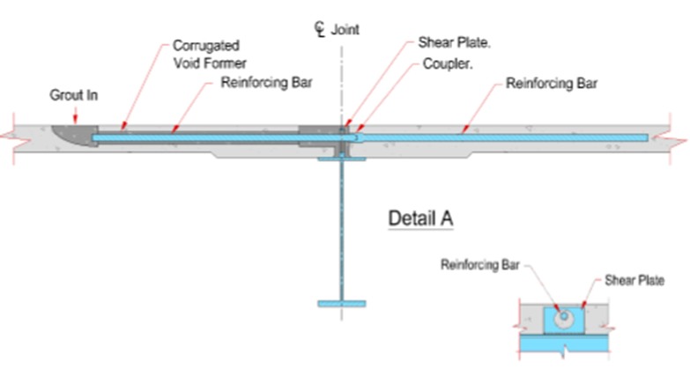
Figure 8, cross section of floor plate for The Leadenhall, J.Stehle, (2013), Engineering Excellence Journal
The basement that was to support it needed to be reinforced, this was done by installing large diameter bored piles into the clay (Younge et al, 2013), as the mega-frame put huge pressure onto the edge of the site, which is unusual as most high-rise buildings put pressure on the centre of the plate (Younge et al, 2013). As the mega-frame structure is aligned with jacks which can be shortened and released to facilitate the alignment of the frame, when correct these are then removed and bolts are restressed, known as ‘Active Alignment’ (Younge et al, 2013).

Sustainability of construction
The façade of the building consists of a single-glaze laminated glass with a gap of between 900mm-1300mm, then an inner double-glaze layer, this works as a weather-line and thermal envelope, allowing the building to be efficient in maintaining temperature (Cousins, 2014). These have computer controlled solar shading blinds which respond to solar radiation, rolling back into the ceiling with the heat being stored as thermal mass (Cousins, 2014). Every floor has its own individual air management system, including heat recovery, allowing a 30% reduction in energy towards atmosphere, making this process more efficient than a centralised air plant (Cousins, 2014). Also, the instillation of movement sensitive light has reduced the energy required for lighting by 20% (Cousins, 2014). Plans for the installation of a 20m x 60m solar photovoltaic array has significant potential (Cousins, 2014).

Durability and climatic resistance
The life cycle of buildings is influenced considerably by environmental factors, with the evolution of climate change extreme weather situations will become a considered factor to the durability of materials used in construction (Keawunruen et al, 2018).
Zhou & Qiao, (2018), have put concrete through tests relating to extreme cold and heat, simulating freeze-thaw scenario, these tests looked at tensile properties and MOE. Showing that as a result to long term exposer there was an increase in deterioration in respect to tensile strength and compression resistance. Due to climate change there is an increase in Chloride-induced corrosion, this in conjunction with temperature and humidity rises, leads to ‘cracking’ (Bastidas-Arteaga, 2018). This intern exposes the reinforcement bars to weather, which results internal corrosion and finally ‘scaling’, with loading of the structure and escalating global warming this is shown to reduce the life of the building by up to 7% (Bastidas-Arteaga, 2018).
The deterioration of steel is due to corrosion, this occurs from severe weather and lack of maintenance, these are drawbacks that need to be considered when choosing steel as a framing material (Secer, Uzun, 2017). Non-maintained steel leads to corrosion, thus becoming detrimental to the load capabilities of the building, Secer & Uzun (2017), testing shows that gone unchecked steel frames over a period reduces its strength by between 9.3% - 19.5%. This shows that even though steel is an extremely hard and durable material, if not maintained and planned for it can quickly loose its structural integrity, as this can be prevented with good planning and design it becomes an economic issue.
Steel frames loose strength and stiffness when exposed to heat, this means that a lot of thought needs to be put into protecting the steal to give it a longer time till failure. Though, Bailey et al (1999) tested unprotected beams, there was no structural collapse even as temperatures reached above 900ºC, suggesting that steel thermal protection should be scrapped for a well-conceived sprinkler system. Though this is not much of an issue for concrete, retaining its structural strength considerably if exposed to fire and has an ability to remain structurally sound (Botte & Caspeele, 2017)

Environmental impact
Construction contributes massively to the world’s consumption of natural resources and adding emissions of CO2 (Helepciuc, 2017).
Concrete is a huge producer of CO2 gasses, with NRMCA (2008) stating that for every tonne of Ordinary Portland Cement (OPC) produced so is 900kg/CO2. To produce concrete the average amount of OPC used is 10% (Helepciuc, 2017) so this would mean that per tonne of concrete produced, 90kg/CO2 would be emitted. 432 Park Avenue replaced just over 70% of its cement with pozzolans, of the 70,000 tonnes of concrete used in its construction only 3% of that was cement. Thus, reducing the constructions carbon footprint to 2100 ton/CO2 for its concrete element.
Though the production of steel the CO2 per tonne output varies, (Hasanbeigi et al, 2016) china produce 2148kg/CO2 per tonne, where Mexico produces 1080kg/CO2 per tonne. Leadenhall used British steel, which outputs1806kg/CO2 per tonne, 18,000 tonnes of steel used in total, amounting to 33,411ton/CO2 emitted accounting for steel alone.

Versatility of the material
Leadenhall, triangular geometry meant that not one floor was the same as the last (Annereal, Eley, Thonger, 2012). So utilising Building Information Modelling (BIM) enabled the visualisation of solutions in detail, this in symmetry with DfMA (figure 9) principles, the team was able to design and manufacture off site (Young et al, 2013), making effective assembly, using just a crane and six fitters, with the pieces being delivered to a ‘just-in-time’ strategy (Young et al, 2013).
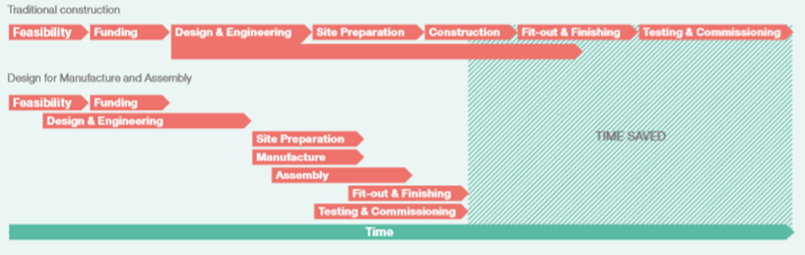
Figure 9, flow chart showing the principles of DfMA, P.Hohnsbeen, (2013), Engineering Excellence Journal
Techniques only works when there is enough planning time, ‘We could have done so much more had we had the luxury of time,’ stated Butler (2013). This was evident in the first five floors of the building as they had to be laid in-situ because of a lack of preparation time (Davies, 2013).
432 Park Avenue would traditionally be a slower build, though as improvements to concrete forming technology and pumps, increased output is attained (Nasvik, 2013).
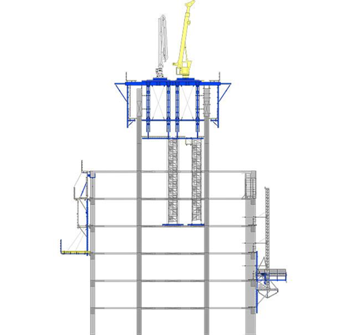
With the process of assembling, each floor working on top of each other, the central core being set ahead of the outer frame, and floor plans being geometrically symmetrical, the efficiency of construction was vastly improved (figure 10) (Nasvik, 2013). Also, when the concrete mix was designed one stipulated requirement was that it had a five-hour walk-time, allowing for a workable platform in a short space of time (Nasvik, 2013).
Figure 10, picture showing the equipment for in-situ concrete at 432 Park Avenue, (2020), https://www.doka.com/en/references/north-america/park-Ave-423

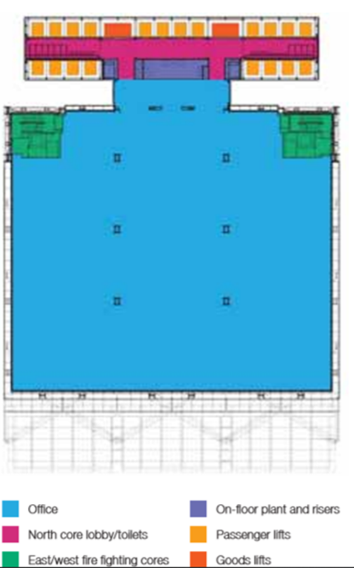
When comparing the materials, adaptability makes a huge difference to the possibility of functions. With Park Avenue, the entire frame is constructed from reinforced concrete, which would not allow you to manipulate the shape of the building, it does allow for multiple scenarios for the floor plan. Whereas the Leadenhall building is a complete contrast, where its design means that different configurations for the floors are limited, this is down to the north spine where all the services and utilities are and the south facing glass façade (figure 11). Though as the building is basically bolted together, with careful planning this could all be undone and reconfigured.
Figure 11, floor plan of the Leadenhall Building showing the designated use for each space, N.Annereal et al, (2012),The ARUP Journal, is 2, The Leadenhall Building

Conclusion
After studying these buildings and reading around the subject, it shows that both materials are essential to the successful completion of high-rise projects. As suggested by Puskas & Moga (2015), a well-designed building will incorporate both materials, both of good quality to compliment each other, with a move towards higher grade steal and bespoke concrete. Aksel & Eren (2015) states that steel frame structures should incorporate concrete to improve thermal mass capabilities, thus improving thermal recovery.
Through this cases study it is seen that most of the design and structural decisions are dictated by the site, its constraints and the solutions developed to overcome them.

References

Aksel, H. and Eren, Ö., 2015. A Discussion on the Advantages of Steel Structures in the Context of Sustainable Construction. NEW ARCH-INTERNATIONAL JOURNAL OF CONTEMPORARY ARCHITECTURE, 2(3), pp.46-53.
Annereau, N, Eley, D & Thonger, J. 2012. The Leadenhall Building. The Arup Journal. 1(2), pp. 11-17.
Bastidas-Arteaga, E., 2018. Reliability of reinforced concrete structures subjected to corrosion-fatigue and climate change. International journal of concrete structures and materials, 12(1), p.10.
Botte, W. and Caspeele, R., 2017. Post-cooling properties of concrete exposed to fire. Fire Safety Journal, 92, pp.142-150.
Cousins, S. 2014. Cutting Carbon at Work. The RIBA Journal. 1(3), pp. 1-2.
Davies, G. 2013. The Leadenhall Building. Engineering Excellence Journal. 3(2), pp. 44-51.
Hasanbeigi, A., Arens, M., Cardenas, J.C.R., Price, L. and Triolo, R., 2016. Comparison of carbon dioxide emissions intensity of steel production in China, Germany, Mexico, and the United States. Resources, Conservation and Recycling, 113, pp.127-139.
Helepciuc, C.M. 2017. The environmental impact of concrete production and necessity of its greening. Resilient Society. 3(2), pp. 81-95.
Kaewunruen, S., Wu, L., Goto, K. and Najih, Y.M., 2018. Vulnerability of Structural Concrete to Extreme Climate Variances. Climate. 2018; 6: 40. Appl. Sci, 8.
Krolikowski, D & Eley, D. 2017. The Leadenhall Building Design for fabrication-digital workflow and downstream fabrication system. Fabricate. 0(5), pp. 68-75.
Lennon, T., Moore, D.B. and Bailey, C., 1999. The behaviour of full-scale steel-framed buildings subjected to compartment fires. Structural Engineering, 77(8), pp.15-21.
Macklowe, H. 2015. The complex path to simple elegance: the story of 432 park avenue. CTBUH New York Conference. 1(1), pp. 48-53.
Marcus et al. 2018. 432 Park. Structure magazine, Macklowe Properties and CIM Group. 1(1), pp. 32-33.
Nasvik, J. 2016. Constructing an Iconic Building using White Portland Cement. Portland Cement Associatior. 1(1), pp. 1-7.
NRMCA concrete Co2 fact sheet 2008 http://www.nrmca.org/greenconcrete/concrete%20co2%20fact%20sheet%20june%202008.pdf
Puskas, A. and MOGA, L., 2015. Sustainability of reinforced concrete frame structures–A case study. International Journal of Sustainable Development and Planning, 10(2), pp.165-176.
Secer, M. and Uzun, E.T., 2017. Corrosion Damage Analysis of Steel Frames Considering Lateral Torsional Buckling. Procedia engineering, 171, pp.1234-1241.
Stehle, J. 2013. DfMA for composite floor structures. Engineering Excellence Journal. 3(1), pp. 20-25.
Young et al. 2013. The Leadenhall Building; London. International Journal of Tall Buildings and Urban Habitat. 1(2), pp. 1-7.
Zhou, Z. and Qiao, P., 2018. Durability of ultra-high performance concrete in tension under cold weather conditions. Cement and Concrete Composites, 94, pp.94-106.

