Programme: Master of Business Administration
Module: Strategic Management
Module code: LCMB7003

Assignment Title: Assessment component - Individual report
Student name: Mohammed Masoom
Student ID number: 2223129

Executive Summary
This report examines the business environment where Uber UK operates in the digital mobility industry, and its strategic position and direction. It also analyses the organisational context of Uber, the platform business model and market position and analyses external pressures using PESTEL and internal advantages using resource analysis, VRIO, dynamic capabilities, value-chain analysis and benchmarking. SWOT incorporates them, and AI, electrification and ecosystem expansion, regulatory, labour, infrastructure and cybersecurity risks are flagged as key opportunities and threats respectively. Uber CSR alignment and the application of the Balanced Scorecard to relate financial performance to customer value, operational efficiency and organisational learning are also evaluated in the report. Porter's Five Forces suggests that there is a lot of competition, buyers have a lot of power, and there are good substitutes, which makes price competition difficult to maintain. The AI-enabled sustainable mobility ecosystem (which combines Uber Green, Uber One and intelligent mobility services) is thus supported by Ansoff analysis. To ensure a successful implementation, phased pilots, stakeholder engagement, clear AI governance, and regulators involved in association with the establishment of continuous performance control are necessary to enhance long-term competitiveness, legitimacy and sustainable creation of value.
Table of Contents
Executive Summary 2
List of Figures 5
List of Tables 5
Section 1 6
Introduction 6
Organisational Context and Overview 7
External and Internal Analysis 10
External Environmental Analysis Using PESTEL 10
External Strategic Implications 11
Resource Analysis 12
Capability and Core Competencies 13
Internal Environment Analysis Using VRIO 13
Dynamic Capabilities 15
Value Chain Analysis 15
Benchmarking Analysis 16
Internal Strategic Implications 17
SWOT Analysis 18
Comprehensive and Holistic Strategic Evaluation 20
Strategic Alignment of CSR and Business Objectives 20
Strategic Performance Evaluation Using the Balanced Scorecard 21
Critical Strategic Synthesis 22
Strategic Choices and Implementation 24
Current Business-Level Strategy 24
Industry Attractiveness Using Porter’s Five Forces 24
Strategic Options Available 25
Ansoff Matrix Evaluation 25
SAFe Evaluation 26
Recommended Strategy and Implementation Plan 27
Implementation Challenges, Change Management and Risk Mitigation 28
Conclusion 29
Section 2 30
Reflective Account 30
Concrete Experience 30
Reflective Observation 31
Abstract Conceptualisation 31
Active Experimentation 31
References 33
Appendices 40
Appendix A: Uber Information on Platform Growth and Financial Performance 40
Appendix B: Uber Corporate and Sustainability Evidence 41

List of Figures
Figure 1: Business Model Canvas of Uber (Author, 2026) 8
Figure 2: Adapted Value Chain for Uber UK (Author, 2026) 16
Figure 3: Integrated SWOT Matrix for Uber UK (Author, 2026) 19
Figure 4: Stakeholder Value Creation Framework for Uber UK (Author, 2026) 21
Figure 5: Porter’s Five Forces Analysis of the UK Ride-Hailing Industry (Author, 2026) 25
Figure 6: Ansoff Matrix for Uber UK's Strategic Growth Options (Author, 2026) 26
Figure 7: Kolb's Reflective Learning Cycle (Kolb, 1984) 30

List of Tables
Table 1: Competitor Comparison (Author, 2026) 9
Table 2: PESTEL Summary for Uber UK (Author,2026) 11
Table 3:Uber's Strategic Resource Analysis (Author, 2026) 13
Table 4: VRIO Analysis of Uber's Strategic Resources and Capabilities (Author, 2026) 14
Table 5: Strategic Benchmarking of Uber, Bolt and FREE NOW (Author, 2026) 17
Table 6: Balanced Scorecard for Uber UK (Author, 2026) 22
Table 7: SAFe Evaluation of the Recommended Strategy (Author, 2026) 27
Table 8: Implementation Roadmap for the Recommended Strategy (Author, 2026) 28

Section 1

Introduction
Strategic management allows organisations to identify and assess their internal capabilities and external environment, develop strategies that align with their goals, and gain a competitive edge in the changing market (Hitt et al., 2024). Digital platform companies like Uber Technologies Inc. need to be able to react well to technology, shifting consumer demands, regulations and competition to be successful in the long run. Uber has transformed itself from a ride-hailing company to a complete mobility company providing transportation, food delivery, freight, advertising, and membership services in the global market. The report has critically analysed Uber UK's strategic situation using external and internal analyses, strategic capability assessment, CSR and performance evaluation and strategic choice frameworks. It is based on the theories of strategic management and draws upon evidence-based recommendations to ensure that Uber's longer-term competitiveness, stakeholder value and its sustainable organisational performance are enhanced.

Organisational Context and Overview
Uber Technologies Inc. is a company that was started in 2009 by Garrett Camp and Travis Kalanick and was a resounding success in the field of urban transportation by providing a unique app-based service called the Uber service (Uber, 2025). It has grown substantially through the power of a scalable and asset-light business model and a reliance on digital innovation. Today, Uber service is available in over 70 countries and in more than 10,000 cities, with integrated mobility solutions, food delivery, freight, and advertising, serving millions of customers, drivers, merchants and businesses around the world (Uber, 2026a). The mission of Uber is to create opportunity through movement, which means that the company is dedicated to bridging people, businesses, and communities with the help of accessible mobility solutions (Uber, 2025). It has a vision of creating the most reliable and sustainable mobility platform in the world through technological innovation that can make transportation safer, smarter, and electrified. To fulfil this vision, Uber runs a multi-sided digital platform, which links riders, drivers, merchants, freight carriers, advertisers, and business customers in an integrated ecosystem (Chung, Zhou and Choi, 2025). The Mobility segment is its main source of revenue, and Uber Eats increases customer interactions by delivering food and groceries. Uber Freight enhances the efficiency of logistics by digitally matching shippers with carriers (Uber Freight, 2023). Moreover, the Uber Advertising business earns high-margin revenue due to targeted in-app promotions, and the Uber One membership programme helps increase customer loyalty by providing exclusive discounts, delivery benefits, and premium mobility services.
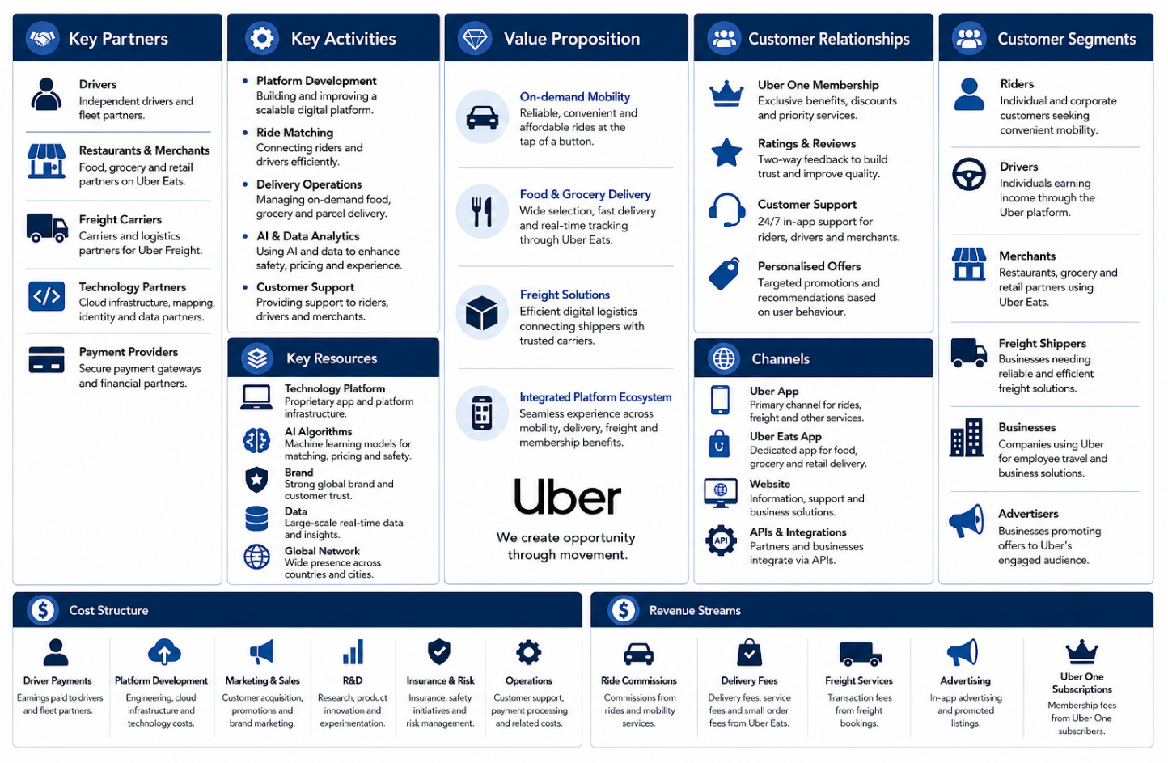
Figure 1: Business Model Canvas of Uber (Author, 2026)
The ride-hailing and digital mobility sector in the UK has been on a steady growth trajectory due to the rising use of smartphones, urbanisation and the growing consumer interest in convenient and mobile transport services. Digital innovation has altered the conventional taxi market with real-time matching of rides, cashless payment, and combined mobility platforms, and regulatory control over licensing, passenger safety, employment rights, and data protection continues to influence the competition in the industry (Čulík et al., 2022). In this dynamic market, Uber has to compete with Bolt, FREE NOW, and traditional black cab and private hire operators, as well as a number of local mobility providers (Santos, 2021). Nonetheless, Uber is still the most popular ride-hailing platform in the UK, as it has a large network of drivers, a diversified range of services, a well-established brand, and a consistent investment in technological innovation.
Competitor | Core Services | Key Competitive Strength | Relative Position to Uber (UK)
Uber | Ride-hailing, Uber Eats, Freight, Uber One | Largest platform ecosystem, strong brand, diversified services | Market leader
Bolt | Ride-hailing, e-scooters | Lower commission rates, competitive pricing | Strong challenger
FREE NOW | Ride-hailing, licensed taxis | Integration with black cabs and private hire vehicles | Established competitor
Traditional Taxi Operators | Taxi services | Regulatory familiarity, local reputation | Indirect competitor
Table 1: Competitor Comparison (Author, 2026)
On the whole, the development of Uber into a diversified digital mobility platform, along with its high market penetration in the UK, offers a solid basis of strategic analysis. It is important to critically evaluate the external and internal factors that affect future competitive advantage by understanding its organisational context.

External and Internal Analysis
External and internal environmental analysis is a process that helps to systematically identify opportunities, threats, strengths and weaknesses so that it can be used as a basis for making strategic decisions. Scanning involves identifying new trends; monitoring involves identifying the key trends; forecasting involves forecasting the next trend; assessment involves assessing the significance of the trend (Hitt et al., 2024). PESTEL shows the external factors that impact the business of Uber UK, while VRIO assesses the internal strength and resources of Uber UK. SWOT then combines all of these inputs into an overall strategic review. The analysis thus starts by first examining the external pressures that are impacting Uber UK, and then moves to determining whether the resources and capabilities are adequate for Uber UK to be able to respond to the pressure in a strategic manner.

External Environmental Analysis Using PESTEL
PESTEL analysis is used to assess the external influences that impact organisational strategy and industry conditions (Hatoum et al., 2023). The forces are interdependent for Uber UK as they impact on each other's areas: regulation on labour costs, technology on service differentiation, and environmental policy on investment in vehicles and infrastructure.
Factor | Key Strategic Issue | Strategic Relevance to Uber UK
Political | TfL licensing, transport regulation, EV policy | Determines operating legitimacy and supports electrification strategy.
Economic | Inflation, fuel prices, interest rates, disposable income | Influences customer demand, driver earnings and profitability.
Social | Urbanisation, digital lifestyles, safety expectations | Drives platform adoption while increasing stakeholder expectations.
Technological | AI, cloud computing, big data, autonomous mobility | Enables innovation, efficiency and competitive differentiation.
Environmental | Net Zero, EV transition, low-emission zones | Accelerates sustainable mobility but increases transition requirements.
Legal | Worker status, GDPR, competition and safety regulation | Shapes compliance obligations, operating flexibility and stakeholder trust.
Table 2: PESTEL Summary for Uber UK (Author,2026)
Transport for London licensing and transport regulation are not just administrative requirements, but a political decision that defines the operational legitimacy of Uber (Transport for London, 2024). Electrification and transport support from the government open the door to Uber Green, but increased regulation of platform companies also increases compliance and reputation risk (Lombardo, 2022). Inflation, fuel prices, interest rates and insurance costs put a strain on both riders and drivers economically, as does the pressure on disposable income (Lubis, 2024). Uber can't pass on cost increases entirely to riders because the price increase will lead to more people switching to other platforms, but if they keep prices low, they will also reduce the earnings of the drivers, participation and availability of the platform.
Urbanisation, smartphone dependence and the need for cashless travel are driving the growth of ride-hailing services socially. But there are issues of legitimacy arising from expectations of safety, fairness, and platform work. Artificial Intelligence, cloud infrastructure, big data and route optimisation are technologically enabling matching, forecasting and personalisation, and autonomous and electric mobility are providing a degree of differentiation (Ghomari, 2025). However, some of these technologies are available to competitors and therefore require responsible governance and integration to gain an advantage.
Sustainable mobility is promoted by the Net Zero policy, low-emission zones and EV transition, but charging infrastructure and vehicle affordability are not within Uber's sphere of influence (Moskal, 2022). From a legal perspective, the worker classification, minimum wage requirements, GDPR, competition law and passenger safety and consumer protection regulations limit the flexibility of platforms, but compliance becomes a strategic asset (Shepherd, 2025). Overall, the most important are the technological, legal and political factors as they directly impact Uber's business model, cost base and future licence to compete.

External Strategic Implications
The potential to merge the three areas of artificial intelligence, electrification and integrated mobility to make strategies more efficient, more differentiated and more customer-centric is the highest external opportunity for Uber. The biggest challenge is the combination of regulatory requirements, high competition and infrastructure limitations, which can lead to costly operations and reduced operational flexibility (Jerab and Mabrouk, 2023). Technological investment is not enough to respond effectively: Uber needs to build up regulatory competence, coordination among stakeholders, engagement of drivers and responsible data governance. These results set the tone for what Uber may work toward; the next step is to determine if the company has the resources and capabilities to do so.

Resource Analysis
Uber's assets are quite tangible, in the form of its considerable financial strength, technology backbone, formal organisational systems, and size and scope of operations. While Uber has no traditional vehicle fleet, it has access to transport capacity via its supply of drivers, its fleet partners and its affiliated vehicle owners (Santos, 2021). Intangible resources are of more strategic value and comprise brand recognition, platform data, algorithms, regulatory knowledge, institutional relationships, customer and driver networks, and corporate reputation (Amajuoyi, Nwobodo and Adegbola, 2024). These assets are intangible and more difficult to replicate, due to the long-term interaction with the market and platforms. But resources by themselves don't constitute a competitive advantage—they are only valuable if Uber can use them in a way that creates a competitive advantage. These resources are useful strategically only when integrated in organisational capabilities.
Resource category | Uber-specific resources | Strategic value
Tangible | Financial capacity, technology infrastructure, organisational systems and global operational reach | Supports platform investment, market expansion and scalable service delivery
Network-based | Drivers, fleet partners, merchants and technology partners | Expands service capacity without requiring direct vehicle ownership
Intangible | Brand, platform data, algorithms, regulatory knowledge and institutional relationships | Strengthens forecasting, innovation, legitimacy and customer adoption
Reputational | Customer trust, driver participation and partner relationships | Supports retention, service availability and stakeholder confidence
Table 3:Uber's Strategic Resource Analysis (Author, 2026)

Capability and Core Competencies
Uber's resources are used to match drivers with passengers in real time, adjust pricing based on demand, predict demand, optimise routes, prevent fraud, personalise customer experience, integrate with other platforms, coordinate with partners and adapt to regulations (Uber, 2026b). Its main strength is the ability to coordinate riders, drivers, merchants and logistics partners on a large scale, using data-driven platform coordination (Santos, 2021). This capability adds value by enhancing the availability, efficiency and convenience of inter-connected services. But individual characteristics like dynamic pricing can be easily copied. The key strength of Uber is the platform system, the network scale and the integration of the organisation, not any single algorithm. The VRIO framework is thus needed to identify those capabilities that offer true competitive advantage.

Internal Environment Analysis Using VRIO
VRIO assesses the value, rarity, imitability and exploitability of the resources and capabilities that Uber has (Barney, 1991). The analysis suggests that the most promising benefits that Uber can offer are derived from its multi-sided platform network, the Uber One Mobility-Delivery-Uber One ecosystem, its regulatory experience and its accumulated data. These resources work together to enhance matching efficiency, service availability, cross-selling and market adaptation. Their strategic importance is in combination: other competitors can imitate individual aspects, but it is not easy to copy the user density, institutional knowledge, partner relations and integrated services at the same time.
Uber's global brand, analytics and customer data give it certain advantages, but they are mostly short-lived, as competitors can catch up over time. The basic application functions, mapping, payment systems and matching algorithms provide competitive parity as they are available or outsourced (Vargas-Hernández, 2020). But network effects are not necessarily persistent. Multi-homing is possible for riders/drivers, platform features can be mimicked by competitors, regulation can limit flexibility, and reputational failures can erode trust.
Resource or capability | Valuable | Rare | Difficult to imitate | Organised | Competitive implication
Multi-sided platform network | Yes | Yes | Yes | Yes | Sustained potential advantage
Global brand | Yes | Yes | Moderate | Yes | Temporary advantage
Platform data and analytics | Yes | Moderate | Moderate | Yes | Temporary advantage
Matching and pricing algorithms | Yes | No | No | Yes | Competitive parity
Mobility–Delivery–Uber One ecosystem | Yes | Yes | Yes | Yes | Sustained potential advantage
Regulatory knowledge | Yes | Moderate | Yes | Yes | Location-specific advantage
External driver network | Yes | No | No | Yes | Competitive parity
Partner ecosystem | Yes | Moderate | Moderate | Yes | Temporary advantage
Table 4: VRIO Analysis of Uber's Strategic Resources and Capabilities (Author, 2026)
Thus, Uber's size is not enough to ensure ongoing success unless it translates into better reliability, safety and value for its stakeholders through data and ecosystem width. In sum, Uber's ongoing success is not about the resources that it has, but about the continuous re-creation, combination and recombination of its resources in response to technological, regulatory and competitive shifts.

Dynamic Capabilities
Dynamic capabilities are the ability of an organisation to adapt, integrate and reconfigure its resources to cope with environmental changes (Cristofaro, Helfat and Teece, 2025). Uber shows this by monitoring policy shifts, EV adoption, shifting customer preferences, and AI and autonomous mobility developments (Uber, 2024). It takes advantage by growing Uber Eats, Uber One, advertising, EV programs and autonomous mobility collaborations. It optimises the use of platform technologies in Mobility, Delivery and Freight and reallocates investment towards sustainability and innovation. But value is only added to the platform through expansion if it reinforces the core platform business model; otherwise, it can lead to organisational complexity and strategic dilution. These capabilities are manifested in the value-creating activities of Uber.

Value Chain Analysis
Porter's Value Chain is a tool that helps identify the point at which organisations can create competitive value, but for digital platforms this needs to be adjusted to take account of the technology-enabled service delivery (Porter, 1985). Uber's primary activities include driver and merchant onboarding, platform operations, ride and delivery matching, transaction processing, marketing, customer acquisition, safety support and complaint resolution. Supporting activities include AI and technology development, data analytics, human-resource development, procurement and partnerships, governance, and legal compliance. Uber's value lies in its platform operations, technological innovation, network coordination, customer data and ecosystem integration. However, the quality of service is largely dependent on independent drivers, and charging infrastructure and vehicle availability are also somewhat out of Uber's hands, meaning that the company has limited direct control over value delivery. The relative strength of these activities needs to be judged against the competition.
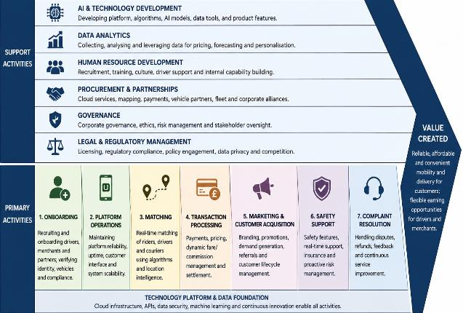
Figure 2: Adapted Value Chain for Uber UK (Author, 2026)

Benchmarking Analysis
Benchmarking shows that Uber's strength is not only its pricing, but its ability to have an ecosystem that is broad, a network that is scalable, and technology integration. Bolt is a better low-cost alternative to Uber, while Uber has a more diverse set of mobility, delivery, membership and advertising products. FREE NOW also gains from tighter relations with the conventional taxi companies, which increases the regulatory acceptance and service coverage in the area. The more drivers and customers that Uber has, the more availability and data they can collect, but size is not the key to loyalty. What makes it advantageous is its ability to transform weight into shorter waiting times, consistent service, membership benefits and a solid sustainability story that is backed up by superior customer experience.
Dimension | Uber | Bolt | FREE NOW | Strategic implication
Ecosystem breadth | Mobility, Delivery, Uber One and advertising | Primarily mobility and micromobility | Mobility and taxi services | Uber has stronger cross-service potential
Network scale | Extensive driver and customer reach | Strong challenger in major cities | Smaller but established coverage | Scale supports availability and data accumulation
Pricing | Dynamic pricing and membership benefits | Strong value-based pricing | Mix of taxi and private-hire pricing | Uber should avoid competing mainly through discounts
Technology | Advanced matching, analytics and personalisation | Efficient app-based platform | Strong booking and taxi integration | Technology must improve reliability and retention
Sustainability | Uber Green and EV partnerships | EV and micromobility initiatives | Taxi electrification potential | Advantage depends on measurable implementation
Taxi integration | Limited compared with FREE NOW | Limited | Strong licensed-taxi integration | FREE NOW may possess greater local institutional legitimacy
Table 5: Strategic Benchmarking of Uber, Bolt and FREE NOW (Author, 2026)

Internal Strategic Implications
Uber's biggest advantage is its platform scale, built-up data, brand recognition, AI power, ecosystem integration, and regulatory expertise. Issues of driver multi-homing, low customer switching costs, reputational exposure, reliance on external infrastructure and imitable app features, though, lessen the durability of these strengths (Guo et al., 2023). Uber should thus focus on developing their capacities to enhance the reliability of their service to more drivers, responsible data handling, and trust among their stakeholders (Najjar and Dahabiyeh, 2021). The analysis indicates differentiated product development: the use of AI-powered mobility, electrification, and integration into a more extensive ecosystem are the more advantageous options than price-driven growth. These internal findings can now be included in the external analysis (SWOT) to figure out Uber's strategic priorities.

SWOT Analysis
SWOT combines the results of the PESTEL, resource analysis, VRIO, dynamic capabilities, value-chain and benchmarking. The AI, platform data, financial power and breadth of the ecosystem of Uber enable the prospects of personalised mobility, electrification, autonomous partnerships, Uber One, and advertising (Uber Investor, 2025). Nonetheless, these benefits translate into reliable service and trust of the stakeholders. The external threats are enhanced by internal weaknesses: reliance on drivers, multi-homing erodes loyalty, external infrastructure slows EV adoption, and concentrated data exacerbates privacy and cybersecurity concerns (Bommenahalli, 2025). Instead, Uber needs to focus more on building a better relationship with drivers, regulatory validity, service quality and ecosystem integration instead of seeking expansion as the sole driver of transaction growth.

Figure 3: Integrated SWOT Matrix for Uber UK (Author, 2026)

Comprehensive and Holistic Strategic Evaluation
This section examines the consistency of Uber's CSR strategy with the objectives shown and the strategic performance assessment and long-term value creation, using the Balanced Scorecard.

Strategic Alignment of CSR and Business Objectives
Corporate social responsibility (CSR) is a strategic way of value creation and not of peripheral philanthropy. The Stakeholder Theory (Freeman, 1984) focuses on the value for customers, drivers, investors, regulators and communities, and the Triple Bottom Line (Elkington, 1997) demands equilibrium among economic, social and environmental performance. What matters about CSR for Uber UK is that the success of its platform is reliant on customer trust, driver participation, regulatory approval and responsible innovations.
Environmentally, the 'Uber Green' idea, incentives and charging partnerships enhance net zero targets for the UK and expose opportunities, through PESTEL & SWOT. But partly beyond Uber's control, there are factors such as vehicle affordability, charging capacity and driver willingness, which limit implementation (Uber, 2025). Socially, driver welfare, safety, accessibility, and diversity and inclusion can help build trust and continuity of services, but could also increase costs of operations if more employment protection is extended. Governance is equally important as Uber handles sensitive data such as location, behaviour and passenger/driver data (Uber, 2025). The notions of privacy, cyber security and algorithmic transparency are therefore important when it comes to regulating legitimacy and reputation. In general, according to Srivastava (2024), CSR only helps to differentiate and enhance confidence on the part of stakeholders when commitments result in measurable outcomes; otherwise, sustainability actions and social ones become symbolic and have an impact that is not strategically valuable so as to enhance differentiation and strengthen the competitive advantage.

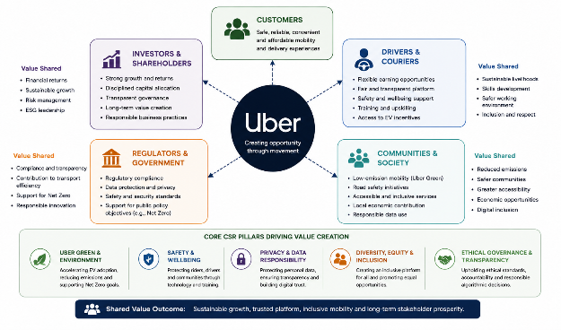
Figure 4: Stakeholder Value Creation Framework for Uber UK (Author, 2026)

Strategic Performance Evaluation Using the Balanced Scorecard
Uber's strategy can be translated into measures—some financial, some non-financial—in the Balanced Scorecard (BSC) framework developed by Kaplan and Norton (1996). Uber should be focused on profitable growth, higher margins, positive free cash flow and less reliance on ride commissions in terms of financials and can track this with the key indicators of revenue, adjusted EBITDA, gross bookings, Uber One and advertising contribution. Loyalty, safety, affordability and shorter waiting times are key from the customer's point of view, and should be measured by satisfaction, retention, active users, growth in membership and resolution of complaints (Ayodeji, Rjoub and Özgit, 2022). At Uber, the focus should be on making the matching process more efficient, driver utilisation more effective, delivery time shorter, platform uptime and safety higher, and on risk management caused by opaque and biased algorithms used. The learning and growth should be directed toward investments in AI, employee and driver development, EV-support participation, innovation, and ESG and compliance training (Deberdt et al., 2025). In summary, improved learning outcomes positively affect internal processes, which boost customer value and, in the long run, promote sustainable financial results, while not compromising the trust and the quality of service to customers.
Perspective | Strategic objective | KPIs | Proposed target | Strategic initiative
Financial | Improve profitable, diversified growth | Revenue growth, adjusted EBITDA, free cash flow, gross bookings | Increase margins and recurring income | Expand Uber One, advertising and cost efficiency
Customer | Strengthen loyalty, safety and convenience | Satisfaction, retention, waiting time, complaints | Improve retention and reduce delays | Personalisation, loyalty benefits and safety controls
Internal Processes | Improve efficiency and reliability | Matching accuracy, idle time, uptime, safety incidents | Reduce delays and incidents | AI forecasting, route optimisation and automated monitoring
Learning and Growth | Build innovation and regulatory capability | AI investment, training, EV participation, ESG compliance | Expand digital and sustainability capability | AI research, driver development and compliance training
Table 6: Balanced Scorecard for Uber UK (Author, 2026)

Critical Strategic Synthesis
The platform scale and technology advances of Uber offer great strategic opportunity, but it is not enough to ensure lasting competitive advantage. The identified regulatory, labour and environmental risks should be taken care of by CSR, and the Balanced Scorecard should bring strategic objectives into measurable outcomes, both financial and non-financial. Thus, future competitiveness relies on the ability to combine innovation with the use of AI and electrification with driver involvement, customer safety, transparent data control and credible environmental deliveries. Sustainable financial growth is only possible if it is backed by stakeholder trust, reliable internal processes and continual organisational learning. This comprehensive strategy will give control over performance and the legitimacy necessary to implement the proposed sustainable mobility strategy in practice.

Strategic Choices and Implementation
This section analyses the current business-level strategy of Uber, analyses the attractiveness of the industry and other growth opportunities, validates the preferred business-level strategy through the established frameworks, and analyses the requirements for implementing the strategy to achieve sustainable competitive advantage.

Current Business-Level Strategy
Uber's differentiation strategy is integrated and is backed by cost efficiency via AI, automation and platform scale. The Mobility, Delivery, Advertising and Uber One ecosystem helps to build customer convenience, cross-selling opportunities and network effects, which are beneficial for market position (Fang, 2025). The advantage, however, is not sustainable due to driver and customer multi-homing, imitability of platform features, regulatory costs and high price competition. Uber's current strategy is therefore competitive, but for the long term, it will be necessary to build differentiated customer value through innovation, ecosystem integration and trusted stakeholder relationships, not just scale and operational efficiency.

Industry Attractiveness Using Porter’s Five Forces
Porter's Five Forces suggests that the ride-hailing market in the United Kingdom has growth potential, but is also competitive (Porter, 1980). Digital entry is possible, but there are significant barriers due to network scale, licensing and customer trust. Drivers have moderate to strong bargaining power as they can multi-home on different platforms, and consumers have low switching costs and clear fare comparisons (Guo et al., 2023). Pricing is limited by public transport, black cabs and other mobility options, while Bolt, FREE NOW and local operators add to competition (Olayode et al., 2023). Therefore, price leadership is not sustainable, and Uber must further differentiate itself with AI-powered reliability, ecosystem integration, safety and sustainable mobility.
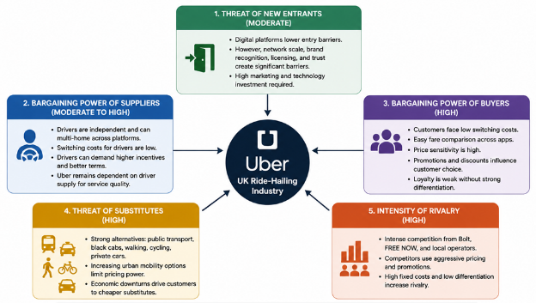
Figure 5: Porter’s Five Forces Analysis of the UK Ride-Hailing Industry (Author, 2026)

Strategic Options Available
There are four main growth avenues for Uber. Market penetration may boost retention and uptake of Uber One in current markets in the UK. Market development may involve expanding existing services to new markets and corporate mobility. Product development may feature AI-powered mobility, EV services and advanced subscriptions. Diversification may be broadened to urban logistics and Mobility as a Service (Bucchiarone et al., 2021). These options vary significantly in terms of strategic fit, execution risk and resource needs, however.

Ansoff Matrix Evaluation
Ansoff's matrix is a comparison of growth via existing or new products/markets (Ansoff, 1965). Market penetration is the least risky option as Uber can strengthen relationships with existing customers, but will require more aggressive discounting, which can lead to price-sensitive behaviour and reduce margins (Varghese, 2025). Market development is geographic and corporate growth, but it needs to be accompanied by demand density in the area, availability of licenses, and driver availability. Product development leverages Uber's existing brand, platform data and network to launch AI-powered mobility, EV services and improved Uber One benefits, while maintaining a strong sense of differentiation and staying close to current offerings (Carbonara et al., 2024). Diversifying into urban logistics or Mobility-as-a-Service may help decrease the need for ride-hailing; however, it will present new markets, management challenges, and capital risks. Product development thus provides the highest strategic fit as it leverages the VRIO resources and dynamic capabilities of Uber and addresses the technological and environmental opportunities identified through PESTEL and SWOT.
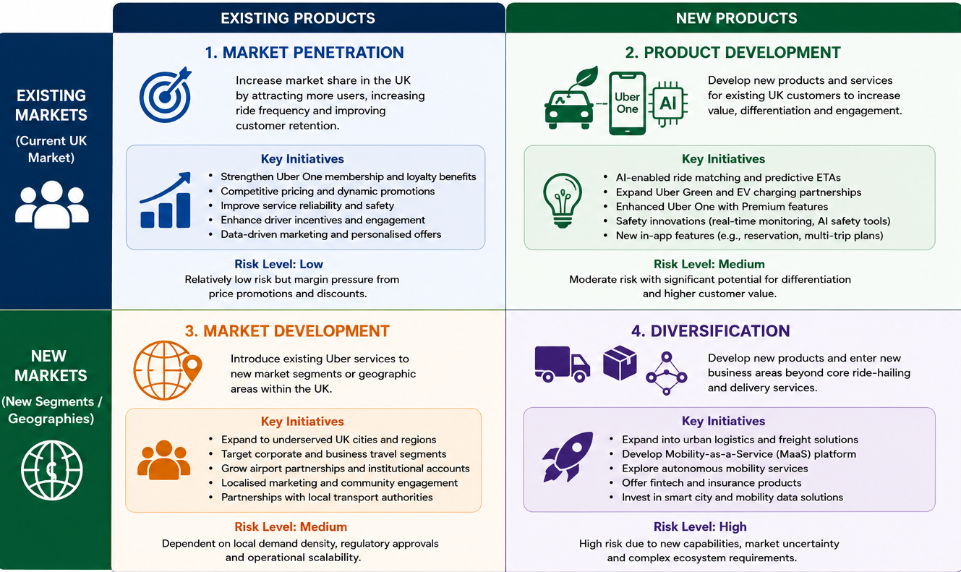
Figure 6: Ansoff Matrix for Uber UK's Strategic Growth Options (Author, 2026)

SAFe Evaluation
Johnson et al. (2023) suggest the suitability, acceptability and feasibility of strategic options. The AI-powered sustainable mobility strategy by Uber is appropriate because it tackles several of the factors that are identified externally (OECD, 2021) and that affect change in the technology, Net Zero goals, competitive pressure and regulatory requirements. It is acceptable if it can provide long-term value to customers, drivers, regulators and investors, but investment needs and labour issues must be managed carefully, including with the appropriate stakeholders (Yusuf, Rasheed and Lindseth, 2025). This is possible because Uber has the platform data, financial resources, AI power, brand, and strategic partnerships to effectively implement this (Uber, 2026a). Overall, the strategy is appropriate, broadly acceptable and feasible, with implementation risks being actively monitored and mitigated.
Criterion | Evaluation | Supporting evidence
Suitability | High | Responds to AI, Net Zero, competition and regulatory pressures identified through PESTEL and Porter’s Five Forces.
Acceptability | High | Creates value for customers, drivers, regulators and investors while supporting CSR objectives.
Feasibility | High | Supported by Uber’s financial capacity, AI capability, platform data, brand and strategic partnerships identified in VRIO.
Table 7: SAFe Evaluation of the Recommended Strategy (Author, 2026)

Recommended Strategy and Implementation Plan
This report suggests the creation of a sustainable mobility ecosystem with the addition of electrification, Uber One and intelligent mobility services. The first phase should focus on improving the efficiency and customer experience of AI-driven matching, demand forecasting and personalised recommendations (Hossain et al., 2025). The second phase should involve further development of Uber Green, with incentives for EVs, charging stations and increased adoption of zero-emission vehicles (Yusuf, Rasheed and Lindseth, 2025). The third phase should focus on enhancing the integration of Uber One in Mobility and Delivery, aiming to boost customer loyalty and repeat sales (Moskal, 2022). The fourth phase should be to build up independent mobility via carefully managed pilot partnerships, rather than to scale up successful ones across large cities in the UK (Department for Transport, 2025). To track strategic performance, KPIs should include EV journey share, average waiting time, customer retention, Uber One membership, driver participation, safety incidents and adjusted contribution margin.
Phase | Timeline | Key action | Performance measure
1 | Months 1–3 | Pilot AI matching and forecasting | Waiting time, matching accuracy
2 | Months 4–8 | Expand Uber Green and charging partnerships | EV journey share, driver adoption
3 | Months 9–12 | Integrate Uber One across services | Membership and retention
4 | Year 2 | Test autonomous mobility partnerships | Safety, cost and customer acceptance
5 | Year 3 | Scale successful initiatives across UK cities | Margin, market share and service quality
Table 8: Implementation Roadmap for the Recommended Strategy (Author, 2026)

Implementation Challenges, Change Management and Risk Mitigation
The adoption of the suggested strategy will likely encounter challenges such as regulatory hurdles, driver resistance, insufficient EV charging infrastructure, cybersecurity concerns, and the financial investment needs and algorithmic bias (Guerrero-Silva et al., 2025). If not handled properly, these challenges might slow down implementation, raise operational expenses and undermine the trust of stakeholders. Adopting Kotter's Eight-Step Change Model can help to effectively reinforce implementation by establishing a clear strategic vision, gaining stakeholder buy-in, communicating change effectively and providing a new way of working that is ingrained in the organisation's culture (Kotter, 1996). Uber should roll out phased pilot programmes, keep consulting with drivers, establish strategic partnerships, engage in targeted training, and ensure the governance of AI is transparent. The monitoring of the progress should be carried out using the Balanced Scorecard, which consists of indicators related to financial, customer, internal processes, and learning, to ensure that innovation does not increase the operational risk but instead improves operational service, regulatory legitimacy, and long-term competitive advantage (Bambang, 2024). This helps to minimise resistance, increase accountability and avoid quick growth that can compromise service quality, stakeholder trust, regulatory acceptance and financial discipline.

Conclusion
This report illustrates Uber's strategic assets, such as scale on its platform, AI in its operations, integration into various ecosystems, and brand recognition, all of which are well suited to continue to compete in the mobility market in the UK. However, external factors such as regulation, heavy competition, labour demands and sustainability criteria all point to the fact that technological superiority is not enough to guarantee a long-term competitive edge. The analyses indicate that product development based on sustainable mobility with the help of AI shows the highest strategic correlation as it fits in with the internal competences of Uber and the future opportunities offered by the environment. For effective implementation, it is important to have strong governance, stakeholder engagement, organisational learning and ongoing measurement of performance using the Balanced Scorecard. Ultimately, the success of Uber's future competitiveness will rely on how it can make innovation become a trusted value creation for all stakeholders, sustainable and socially responsible.

Section 2

Reflective Account
The process of preparing this report gave me the opportunity to learn the strategic management process beyond theory. I critically reflect on the process of researching, analysing and developing the report, the challenges I faced, the knowledge I acquired, and how this experience will help me to be a better academic and/or professional in the future, using Kolb's Reflective Cycle (1984).
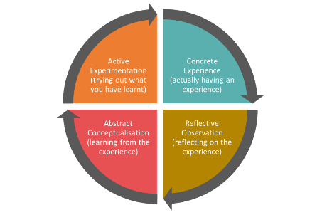
Figure 7: Kolb's Reflective Learning Cycle (Kolb, 1984)

Concrete Experience
I selected Uber since the company works in an industry with swiftly evolving technology, regulation, sustainability and customer expectations. I was keen on reading about a company that is well-known to many and is, however, far more complicated than it may seem. Initially, I believed that I would easily access information due to the fact that Uber is a multinational business. But I quickly realised that there was a lot of content and not everything was as credible.
In order to enhance the quality of my research, I resorted to the use of academic books, journal articles, annual reports, sustainability reports and investor publications of Uber. Academic sources assisted me in grasping the theories, whereas reports on the company provided me with evidence regarding the real strategy and performance of Uber. This mix enabled me not to make general statements and enabled me to relate theory and practice.

Reflective Observation
In the analysis process, I realised that I was originally treating the different frameworks as distinct tasks. PESTEL, VRIO, SWOT and the Balanced Scorecard were all completed one after another, though the report did not seem quite integrated. When reading through my work, I realised that the structures were more viable when they complemented each other.
To illustrate, PESTEL was used to recognise external forces, VRIO was used to evaluate the ability of the Uber company to counteract them, and SWOT was used to unite both. This simplified the analysis and made sense. I also realised that I was being too descriptive at times. It was necessary to go beyond what Uber does and begin to ask questions about whether its advantages were sustainable. This was particularly significant with regard to AI, network effects, driver dependence and regulation.

Abstract Conceptualisation
The greatest lesson that I have learned is that strategic management is not merely a matter of selection of models. It is concerned with evidence to know the interaction between various sections of an organisation. I learned that a good resource does not necessarily generate lasting benefit. It has to be hard to imitate, well structured and constantly improved. It also taught me the importance of critically questioning evidence rather than believing what the company is saying.
I also enhanced my knowledge of academic referencing. Sometimes, in the past, references were to me as evidence that I had read widely. In this report, I learned how to use sources for particular purposes. Barney was in favour of VRIO analysis, Freeman was used to clarify the duties of the stakeholders, and Kaplan and Norton were used to aid performance measurement. This rendered the references more purposeful and enhanced the argument.

Active Experimentation
If I completed the report again, I would start it earlier and systematise my sources at the very beginning. I would then use the reference-management software to isolate the academic theories, company evidence and industry data. This would be time-saving and would make the process of writing more organised.
I would also compare Uber to competitors in more detail and would utilise more trend data rather than focusing primarily on annual data. Above all, I would map out the connections between parts prior to composition. It was a lesson that a good report must read as a single argument, rather than a set of models. I am now more certain in my ability to be critical in the application of strategic theories and generate realistic recommendations supported and relevant to stakeholders.

References
Amajuoyi, C.P., Nwobodo, L.K. and Adegbola, M.D. (2024) ‘Transforming business scalability and operational flexibility with advanced cloud computing technologies’, Computer Science & IT Research Journal, 5(6), pp. 1469–1487. Available at: https://www.researchgate.net/publication/381717527_Transforming_business_scalability_and_operational_flexibility_with_advanced_cloud_computing_technologies (Accessed: 8 July 2026).
Ansoff, H.I. (1965) Corporate Strategy: An Analytical Approach to Business Policy for Growth and Expansion. New York: McGraw-Hill.
Ayodeji, Y., Rjoub, H. and Özgit, H. (2022) ‘Achieving sustainable customer loyalty in airports: the role of waiting time satisfaction and self-service technologies’, Technology in Society, 72, article 102106. Available at: https://www.researchgate.net/publication/363931247_Achieving_sustainable_customer_loyalty_in_airports_The_role_of_waiting_time_satisfaction_and_self-service_technologies (Accessed: 11 July 2026).
Bambang, M. (2024) ‘Implementation of balanced scorecard to achieve the company’s strategic objectives’, Eduvest, 4(3), pp. 818–826. Available at: https://www.researchgate.net/publication/379239449_Implementation_of_Balanced_Scorecard_to_Achieve_The_Company’s_Strategic_Objectives (Accessed: 8 July 2026).
Barney, J.B. (1991) ‘Firm resources and sustained competitive advantage’, Journal of Management, 17(1), pp. 99–120.
Bommenahalli, R. (2025) ‘Cybersecurity challenges in the electric vehicle industry: a technical overview’, International Journal of Scientific Research in Computer Science, Engineering and Information Technology, 11(1), pp. 1033–1041. Available at: https://www.researchgate.net/publication/388370093_Cybersecurity_Challenges_in_the_Electric_Vehicle_Industry_A_Technical_Overview (Accessed: 8 July 2026).
Bucchiarone, A., Battisti, S., Dias, T.G. and Feldman, P. (2021) ‘Guest editorial: diversification in urban transportation systems and beyond—integrating people and goods for the future of mobility’, IEEE Transactions on Intelligent Transportation Systems, 22(4), pp. 2008–2012. Available at: https://www.researchgate.net/publication/350514684_diversification_in_urban_transportation_systems_and_beyond_integrating_people_and_goods_for_the_future_of_mobility (Accessed: 11 July 2026).
Carbonara, N., Messeni Petruzzelli, A., Panniello, U. and De Vita, D. (2024) ‘Embracing new disruptions: business model innovation in the transition to mobility as a service (MaaS)’, Journal of Cleaner Production, article 142744. Available at: https://www.sciencedirect.com/science/article/pii/S0959652624021929 (Accessed: 9 July 2026).
Chung, H.D., Zhou, Y.M. and Choi, C. (2025) ‘When Uber eats its own business, and its competitors’ too: resource exclusivity and oscillation following platform diversification’, SSRN Electronic Journal, 46(2), pp. 411–435. Available at: https://www.researchgate.net/publication/380145957_when_uber_eats_its_own_business_and_its_competitors (Accessed: 8 July 2026).
Cristofaro, M., Helfat, C.E. and Teece, D.J. (2025) ‘Adapting, shaping, evolving: refocusing on the dynamic capabilities–environment nexus’, Academy of Management Collections, 4(1), pp. 20–46. Available at: https://journals.aom.org/doi/abs/10.5465/amc.2022.0008 (Accessed: 9 July 2026).
Čulík, K., Hrudkay, K., Kalašová, A., Štefancová, V. and Nedeliaková, E. (2022) ‘Impact of technological changes and taxi market regulation on taxi vehicle fleets—the case study of Slovakia’, Vehicles, 4(4), pp. 1158–1175. Available at: https://www.researchgate.net/publication/364401097_impact_of_technological_changes_and_taxi_market_regulation_on_the_taxi_vehicle_fleets-the_case_study_of_slovakia (Accessed: 8 July 2026).
Deberdt, R., Le Billon, P., Makinde, O., Dauvergne, P., Solwati, T., Razmi, S., Kumar, G. and Belhabib, D. (2025) ‘Artificial intelligence and ESG in resource-intensive industries: reviewing the use of AI in fisheries, mining, plastics and forestry’, The Extractive Industries and Society, 23, article 101690. Available at: https://www.sciencedirect.com/science/article/pii/S2214790X25000796 (Accessed: 8 July 2026).
Department for Transport (2025) Demand Responsive Transport. Available at: https://www.gov.uk/government/publications/demand-responsive-transport/demand-responsive-transport (Accessed: 9 July 2026).
Elkington, J. (1997) Cannibals with Forks: The Triple Bottom Line of 21st Century Business. Oxford: Capstone.
Fang, S. (2025) ‘Improvement of customer satisfaction and operational efficiency by data-driven management—a case study of Uber’, Journal of Innovation and Development, 13(1), pp. 227–232. Available at: https://drpress.org/ojs/index.php/jid/article/view/31873 (Accessed: 10 July 2026).
Freeman, R.E. (1984) Strategic Management: A Stakeholder Approach. Boston, MA: Pitman.
Ghomari, L.Z. (2025) ‘Artificial intelligence in intelligent transportation systems’, Journal of Intelligent Manufacturing and Special Equipment. Available at: https://www.researchgate.net/publication/388425997_Artificial_intelligence_in_intelligent_transportation_systems (Accessed: 11 July 2026).
Guerrero-Silva, J.A., Romero-Gelvez, J.I., Aristizábal, A.J. and Zapata, S. (2025) 'Optimisation and trends in EV charging infrastructure: a PCA-based systematic review', World Electric Vehicle Journal, 16(7), article 345. Available at: https://www.mdpi.com/2032-6653/16/7/345 (Accessed: 10 July 2026).
Guo, X., Haupt, A., Wang, H., Qadri, R. and Zhao, J. (2023) ‘Understanding multi-homing and switching by platform drivers’, Transportation Research Part C: Emerging Technologies, 154(3), article 104233. Available at: https://www.researchgate.net/publication/372582627_understanding_multi-homing_and_switching_by_platform_drivers (Accessed: 9 July 2026).
Hatoum, M.B., Nassereddine, H., Musick, S. and Eljazzar, M.S. (2023) 'Investigation of PESTEL factors driving change in capital project organisations', Frontiers in Built Environment, 9(1). Available at: https://www.frontiersin.org/journals/built-environment/articles/10.3389/fbuil.2023.1207564/full (Accessed: 10 July 2026).
Hitt, M.A., Ireland, R.D., Hoskisson, R.E. and Harrison, J.S. (2024) Strategic Management: Concepts and Cases. 14th edn. Boston, MA: Cengage.
Hossain, M., Ahmad, F., Aleem, M., Bask, A. and Rajahonka, M. (2025) ‘Emerging technologies in the sharing economy: a review and research agenda’, Technological Forecasting and Social Change, 218, article 124218. Available at: https://www.sciencedirect.com/science/article/pii/S0040162525002495 (Accessed: 8 July 2026).
Jerab, D.A. and Mabrouk, T. (2023) ‘Achieving competitive advantage through cost leadership strategy: strategies for sustainable success’. Available at: https://www.researchgate.net/publication/374000449_Achieving_Competitive_Advantage_through_Cost_Leadership_Strategy_Strategies_for_Sustainable_Success (Accessed: 11 July 2026).
Johnson, G., Regnér, P., Angwin, D., Whittington, R. and Scholes, K. (2023) Exploring Strategy. 13th edn. Harlow: Pearson.
Kaplan, R.S. and Norton, D.P. (1996) The Balanced Scorecard: Translating Strategy into Action. Boston, MA: Harvard Business Review Press.
Kolb, D.A. (1984) Experiential Learning: Experience as the Source of Learning and Development. Englewood Cliffs, NJ: Prentice-Hall.
Kotter, J.P. (1996) Leading Change. Boston, MA: Harvard Business School Press.
Lombardo, A. (2022) ‘The Uber challenge: a comparative analysis of regulatory schemes governing transportation app firms’. Available at: https://www.researchgate.net/publication/395264742_THE_UBER_CHALLENGE_A_COMPARATIVE_ANALYSIS_OF_REGULATORY_SCHEMES_GOVERNING_TRANSPORTATION_APP_FIRMS (Accessed: 9 July 2026).
Lubis, J. (2024) ‘How fuel prices, interest rates and exchange rates affect inflation and economic growth’, Growth, pp. 73–83. Available at: https://www.researchgate.net/publication/377392688_How_the_fuel_prices_interest_rates_and_exchange_rate_affect_inflation_and_economic_growth (Accessed: 11 July 2026).
Moskal, A. (2022) ‘Moving towards a sustainable digital future with Uber—a legitimate step towards a greener economy or merely greenwashing policy?’, Politeja, 19(3(78)), pp. 267–282. Available at: https://www.researchgate.net/publication/365751670_Moving_Towards_a_Sustainable_Digital_Future_with_Uber_-_a_Legitimate_Step_Towards_a_Greener_Economy_or_Merely_Greenwashing_Policy (Accessed: 10 July 2026).
Najjar, M.S. and Dahabiyeh, L. (2021) ‘Trust in the ride-hailing service of the sharing economy’, Journal of Organisational and End User Computing, 33(6), pp. 1–24. Available at: https://www.sciencedirect.com/org/science/article/pii/S1546223421000125 (Accessed: 9 July 2026).
OECD (2021) Transport Strategies for Net-Zero Systems by Design. Available at: https://www.oecd.org/content/dam/oecd/en/publications/reports/2021/11/transport-strategies-for-net-zero-systems-by-design_50206985/0a20f779-en.pdf (Accessed: 9 July 2026).
Olayode, I.O., Severino, A., Justice Alex, F., Macioszek, E. and Tartibu, L.K. (2023) ‘Systematic review on the evaluation of the effects of ride-hailing services on public road transportation’, Transportation Research Interdisciplinary Perspectives, 22, article 100943. Available at: https://www.sciencedirect.com/science/article/pii/S2590198223001902 (Accessed: 10 July 2026).
Porter, M.E. (1980) Competitive Strategy: Techniques for Analysing Industries and Competitors. New York: Free Press.
Porter, M.E. (1985) Competitive Advantage: Creating and Sustaining Superior Performance. New York: Free Press.
Santos, G. (2021) ‘Uber versus taxis’, Uber Versus Taxis, pp. 566–571. Available at: https://www.researchgate.net/publication/351691030_Uber_Versus_Taxis (Accessed: 9 July 2026).
Shepherd, N.J. (2025) ‘Gig economy workers’ rights: legal classification and social protection in digital labour markets’, International Journal of Law and Societal Studies, 2(1), pp. 24–35. https://doi.org/10.61424/ijlss.v2i1.379 (Accessed: 10 July 2026).
Srivastava, V.K. (2024) ‘Impact of corporate social responsibility (CSR) initiatives on brand reputation: a study of how CSR activities enhance brand reputation and consumer loyalty in sustainable marketing practices’, International Journal of Science and Research Archive, 13(1), pp. 1910–1930. Available at: https://www.researchgate.net/publication/384695217_Impact_of_Corporate_Social_Responsibility_CSR_initiatives_on_brand_reputation_A_study_on_how_CSR_activities_enhance_brand_reputation_and_consumer_loyalty_in_the_context_of_sustainable_marketing_practi (Accessed: 11 July 2026).
Transport for London (2024) FOI Request Detail. Available at: https://tfl.gov.uk/corporate/transparency/freedom-of-information/foi-request-detail (Accessed: 8 July 2026).
Uber (2024) Uber Autonomous Solution. Available at: https://www.uber.com/us/en/autonomous/ (Accessed: 10 July 2026).
Uber (2025) About Us. Available at: https://www.uber.com/us/en/about/ (Accessed: 10 July 2026).
Uber (2026a) Uber Apps, Products and Offerings. Available at: https://www.uber.com/us/en/about/uber-offerings/ (Accessed: 11 July 2026).
Uber (2026b) Understanding Algorithms and AI at Uber. Available at: https://www.uber.com/be/en/blog/understanding-algorithms-and-ai-at-uber/ (Accessed: 8 July 2026).
Uber Freight (2023) Achieving Better Load Matching with AI. Available at: https://www.uberfreight.com/en-us/blog/better-load-matching-with-ai (Accessed: 11 July 2026).
Uber Investor (2025) Uber Expands AI Data Platform to Power Next-Generation Enterprise and AI Lab Needs. Available at: https://investor.uber.com/news-events/news/press-release-details/2025/Uber-Expands-AI-Data-Platform-to-Power-Next-Gen-Enterprise-and-AI-Lab-Needs/default.aspx (Accessed: 10 July 2026).
Vargas-Hernández, J.G. (2020) ‘Uber’s strategy as a competitive business model of the sharing economy’, in Sharing Economy and the Impact of Collaborative Consumption, pp. 97–115. Available at: https://www.researchgate.net/publication/338302494_Uber’s_Strategy_as_a_Competitive_Business_Model_of_Sharing_Economy (Accessed: 11 July 2026).
Varghese, H. (2025) ‘The role of dynamic pricing strategies in e-commerce: a case study of Uber and its impact on consumer behaviour’, International Journal for Multidisciplinary Research, 7(2). Available at: https://www.researchgate.net/publication/390741837_The_Role_of_Dynamic_Pricing_Strategies_in_E-Commerce_A_Case_Study_of_Uber_and_its_Impact_on_Consumer_Behavior (Accessed: 9 July 2026).
Yusuf, O., Rasheed, A. and Lindseth, F. (2025) ‘Leveraging big data and AI for sustainable urban mobility solutions’, Urban Science, 9(8), article 301. Available at: https://www.mdpi.com/2413-8851/9/8/301 (Accessed: 10 July 2026).

Appendices

Appendix A: Uber Information on Platform Growth and Financial Performance
Sources:https://www.uber.com/bd/en/about/?uclick_id=72eccb6e-bb9d-4099-b64a-294906028de0
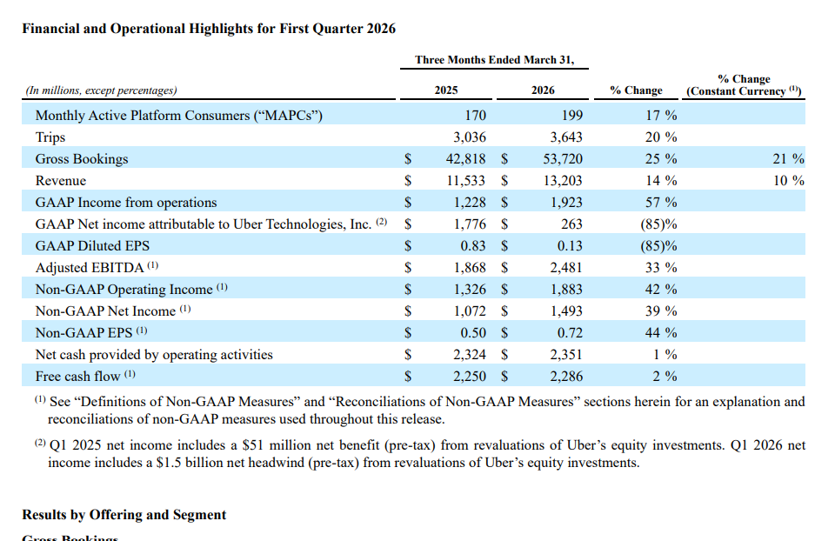
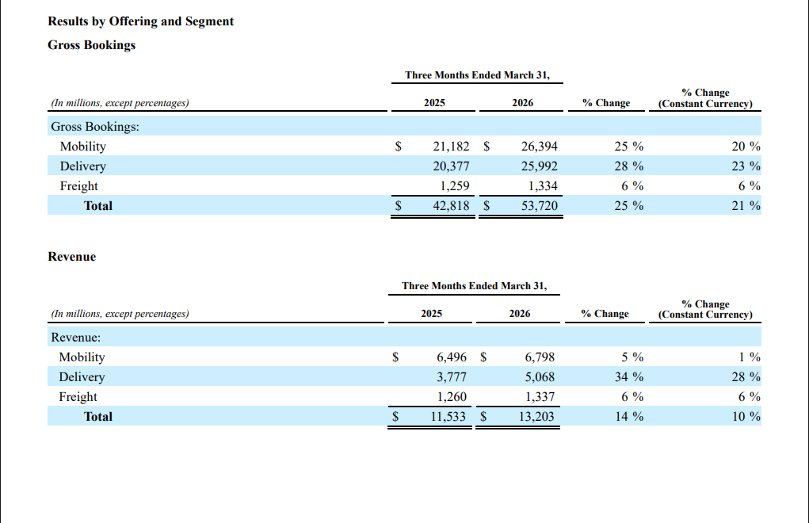

Appendix B: Uber Corporate and Sustainability Evidence


