Cover Page
Business Development Proposal Outline

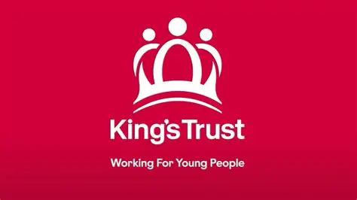
Programme: MSc International Business Leadership and Management – LCMB7037
Student Name: Alicia Naomi Blake
Student ID: 2208796
Title: Improving Youth Employability at The King’s Trust: Assessing the Feasibility of Coordinating Digital Skills, Mentoring and Employer Partnerships in Birmingham
Pathway: Path B — Business Plan for an Existing Organisation
Supervisor: Dr Ibrahim Rufai

Cover Page 1
Introduction 2
1. Company and Idea Description 3
2. Methodology 6
3. Market Research and Validation 9
4. Risks to the Researcher and the Project 11
5. Timeline: Gantt Chart 12
References 13
Appendix 18

Introduction
This proposal examines a potential business development opportunity within The King’s Trust’s UK employability provision. It focuses on disadvantaged young people aged 18–24 in Birmingham who are not in employment, education or training (NEET). The research will assess whether closer coordination between existing digital-skills support, mentoring and employer partnerships represents a feasible improvement. Using secondary evidence, it will consider strategic fit, operational requirements and financial feasibility before recommending improvements to existing provision, a targeted pilot or further investigation.

1. Company and Idea Description
Organisational background
The King’s Trust is a charitable organisation supporting young people aged 11–30 to develop confidence, skills and opportunities for progression into education, training, employment and self-employment. King Charles III, then Prince of Wales, founded the charity in 1976. The Royal Family, (2023). Originally known as The Prince’s Trust, it adopted the name The King’s Trust in October 2024 (The King’s Trust, 2025a; The Royal Household, 2018).
The UK charity is incorporated by Royal Charter and registered with the Charity Commission for England and Wales under charity number 1079675. Its trustees, collectively known as the Council, oversee its charitable purposes, governance and strategic direction. The organisation therefore has a charitable governance structure rather than commercial shareholders (The King’s Trust, 2025a, pp. 41–43).
The organisation also forms part of a wider international network. During 2024/25, The King’s Trust International supported 20,269 young people through 37 partners in 19 countries. The wider King’s Trust group of charities, including the UK organisation, supported more than 91,000 young people across 24 countries (The King’s Trust International, 2025). This provides organisational context; the proposed research remains focused on Birmingham.
Strategy, services and value proposition
The King’s Trust’s 2025–2030 UK strategy sets out a vision of ending youth unemployment. Its priorities include addressing inequality, developing the future workforce, strengthening advocacy and improving organisational sustainability. Commitments to digital capabilities, employer relationships and outcome measurement provide a strategic connection to this proposal (The King’s Trust, 2025b).
The King’s Trust combines personal development with practical support to help young people prepare for employment. Its Get Into programmes offer workplace-related training and job preparation, while Get Hired activities connect young people with employers who are recruiting. Mentoring provides additional guidance and encouragement (The King’s Trust, 2025a). The Trust also offers a Digital Skills unit to help young people develop practical digital capabilities (Kings Trust, 2025a).
Taken together, these services suggest a value proposition that combines youth-focused support, skills development and access to employer networks. The proposed project will investigate how these elements might work together more effectively for a defined local group. It will not assume that digital training, mentoring or employer engagement are absent.
Proposed business development opportunity
The proposed beneficiary group is disadvantaged 18–24-year-olds living in Birmingham who are NEET. This focus gives the project a defined age group and location.
Birmingham’s August 2026 claimant rate for 18–24-year-olds was higher than the corresponding regional and national rates, supporting investigation of employment-related need (Office for National Statistics, n.d.; see Table 1). The Trust also has a Birmingham centre, providing a local organisational setting for the study (Kings Trust, 2025a).
These sources support the choice of setting; they do not establish the size of the local NEET population or demand for a new programme. The research will examine barriers associated with low qualifications, limited work experience, financial constraints and access to suitable opportunities, informed by the distinction between individual factors, personal circumstances and external conditions in McQuaid and Lindsay (2005). Any eventual eligibility criteria would require further operational consideration.
The potential opportunity is closer coordination between existing digital-skills support, mentoring and employer opportunities. The research will examine published evidence of barriers to access, referrals and continuity of support. Published documents can provide incomplete or selectively reported evidence (Bowen, 2009). Accordingly, missing information will be treated as an evidence limitation rather than proof of a service gap.
For this project, digital skills means practical capabilities relevant to obtaining and undertaking entry-level work, including digital communication, online applications, basic workplace software and safe technology use (Department for Education, 2018). Specialist technology training is outside the proposed scope.
Depending on the findings, improvements could include clearer referral arrangements, preparatory digital learning, coordinated mentoring or employer-led activities. A targeted pilot would be recommended only where evidence supports additional provision. Its size, duration and delivery arrangements would depend on estimated demand, resources and partner capacity.
Theoretical foundation
Human capital theory provides a rationale for examining how education and training develop productive capabilities and employment prospects (Becker, 1964). Granovetter’s (1983) discussion of weak ties explains how connections beyond an individual’s immediate social circle can increase access to information and opportunities.
Together, these perspectives support examining skills development and employer networks. However, they do not establish that training and connections alone can overcome barriers such as insufficient vacancies, caring responsibilities or transport costs (McQuaid and Lindsay, 2005).
Research question
To what extent is closer coordination between digital-skills support, mentoring and employer partnerships a feasible business development opportunity for The King’s Trust’s provision for disadvantaged 18–24-year-olds in Birmingham?
Aim
To assess the strategic, operational and financial feasibility of improving coordination between digital-skills support, mentoring and employer partnerships for disadvantaged 18–24-year-olds in Birmingham who are not in employment, education or training.
Objectives
- Analyse published evidence of employment barriers and support needs affecting the target group.
- Evaluate existing employability provision and identify evidenced gaps or potential opportunities for improved coordination.
- Assess the feasibility of a proposed improvement, considering partnerships, delivery capacity, resources, costs and potential funding.
- Recommend whether to improve existing provision, develop a targeted pilot or undertake further investigation, identifying appropriate measures of success.

2. Methodology
Research design and scope
As agreed with the supervisor, the project will adopt a secondary-research case-study approach. Research design and the assessment of secondary evidence will be informed by Saunders et al. (2019). The King’s Trust will form the organisational case, with Birmingham as the geographical focus. The project will assess feasibility; it will not implement an intervention or measure its employment effects.
Regional and national research will provide context where local evidence is limited. Findings directly concerning Birmingham’s target group will be distinguished from broader evidence.
Evidence collection
Will include:
- The King’s Trust’s UK strategy, programme information, annual reports and financial statements, to examine its priorities, existing services, resources and financial position.
- The Charities Act 2011 and guidance from the Charity Commission for England and Wales, to inform the assessment of charitable purposes, public benefit, governance and reporting requirements.
- ONS/Nomis labour-market statistics and Birmingham City Council publications, to examine local employment-related need.
- West Midlands Combined Authority employment and skills research, to understand regional priorities and existing provision.
- Government policy documents and evaluation guidance, to assess policy alignment and appropriate outcome measures.
- Academic research and independent evaluations concerning employability, digital inclusion, mentoring and employer engagement.
- Published provider information and salary, premises and service-cost benchmarks, to compare services and inform realistic cost estimates.
The UK charity’s annual report and accounts will inform the organisational financial analysis (The King’s Trust, 2025a). The King’s Trust International’s accounts will provide background only and will not substitute for UK financial evidence.
A documented search strategy will use terms including “Birmingham youth employability”, “digital inclusion”, “employment mentoring”, “employer partnerships” and “sustained employment”. Sources will be assessed for relevance, methodology, publication date, geographical coverage and potential bias, drawing on guidance on document selection and appraisal (Bowen, 2009). Established theoretical literature will be retained alongside recent empirical evidence.
Analysis
Qualitative evidence will be coded and organised into themes covering access barriers, digital capability, referrals, employer involvement and progression support, drawing on Braun and Clarke (2006). These initial themes will be reviewed and refined as the evidence is analysed.
Quantitative evidence will be analysed descriptively, following general research-methods guidance (Saunders et al., 2019). Differences in age groups, dates, geographical boundaries and outcome definitions will be recorded before comparisons are made.
Strategic analysis will draw on the frameworks discussed by Whittington et al. (2023), adapted to The King’s Trust’s charitable context. PESTLE, SWOT, Competitor Analysis, Porter’s Five Forces and Ansoff’s Matrix will inform the business analysis, recognising the Trust’s relationships with beneficiaries, funders and delivery partners. These frameworks will structure the analysis; they will not, by themselves, demonstrate a service gap.
Using the Business Model Canvas framework (Strategyzer, n.d.), the research will describe the existing organisational model and identify how the proposed improvement would affect activities, partners, resources, costs and beneficiary value. Beneficiaries will be distinguished from the organisations and individuals financing delivery.
Financial analysis will examine the latest available UK organisational accounts, including the cash flow statement, alongside estimated improvement costs. The 2024/25 accounts provide an initial organisational source (The King’s Trust, 2025a); the research will check for a more recent report before completing the financial analysis. It will distinguish initial expenditure from recurring costs and assess alternative funding and delivery scenarios. Estimated affordability will not be presented as guaranteed financial sustainability.
Limitations
Documentary evidence may be incomplete and was usually produced for purposes other than this study (Bowen, 2009). Secondary research alone will therefore not be treated as confirmation of current participant preferences, employer commitments or internal delivery capacity. Recommendations will distinguish established evidence, reasonable inferences and assumptions requiring verification.
Local claimant statistics will indicate employment-related need but will not be treated as a measure of the NEET population. The Nomis profile identifies the claimant count separately from its survey-based employment and unemployment measures (ONS, 2024).
The Department for Education’s March 2025 parliamentary response identified sample-size limitations preventing publication of its survey-based NEET estimates for Birmingham’s 16–24 population (Department for Education, 2025).
To address this limitation, the study will combine local claimant and labour-market information with the Trust’s programme information, WMCA provision and wider employability research (ONS, 2024; The King’s Trust, 2025; WMCA, 2025; McQuaid and Lindsay, 2005). This will support an initial feasibility assessment rather than a precise estimate of Birmingham’s 18–24 NEET population.

3. Market Research and Validation
Initial local evidence
Table A1: National context and local evidence National research identifies a recent rise in the proportion of young people who are not in employment, education or training. Michael et al. (2026) find that administrative employment and benefit data broadly support this increase. Their analysis also suggests that the rise cannot be explained entirely by a general economic downturn. These findings provide context for investigating youth employability in Birmingham, but do not establish a gap in local services.
Birmingham’s claimant rate for 18–24-year-olds was 11.4% in August 2026, compared with 8.4% in the West Midlands and 5.9% in Great Britain (ONS/Nomis, 2026). The comparison indicates greater employment-related need in Birmingham but does not establish the size of the NEET population or a service gap. Appendix A, Table A1 provides the supporting comparison.

Stakeholders and existing provision
Table B1. Stakeholder groups and proposed research questions.
The research will examine the needs of young people, employers, referral organisations and funders. It will consider accessibility, employment requirements, referral arrangements and funding expectations. Appendix B, Table B1 sets out the proposed questions for each stakeholder group; these are areas for investigation rather than confirmed findings. Table 2 sets out the different stakeholder requirements the research will investigate. These are research questions rather than confirmed findings about stakeholder preferences.
Existing provision will be compared by target group, eligibility, location, delivery format, digital content, mentoring, employer involvement and participant charges. The comparison will include The King’s Trust and relevant local or regional providers, starting with published Trust programme information and the WMCA Youth Employment Plan (The King’s Trust, 2025a; WMCA, 2025).
The WMCA Youth Employment Plan already includes employer-related pathways for young people. YouthPath, launched in February 2025 with Movement to Work, connects NEET young people aged 18–30 with employers (WMCA, 2025).
The proposed research will therefore assess existing initiatives as potential partners and possible sources of overlap before recommending additional provision. Programme eligibility and availability will require confirmation before any implementation.
Digital skills, policy and demand
The Department for Education’s Essential Digital Skills Framework will inform the assessment of practical capabilities relevant to employment (Department for Education, 2018).
Lindsay’s (2005) research highlights how unequal access to technology and skills can affect online job seeking. As this is an older study of Glasgow, it provides a conceptual rationale for investigating digital barriers rather than current evidence of their prevalence in Birmingham.
Local vacancy information and published skills research will help assess employer requirements. Vacancy advertisements will indicate advertised demand but will not be treated as evidence that employers have committed to this proposal.
The Government’s Get Britain Working White Paper provides policy context for coordinated employment support (DWP, 2024). Policy alignment will not be interpreted as confirmation of funding.
Validation criteria and decision
The research will assess whether the proposed improvement addresses an evidenced local need and adds value beyond existing provision. Options will be compared by accessibility, delivery capacity, cost and potential benefit to young people.
The analysis will consider whether improved referrals between existing services could meet the need before recommending a separate pilot. Where evidence is insufficient, the recommendation will identify the information required before implementation.
Potential outcome measures include participation, completion, digital competence, job entry and employment retention. These would support evaluation of a future intervention; the dissertation will assess feasibility rather than measure impact. Before-and-after changes alone would not establish causal impact (HM Treasury, 2026).

4. Risks to the Researcher and the Project
Table 3 identifies the main research and potential delivery risks, together with proportionate controls. It distinguishes risks arising during the dissertation from those associated with implementing a future recommendation.
Table C1. Initial research and proposed delivery risk assessment.
The main research risks are excessive workload, limited local evidence, inconsistent data and researcher bias. Controls include maintaining the agreed scope, checking source definitions, documenting assumptions and considering alternative recommendations. Potential implementation risks include uncertain funding, limited partner capacity and accessibility barriers. Appendix C, Table C1 presents these risks and the proposed controls. The project timetable will show the planned research activities, their duration and the sequence for completing the Business Development Proposal. It will include evidence collection, analysis of existing provision, application of business models, financial assessment, drafting, feedback and revision.

5. Timeline: Gantt Chart

- Timeline (Gantt chart). Click the link below.
Gantt Chart
Figure D1. Business Development Proposal research timetable.
The research timetable covers evidence collection, analysis, feasibility assessment, drafting and revision. Appendix D, Figure D1 presents the full Gantt chart, showing the planned activities, their duration and overlap, including time for feedback.

References
Becker, G.S. (1964). Human capital: A theoretical and empirical analysis with special reference to education, first edition. NBER. Available at: https://www.nber.org/books-and-chapters/human-capital-theoretical-and-empirical-analysis-special-reference-education-first-edition?utm (Accessed 27 September 2026).
Bovaird, T. (2023). Strategic management and marketing in public service organizations. Public Management and Governance, pp.79–102. https://doi:10.4324/9781003282839-9.
Bowen, G.A. (2009). Document analysis as a qualitative research method. Qualitative Research Journal, 9(2), pp.27–40. https://doi:https://doi.org/10.3316/QRJ0902027.
Braun, V. and Clarke, V. (2006). Using thematic analysis in psychology. Qualitative Research in Psychology, 3(2), pp.77–101. https://doi:10.1191/1478088706qp063oa.
BERA (2024). Ethical guidelines for Educational Research, fifth edition (2024). Available at: https://www.bera.ac.uk/publication/ethical-guidelines-for-educational-research-fifth-edition-2024 (Accessed 27 September 2026).
CHARITY COMMISSION (2022). The King’s Trust Group Company - charity 1200643. prd-ds-register-of-charities.charitycommission.gov.uk. Available at: https://register-of-charities.charitycommission.gov.uk/en/charity-search/-/charity-details/5201055/governing-document (Accessed 7 October 2026).
Department for Culture, Media and Sport (2025). Government unveils ambitious plan to tackle youth isolation crisis and deliver real life opportunities. GOV.UK. Available at: https://www.gov.uk/government/news/government-unveils-ambitious-plan-to-tackle-youth-isolation-crisis-and-deliver-real-life-opportunities (Accessed 6 October 2026).
Department for Education (2018). Essential digital skills framework. GOV.UK. Available at: https://www.gov.uk/government/publications/essential-digital-skills-framework/essential-digital-skills-framework (Accessed 27 September 2026).
GOV.UK (2024). Get Britain working white paper. Available at: https://www.gov.uk/government/publications/get-britain-working-white-paper/get-britain-working-white-paper (Accessed 22 September 2026).
GOV.UK. (2026). Major new package of support for Young People announced with kings trust. Available at: https://www.gov.uk/government/news/major-new-package-of-support-for-young-people-announced-with-kings-trust (Accessed 6 October 2026).
Granovetter, M. (1973). The strength of weak ties: A network theory revisited. Sociological Theory, 1(6), pp.201–233. https://doi:10.2307/202051.
HM Trasury. (2025). Magenta book: Central government guidance on evaluation (HTML). Available at: https://www.gov.uk/government/publications/the-magenta-book/magenta-book-central-government-guidance-on-evaluation-html (Accessed 26 September 2026).
IMPACT Report. (2025). The Kings Trust. The Kings Trust. Available at: https://kingstrustinternational.org/wp-content/uploads/2025/11/Y1080-KTI-Impact-Report_FINAL.pdf (Accessed 25 September 2026).
Kings Trust (2024). The king’s trust | confidence, courses, careers. Kingstrust.org.uk. Available at: https://www.kingstrust.org.uk/ (Accessed 25 September 2026).
Kings Trust (2025a). Digital Skills (PDE). Kingstrust.org.uk. Available at: https://education.kingstrust.org.uk/en/units/detail/4FOvopcdPrhaQWG26yPPf8 (Accessed 7 October 2026).
Kings Trust. (2025b). Our 2025 to 2030 strategy | the king’s trust. Available at: https://www.kingstrust.org.uk/about-us/our-strategy (Accessed 25 September 2026).
GOV.UK (2011). Charities act 2011.Legislation.gov.uk. Available at: https://www.legislation.gov.uk/ukpga/2011/25/contents (Accessed 7 October 2026).
Lindsay, C. (2026). Employability, services for unemployed job seekers and the digital divide - strathprints. Strath.ac.uk. Available at: https://strathprints.strath.ac.uk/40094/ (Accessed 25 September 2026).
McQuaid, R.W. and Lindsay, C. (2005). The concept of employability. Urban Studies, 42(2), pp.197–219. https://doi:10.1080/0042098042000316100.
Michael, J., Waters, T. and Xu, X. (2026). Why has the NEET rate risen? Understanding trends and drivers using administrative data. IFS. https://doi:10.1920/re.ifs.2026.0030.
ONS (2024). Labour market profile - nomis - official census and labour market statistics. Nomisweb.co.uk. Available at: https://www.nomisweb.co.uk/reports/lmp/lad/1778385147/report.aspx?utm (Accessed 25 September 2026).
Powell, A., Francis-Devine, B. and Foley, N. (2026). Youth unemployment statistics. commonslibrary.parliament.uk. Available at: https://commonslibrary.parliament.uk/research-briefings/sn05871/ (Accessed 25 September 2026).
Saunders, M., Lewis, P. and Thornhill, A. (2019). Title: Research methods for business students author. Available at: https://amberton.edu/wp-content/uploads/2024/07/RGS6035_E2_Fall2024.pdf (Accessed 27 September 2026).
The King’s Trust (2025a). Annual Report and Accounts 2024/25. The King’s Trust . Available at: https://assets.ctfassets.net/qq0roodynp09/7l8lx8RwNdcL5lERtP2Xox/a9c686cc2ca8639bfa8544fd3e549b6a/King-s_Trust_Annual_Report_2024-25.pdf (Accessed 25 September 2026).
The King’s Trust (2025b). Building a future that works for young people our 2025 -2030 UK strategy. The Kings Trust. The Kings Trust. Available at: https://assets.ctfassets.net/qq0roodynp09/7gEucIbAX83Q49Bhisay6v/9e9b6748d581a21007d0ed8d9f2eb661/DSN5704_KT_strategy_2025-30_Final_accessible.pdf (Accessed 25 September 2026).
The Royal Family. (2018). The prince of Wales’s charities. Available at: https://www.royal.uk/clarencehouse/prince-of-wales-charities (Accessed 25 September 2026).
The Royal Family. (2023). Charities founded by his majesty the king as the prince of Wales. Available at: https://www.royal.uk/news-and-activity/2023-11-10/charities-founded-by-his-majesty-the-king-as-the-prince-of-wales (Accessed 8 October 2026).
UK Parliament. (2025). Written questions and answers - Written questions, answers and statements - UK Parliament. Available at: https://questions-statements.parliament.uk/written-questions/detail/2025-03-19/39542?utm (Accessed 25 September 2026).
WMCA (2024). Employment and skills strategy 2024 - 2027. Available at: https://www.wmca.org.uk/documents/productivity-skills/employment-and-skills-strategy-2024-2027/employment-and-skills-strategy-2024-2027/ (Accessed 27 September 2026).
WMCA. (2025). WMCA Board approves £1.2bn budget to drive growth, jobs, housing and better transport. Available at: https://www.wmca.org.uk/news/wmca-board-approves-1-2bn-budget-to-drive-growth-jobs-housing-and-better-transport/ (Accessed 25 September 2026).
World Desk, T. (2026). How king Charles III used his navy severance pay to start a youth charity that grew far beyond him. The Times of India. Available at: https://timesofindia.indiatimes.com/world/uk/how-king-charles-iii-used-his-navy-severance-pay-to-start-a-youth-charity-that-grew-far-beyond-him/articleshow/131387929.cms (Accessed 25 September 2026).

Appendix
Appendix A
Table 1. Claimant rates for people aged 18–24, August 2026.
Area | Claimant rate
Birmingham | 11.4%
West Midlands region | 8.4%
Great Britain | 5.9%
(ONS/Nomis, 2026).
Appendix B
Table 2. Stakeholder groups and proposed research questions.
Stakeholder | Issues to examine
Young people | Accessibility, support needs, participation barriers and progression opportunities.
Employers | Entry-level skills requirements, recruitment needs and capacity to support activities or placements.
Referral organisations | Eligibility, referral processes and continuity between services.
Funders | Strategic fit, delivery costs, measurable outcomes and sustainability requirements.
McQuaid and Lindsay (2005), The King’s Trust (2025b) and HM Treasury (2026).
Appendix C
Table 3. Initial research and proposed delivery risk assessment.
Risk area | Potential risk | Proposed response
Researcher workload and wellbeing | Excessive scope or emotionally demanding material. | Focus on Birmingham and ages 18–24; use milestones, breaks and supervision.
Research ethics | Sensitive information in published sources. | Avoid unnecessary personal details and follow university guidance BERA, (2024).
Evidence quality and availability | Missing data or misleading comparisons. | Check definitions, distinguish local from wider evidence and disclose gaps (Bowen, 2009).
Bias and unsupported conclusions | Assuming a service gap or favouring a pilot without sufficient evidence. | Examine conflicting findings, separate evidence from assumptions and consider alternatives (Bowen, 2009).
Financial feasibility | Underestimated costs or uncertain funding. | Include full costs and test alternative financial scenarios.
Future delivery | Low participation or insufficient staff and partner capacity. | Assess recruitment, support and resources; confirm partners before implementation.
Accessibility and safeguarding | Digital exclusion or unsuitable placements. | Assess technology access, accessible delivery and placement safeguards.
(Bowen, 2009; BERA, 2024; Lindsay 2005).
Appendix D
Figure D1. Business Development Proposal research timetable.
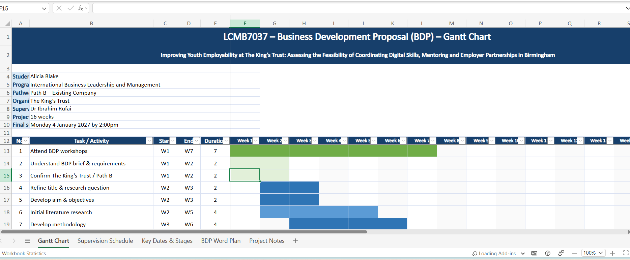
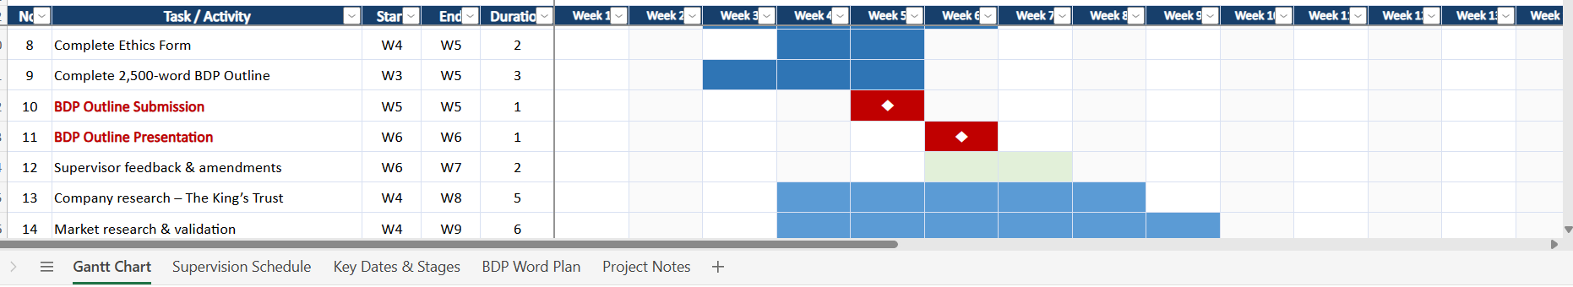
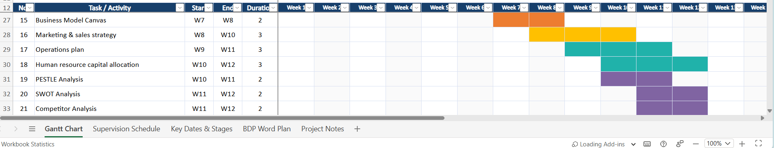
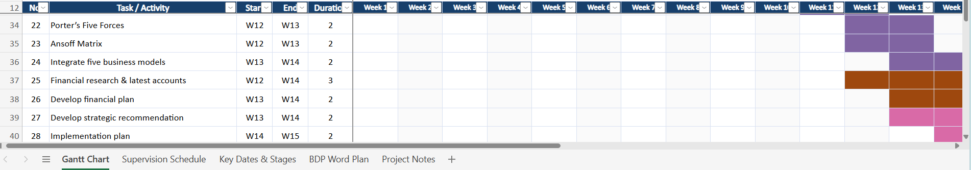
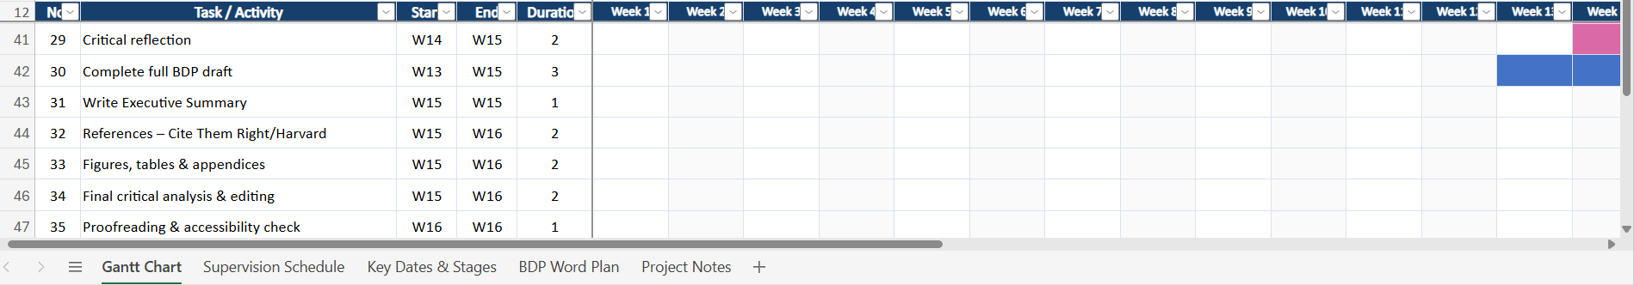
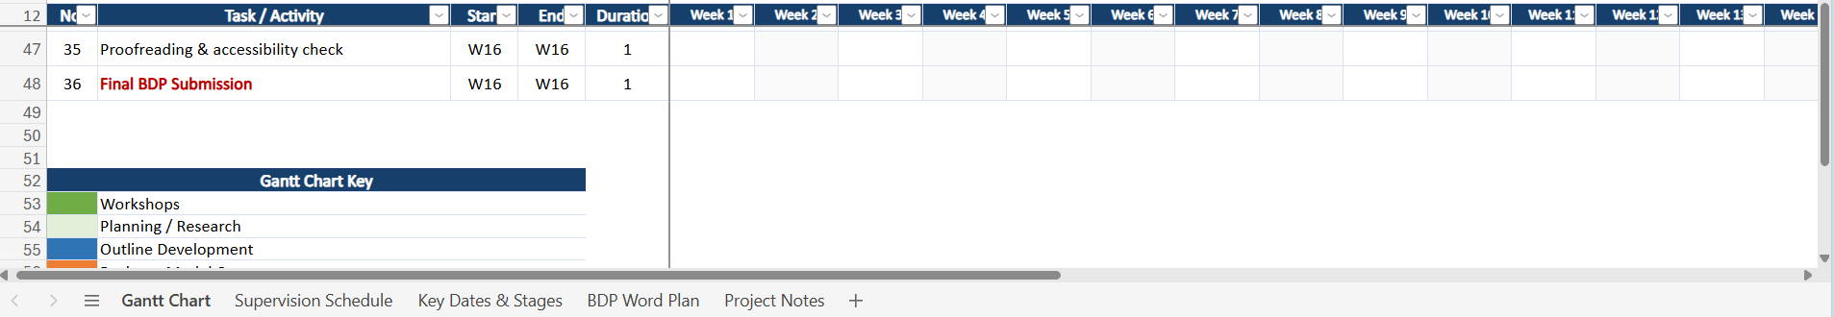
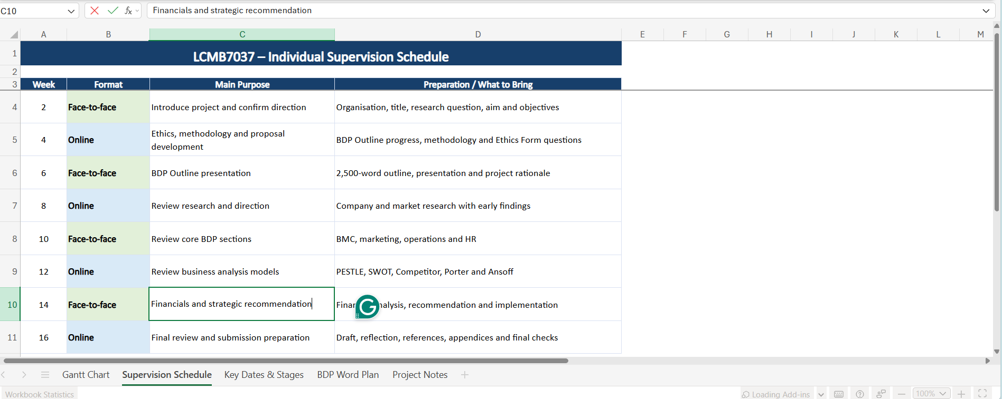
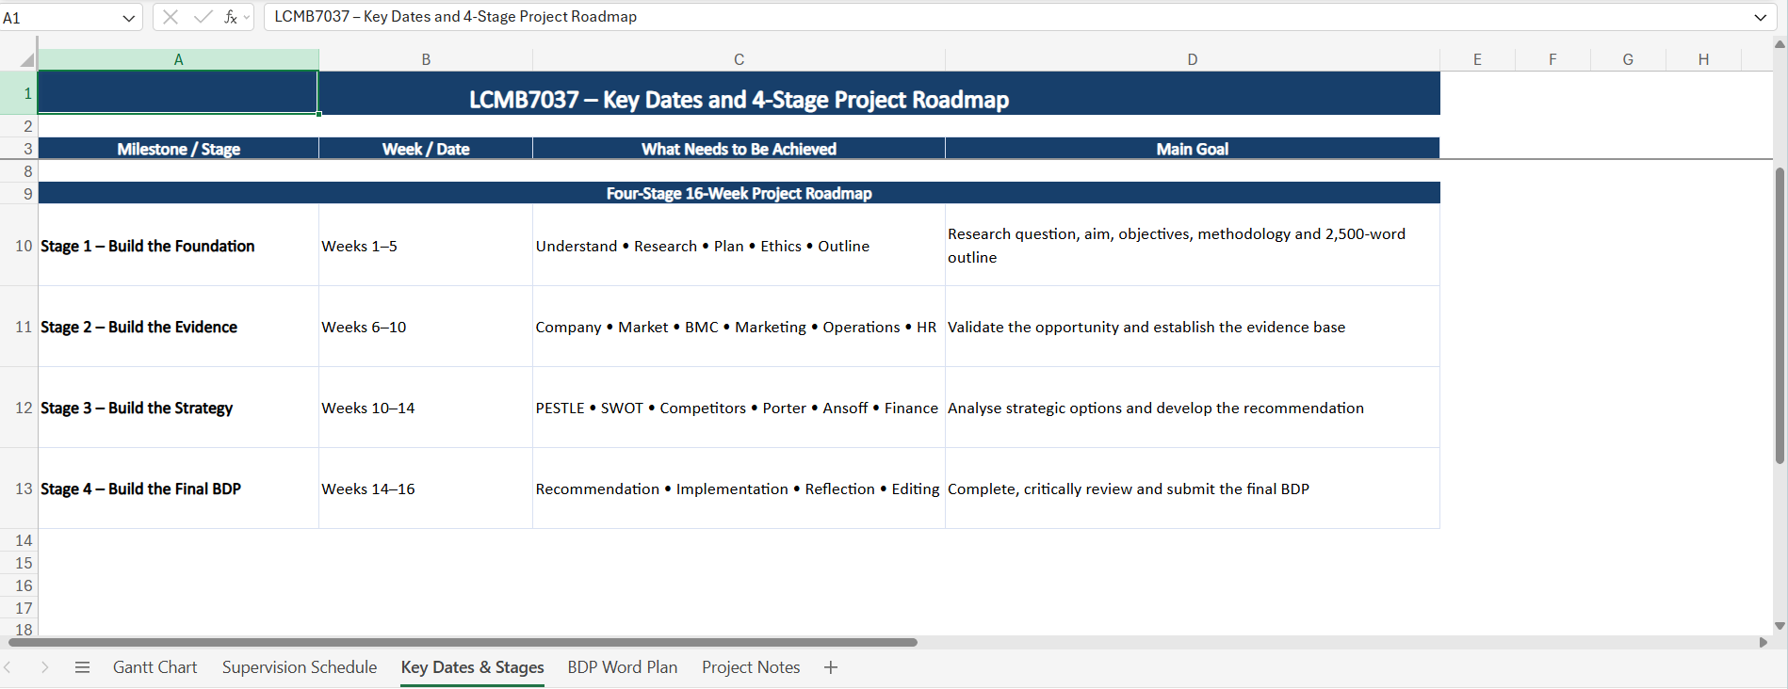

Planned structure of the final 15,000-word BDP
The completed business plan will follow the required assignment structure:
- Executive Summary
- Company Description
- Market Research and Validation
- Business Model Canvas
- Marketing and Sales Strategy
- Operation Plan
- Human Resource Capital Allocation
- Business Analysis Models
- Financial Plan
- Reflection
- References
- Appendices, where required

