Ellise Lewis
1702836
Graphic Design
Donna Williams

‘How does social media have such an impact on today’s society and a young person’s
mental health? Does Design play a role?

5594 words

Introduction
Social media has become a massive influence in people’s day to day lives. According to Soren Gordhamer (2009), “social media communication tools have profoundly changed our lives and how we interact with one another and the world around us.” (Gordhamer, 2009) Through social media we are able to connect with people from all over the world, it’s a powerful source for research, marketing and also for educational purposes, but despite the small pros to social media such as bringing people together around the world or even boosting confidence in people who struggle with face to face interactions, there comes a lot of cons which can do more harm than good, in particular, cyberbullying and online trolling. A majority of people will wake up in the morning and the first thing they do is look on social media. Throughout the days they will scan through social media and also a person’s ‘relaxing’ time will involve scrolling through Facebook, Instagram, snapchat and other social media sites. Booher (2014) speaks about her morning routine, “Every morning, my eyes pop open with the thought, “I need to post.” Not I need to eat, call home, pray — but post.” (Booher, 2014) individuals are becoming so invested in virtual reality that the majority of us will often forget that life around us is passing. “Social media is on the rise to becoming the most harmful addiction”. (Pilcher, 2018) Social media for today’s generation has become the most addictive addiction and people are losing touch of life itself and focusing more on the façade that social media portrays. Social media is such a powerful platform and a great way to bring others together. However, in my opinion, it is important to understand the negative impacts that can occur with social media such as bullying, anxiety and other personal issues.

Social Media
Social media started in the 1970s. The first social idea was the BBS which stood for bulletin board system which was small servers that connected from a personal computer to a mobile phone. It allowed people to have community conversations, play games and also allowed people to upload and download files. It wasn’t social media as we have today, but it was the closest they got to it. Social media’s popularity increased during the ’90s when the ‘world wide web’ became accessible to masses. My space (2003) was the largest trend that was first discovered and also the main concept around social media. It was made to allow individuals to have ‘profiles’ and chat with friends. It was becoming more acceptable to put your identity up for the world to see. “As the Internet became a necessary tool for everyday life, people began to let go of the fear of revealing their real identity.” (Sundheim, 2011)
The rise of users who have access to social media has skyrocketed over the last 10 years by a substantial amount. In 2010 social media users were at 0.9 billion and throughout a decade it has already risen to 2.8 billion users. Throughout time more and more people will have access to social media and the increase in users will just rise. “In 2018, an estimated 2.65 billion people were using social media worldwide, a number projected to increase to almost 3.1 billion in 2021.” (Clement, 2019)
Research has shown that the most used social media site in 2019 is Facebook and there are 2.32 billion active users. “it’s safe to say that nearly every social media user is on Facebook.” (InfluenerMarketing, 2019) Facebook is a great platform if you enjoy sharing your life with friends and family. You can share, like posts, upload pictures and even talk to people from all around the world. The second biggest social media site is Instagram which is an obvious one as it “is the fastest-growing social network platform.” (InfluenerMarketing, 2019) Instagram now has over 1 billion monthly users which are coming close to Facebook. Then the third biggest social platform is Twitter. Twitter is great for staying up to date with the top trends and also is one of the best platforms to express yourself. Twitter isn’t as popular as Facebook and Instagram, but it does have a different style on how it is used.

Figure 1 - Who is more active on social media? Men or Women?
One question that I really wanted to research was which gender was more active when using social media. This can be a major question for business people and companies as if they are trying to reach a certain customer then they need to know what type of social media they need to use. This website shows that women are using social media 4% more than men. Women seem to use social media to keep in touch with friends and family and also to just flick through wasting type whereas this research shows that men use more on video sites, job websites and websites such as google plus.
There are many different dangers when it comes to social media. As social media is internet based there is a high chance that your personal information can be accessed one way or another. Privacy issues is a common danger that many social media users face. When starting a new social media account, the questions usually ask for your name, email address, date of birth, gender and many more personal questions yet we never question ourselves to why they ask for such confidential information. Individuals would never just start telling random people on the street what our date of birth was so why is it so normal for us to instantly answer all these questions?
“In an offline world, social communities tend to follow and practise the norms of privacy. You don’t have to share your birthday, address or marital status with the people in your neighbourhood.” (Zaki, 2017)

As social media has risen throughout the last decade, so has the risks. It is now in our second nature to check all of our social media’s. “We mindlessly scroll through hundreds of posts. We comment, we react, we ‘like’ and we ‘share’. (Zaki, 2017)
Users are now so dependent on using it daily that some block out all the dangers social media comes with. Social media has restricted privacy terms so even if a user believes their profile is private it will never fully be shut out to people you don’t know. Photos, messages, search history and anything an individual has clicked on will always be able to be found in some way. “They find out about your habits, your browsing history, where you like to go, what you like to eat and who you interact with the most.” (Zaki, 2017)
Another big issue is for the ‘young and gullible’, many youths in this era haven’t known life without social media. They have been brought up with computers, phones, twitter, Facebook etc. The younger generation are using social media more than any other generation, “Around 91% of 16-24 year olds use the internet for social networking. They use social media now more than ever before.” (Zaki, 2017) This age group give away more personal information than any other and get sucked into the dangerous gaming and trends online. “There have even been cases where suicide games were trending online, that children all encouraged each other to participate in. It can be a dark and unpredictable place.” (Zaki, 2017) Although social media can be a great source of communication for people, Users do need to remember that social media is just one big façade an individual has a life to live outside of Instagram.
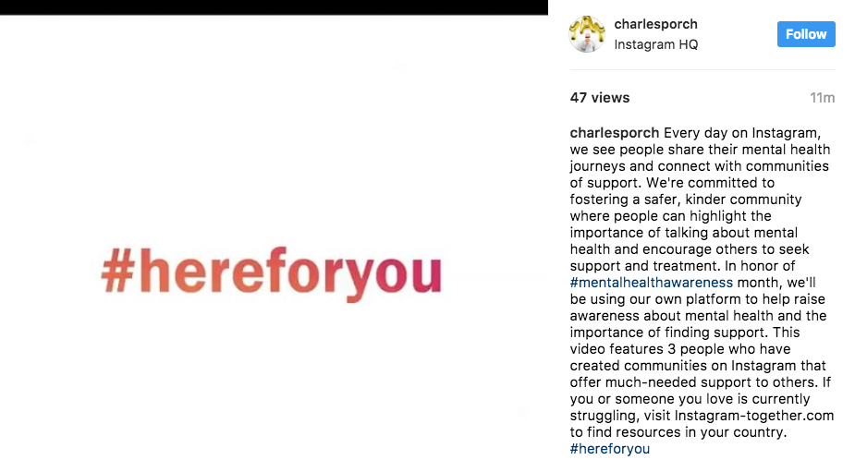

Figure 2 - #HereForYou
#HereForYou (fig 2) is a campaign was launched by Instagram to shed light on mental health. Many are hesitant to speak yet is one of the biggest issues in nearly every person’s life. This hashtag is to try and bring people together and help each other through social media. It’s always important to speak to someone otherwise the build-up can make you break down. “it’s so important that we talk about mental health – so we can break down the stigma and make it easier for everyone to get help when they need it.” (Mcnamara, 2017) Social media can be an incredible thing for promoting mental health as it’s a great platform to bring awareness to the issue, it brings people together every day by just speaking about their struggles or even a simple visual can speak a thousand words. “Through an image, people can communicate how they're feeling, making even the most invisible struggles more visible to friends and family.” (Levine, 2017)

Mental health
Social media is mainly affecting the younger generation as more teenage/ young adults spend most of their days using social media platforms. Rachel Ehmke (date) has found studies that prove how social media is impacting youth’s health. “A survey conducted by the Royal Society for Public Health asked 14-24-year-olds in the UK how social media platforms impacted their health and wellbeing.” (Ehmke, n.d.)
In some cases, social media can be great for an individual as it may help with making friends, being more active in activities and may even help with personal issues. On the other hand, more young adults are experiencing anxiety, depression and other disorders because of the rise of social media. “The survey results found that Snapchat, Facebook, Twitter, and Instagram all led to increased feelings of depression, anxiety, poor body image, and loneliness.” (Ehmke, n.d.)
Teenagers start becoming more and more dependent on how many likes their photos/videos get, more teenagers are experience cyberbullying and also more teenagers are experiencing disorders such as eating disorders because of how Instagram portrays celebrities and influencers, “They need to gain “likes” on social media can cause teens to make choices they would otherwise not make, including altering their appearance, engaging in negative behaviours, and accepting risky social media challenges.” (Hurley, 2019)
The differences between the younger and older generation are that most of the older generation wasn’t brought up with any type of social media platform so they had to experience life without television, computers, WIFI, and mobile phones, “older users have been especially enthusiastic over the past year about embracing new networking tools.” (Madden, 2010)
Social media has an impact on everyone’s mental health whether it’s for good or bad. It has brought people together and has created a ‘new style of communication for us’ but on the other hand, it has completely changed individuals’ behaviours and their outlook on society. “The daily use of social media by people has increased so much that it is slowly injecting an inflection into our behaviour.” (Indibrian, 2018)
Social media is becoming almost impossible to avoid online bullying, negative influences and a fake outlook on life, with social media’s negative influences, more people are suffering from anxiety and stress. “People become unhappy with their current circumstances, leading to problems with self-esteem.” (Indibrian, 2018)

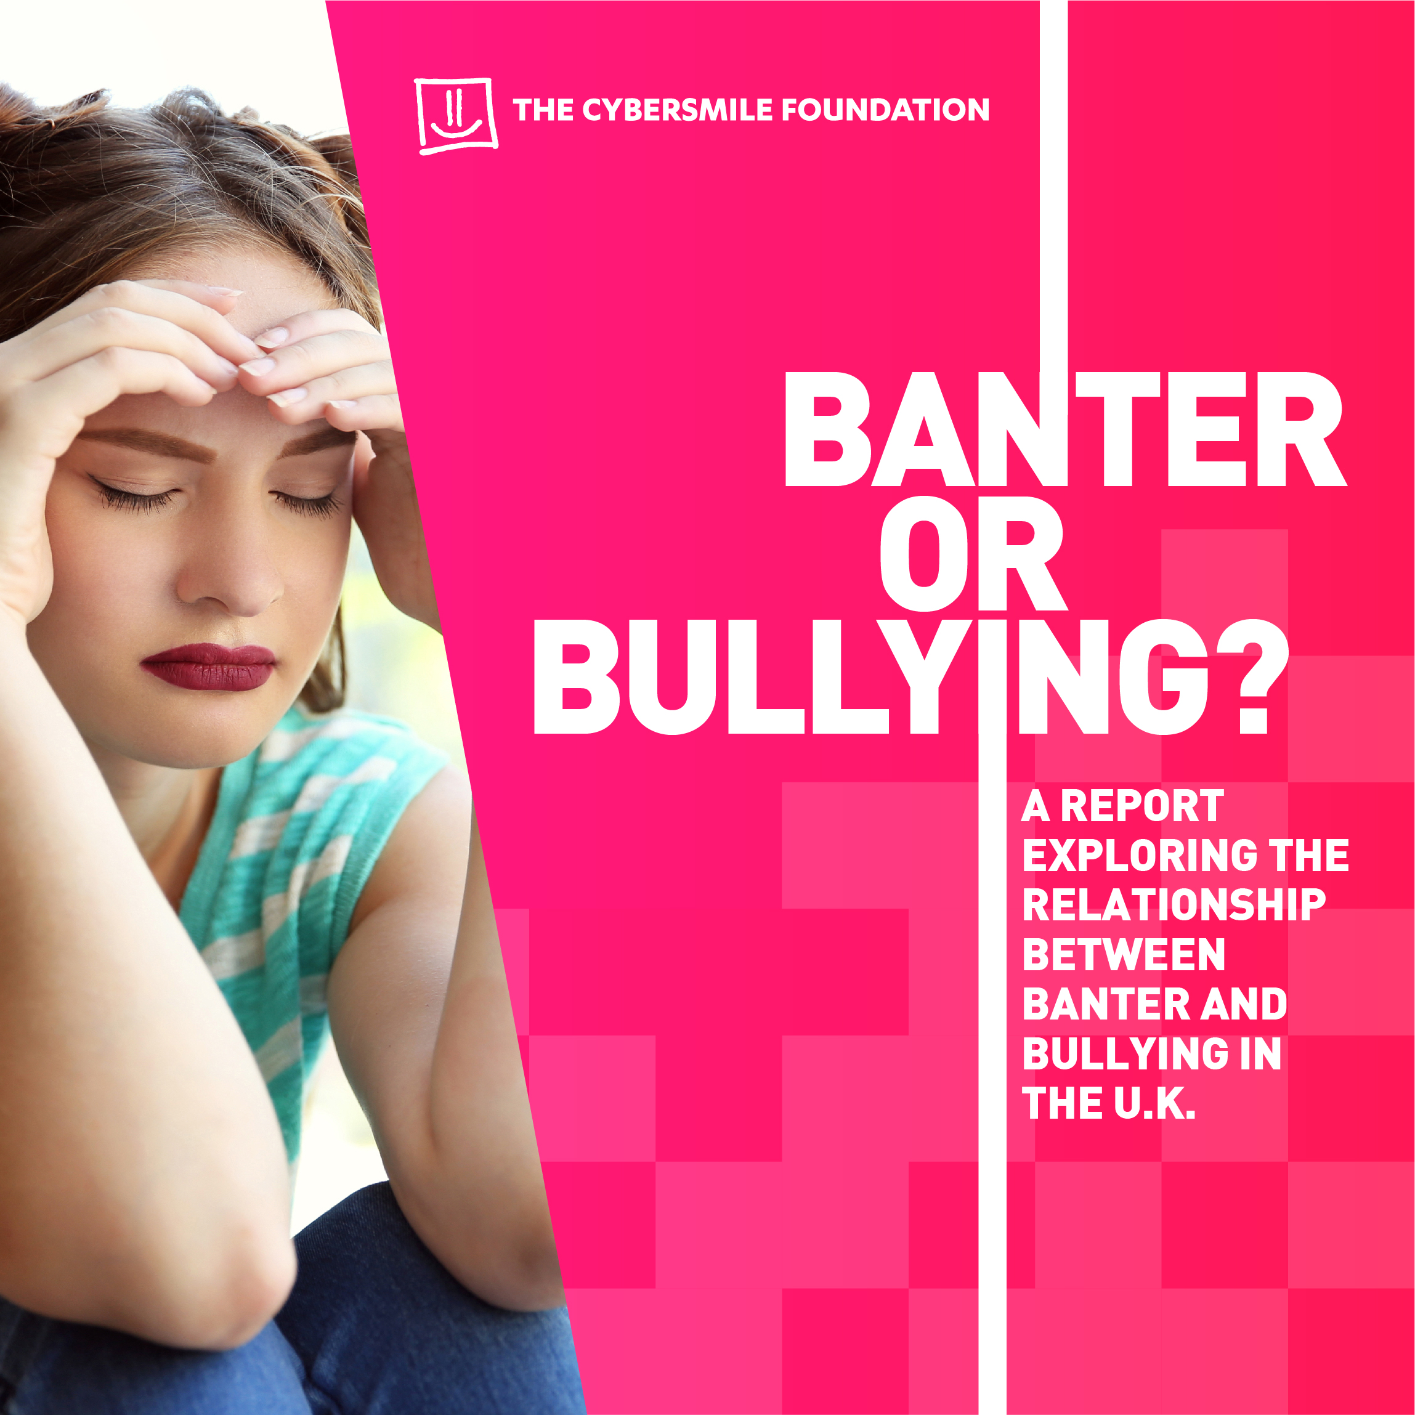

Figure 3 – Banter or Bullying?
The word 'banter' is a slang word that has grown popular over the years, it initially means ‘playful or teasing’. Banter is supposed to make you laugh if used correctly. There is a fine line between banter and bullying. Some individuals think that being snide or malicious is just ‘having a bit of banter’ when it’s a cover-up of a form of bullying. ‘The Cybersmile Foundation’ (Cybersmile 2010) is a campaign that is trying to help people learn the relationship between bullying and banter. They worked in partner with Instagram to create a report on this issue. “Banter or Bullying? Study asked 3001 respondents aged 13-18 a series of 11 questions to share their thoughts on the fine line between banter and bullying while exploring the effects of banter on the wider community.” (Cybersmile, 2010) This report was aimed at the younger audience to see if they were aware of how their tone was projected on social media and if they thought banter was just an innocent way of making fun of someone or something. After Cybersmile foundation carrying out a survey, they found “47% of respondents said they had personally been left upset or insulted by banter on at least one occasion.” This statistic shows 47% of respondents, which is almost half of all the people they surveyed believed they had been left upset after ‘banter’ which is quite a high percentage of individuals.
This foundation aims to empower social media users to try and tackle online bullying and shut down cyberbullying.
Cyberbullying is one of the biggest problems that comes from social media. A majority of social media users are being bullied on their social media in one way or another and have impacted so many people throughout young adults and yet no consequence seem to come to any of the bullies. “Social media companies should take complaints more seriously. If someone reports something, they shouldn't take days to review it.” (BBC, 2018) Most individuals who are suffering from anxiety or depression through social media have all been targeted by a cyberbully whether it is a nasty comment or constant harassment. “Although these things that are hurtful are not being said online, saying them online can amount to just as much hurt and maybe even more.” (Russell, 2017)
New studies have found that many youngsters are becoming more vulnerable
using social media as cyberbullying is at an all-time high, “cyberbullying makes young people more than twice as likely to self-harm or attempt suicide.” (Knapton, 2018) Cyberbullying is leaving damaging effects ‘one third’ of younger users. Online bullying can be anything from threats, humiliation or even intimidating messages which is leaving some users risking their own lives as they believe that is the only way to end the torment. “They found that cyberbullying raised the risk of self-harm or suicidal behaviour 2.3 times.” (Knapton, 2018) More needs to be done to stop online bullying. Professor Ann John, (John date) Swansea University Medical School believes that to prevent cyberbullying you need to put in school anti-bullying policies and online support for victims on online bullying.
One story that I came across was a teenager name Hannah Smith who committed suicide due to online bullying. In 2013 Hannah Smith was just 14 years old when she passed away as a cause of cyberbullying, social media is great for bullies because they can sit behind a screen and torture people for the way they are or how they look without thinking twice about it. Hannah’s family are tried for years to make a stop to this devasting act. “How many more teenagers will kill themselves because of online abuse before something is done?” (Smith, 2013) It is extremely frightening to see how cyberbullying can affect a person to the extent of thinking death is the only way out, especially for a young child who could have had an incredible life ahead of her. I believe cyberbullying should be a sentence, if someone has taken their own life due to another individual pushing them to that extent then they should be charged the same as murder.
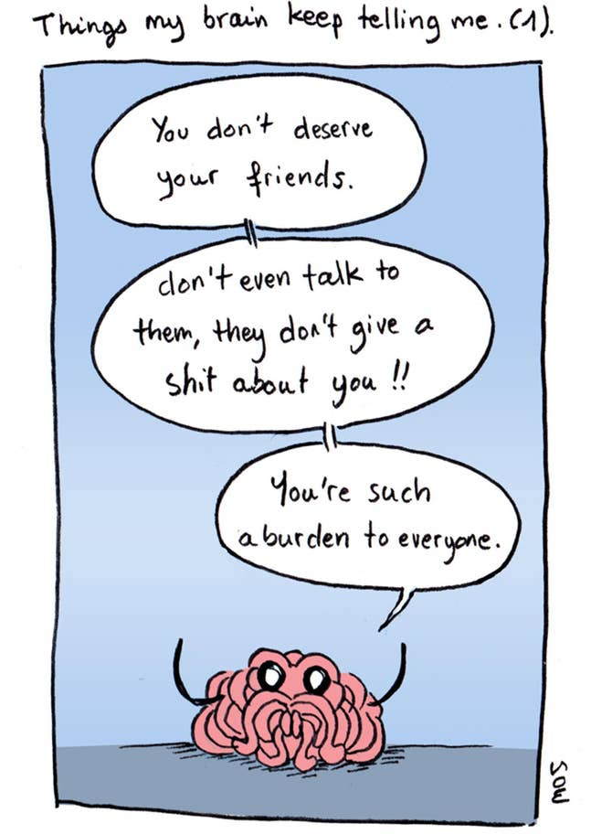
Loneliness

Figure 4 – Things my brain keeps telling me.
Loneliness can be a horrible issue to deal with, whatever age you are. The majority of people will feel lonely throughout their lives and everyone’s experiences are different as each is personal reasons. Some individuals may live a very independent life and enjoy spending most of their free time alone and even may live alone, but to another individual, this could be the hardest thing in the world as they depend on the comfort of others around them, like family and friends. But whether you’re an independent person or a dependent person, sometimes you can still feel loneliness as the mind can take someone to that place. Loneliness can separate a person from the world. Feeling lonely doesn’t mean someone has mental health problems as everyone in a stage of their lives will feel this way but a person who suffers from mental health may struggle immensely when that person becomes lonely. Being able to speak to someone whether it’s a friend or a professional is always a great way to tackle feeling lonely as the individual can open up the negative feelings and connecting with another individual. If the feeling doesn’t shift for a while the person can start to suffer from anxiety as the individual may feel no one wants them around and that can make it even harder to pull out of that dark feeling. “I want to be able to interact with people and make new connections, but my anxiety feels like an invisible barrier that I can’t breakthrough.” (Mind, 2019)
There are many reasons why a person becomes lonely. For some, it may be linked to a loss, changing your lifestyle; jobs or moving away and even breaking away for a relationship or friendship. To other individuals it could feel a lot different, it may be feeling like you have no one, maybe they don’t have any family or friends or finding it hard to maintain a social life. To a certain extent, some people may feel lonely because of abuse, whether physical or mental.
In my opinion if someone is feeling disconnected from the world, then that person may start to use social media a little more to interact and break away from feeling lonely, but slowly social media can bring you back into that lonely space as it will start to drag you away from the reality that little bit more. An individual may feel great as your mind it in another place- in the mind, but as soon the computer or phone is shut down the problems will still be there.
In my opinion ... social media is a great technology if used in moderation. It’s like being on a diet, if an individual starts to wobble on the diet then they will start to gain weight and get fatter, well social media is a similar concept. When someone starts to use social media more and more instead of sticking to a plan, then you’re going to become more addictive and become more closed off from the world. “That lack nutritional value, an excessive intake of social media may be bad for your health.” (Nobel, 2018)
Some individuals have a positive outlook from social media as it has some good attributes but now studies are trying to indicate if social media is bringing more loneliness to others rather than happiness. “In a survey exploring social media patterns, it was found that individuals who spent more time on social media every day felt lonelier than those who spent less time engaged in social media.” (Shainna Ali Ph.D., 2018) Being so involved on social media can isolate individuals from others without that person realising. There’s a lack of effort from the individual, they become more distant and less social to be around.

Anxiety
Anxiety is an anxious or worried feeling. It makes you feel uneasy. Anxiety can be mild or severe. Some people start having anxiety if they are nervous about a job interview or if they have a test – which is perfectly normal. Others have anxiety which can affect them massively through their day to day lives. Having anxiety can make it hard to control your worries and it can leave you feeling very upset or even annoyed.
Anxiety can be triggered by more or less anything. It can be because of a life event or it can be caused by stress. There are proven ways (NHS, 2018) to reduce your anxiety such as breathing techniques to calm yourself down, changing your sleep pattern. Sleep can affect your anxiety as your body is exhausted. Also surrounding yourself with positivity is a great way to reduce anxiety.
Social media does have a role to play when it comes to anxiety. There has been research to show that social media users are facing more anxiety because there is more pressure when it comes to social media now. People do tend to suffer from insecurities because of Instagram and Facebook because people try to sugar coat their lives and please others. “Over half of the social media users polled said Facebook, Twitter, and other networking sites had changed their lives -- and 51 percent of those said it's not been for the better.” (Fitzgerald, 2012)

Self Esteem
Self-esteem is basically how we view ourselves. It is how much you like and value yourself, for some this can be extremely hard as we all seem to pick out the negatives in ourselves, but some can be very critical about themselves which can cause a lack of self-worth. It is always so simple to pick out the things we like about another person. Is it really hard for some individuals to find good attributes about themselves? For some people, it is hard allowing yourself to like things about yourself because you do not want to come across as if you have a big ego, which I feel is how everyone feels. Some individuals have a terrible self-image of themselves and will see something completely different from what others around them will see, they could be the most generous, kind-hearted person and they will still negatively view themselves. “My self-esteem has almost disappeared... I don't know how to interact with people anymore and find it hard to enjoy the things that I like.” (Mind, 2019)
For some individuals, social media plays a significant role in their self-esteem as they can be whom they want online, they can choose what to say about themselves and what they want to put. People’s perception of them would be greater online. But studies have shown that social media has impacted people’s self-esteem, anxiety, loneliness and has also decreased their social skills. Social media is a great platform to only show off the best parts of your life- the best parts of your relationship, holidays, social outings and we get so caught up in the façade of their lives that we start to question our own, is our relationship good enough? Why can’t I afford lavish holidays? Questioning our own lives can decrease our mood dramatically and start to make us feel almost worthless. “it seems that social media is creating a paradox effect: giving off the illusion of many choices while making it harder to find viable options. Can it be that our highly connected world has now become disconnected? (Silva, 2017) Social media can lower your self-esteem as a person may feel that someone is pretty than you, or they have more online friends than another person or even envying their lifestyle. One campaign that is trying to tackle self-esteem is the less is more campaign.
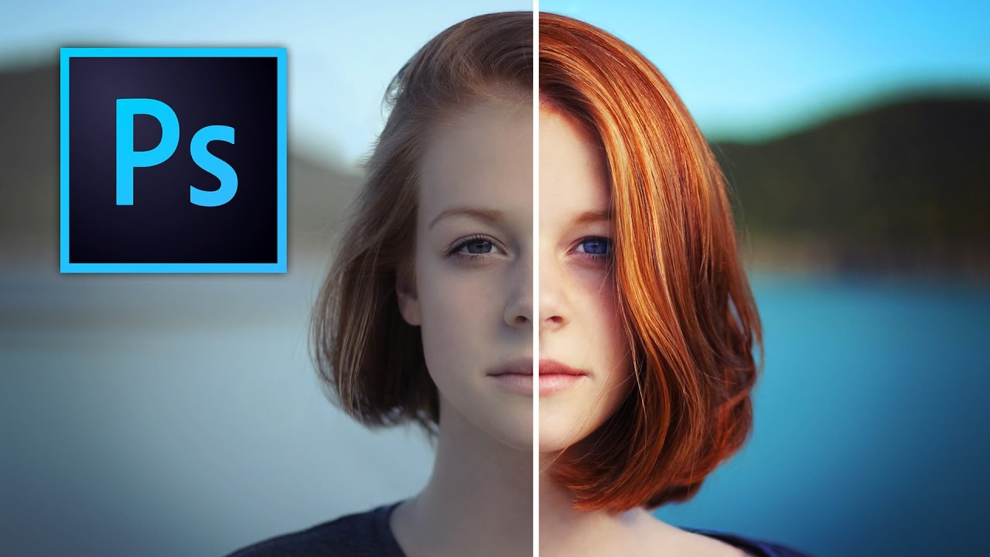

Figure 4 – Less is more.
Less is more being a campaign that was built by the ‘RAW beauty’ brand, which was launched in 2015. The campaign was aimed mostly towards magazines and to try to minimise the use of photoshop being used on their images. Photoshopping someone can make their entire look different and individuals start to pick at themselves for not having flawless skin and big pouty lips like they do in these pictures. It influences the younger generation as they get brought up looking at these images and doubting themselves and questioning their own appearances. “This campaign ensured that young women and men do not get influenced by society and media’s set definition of beautiful.” (AGGARWAL, 2018) The hashtag from this campaign was created to stop the hate around women and their bodies. People started shaming women’s bodies because they didn’t look the way some women looked on social media, many celebrities are also trying to stop the airbrushing when putting photos online, celebrities like Chrissy (2015) has vowed to stop using photoshop tools because she believes her blemishes and cellulite have created wonderful memories in her life such as given birth to her two children, she also wants people to start looking ‘normal’ again. “I have those apps, those Facetunes, those Photoshopping ones, and I just didn't feel like doing it anymore, and I'm never doing it again, because I think we forgot what normal people look like now. The standard is so ridiculous." (Teigan, 2015)
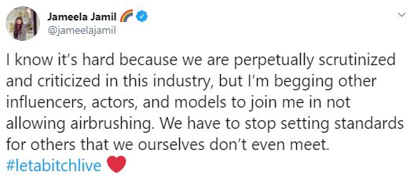

Figure 5 – Jameela Jamil Twitter.
Jameela Jamil has also spoke out to other celebrities to stop using airbrush and photoshop tools as she believes we are setting standards for other women that we can’t meet, she tweeted “I know it’s hard because we are perpetually scrutinized and criticized in this industry, but I’m begging other influencers, actors, and models to join me in not allowing airbrushing.” (Jamil, 2019)

Visual Designs
As you can tell by all the visual campaigns I have included, I believe design plays a significant part in how you portray an issue. Without the visual designs and wording, the campaign wouldn’t be able to entice the audience in. A good campaign will sit in someone’s mind and really make a person think about that issue. There are many ways you can create a campaign, but a good design will know what type of visual design needs to be used for an issue. “A visual communication campaign targets one or more common goals using strategic visual content. It is a series of branded media that lives within a defined art direction” (Tra, 2016)
The campaigns that I have researched into have got some beautiful and meaningful ideas behind them. Some of the visuals use just words, some have illustration strips to create a scene, some have word and image. I believe that design is a powerful source for bringing light to an issue, we use design in everyday life. “Design is one of the most powerful forces in our lives, whether or not we are aware of it, and can also be inspiring, empowering and enlightening,” (Heller, 2014)
I think the campaigns can work greatly for the younger generation because campaigns can pop up when your using social media, pop ups of small adverts addressing the issue between videos are useful. Campaigns can be used nearly everywhere whether it’s on the side of a street or on the tiniest of phones.
Making teenagers and young adults aware of protentional issues from social media is the main result in the visuals I have researched into.

Discussion
Throughout writing this essay I have recognised that social media can be portrayed in many different ways. Although social media has some positive attributes, my inquiry into this subject is to tackle how mental health is negatively affecting individuals. Social media is such a huge part of our life that we need to be taking more precautions when using these sites. Children are starting to use social media at a very young age that professionals should be more invested in safeguarding to look after the next generation's mental health and prepare them for the cruel world around social media.
Many campaigns have been going on throughout the last few years, and many celebrities have started campaigning to stop cyberbullying.
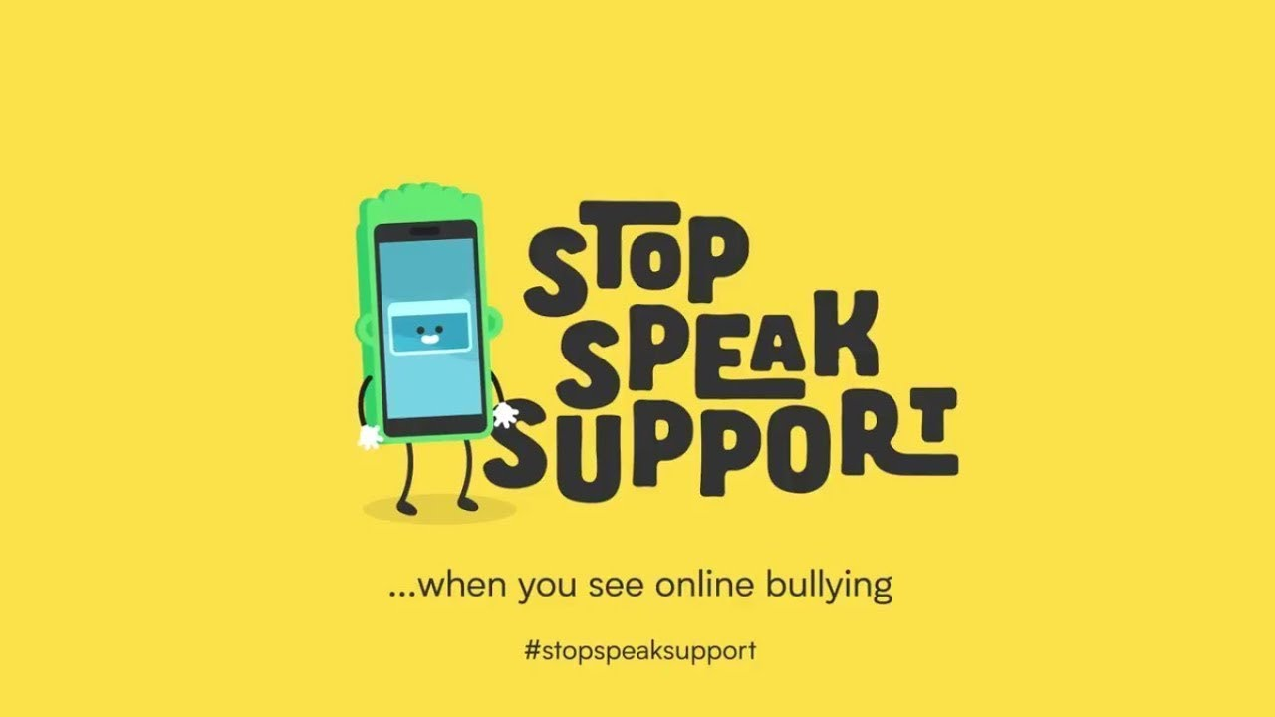

Figure 6 – Stop, Speak, Support
Stop, Speak, Support is a campaign about cyberbullying. It was established by the Duke and Duchess of Cambridge with Prince Harry also being involved. They worked closely with the technology to create something that would be useful in reducing cyberbullying. The campaign is based mainly at 11-16 year olds as they are the best target group, even though the majority of them are using social media a lot, if they can notice the signs of online bullying then they can put an end to it before it blows up and potentially become dangerous. It encourages children to realise how cyber bullying impacts a child’s mental health. Some people believe it’s just ‘banter’ but if something is starting to affect you in a massively and it hurts your feelings then it’s not bantering anymore, and it becomes more serious and points more towards bullying. The campaign has a code of conduct which is called ‘stop, speak support’. Many people have supported this throughout the last year and it is being spoken more from Kensington Palace, “A statement from Kensington Palace said Prince William hoped the plan would reach every 11 to 16-year-old in Britain and empower them to stop cyberbullying and seek support.” (thirdsector,2017) By having big influences supporting this campaign then it may shine some light on the cause. (https://www.youtube.com/watch?time_continue=13&v=RGcLa-vyxVQ&feature=emb_logo)

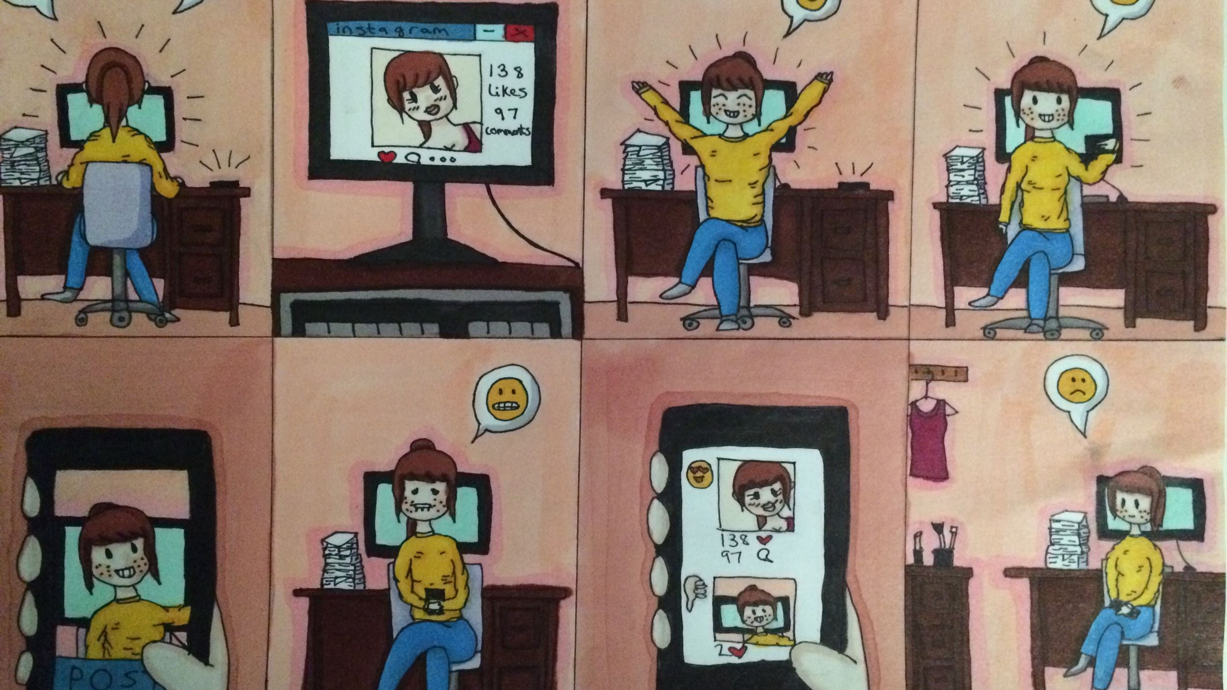

Figure 7 – Life on the web.
This campaign is called ‘Life on the Web’. It’s a campaign to try a tackle the pressures of social media on today’s society. The campaign tackles more than just cyberbullying, it brings awareness to social media addiction, body image, online privacy, and FOMO which stands for ‘fear of missing out’, FOMO gives many individuals anxiety that something is happening, and they are worried that they are always missing out.
I feel the outcome to this campaign is successful as they created useful cartoon strips, included students in the bullying video, and also spoke about their lives around social media. The activists for this campaign shared their lives on social media and also off of social media and how differently each was. “Through the #LifeOnTheWeb campaign, young people shared their own experiences and advice about the mental health effects of the internet.” (YoungMinds, 2016)
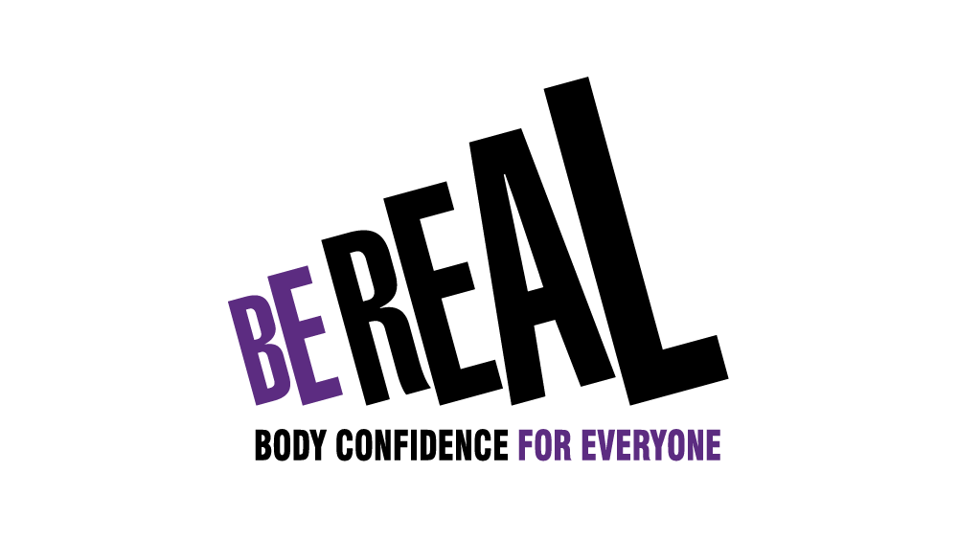

Figure 8 – Be real
‘Be Real’ is a body confidence campaign that is trying to change the attitudes about body confidence whether it’s on social media or just in life. It’s to put us on a path of happiness and however, we look as long as we are happy in our skin then that’s all that matters. All you see online is snide comments on the way a woman’s stomach looks or how a man has dressed, some individuals seem to pick out all the negatives instead of seeing someone’s appearance as a beauty. “We know that low body confidence is damaging people’s lives. It affects everyone – all ages, both sexes – and starts young.” (Preston, 2014) For this campaign, the best way to promote body confidence is by starting with education and with the younger generation. If we start giving small children and young teens confidence, then it will follow them throughout life. Making parents set positive examples for their children with how they live their lives. “The Be Real Campaign is determined to change attitudes to body image and help all of us put health above appearance.” (Preston, 2014) By bringing positivity to all different bodies then it may help most of us become body confident and allow all of use to be happy with the way we look. It doesn’t matter how someone else sees you, as long as you like what you see in yourself.

Conclusion
My discussion was based on how mental health has impacted the younger generation and how visual design has helped bring awareness to the issue. My research and statistics I have been able to bring forward strong evidence to each chapter. To be able to answer my question properly, I have backed it up using articles and statistics which show how social media has developed over the years and how it has impacted the majority of user’s daily lives. From the research I have included I have found that with social media comes many varieties of issues whether it is good for some and bad for others. I have backed up my discussion using quotes and visuals. From looking into research from the BBC and also HuffPost’s the perception around social media is mainly based around people mental health and how individuals need to be aware of the negatives. I discovered much more than what I thought I would when I first started researching about my discussion. I found many issues around cyberbullying, anxiety/depression and also body image. Although social media carries many qualities for some individuals, everything always comes with risks and the research in my discussion show that sadly our mental health is the main area that becomes affected. My discussion wasn’t necessarily to beat down social media and deny the benefits around it because I, myself love social media in moderation, but it was to make individuals more aware of the possibilities of social media affecting them in a negative way. As many say, everything is fine in moderation. Although my discussion was answered using professional research, I wanted to incorporate visual designs and how the impact people’s perception on an issue. Throughout my discussion I have included campaigns which are made from visuals. Without visual design, I feel that many issues couldn’t come across appropriately. Word and image are the best way to bring awareness and it can be used in any way the designer feels. I think as designers have progressed over the years so have campaigns and its bringing even more public appreciation to the issues behind the visuals. Throughout independent inquiry I have fully explained different matters in the mental health and social media sectors. I have gone in depth and back up everything I have said using the appropriate evidence. I have made it clear that social media is a great tool for businesses and also for people who feel like their lives are better with social media, but my question was to look into the negative impacts, so I have also included a well thought out comparison towards the issue. Including both positive and negative into my discussion shows that I am not just one sided on the matter. I want people to be more open minded towards social media and I also want people to start looking after their mental health and realise when something is impacted their mental health.

Illustration reference
Figure 1:
Figure 2: Instagram. (2017) #HereForYou
Available at: https://www.huffingtonpost.ca/2017/05/09/instagram-mental-health-campaign (Accessed: 20 November 2019)
Figure 3: Cybersmile. (2018) Banter or Bullying?
Available at: https://www.cybersmile.org/news/banter-or-bullying-a-report-exploring-the-relationship-between-banter-and-bullying-in-the-u-k
(Accessed 15 November 2019)
Figure 4: Raw
Figure 5
Figure 6
Figure 7
Figure 8

Bibliography
(www.mashable.com), “. m. c. t. h. p. c. o. l. a. h. w. i. w. o. a. a. t. w. a. u., 2009. 5 Ways Social Media is Changing Our Daily Lives. [Online]
Available at: https://mashable.com/2009/10/16/social-media-changing-lives/?europe=true
[Accessed 7 october 2019].

AGGARWAL, V., 2018. 10 Self-Esteem Social Media Campaigns: changing beauty perceptions. [Online]
Available at: https://streettrotter.com/wellness/10-self-esteem-social-media-campaigns/
[Accessed 2 December 2019].

Anon., n.d. Social Media: Impact on human behavior and society. [Online]
Available at: https://www.indibrain.com/article/547/social-media-impact-on-human-behavior-and-society
[Accessed 7 october 2019].

BBC, 2018. Social media firms 'failing' to tackle cyber-bullying. [Online]
Available at: https://www.bbc.co.uk/news/technology-43197937
[Accessed 20 October 2019].

Booher, D., 2014. 6 Ways Social Media Is Doing More Harm Than Good. [Online]
Available at: https://www.huffpost.com/entry/social-media_b_5375853
[Accessed 2 october 2019].

Clement, J., 2019. Number of social network users worldwide from 2010 to 2021. [Online]
Available at: https://www.statista.com/statistics/278414/number-of-worldwide-social-network-users/
[Accessed 2 October 2019].

CYBERSMILE, 2010. BANTER OR BULLYING: A REPORT EXPLORING THE RELATIONSHIP BETWEEN BANTER AND BULLYING IN THE U.K. [Online]
Available at: https://www.cybersmile.org/news/banter-or-bullying-a-report-exploring-the-relationship-between-banter-and-bullying-in-the-u-k
[Accessed 15 November 2019].

Ehmke, R., n.d. How Using Social Media Affects Teenagers. [Online]
Available at: https://childmind.org/article/how-using-social-media-affects-teenagers/
[Accessed November 2019].

Fitzgerald, B., 2012. Social Media Is Causing Anxiety, Study Finds. [Online]
Available at: https://www.huffingtonpost.co.uk/entry/social-media-anxiety_n_1662224?ri18n=true
[Accessed 30 November 2019].

Gordhamer, S., 2009. 5 Ways Social Media is Changing Our Daily Lives. [Online]
Available at: https://mashable.com/2009/10/16/social-media-changing-lives/?europe=true
[Accessed 7 October 2019].

Heller, S., 2014. 'Design Is One of the Most Powerful Forces in Our Lives'. [Online]
Available at: https://www.theatlantic.com/entertainment/archive/2014/03/design-is-one-of-the-most-powerful-forces-in-our-lives/284388/
[Accessed 4 December 2019].

Hurley, K., 2019. Social Media and Teens: How Does Social Media Affect Teenagers’ Mental Health. [Online]
Available at: https://www.psycom.net/social-media-teen-mental-health
[Accessed 7 October 2019].

Indibrian, 2018. Social Media: Impact on human behavior and society. [Online]
Available at: https://www.indibrain.com/article/547/social-media-impact-on-human-behavior-and-society
[Accessed 4 December 2019].

InfluenerMarketing, 2019. 50+ Social Media Sites You Need to Know in 2019. [Online]
Available at: https://influencermarketinghub.com/50-social-media-sites-you-need-to-know/
[Accessed 27 November 2019].

Jamil, J., 2019. Jameela Jamil asks celebrities, models to stop airbrushing pictures. [Online]
Available at: https://www.maharashtrasamachar.com/news/jameela-jamil-asks-celebrities-models-to-stop-airbrushing-pictures20190811092053/
[Accessed 2 December 2019].

Knapton, S., 2018. Cyberbullying makes young people twice as likely to self harm or attempt suicide. [Online]
Available at: https://www.telegraph.co.uk/science/2018/04/22/cyberbullying-makes-young-people-twice-likely-self-harm-attempt/
[Accessed 24 November 2019].

Levine, M., 2017. Instagram Launches #HereForYou Mental Health Campaign. [Online]
Available at: https://www.teenvogue.com/story/instagram-launches-here-for-you-mental-health-campaign
[Accessed 20 November 2019].

MADDEN, M., 2010. Older Adults and Social Media. [Online]
Available at: https://www.pewinternet.org/2010/08/27/older-adults-and-social-media/
[Accessed 6 October 2019].

Mcnamara, B., 2017. Instagram Launches #HereForYou Mental health Campaign. [Online]
Available at: https://www.teenvogue.com/story/instagram-launches-here-for-you-mental-health-campaign
[Accessed 21 November 2019].

Mind, 2019. Loneliness. [Online]
Available at: https://www.mind.org.uk/information-support/tips-for-everyday-living/loneliness/#.XeLemC-cbBI
[Accessed 29 November 2019].

Mind, 2019. Self-esteem. [Online]
Available at: https://www.mind.org.uk/information-support/types-of-mental-health-problems/self-esteem/#.XeZFai-cZAY
[Accessed 2 December 2019].

NHS, 2018. 10 stress busters. [Online]
Available at: https://www.nhs.uk/conditions/stress-anxiety-depression/reduce-stress/
[Accessed 3 December 2019].

Nobel, J., 2018. Does social media make you lonely?. [Online]
Available at: https://www.health.harvard.edu/blog/is-a-steady-diet-of-social-media-unhealthy-2018122115600
[Accessed 20 October 2019].

Pilcher, E., 2018. Is Social Media Becoming A Harmful Addiction?. [Online]
Available at: https://www.huffingtonpost.co.uk/entry/is-social-media-becoming-a-harmful-addiction_uk_5bfee474e4b0d09702102475
[Accessed 3 October 2019].

Preston, L., 2014. Be Real Talks body image. [Online]
Available at: https://www.berealcampaign.co.uk/about
[Accessed 28 November 2019].

Russell, B., 2017. Cyber bullying and Social Media. [Online]
Available at: https://www.hastac.org/blogs/bahatiakili/2017/12/02/cyber-bullying-and-social-media
[Accessed 9 October 2019].
Shainna Ali Ph.D., L., 2018. Is Social Media Making You Lonely?. [Online]
Available at: https://www.psychologytoday.com/gb/blog/modern-mentality/201810/is-social-media-making-you-lonely
[Accessed 13th November 2019].

Silva, C., 2017. Social Media’s Impact On Self-Esteem. [Online]
Available at: https://www.huffpost.com/entry/social-medias-impact-on-self-esteem_b_58ade038e4b0d818c4f0a4e4
[Accessed 2 December 2019].

Smith, D., 2013. Teenager Hannah Smith killed herself because of online bullying, says father. [Online]
Available at: https://www.theguardian.com/society/2013/aug/06/hannah-smith-online-bullying
[Accessed 29 November 2019].

Sundheim, K., 2011. Where They Started, the Beginning of Facebook and Twitter: A Brief History of Social Media. [Online]
Available at: https://www.businessinsider.com/a-brief-history-of-social-media-2011-7?r=US&IR=T
[Accessed 3 October 2019].

Teigan, C., 2015. Model Chrissy Teigen vows to stop airbrushing. [Online]
Available at: https://www.nzherald.co.nz/lifestyle/news/article.cfm?c_id=6&objectid=11439164
[Accessed 2 December 2019].

thirdsector, 2017. NSPCC joins prince's anti-cyberbullying campaign. [Online]
Available at: https://www.thirdsector.co.uk/nspcc-joins-princes-anti-cyberbullying-campaign/digital/article/1450527
[Accessed 13 November 2019].

Tra, E., 2016. THE BENEFITS OF VISUAL CAMPAIGNS. [Online]
Available at: https://killervisualstrategies.com/blog/benefits-visual-campaigns.html
[Accessed 4 December 2019].

YoungMinds, 2016. Life on the Web. [Online]
Available at: https://youngminds.org.uk/get-involved/campaign-with-us/life-on-the-web/#our-solution
[Accessed 28 November 2019].

Zaki, 2017. The dangers of social media that no one likes to admit. [Online]
Available at: https://gulfnews.com/opinion/op-eds/the-dangers-of-social-media-that-no-one-likes-to-admit-1.2087285
[Accessed 4 October 2019].

Zaki, Y., 2017. The dangers of social media that no one likes to admit. [Online]
Available at: https://gulfnews.com/opinion/op-eds/the-dangers-of-social-media-that-no-one-likes-to-admit-1.2087285
[Accessed 24 October 2019].
Zaki, Y., 2017. Social Media: Impact on human behavior and society. [Online]
Available at: https://www.indibrain.com/article/547/social-media-impact-on-human-behavior-and-society
[Accessed 7 october 2019].

Zaki, Y., 2017. The dangers of social media that no one likes to admit. [Online]
Available at: https://gulfnews.com/opinion/op-eds/the-dangers-of-social-media-that-no-one-likes-to-admit-1.2087285
[Accessed 28 November 2019].

