

MODULE HANDBOOK

Yr Athrofa: Centre for Education

Postgraduate Certificate in Teaching
in Higher Education (Advance HE accredited)

UNHE7009
Effective Teaching & Assessment in Higher Education
PSF 2023

Institute of Education and Humanities

2025/6

WELCOME
Welcome to the Post Graduate Certificate in Teaching in Higher Education (PG Cert tHE).
Whilst the Programme Handbook provides general information to students about UWTSD with an introduction to the Professional Standards Framework (PSF 2023), this module handbook provides you with detailed information relating to the first module of the award, ‘Effective Teaching and Assessment in Higher Education UNHE7009. Since Advance HE accreditation is an integrated element of the PG Cert tHE programme, the Learning Outcomes have been mapped to the PSF 2023.
Since the PG Cert programme is accredited by Advance HE recognition can be given to those who teach or support learners in Higher Education, whether in the classroom, online or in a support role. It is essential that you fully familiarise yourself with the PSF 2023, which can be found on Advance HE’s website: Professional Standards Framework (PSF 2023) | Advance HE (advance-he.ac.uk)
You may be undertaking only this module aligned to Descriptor 1 of the PSF 2023 (Associate Fellow status) or undertaking both this module and UNHE7010 to gain the full PGCert aligned to Descriptor 2 of the Fellowship status. The PSF 2023 is of direct relevance to academic staff, but many other staff supporting student learning will also be able to provide appropriate evidence for the various criteria statements..
The appendices included in this module handbook, all relevant to elements of your portfolio, can also be found on the Programme Moodle site.
KEY INDIVIDUALS
Academic Director: Caroline Lewis SFHEA – caroline.lewis@uwtsd.ac.uk
Programme Lead: Mark Flagg FHEA- mark.flagg@uwtsd.ac.uk
Professional Values Lead: Katie Gardner FHEA katie.gardner@uwtsd.ac.uk
You are very welcome to email Mark with queries that you may have relating to this module or the programme in general. Do check the information on Moodle and Teams first however, to see if the answers are already there for you. Mark will advise on the PSF 2023 and the portfolio requirements and facilitate learning throughout the programme. Two Senior Fellows also support the programme.
Practice Advisor
To support you in evidence gathering for this module and broader day-to-day practical issues relating to your teaching, a Practice Advisor will be identified, ideally at your campus. Your Practice Advisor, who will be an experienced staff member, will be chosen in discussion between the Programme Manager and your Academic Director or equivalent. Your Practice Advisor is required to be one of the two individuals who observe you teaching as part of UNHE7009. Mandatory training is provided for all Practice Advisors by the Programme Manager.
UNHE7009 LEARNING OUTCOMES & ADVANCE HE ACCREDITATION
Upon the successful completion of this module, participants should be able to demonstrate the ability to meet the module outcomes.
- Display awareness and critical appreciation of the scholarly background to the theories and concepts relating to the expedition pedagogy, andragogy and heutagogy in the Higher Education context. [V3, K1, K2. A2]
- Critically reflect on the appropriate application of a range of teaching and learning methods, focusing on improving their effectiveness and efficiency in inclusive teaching practice, using the information gained through peer observation and evaluating teaching in praxis. [V3, K1, K2,K3, A2, A5]
- Critically apply a variety of assessment techniques and provide constructive feedback to students. [V1, K2,K3 A2, A3]
- Reflect analytically on their own personal and professional development. [V3, K1, K2, K3 A5]
- Demonstrate competence in aligning their practice to D1 of the PSF 2023.
In addition to meeting the module learning outcomes, students must provide evidence to meet D1 of the PSF 2023.

D 1 is suitable for individuals whose practice enables them to evidence some of the criteria statements that are relevant to their professional practice.. Effectiveness of practise teaching, and or support of learning is demonstrated through evidence of:

D1.1 Use of appropriate Professional Values, including at least V1 and V3
D1.2 Application of appropriate Core Knowledge, including at least K1, K2 & K3
D1.3 Effective and inclusive practice in at least two of the five Areas of Activity.

Details of the professional values, core knowledge and areas of activity are set out in the Advance HE illustration.

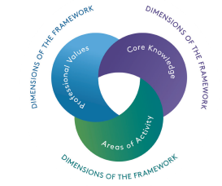
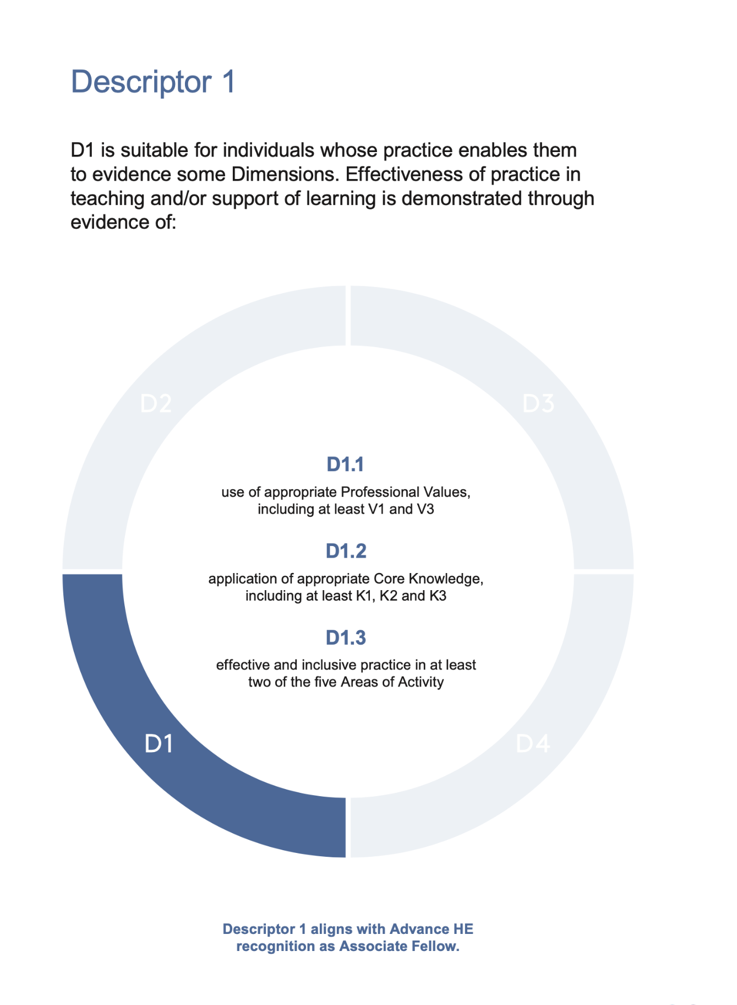
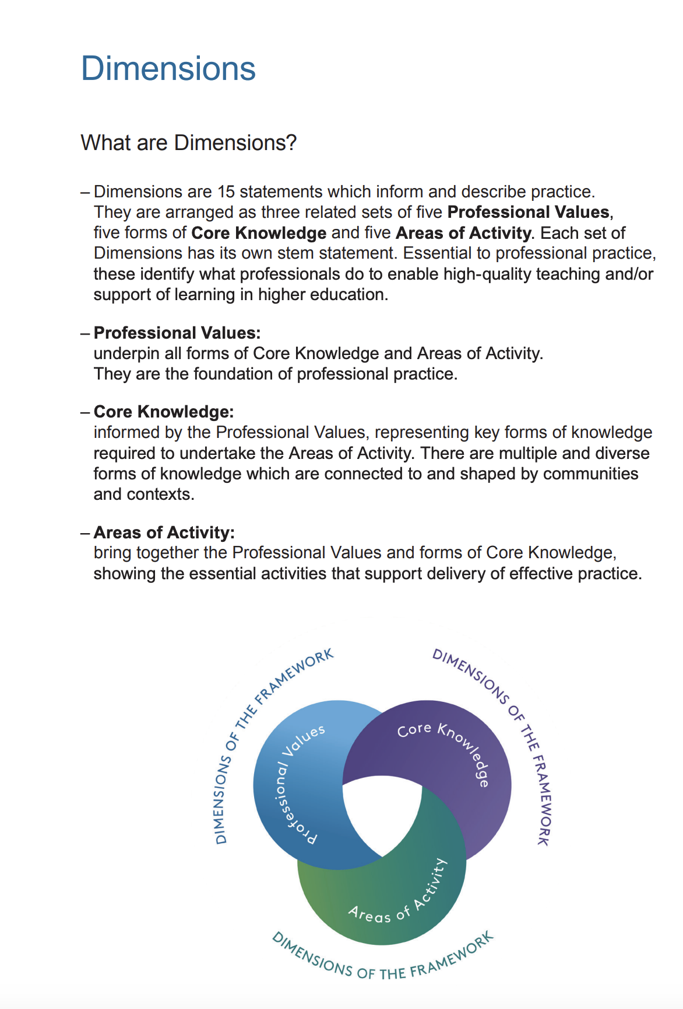
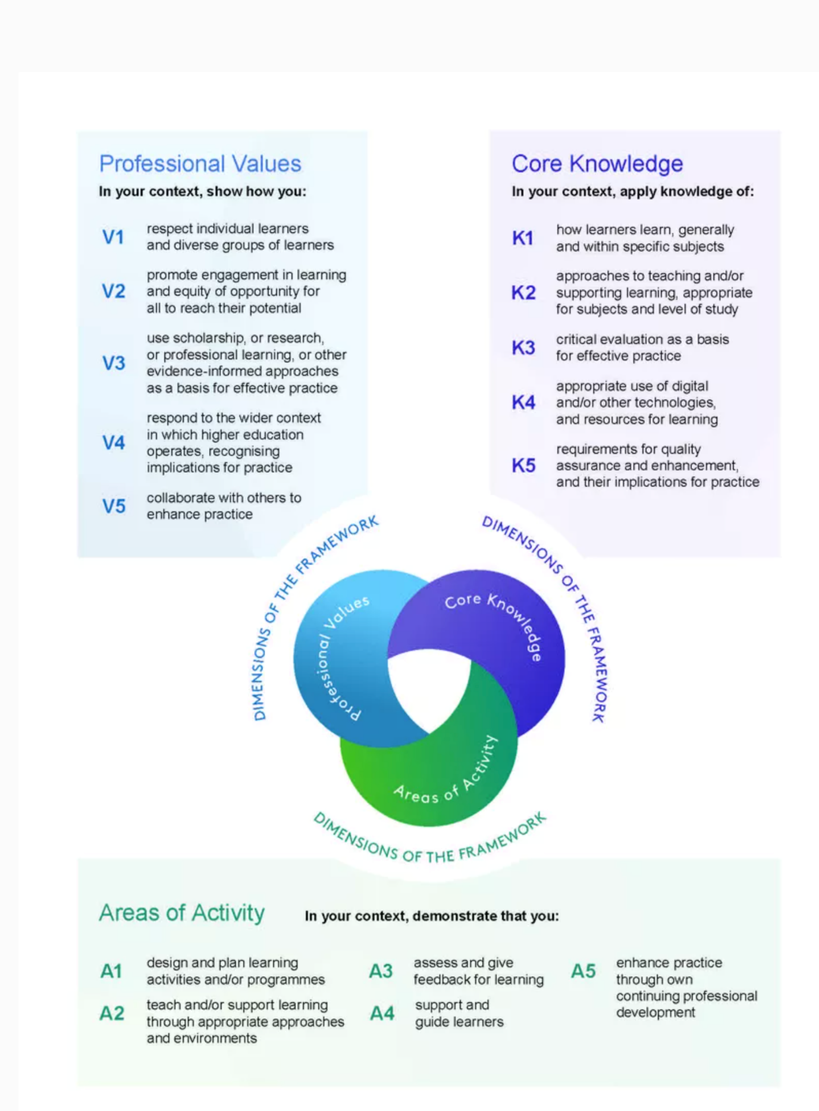

Please note therefore that the focus of the module is to provide evidence for all the module learning outcomes and the requirements of D1 of the PSF2023.
V1- Respect individual learners and diverse groups of learners.
V3- Use scholarship, or research, or professional learning, or other evidence-informed approaches as a basis for effective practice
K1- How learners learn generally within specific subjects.
K2 Approaches to teaching and/or supporting learning, appropriate for subjects and level of studyK3- Critical evaluation as a basis for effective practice.

Two of the Areas of Activity that map to the learning outcomes for this module.
A2 - Teach and /or support learning through appropriate approaches and environments.
A4- Support and guide learners
DELIVERY, CURRICULUM AND ASSESSMENT
The PGCert tHE is a distance learning programme, but those participants based at one of the UWTSD Welsh campuses, can opt for a blended learning approach, through the inclusion of teaching on campus if there are enough. The Programme team delivers both the on campus and electronic sessions, using identical materials and content, thereby ensuring parity of opportunity for all. Further details regarding the delivery method can be found on page 12 of the Programme Handbook. Assessment is by means of a portfolio. The diagram below represents the portfolio's key components, and you are strongly advised to read the assessment brief for the module. This is Appendix B of this handbook. The assessment brief has details of the grading criteria rubric.

The programme
Exam Board
UNHE7009: Portfolio Components.
Teaching statement
Teaching Intervention Report 1
Teaching Observation 1 (by you)
CPD Reflective report 1
Summative Assessment
[Refer to Appendix C]

Registry to arrange award certificates
Teaching Observation 2 (Of you by a colleague)
CPD Reflective report 2
Academic Office notified to arrange AFHEA certificates
Micro-teaching evidence
Teaching Observation 3 (Of you by a colleague)
CPD Reflective report 3

PSF 2023D1 evidence is gathered and mapped by the student within these assessment tasks

HOW THE CURRICULUM FOR UNHE7009 MEETS D1 OF THE PSF 2023

Topic | Area/s of Activity | Core Knowledge | Professional Values
Roles and responsibilities of the HE lecturer/support tutor | A2,5 | K1,2,3 | V1,3
The criteria statements of the PSF 2023 and Descriptor 1 | A2,5 | K1,2,3 | V1,2
An introduction to educational theory | A2 | K1 | V3
Inclusive practice within higher education | A1, 2, 4, 5 | K1,2,3 | V1,2, 3
Understanding diversity and equity within higher education | A1, 2, 4, 5 | K1,2,3 | V1, 2, 3
Curriculum design and constructive alignment | A2 | K1,2,3 | V1,2
Teaching and learning strategies | A2 | K1,2 | V1
Formative and summative assessment | A2,3 | K1,2,5 | V1
Feedback mechanisms | A3 | K1,2,5 | V1
The Reflective Practitioner | A 5 | K3 | V1,3
Purposeful observations of teaching | A2,5 | K1,2,3 | V1,3
PDP and the alignment of practice to the PSF 2023 | A2,5 | K3 | V3

HOW THE ASSESSMENT FOR UNHE7009 MEETS D1 OF THE PSF 2023

Portfolio assessment component | PSF 2023 mapping (D1 Associate Fellow)
General statement | The statement describes the context of your teaching.  - D1 requires the provision of evidence that confirms effective and inclusive practice in at least two of the five areas of activity  - At the very least you will describe how you  - A2- Teach/Support learning through appropriate approaches and environments  - A4 - Support and guide learners  - In terms of Core Knowledge, you must show evidence of  - K1- how learners learn generally within specific subject areas  - K2 -approaches to teaching /supporting learners appropriate to the level of study.  - K3 –Critical evaluation as a basis for effective practice  - In addition to explain how you demonstrate the following professional values.  - V1- respect individual learners and diverse groups of learners  - V3 use scholarship, or research professional learning or other informed based approaches for effective practice
Micro teaching session | - The microteach will be an opportunity to provide evidence of designing learning, current practice in teaching, thus being observed teaching, assessing and supporting learners through positive learning environments [A2] and then taking on the peer feedback to enhance your practice to inform how you support and guide learners[A4]  - whilst also you must show evidence of your knowledge how learners learn [K1] approaches to teaching [K2].  - It is an opportunity to explain how you demonstrate professional values, respecting individual or groups of learners [V1, V3].
Teaching Intervention | - This is a major reflective piece of work and will satisfy most if not all of the evidence requirements for Descriptor D1 , therefore exceeding what is required, so it is important to focus on D1 and ensure that is fully evidenced. Consider the criteria statements and the D1 Descriptor carefully therefore when writing your reflective account.
Reports of three teaching observations  [See Appendix B for a copy of the observation form.] | - The teaching observations authenticate your practice and will be an opportunity to provide clear evidence of designing learning and your current practice in teaching, and supporting learners through appropriate learning environments [A2,4] You should evidence your knowledge of how learners learn, generally and within specific subjects [K1] ,knowledge of approaches to teaching/supporting learning appropriate to subjects and levels of study [K2].  - Specific focus should be on the professional values, and observational evidence pf respecting individual and diverse groups of learners [V1]
Reflective evaluations of three CPD events attended | - The CPD reports will provide evidence much of the PSF 2023 but particularly  - A2, A44- How CPD events inform your developing teaching practice and your approach to supporting and guiding learners.  - In addition, K3 -how you use critical evaluation as a basis of effective practice  - V3 use of scholarship, professional learning as a basis of effective practice

Guidance for participants working towards D2

This descriptor is suitable for individuals whose practise with learners is of an appropriate breadth of depth enabling them to evidence all of the criteria statements. This is through reflection on the effectiveness of practise in teaching and/or the support of high-quality learning demonstrated through evidence of:
D2.1 Use of all five professional values.
D2.2 Application of all forms of core knowledge.
D2.3 Effectiveness and inclusive practise in all five areas of activity.
It is important to note ALL participants, not just those undertaking UNHE7009 as a stand-alone module, need to pass UNHE7009 and gain Associate Fellowship before progressing to the second module UNHE7010. The Academic Office will advise the Advance HE of your result who will issue your AFHEA certification directly to you electronically. For more information, please refer to the Programme Handbook.

EVIDENCE OF PRACTICE

You must provide evidence of at least 40 hours of teaching in your portfolio. What constitutes teaching in this respect is anything that is directly supporting or teaching a student or students addressing learning outcomes or academic study skills.
There is a form to evidence your teaching hours. This Teaching Log is included as Appendix A in this Module Handbook and can be accessed on Moodle. Your Practice Advisor is required to sign off your Teaching Log, whether you be an internal staff member or working in one of UWTSDs collaborative partners.

When providing evidence for the assessed components of UN7009, you should make the links to the PSF 2023 D1 criteria statements of the clear, focusing on your impact as a practitioner in at least two of the PSF 2023 Areas of Activity ,A2,A4, Core Knowledge K1 K2 & K3, and Professional Values V1, V3. When portfolio building, the Programme Team and your Practice Advisor will provide guidance on how your practice can be mapped to the PSF 2023. You will have discussed in detail how the PSF 2023 applies to your particular role with the Programme Leader at interview and your first tutorial will continue this exploration. Likewise, your meetings with your Practice Advisor, familiar with your professional setting, will further enable such discussions regarding the building of your portfolio. All Practice Advisors will receive training specifically on the PSF 2023.

TO SUMMARISE
Assessment component | PGCert Learning outcomes | PSF 2023 – relevant criteria statements to consider depending on your role
General statement | LO 1, 2, 3 & 4 | A2, V1,2,3 , V1,3
Micro teaching session | LO 1, 2, 3 & 4 | A2,4 K1,2, V1,3
Teaching Intervention | LO 1, 2, 3 & 4 | A2,4, K1,2,3 V1,3
Reports of three teaching observations | LO 1, 2, 3 & 4 | A2,4, K1,2, V1
Reflective evaluations of three CPD events attended | LO 1, 2, 3 & 4 | A2, A4, K3, V3

ASSESSMENT AND AWARD
Your portfolio will be assessed by the Programme Team, who will consider - whether your work achieves the minimum Level 7 pass mark of 50%. Assessments are moderated internally by a member of the Programme Team and confirmed by the External Examiner and finally the UWTSD Exam Board. Decisions ratified in the Exam Board are then reported to the Academic Office and Associate Fellow/ Fellow numbers noted for information in the University’s Learning and Teaching Board.
Any portfolios considered by the Exam Board as not having achieved the minimum pass mark of 50%, are required to be resubmitted following a rework by a date agreed at the Exam Board. The maximum mark achievable for a rework is 50%. One resubmission only is permitted.
UNHE7009: Summary

Induction
PG Cert tHE
Learning outcomes UNHE7009
PSF 2023 -D1
Portfolio building
Supported with tutorials
Distance learning
Reading
Assessment
Level 7 assessment criteria
Accreditation
PSF 2023

READING

Advance HE – PSF 2023
The PSF 2023 resources are available here at the Advance HE website
https://www.advance-he.ac.uk/guidance/teaching-and-learning/ukpsf
The website has several interesting and informative articles, for example, this article discusses Advance HE accreditation
https://www.advance-he.ac.uk/news-and-views/cross-campus-teaching-coordination-new-campus-education-experience-development-and

Roles and responsibilities of a teacher in Higher Education
Biggs J and Tang C (2011) ‘Teaching for quality learning at university OU McGraw Hill- Chapter 1 and 4 The changing scene at university
Petty G (2009) ‘Teaching today; A practical guide’ Nelson Thornes 4th Ed -Chapter 4
Reece I and Walker S (2007) ‘Teaching, training and learning: A practical guide’ Business Education Publishers – Chapter 1

Introduction to Learning Theory
Knowles et al (2015) ‘The Adult Learner: The definitive classic adult education and human resource development’ Routledge - Chapter 6
Armitage et al (2003)’ Teaching and training in post-compulsory education’ 2nd Ed OU McGraw Hill- Chapter 3.3 page 73

Curriculum design
Downey and Kelly (1977) ’Theory and Practice of Education’ Harper and row Chapter VI

Teaching strategies
Petty G (2009) ‘Teaching today; A practical guide’ Nelson Thornes 4th Ed Part 2
Davis JR and Arend BD (2013) ‘Facilitating Seven Ways of Learning: A resources for more effective and enjoyable college teaching’ Stylus.
Illeris C (2007) ‘How we learn; Learning and non-learning in school and beyond’ Routledge - Chapter 4 Different types of learning
Aubrey K and Riley A (2016) ‘Understanding and using Educational Theories’ Sage

Flipped Classrooms
Bergman J and Sams A (2012) ‘Flip your classroom: Reach every student every day.’

Assessment
Gray et al. (2005) ‘Training to teach in Further and Adult Education’ Chapter 2
Petty G (2009) ‘Teaching today; A practical guide’ Nelson Thornes 4th Ed part 4 chapters 43&44
Reece I and Walker S (2007) ‘Teaching, training and learning: A practical guide’ Business Education Publishers – Chapter 7
Armitage et al. (2003) ’Teaching and training in post-compulsory education’ 2nd Ed OU McGraw Hill- Chapter 7
Biggs J and Tang C (2011) ‘Teaching for quality learning at university OU McGraw Hill- Part 2 Chapter 10&11

Reflective practitioner
Philpott C (2015) ‘Theories of professional learning; A critical guide for teacher educators’ Critical publishing
Ashwin et al. (2015) ‘Reflective Practice in Higher Education’ Bloomsbury

Continuous Professional Development
Megginson D & Whitaker V (2009) ‘Continuous Professional Development’ CIPD
Petty G (2009) ‘Teaching today; A practical guide’ Nelson Thornes 4th Ed Chapter 5

Appendix A

PG Cert tHE -TEACHING LOG

Candidate: | Campus:

Date | Session Details | No of Hours | Practice Advisor’s Signature
Hours = | Hours Carried Over= | Total Hours =

Participant’s signature……………………….

Practice Advisor’s signature ……………….

Appendix B

PGCert tHE OBSERVATION FORM -PSF 2023


Details of the Observation
Observee

Practice Advisor / Expert peer observer

Date of the Observation

Campus / Location

Date, Time, Duration

Subject Speciality

Type of activity

This observation will contribute to the participant’s portfolio of evidence to satisfy the assessment of the PGCert tHE and should be undertaken by an experienced academic colleague or professional colleague. Observation by a fellow participant on the programme is not permissible as a means of authenticating practice.

Teaching/Support preparation [A1: Design and plan learning activities/programmes
i.e. Preparation, selection and organisation of content. Choice of teaching/learning methods.

Comments

Teaching [A2: Teach and/or support learning through appropriate approaches and environments.]
i.e. Beginning class, introduction, continuity with other sessions, students’ prior knowledge. Clarity of presentation. Pace. Attitude to the subject matter. Use of appropriate reinforcement. Ending the session – summary, future work etc. Technique and Aids: General apparatus – board, data projector, use of handouts. Was effective communication achieved? Was there good student–teacher rapport? Were the aims/outcomes achieved? Appropriateness of teaching/learning methods.
Comments

Effective Learning Environments [A4: support and guide learners /V1 Respect individual learners/diverse groups of learners]
i.e General class atmosphere, level of participation, attention, and interest. Student attitude and ability to carry out classwork. Were learning problems identified and overcome? Awareness of individual needs. Attitude to students.
Comments

Assessment [A3: Assess and give feedback for learning]
i.e Formative/summative assessment examples , Question and answer technique. Other evaluation procedures, class management, instructions to students005C.
Comments
Core Knowledge
- K1 How learners learn, generally and within specific subjects
- K2 approaches to teaching and or/supporting learning appropriate for subjects and levels of study.
- K3 Critical evaluation as a basis for effective practice.
- K4 Appropriate use of digital technologies / resources.
- K5 requirements for quality assurance, enhancement and implications for practice

Comments

Professional values
- V1 Respect for individual learners /diverse groups of learners
- V2 Promote engagement and learning and equity of opportunity for all to reach their potential.
- V3 Use scholarship, research or professional learning, or other evidence informed approaches as the basis of effective practise.
- V4 respond to the wider context in which higher education operates, recognising implications for practice.
- V5 Collaborate with others to enhance practice.
Comments

Examples of good practice:

Action points:
For Observee

Write a short statement to address Area of activity [A5] .Decribe how this observation will enhance your practice.
Observer ...................................................... Date

Observee ................................................... Date

PGCert PARTICIPANTS
On completion of the peer observation reports for each module, compose a short reflective paragraph on your observation experiences for inclusion in your portfolio along with the observation sheets.

Appendix C

ASSESSMENT BRIEF

Participant name: |  | UWTSD ID number:
Programme: | Postgraduate Certificate in teaching in Higher Education
Module: | Effective Teaching and Assessment in Higher Education
Module code: | UNHE 7009 | Contribution to Overall Module Assessment (%):
Lecturer: |  | Internal Moderator:
Assignment Title: | Professional Portfolio 1 | Word count (or equivalent):
Submission deadline: |  | Return date of provisional marks & written feedback:
Submission method: | All written assessments, where practical and possible, must be submitted via Turnitin unless otherwise instructed by the Lecturer. (Please DO NOT put this assessment specification into Turnitin or it will match many similarities with other submissions.)  Alternative submission method (if applicable):  Late submission of the assessment will result in a late penalty mark. Penalties for late submission: Up to one week late, maximum mark of 50%. Over one week late, 0%. Only the Extenuating Circumstances Panel may approve a change to submission dates.
Academic honesty / referencing: | Academic honesty is required. In the main body of your submission you must give credit to authors on whose research and ideas your work is based. Append to your submission a reference list that indicates the books, articles, etc. that you have used, cited or quoted in order to complete this assessment.

Module Aims & Learning Outcomes (from module syllabus)
Aims
- To provide an opportunity for educational professionals who are new to HE to engage with recent developments in teaching and learning.

- To develop practice in a work context through reflection and analysis.

Learning outcomes
Upon the successful completion of this module, the student should be able to demonstrate the ability to:
- Display an awareness and critical appreciation of the scholarly background to the
theories and concepts relating to the expedition pedagogy, andragogy and heutagogy
in the Higher Education context;

- Critically reflect on the appropriate application of a range of teaching and learning
methods, with a focus on improving their own effectiveness and efficiency in inclusive teaching practice, using the information gained through peer observation and evaluation of teaching in praxis;

- Critically apply a variety of assessment techniques and provide constructive feedback to students;

- Reflect analytically on their own personal and professional development to enhance
teaching practice;

- Demonstrate competence in aligning their practice to D1 of the PSF 2023.

TASK DESCRIPTION

The portfolio for UNHE7009 Effective Teaching & Assessment in Higher Education should consist of the following:
- A general statement on how you view teaching and learning (approx. 750 words);
- A micro teaching session consisting of a 10-minute oral presentation presented to colleagues together with a short reflection of 250 words based on feedback received from peers;
- A reflective report of a teaching intervention cycle (3,250 words);
- Reports of three teaching observations (500 words x 3) – one by you, two of you by senior academic colleagues, one of whom must be your Practice Advisor;
- Reflective evaluations of three CPD events attended (500 words x 3);
- Evidence of 40 hours teaching or support for teaching at HE level.

Your portfolio needs to demonstrate engagement with a minimum of two of the PSF 2023 Areas of Activity. You should choose areas that are relevant to your particular role and/or which will develop your skills for future development and activities. In addition, you must show through the narrative, how your practice aligns to the Core Knowledge (at least K1 and K2) and displays a commitment to appropriate Professional Values in facilitating others’ learning.
GUIDANCE FOR INDIVIDUALS IN THE COMPLETION OF TASKS

NOTE: The guidance offered below is linked to the five generic assessment criteria overleaf.
- Engagement with Literature Skills
Your work must be informed and supported by scholarly material that is relevant to and focused on the task(s) set; you should make use of scholarly reviews and primary sources, as appropriate (for example, refereed research articles and/or original materials appropriate to the discipline). You should provide evidence that you have accessed a wide range of sources, which may be academic, governmental and industrial; these sources may include academic journal articles, textbooks, current news articles, organisational documents, and websites. You should consider the credibility of your sources; academic journals are normally highly credible sources while websites require careful consideration/selection and should be used sparingly. Any sources you use should be current and up-to-date, mostly published within the last five years or so, though seminal/important works in the field may be older. You must provide evidence of your research/own reading throughout your work, using correctly a suitable referencing system, including in-text citations in the main body of your work and a reference list at the end of your work.
Guidance specific to this assessment: (to filled in by the tutor in all instances where applicable)

- Knowledge and Understanding Skills
At level 7, you should be able to demonstrate a systematic understanding of knowledge, and a critical awareness of current problems and/or new insights, much of which is at, or informed by, the forefront of your academic discipline, field of study or area of professional practice, with a comprehensive understanding of techniques applicable to your own research or advanced scholarship. Your work must demonstrate your growing mastery of these concepts, principles, current challenges, innovation and insights associated with the subject area. Knowledge relates to the facts, information and skills you have acquired through your learning. You demonstrate your understanding by interpreting the meaning of the facts and information (knowledge). This means that you need to select and include in your work the contemporary concepts, techniques, models, theories, etc. appropriate to the task(s) set. You should be able to explain the theories, concepts, etc. meaningfully to show your understanding. Your mark/grade will also depend upon the extent to which you demonstrate your knowledge and understanding; ideally each should be complete and detailed, with comprehensive coverage.
Guidance specific to this assessment:

- Cognitive and Intellectual Skills
You should be able to: evaluate critically current research and advanced scholarship in the discipline; evaluate methodologies and develop critiques of them and, where appropriate, to propose new hypotheses; deal with complex issues both systematically and creatively to make sound judgements in the absence of complete data. Your work must contain evidence of logical, analytical thinking, evaluation and synthesis. For example, to examine and break information down into parts, make inferences, compile, compare and contrast information. This means not just describing what! But also justifying: Why? How? When? Who? Where? At what cost? At all times, you must provide justification for your arguments and judgements. Evidence that you have reflected upon the ideas of experts within the subject area is crucial to you providing a reasoned and informed debate within your work. Your choice of methodologies to gather data and information must be rigorously defended. Furthermore, you should provide evidence that you are able to make sound judgements and convincing arguments using data and concepts. Sound, valid, persuasive conclusions are necessary and must be derived from the content of your work. Where relevant, alternative solutions and recommendations may be proposed.
Guidance specific to this assessment:

- Practical Skills
At level 7, you should be able to demonstrate originality in the application of knowledge, together with a practical understanding of how established techniques of research and enquiry are used to create and interpret knowledge in the discipline. This includes acting autonomously in planning and implementing tasks at a professional or equivalent level, originality in tackling and solving problems, and decision-making in complex and unpredictable contexts or situations.
You should be able to demonstrate mastery of the leading-edge subject-related concepts and ideas as they relate to real world situations and/or particular contexts. How do they work in practice? You will deploy models, methods, techniques, and/or theories, in those contexts or circumstances, to assess current situations, perhaps to formulate plans or plausible, justifiable recommendations to solve problems, or to propose new models, or to create artefacts, which may be innovative and creative, thereby demonstrating your understanding of how the boundaries of knowledge are advanced through research and/or application. This is likely to involve, for instance, the use of real world artefacts, examples and cases, the application of a model within an organisation and/or benchmarking one theory or organisation against others.
Guidance specific to this assessment:
- Transferable Skills for Life and Professional Practice
Your work must provide evidence of the qualities and transferable skills necessary for postgraduate-level employment in circumstances requiring sound judgement, personal responsibility and initiative in complex and unpredictable professional environments. This includes demonstrating: the independent learning ability for continuing professional development to advance existing skills and acquire new competences of a professional nature that will enable you to assume significant responsibility within organisations; that you can initiate and complete tasks, projects and procedures, whether individually and/or collaboratively, to a professional level; that you can use appropriate media to effectively communicate information, arguments and analysis in a variety of forms for a variety of audiences; fluency of expression; clarity and effectiveness in presentation and organisation. Work should be coherent and well-structured in presentation and organisation.

APPENDIX A: FEEDBACK FORM
This section details the extent to which the assessment criteria are demonstrated by you, which in turn determines your mark. The marks available for each category of skill are shown. Lecturers will use the space provided to comment on the achievement of the task(s), including those areas in which you have performed well and areas that would benefit from development/improvement
Generic Assessment Criteria | Marks available | Marks  awarded
1. Engagement with Literature Skills | 20
2. Knowledge and Understanding Skills | 20
3. Cognitive and Intellectual Skills | 20
4. Practical Application Skills | 20
5. Transferable Skills for Life and Professional Practice | 20
Assessment Mark Assessment marks are subject to ratification at the Exam Board. These comments and marks are to give feedback on module work.  They are for guidance only therefore at this stage until confirmed by the Exam Board. | Late Submission Penalties (tick if appropriate)  Up to 1 week late (50% Max)  Over 1 week late (0%) | %
Has the student provided evidence of D1 of the PSF 2023 –
Effectiveness of practice in teaching and/or support of learning is demonstrated through evidence of:
D1.1 use of appropriate Professional Values, including at least V1 and V3
D1.2 application of appropriate Core Knowledge, including at least K1, K2 and K3D1.3 effective and inclusive practice in at least two of the five Areas of ActivityComments.

Marker (Name/Signature)  Advance HE Designation – SFHEA/FHEA [delete as appropriate] | Date

APPENDIX B
GENERIC ASSESSMENT CRITERIA

Level 7
In accordance with the Framework for Higher Education Qualifications, at the end of Level 7 students should be able to demonstrate: a systematic understanding of knowledge, and a critical awareness of current problems and/or new insights, much of which is at, or informed by, the forefront of their academic discipline or area of professional practice; a comprehensive understanding of techniques applicable to their own research or advanced scholarship; originality in the application of knowledge, together with a practical understanding of how established techniques of research and enquiry are used to create and interpret knowledge in the discipline; conceptual understanding that enables the student to evaluate critically current research and advanced scholarship in the discipline to evaluate methodologies and develop critiques of them and, where appropriate, to propose new hypotheses. They will be able to deal with complex issues both systematically and creatively, make sound judgements in the absence of complete data, and communicate their conclusions clearly to specialist and non-specialist audiences. They will demonstrate self-direction and originality in tackling and solving problems, and act autonomously in planning and implementing tasks at a professional or equivalent level to continue to advance their knowledge and understanding, and to develop new skills to a high level. They the qualities and transferable skills necessary for employment requiring the exercise of initiative and personal responsibility; decision-making in complex and unpredictable situations/professional environments; and the independent learning ability required for continuing professional development.

Level 7 | FAIL | FAIL | MARGINAL FAIL | SATISFACTORY  (Pass) | GOOD to VERY GOOD  (Merit) | EXCELLENT  (Distinction) | EXCEPTIONAL  (Distinction)
Category | 0-29% | 30-44% | 45-49% | 50-59% | 60-69% | 70-84% | 85-100%
Engagement with literature (including current research, referencing,  academic conventions and  academic honesty) | Little or no evidence of reading and/or reliance on inappropriate sources.  Views and findings mostly unsupported and non-authoritative.  Referencing conventions used incoherently or largely absent. | Poor engagement with essential reading. No evidence of wider reading. Reliance on inappropriate sources, and/or indiscriminate use of sources. Heavily reliant on information gained through class contact. Inconsistent and weak use of referencing. | Engagement with a very limited range of relevant and credible sources. Some omissions and minor errors.  Referencing conventions evident though not always applied accurately or consistently. | Engagement with an appropriate range of research-informed literature, including sources retrieved independently. Some over-reliance on texts. Referencing may show minor inaccuracies or inconsistencies. | Engagement with a wide range of research-informed literature, including sources retrieved independently.  Selection of relevant and credible sources. Very good use of referencing, with no/very few inaccuracies or inconsistencies. | Engagement with an extensive range of relevant and credible literature, informed by the latest research. Consistently accurate application of referencing. | Exceptional engagement with an extensive range of relevant and credible literature, informed by the latest research. High-level referencing skills consistently and professionally applied.
Knowledge and understanding (A systematic, conceptual understanding of knowledge, and a critical awareness of current problems and/or new insights, much of which is at, or informed by, the forefront of the discipline; a comprehensive understanding of techniques applicable to their own research) | Major gaps in knowledge and understanding of the subject matter is not systematic. Substantial inaccuracies. No awareness of current problems, insights or the latest research and/or advanced scholarship within the discipline. | Gaps in knowledge, with only superficial systematic understanding. Some significant inaccuracies and/or irrelevant material. No critical awareness of current problems, insights, or latest research within the discipline. | Limited knowledge and systematic understanding of the concepts and principles within the subject area, which to some marginal extent, is informed by current research and scholarship. Some critical awareness of current problems and/or new insights, but often under-developed. | Knowledge is accurate and reasonably detailed. A systematic understanding of the field of study informed by, to some extent, current research and scholarship, A critical awareness of current problems and/or new insights though this may be under-developed occasionally. | Knowledge has a well-defined focus, which is reasonably extensive, coherent and detailed, with a critical awareness of current problems and/or new insights. Exhibits good understanding of the breadth and depth of contemporary and established views, and the work is, at least in part, well-informed by current research and scholarship. | Excellent mastery of a complex and specialised area of knowledge. A systematic, excellent understanding of the concepts of the subject informed by current research and scholarship. Highly critical awareness of current problems and/or new insights. A critical, awareness of how the boundaries of knowledge are advanced through research. | Exceptional mastery of a complex and specialised area of knowledge. An exceptionally critical awareness of current problems and/or new insights. An outstanding understanding of the concepts of the subject, well-informed by current research and scholarship. A critical, sophisticated and nuanced awareness of how the boundaries of knowledge are advanced through research.
Cognitive and intellectual skills  (Critical evaluation of current research and methodologies and develop critiques of them and, where appropriate, to propose new hypotheses; make sound judgements in the absence of complete data.) | Wholly or almost wholly descriptive work. Little or no evaluation or critique or attempt at a systematic approach.  Failure to develop arguments, leading to illogical or invalid judgements. Unsubstantiated generalisations, made without use of credible evidence. | Largely descriptive work, with superficial use of critical evaluation of research and methodologies. Absent or weak development of hypotheses and judgements. Information accepted uncritically, uses generalised statements made with scant evidence and unsubstantiated opinions. Ideas sometimes illogical and contradictory. | Limited attempt at critical evaluation/ critique of current research and methodologies, tending towards description.  Limited attempt to propose new hypotheses. Can deal with complex issues but not systematically or creatively. Some evidence to support emerging judgements but these may be underdeveloped or with a little inconsistency / mis-interpretation.  May assert rather than argue a case. | Some critical evaluation/ critique of current research and methodologies, though slightly underdeveloped in places, Proposes adequate but limited new hypotheses, where relevant. Can deal with complex issues but not fully systematically or creatively. Ability to make judgements based on data (that may be incomplete) but with some tendency to assert/state opinion rather than argue on the basis of reason and evidence. | Sound critical evaluation/ critique of current research and methodologies, Proposes new hypotheses, where appropriate. Can deal with complex issues systematically and with some creativity. Ability to make sound judgements based on data (that may be incomplete) | Excellent critical evaluation/ critique of current research and methodologies, Proposes innovative hypotheses, where appropriate. Can synthesise complex issues systematically and creatively. Ability to investigate contradictory or incomplete information and make strong, persuasive, arguments and sophisticated judgements. | Exceptional critical evaluation/ critique of current research and methodologies, Proposes innovative hypotheses, where appropriate. Exemplary systematic and creative synthesis of complex issues.  Ability to investigate contradictory or incomplete information and make strong, persuasive, arguments and sophisticated, nuanced, judgements. Potential for journal publication or doctoral research.
Practical skills  (Originality / creativity in the application of knowledge, tools and techniques and in tackling and solving problems in complex and unpredictable professional situations; practical use of established techniques of research and enquiry to create and interpret knowledge in the discipline.) | Limited or no use of methods, materials, tools and/or techniques.  Little or no appreciation of the context of the application.  Limited understanding of the application of theory to practice or making appropriate links between the two.  Very weak problem-solving skills in complex and unpredictable contexts. | Rudimentary application of methods, materials, tools and/or techniques but without consideration and competence. Flawed appreciation of the context of the application.  Weak understanding of the application of theory to practice, with only occasional evidence of making appropriate links between the two. Weak problem-solving skills in complex and unpredictable contexts. | An awareness and mostly appropriate application of well-established methods, materials, tools and/or techniques, with occasional errors.  Basic appreciation of the context of the application. Theoretical knowledge and understanding applied in practice, but not always making logical links between the two.  Can identify problems and propose basic solutions without fully appreciating the complexity of unpredictable contexts. | An appropriate application of standard methods, materials, tools and/or techniques.  Clear appreciation of the context of the application. Mainly consistent, accurate and logical application of theory to practice, making appropriate links between the two.  Can identify problems and propose mostly appropriate solutions in complex and unpredictable contexts, with elements of originality. | A very good application of a range of methods, materials, tools and/or techniques.  Very good consideration of the context of the application, with perceptive insights. Can identify problems and propose appropriate solutions in complex and unpredictable contexts.  Evidence of originality and creativity. | An advanced application of knowledge, methods, materials, tools and/or techniques.  The context of the application is well considered, and insightful.  Can identify complex problems and propose excellent solutions. An excellent grasp of techniques applicable to own research or advanced scholarship.  Shows originality in application of knowledge and techniques, and of how established techniques of enquiry create and interpret knowledge in the discipline. | Exceptional application skills in complex, unpredictable, contexts, drawing skilfully on the latest research within the discipline. Can identify complex problems and propose sophisticated, original solutions.  An outstanding application of techniques applicable to own research or advanced scholarship.  Shows originality in application of knowledge and techniques, and of how established techniques of enquiry create and interpret knowledge in the discipline with assimilation and development of cutting edge processes and techniques.
Transferable skills for life and professional practice  (Exercise of self-direction, autonomy and personal responsibility; plan and implement tasks at a professional level; independent learning; use appropriate media to communicate effectively and professionally to a variety of audiences; fluency of expression; systematic approach; clarity and effectiveness in presentation and organisation.) | Communication medium is inappropriate or misapplied.  Work is poorly structured, disorganised and/or confusingly expressed. Very weak use of language and/or very inappropriate style. Little or no evidence of autonomy (or collaboration, where relevant) in the completion of tasks. Little or no evidence of the skills required in professional, postgraduate employment. | Communication medium is poorly designed and/or not suitable for the audience.  Work is poorly presented in a disjointed manner. It is loosely, and at times incoherently, structured, with information and ideas often poorly expressed. Weak use of language and/or inappropriate style. Weak independent initiative (or collaboration, if relevant). Limited evidence of the skills required in professional, postgraduate employment. | Can communicate in a suitable medium but with some room for improvement.  Mostly ordered presentation and structure in which relevant ideas / concepts are reasonably expressed. Work may lack coherence in places. Can work as part of a team, but with limited involvement in group activities.  Demonstrates some but not all of the basic skills required in professional, postgraduate employment, with some areas of minor weakness. | Can communicate effectively in a suitable format, but may have minor errors.  Mostly coherent, organised work, in a suitable structure and is for the most part clearly expressed. Can work effectively independently and/or as part of a team, with clear contribution to group activities.  Demonstrates the skills required in professional, postgraduate employment, with some areas of strength and some of minor weakness. | Can communicate well, confidently and consistently in a suitable format.  Work is coherent, fluent, well-structured and organised. Can work very well autonomously and/or as part of a team, with a good contribution to group activities.  Demonstrates comprehensive professional, postgraduate employment skills. | Can communicate professionally confidently and consistently in a suitable format.  Work is coherent, very fluent and is presented professionally. Can work autonomously with initiative. Where relevant can work professionally within a team, showing leadership skills as appropriate, managing conflict and meeting obligations. Demonstrates excellent professional, postgraduate employment skills and a strong appetite for further development. | Can communicate with an exceptionally high level of professionalism.  Work is remarkably coherent, very fluent and is presented professionally. Can work outstandingly well and professionally within a team, showing advanced leadership skills. Demonstrates exemplary professional, postgraduate employment skills and a strong appetite for further development.

