

Programme: Master of Business Administration
Module: Marketing Management
Module code: LCMB7024
Assignment Title: Assessment component 1: Marketing Environment Analysis
Lecturer: Laila Maazouz (London)
TaongaKaonga Sobere-Snithers (Birmingham)
Student Name:
Student ID:
Word Count: 2507
Submission Date: Week 7. Thursday 22nd October 2026. By 2 PM

Table of Contents
1.0 Task 1: Marketing Environment Analysis 3
1.1 Introduction to the Chosen Company 3
1.2 Actor 1: The Environmental Actor (Primary Focus) 4
1.2.1 Climate Change, Resource Scarcity and Sustainability Expectations 4
1.2.2 Environmental Pressures Driving Cleaner Production 5
1.3 Actor 2: The Political / Regulatory Actor 6
1.3.1 Government Regulations, Carbon Taxes and Climate Agreements 6
1.3.2 Regulatory Opportunities and Operational Threats 7
1.4 Actor 3: The Technological Actor 8
1.4.1 Green Technology, Hydrogen and Renewable Energy Integration 8
1.4.2 Stakeholder Pressure for Ethical and Sustainable Practices 9
2.0 Task 2: Strategic Growth and Competitive Positioning 11
2.1 Recommended Strategic Growth (Ansoff Matrix) 11
2.1.1 Applying the Ansoff Matrix Framework 11
2.1.2 Product Development: Lower-Carbon Steel Products 12
2.1.3 Market Penetration: Expanding Sustainable Steel Products 12
2.1.4 Implementation, Investment Costs and Strategic Risks 12
2.2 Achieving Competitive Advantage (Porter’s Generic Strategies) 13
2.2.1 Apply Porter’s Generic Strategies framework 13
2.2.2 Differentiation Through Certified Green Steel 14
2.2.3 Competitive Advantage Through Low-Carbon Differentiation 14
3.0 Task 3: Managerial and Professional Reflection 15
3.1 Rationale for Key Decisions 15
3.2 Limitations of the Analysis and Information Gaps 16
References 17

1.0 Task 1: Marketing Environment Analysis

1.1 Introduction to the Chosen Company
Tata Steel produces high-quality steel and has global interests in sustainable low-carbon production technologies. Tata Steel is a suitable selection because it is a major metals company. In FY2026, Tata Steel (India) reached 23.48 million tonnes of crude steel, which is 8% higher than the previous year (Tata Steel, 2026a).
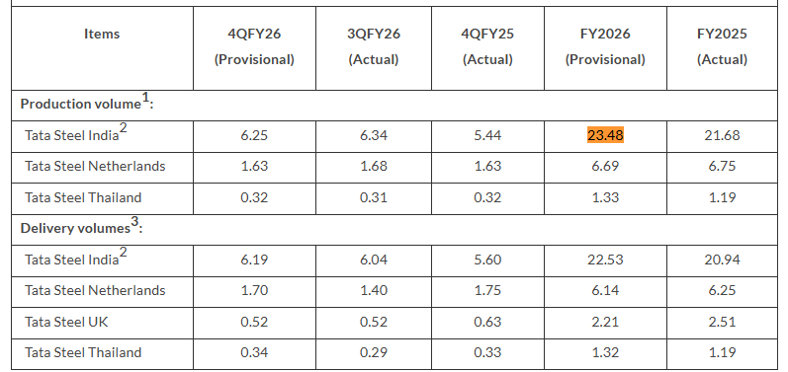
Table 1: Tata Steel: 4QFY2026 and FY2026 Production and Delivery Volumes
(Source: Tata Steel, 2026a)
Tata Steel's consolidated footprint for Financial Year 2026 stands at 116 million tonnes of CO₂e, which comprises of 32 million tonnes Scope 3, 6 Mt Scope 2 and 78 Mt Scope 1 carbon emissions (Tata Steel, 2026b). The steel industry has a carbon intensity of 2.18 Tco2e/t crude steel and represents 7–8% of the world's Greenhouse Gas emissions; there is growing pressure to decarbonise the sector (World Steel Association, 2025).
This section critically analyses how natural environment, political and regulatory conditions and technological and scientific changes affect Tata Steel's journey to a low carbon portfolio, showing environmental pressures, scarcity and resources, decarbonisation opportunities, risks of operation, as well as their effect on competitiveness and strategic choices.

1.2 Actor 1: The Environmental Actor (Primary Focus)

1.2.1 Climate Change, Resource Scarcity and Sustainability Expectations
Tata Steel is under pressure to revamp its production model due to climate change, resource scarcity and elevated sustainability expectations. Water is especially relevant, being key to the steel making process with Tata Steel disclosing a water intensity of 4.1 m³/t of crude steel, and water being a material business risk, (Tata Steel, 2026c). Therefore, environmental pressures are getting turned into capital investment and not just a question of reputation. In March 2026, Tata Steel announced an investment of about ₹3200 crore towards building a 0.75 MTPA (Million Tonnes Per Annum) capacity electric arc furnace (EAF) based on scrap for CO₂ emission below 0.3 tCO₂e per tonne of steel, located at Ludhiana (Tata Steel, 2026d). Additionally, its 2026 EASyMelt project will cut CO₂ emissions from the blast furnace by 50% and over, a testament to the increased pace of technological change in response to decarbonisation expectations (Tata Steel, 2026e).
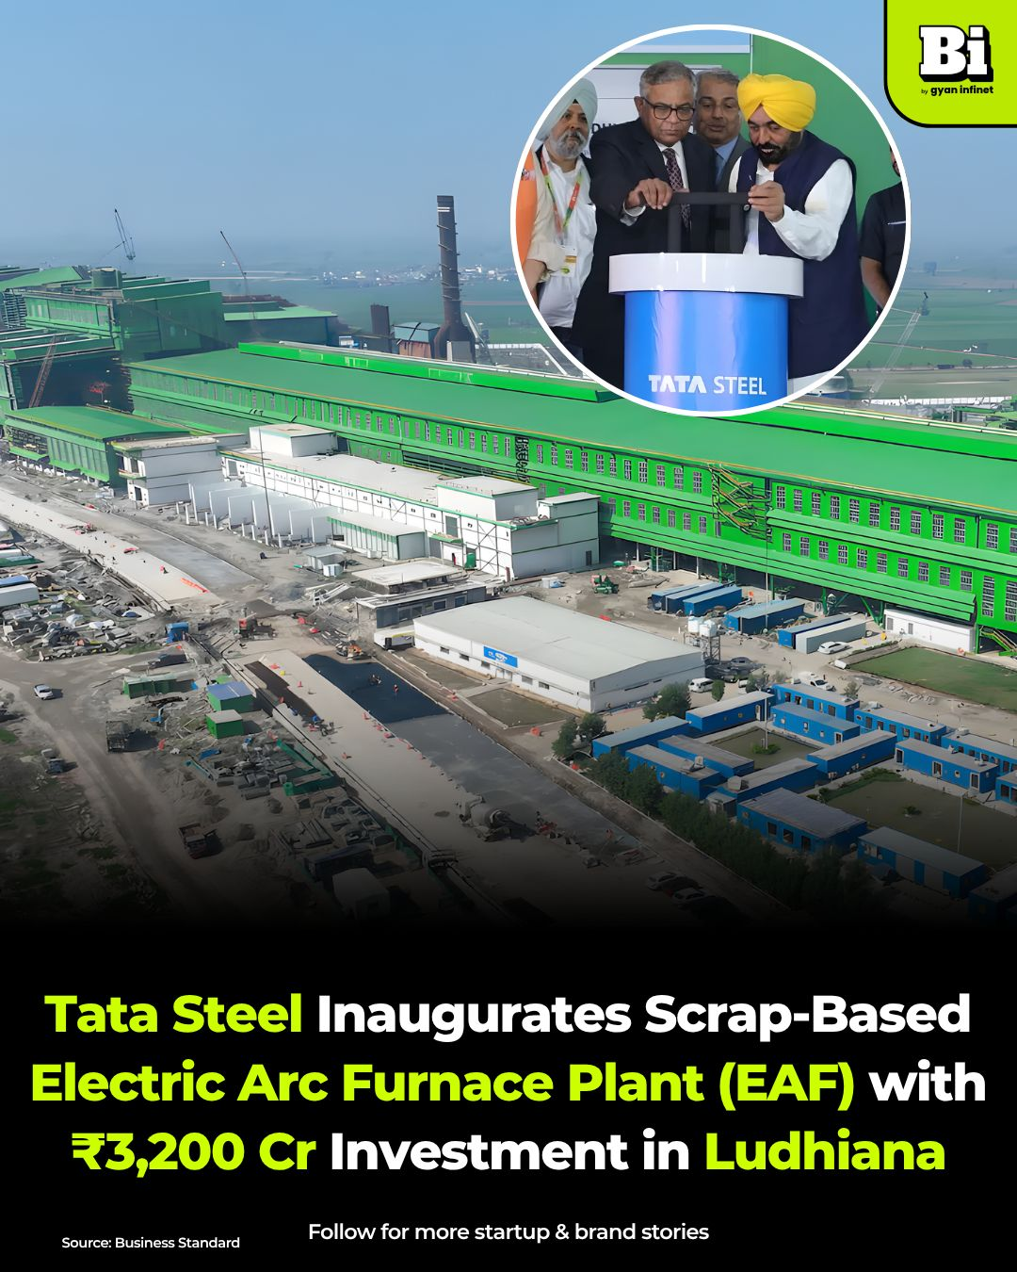
Figure 1: Tata Steel Inaugurates ₹3,200 Cr Scrap-Based EAF Plant
(Source: Gyan Infinet, 2026)

1.2.2 Environmental Pressures Driving Cleaner Production
Issues relating to environment compel Tata Steel to invest huge capital in cleaner production processes and not only incremental enhancements in efficiencies. Limited resources amplify the importance of recycling and revolutionising production using scrap, and climate risks expose them to financial and operational risks. Meanwhile, Tata Steel took a step towards renewable-energy transition with the acquisition of 379 Megawatt of the round-the-clock hybrid wind–solar energy in 2026 which is equivalent to 966 MW of installed capacity, along with a 70 MW solar project in Maharashtra (Tata Steel, 2026f). The investment will lower reliance on fossil fuel-based electricity and help to improve clean steel production. In September 2026, Tata Steel implemented the Coke Oven Gas (COG) Injection Project in the Blast Furnace 1 at Meramandali, which aims to lower fossil fuel consumption and CO₂ emissions by introducing more internally generated process gas to the blast furnace (Tata Steel, 2026g).

1.3 Actor 2: The Political / Regulatory Actor

1.3.1 Government Regulations, Carbon Taxes and Climate Agreements
Steel production has been affected by government regulation increasingly changing the economics of making the product. India's Green Steel Taxonomy, which has started in FY2025–26, certified 90 steel units accounting for 12.4 million tonnes green steel and providing opportunities for Tata Steel to differentiate lower-carbon products (Ministry of Steel, 2026). The EU's Carbon Border Adjustment Mechanism (CBAM) has transitioned to its real or final regime on 1 January 2026, applying to imports of iron and steel, which includes the need for carbon costs associated with embedded emissions. The price of these CBAM certificates has grown to be more significant, as the price of the certificates will be €75.28 per tonne of CO₂ when they are issued in Q2 2026. (European Commission, 2026). Such climate regulation developments translate decarbonisation into market and compliance pressure as they put into practice commitments to decarbonise, like the Paris Agreement.
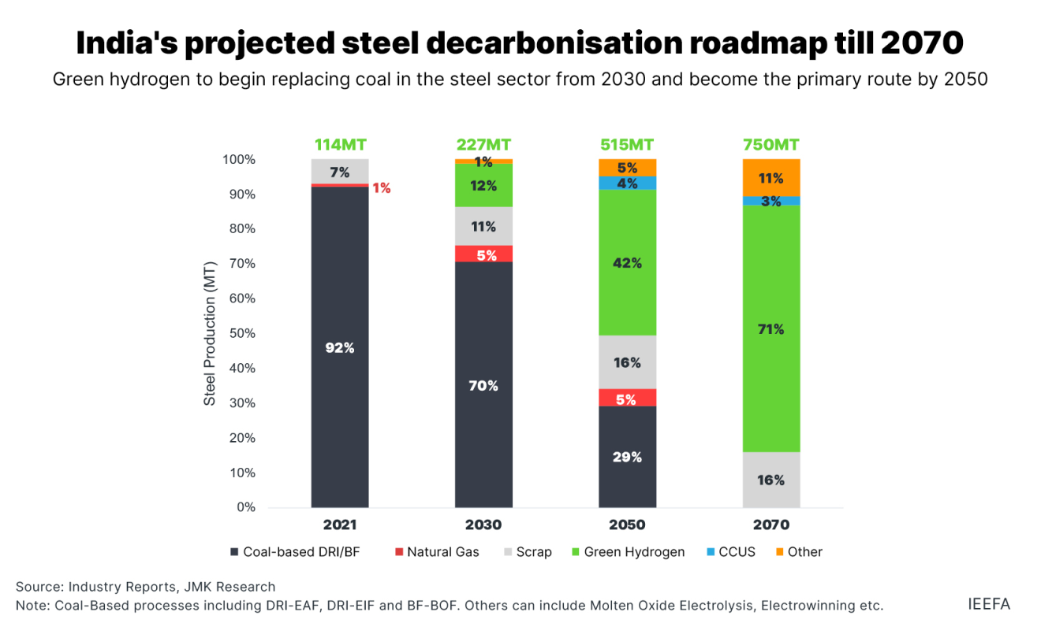
Figure 2: Green steel taxonomy key to kickstart decarbonisation
(Source: IEEFA, 2026)

1.3.2 Regulatory Opportunities and Operational Threats
Opportunity: The iron and steel industry is incorporated in the Carbon Credit Trading Scheme (CCTS) in India, which allows Tata Steel to monetize emissions reductions that are more than the prescribed limits with carbon-credit certificates (Nayak et al., 2026). This can help finance the adoption of green technologies and build its solid, low-carbon footprint market profile.
Threat: Enabling compliance will result in extra costs for Tata Steel in terms of the monitoring and verification of emissions as well as upgrading the technology and, possibly the purchase of carbon credits. Tata Steel's capital expenditure of ₹14,026 crore in FY2026 underscores the significant financial investment associated with their current operations (Tata Steel, 2026h). Thus, regulatory de-carbonisation obligations could put more pressure on investments and impact operating margins. Tata Steel's capex spending for FY25-26 is largely focused in India – for aggressive expansion – and limited overseas.
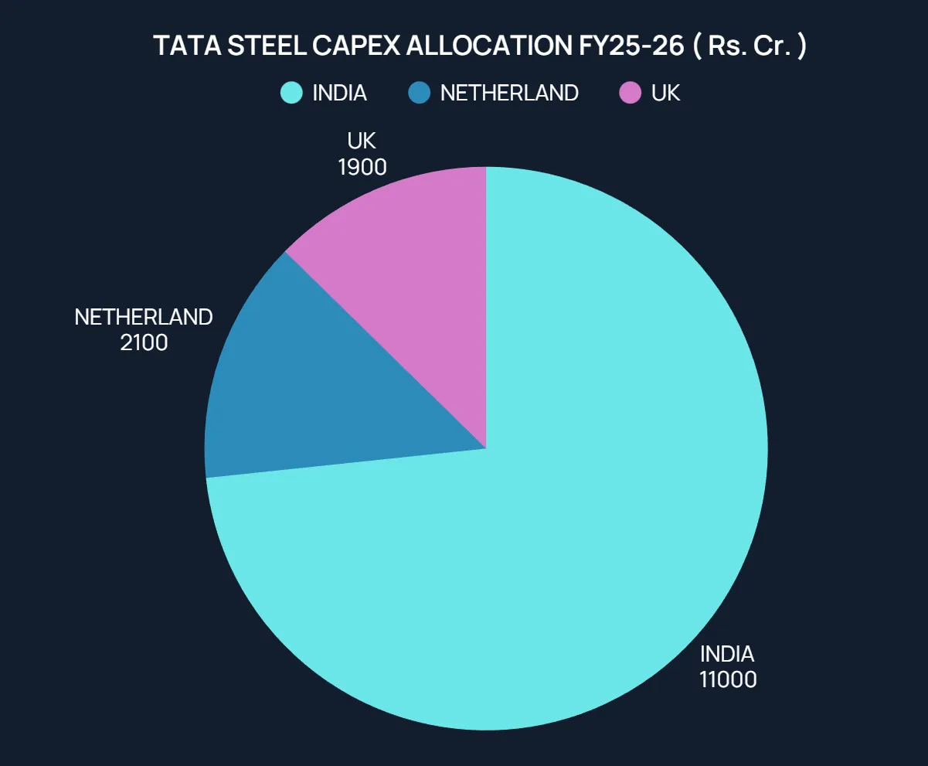
Figure 3: Tata Steel Capex allocation
(Source: Wright Research, 2026)

1.4 Actor 3: The Technological Actor

1.4.1 Green Technology, Hydrogen and Renewable Energy Integration
Technology is increasingly playing a key role in Tata Steel's decarbonisation efforts. Tata Steel allocated ₹1,456 crore towards R&D in FY2026 to develop the technologies for making steel from waste, including technologies for making scrap based steelmaking, and carbon-capture technologies (Tata Steel, 2026i). The company has also experimented with injecting hydrogen into its blast furnace in Jamshedpur and is working on long-term possibilities to use hydrogen in steelmaking itself. Progressive integration of renewables is taking place, with 379 MW of 24/7 hybrid wind and solar energy and further solar projects (Tata Steel, 2026f). These technologies can help Tata Steel to lessen the dependence on fossil fuels, enhance the energy's resilience and help Tata Steel to produce lower carbon steel. The risks regarding implementation however are high due to the technological maturity and investment requirements and dependence on easily available clean energy. In consequence, Tata Steel will need to combine hydrogen, renewable power, energy efficiency and circular technologies and not pursue a single decarbonisation pathway. The Indian steel market will witness steady growth till 2034, reaching 220.5 MT by the end of the year.
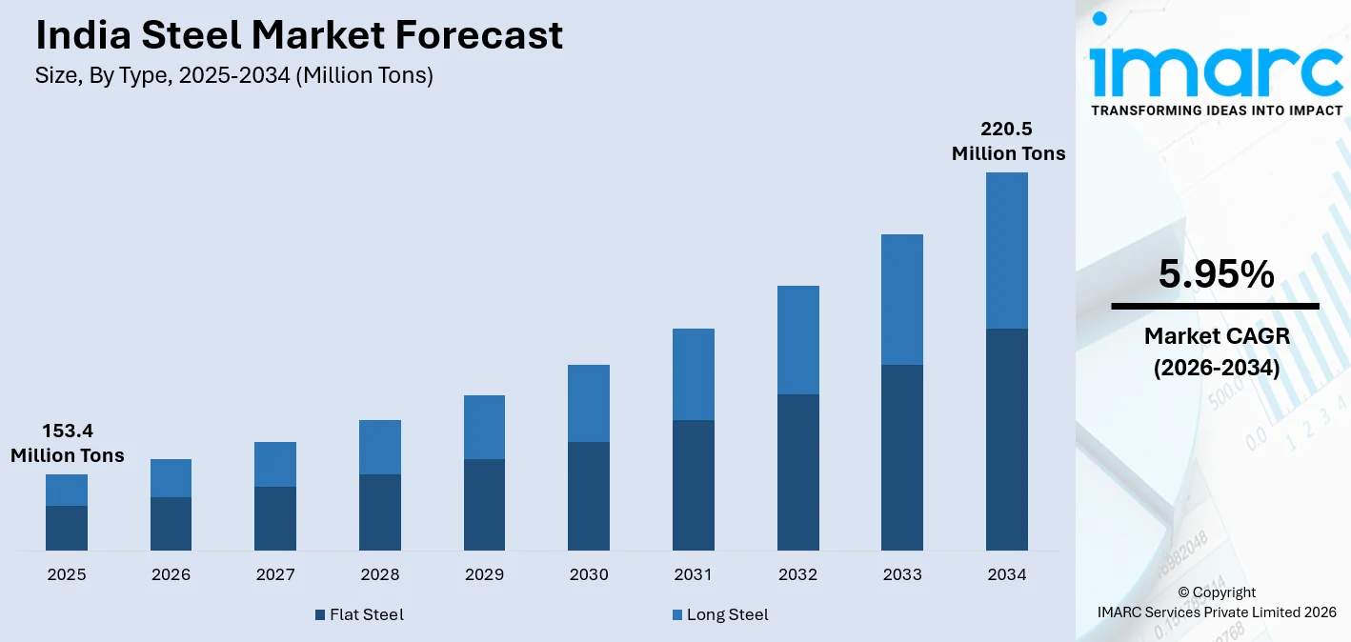
Figure 4: India Steel Market Forecast
(Source: IMARC Group, 2026)

1.4.2 Stakeholder Pressure for Ethical and Sustainable Practices
Tata Steel's sustainability decisions are guided by sociocultural pressure of investors, consumers and local communities. In FY2025-26, Tata Steel reached more than 6.9 Million people through its community programmes showing the extent of the community expectation of social value as well as responsible operations (Tata Steel, 2026j). Investor scrutiny is similarly relevant as Tata Steel sees societal pressure and financial market expectations as pending risks of transition which might drive up financing costs. Tata Steel's transformation to low carbon steel relies on the natural environment, political/regulatory actor and technological actor. From the perspective, environmental responsibility, regulatory compliance and technological innovation can help improve competitiveness. This needs to be done in steps though because of financial constraints and technological uncertainties, so community engagement and effective strategic planning should go on continuously.
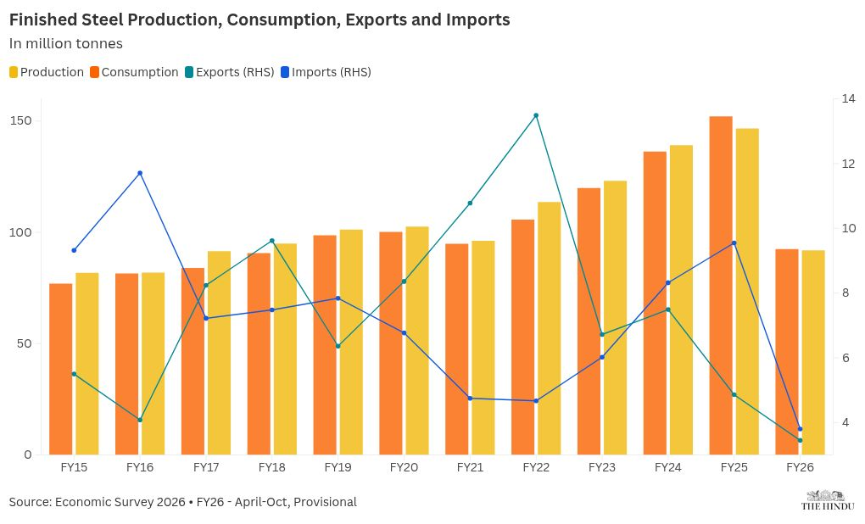
Figure 5: Steel Sector Faces Challenges of International Price Disparity
(Source: The Hindu, 2026)

2.0 Task 2: Strategic Growth and Competitive Positioning

2.1 Recommended Strategic Growth (Ansoff Matrix)

2.1.1 Applying the Ansoff Matrix Framework
The Ansoff Matrix shows that there are four growth options: Market Penetration, Market Development, Product Development and Diversification (Ansoff, 1957). Product development is especially relevant to Tata Steel as environmental pressures drive demand for lower-carbon, value added-steel. In FY2026, Tata Steel had the capability of coming up with 120+ new products (Tata Steel, 2026m). Tata Steel's Indian deliveries set a new high of 22.53 million tonnes in FY2026, suggesting its existing customers are a loyal base that can support further growth of sustainable offerings (Tata Steel, 2026n). Thus, Product Development and Market Penetration can help in achieving growth simultaneously with ensuring Tata Steel's product mix could create a base to transition towards low-carbon steel. The Indian steel market is expected to experience high growth rates, and by 2031, it will reach a total of 273.88 million tons.
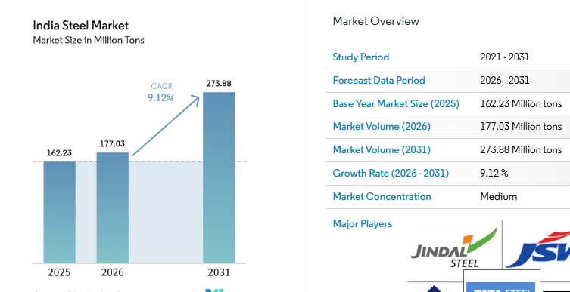
Figure 6: India Steel Market Size and Share
(Source: Mordor Intelligence, 2026)

2.1.2 Product Development: Lower-Carbon Steel Products
Aligned with the swelling demand for sustainable materials, Tata Steel should innovate new products to meet the lower-carbon steel requirements for the existing automotive, construction and packaging companies. Tata Steel introduced a research program, in 2026, titled ADAPT-EAF, to create a new generation of automotive and automotive packaging steels especially suitable for EAF production (Tata Steel, 2026b). This allows them to integrate product performance with reduced emissions in the manufacture and boost differentiation..

2.1.3 Market Penetration: Expanding Sustainable Steel Products
Tata Steel should expand market penetration by leveraging on the existing sustainable product by encouraging its validation through green certification, rallying customers and arranging some targeted procurement deals. In FY2026, Tata Steel's annual sales were around 3.4 million tonnes with high-end products seeing an 11% year-on-year increase, marking a solid market base for scaling up sustainable steel products (Tata Steel, 2026a). Tata Steel can leverage its own product pathways verified to be low-emission to enhance uptake by customers in the automotive, construction and infrastructure sectors.

2.1.4 Implementation, Investment Costs and Strategic Risks
Implementation will involve a phased approach to R&D, customer trials, certification and targeted marketing, including a disciplined approach to capital allocation. Tata Steel spent ₹14,559 crore in FY2025–26 and is aiming for capex of roughly ₹20,000 crore in FY2026–27 (more than 60% to be spent in India) (Tata Steel, 2026m). But when it comes to investment, there may be financial and technological dangers.
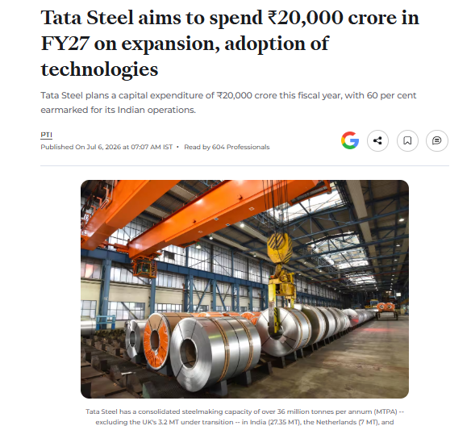
Figure 7: Tata Steel aims to spend ₹20,000 crore in FY27
(Source: ETInfra, 2026)

2.2 Achieving Competitive Advantage (Porter’s Generic Strategies)

2.2.1 Apply Porter’s Generic Strategies framework
Porter’s Generic Strategies identify cost leadership, differentiation and focus as three routes to competitive advantage.
Cost leadership: Tata Steel's pursuit of cost leadership would see it rely on size and efficiency, lower production costs, but investments and regulation aimed at reducing carbon may hinder the ability to compete on cost (Liu et al., 2025).
Focus: Focusing on a specific set of customers with the need for particular low-carbon steel could limit the market reach (Lenton et al., 2026). However, a focus on automotive, construction and infrastructure customers could establish deeper engagement with buyers who place a high value on quantifiable emissions reductions.
Differentiation: It provides a more significant strategic fit as Tata Steel can differentiate its products by evidenced lower-carbon production, recycled content, use of renewables and environmental certification.
This will directly work to address the environmental pressures identified in Task 1, and provide extra value to customers who want to reduce their own Scope 3 emissions.

2.2.2 Differentiation Through Certified Green Steel
Tata Steel should differentiate – increase the number of verified low-carbon steel products; otherwise, focus on price. In 2026, Tata Steel has announced that its low-emission steel routes have been independently verified by an accredited third party to provide credible environmental claims and meet customer procurement requirements (Tata Steel, 2026f). Tata Steel's approach is to differentiate on sought-after emissions performance, recycled content and sustainability credentials.

2.2.3 Competitive Advantage Through Low-Carbon Differentiation
Differentiation could enhance Tata Steel's competitiveness as it will enable them to send a message through an approved environmental benefit, not just by selling on a lower price. In 2026, Tata Steel mentioned green-certified products such as Environmental Product Declarations (EPDs) and eco-labelling as opportunities for additional premium revenues. (Tata Steel, 2026). It is also a strategic move in consideration of the fact that customers will be able to use verified emissions reductions to satisfy their own Scope 3 targets. The company's low-carbon products are increasing in the construction industry as well as the automotive and packaging sectors (Tata Steel, 2026b). CO₂ emissions with Tata Steel Nederland are mainly Scope 1 emissions and there are limited emissions coming from Scope 2, 3 and scope 4.
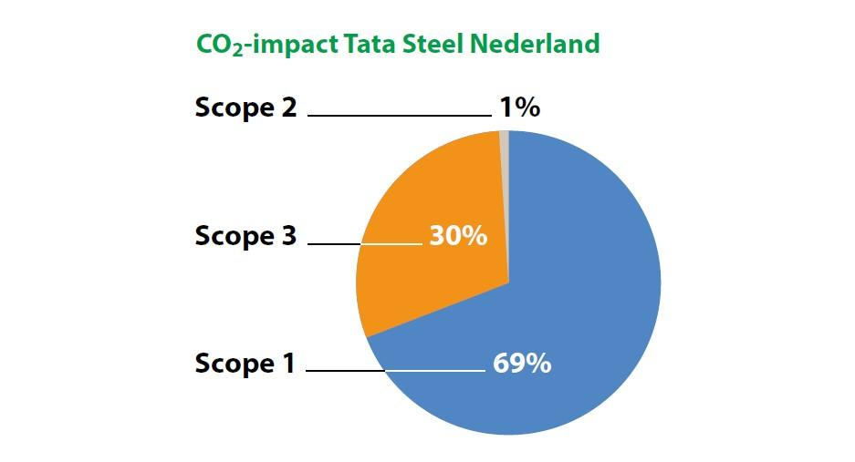
Figure 8: The Way Towards Carbon Neutral Steel
(Source: Tata Steel Nederland, 2026)

3.0 Task 3: Managerial and Professional Reflection

3.1 Rationale for Key Decisions
Tata Steel has been chosen due to its strategic importance for large-scale decarbonisation transition in steelmaking. The company is a good candidate for understanding the impacts of the climate and the challenges of scarce resources and evolving regulations on an established industrial organisation. It also has significant business abroad and a large customer base, providing opportunities for evaluation as to how sustainability can help to improve competitiveness. Tata Steel provides, accordingly, a context through which the marketing environment and strategic management frameworks can be applied to transformation to low carbon.
I placed greater emphasis on environmental, political and technological actors as they directly relate to Tata Steel's decarbonisation costs, operational needs and priorities for innovation. Cleaner production is both a market opportunity and compliance demand brought about by environmental pressures (Li et al., 2026). The potential for low-carbon steelmaking is dependent upon technology. Differentiation and product development were chosen as they are clearly relatable to sustainability and customer value.
According to my findings, Tata Steel's transition is influenced by the environment, regulations, technological advancement, and evolving customer demands. With these indications, I decided that it was not another sustainability activity to be performed but a competitive strategy to be followed. Differentiation and product development thus seem relevant from a strategic perspective in order to link lower carbon production with customer value (Zaman et al., 2026). But I know from my professional judgement there are financial and technological, and implementation risks and phased investment will need to take place.

3.2 Limitations of the Analysis and Information Gaps
One of the main limitations is that the study is based on publicly available data, which might not capture the specific internal costs, investment focuses or strategic decisions made at Tata Steel. Some environment-related, political and technological considerations are also highlighted in the report and other considerations, such as economic and geopolitical ones, may be missing. Additionally, competitor comparisons can be challenging due to variations in reporting processes and data sources (Tsiu et al., 2025). Therefore, some strategic recommendations are indicative instead of being completely substantiated by financial, operational and customer-level evidence within the firm.
Key information was missing, such as Tata Steel's financial limits at the project level, detailed R&D spend for each decarbonisation tech, in-house cost predictions and expected returns from investing in green steel. Customer contracts and other competitors' investment plans, and their production costs were also unavailable, nor were the competitors' proprietary technologies (Batista, 2026).
To finalise one's recommendations, a consultant must have project-level investment costs, technology readiness, expected carbon abatement costs and potential financial returns (Meng et al., 2025). Willingness to pay for certified low-carbon steel and demand should be agreed among key sectors through detailed customer research. The consultant should also appraise regulatory scenarios and carbon-price assumptions, supply availability and operational risks as well.

References
Batista, A.S. (2026) ‘Open source vs. proprietary software’, Journal International Review of Research Studies, 1(3), pp. 1–98. Available at: https://jirrs.org.uk/jirrs/article/view/5868
ETInfra (2026) ‘Tata Steel aims to spend ₹20,000 crore in FY27 on expansion, adoption of technologies’, ETInfra. Available at: https://infra.economictimes.indiatimes.com/news/construction/tata-steel-aims-to-spend-20000-crore-in-fy27-on-expansion-adoption-of-technologies/132205289
European Commission (2026) ‘Carbon Border Adjustment Mechanism (CBAM) – definitive regime’, Taxation and Customs Union. Available at: https://taxation-customs.ec.europa.eu/carbon-border-adjustment-mechanism/cbam-definitive-regime_en
Gyan Infinet (2026) ‘Tata Steel inaugurates ₹3,200 Cr scrap-based EAF plant in Ludhiana’, LinkedIn, 16 April. Available at: https://www.linkedin.com/posts/gyan-infinet_gyaninfinet-tatasteel-greensteel-activity-7441748897007349760-hcg0
IMARC Group (2026) ‘India steel market: Industry trends, share, size, growth, opportunity and forecast 2026–2034’, IMARC Group. Available at: https://www.imarcgroup.com/india-steel-market
Institute for Energy Economics and Financial Analysis (IEEFA) (2026) ‘Green steel taxonomy key to kickstart decarbonisation of India’s steel sector’, IEEFA. Available at: https://ieefa.org/articles/green-steel-taxonomy-key-kickstart-decarbonisation-indias-steel-sector
Lenton, T.M., Powell, T.W., Smith, S.R., Geels, F.W., Alkemade, F., Ayoub, M., Barbrook-Johnson, P., Benson, S., Blomsma, F., Boulton, C.A. and Buxton, J.E. (2026) ‘A method to identify positive tipping points to accelerate low-carbon transitions and actions to trigger them’, Sustainability Science, 21(1), pp. 201–220. Available at: https://link.springer.com/article/10.1007/s11625-025-01704-9
Li, S., Lin, D. and Du, B. (2026) ‘The impact of environmental regulation on the development of new quality productive forces in heavily polluting enterprises’, Scientific Reports, 16(1), p. 13899. Available at: https://www.nature.com/articles/s41598-025-02273-8
Liu, X., Du, W., Olasehinde, T. and Fan, Y. (2025) ‘Balancing competition and sustainability: Strategic supply chain configurations in response to consumer low-carbon preferences’, Sustainable Futures, 9, p. 100411. Available at: https://www.sciencedirect.com/science/article/pii/S2666188824002594
Meng, J., Zhao, W., Li, J., Ma, S., Wu, X., Guo, S. and Zhang, X. (2025) ‘Technologies and gaps in deep decarbonization of hard-to-abate industrial sectors’, Nature Reviews Clean Technology, 1(8), pp. 578–595. Available at: https://www.nature.com/articles/s44359-025-00082-w
Ministry of Steel (2026) ‘Green Steel Initiative’, Ministry of Steel, Government of India. Available at: https://steel.gov.in/green-steel-initiative
Mordor Intelligence (2026) ‘India steel market size & industry report 2031’, Mordor Intelligence. Available at: https://www.mordorintelligence.com/industry-reports/india-steel-market
Nayak, A., Nayak, N. and Sahu, B.K. (2026) ‘Transitioning from Energy Saving Certificates to Carbon Credits: Evidence from India’s Integrated Steel Industry’, Sustainable Chemistry for Climate Action, p. 100199. Available at: https://www.sciencedirect.com/science/article/pii/S2772826926000179
Tata Steel (2026a) ‘Tata Steel: 4QFY2026 and FY2026 Production and Delivery Volumes (Provisional)’, Tata Steel, 7 April. Available at: https://www.tatasteel.com/newsroom/press-releases/india/2026/tata-steel-4qfy2026-and-fy2026-production-and-delivery-volumes-provisional/
Tata Steel (2026b) Integrated Annual Report 2025–26. Tata Steel Limited. Available at: https://www.tatasteel.com/media/25904/tatasteel-iar-2025-26.pdf
Tata Steel (2026c) ‘Water Management’, Tata Steel. Available at: https://www.tatasteel.com/sustainability/environment/water-management/
Tata Steel (2026d) ‘Tata Steel inaugurates its first scrap-based electric arc furnace in India’, Tata Steel. Available at: https://www.tatasteel.com/newsroom/press-releases/india/2026/tata-steel-inaugurates-its-first-scrap-based-electric-arc-furnace-in-india/
Tata Steel (2026e) ‘Tata Steel partners SMS group to deploy world-first EASyMelt decarbonisation technology’, Tata Steel. Available at: https://www.tatasteel.com/newsroom/press-releases/india/2026/tata-steel-partners-sms-group-to-deploy-world-first-easymelt-decarbonisation-technology/
Tata Steel (2026f) ‘Climate Change Report’, Integrated Report 2025–26. Available at: https://www.tatasteel.com/investors/integrated-report-2025-26/climate-change-report.html
Tata Steel (2026g) ‘Tata Steel advances sustainable steelmaking with India’s first-of-its-kind coke oven gas injection project at Meramandali’, Tata Steel. Available at: https://www.tatasteel.com/newsroom/press-releases/india/2026/tata-steel-advances-sustainable-steelmaking-with-india-s-first-of-its-kind-coke-oven-gas-injection-project-at-meramandali/
Tata Steel (2026h) ‘Tata Steel reports consolidated EBITDA of ₹34,848 crores and profit after tax of ₹10,886 crores for the twelve months ended March 31, 2026’, Tata Steel. Available at: https://www.tatasteel.com/newsroom/press-releases/india/2026/tata-steel-reports-consolidated-ebitda-of-rs-34-848-crores-and-profit-after-tax-of-rs-10-886-crores-for-the-twelve-months-ended-march-31-2026/
Tata Steel (2026i) ‘Introducing Our Capitals’, Integrated Report 2025–26. Available at: https://www.tatasteel.com/investors/integrated-report-2025-26/introducing-our-capitals.html
Tata Steel (2026j) Business Responsibility and Sustainability Report 2025–26. Tata Steel Limited. Available at: https://www.tatasteel.com/investors/integrated-report-2025-26/pdf/Business%20Responsibility%20and%20Sustainability%20Report.pdf
Tata Steel (2026k) ‘Corporate Social Responsibility (CSR)’, Tata Steel. Available at: https://www.tatasteel.com/corporate/our-organisation/csr/
Tata Steel (2026l) ‘Climate Action’, Tata Steel. Available at: https://www.tatasteel.com/sustainability/environment/climate-action/
Tata Steel (2026m) Integrated Annual Report 2025–26. Tata Steel Limited. Available at: https://www.tatasteel.com/media/25904/tatasteel-iar-2025-26.pdf
Tata Steel (2026n) ‘Tata Steel: 4QFY2026 and FY2026 production and delivery volumes (provisional)’, Tata Steel. Available at: https://www.tatasteel.com/newsroom/press-releases/india/2026/tata-steel-4qfy2026-and-fy2026-production-and-delivery-volumes-provisional/
Tata Steel Nederland (2026) ‘The way towards carbon neutral steel’, Tata Steel Nederland. Available at: https://www.tatasteelnederland.com/en/sustainability/green-steel/how-will-we-produce-carbon-neutral-steel
The Hindu (2026) ‘Economic Survey 2025–26: Steel sector faces challenges of international price disparity, raw material security’, The Hindu. Available at: https://www.thehindu.com/business/budget/economic-survey-2025-26-steel-sector-faces-challenges-of-international-price-disparity-raw-material-security/article70564601.ece
Tsiu, S.V., Ngobeni, M., Mathabela, L. and Thango, B. (2025) ‘Applications and competitive advantages of data mining and business intelligence in SMEs performance: A systematic review’, Businesses, 5(2), p. 22. Available at: https://www.mdpi.com/2673-7116/5/2/22
World Steel Association (2025) ‘Climate change and the production of iron and steel’, worldsteel. Available at: https://worldsteel.org/climate-action/climate-change-and-the-production-of-iron-and-steel/
Wright Research (2026) ‘Tata Steel India expansion plans 2025–26: Growing capacity, strengthening market leadership’, Wright Research. Available at: https://www.wrightresearch.in/blog/tata-steel-india-expansion-plans-2025-26-growing-capacity-strengthening-market-leadership/
Zaman, Q.U., Rossetto, L. and Cei, L. (2026) ‘Upcycled foods: what influences consumer responses to a circular economy-based consumption strategy? Insights from a systematic literature review’, Foods, 15(2), p. 364. Available at: https://www.mdpi.com/2304-8158/15/2/364

