Daniel James (2218766)
2218766@student.uwtsd.ac.uk
University of Wales Trinity Saint David
BSc Computing (Computer Networks & Cyber Security)
Research and case scenario in data security and compliance
Data Security and Compliance

Table of Contents
1.0 Introduction 2
2.0 Task A - Research 3
2.1 Security Technologies 3
2.1.1 VPNs 3
2.1.2 Firewalls 4
2.1.3 Access Controls 4
2.2 Cryptography 5
2.3 ISO 27000 Framework 6
3.0 Task B – Case Study 7
3.1 Organisation Structure 7
3.2 Policies and Procedures 8
3.3 Compliance regarding Law and Ethics 9
3.3.1 Legal Compliance 9
3.3.2 Ethical Compliance 9
3.4 Governance and Strategic Planning for Security 10
3.4.1 Strategic Alignment 10
3.4.2 Resource Management 10
3.4.3 Performance Measurement 10
3.4.4 Value Delivery 10
3.5 Risk Management 11
3.6 Contingencies Planning 11
3.7 Protection Mechanisms 12
4.0 Conclusion 12
5.0 References 13

1.0 Introduction
In this paper we research and analyse why organisations need to create safe environments for the data they are storing and transferring. The paper will focus on the technologies and software that have been developed to protect and secure data in the modern world. Section 2 is the research part of the paper, outlining the different types of technologies: VPNs, firewalls, data encryption and access control. This paper then goes into more depth of data encryption by investigating cryptography and how it works. This section also outlines the benefits of using all these together to provide the highest level of data security. Finally, this section will explain the popular security framework, ISO 27000. Section 3 is a case study, using all the previous research to provide an example approach to setting up a new unit at an organisation. Finally, Section 4 concludes the paper concisely to combine the findings from the research and case study.

2.0 Task A - Research

2.1 Security Technologies
To ensure the safe use of computer technologies for a long time, security software and technologies must be used; due to the inherent presence of loopholes in software the incorrect use by a user could lead to security issues. [1] Due to the sensitive nature of the everyday data that is collected, such as medical or economic, all data must be handled carefully to ensure that nothing is handed to nefarious third parties via security attacks or unintentional mishandling. Organisations must follow strict policies to remain legally complaint when handling data to ensure confidentiality, availability and to ensure the integrity of the data remains intact. [2] There are many different technologies and software’s that are utilised to ensure the security of data, some of which are researched in more detail below, such as VPNs, firewalls, and access control. To ensure the highest level of data security, organisations should employ all the following technologies on their systems, while also using other technologies and techniques that are not outlined within this paper, such as: security frameworks, physical security, frequently updated policies, and many more.

2.1.1 VPNs
Virtual Private Networks (VPN) work by establishing a secure tunnel through public networks to provide the capabilities of a private network while keeping costs low. This is done using different security protocols. To ensure data security, VPNs need to encrypt all data while it is being transferred across the public internet, to uphold this security the VPN must also update and generate new encryption keys for the receiver and host frequently to prevent security breaches. Fundamentally, security is the main priority of a VPN, ahead of other quality of life features like transfer speed. [3] [4]
VPN technologies have become so effective that the traffic that is being transferred is not only illegible to all the network nodes that it hops across but also the traffic is illegible to the internet service provider itself. As VPNs use data encryption the worry of data leaks from compromised systems along the path is gone, as even if data is leaked on one of these compromised systems there would be no value to it as the data is illegible without the decryption key which is provided by the VPN at the destination. All data sent through VPN tunnels are first sent to a central data centre operated by the VPN company which then routes the data to the destination through more VPN tunnels. When the data is sent to these data centres, the host location is obfuscated and the data centre acts as a host to provide increased privacy and security as the data cannot be traced back further than the data centre. Although the existence of the VPN tunnels may be discovered by other users of the internet, the incredible benefit of these tunnels is the data cannot be accessed due to being completely unintelligible throughout the whole process. [4]
VPNs require very little setup and maintenance from the user, which is incredibly beneficial to modern day organisations. They are very easy to use for employees and require little to no configuration to use. Employees also do not need to configure any expensive equipment as this is provided pre-configured at the data centres by the VPN companies. Due to the high risk of data leakage while transferring data across the internet, it is recommended to always use a VPN, although it is especially recommended when completing confidential work to prevent harm to the organisation. Employers should write policies that require all employees to use a VPN while working offsite or transferring data outside of the local network. [4]
The increase in cloud computing including on mobile devices has further highlighted the security issue of transferring data across the internet. An issue with VPNs on mobile devices is due to the wireless connections, it is possible for a device to lose connection to their VPN while switching from cellular to a WIFI network for example. An intelligent software must be used to ensure the user does not need to reconfigure the VPN connection every time the internet connection changes or is lost due to poor coverage. [5]

2.1.2 Firewalls
Firewalls is a technology used on devices to foreign software, such as viruses, from attacking the computer through the network. [6] The firewall works by isolating the device within the network and only allowing trusted access to the device, achieving secure data transmission between two or more devices on a network. Firewall technologies also monitor the entire network for malicious traffic, which is then reported and investigated; these investigations find out if there was an attempted attack or if the traffic was wrongfully flagged. [1] [7] Firewall technologies can come in the form of hardware such as a router, or software on a device. Routers work to prevent unauthorised access to devices from external sources outside the network whereas software firewalls will prevent unauthorised access to devices that have access to the network. Firewalls extract the information from the application layer in the TCP/IP model to decipher whether the traffic should be allowed or not; through a technique called dynamic packet filtering, firewalls are then able to detect and intercept these packets before they enter the devices. [7]
Like firewall technologies, hacking technologies continue to evolve to threaten network and end-user devices. [6] There are many different attacks that are being used, such as: a backdoor attack, where a hacker uses a vulnerability or malicious code left within programs to gain access directly to the user’s device; these backdoor attacks cannot be detected or prevented by the firewall due to their design, marking them as more destructive than other attacks. However, it is possible to configure firewalls to be able to recognise common malicious code when downloading or transferring files, warning the user, or preventing the file from being downloaded. Another attack is a denial-of-service attack, where someone will take advantage of vulnerabilities in operating systems, network devices and the TCP/IP model to send many bogus packets to the host, preventing the host from being able to accept genuine packets from the user. Finally, deception attacks are commonly used, by spoofing a devices IP or DNS to act as a trusted device on the network, which would then give access to the device allowing some sort of backdoor program to be installed to give access at any point in the future. [7]

2.1.3 Access Controls
In data security, the access of data must be restricted to prevent unauthorised access. There are many different methods for this, a popular method is called role-based access control (RBAC). RBAC works by setting access permissions based on access requirements dictated by the organisations policies. Organising access control based on a person’s job role rather than individually is much simpler to administrate and manage the organisations resources. In systems with a RBAC, they are usually hierarchical where more senior employees will usually have more access to resources. Although this may not be the case in all systems, as assigning access to senior roles that do not require access to resources defeats the purpose of the system and introduces extra places for data to be accessed and leaked. [8] [9]
Access control systems not only restrict access to illegal users attempting to access restricted data but also prevents access to curios legitimate users who are attempting to access files they aren’t supposed to. Access control focuses on authenticating users before allowing access to the data, which is encrypted and cannot be accessed without a key. Due to the rise of cloud computing, access control systems not only need to restrict access to local systems, but also restrict access to cloud resources. Furthermore, access control systems need to be able to restrict data leaving systems to prevent most if not all users from directly downloading the restricted data to a personal device. [10]
There are different methods other than RBAC, including: Discretionary Access Control (DAC), Mandatory Access Control (MAC), Attribute-Based Access Control (ABAC), and Policy-Based Access Control (PBAC). While these all work similarly to restrict access to resources, the algorithms they use differ to meet the need of the method. These algorithms have their own advantages and disadvantages, but generally, the algorithms all decrease the speed at which data can be processed. Improving the data storage method would recover some of this speed but overall, the industry sees the performance decrease as a necessity as the advantages of access control outweigh the negatives. [9] [10]
Access Controls also have other disadvantages, including the lack of consideration for internal attacks and poor flexibility. There are other strategies that combine multiple methods together such as Fine-Grained Access Control Mechanism (FGAC) however, these still come with other limitations, usually missing consideration for internal attacks. Internal attacks are hard to be considered while solely focusing on access controls though, it can be minimalised by restricting permissions to the bare minimum for employees to complete work; but for the best security access control methods need to be combined with other data and organisational security methods such as correct and updated policies and procedures. [9] [11]

2.2 Cryptography
To protect data, whether it be in storage or during transfer a process called cryptography is used. Cryptography, or more commonly called data encryption, uses mathematical ciphers to obfuscate the data so only the users with the correct key can decrypt and read the data. Cryptography is a fundamental part of data security and is used in all parts of the chain of custody of data. The loss of unencrypted data not only ruins the reputation of an organisation, but also can have major affects on the economy. For example, if customers credit card information or banking information was transferred unencrypted not only could they lose their financials, but they would also lose confidence in online shopping or banking. [12]
Cryptology is the act of encrypting and decrypting information. Encrypting is the process of using ciphers to turn the data into unreadable text, decrypting is the opposite process, using a key to turn this unreadable text back into usable data. The use of two different complex keys, one for encryption and a different one for decryption, is essential to ensure the security of the data. If the same simple key is used to both encrypt and decrypt, the encryption becomes trivial to break, making the use of cryptography pointless. [12]
A fundamental weakness of cryptography is the need for a key to be transferred to the destination beforehand to allow the data to be encrypted. This weakness can be exploited by hackers to attempt to decrypt the data. A work around to this exploit is to frequently change keys to ensure that any compromised keys are not compromising the data. [12] Another solution that is currently popular is to use a public and private key to encrypt data. According to [13], the public key is used by the sender to encrypt the messages, and the private key is used by the receiver to decrypt the message. This method allows for two parties to send encrypted data without having to establish a shared key beforehand. This method uses complex mathematical functions with the public key that are difficult to decipher without the use of the private key. The public key not being able to decrypt a message means it can be shared to many different people on the internet without having to worry about security risks. [13]
There is current research into the use of quantum cryptography to eliminate the weakness of encryption and decryption keys altogether, however this is mostly theoretical as quantum computing is not widely available to users. [12] [14] The dawn of quantum computing is also expected to break modern cryptography due to the efficiency of the devices being able to decipher the keys and ciphers used much faster than current methods. Over the next couple of decades, organisations will have to transition towards algorithms supported by quantum computing to ensure the security and compliance when transferring and storing data. These algorithms have already been standardised by agencies allowing for clear documentation to transition. [14]

Figure 1 Example of public key encryption. [13]

2.3 ISO 27000 Framework
The ISO framework is a standard that all information systems must follow before they can be certified. The ISO 27000 standards are much more complex than previous iterations of the same standards, leading a slower adoption by organisations. The framework is also estimated to cost around £22,000 to implement, leading to even less adoption, especially for smaller organisations. Beneficially, some governments, such as the Japanese Government, mandated that the ISO 27000 is required for any government contracts. This mandate, as well as organisations with the previous outdated ISO standards has led to an increase in the rate of organisations becoming ISO 27000 credited in recent years. [15]
The ISO standards are a large set of standards of best practices for organisations to handle and improve their data security. The goals of the ISO standards are to prevent and mitigate the effects of data breaches. The standards specialise in handling financial information, copyrighted and intellectual property, employee data and data that has been shared with third party companies. [16]

3.0 Task B – Case Study
Task B of this paper is a case study to design an approach for a new information security unit for a company, StresSolution. In the sections below, we discuss the best approach to the organisation structure; the day-to-day policies and procedures of StresSolution and the legal and ethical implications of remaining compliant; the contingencies plan in case of the worst-case scenarios or disasters; and finally, the protection mechanisms of the storing the information.

3.1 Organisation Structure
The structure of the organisation must be considered to ensure the safe deployment and development of products and services provided by the organisation. There are two different approaches to hierarchy, the top-down approach and the bottom-up approach. The bottom-up approach allows for quicker development as the developers can quickly test and deploy new products without the approval or knowledge of their superiors. Although this is a faster approach for a business, for larger organisations, creating and deploying quick products without much thought or consideration could cause irreparable damage to the organisation’s reputation when poor products are released. For this reason, StresSolution should use the top-down approach. In the top-down approach, the key business decisions and directions are decided at the top of the structure, then fed down through the layers to be completed by the relevant team.
In the top-down approach, there is usually a board of directors, consisting of job roles including: a Chief Executive Officer (CEO), Chief Financial Officer (CFO), Chief Marketing Officer (CMO), etc. These roles are usually relatively equal in terms of making business decisions, however the CEO is seen as more senior. Each of the members specialise in different areas of the business to contribute equally. Underneath the board of directors in this approach is the senior management team. For StresSolution, there would be a senior manager for each unit, such as one for the threat intelligence unit, one for the consultancy unit and there would be a new manager for the information security unit. The senior management should be familiar with the day-to-day operations of the teams working underneath them, but also require strong business knowledge to ensure the business remains profitable. Beneath the senior management team would be the management team who are extremely familiar with the day-to-day operations and delegate the work directly to their teams. Finally, beneath the managers is the lowest level team, specialising in their field of work and not needing to worry about making the key business decisions.
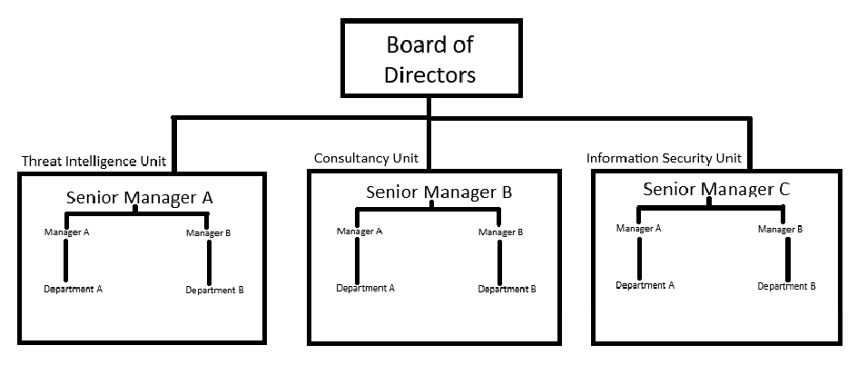
Figure 2 Example organisation chart for StresSolution
As shown by the example chart in Figure 2, a weakness of this approach is the lack of communication between departments and units. There are different ways to improve this, such as cross-departmental meetings. However, it is generally seen more advantageous to use this approach for larger organisations despite the weaknesses.

3.2 Policies and Procedures
Policies and procedures should be regularly reviewed and updated to ensure legal compliance; they should also be regularly reviewed to ensure they remain relevant with the current business model. There are two different major policies that an organisation must create when handling data. The first is a privacy policy, which is a document that is available to customers and must be agreed to and outlines how the organisation will handle and collect their data. The other type of policy is a data protection policy, this is a document for internal employees and third-party contractors. This document outlines how sensitive company and employee data is stored and handled. [17]
Some policies that relate to the security of the data held within the organisation may include: a physical security policy, which outlines the ways to protect both data and business assets through physical access; a Bring Your Own Device (BYOD) policy which is a set of rules as to how employees will be able to use their own personal devices for work, the security of sensitive data must be the highest priority for this policy; furthermore, a network security policy would be required to define how network devices are configured, including routers and wireless access points. The configuration of devices that connect to the network would also be outlined in this policy, such as computers and other mobile devices. This policy will also define the configuration of tools such as firewalls and intrusion prevention and detection systems; finally, a security awareness and training policy is established to ensure all employees are educated appropriately in the relevant parts of information security.
As outlined in the contingencies planning section below, incident response policies and communication procedures must also be established to ensure there is a clear understanding of roles during an emergency. Also as established in the protection mechanisms section below, an appropriate access control policy must be established which will define how user’s access is added or removed; and the process for creating new users.

3.3 Compliance regarding Law and Ethics

3.3.1 Legal Compliance
As StresSolution operates within the United Kingdom, they will have to abide by the Data Protection Act [18] to operate legally. The core principles of the data protection act are outlined in figure 3 below. There is stronger protection on more sensitive information, leading to larger fines if handled incorrectly. The Information Commissioner’s Office (ICO) follows their policies to act against breaches of the data protection act. ICO complete audits and monitor complaints from consumers to ensure compliance is being upheld. ICO has the power to act against businesses in a variety of ways; StresSolution must remain compliant otherwise a fine could be given up to £17.5 million or 4% of their annual turnover, whichever is higher. [19]
Policies outlined in the previous section will establish how data will be used, and the correct training will allow for employees to remain complaint with the current legal requirements. There will have to be a procedure at the StresSolution to constantly monitor the changes to the Data Protection Act and the other relevant laws and regulations to ensure compliance long into the future.
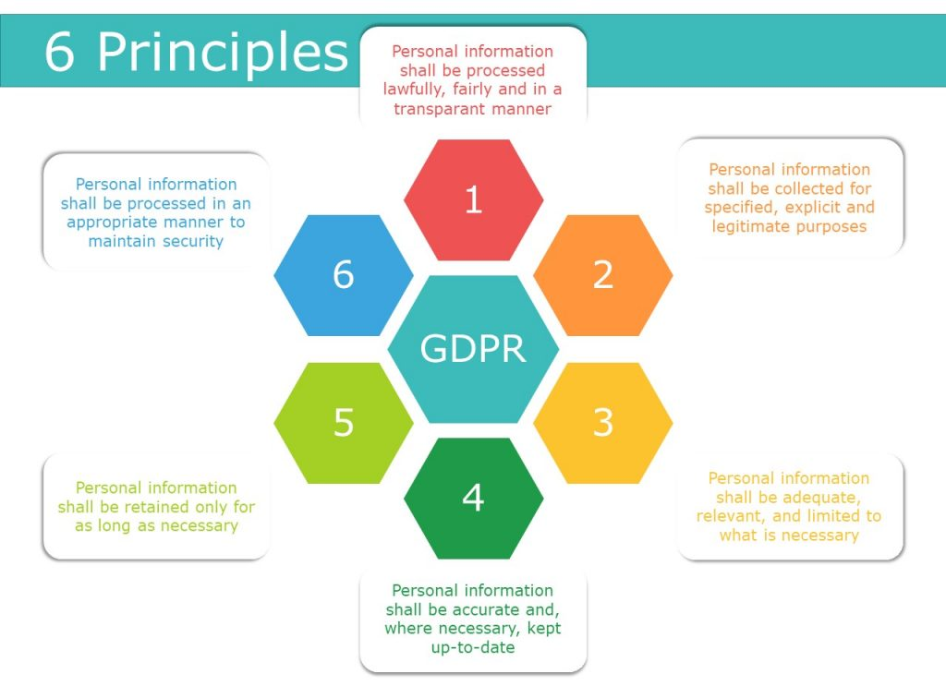
Figure 3 Core principles of the data protection act as outlined by UK Legislation [20]

3.3.2 Ethical Compliance
While legal compliance must be adhered to continue operating without fines, this compliance may cause actions to be undertaken that are not in the best interest of the organisation or customers. To remain ethically compliant, organisations need to develop a framework that outlines the acceptable behaviour that employees must follow both in general and in terms of handling data. Due to the sensitivity of the data that the new information unit will handle, it is important that employees have strong ethics, and these expectations are written in policies and procedures by the organisation to protect and mitigate damages in the event of a data breach by a disgruntled employee.
There should also be procedures in place to outline and enforce how confidentiality is maintained regarding customers and their data. Furthermore, ethical standards should outline how the integrity of the data is maintained; these standards would outline the path of the data within the network and the different security measures used at each point to protect the integrity of the data to guarantee there is no tampering or unauthorised access at any node.

3.4 Governance and Strategic Planning for Security
In general, governance within an organisation is the idea of translating theoretical strategic plans into more specific and actionable tactical objectives. The governance is the responsibilities and best practices that are carried out by the board of directors and senior management team. The responsibilities are outlined then assigned to the functional roles as per the organisation chart, this ranges from responsibilities for the CEO to the lowest level employees at the organisation. There are five goals included with governance which are outlined in relation to StresSolution below, while risk management is a key goal of governance, it is also an important approach that needs discussing separately, so can be found later in section 3.5.

3.4.1 Strategic Alignment
StresSolution should regularly monitor and review the strategic alignment of the business to ensure the data security objectives align with the overall objectives and goals of the business. Regularly reviewing the alignment will ensure the company does not fall out of compliance and ensuring the objectives align with the overall business goals is fundamental to building a strong and reputable information security unit.

3.4.2 Resource Management
For StresSolution, resources will include finances, employees, physical and digital assets. These resources must be efficiently and effectively managed to ensure they are being used to support the data security policies. StresSolution will have a policy to outline the process of monitoring and allocating the correct resources to the correct projects, while adhering to both legal and ethical compliance.

3.4.3 Performance Measurement
StresSolution should also establish relevant key performance metrics (KPI) to constantly track performance and the effectiveness of the information security unit. These KPIs would be used by senior management and the board of directors to evaluate how the business is progressing and would allow for early detection of operational and data concerns.

3.4.4 Value Delivery
The value delivery outlines how the efforts of the information security unit contributes to the overall organisation. The new information security unit should be able to provide solid benefits to StresSolution’s overall operation and should align with the direction of the business objectives.

3.5 Risk Management
To accurately manage risks, a strategy is used which involves identifying, assessing, and mitigating risks to safeguard StresSolution’s physical and data assets. To accurately identify risks, an inventory should be completed on all assets, which would include physical devices and facilities, as well as digital assets such as data and networks. Once the inventory has been completed, the potential threats to these assets should be identified, examples would include hackers attempting to access a computer network or an employee inputting incorrect customer information by accident.
As a part of the risk accessing section, StresSolution would have a few ideas to consider. The likelihood of loss needs calculating and the suspected impact this would have on the business operations and reputation of the organisation. The overall risk then needs to be calculated based on the likelihood and impact, with higher risks being assigned a higher level of priority. Finally, if the calculated risk is not high enough, it may be decided that the cost of avoidance is higher than the potential loss from the risk; in this case it is acknowledged that nothing will be done unless a problem arises. This is known as assessing the risk acceptability and is frequently used to save on business expenses.
Finally, StresSolution would have a risk mitigation approach established to reduce the severity of attacks. The approach is split up into three different plans; the incident response plan which outlines the actions to undertake while there is an ongoing incident, a disaster recovery plan which summaries the actions to take once the attack has ended, and finally the business continuity plan which is a framework to allow the continuation of business operations in the event of a catastrophic attack.

3.6 Contingencies Planning
The contingencies should be planned in the case of unplanned incidents that could tarnish the reputation of the organisation. Firstly, the means of communication need to be planned and established to enable the correct communication between the management and senior management team and the directors. Having quick and efficient communication will allow for accurate responses to take place. A response plan should be developed for physical or data security incidents. In this plan, it should outline the steps taken to mitigate and accept or avoid blame. For example, in the event of a physical break in, it should be established before any press release what damages there have been, both physical and to the data stored.
In the event of a loss of infrastructure due to a natural disaster, such as flooding, power cut, etc. procedures should be established to ensure the quick restoration of operations and to ensure the business recovers from the incident. A key procedure would be to provide a backup power source or generator onsite to quickly restore function in the event of a power cut. Another procedure would be to provide a copy of the network hosted offsite accessible remotely in the event of flooding or harsh weather conditions so that operations can continue seamlessly at a remote location such as at a separate office or at home.

3.7 Protection Mechanisms
There are many different protection mechanisms, some of which we discussed in part A of this paper. To ensure the highest level of protection to data that is being stored, all available security tools should be used where possible. The advantages and disadvantages of the various popular security technologies has been discussed in more detail in part A, in summary, the use of Firewalls, VPNs, Access Control policy, and data encryption should be used in conjunction with each other at all points where data processing takes place to provide the highest level of security. An antivirus software should be used as a monitoring and prevention tool as a backup in case a vulnerability is found and exploited to gain access to a network or device.
Another major security concern is physical security. StresSolution should not only use digital access control but also physical access control to prevent unauthorised access to the office space or secure rooms such as the server room. This access control system should be monitored to ensure that any attempted unauthorised access can be prevented as soon as possible. As discussed in part A, a role-based access control model would work well for the physical access control system too; rooms could have electronic locks that only open to authorised individuals, such as a server room. Furthermore, to further reinforce the physical security, surveillance such as CCTV cameras should be used to allow for monitoring and quick response to intruders.
Security frameworks such as the ISO 27000 framework can be a form of protection mechanism, they establish standards that ensure organisations are compliant by completing the correct risk assessments on the information they store and other parts of the business that could cause harm, such as employees. The framework also demonstrates the best possible practise for business operations, serving as a guide for organisations to follow to remain compliant. Becoming complaint to security frameworks such as ISO and others demonstrates to customers and clients that the organisation can be trusted.

4.0 Conclusion
The need for information and data security for organisations that handle data has been thoroughly explained throughout this paper. The advantages of using multiple security tools; VPNs, data encryption, firewalls; and using other security tools such as the security frameworks in conjunction with each other has been overwhelmingly proven in part A of this research paper. The case study carried out in part B of the paper has provided the company, StresSolution, with an informative guide on the steps to setup a compliant, competent and competitive information security unit. Finally, with the hundreds of millions of pounds of fines handed to organisations yearly it is clear information security should be at the forefront of every business decision, not just an information security unit.

5.0 References
References
[1] J. Sun, "Computer Network Security Technology and Prevention Strategy Analysis," Procedia computer science, vol. 208, pp.570-576, 2022. doi: 10.1016/j.procs.2022.10.079.
[2] C. Cobb, et al., "Computer security for data collection technologies," Development engineering, vol. 3, pp.1-11, 2018. doi: 10.1016/j.deveng.2017.12.002.
[3] Y. Q. Fan, S. S. Qian and F. S. Liang, "VPN Security Technology Theory Modeling and Simulation," Applied Mechanics and Materials, vol. 135-136, pp.1114-1119, 2011. doi: 10.4028/www.scientific.net/AMM.135-136.1114.
[4] R. Bucşa, "Teleworking and Securing Data with VPN Technology," Economy transdisciplinarity cognition journal, vol. 23, no. 1, pp.78-85, 2020.
[5] A. Alshalan, S. Pisharody and D. Huang, "A Survey of Mobile VPN Technologies," COMST, vol. 18, no. 2, pp.1177-1196, 2016. doi: 10.1109/COMST.2015.2496624.
[6] X. Song, "Firewall Technology in Computer Network Security in 5G Environment," Journal of physics.Conference series, vol. 1544, no. 1, pp.12090, 2020. doi: 10.1088/1742-6596/1544/1/012090.
[7] X. He, "Research on Computer Network Security Based on Firewall Technology," Journal of physics.Conference series, vol. 1744, no. 4, pp.42037, 2021. doi: 10.1088/1742-6596/1744/4/042037.
[8] A. Lin and R. Brown, "The application of security policy to role-based access control and the common data security architecture," Comput.Commun., vol. 23, no. 17, pp.1584-1593, 2000. doi: 10.1016/S0140-3664(00)00244-9.
[9] G. M. Kiran and N. Nalini, "Enhanced security‐aware technique and ontology data access control in cloud computing," International journal of communication systems, vol. 33, no. 15, pp.n/a, 2020. doi: 10.1002/dac.4554.
[10] J. Peng, et al., "Big data security access control algorithm based on memory index acceleration in WSNs," J Wireless Com Network, vol. 2020, no. 1, pp.1-17, 2020. doi: 10.1186/s13638-020-01725-1.
[11] Y. Hou, et al., "A Data Security Enhanced Access Control Mechanism in Mobile Edge Computing," Access, vol. 8, pp.136119-136130, 2020. doi: 10.1109/ACCESS.2020.3011477.
[12] B. Kapoor, P. Pandya and J. S. Sherif, "Cryptography," Kybernetes, vol. 40, no. 9, pp.1422-1439, 2011. doi: 10.1108/03684921111169468.
[13] S. M. West, "Cryptography as information control," Soc.Stud.Sci., vol. 52, no. 3, pp.353-375, 2022. doi: 10.1177/03063127221078314.
[14] D. Joseph, et al., "Transitioning organizations to post-quantum cryptography," Nature (London), vol. 605, no. 7909, pp.237-243, 2022. doi: 10.1038/s41586-022-04623-2.
[15] A. Gillies, "Improving the quality of information security management systems with ISO27000," TQM journal, vol. 23, no. 4, pp.367-376, 2011. doi: 10.1108/17542731111139455.
[16] "ISO/IEC 27000 family." ISO. https://www.iso.org/standard/iso-iec-27000-family (accessed Dec 9,).
[17] "Data Protection Policy: Key Elements to Include & Best Practices." Cloudian. https://cloudian.com/guides/data-protection/data-protection-policy-9-things-to-include-and-3-best-practices/ (accessed Dec 12,).
[18] "Data Protection Act 2018." Legislation Gov UK. https://www.legislation.gov.uk/ukpga/2018/12/contents (accessed 12 Dec,).
[19] "Enforcement of this code | ICO." ICO. https://ico.org.uk/for-organisations/uk-gdpr-guidance-and-resources/data-sharing/data-sharing-a-code-of-practice/enforcement-of-this-code/ (accessed Dec 12,).
[20] "Six Principles from the European General Data Protection Regulation." VIB. https://elearning.vib.be/courses/writing-a-data-management-plan/lessons/privacy/topic/six-principles-from-the-european-general-data-protection-regulation/ (accessed Dec 12,).

