Penny Myles 2501939
Ways of Thinking
ADDA4022
1,568 Words
Chris Harrendence

How Did the depictions of Women in Pre-Raphaelite Art Compare to the Ideal
Woman of the Nineteenth Century?

The aim of this essay is to explore and compare the representations of women throughout popular Pre-Raphaelite art to the perfect nineteenth century woman. To begin, I will discuss the social expectations for women. I will do this to support my later findings and to provide context. I will then go on to analyse the women of multiple famous paintings by artists Dante Gabriel Rosseti, Frederick Sandys and William Holman Hunt and see how they compare to my previous research. Pre-Raphaelite artists broke social normalities and portrayed women in a way that contrasted against the popular beliefs that women should be both virtuous and pure. To back up this statement I will be looking at quotes from John Ruskin, a popular art critic, writer and historian from the nineteenth century and Jan Marsh, a British writer and curator that specialises in Victorian art. I will also be looking at writings from popular author Thomas Branagan, and Art historian and Yale University lecturer Tim Barringer.

“She must be enduringly, incorruptibly good; instinctively, infallibly wise, wise not for self-development, but for self-renunciation: wise, not that she may set herself above her husband, but that she man never fail from his side.”
(John Ruskin 1865, quoted in Cossar, 2021)
Throughout history, women have been expected to be pure, submissive, religious and virtuous. If they didn’t meet these expectations, they were heavily judged and casted out of respectable society. However, according to Digby (1992), during the mid nineteenth century, the social and moral expectations placed upon women sharpened significantly more. This being around the time the Pre-Raphaelite art movement was founded meant it would likely impact the themes of the artwork. Any woman who was considered to be impure was deemed a ‘fallen woman’ that would spread disease and misfortune. This includes prostitutes, mistresses, and adulterers, all of whom were commonly yet controversially the subject of Pre-Raphaelite art. In contrast to this, men rarely faced any punishment for their impurities and remained in positions of power.
“The villain who robs the innocent defenceless virgin of her virtue, bereaves society of a gem that might become its brightest ornament, and its boast, and lets loose, sends forth, constitutes and qualifies a pest, a curse, a disgrace to society, who will in future live to ensnare and enslave others, trample upon her own character, expose her constitution, murder her soul, and at last die the victim of a fearful and fatal disorder, and a tortured mind, cursing with her last breath the murderer of her body and soul” (Branagan 1808, pp. 20-21)
This quote written in 1808 already strongly stresses the importance of a woman’s purity and makes it hard to believe that these social constructs became even stricter. Throughout the text this quote is from, Branagan continues to stress the importance of it being the woman’s responsibility to stay pure and resist the actions of men, who according to him, cannot help but sin. If the woman who is meant to be pure and virtuous gives in, he concluded that they are an imbecile (Welter, 1966).
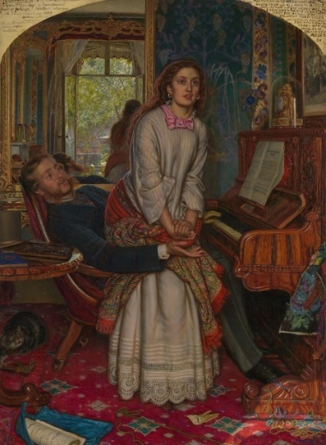

Figure 1: The Awakening Conscience (Hunt, 1853)

The first painting I will be looking at is The Awakening Conscience (Fig 1) by William Holman Hunt. In this painting, we see a woman in her undergarments rising from the lap of an aristocratic man. Using the mirror, Hunt gives us a glimpse of what caught her attention: a window displaying an inviting sunny outdoors scene. The room the painting takes place in is made to feel claustrophobic with its tacky furnishing and cluttered décor to make the view from the window feel freeing.
“There is nothing to be learnt from the terrible lustre of it, from its fatal newness, nothing there that has the old thoughts of home or that is ever to become a part of home” (Ruskin 1854, quoted in Barringer 1999, p. 96).
This is a quote written to The Times by Ruskin explaining the significance of the décor of the room. I think this quote describes the situation the woman is in beautifully. It shows that he has no love to offer her, only a superficial connection built upon his power over her. We also see a cat hunting an injured bird under the table, a parallel to the predatory situation the woman is in; the woman is the prey and the man the predator. The injured bird is used to show that the man took advantage of the woman’s vulnerable situation (The Tate, a). All of this was done purposely by the artist to shed a light on the woman being the victim of this relationship, a way of protesting against the common beliefs of the period. I have always respected this painting and the artist for what I believe is an empathetic and forward way of presenting a woman of this circumstance. As shown in my previous paragraph women were typically blamed yet Hunt controversially makes the man the culprit. The woman in this painting differs completely from the ideal woman, backing up my initial statement.

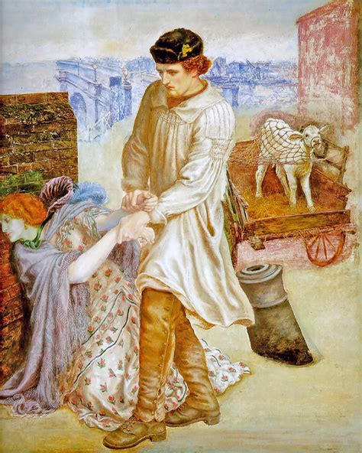
Figure 2: Found (Rossetti, 1853-1882)

Next, I will be looking at Found by Dante Gabriel Rosseti (Figure 2). This unfinished painting explores similar themes to The Awakening Conscience. The painting depicts a man finding his former lover as a victim of prostitution. She is so riddled with shame can’t bear to look at him. Her green face is either depicting sickness caught from her situation or the contamination of the streets. In the background we see a baby calf, its white coat and youth representing her innocence and entrapment.
“The calf, caught up in a mesh of rope and on an inexorable road to slaughter, is a symbol of her fate but also of her fundamental innocence”. (Barringer 1999, p. 97)
I found this interpretation interesting and would like to explore it further. Similarly to The Awakening Conscience, this has led me to believe that Found is an empathetic interpretation of a lower-class woman who has succumb to the streets. This portrayal again contradicts with the image of the favourable nineteenth century woman. The fact that the artist recognises the woman is not the one at fault and is showing sympathy for her was extremely rare. This painting was unfortunately left unfinished by Rossetti, so it is somewhat lacking in symbolism to dissect. However, I think its meaning was still made clear.
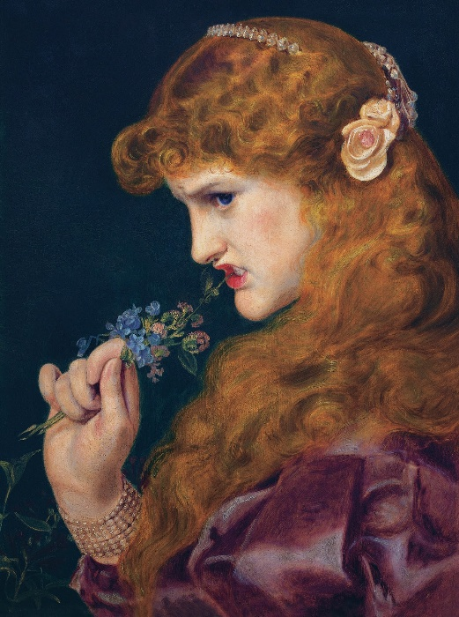

Figure 3: Love’s Shadow (Sandys, 1867)

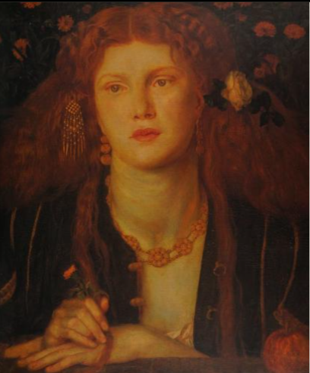
Loves Shadow (Fig 3) features a girl who appears to be of nobility as we can see that she’s wearing jewellery and an expensive gown. Her expression is rather different from what we’d expect from the virtuous, kind-hearted qualities expected from the upper-class woman. Her face screams jealousy and bitterness as she bites the honeysuckle she’s holding. The honeysuckle represents love yet this contrasts completely with her expression. She may be rebelling against the shackles of having to be the loveable woman of high society contradicting the idea that women must be submissive. Her red hair, a popular staple of women in Pre-Raphaelite art, being let down represents passion. This again opposes the ideal pure Victorian woman (Gibson, 2018).

Figure 4: Bocca Baciata (Rossetti, 1859)

The last painting I will be looking at is Bocca Baciata (Fig 4) - another painting by Dante Gabriel Rossetti that defies the stereotypical image of the perfect pure and virtuous woman. The painting’s title originates from one of Giovanni Boccaccio’s stories about a woman who has had many lovers. However, in contrast to popular belief her ‘freshness’ never diminishes (Marsh, 2018). Like in figure 3, the woman’s hair is down, and she is wearing lavish gold jewellery, all of which would be considered very improper for the time. The title and the promiscuous imagery of the painting sparked an uproar from many viewers and art critics.
“The representation of figures shamelessly exhibiting their physical charms was an innovation in Pre-Raphaelite art, and was deeply shocking to many” (Marsh, 1987 p. 86)
This painting was extremely different from what was believed to be acceptable and resulted in a series of similar paintings being produced by Rossetti.

Pre-Raphaelite artists broke social normalities and portrayed women in a way that contrasted against the popular beliefs that women should be both virtuous and pure. Since ancient times society has pushed the idea of the perfect woman being one that is pure, religious and virtuous. Any woman who failed to meet these expectations would be subject to social rejection and ridicule. This was especially relevant during the nineteenth century where the rules and regulations that confined women stiffened further. It was very rare that depictions of women in art would stray from the image of the perfect woman and anything that did otherwise was seen as taboo. The Pre-Raphaelite movement in the mid nineteenth century was the catalyst that helped begin to change this narrative. Prostitution and sexuality were just a few of the topics they faced contemporarily and empathetically. This was especially rare during this time period as society came down harshly on women even if they were victims of circumstance or abuse. This essay has inspired me to dive deeper into how women have been presented in different art movements and to further study the significance of women in art and literature. Furthermore, I have also been inspired to research more into how Pre-Raphaelite artists like William Holman Hunt used symbolism in their work. This is something especially important to me as I would like to experiment with symbolism more to develop and strengthen my storytelling and illustrative abilities.

References
Cossar, E. (2021) The role of women in victorian England. Available at: https://www.ool.co.uk/blog/the-role-of-women-in-victorian-england/ (Accessed: 18 November 2025)
Digby, A. (1992) ‘Victorian values and women in public and private’, Proceedings of the British Academy, 78, pp. 195-215. Available at: https://www.thebritishacademy.ac.uk/documents/4031/78p195.pdf (Accessed: 20 November 2025)
Branagan, T. (1808) The excellency of the female character vindicated. Philadelphia: J. Rakestraw. Available at: https://archive.org/details/excellencyoffema00bran/page/24/mode/2up (Accessed: 20 November 2025)
Welter, B. (1966) ‘The cult of true womanhood’, American Quarterly, 18(2), pp. 151-174. Available at: https://www.jstor.org/stable/2711179 (Accessed:19 November 2025)
Hunt, W.T. (1853) The Awakening Conscience [Oil on canvas] Available at: https://www.tate.org.uk/art/artworks/hunt-the-awakening-conscience-t02075 (Accessed: 17 November 2025)
Baringer, T. (1999) Reading the Pre Raphaelites. London: Orion Publishing Group.
The Tate. (a) The Awakening Conscience. Available at: https://www.tate.org.uk/art/artworks/hunt-the-awakening-conscience-t02075 (Accessed: 14 November 2025)
Rossetti, D.G. (1853-1882) Found [Oil on canvas] Available at: https://rossettiarchive.iath.virginia.edu/docs/s64.rap.html (Accessed: 17 November 2025)
Baringer, T. (1999) Reading the Pre Raphaelites. London: Orion Publishing Group.
Sandys. F. (1867) Love’s Shadow [Oil on canvas] Available at: https://victorianweb.org/painting/sandys/paintings/16.html (Accessed: 17 November 2025)
Gibson, R. (2018) Why are artists infatuated with red hair? Available at: https://artuk.org/discover/stories/why-are-artists-infatuated-with-red-hair (Accessed: 17 November 2025)
Rossetti, D.G. (1859) Bocca Baciata [oil on panel] Available at: https://collections.mfa.org/objects/34360/bocca-baciata-lips-that-have-been-kissed?ctx=95f7dc8c-9d39-4eb8-bc68-898cb512d25fidx=15 (Accessed: 18 November)
Marsh, J. (1987) Pre-Raphaelite Women. London: George Weidenfeld & Nicholson Ltd

Bibliography.
Baringer, T. (1999) Reading the Pre Raphaelites. London: Orion Publishing Group.
Barringer, T. and Dorment, R. (2003) Pre-raphaelite and other masters: the Andrew Lloyd Webber collection. London: Royal Academy of Arts.
Branagan, T. (1808) The excellency of the female character vindicated. Philadelphia: J. Rakestraw. Available at: https://archive.org/details/excellencyoffema00bran/page/24/mode/2up (Accessed: 20 November 2025)
Cobby, H. (2020) Rossetti and The Blue Bower: Pre-Raphaelite symbolism and ideals of beauty with a single female muse. Available at: https://barber.org.uk/wp-content/uploads/2020/12/1.-Rossetti-and-The-Blue-Bower-transcript-for-12.05.pdf (Accessed: 15 November 2025)
Cossar, E. (2021) The role of women in Victorian England. Available at: https://www.ool.co.uk/blog/the-role-of-women-in-victorian-england/ (Accessed: 18 November 2025)
Digby, A. (1992) ‘Victorian values and women in public and private’, Proceedings of the British Academy, 78, pp. 195-215. Available at: https://www.thebritishacademy.ac.uk/documents/4031/78p195.pdf (Accessed: 20 November 2025)
Frey, A. (2020) The Women of Pre-Raphaelite Art. Available at: https://www.artandobject.com/articles/women-pre-raphaelite-art (Accessed: 18 November 2025)
Gibson, R. (2018) Why are artists infatuated with red hair? Available at: https://artuk.org/discover/stories/why-are-artists-infatuated-with-red-hair (Accessed: 17 November 2025)
Hunt, W.T. (1853) The Awakening Conscience [Oil on canvas] Available at: https://www.tate.org.uk/art/artworks/hunt-the-awakening-conscience-t02075 (Accessed: 17 November 2025)
Marsh, J. (1987) Pre-Raphaelite Women. London: George Weidenfeld & Nicholson Ltd
Rossetti, D.G. (1853-1882) Found [Oil on canvas] Available at: https://rossettiarchive.iath.virginia.edu/docs/s64.rap.html (Accessed: 17 November 2025)
Rossetti, D.G. (1859) Bocca Baciata [oil on panel] Available at: https://collections.mfa.org/objects/34360/bocca-baciata-lips-that-have-been-kissed?ctx=95f7dc8c-9d39-4eb8-bc68-898cb512d25fidx=15 (Accessed: 18 November)
Sandys. F. (1867) Love’s Shadow [Oil on canvas] Available at: https://victorianweb.org/painting/sandys/paintings/16.html (Accessed: 17 November 2025)
Sebag-Montefiore C. (2018) Sensuality, lust and passion: how the Pre-Raphaelites changed the way the world sees women. The Guardian. Available at: https://www.theguardian.com/artanddesign/2018/dec/19/sensuality-lust-and-passion-how-the-pre-raphaelites-changed-the-way-the-world-sees-women (Accessed: 21 November 2025)
The Tate. (a) The Awakening Conscience. Available at: https://www.tate.org.uk/art/artworks/hunt-the-awakening-conscience-t02075 (Accessed: 14 November 2025)
The Tate. (b) Why were the Pre-Raphaelites so shocking?. Available at https://www.tate.org.uk/art/art-terms/p/pre-raphaelite/why-were-pre-raphaelites-so-shocking (Accessed: 14 November 2025)
The Tate. (c) Ophelia. Available at: https://www.tate.org.uk/art/artworks/millais-ophelia-n01506 (Accessed: 15 November 2025)
Welter, B. (1966) ‘The cult of true womanhood’, American Quarterly, 18(2), pp. 151-174. Available at: https://www.jstor.org/stable/2711179 (Accessed:19 November 2025)

