Assignment 1
Rhys Treharne - 2120039
Introduction
In this document I will be explaining what threats are, what vulnerabilities are and what attacks are. I will also be covering and explaining some vulnerabilities and how to recover from a vulnerability. I will also be using packet tracer to create a logical and physical topology, and ways on how to improve the vulnerabilities in the network/organisation
Table of contents
Task 1: Threats, Vulnerabilities and Attacks… Pages 1-2
Task 2: Vulnerabilities… Pages 2-3
Task 3: Mitigation Strategies… Page 3
Task 4: Logical and Physical Drawings and Screenshot Evidence… Pages 3-11
Task 5: Network Vulnerability Improvements… Pages 11-12
Abstract: Page 12
References: Page 12-13

Task 1
Threats
A threat is like an event that is unexpected, and the purpose of the event Is to harm something or someone. The threat could be something like an intruder to the system would want to exploit data or even steal data. The different types of threats would be:
Viruses & Worms: The purpose of these threats would be to input malicious code into a system and that code would copy and attach itself to a file etc. Once somebody has activated it (knowingly or not knowingly) that virus will spread
Phishing: Phishing attacks tend to be attacks sent by email. They would insert a link that takes you to page asking for credentials. If the user enters these credentials the attacker could access that user’s data by using the credentials they inputted
For example, a key example of a threat within an organisation would be that attackers would gather the organisations information, money or other data. The threat could be silent as they would do the move unnoticed. This exact attack would be called a DoS attack.

Vulnerabilities
A vulnerability within a system would be the weakness of that system. This weakness would be a primary target for the attackers. By having this weakness this is the key for the attackers to have a successful attack to breach the system. Why is vulnerability important? As I have just explained, vulnerabilities are crucial to a system and having them being exposed to hackers can cause serious damage. It is important for the cyber security team within an organisation make sure they clear these weaknesses because attackers will grasp on the weakness if not patched. It is also important for cyber teams to do plenty of testing with the system because that is their best shot of trying to find the weaknesses. There are ways of how to identity a weakness within the system, one would be to check if the system is up to date and to conduct a vulnerability assessment that covers all areas of the system.

Attacks
An attack is when one or more cybercriminals attack a organisations system where they would attempt to steal data, steal money or delete any data. The attacker could use one or more computers to do this. The reason why the cybercriminals attack is because their goal is to steal information or to gain information. Like I had mentioned in the previous section, the attackers would
exploit the system by finding their weaknesses, that would be their way through the systems defences.
Task 2
A default login credential is basically how a user would log in to a PC or log in to the system, this is the gateway essentially into the system. The vulnerabilities with default login credentials would be that if a user uses a default password the attackers would easily be able to use that password to get into the system. This would leave the system vulnerable because the attacker would be able to get into anything and delete anything. How to avoid this? The best way to avoid a attacker from getting into your login would be to create a strong and secure password, this would then stop the attacker from entering the login. Why are default credentials a vulnerability? The reason why it is a vulnerability is because people who aren’t clued on with technology will more than likely to have a weaker password. This is an easy way for the attacker to break into the system.
Next, I will be focussing on a remote host is running a telnet service allowing cleartext logins over unencrypted connections. This is basically a session is created where credentials aren’t encrypted. All of the text is in cleartext, and this suggests that any secure passwords or any sensitive information will be in clear text so anyone can view it. This is a vulnerability because an attacker could be eavesdropping the session, and this would reveal all of the passwords or any sensitive information. This suggests that the attacker would now have the information he needs to get into the system. This method is not recommended because this shows how vulnerable it makes the system because information is on show and not encrypted.
The next section I will be going over a server is running with ssl/tls is prone to an information disclosure vulnerability. This could lead to a very skilled malicious user be positioned onto the network, this can also then lead to a man in the middle attack. A man in the middle attack is when the attacker intercepts any form of communication like messages between people and he can listen in to the communication and gather information. This is a vulnerability that can cause issues because the users who are having a conversion with each other wouldn’t know that the attacker is listening in.
SSLv2 and SSLv3 are very old protocols. These protocols should not be used because how old they are. SSLv3 is basically a form of security system that does secure web transactions; however, this is an older version. So, it is recommended not to use this. With SSLv2 it is similar to SSLv3, they should not be used because if a user has SSLv2 still activated this is likely to cause a man in the middle attack. The best way to avoid having any attacks like a man in the middle etc, would be to upgrade your web server or disable the sslv3 and sslv2.
SSL stands for Secure Socket Layer and TLS stands for Transport Layer Security, and the purpose of these protocols would be to make sure users have secure connections when on a computer network. A TLS was a replacement for the sslv3, the reason why it was a replacement was because the sslv3 was vulnerable to attacks because on how old it is. SSL and TLS are the same, just nowadays it is referred as TLS. TLS is a data encryption protocol, data integrity protocol and a authentication protocol. By using TLS, it can reassure you that nobody has read your messages, makes sure that nobody has edited your message and it also makes sure that you are aware that you’re talking to the correct person. However, if you do come across any issues with TLS there are ways you can go about it. You could encrypt data/messages. This would make the content unreadable if any attacker or middleman was to listen in or try to read anything, or you would sign everything which shows that what you’re sending or receiving belongs to the correct person. To be able to do this you will need a specific key. There are two types of keys, such as public keys and private keys. If a message was encrypted with a public key this would suggest that you would need a different private key to decrypt that message. This shows that you cannot decrypt a message with the same key. As I previously mentioned there are two types of keys, the public key is available for everyone, and the private key is not.
Task 3
RNSMWR
RNSMWR is a form of attack that denies any users or any organisation from accessing any files on their computer. Additionally, the attackers would encrypt the files to stop the users/organisation from accessing them, the attackers would demand a payment. This would be the easiest method of retrieving their files back. It can affect the company by data exposure and loss of money due to the payment they need to make to have the files decrypted. If anything was to be deleted or stolen from the attack, one of the best methods would be to do a system backup, providing there is one in place.
EVILLOCK
Evillock is another form of ransomware which essentially is a form of virus. It would install itself onto a pc (targeted). The best way to figure out if any files have this Evillock malware on it, you can look on the file extension, if it has .evillock on it, this shows that you have the malware installed on your pc. You will find the evillock is distributed through an email, they would try to force the user to engage with the attachment they provide in the email. Similar to RNSMWR it locks people from opening files. The best way to fix this would be to use a anti-malware tool that can remove the evillock.

Task 4
During task 4 I will be creating a topology and a vulnerability on default login credentials as I feel I will be able to give a good drawing (logically and physically) topology. Down below are my screenshots of the drawings, with a brief description.
Physical

Here is my physical drawing of the network. The purpose of this is to show how the network would be set up or run in an office environment.
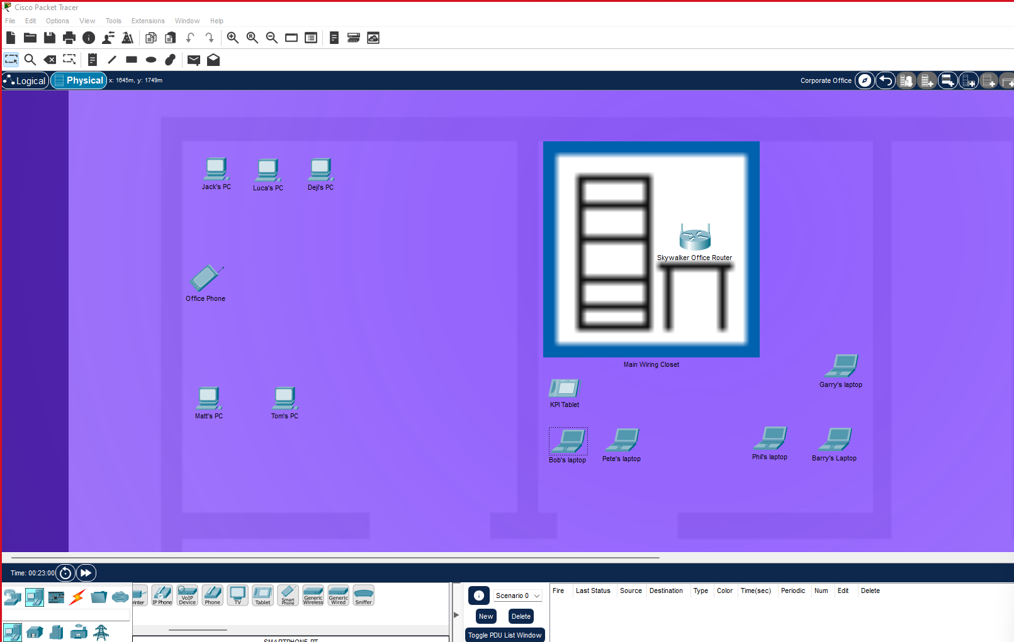

Logical
Here is the logical topology. This shows how all the devices connect to the router via the IP address
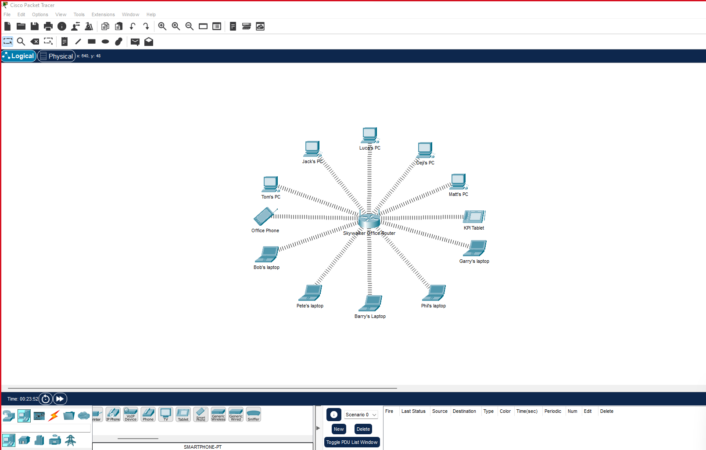
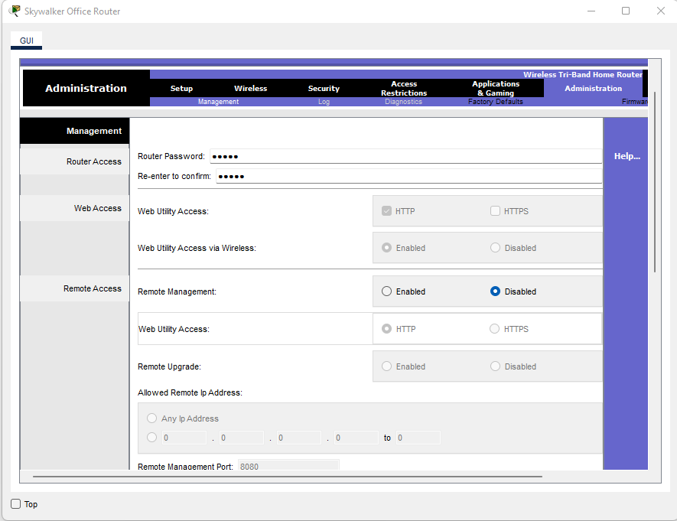
This shows that the password is set to default
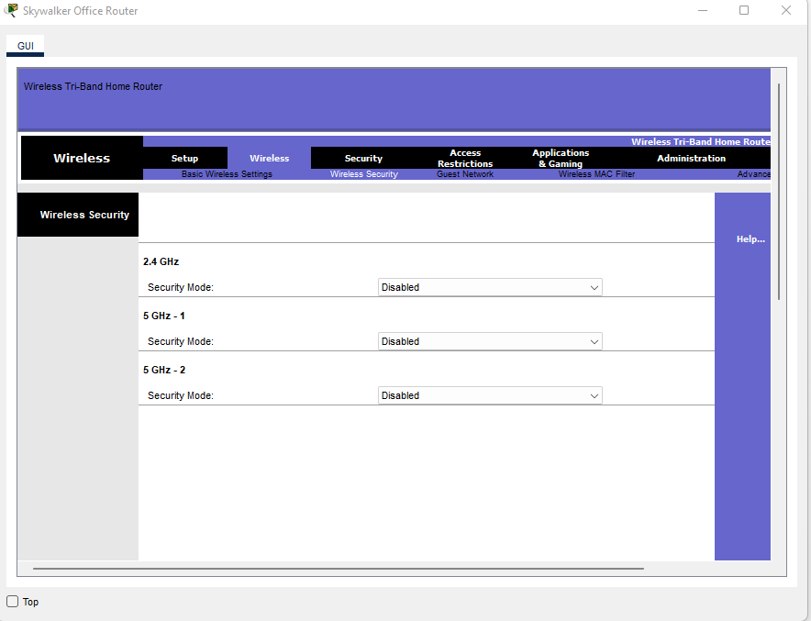
All of the settings here are set to default, and all of the security has been disabled.
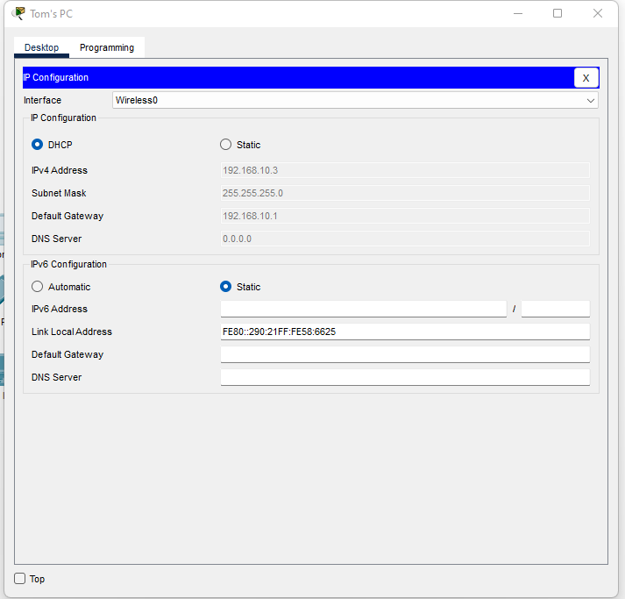
Here is an example of the PC’s. as you can see the subnet mask is the same as the router and the IP address corresponds with the router (192.168.10.1)
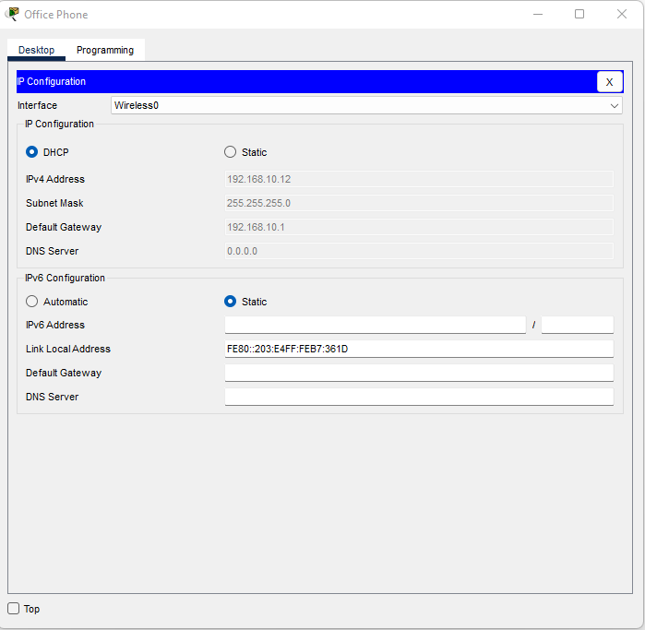
This is an office phone (smartphone) and as you can see it corresponds with the routers IP address (192.168.10.1)
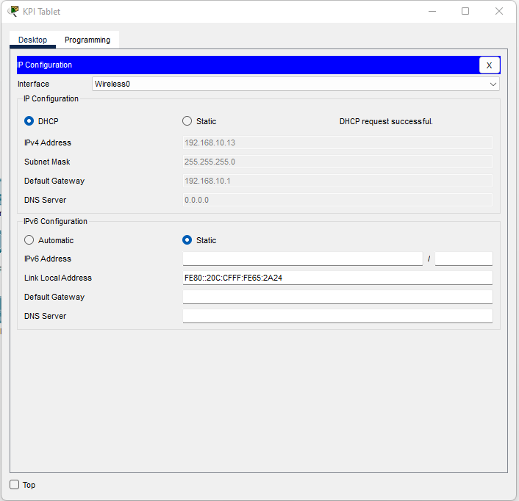
This is the tablet they use in the office, this also corresponds with the routers IP address (192.168.10.1)
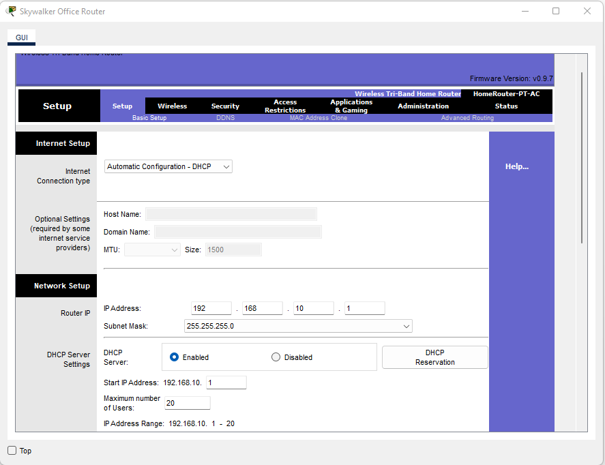
Here are the Reuters network settings, as you can see the subnet mask is 255.255.255.0 and the start IP is 192.168.10.1. This shows how all of my devices are connected up to the router properly. Also, I have enabled DHCP, this shows that If I enable DHCP on the devices it should pick up the network details instantly, and it had.
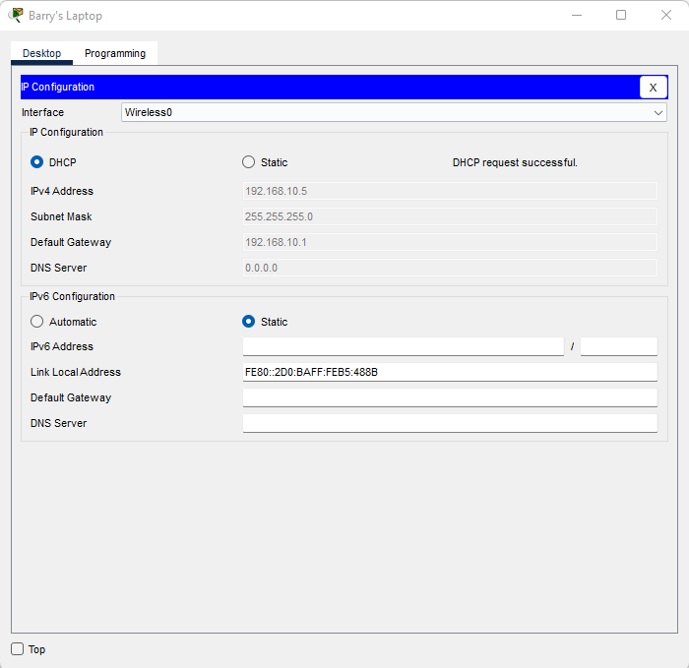
As you can see the laptops are connected successfully, picked up the correct IP and other network settings

Task 5
There are flaws within this organisation that can cause a threat, due to the fact that there are no security measures in place physical or logical. There is obvious solution for the physical security measures would put in intrusion detection systems in the building, this can apply security if anyone was to break into the building. Another form of security for the physical side, would install a bunch of CCTV cameras around the office and around the building, so if there was an intrusion, you’d have it on camera for evidence. Onto the next part, the router needs more security measures because currently there aren’t any in place. To begin with, the company would need to strengthen the password for the router, as it is currently on default. An attacker would be able to bypass that within seconds. The next step would be to look into setting up the firewall. This can prevent anyone outside the organisation from entering the system or the network. In the screenshots I provided, you can see that the security has been disabled, this will need to be enabled. Another factor that can be used to help prevent any attacks would be a VPN. A VPN makes sure that the device has a secure connection between the device and internet. This can prevent any sort of attacks such as a middleman attack etc. The VPN can hide things such as the location of that device and the VPN can encrypt any credentials or network information. The VPN also offers another type of VPN called remote access VPN; this can allow you to remote onto another network securely if the organisation wishes to. This can provide additional security to the organisations network.

Abstract
Throughout this report I have covered different threats, vulnerabilities and attacks. Through doing the research I have learned a lot about the different attacks, vulnerabilities and threats. Next, I moved on to going doing more research on vulnerabilities and how to do a recover if there was an attack or if a vulnerability got exposed to an attacker, this gave me the chance to learn how to do secure recovers. The next stage was looking into mitigation strategies. I covered the RNSMWR and Evillock. Conducting research on these was interesting and learnt a lot from that. The following stage in the report will be the creating a logical and physical topology. To do this I used Packet Tracer to draw out the topologies. The logical was to show how all devices would connect through the network, so I had 6 laptops, 6 PC’s and 2 additional devices. They all connected to a router (IP address). The physical topology was based on how all the devices would be set up in an office environment. The final stage would be how to make my network and organisation more secure from any form of vulnerability. In this section I wrote about VPN installation, setting up a firewall and activating it, I also mentioned to set up CCTV cameras and an intrusion system within the building to avoid any intrusions and if there was to be any, the CCTV would capture it for evidence. In conclusion I have enjoyed doing this report because I felt like I have learned a lot through doing research on the different essentials to cybersecurity and networking

References
[1]"Top 10 types of information security threats for IT teams", SearchSecurity, 2022. [Online]. Available: https://www.techtarget.com/searchsecurity/feature/Top-10-types-of-information-security-threats-for-IT-teams. [Accessed: 22- Jul- 2022].
[2]"What are vulnerabilities, and how are they exploited?", INFORMATION Understanding vulnerabilities, 2022. [Online]. Available: https://www.ncsc.gov.uk/information/understanding-vulnerabilities#:~:text=A%20vulnerability%20is%20a%20weakness,to%20achieve%20their%20end%20goal. [Accessed: 25- Jul- 2022].
[3]2. Eric Dosal December 21, "4 Steps to Improve Your Vulnerability Management Process", Compuquip.com, 2022. [Online]. Available: https://www.compuquip.com/blog/importance-of-vulnerability-management. [Accessed: 25- Jul- 2022].
[4]"How to Identify Security Vulnerabilities in Businesses | Consolidated Technologies, Inc.", Consolidated Technologies, Inc., 2022. [Online]. Available: https://consoltech.com/blog/identifying-business-security-vulnerabilities/. [Accessed: 25- Jul- 2022].
[4]"What is a Cyber Attack? - Check Point Software", Check Point Software, 2022. [Online]. Available: https://www.checkpoint.com/cyber-hub/cyber-security/what-is-cyber-attack/#:~:text=A%20cyber%20attack%20is%20an,launch%20point%20for%20other%20attacks. [Accessed: 25- Jul- 2022].
[6]"Unencrypted Telnet Server", Tenable.com, 2022. [Online]. Available: https://www.tenable.com/plugins/nessus/42263. [Accessed: 25- Jul- 2022].
[7]"What Is a Man-in-the-Middle Attack (MitM)? - Definition from IoTAgenda", IoT Agenda, 2022. [Online]. Available: https://www.techtarget.com/iotagenda/definition/man-in-the-middle-attack-MitM. [Accessed: 25- Jul- 2022].
[8]"The POODLE Attack and the End of SSL 3.0 – Mozilla Security Blog", Mozilla Security Blog, 2022. [Online]. Available: https://blog.mozilla.org/security/2014/10/14/the-poodle-attack-and-the-end-of-ssl-3-0/. [Accessed: 26- Jul- 2022].
[9]"SSL and SSL Certificates Explained For Beginners", Steves internet guide, 2022. [Online]. Available: http://www.steves-internet-guide.com/ssl-certificates-explained/. [Accessed: 26- Jul- 2022].
[10]"Ransomware Data Recovery: 5 Ways to Save Your Data", Cloudian, 2022. [Online]. Available: https://cloudian.com/guides/ransomware-backup/ransomware-data-recovery-5-ways-to-save-your-data/. [Accessed: 26- Jul- 2022].
[11]G. Ivanova, M. Beltov and A. Dimchev, "EvilLock Ransomware Removal and .Evillock Decryption", Best Security Search, 2022. [Online]. Available: https://bestsecuritysearch.com/remove-evillock-ransomware-decrypt-evillock/. [Accessed: 26- Jul- 2022].
[12]"What Does a Firewall Do? | FortinetWhat Does a Firewall Do? And What Firewalls Don’t Do | Fortinet", Fortinet, 2022. [Online]. Available:
[13]” https://www.fortinet.com/resources/cyberglossary/what-does-a-firewall-do#:~:text=A%20firewall%20is%20a%20security,intranets%2C%20connected%20to%20the%20internet”. [Accessed: 28- Jul- 2022].
[14]"8 tips to keep your office secure | Markel Direct UK", Markeluk.com, 2022. [Online]. Available: https://www.markeluk.com/articles/8-tips-to-keep-your-office-secure. [Accessed: 28- Jul- 2022].

