

Certificate of Higher Education Skills for the Workplace
Health & Social Care

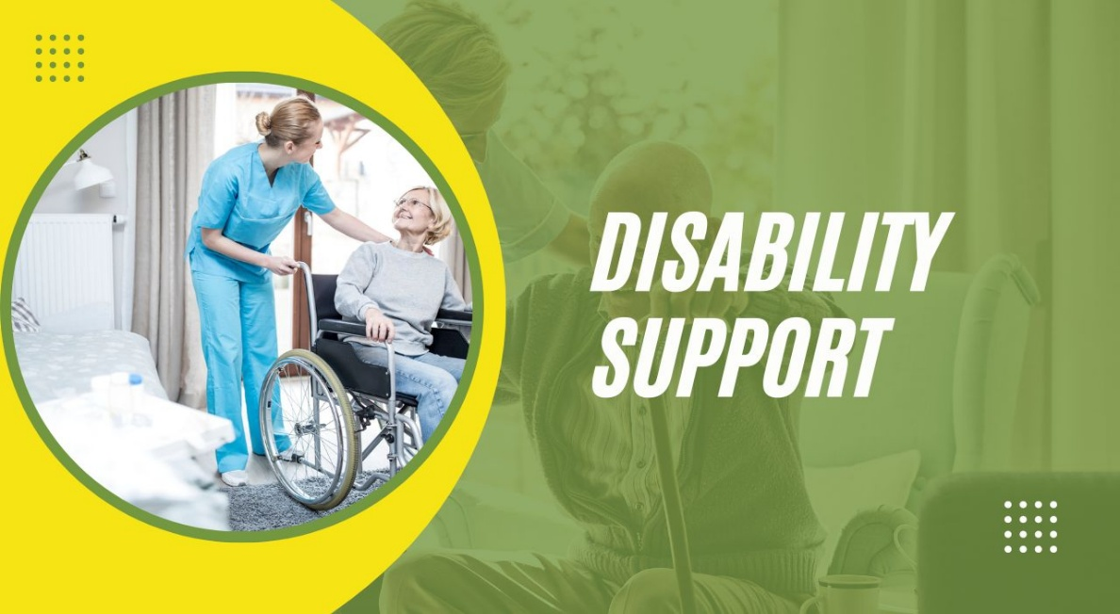

Name: Katherine Elizabeth Montero Coello
Student number: 2512506
Module code: LCHS4001_LON
Module: Academic and employability skills
Lecture: Naomi Doerge
Count word: 1320 (10%up)

TABLE OF CONTENTS:

I. - Introduction……………………………………………………………………....3

II.- Task 3: Describe a specific role – Health and social care….4
2.1.- Disability support worker……………………………………………....4
2.2.- Disability support worker skills……………………………………….5
2.2.1.- Communication skills………………………………………………5
2.2.2.- Good organisational skills…………………………………………5
2.2.3.-Empathy skills……………………………………………………….6
2.3.- Strategies to improve those skills and examples……………….6
2.3.1.-Communication Skills-Strategy and Examples………………….6
2.3.2.- Good organisational skills-Strategy and examples……………..7
2.3.3.- Empathy Skills-Strategy and examples………………………….7
III.- Conclusion………………………………………………………………………8
IV.- References………………………………………………………..…………….9

INTRODUCTION:

The role of a DSW is deeply meaningful, as it focuses on helping disabled people live with dignity and confidence and become as independent as possible. This report will describe the role's involvement, looking beyond the basic duties, and will also include three essential skills for this role that every professional should have. For each skill will include a simple strategy and a real-life example that shows how a professional can make some small changes and make a difference in someone’s life. The goal of this report is to offer a clear and approachable overview of the role.

II- TASK-3: Describing a specific role – Health and Social Care

2.1.- Disability support worker:

DSWs are professionals who provide specific support according to the patient’s disability in order to achieve greater independence and learn new skills. Usually, a DSW works in hospices, home care, or other settings. Its tasks are personalised and socio-educational, aiming to enable people with disabilities to have a proper life and enjoy time with their families, friends and society in general. (Menniss,2024)
The role of the DSW plays an important part in helping disabled people; it is more than covering the basic needs; it is about supporting independence, building confidence and ensuring the patient is treated with respect. (Topping et al.,2022)
This role allows providing practical and emotional support to individuals with any disability, whether it is physical or intellectual. Every patient will need a different type of support. It might include helping with personal care, such as bathing and dressing; assisting with medication; learning new skills; helping maintain the home clean to ensure their safety; and going with them to any appointment.
The DSW is considered a representative of the service for people with disabilities and is an essential part of the community by providing quality service and encouraging patients to feel included in community life. This helps to make new friends and create social connections, which are essential for emotional well-being. (Bogenschutz, Hewitt, Nord, & Hepperlen, 2014; Hewitt & Larson, 2007; Iacono, 2010). (M Vassos, K Nankervis, J Chan, 2019).

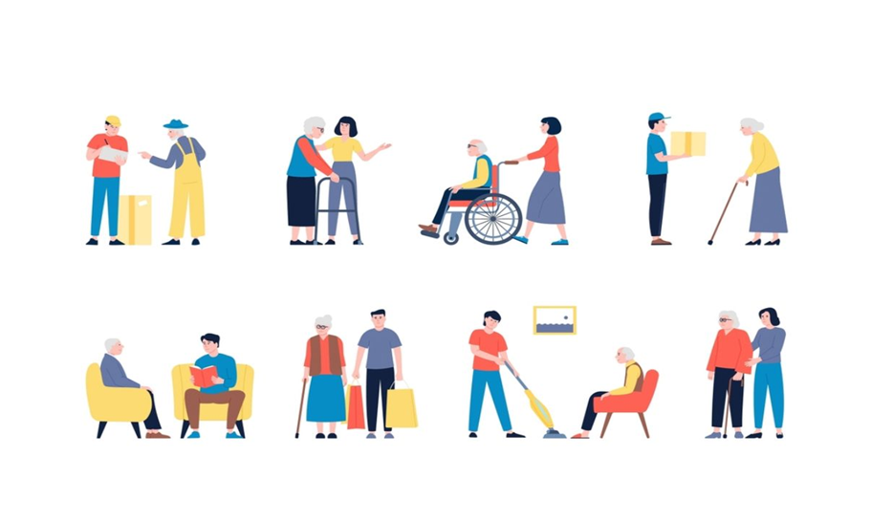

2.2.- Disability Support Worker Skills:

Disability support worker skills are the helpful abilities and personal qualities a worker needs to support people with disability in their lives.
This report will review three essential skills for being a good DSW.
- Communication skills
- Good organisational skills
- Empathy skills

2.2.1.- Communication skills:

Good communication skills are essential for developing your career successfully; therefore, it is vital to feel confident in this skill, as DSW will be supporting patients who have difficulty expressing themselves, understanding, and following conversations.
In this work environment, it is essential to communicate appropriately and personalise, taking into consideration and evaluating the type of disability of each patient.
The DSW must not forget that good communication must be active; paying full attention to the patient, recognising and validating what it feels, showing interest, and, at the same time, trying to understand correctly the message it wants to deliver.
Communication manifests in different ways, both verbal and nonverbal. Some patients will use sign language and iconic language. (Nursing at home,2023)

2.2.2.- Good Organisational Skills:

As a DSW, there are many organisational tasks that must be carried out daily and resolved on time. Therefore, as a professional, you must be very organised and know how to manage action times. The principal aim is to ensure the patient's comfort and success.
The tasks should be organised by priority, while always covering the patient’s basic needs; obviously, we will adapt if any unexpected circumstances arise. Just as if on that day the patient had any medical appointment, some activity or the patient's medical condition suddenly changed.
It is crucial to have all medical documentation organised up to date and have easy access to it. (D’Amico,2022)

2.2.3.- Empathy Skills:

Empathy is the ability to put oneself in the patient's shoes and experience or perceive the patient's emotions. (Ioannidou and Konstantikaki,2008)
In that role as a DSW, it is crucial to have empathy when providing emotional support to patients. DSWS need to recognise how disability, frustration and probably pain can impact a patient’s emotions. The professional must understand the challenges the patient is facing, acknowledge the patient's feelings without judgment, and encourage open communication to help the patient feel heard and validated. (Tilley,2012). Additionally, addressing emotional well-being is as crucial as meeting basic needs. (Support Worker, 2021)

2.3.- Strategies to improve those skills and real examples:

2.3.1.- Communication Skills – Strategy and example

The DSW can improve their communication skills, based on specific training and practices aimed at patients with disabilities. Among them, it can be mentioned that some communication and learning methods should be more prevalent in health centres to improve the service:

- Makaton: based on signs and symbols, helps to communicate with people with physical and hearing problems.

- Body language: based on gestures, facial expressions, eye contact and body movements. By adopting a positive body language, the disability support worker can transmit calmness, which helps to build trust and makes the patient feel safe, making it easier for them to share personal information.
The strategy for communication skills is to learn new communication methods. For example, something that might be useful is learning short phrases in Makaton or the professional name to introduce herself with this simple gesture; the professional and patient can build a strong connection. (Skills for Care. (2015)

2.3.2.- Good Organisational Skills – Strategy and example

Create a to-do list and place the tasks in order of priority and responsibility, with a clear, structured format. Its primary purpose is to plan and simplify tasks, making it easier to follow progress in the patient. (Academy of Learning College, 2024).
However, the professional cannot forget to practice flexibility to adapt to any changes in the patient's condition. For example, prioritise the patient's basic needs, then create a plan with the patient on skills that the patient wants to improve and work on it one at a time and frequently check the list to see patient progress however if during this progress the patient had a stormy night, pain or feels vulnerable, the DSW can change the plan until the patient feel better in the main time be focused on the patient's wellbeing and mental health. (Lawrence,2025)

2.3.3.- Empathy Skills – Strategy and example

Have constant training in empathy that will help the DSW to understand the difficulties and the challenges that people with disabilities face every day. Some workshops use role-playing or virtual reality, where the professional learns to feel what the other person might feel, and that training must be more practical, with no lectures or slides. (Wilding et al.,2022)
A real example, a few years ago, when the author of this report worked as a health care assistant, did a training. The author participated as a disabled patient; the author could not talk and had a locomotor disability. When the care assistants came to support the author, did not say a word, opened the curtains, and began moving the patient. The care assistant had a cold hand, and the author tried to convey this with her eyes, but the professional was focused on finishing her task and leaving. At that point, the author felt disrespected and frustrated. Unfortunately, this is how many disabled patients feel every day, so in this brief, the DSW can experiment in the first person for what the patient is going through.

III.- CONCLUSION:
In the end, being a DSW is more than just stepping into someone's life to assist the disabled patient; it is about building independence and confidence.
Communication, organisation and empathy are not just practical tools; they are the heart of effective support. Thoughtful communication helps individuals feel heard, enabling them to express their feelings and needs. Strong organisational skills bring consistency and control to their routine. Empathy allows workers to see beyond the tasks.
What makes this work powerful is how these skills come together can transform the disabled people's lives.

IV.- REFERENCES:
Academy of Learning College. “6 Skills Every Successful Community Support Worker Needs.” Academy of Learning, 22 June 2024, www.academyoflearning.com/blog/6-skills-every-successful-community-support-worker-needs/. Accessed 28 Nov. 2025.
D’Amico, Linda. “Duties and Responsibilities of a Disability Support Worker.” Insight Training, 27 Sept. 2022, insight.edu.au/blog/what-are-the-duties-and-responsibilities-of-a-disability-support-worker/. Accessed 27 Nov. 2025.
Ioannidou, F, and Vaya Konstantikaki. “(PDF) Empathy and Emotional Intelligence: What Is It Really About.” ResearchGate, Jan. 2008, www.researchgate.net/publication/47374425_Empathy_and_Emotional_intelligence_What_is_it_really_about.
Kelly, Andi. “16 Important Skills & Qualities to Be a Great Support Worker.” Swanton Community Services, 4 Jan. 2024, swantoncommunityservices.com/be-amazing/support-worker-skills/. Accessed 28 Nov. 2025.
Lawrence. “Top 10 Must-Have Skills for Support Workers in the Community.” THE ANGELS DISABILITY SUPPORT SERVICES - It’s All about You!, 20 June 2025, theangelsdisability.com.au/support-workers-in-the-community/. Accessed 28 Nov. 2025.
Menniss, Kate. “What Are the Different Types of Support Worker? - CareStaff24.” CareStaff24, 17 May 2024, carestaff24.co.uk/what-are-the-different-types-of-support-worker/. Accessed 26 Nov. 2025.
Nursing at home, Pulse. “6 Important Skills and Qualities of a Good Support Worker.” M.pulsenursingathome.co.uk, 4 Aug. 2023, m.pulsenursingathome.co.uk/news/2023/03/6-important-skills-and-qualities-of-a-good-support-worker/. Accessed 27 Nov. 2025.
Skills for Care. (2015) The Care Certificate: Standard 6 – Communication. Available at: https://www.skillsforcare.org.uk/resources/documents/Developing-your-workforce/Care-Certificate/Care-Certificate-Standards/Standard-6.pdf (Accessed: 28 November 2025).
Support worker. “Support Worker.” Careers in Learning Disability, 2021, learning-disability.hee.nhs.uk/careers/find-a-role-to-suit-you/social-care/support-worker/. Accessed 28 Nov. 2025.
Tilley, Liz. “Active Support: Enabling and Empowering People with Intellectual Disabilities Jim Mansell & Julie Beadle-Brown Jessica Kingsley Publishers, London, 2012, Pp. 224. ISBN 9781849051118. Price: £19.99.” British Journal of Learning Disabilities, vol. 40, no. 4, 14 Nov. 2012, pp. 328–329, https://doi.org/10.1111/bld.12017.
Topping, Megan, et al. ““Let the People You’re Supporting Be How You Learn”: A Grounded Theory Study on Quality Support from the Perspective of Disability Support Workers.” Disability and Rehabilitation, vol. 45, no. 25, 22 Nov. 2022, pp. 1–13, https://doi.org/10.1080/09638288.2022.2148300.
Vassos, Maria, et al. “Defining the Work of a Disability Support Worker in Australia: A Review of the Work Role.” Researchgate.net, 1 Mar. 2019, www.researchgate.net/publication/348804916_Defining_the_work_of_a_disability_support_worker_in_Australia_A_review_of_the_work_role. Accessed 27 Nov. 2025.
Wilding, Clare, et al. “Virtual Reality to Foster Empathy in Disability Workers: A Feasibility Study during COVID ‐19.” Journal of Applied Research in Intellectual Disabilities, vol. 36, no. 1, 17 Oct. 2022, pp. 132–142, https://doi.org/10.1111/jar.13042. Accessed 28 Nov. 2025.
Additional resources:
All Health Training. “Skills for Excelling in Disability Support Work.” Allhealthtraining.edu.au, J&F Corporation Pty Ltd, trading as All Health Training, 26 June 2023, blog.allhealthtraining.edu.au/skills-for-excelling-in-disability-support-work. Accessed 2 Dec. 2025.
Windley, Debbie, and Melanie Chapman. “Support Workers within Learning/Intellectual Disability Services Perception of Their Role, Training and Support Needs.” British Journal of Learning Disabilities, vol. 38, no. 4, 4 Nov. 2010, pp. 310–318, https://doi.org/10.1111/j.1468-3156.2010.00610.x.

