

Module Name: Problem Solving and Innovation
Module Code: BMSW4014
Assessment 2: Understanding the Business Environment of the Influencer industry
Student Name: Krisztian Kovacs
Student Number: 2514628
Lecturer: Christopher Wilkin
Deadline: Friday 10th July 23:59PM

Wordcount: 1556
AI Acknowledgement:
I acknowledge the use of Google AI (www.google.com/search) on 06 July 2026 to support my research using the prompt(s):
- Who regulates social media advertising UK?
- Influencers legal obligations disclosure.
I acknowledge the use of Google AI (www.google.com/search) on 07 July 2026 to support my research using the prompt(s):
- Official list of top earning content creators 2026.
- Rising influencers UK.
- List of UK food content creators.
I acknowledge the use of Google AI (www.google.com/search) on 08 July 2026 to support my research using the prompt(s):
- Official public reports detailing statistics on internet behavior UK.
- DPSIR framework.
I confirm that I have not presented any AI generated text as my own work. I confirm that I have copies of my drafts, notes, and other resources I used before and after the use of AI tools which I may be asked to provide in evidence.

Introduction and background
The creator economy or influencer industry are people who create online content on platforms such as YouTube or Instagram. They can typically earn money through sponsorship, advertising, partnering with different brands or support from their followers. The social media now is linked to advertising and online shopping. GlobalData (2026) forecast social commerce to grow from $1.6 trillion in 2025 to $6.2 trillion by 2030 (See Appendix 1). Also, GlobalData (2025) forecast digital advertising to grow to $729 billion by 2029 (See Appendix 2). So, the content creators are not only entertainers, they are part of a wider commercial system. In my report I will use STEEPLE analysis, SWOT and for a future lens using DPSIR and recommendations.

STEEPLE Analysis
Social factors
The most important social factor is why people follow influencers. They are not only followed because they are famous or entertaining. Many people follow them because they seem real and also, they give lifestyle advice, show products or creates a bond between the viewer and creator. Lee et al. (2022) found that people follow Instagram influencers for reasons like authenticity, consumerism, inspiration and envy. Another reason why a consumer might follow creators because of trust and connection (Firmansyah, Losa and Yahya, 2026). This explains why influencers can affect what we trust in and what we buy.
The audience size also important. Ofcom (2025) reported that YouTube reached 94% of UK online adults in May 2025, while Instagram reached 78% and TikTok is 56% (See Appendix 3). This gives creators access to large viewer bases. However, if people feel that too much content sponsored or only made to sell something, they may stop trusting. So, on other hand the social strength of the industry also one of its weak point.
Technological factors
Technology is a major factor because the creator economy could not exist without platforms like YouTube or TikTok. These platforms help creators reach people quickly and cheaply, often even for no money at all. At the same time, creators are not fully control them. The platform algorithms decide which content is recommended and what becomes visible. Möhlmann, Gregory and Henfridsson (2025) explain that content platforms use algorithmic governance to manage relationship between the creators, consumers and advertisers. The creators may feel independent, but they are still working inside a system, controlled by the platforms they work on.
AI is another technological pressure. Whilst it can help creators make content faster, it can also create competition as well. Kim and Wang (2024) found that human like virtual influencers can sometimes be effective and followed like human influencers, although messages regarding profit can reduce authenticity and source credibility. Also, that virtual influencers can be seen similarly to human influencers in some areas (Zeng and Lin, 2025). This means virtual influencers maybe useful for brands but the bond between viewer and influencer get broken.
Economic factors
The creator economy has strong opportunities because digital advertising and social commerce are growing, as I mentioned in the introduction. That GlobalData (2025) forecast also show, mobile advertising made up to 72.6% of the market in 2024. The reason is because most content is made for mobile heavy platforms.
Another factor is the market stability. Not every creator makes the same money, this depends on views and platform monetization. These income sources can change quickly if a platform change its rules or a brand stop sponsoring.
Environmental factors
The environmental factor is less apparent. But influencers can shape what people want to buy, especially in fashion, beauty, lifestyle and travel. This can be positive if content creators promote sustainable products but it can also encourage over consumption through constant marketing.
Wan et al. (2026) discuss about AI powered virtual influencers in green marketing, which shows in theory that technology could promote environmental messages. But this can creates trust issues. The CMA (2025) warns about creators should not claim something is eco-friendly if they can`t prove it.
Political factors
A political factor is that governments are changing law and put more pressure on social media platforms to take responsibility for online safety and harmful content. In the UK, the Online Safety Act puts new duties on social media platforms (GOV.UK, 2025). These political decisions can change platform rules and what type of content allowed. This will heavily affect content creators.
Legal factors
Legal factors are becoming more important because influencer content can sometimes blur the line between personal opinion and advertising. The ASA (2025) says that when an influencer receive payment or has commercial connection with a brand, the content must be clearly labelled as advertising. Also, the CMA (2025) explain that hidden ads can be illegal and harmful because they may make people think about seeing an independent opinion, when actually it is a paid content.
Ethical factors
This is the hardest part for the creators and the brands. They need to make money, but they also need to keep trust between viewers and them. Clear information about advertising protect consumers but they can feel the content more commercial. Liu and Zhao (2025) found that sponsorship disclosure can increase people awareness, but also can reduce credibility because viewers become more skeptical. Transparency is necessary, but influencers need to keep their content feeling honest.

SWOT Analysis
I used two real examples for my analysis. MrBeast, currently one of the biggest content creator and Poppy O`Toole, who is a smaller food specialized creator. They are two different types of influencers. This shows that the creator economy does not work in only one way, but is different for everyone.
Strengths:
MrBeast prove that creator can grow into a large business, beyond a YouTube channel. Bertoni (2026) listed him as the top creator, with very high followers and earnings. Poppy shows different strength. She is known for food content and recipes, so her value is based on clear food area and viewers trust (Nicholson, 2025). This links to STEEPLE because people often follow creators when the contents feel authentic or trustworthy.
Weaknesses:
Both influencers still depend on platforms. MrBeast is huge, but YouTube and other platforms are important to reach his content. Poppy O`Toole has even written her cooking books, but online platforms are still important for reaching her viewers and keeping public attention. This is weakness because they can`t control algorithms and visibility.
Opportunities:
MrBeast shows that creators can build partnerships and bigger businesses. Poppy example prove that smaller content creators can still valuable if they have specific followers who support them. This also connects to STEEPLE, because social commerce growth means creators can be more involved in product discovery.
Threats:
MrBeast faces pressure from high costs for each video and public attention. Poppy O`Toole has different risks. She needs to keep her trust and community alive. Both could be effected by algorithm changes and advertising rules. However, the SWOT shows that more growth is possible but trust and platform dependence are serious issues.

Future Lens using DPSIR
The future of the creator economy explained through DPSIR, which looks at drivers, pressures, state, impacts and responses (Smeets and Weterings, 1999).
The main drivers are virtual influencers, social commerce growth, stronger regulation and platform competition. These are pushing the industry forward but also making it harder for most creators.
The pressures are easy to see, even for us. There is more content online than ever before, more creators trying to get attention and earn money. This can make the market feel crowded. Also, harder to be transparent with viewers because ASA and CMA guidance makes it clear that paid content must be labelled properly.
The current state of the influencer industry is that growing, but it is very dependent on platforms. Creators can reach high viewer numbers but they can`t control algorithms and visibility.
The impacts are mixed. Some creators will benefit from new tools and social commerce but smaller influencers may find it harder to stand out. Actual human content creators maybe also face more competition from virtual influencers.
The response should be real. Creators need to be more transparent and need to build stronger communities around specific interest. The future issue is how creators can keep their trust while the industry becomes more commercial and regulated.

Recommendations
Creators should not depend on only one platform. If an influencer only uses just TikTok for example, an algorithm can change their reach very quickly. So, instead they should use other platform as well, even it takes more time, but this reduce the risk of losing visibility.
Second recommendation is creators and brands should be clearer about paid content. ASA and CMA guidance shows that paid content must be easy to recognize as advertising. It is better to be honest with followers than hide sponsorships and damage credibility.
Smaller or new creators should focus on clear audience and actually useful content, not only follower numbers. A loyal viewer base is more valuable than some random views.
Conclusion
Overall, the creator economy has strong growth potential, but it is not a simple industry without risk. STEEPLE analysis shows that creators are effected by viewers behavior, technology, platform control, regulation and trust. The SWOT and DPSIR show us that the same factors can create opportunities and threats as well. In the future, those creators who are transparent and less platform dependent are more likely to survive and grow, with lower risk if one platform changes.

Reference List:
ASA (2025) Recognising ads: Social media and influencer marketing. Available at: https://www.asa.org.uk/advice-online/recognising-ads-social-media.html (Accessed: 06 July 2026).

Bertoni, S. (2026) Forbes Top Creators 2026. Forbes, 23 June. Available at: https://www.forbes.com/sites/stevenbertoni/2026/06/23/forbes-top-creators-2026/ (Accessed: 07 July 2026).

CMA (2025) Social media endorsements: guidance for content creators. Available at: https://www.gov.uk/government/publications/social-media-endorsements-guidance-for-content-creators/social-media-endorsements-being-transparent-with-your-followers (Accessed: 06 July 2026).

GlobalData (2025) Global – Digital Advertising. Available at: https://explorer-globaldata-com.uwtsd.idm.oclc.org/Analysis/details/global-digital-advertising-gdx (Accessed: 07 July 2026).

GlobalData (2026) Social Commerce – Global Industry Data (2021-2030). Available at: https://explorer-globaldata-com.uwtsd.idm.oclc.org/Analysis/details/social-commerce-global-industry-data-167134 (Accessed: 07 July 2026).

GOV.UK (2025) Online Safety Act: explainer. Available at: https://www.gov.uk/government/publications/online-safety-act-explainer/online-safety-act-explainer (Accessed: 08 July 2026).
Kim, D. and Wang, Z. (2024) “Social media influencer vs. virtual influencer: The mediating role of source credibility and authenticity in advertising effectiveness within AI influencer marketing,” Computers in Human Behavior: Artificial Humans, 2(2). Available at: https://doi.org/10.1016/j.chbah.2024.100100.

Lee, J.A. et al. (2022) “Why are consumers following social media influencers on Instagram? Exploration of consumers’ motives for following influencers and the role of materialism,” International journal of advertising, 41(1), pp. 78–100. Available at: https://doi.org/10.1080/02650487.2021.1964226.

Liu, X. and Zhao, H. (2025) “A meta-analysis of the effects of sponsorship disclosure in influencer marketing,” Marketing letters, 36(3), pp. 519–532. Available at: https://doi.org/10.1007/s11002-024-09757-z.

Möhlmann, M., Gregory, R. and Henfridsson, O. (2025) “Algorithmic Stakeholder Governance on Content Platforms: A Lead Role Perspective,” Journal of management information systems, 42(3), pp. 799–831. Available at: https://doi.org/10.1080/07421222.2025.2520177.

Nicholson, R. (2025) Salt ’n’ pepper chips, hash brown bhaji, hot honey and bacon mash – Poppy O’Toole’s potato recipes. The Guardian, 26 January. Available at: https://www.theguardian.com/food/2025/jan/26/salt-n-pepper-chips-hash-brown-bhaji-hot-honey-and-bacon-mash-poppy-otooles-potato-recipes (Accessed: 07 July 2026).

Ofcom (2025) Online Nation: 2025 Report. London: Ofcom. Available at: https://www.ofcom.org.uk/media-use-and-attitudes/online-habits/online-nation (Accessed: 08 July 2026).

Smeets, E. and Weterings, R. (1999) Environmental indicators: Typology and overview. Technical report No. 25. Copenhagen: European Environment Agency. Available at: https://www.eea.europa.eu/en/analysis/publications/tec25 (Accessed: 08 July 2026).

Wan, C. et al. (2026) “Going Green with AI-Powered Virtual Influencers: The Role of Social Cues, Source Credibility and Environmental Identity,” International journal of human-computer interaction, 42(11), pp. 7974–7996. Available at: https://doi.org/10.1080/10447318.2025.2561771.

Zeng, H.-K. and Lin, C.A. (2025) “Consumer Evaluation of Virtual vs. Human Influencers via Source Credibility, Perceived Social Similarity, and Consumption Motivation,” Journal of theoretical and applied electronic commerce research, 20(3), p. 168. Available at: https://doi.org/10.3390/jtaer20030168.

Appendices:
Appendix 1
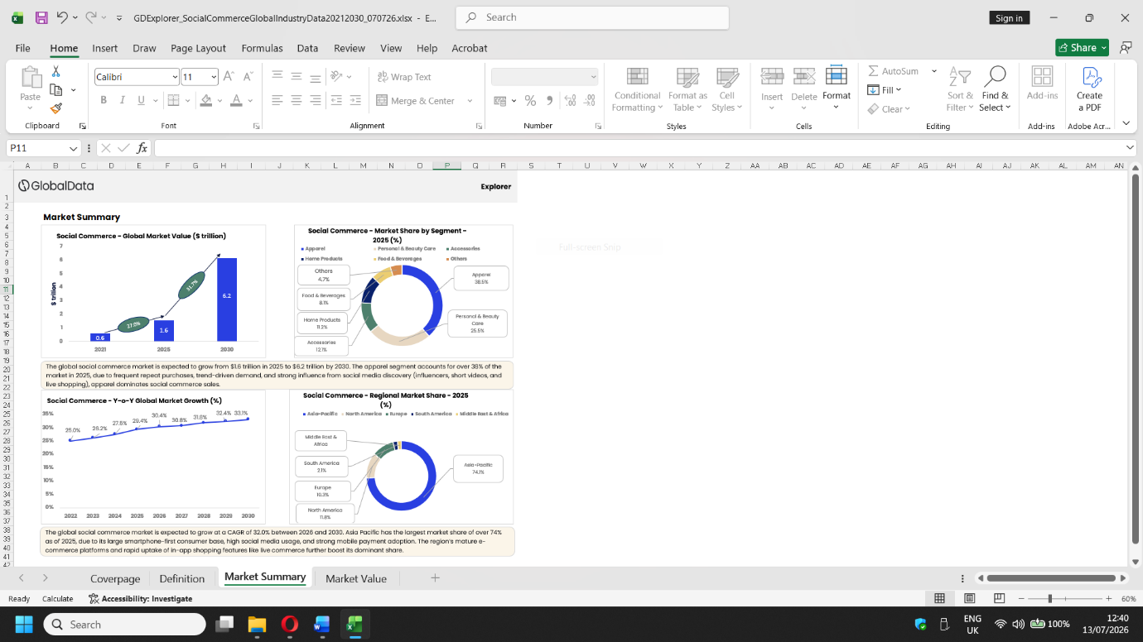
Appendix 2
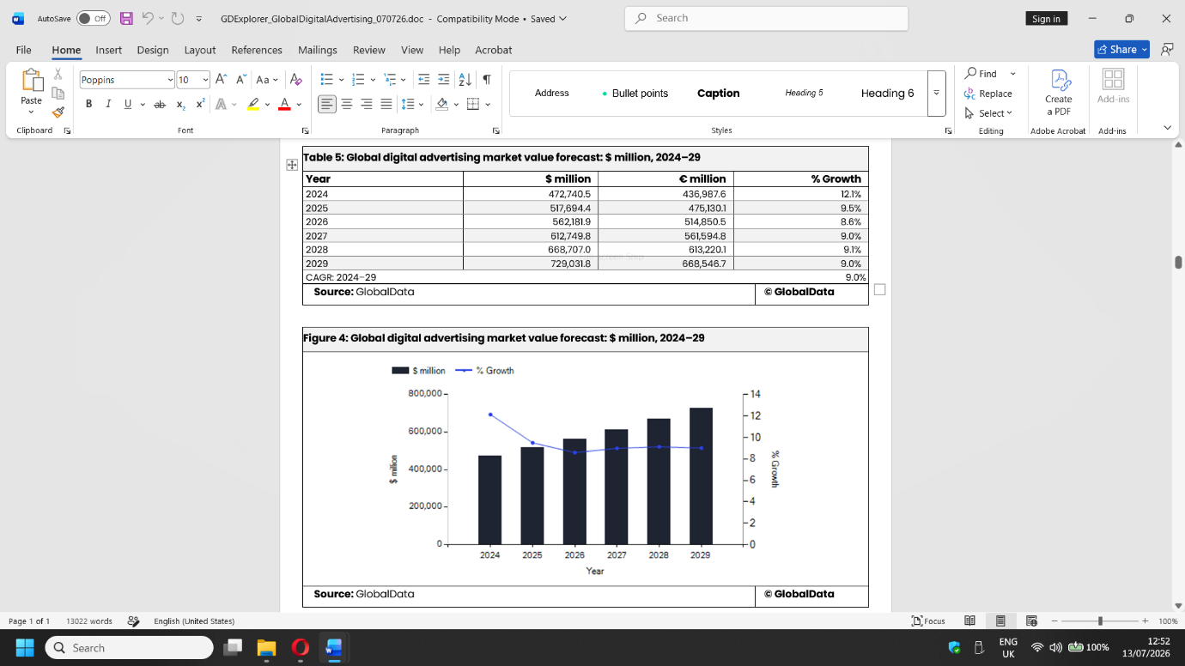

Appendix 3


