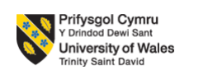

Assignment title
Aligning People and Performance at Aether Innovations

Module name and Module code
Human Capital Management_LCMB7023

Lecturer name
Dr Nerys Dosseh

Name of Student
PEW PEAKHOM

Number of ID
2433833

Date of Submission
17-03-2026

Table of Contents
Part 1: Building a Culture of Innovation & Future Work Practices 3
1.0 Introduction 3
2.0 Current Practices in Tech Companies 3
2.1 Innovation Culture in Tech Firms 3
2.2 Work Models in Tech Industry 4
2.3 HR Structures in Tech Firms 4
3.0 Building a Culture of Innovation 5
3.1 Cultural Initiatives 5
4.0 Structural Changes to Support Innovation 6
4.1 Applying Ulrich’s Model 6
4.2 Blending Hard and Soft HRM 6
5.0 Future of Work Model for Aether Innovations 6
5.1 Hybrid Work Model 6
5.2 Technology Integration 6
5.3 Flexible Talent Strategy 6
6.0 Motivating Employees for High Performance 7
6.1 Job Design and Autonomy 7
6.2 Employee Engagement 7
6.3 Leadership Development 7
7.0 Linking Culture, Structure and Performance 7
8.0 Conclusion 7
References 8
Part 2: Reflection Analysis 11
1.0 Gibbs Reflective Cycle 11
2.0 Staying Relevant in the Age of AI 13
References 14

Part 1: Building a Culture of Innovation & Future Work Practices

1.0 Introduction
Aether Innovations is a tech company with 300 employees. Aether is struggling with three major problems such as: high staff turnover, flat growth and decreasing customer satisfaction. These core problems are also affecting company’s reputation, and profitability negatively (Aether Innovations, 2025). These problems clearly reflect that there is a gap among business strategy and people management. The primary purpose of this report is to recommend an integrated HR strategy to construct a culture of innovation and design future-focused work model.

2.0 Current Practices in Tech Companies
Today, technologies companies like Google, and Microsoft function in highly competitive markets were incessant essential. ARM Holdings capitalises profoundly in research and development to design advanced chip architectures (Yaqub and Alsabban, 2023). But high R&D investment also raises operational expenditures and fiscal risk. Smaller firms like Aether cannot have comparable monetary strength, so strategic prioritisation is needed.

2.1 Innovation Culture in Tech Firms
Big companies like Microsoft and Google inspire innovation and experimentation. Google presented its well-known “20% time” policy, permitting all the level of employees to spend 20% of their time and efforts on new and unique ideas. This helped the company to introduce or present efficacious products like Gmail in the market (Clark, 2021). Despite having an innovation policy like the 20% Time policy, there are criticisms of these types of policies. Research suggests that if there is no structure around initiatives, they may hinder productivity and create ambiguity regarding priorities for employees. Adding new work pressure due to Innovation sprints could make employees feel burned out because they are not provided with adjustments to their current work. To achieve both creativity and performance discipline, Aether must achieve a balance. Gallup (2025) fund, only 23% of employees globally feel motivated and engaged at work and low engagement and motivation decreases productivity, creativity and innovation. But engagement initiatives also need fiscal investment in leadership growth, training, and technology systems, which can rise temporary expenses for Aether.

2.2 Work Models in Tech Industry
After covid-19 pandemic, most of tech companies implemented hybrid work model to enhance productivity, employee wellbeing while upholding organisational performance Microsoft introduced more flexible work strategies and policies across its worldwide offices. About 73% of employees prefer flexible working choices (Howley, 2021). Hybrid work is frequently associated with lower levels of unplanned collaboration and innovation than traditional forms of work. Research indicates that teams working 100% remotely have a slower rate of decision-making and a less effective informal communication network. The increase in operational expenses resulting from investments in digital infrastructure and rework of existing offices associated with hybrid systems can be significant. It is critical that a 300-employee company such as Aether conducts a thorough evaluation of the financial and coordination issues associated with implementing hybrid systems using a cost-benefit analysis. Employees or staff within the tech companies can feel isolated which can directly lower creativity, motivation and engagement if companies do not construct robust digital communication systems and supportive leadership practices (Wu, Wu and Peng, 2025).

2.3 HR Structures in Tech Firms
Today, most of modern tech companies like Microsoft, Google, Apple, and Amazon gradually follow Ulrich’s HR model, proposed by Dave Ulrich. This model mainly describes four important HR roles such as: Change Agent, Strategic Partner, Administrative Expert and Employee Champion. Today, HR is not only about handling role related to recruitment, hiring and payroll. In its place, it plays a strategic role in aligning people practices with business objectives or goals (Zhang and Chen, 2023). As a strategic Partner, HR managers are directly responsible to support leadership in attaining enduring growth. As a change agent, HR plays key role in managing creativity, innovation and transformation. As an Employee Champion, HR managers are accountable to enhance employee wellbeing and engagement (El, 2026). Finally, as an administrative expert, HR guarantees well-organized systems and compliance. Largest tech companies such as Google exhibit how strategic HR contributes performance and innovation. Thus, Aether must adopt a similar strategic HR structure to remain competitive in the industry and construct a robust, innovative organisational culture (Khatoon et al., 2025). Nevertheless, there are critics who feel that this model may leave HR professionals struggling with role ambiguity and will create additional work complexity and pressure on them to perform all of their multiple duties at the same time (El, 2026).

3.0 Building a Culture of Innovation
Culture refers to shared beliefs, norms, values and behaviours in a company. As per Harvard Model of HRM (Beer et al., 1985), HR policies affect staff promise and enduring performance. Thus, Aether should shift from a control-based culture to a trust-based, innovative culture. Yet, cultural shifts typically encounter organizational resistance because employees may resist new systems for many reasons. These changes must be implemented in phases with leadership support.

3.1 Cultural Initiatives

3.1.1 Innovation Sprints
Generally, innovation sprints are short and focused projects where employees from diverse departments work collectively to solve precise business issues or problems effectively. The main purpose of an innovation sprint is to produce practical solutions rapidly. Spotify establishes “hack weeks,” throughout which employees develop unique and new experiment and ideas with creative and innovative solution (Krüger et al., 2023). Aether can present a three-monthly innovation sprints to inspire collaboration across teams such as customer service, marketing and engineering (Bangerter and Endris sat, 2022).

3.1.2 Intrapreneurship Programs
Intrapreneurship directly inspires all the level of employees to think and act like entrepreneurs inside the company. 3M, an American multinational company that directly supports employee experimentation which leads to the formation of Post-it Notes. Thus, Aether can also establish an internal innovation fund where all the employees pitch thoughts and obtain funding and mentoring support. Senior leaders evaluate proposals and approve staged funding support (Ashal, Masa’deh and Twaissi, 2023).

3.1.3 Cross-Functional Teams
Aether must emphasis on creating cross-functional project teams that comprise marketers, engineers and service staff. Working collectively helps employees or team to solve issues quickly and understand buyer needs better. Apple leverages cross-functional teamwork to design products that syndicate technology, design, and customer experience positively. Failure learning policy encourages experimentation without fear of punishment. (Ambrose, Matthews and Rutherford, 2018).

4.0 Structural Changes to Support Innovation

4.1 Applying Ulrich’s Model
- As Strategic Partner, HR aligns innovation objectives with business approach.
- As Change Agent, HR supports change.
- As Employee Champion, HR guarantees happiness.
- As Administrative Expert, HR advances systems using technology (Zhang and Chen, 2023).
Aether must introduce HR Business Partners to work closely with department heads.

4.2 Blending Hard and Soft HRM
Hard HRM mainly emphasises performance metrics and efficiency, whereas soft HRM emphasises development and motivation. A robust KPI burden can decrease intrinsic inspiration and discourage risk-taking. So, Aether should avoid generating a performance philosophy that punishes failure, as this would contradict innovation objectives (Cayrat and Boxall, 2023).

5.0 Future of Work Model for Aether Innovations

Hybrid Work Model
To handle risks, Aether must execute a 12-month phased plan:
- Phase 1 (Months 1–3): Pilot hybrid teams and measure engagement.
- Phase 2 (Months 4–8): Enlarge hybrid model with collaboration tools.
- Phase 3 (Months 9–12): Assess output, turnover and buyer metrics before full rollout.

5.2 Technology Integration
By using advanced and innovative technology, Aether can enhance efficiency. Thus, it is essential for the company to adopt more advanced AI recruitment tools, HR analytics for forecasting turnover and digital collaboration platforms. But, ethical issues like bias and data privacy should be addressed (Krüger et al., 2023).

5.3 Flexible Talent Strategy
According to Gal, Forma and Singer (2022), Amazon put in $1.2B into up-skill programs but must consider budgets as well - an annual investment of £1,000 per employee (around 3000 employees) will need an investment of £300k. Return on investment will need to measure: innovation output; reduced turnover; productivity increase.
.

6.0 Motivating Employees for High Performance

6.1 Job Design and Autonomy
Job Characteristics Model suggests autonomy and task importance rise inspiration. But, too much independence without responsibility can decrease alignment with administrative objectives. Consequently, autonomy should be reinforced with strong performance metrics and innovation KPIs (Nie et al., 2023).

6.2 Employee Engagement and Leadership Development
Aether should also emphasis on conducting engagement surveys on the regular basis, introducing recognition programs and enhancing internal communication to motivate and encourage all the level of employees. The leaders Aether must adopt transformational leadership style as it directly supports innovation (Woods et al., 2024).

7.0 Linking Culture, Structure and Performance
According to the Guest Model, effective HR practices play an important role in constructing employee promise which enhances employee motivation and performance outcomes (Huynh and Nguyen, 2025). To generate integration rather than fragmented initiatives, Aether should follow this causal chain:
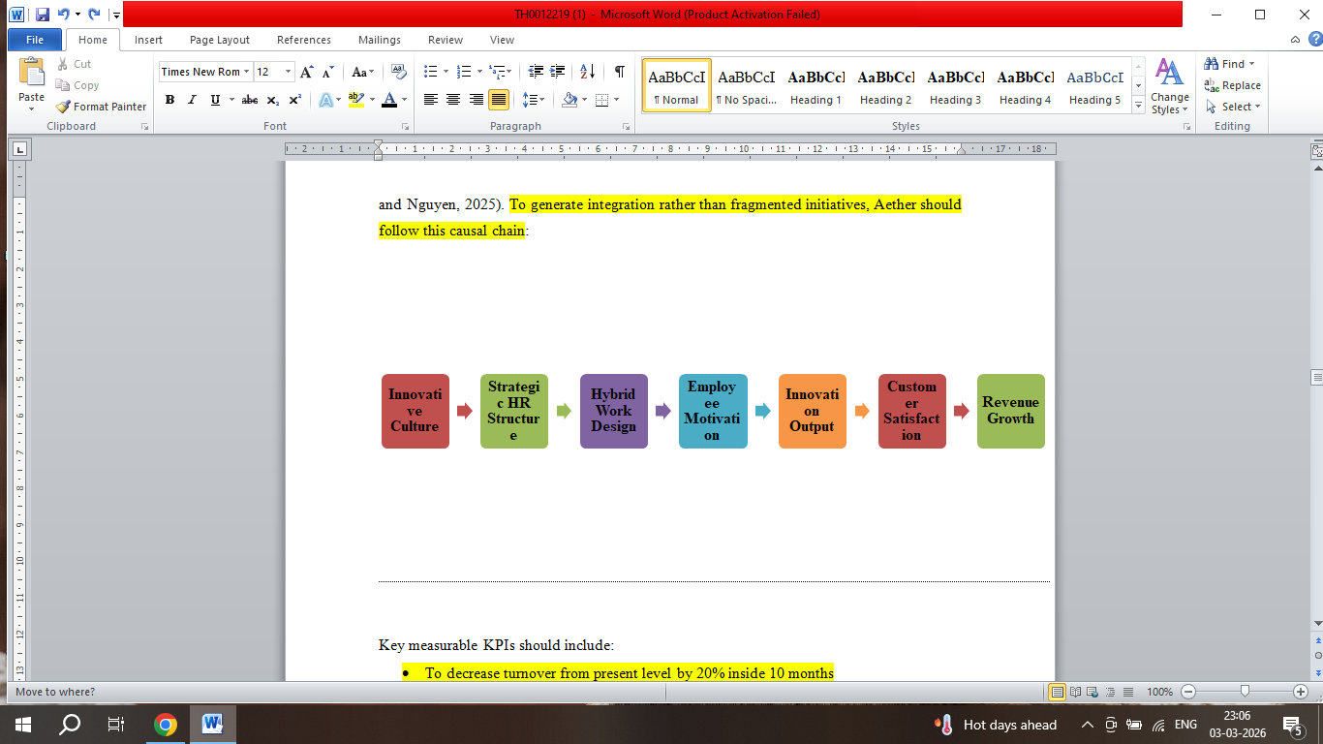
Figure 1- Causal chain
(Source-Self-Made)
Key measurable KPIs should include:
- To decrease turnover from present level by 20% in 10 months
- To rise employee engagement scores by 30%
- Enhance customer satisfaction score by 20%

Part 2: Reflection Analysis

Gibbs Reflective Cycle

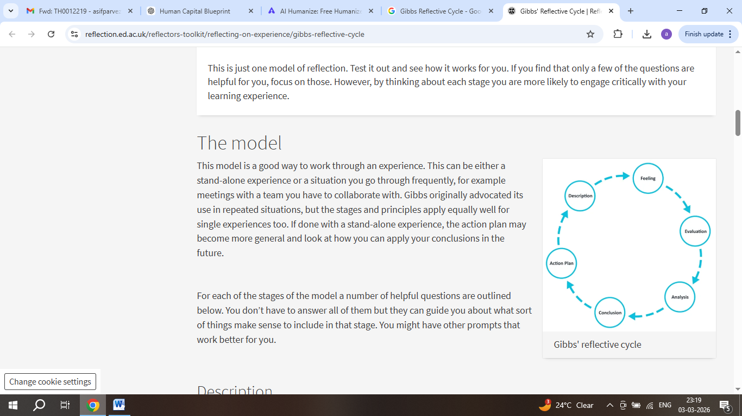

Figure 1- Gibbs Reflective Cycle

(Source: The University of Edinburgh, 2024)
Description: throughout this module, I learned about innovation culture, SHRM the AMO model, HPWS, and future work practices like hybrid working. Before starting this module, I thought HR is all about payroll, recruitment, and employee records. I want not familiar about how HR directly connects to organisational growth and business strategy. Through academic reading, lectures notes, it learned that HR plays a strategic role in constructing culture, driving innovation and enhancing engagement. Studying companies like Google, Apple also helped me to see how robust people or HR approaches directly support lasting development and competitive advantage. One lecture debate challenged my fixed HR mindset deeply (Sekarwinahyu et al., 2019).

Feelings: At the starting of this module, I felt more confused and faintly overwhelmed. Some important theories like the AMO framework, and High-Performance Work Systems seemed multifaceted. I was hesitant how to use these models or theories in real companies. Throughout my first assignment, I struggled applying AMO practically. But, as I sustained learning and applying these models to actual instances, my self-assurance enhanced. When I related theory to practice, specifically in assignments, I started to understand the practical value of these frameworks. I felt interested when I understood that strategic HR decisions can advance performance, and employee gratification. I firstly doubted my ability to think strategically (Husebø, O’Regan and Nestel, 2015).

Evaluation: The lesson I value the most is that the performance of an organisation is heavily influenced by its culture. When an employee feels engaged and supported, they will be able to create new ideas and operate in a productive manner. I also learned that innovation does not happen naturally and is instead due to the use of structured systems, such as creating learning programmes, having a performance management system and having strong leadership support. In group discussion, I hesitated to challenge peers’ opinions. The use of group discussions was incredibly beneficial to me because I was able to hear many different opinions on a single topic, which helped me enhance my ability to think critically. By reading journal articles I have been able to improve both my academic writing and researching skills tremendously (Noora et al., 2024).

Analysis: Using Gibbs' reflective cycle as a framework, I'm able to reflect on how I grew as an HR professional from this module. My understanding of HR's role in aligning people practices with business strategy has developed. The AMO model is a good example of HR aligning people with their company's strategic goals. The model identifies three main factors that influence employee performance: ability (how well an employee can perform their job), motivation (why an employee performs to a certain standard), and opportunity (providing the employee with the opportunity to perform at their highest level through involvement in decision-making) (Ahmadpour, Shariati and Moghadam, 2025). I realised I avoided complex data interpretation tasks. I now understand that a culture of innovation within an organisation is only possible if there is an environment of psychological safety, leadership support and continuous learning; therefore, High-Performance Work Systems (HPWS) encompass all aspects of the recruitment, training and reward processes to achieve improved results (Zhan et al., 2023).

Conclusion: Effective HR leadership requires strategic thinking, judgement and ethics, adaptability and creativity. To facilitate change and drive collaboration while making data-driven decisions, HR professionals must demonstrate these qualities. Furthermore, I identified areas where I need to develop; I want to strengthen my HR analytics capabilities, my confidence as a leader and how I communicate strategically. I must speak confidently even when uncertain. My goal is to present my ideas and create arguments that are based on evidence more comfortably (Praveena et al., 2025).

Action Plan: There are many actions that I will be taking in order to create a culture of innovation and a growth mentality in myself. I will begin by taking an online course in HR analytics and data analytics, which will enable me to improve my technical abilities. I will volunteer to lead one team discussion. Secondly, I will be attending webinars and workshops related to innovation management and digital transformation. Thirdly, I plan to read at least one academic journal article every month to further enhance my knowledge of research. I will also engage in reflective learning on a regular basis by reviewing my experiences and identifying areas for improvement (Zhan et al., 2023).

2.0 Staying Relevant in the Age of AI
Generally, AI (Artificial Intelligence) can be defined as the capability of machines or computers systems to perform tasks that usually needs human intelligence like problem-solving, learning, decision making and understanding language. AI also play a key role in changing the way companies or organisations works. In the context of HR, most of traditional tasks like payroll processing, and attendance tracking can now be automatic (Madanchian and Taherdoost, 2025). AI systems are more powerful tool as they have ability to examine great amounts of information speedily and decrease administrative workload successfully. This raises effectiveness and saves time. But AI cannot completely replace human abilities like ethical judgement, emotional intelligence, leadership influence and empathy. These human traits are not only important but also indispensable in managing people (Tai, 2020). But AI can generate algorithmic bias and discrimination risks. There are anxieties about employee data surveillance and privacy.
To stay relevant, I plan to continuously develop future-focused skills. As per the World Economic Forum (2023), about 44% of workers’ core abilities would change within next five years. It means incessant learning is not only important but also essential to stay relevant. I would also enhance my skills in the area of innovation, strategic thinking, critical analysis, creativity and ethical leadership. I would also reinforce relationship-building as well as communication capabilities because HR is people-centred (Brandao, 2025). AI can be used to examine employee engagement surveys and recognize trends. It can also help with workforce planning and performance analytics. By leveraging AI for data-driven insights, I would be able to make better strategic decision effectively. But final decisions must remain human-led. For case, HR needs empathy, impartiality and ethical responsibility. AI cannot completely comprehend organisational philosophy, feelings, or multifaceted workplace conflicts. I would emphasis on uniting human judgement with AI-supported data (Harvard Business School, 2025).

8.0 Conclusion
Aether should move from traditional management to an innovative strategic and strategic HR approach to resolve its current issues and attain competitive advantages. By implanting innovation sprints, cross-functional teams, and HR analytics, Aether can reconstruct performance and engagement. But success depends on cost control, risk management, strong leadership commitment and measurable performance tracking. Without incorporation, initiatives related to innovation can fail.

References
Aether Innovations (2025). About – AiG. [online] Available at: https://aetherinnovations.co.uk/about/.
Ambrose, S.C., Matthews, L.M. and Rutherford, B.N. (2018). Cross-functional teams and social identity theory: A study of sales and operations planning (S&OP). Journal of Business Research, 92, pp.270–278. doi:https://doi.org/10.1016/j.jbusres.2018.07.052.
Ashal, N., Masa’deh, R. and Twaissi, N.M. (2023). The Impact of Learning Organization on Intrapreneurship: The Case of Jordanian Pharmaceutics. Sustainability, [online] 15(16), p.12211. doi:https://doi.org/10.3390/su151612211.
Bangerter, E. and Endrissat, N. (2022). Resilience through Innovation. Resilienz durch Organisationsentwicklung, pp.121–137. doi:https://doi.org/10.1007/978-3-658-36022-1_6.
Banholzer, M., LaBerge, L., West, A. and Williams, E. (2023). How innovative companies leverage tech to outperform | McKinsey. [online] www.mckinsey.com. Available at: https://www.mckinsey.com/capabilities/strategy-and-corporate-finance/our-insights/how-innovative-companies-leverage-tech-to-outperform.
Ben-Gal, H.C., Forma, I.A. and Singer, G. (2022). A flexible employee recruitment and compensation model: A bi-level optimization approach. Computers & Industrial Engineering, [online] 165, p.107916. doi:https://doi.org/10.1016/j.cie.2021.107916.
Cayrat, C. and Boxall, P. (2023). The Roles of the HR function: a Systematic Review of tensions, Continuity and Change. Human Resource Management Review, 33(4).
CIPD (2023). 2023 Flexible Hybrid Working Practices Report 8392. [online] Scribd. Available at: https://www.scribd.com/document/935544047/2023-Flexible-Hybrid-Working-Practices-Report-8392.
Clark, D. (2021). Google’s ’20% rule’ shows exactly how much time you should spend learning new skills—and why it works. [online] CNBC. Available at: https://www.cnbc.com/2021/12/16/google-20-percent-rule-shows-exactly-how-much-time-you-should-spend-learning-new-skills.html.
El, A. (2026). HR digital transformation: enhancing human resource management through technology. Future Business Journal, 12(1). doi:https://doi.org/10.1186/s43093-025-00703-7.
Gallup (2025). State of the Global Workplace Report. [online] Gallup. Available at: https://www.gallup.com/workplace/349484/state-of-the-global-workplace.aspx.
Hamadamin, H.H. and Atan, T. (2019). The Impact of Strategic Human Resource Management Practices on Competitive Advantage Sustainability: The Mediation of Human Capital Development and Employee Commitment. Sustainability, [online] 11(20), p.5782. doi:https://doi.org/10.3390/su11205782.
Howley, D. (2021). Microsoft survey: 73% of workers want to be able to work from home after the pandemic. Available at: https://finance.yahoo.com/news/microsoft-survey-73-percent-of-workers-want-to-work-from-home-after-pandemic-130029295.html?guccounter=1&guce_referrer=aHR0cHM6Ly93d3cuZ29vZ2xlLmNvbS8&guce_referrer_sig=AQAAADyCe64GlhpxymbIVGYsLieHRRJo31-qgEKZnVnZONRQ219A403qdbHHR-WXuEHk35K5hukqujPsJDdpF5tIrIcKS91cm7pD4AZ5ihl_vQ_yWoTiYG4NyzDXThcfFLw3e4othBrhKRcGW5flnPdgwZcNwVa53JqcmFRYRZjEDBXb
Huynh, Q.L. and Nguyen, V.K. (2025). The corporate culture—performance linkage via corporate structure in Vietnam. Cogent Business & Management, 12(1). doi:https://doi.org/10.1080/23311975.2025.2537805.
Khatoon, U.T., Babgi, M., Hadi, N.T., Mir, R.N. and Velidandi, A. (2025). Technology-Driven Change in Human Resource Management: Reshaping Talent Management and Organizational Design. Administrative Sciences, [online] 15(11), p.452. doi:https://doi.org/10.3390/admsci15110452.
Krüger, J., Doloresco, F., Maerten-Rivera, J., Zafron, M., Borden, H. and Fusco, N.M. (2023). An Innovation Sprint to Promote Problem-solving and Interprofessional Skills Among Pharmacy and Public Health Students. The American Journal of Pharmaceutical Education, 87(1), pp.ajpe8852–ajpe8852. doi:https://doi.org/10.5688/ajpe8852.
Nie, T., Tian, M., Cai, M. and Qiao, Y. (2023). Job Autonomy and Work Meaning: Drivers of Employee Job-Crafting Behaviors in the VUCA Times. Behavioural Sciences, [online] 13(6), pp.493–493. doi:https://doi.org/10.3390/bs13060493.
Richik Maity and Lee, K.L. (2025). The impact of remote and hybrid work models on small and Medium-sized enterprises productivity: a systematic literature review. SN Business & Economics, 5(10). doi:https://doi.org/10.1007/s43546-025-00931-7.
Woods, S.A., Ahmed, S., Zhou, Y. and Filip Agneessens (2024). The perils of leadership development: unintended consequences for employee withdrawal behaviour and conflict. Work and stress, 38(4), pp.1–21. doi:https://doi.org/10.1080/02678373.2024.2332174.
Wu, Y.J., Wu, C.-H. and Peng, K.-L. (2025). Effects of Creativity Styles on Learning Engagement and Motivation in STEAM Education. Sustainability, [online] 17(6), pp.2755–2755. doi:https://doi.org/10.3390/su17062755.
Yaqub, M.Z. and Alsabban, A. (2023). Industry-4.0-Enabled Digital Transformation: Prospects, Instruments, Challenges, and Implications for Business Strategies. Sustainability, [online] 15(11), pp.8553–8553. doi:https://doi.org/10.3390/su15118553.
Zhang, J. and Chen, Z. (2023). Exploring Human Resource Management Digital Transformation in the Digital Age. Journal of the Knowledge Economy, [online] 15(1). Available at: https://link.springer.com/article/10.1007/s13132-023-01214-y.
Part 2:
Ahmadpour, N., Shariati, A. and Moghadam, M.P. (2025). Effect of Narrative Writing Based on Gibbs’ Reflective Model on the Empathy and Communication Skills of Nursing Students. BMC Medical Education, 25(1), pp.1–9. doi:https://doi.org/10.1186/s12909-024-06593-7.
Brandao, P.R. (2025). The Impact of Artificial Intelligence on Modern Society. AI, [online] 6(8), pp.190–190. doi:https://doi.org/10.3390/ai6080190.
Harvard Business School. (2025). Why Soft Skills Still Matter in the Age of AI. [online] Available at: https://www.library.hbs.edu/working-knowledge/why-soft-skills-still-matter-in-the-age-of-ai.
Husebø, S.E., O’Regan, S. and Nestel, D. (2015). Reflective Practice and Its Role in Simulation. Clinical Simulation in Nursing, [online] 11(8), pp.368–375. doi:https://doi.org/10.1016/j.ecns.2015.04.005.
Madanchian, M. and Taherdoost, H. (2025). The Impact of Artificial Intelligence on Research Efficiency. Results in Engineering, [online] 26, p.104743. doi:https://doi.org/10.1016/j.rineng.2025.104743.
Noora, A., Mahmoud, M.H., Grace, K., Daher-Nashif, S. and Al Wahedi, Z. (2024). Reflective writing among healthcare practitioners in primary care: a qualitative study from Qatar. Cogent education, 11(1). doi:https://doi.org/10.1080/2331186x.2024.2373555.
Praveena, K.S., Juslin F, Patil, C.M. and Bhargavi K (2025). Using Gibb’s Reflective Model Approach for Enhancing Project-Based Learning Among Students Through Reflective Assessment. Journal of Engineering Education Transformations, [online] 38(2), pp.148–155. Available at: https://journaleet.in/index.php/jeet/article/view/2071.
Sekarwinahyu, M., Rustaman, N.Y., Widodo, A. and Riandi, R. (2019). Development of problem based learning for online tutorial program in plant development using Gibbs’ reflective cycle and e-portfolio to enhance reflective thinking skills. Journal of Physics: Conference Series, [online] 1157(2), p.022099. doi:https://doi.org/10.1088/1742-6596/1157/2/022099.
Tai, M.C.-T. (2020). The Impact of Artificial Intelligence on Human Society and Bioethics. Tzu Chi Medical Journal, [online] 32(4), pp.339–343. doi:https://doi.org/10.4103/tcmj.tcmj_71_20.
The University of Edinburgh (2024). Gibbs’ Reflective Cycle. [online] The University of Edinburgh. Available at: https://reflection.ed.ac.uk/reflectors-toolkit/reflecting-on-experience/gibbs-reflective-cycle.
Zhan, T., Wang, L., Wang, Y. and Sun, C. (2023). Master of Nursing Specialist Experiences of an Internship through the Use of Written reflections: a Qualitative Research Study. Heliyon, [online] 9(2), p.e13299. doi:https://doi.org/10.1016/j.heliyon.2023.e13299.

