
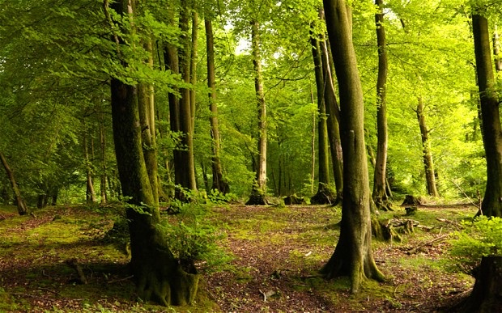
Evaluating the Use of GIS Software as a Modelling Tool for Environmental Analysis
A case study showing the spread of Phytophthora Ramorum to Larch trees in Wales
Natasha Rose Dodds
UWTSD - Year 3
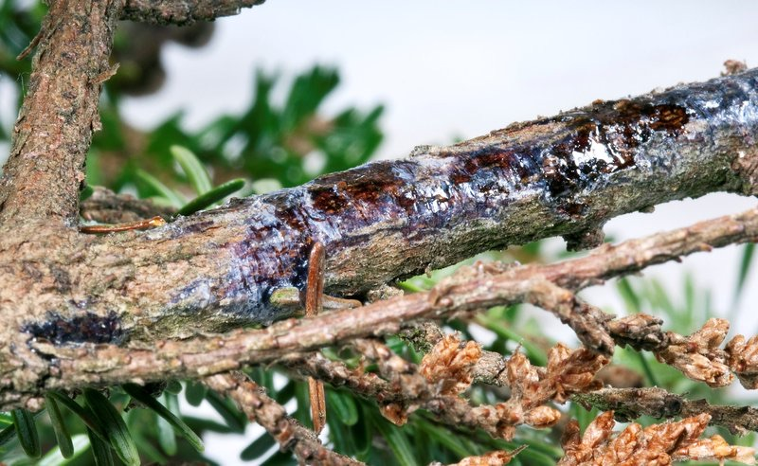

Table of Contents
Abstract 1
1.0 Introduction to GIS 1
1.1 Introduction to Phytophthora Ramorum 1.1 1
1.2 Research Aims 2
1.3 Objectives 2
1.4 Hypothesis 2
2.0 Literature Review 3
2.1 History of GIS 3
2.2 GIS and Environmental monitoring 4
2.3 Phytophthora Ramorum 5
3.0 Methodology 6
4.0 Results and Analysis 9
5.0 Conclusion 20
6.0 References 21

Table of Figures

Figure 1 Maps depicting original map by Jon Snow 4
Figure 2 Diagram showing varying spatial layers to a GIS - Esri, 2019 5
Figure 3 Map showing Control management and Core disease zones - NRW, 2019 6
Figure 4 Map or Raster image - Digimaps 2019 7
Figure 5 Map showing Infected data on Map - Mapinfo, 2020 8
Figure 6 Map showing SQL query 1 2010-2011 data 10
Figure 7 Map showing SQL query 1 2012-2013 data 11
Figure 8 Map showing SQL query 2014 data 11
Figure 9 Map showing all Year data 12
Figure 11 Thematic Map showing spread by year 2010-2011 13
Figure 12 Thematic Map showing spread by year 2012-2013 13
Figure 13 Thematic Map showing spread by year 2014 14
Figure 14 Bar chart map from thematic map of year by year data 14
Figure 15 Map showing Tourist recreational hotspots and infected tree data 15
Figure 16 Map showing country parks and infected tree data 15
Figure 17 Map showing A roads and infected tree data 16
Figure 18 Map showing rivers and infected tree data 17
Figure 19 Map showing A roads, rivers and infected tree data 17
Figure 20 Map showing Woodland inventory and infected tree data and zoomed 18
Figure 21 Map showing Woodland inventory , river and infected tree data close up 18
Figure 22 Map showing Riparian woodland, rivers and infected tree data 19
Figure 23 Map showing Riparian woodland, rivers and infected tree data close up 20
Figure 24 Map showing Riparian woodland, rivers, attenuation/runoff and infected tree data 20
Figure 25 Map showing surface water runoff and infected tree data 21

Table ofTables

Table 1 Table showing use of coordinate data on Excel - Boyd, 2016 7
Table 2 Table showing infected tree data, Mapinfo, 2020 8
Table 3 Mao showing infected tree data query 2010-2011 range - mapinfo, 2020 9

Abstract

This research looks into the spread of Phytophthora Ramorum to varying species of Larch in Wales between the years of 2010 and 2014. Through the use of Geographical information systems and varying sets of geospatial data, conclusions were able to support the literature found implying that Phytophora Ramorum was likely spread via water and through the use of statistical modelling this can be shown in a timely and accurate manner utilizing software such as Mapinfo and Excel.

1.0 Introduction to GIS

Geographical information systems are frameworks to analyse, store and visualise data collected from geographical locations. They are the evolution of traditional cartography sharing a fundamental similarity, utilization of a base map. The difference is that GIS maps can store limitless amounts of data and can enable statistics and analysis to present data to support particular scientific or social arguments (Dempsey, 2012). GIS enables examination of spatial relationships, trends and patterns and connects geography with science and technology. GIS is increasingly important in environmental monitoring as the ability to view and analyse this spatial data on a map helps to better understand these patterns and trends to make more informed decisions on data collected, in a simpler, faster and more accurate way (Esri, 2018b). This research provides sustenance to infected tree data provided by the forestry commission wales. Through the use of GIS the research aims to highlight any patterns found and link these to causation through research of established literature.

1.1 Introduction to Phytophthora Ramorum 1.1

Phytophthora Ramorum (PR) is an organism similar to algae called a water mould. It is classified as a pathogen and has been known to affect over 150 plant and forest species (Chadfield and Pautasso, 2012; Forest Research, 2019) Phytophthora Ramorum was first found in South Wales on larch in 2010 in the Afan Valley and is thought to be one of the most serious diseases to affect welsh forestry. Larch represents around 7% of welsh woodland, over 23,000 hectares (Warren-Thomas and Henderson, 2017) and though the disease does not affect the timber of larch it has had serious consequences for the forestry Industry in wales with regional and local economic impacts. Since the beginning of the spread from 2010 to 2015 over 6 million trees have been infected. In 2012 the wetter than average conditions likely aided the increased dispersal of the disease as in 2013 3 million trees were infected. (Venette and Cohen, 2006; King, Harris and Webber, 2015) The pathogen is thought to spread via water and prefers wet and windy conditions which help the sporulation rates and allow the pathogen to be spread further. Since 2010 disease management zones have been designated and over 23,105 hectares of larch designated within the control zones (Assembly Wales, 2018)

1.2 Research Aims

- To understand whether the use of GIS software and geospatial data can help support literature found regarding the Phytophthora ramorum tree disease spread to Larch trees in Wales

- To utilize data provided by the Forestry Commission in Wales to investigate ways of mapping, visualising and building GIS models that could be used to monitor and control the spread of the Phytophthora ramorum disease and perhaps help lessen the impact on the environment

- To bring together existing literature to analyse through the use of GIS the spread of GIS over specific time periods to add to existing research ways to minimize the social, economic, environmental and cultural impacts of P. ramorum

1.3 Objectives

- Research a variety of resources and build a case study on the spread of Phytophthora Ramorum

- Utilize Map info and a variety of software programs and resources for spatial analysis and statistical modelling

- Build a geographical information system to support my findings regarding the photophore ramorum tree disease spread to Larch trees in Wales

- Identify whether there are patterns to the pathogens spread that can be identified through the use of GIS.

1.4 Hypothesis

- There are patterns to the spread of P.Ramorum to larch in wales through water

- There are patterns to the spread of P.Ramorum to larch in wales through recreational and human footfall

2.0 Literature Review

2.1 History of GIS

In 1854 a cholera outbreak in sighted a doctor named Jon Snow to map the outbreak locations along with the property boundaries, roads and water pumps which helped the discovery that the disease was in fact spread via water and not airborne, as initially perceived, and even indicated a specific water pump (Steenson, 2019). The map (fig1)was a colour graded map which highlighted the 48 districts and is considered the first spatial analysis map (Dempsey, 2012). This was the early beginnings of spatial analysis and the thought of linking ‘what’ with ‘where’ (Steenson, 2019). Spatial analysis is defined as “a research paradigm that provides a unique set of techniques and methods for analysing events—events in a very general sense—that are located in geographical space”(Fischer, 2001).

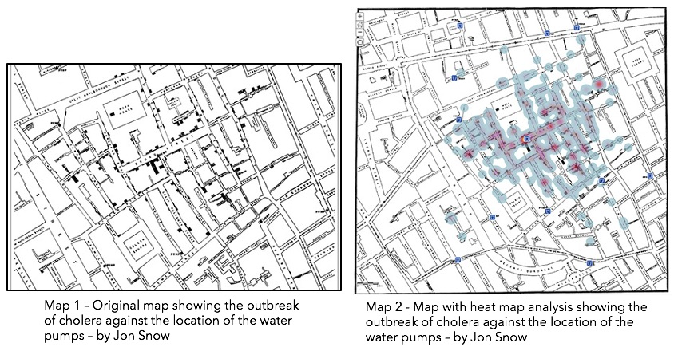
Figure 1 Maps depicting original map by Jon Snow

The field of GIS began as early concepts of computational and quantifiable geography emerged, during the 1960’s. Michael Goodchild of the National Centre for Geographical Information and Analysis provided essential research along with the academic community on science topics such as visualization and spatial analysis which prepared the groundwork for GIS (Esri, 2018b). In 1963 Roger Tomlinson pioneered work to develop the Canada Geographic information system which was the first computerized GIS system created. Tomlinson’s design enabled automated computing to store and process data , which had been commissioned by
the Canadian government to create an easy way to manage their inventory of national resources and begin a national land use and management program (Esri, 2019).
Three important technological advancements occurred during 1960 and 1975 which provided the ability to record co-ordinates as data and perform calculations on them, leading to the birth of modern GIS. The three advancements are listed below.

- the ability to output map graphic using line printers
- advances in data storage
- advances in processing power of mainframe computers

During this period Jack Dangermond, co-founder of Esri inc developed the first vector GIS called Odyssey GIS from his laboratory at Harvard. By the late 70’s computer memory and improved graphic capabilities led to the creation of commercial GIS software. Esri which is one of the largest companies in the world when regarding software played a key role in its development and history (Esri, 2015).

2.2 GIS and Environmental monitoring

GIS provides the ability to aggregate data from a variety of inputs, which when considered in map format can be a useful and important method to increase general awareness of environmental conditions and issues and help to enable accurate decision making. GIS has the ability to present environmental data as maps or graphs through classification, visualisation and symbolisations, helping scientists and users to draw conclusions about the data (Larsen, 1999). Spatial analysis is the stacking of layers (fig 2) containing different strings of data which enable compassion with each other based on location. The layers are georeferenced and true to geographic space (Esri, 2018a).

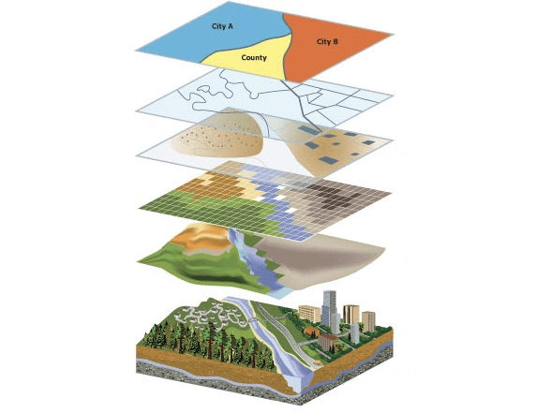
Figure 2 Diagram showing varying spatial layers to a GIS - Esri, 2019

2.3 Phytophthora Ramorum

Phytophthora Ramorum is an organism similar to fungus, affecting a wide range of species, this deadly tree pathogen was first discovered in 2002 in Sussex at an ornamental nursery and the cause was likely thought to be from plant trade pathways. The disease was first found on plants and in gardens, particularly rhododendron (Ponticum P. Ramorum) and was found first on Larch in South West of England and then found in South Wales the year later in the Afan Valley. The disease spread The disease has two different lineages EU1 and EU2 with the EU1 strain present in Wales and being more common across Europe (King, Harris and Webber, 2015) The Pathogen leads to dieback of the stem, branch and foliage, travelling from the needles of larch trees into the branches and eventually infecting the live tissues under bark which has been found to cause lesions, cankers and necrosis (Daera, 2019). A number of biotic and abiotic factors including weather, proximity and sporulation rate can affect the rate of infection. Zoospores are the main route of spread which are spores that swim in droplets or water film but the disease can also be spread via Chlamydospores (resting spores) which enables the disease to survive through unfavourable conditions (Assembly, 2018). A study and climatic model were created by Cambridge University which found that the main reason affecting the rate of spread in Wales is the climate and through the use of this model areas of high risk were designated (Assembly, 2018). Zoospores are best suited to moist and windy air and so climate change is a worrying factor when regarding this disease. These Zoospores are produced in large quantities on the needles of larch and other foliar hosts which can be released up to 40m above ground level. This enables the disease to infect over large distances (Chadfield and Pautasso, 2012). There are now designated risk zones (shown below in fig 3) which were introduced in 2014 by Welsh Government and stakeholders, after a review by scientists and their understanding of the disease.

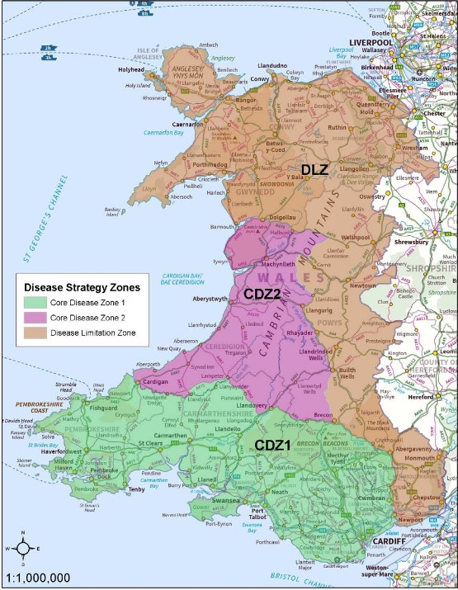
Figure 3 Map showing Control management and Core disease zones - NRW, 2019

3.0 Methodology

In order to create a GIS to show the spread of PR, a number of tools were utilized. Initially data sets containing geospatial data in the form of excel spreadsheets (table 1) were provided by the forestry commission wales and the data was then directly opened in Map Info and added to a base map or Raster (fig 4)of the UK found by searching Digimaps online and converting the data download from a zip file to a MapInfo tab, shape or esri file. This provides a base layer or raster map to work from. The datasets used did not require much cleaning, but it can be essential to add dummy data if the datasets are incomplete, known as cleaning the datasets.
Spatial layers have then been added to compare to the initial infected tree dataset (table 2) with different geospatial datasets found from a variety of sources such as The forestry Commission, Natural Resources Wales and added to the base map and data so patterns and concurrences could be analysed. Data queries using the SQL select function have been performed and added to the GIS to separate data into various specific sets such as Forestry Sites and Private sites and different years of the diseases and locations of sightings and have been colour coded by year range to look at the spread annually between 2010 and 2014. The queried maps were also used to create thematic maps which enabled a different form of visualization and the ability to create a bar graph to show different rates of spread across the boundary areas from the vector boundary map used.
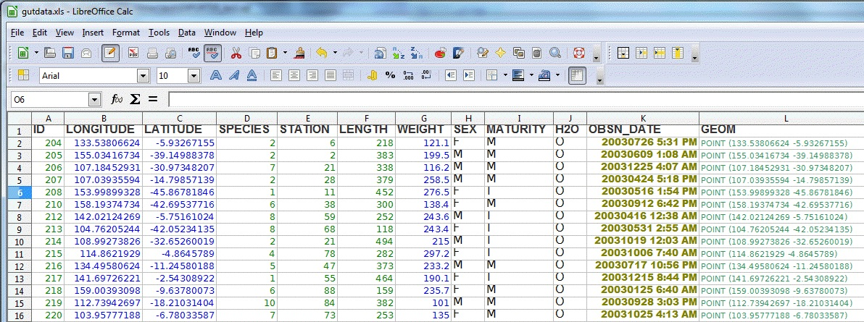
Table 1 Table showing use of coordinate data on Excel - Boyd, 2016

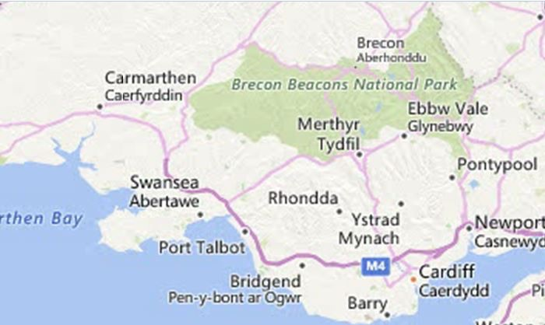
Figure 4 Map or Raster image - Digimaps 2019

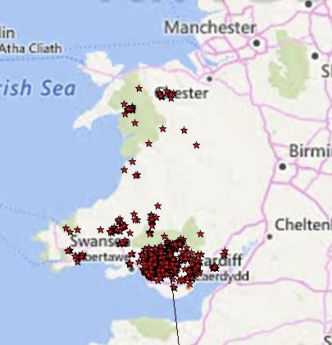
Figure 5 Map showing Infected data on Map - Mapinfo, 2020

Table 2 Table showing infected tree data, Mapinfo, 2020
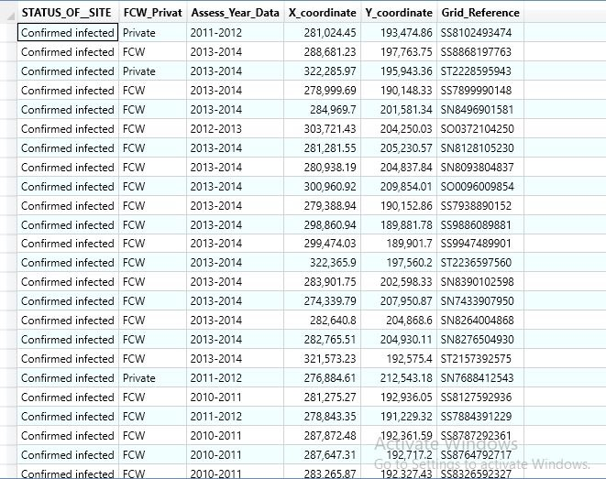

Table 3 Mao showing infected tree data query 2010-2011 range - mapinfo, 2020
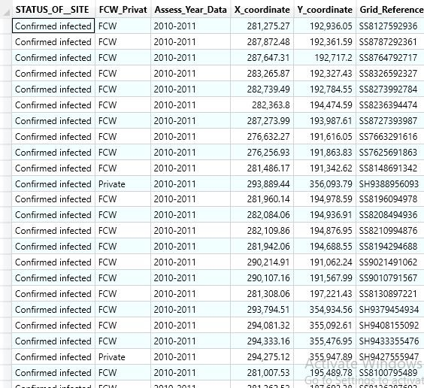

4.0 Results and Analysis

The variables are shown as overlays to the base raster map and boundaries maps found on Digi maps. The spatial layers will be discussed above each screenshot to provide analysis of the results found when building this case study.

The Analytical visualisation point for the study began by querying and drilling down on specific data distribution in order to get a look at the spread of the disease by year. The data was separated into years ranging from 2010-2011 (fig 6), 2012-2013 (fig 7)and 2014 (fig 8) and it became clear when visualising the data that the spread was growing each year from 2010-2014, which would seem concurrent with the movement of air water droplets and mist etc which is largely based on wind strength and climatic conditions as previously mentioned. In the first screenshot you can see the spread is quite contained within an area of the Afan Valley but over the 2 following screenshots that the spread is increasing. The thematic maps (fig 10-13) show the SQL queries by year and the spread per boundary area by counts and enable a different type of visualisation of the data. The bar chart below acts as an analysis tool by shpwing different spread amounts per boundary area (fig 14)

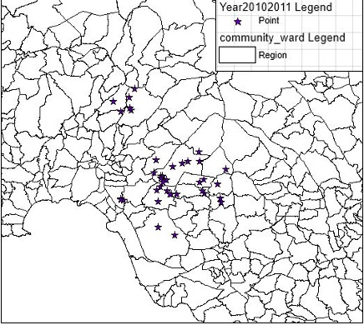
Figure 6 Map showing SQL query 1 2010-2011 data

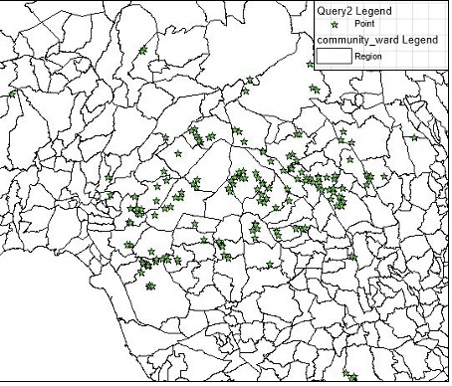
Figure 7 Map showing SQL query 1 2012-2013 data

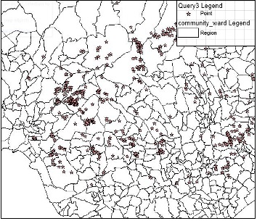
Figure 8 Map showing SQL query 2014 data

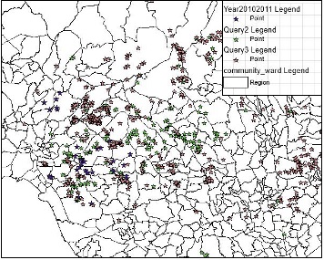
Figure 9 Map showing all Year data

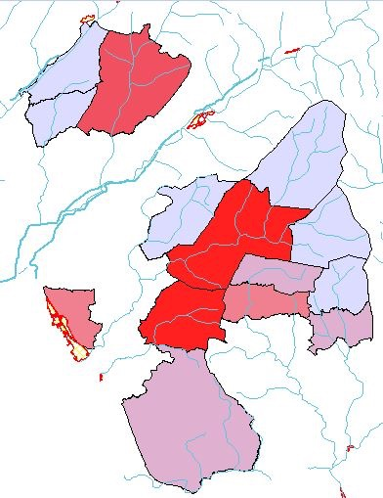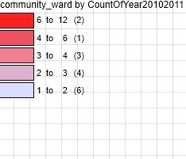
Figure 11 Thematic Map showing spread by year 2010-2011

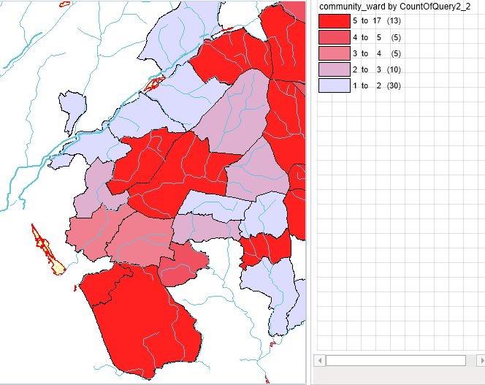
Figure 12 Thematic Map showing spread by year 2012-2013

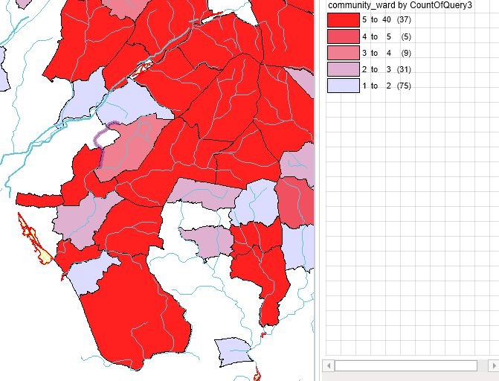
Figure 13 Thematic Map showing spread by year 2014

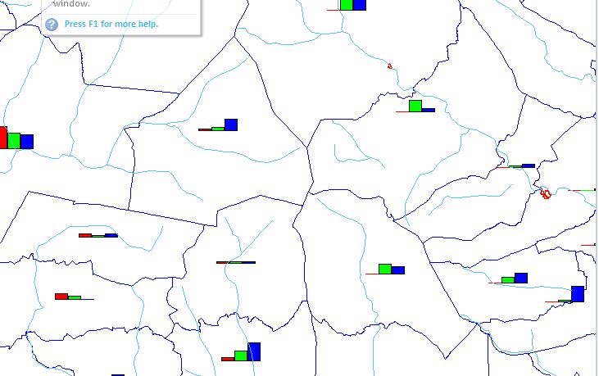
Figure 14 Bar chart map from thematic map of year by year data

In order to test hypothesis 2 a selection of tourist and recreational hotspot overlays along with A roads were added as variables to understand whether human footfall and travel could be affecting the spread of the disease. In the first screenshot (fig 15)the overlay of tourist hotspots shows some correlation to the clustering but with the possibility that tourist hotspots could well be locations with trees without this being conclusive of disease spread, so the layer proved inconclusive.

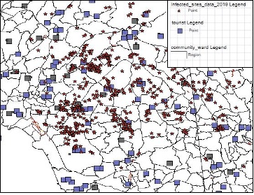
Figure 15 Map showing Tourist recreational hotspots and infected tree data

Again whilst adding Country parks (fig 16) to look further into whether this could be due to typical locations of human footfall being visits to forests for recreation, the country parks overlay did not add any further conclusions or correlations.
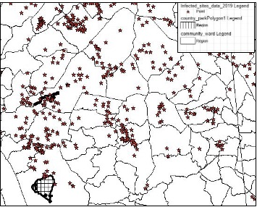
Figure 16 Map showing country parks and infected tree data

In the below screenshot (fig17) I have added the variable of A roads in Wales which when combined with the infected tree data provided by the Forestry commission, found little correlation, there appear to be some clusters along roadsides but nothing conclusive to support the hypothesis that the movement of people may contribute to the spread.

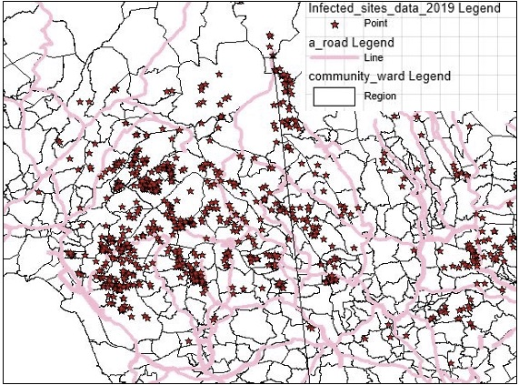
Figure 17 Map showing A roads and infected tree data

In the following screenshot of the GIS, data was added from geographical locations of rivers across Wales and found some correlations to the spread. You can see (fig 18) that on a number of drilled in views, the disease appears to follow the waterways, there are other potential variables which could make this inconclusive and so further digression and dataset analysis was necessary to support the hypothesis 1.

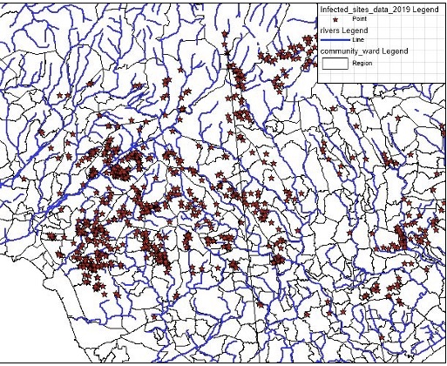
Figure 18 Map showing rivers and infected tree data

In the screenshot below (fig 19) I have combined A roads and rivers to look for correlation and found some clusters alongside rivers and roads but again not conclusive evidence.
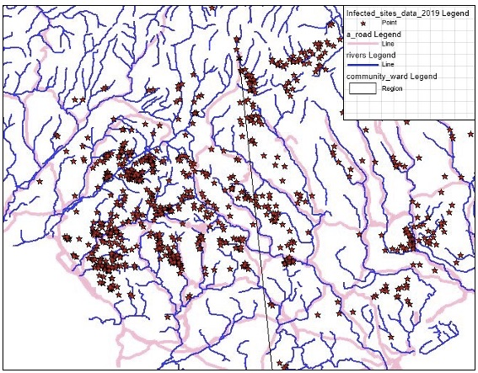
Figure 19 Map showing A roads, rivers and infected tree data

For the following query, geospatial data containing a full woodland inventory (fig 20 - 21) from the LLE portal on NRW’s website was overlaid and offered a variety of categories which could be drilled down and when selecting types and adding the overlay to the infected tree data that there was some correlation between infected sights and felled and young trees, this could also be due to the data provided by forestry commission data being restricted and only showing spread between 2010-2014 2014 and as this overlay is possibly more up to date so this could mean that this is just locations already managed over more recent years than the data provides. An additional comparison was made by adding a river spatial map, but no further concurrences were found through this method.

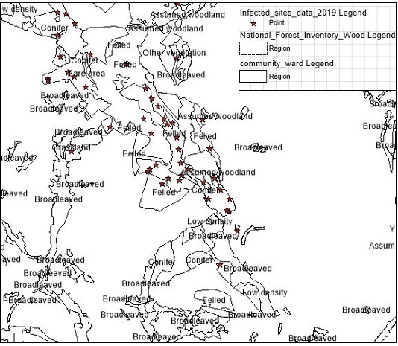
Figure 20 Map showing Woodland inventory and infected tree data and zoomed
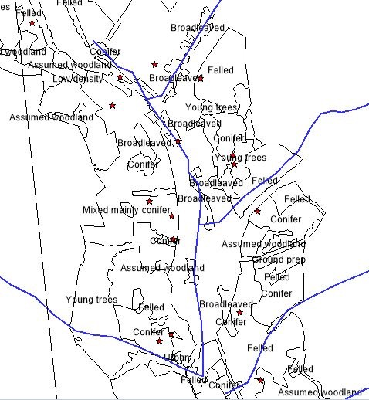
Figure 21 Map showing Woodland inventory , river and infected tree data close up

The screenshot below (fig 22 )provided some strong providing evidence to the hypothesis 1 and literature found that the pathigen PR is spread via water. . The following datasets were provided by Natural Resources Wales from the LLE portal site and options of Woodland inventory, Riparin Woodland and Attenuation spots along with surface water flooding and through the addition of these layers some firm correlations were concluded. The datasets of Riparian woodland, waterway locations and the infected tree dataset highlighted clear clusters on the map and when drilling down onto specific areas as shown below in ( fig 23) there is a clear curve to the spread and the rivers and riparian woodland. When adding the attenuation maps (fig 24) and surface water spread(fig 25), this did not provide any further evidence.

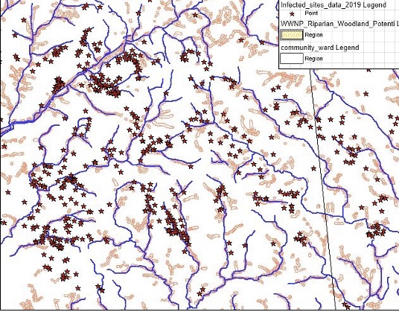
Figure 22 Map showing Riparian woodland, rivers and infected tree data

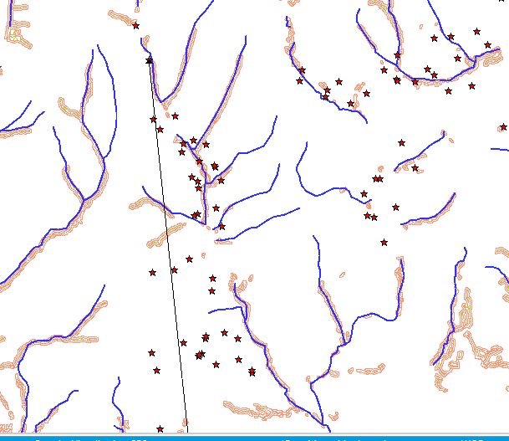
Figure 23 Map showing Riparian woodland, rivers and infected tree data close up

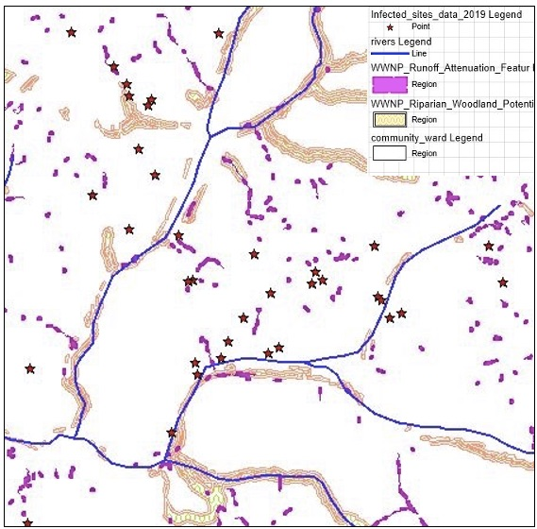
Figure 24 Map showing Riparian woodland, rivers, attenuation/runoff and infected tree data

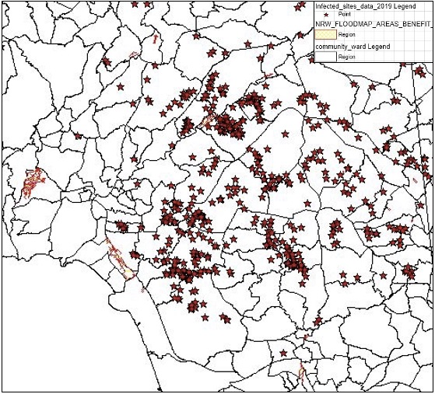
Figure 25 Map showing surface water runoff and infected tree data

5.0 Conclusion

In conclusion the use of Geographical information systems for use as a modelling tool in environmental management and analysis provides a fast visualisation of the data collected and indeed helps to show patterns that help form conclusions through statistical analysis of environmental issues. The spread of PR can clearly be linked to water and there was a clear pattern found when combing spatial datasets. When regarding the spread of PR through human footfall, less conclusions were drawn, and further datasets would be recommended to analyse this further. A greater availability of spatial data would help to form clearer conclusions and was quite difficult to obtain, the movement of timber imports would be recommended but was not found on this occasion but could provide further insight whether the spread can be attributed to footfall and human activity. The software MapInfo was somewhat difficult to run on a mac through a virtual box and slowed down processing time which could be seen as a downside, the processing of each layer was slow and cumbersome but the results worth the wait.

6.0 References

Assembly, W. (2018) ‘Strategy for Wales’, (June).

Chadfield, V. and Pautasso, M. (2012) ‘Phytophthora ramorum in England and Wales: Which environmental variables predict county disease incidence?’, Forest Pathology, 42(2), pp. 150–159. doi: 10.1111/j.1439-0329.2011.00735.x.

Daera (2019) Sudden larch death/Sudden oak death (P. ramorum) | Department of Agriculture, Environment and Rural Affairs. Available at: https://www.daera-ni.gov.uk/articles/phytophthora-ramorum (Accessed: 31 January 2020).

Dempsey, C. (2012) History of GIS ~ GIS Lounge. Available at: https://www.gislounge.com/history-of-gis/ (Accessed: 24 January 2020).

Esri (2015) ‘History up close’, pp. 1–5. Available at: http://www.esri.com/~/media/Files/Pdfs/about-esri/esri-history-up-close.

Esri (2018a) How to Perform Spatial Analysis. Available at: https://www.esri.com/arcgis-blog/products/product/analytics/how-to-perform-spatial-analysis/ (Accessed: 31 January 2020).

Esri (2018b) The Power of Where: How Spatial Analysis Leads to Insight. Available at: https://www.esri.com/arcgis-blog/products/product/analytics/the-power-of-where-how-spatial-analysis-leads-to-insight/ (Accessed: 24 January 2020).

Esri (2019) History of GIS | Early History and the Future of GIS - Esri. Available at: https://www.esri.com/en-us/what-is-gis/history-of-gis (Accessed: 31 January 2020).

Fischer, M. . (2001) Spatial Analysis in Geography, International Encyclopedia of the Social & Behavioral Sciences. Available at: https://www.sciencedirect.com/referencework/9780080430768/international-encyclopedia-of-the-social-and-behavioral-sciences#book-description (Accessed: 24 January 2020).

Forest Research (2019) Ramorum disease (Phytophthora ramorum) - Forest Research. Available at: https://www.forestresearch.gov.uk/tools-and-resources/pest-and-disease-resources/ramorum-disease-phytophthora-ramorum/ (Accessed: 31 January 2020).

King, K. M., Harris, A. R. and Webber, J. F. (2015) ‘In planta detection used to define the distribution of the European lineages of Phytophthora ramorum on larch in the UK’, Plant Pathology, 64(5), pp. 1168–1175. doi: 10.1111/ppa.12345.

Larsen, L. (1999) ‘GIS in environmental monitoring and assessment’, Geographical information systems, pp. 999–1007. Available at: http://www.geos.ed.ac.uk/~gisteac/gis_book_abridged/files/ch71.pdf.

Steenson, R. (2019) The history of Geographic Information Systems (GIS) | BCS - The Chartered Institute for IT. Available at: https://www.bcs.org/content-hub/the-history-of-geographic-information-systems-gis (Accessed: 24 January 2020).

Venette, R. C. and Cohen, S. D. (2006) ‘Potential climatic suitability for establishment of Phytophthora ramorum within the contiguous United States’, Forest Ecology and Management, 231(1–3), pp. 18–26. doi: 10.1016/j.foreco.2006.04.036.

Warren-Thomas, E. and Henderson, E. (2017) ‘Research Briefing: Woodlands in Wales, A Quick Guide’, (May).

