
BA (Hons) Leadership and Management Skills for the Workplace
Module: Design Thinking and Innovation
Module Code: LCLM 6002
“Greggs plc — Digital innovation, customer journey and a proposed digital transformation initiative”

Name: Maria Manuela Silva Pereira
Student Id: 2314740
Lecturer Names:
Md Kalam
Samuel Ofori

Table of Contents
1. Introduction 3
1.1. Key consumer and industry trends affecting Greggs 4
2. Part 1 - Analysis of Greggs’ approach to innovation 5
2.1. Innovation Ambition Matrix (application and assessment) 5
A. Fundamental Innovations (Safeguard and Expand) 5
B. Exploring Related Markets through Adjacent Innovations 5
C. Innovative Transformations (Establish new markets) 6
What current design thinking and innovations is Greggs engaged in? 7
2.2. Current customer journey mapping (core customer: urban commuter / lunch buyer) 7
3. Part 2 – Proposed Digital Transformation Initiative (1,500 words) 10
3.1. Introduction to the Proposed Initiative 10
3.2. Core Components of the Initiative 11
A. Client Customisation and Recommendation System 11
B. Forecasting for Predictive Inventory and Production 12
C. Intelligent Pickup and Queue Administration 12
D. Coordinated Delivery Management 13
E. Post-Purchase Evaluation and Learning System 14
3.3. How the Initiative Addresses Greggs’ Operational and Customer-Experience Challenges 14
3.3.1 Reducing Queuing and Friction 14
3.3.2 Enhancing Product Availability 15
3.3.3 Increasing Digital Sales and Basket Size 15
3.3.4 Enhancing Brand Positioning 15
3.3.5 Advancing ESG and Sustainability Objectives 16
3.4 Implementation Phasing 16
3.5 Enhanced Customer Journey Map (Post-Transformation) 18
3.6 Key Performance Indicators (KPIs) and Measurement Plan 19
2.7 Risks and Mitigations 20
3.8 Assessing Viability and Strategic Alignment 21
4. Conclusion 22
References 23

Introduction

Greggs plc stands as the foremost food-on-the-go retailer in the United Kingdom, having been established in 1939 and based in Newcastle upon Tyne. In the last ten years, Greggs has transformed from primarily a bakery into a diverse food-to-go enterprise. This evolution includes an increasing presence across various meal times, a rapidly developing digital platform, and a strong focus on providing affordable and convenient options for everyday consumers (Greggs plc, 2024). In 2024, the company achieved a remarkable milestone with a turnover exceeding £2 billion. This success was driven by growth in retail shops, the expansion of multi-channel distribution methods such as delivery and Click + Collect, and a diverse product range that now features popular vegan options introduced in recent years (Greggs plc, 2024; Financial Times, 2024).

This portfolio utilises two frameworks the Innovation Ambition Matrix and Customer Journey Mapping to assess Greggs’ current approach to innovation and the experience of its customers. Expanding on that analysis, the report suggests a specific digital transformation initiative designed to enhance customer lifetime value, boost operational efficiency, and reinforce competitive advantage. The proposed initiative comes with an improved customer journey map and a plan to measure success effectively.

Key consumer and industry trends affecting Greggs
Different macro and sectoral trends shape Greggs' strategy and the development of its digital initiatives:
- The increasing demand for food-to-go and baked goods: The foodservice and baked goods markets in the UK continue to be substantial and vibrant. Recent industry data indicates that the UK baked goods market reached a valuation in the tens of billions of USD in 2024, while the foodservice sector is steadily recovering and adapting in the aftermath of pandemic-related disruptions (Euromonitor, 2024a; Euromonitor, 2024b). Consumers are looking for convenience, value, and variety throughout different times of the day (Euromonitor, 2024a).

- The growth of digital ordering and delivery services: Delivery platforms and click-and-collect services have emerged as essential avenues for retailers catering to the on-the-go food market. Greggs has broadened its delivery partnerships and introduced Click + Collect, along with a dedicated mobile app, to effectively meet the growing digital demand (Greggs, 2024; Greggs app, 2025).

- Utilising personalisation and loyalty as strategic advantages: Retailers are increasingly leveraging CRM systems, mobile applications, and data analytics to enhance customer engagement and increase both purchase frequency and basket size through personalised offers and loyalty programs. Greggs' investments in its app and customer relationship management systems enable the company to take advantage of this emerging trend (Greggs, 2024).

- Product innovation and brand-driven cultural events: Greggs' prominent product introductions, particularly the 2019 vegan banger roll, fostered significant brand engagement and exemplified the importance of culturally relevant innovation (The Guardian, 2019; MarketingWeek, 2020).

- Margin pressure and cost volatility: Increasing input costs (ingredients, energy, labour) and overarching macroeconomic instability exert pressure on margins, necessitating more operational efficiency and the prioritisation of higher-value digital channels (Greggs plc, 2024).

- Sustainability and social expectations: Greggs reports and activities increasingly highlight sustainability and ethical sourcing, as consumers and stakeholders expect action on these issues (Greggs plc, 2024).

Part 1 - Analysis of Greggs’ approach to innovation

Innovation Ambition Matrix (application and assessment)
The Innovation Ambition Matrix categorises innovation into three horizons: Core (improving existing products), Adjacent (new to the organisation but related to current operations), and Transformational (novel or groundbreaking innovations). Implementing this in the context of Greggs:

Fundamental Innovations (Safeguard and Expand)
- Evolution of product lines and menu engineering: Ongoing seasonal introductions, menu modifications, and product reintroductions to sustain daily patronage and basket size (Greggs plc, 2024). Greggs enhances their best-selling items (breakfast buns, sausage rolls, pasties) while revitalising the assortment.

- Enhancements in operations: Optimisation of shop layout, modifications to the in-store experience, and staff training aimed at minimising wait times and increasing throughput.

Exploring Related Markets through Adjacent Innovations
- Delivery and Click & Collect: By forming partnerships with food delivery platforms and developing an in-house Click + Collect capability, Greggs is able to tap into new consumption occasions, such as home and workplace delivery during non-peak shop hours (Greggs corporate, 2024).

- Application and Customer Loyalty: The Greggs App, along with its loyalty features, enhances digital ordering and offers personalised promotions, thereby broadening customer interactions and improving CRM capabilities (Greggs app, 2025).

Innovative Transformations (Establish new markets)
- Innovating plant-based products through the lens of cultural marketing:
The introduction of the vegan banger in 2019, along with subsequent vegan offerings, transformed Greggs from a traditional bakery into a brand that engages in broader cultural discussions. This shift garnered national media attention and extended its relevance beyond its primary market segment (The Guardian, 2019; Nature Humanities Research, 2022). This product innovation, though not revolutionary in terms of technology, had a significant and transformative effect on marketing.

- Possible transformative digital frameworks (opportunity):
Greggs possesses the potential to leverage data, AI, and advanced logistics to enhance the way it interacts with customers. This includes initiatives like predictive replenishment, hyper-personalised menus, and micro-fulfilment. However, these efforts are still in the early stages compared to their core and adjacent activities.

Assessment: Greggs’ innovation efforts are primarily focused on core and adjacent areas, emphasising incremental product and channel improvements alongside the swift integration of established digital platforms. Transformational innovation has been more evident in the narratives surrounding brands and products, such as the vegan roll, than in shifts driven by technology in business models. Greggs is focussing on digital channels as a key part of its strategy, demonstrating a clear intention to shift sales towards more profitable and scalable avenues (Greggs plc, 2024).

What current design thinking and innovations is Greggs engaged in?
Greggs demonstrates a variety of design and innovation approaches:
- Rapid testing focused on the needs of customers: Limited product drops and seasonal experimentation enable the business to explore new offerings and quickly adapt to consumer demand (MarketingWeek, 2020).

- Collaborative alliances between platforms: Partnerships with delivery aggregators enable a swift expansion of reach and provide access to established logistics capabilities (Greggs corporate, 2024).

- Streamlining experiences: The implementation of Click + Collect and digital ordering serves to alleviate obstacles in the customer experience (Greggs app, 2025).

- Marketing informed by data: Investments in apps and CRM systems facilitate the creation of personalised campaigns and promotions (Econsultancy, 2023).

The activities demonstrate key principles of design thinking, such as empathy through actively listening to customers, prototyping via limited drops, and iteration through regular menu updates. Nonetheless, there exists an opportunity to integrate more comprehensive systems-level design by merging real-time operational data with customer insights, allowing for the simultaneous optimisation of inventory, queues, and fulfilment.

Current customer journey mapping (core customer: urban commuter / lunch buyer)
The following is a detailed customer journey map that illustrates the experience of Greggs' primary customer, an urban commuter who typically purchases during lunchtime and engages with digital platforms. Outline the various stages, identify customer goals, and examine their pain and gain points, as well as the potential digital opportunities that arise.
Stage 1 - Awareness
- Customer engagement: Observes Greggs through its visibility on the high street, interactions on social media, notifications from the app, or simply by passing by.
- Benefits include widespread presence and enhanced brand recognition stemming from product launches.
- Challenges: Excessive exposure to competitor offers; restricted awareness of particular limited items.
Digital opportunities include personalised push notifications and geo-targeted offers.

Stage 2 - Consideration / Decision
- A customer decides where to purchase their lunch, potentially reviewing the menu on an app or delivery service.
- Benefits include transparent pricing and a diverse menu that caters to various dietary preferences, including vegan options.
- Challenges: Complicated menu options during busy times; lack of clarity regarding availability.
Digital opportunities include the ability to display real-time stock and status for each shop, provide estimated pickup and delivery times, and offer personalised order suggestions based on past purchasing history.

Phase 3 - Order / Payment
- Customer engagement: Placing orders in-store, utilising Click + Collect, or through a delivery application.
- Benefits include various channels and advantages associated with app loyalty.
- Challenges: Long wait times; difficulties with the app's user experience; problems with payment processing; promotions available only through the app that do not include walk-in customers.
Digital opportunities include mobile ordering and payment options that ensure a guaranteed pickup window, seamless synchronisation of shopping baskets across different channels, and smooth payment methods such as mobile wallets and stored cards.

Stage 4 - Fulfilment / Pickup
- Customers have the option to pick up their orders in-store or have them delivered to their workstation or home.
- Benefits include increased speed, particularly if the click and collect option is effective, as well as enhanced convenience through delivery services.
- Challenges include variations in wait times, mix-ups with orders, delays in delivery, and the absence of designated pickup areas, which leads to congestion.
Digital opportunities include smart queueing systems and pickup lockers, live order status updates, and staff notifications for early or late orders.

Stage 5 - Consumption and Aftercare
- Customers engage with the product by enjoying it at their desks, in the office, or while on the go. They may also take the time to rate or share their feedback through the app.
- Benefits: A fulfilling product; unique items foster social interaction.
- Challenges include ensuring product temperature and freshness during delivery, as well as the need for more comprehensive feedback follow-up.
Exploring digital opportunities involves implementing post-purchase prompts, offering personalised next-order suggestions, and creating an integrated feedback loop to enhance quality control.
Fig. Current customer journey mapping. Source: Own owernship
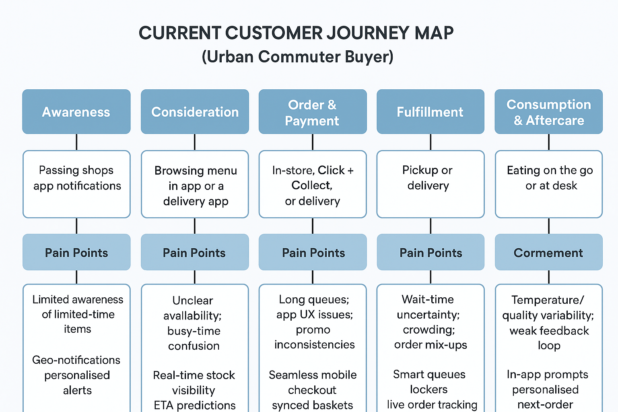
Summary of strengths: Greggs excels in brand recognition, accessibility, and affordability. Significant challenges arise concerning real-time visibility (is my item available?), the accuracy of fulfilment, and the friction experienced during queueing and collection. Digital opportunities are present in various aspects such as the availability of real-time services, tailored offers, the experience of order pick-up, and the dependability of delivery. The opportunities identified resonate with Greggs' strategic emphasis on digital channels; however, they indicate a necessity for a more profound integration of customer insights with store operations.

Part 2 - Proposed Digital Transformation Initiative (1,500 words)

Introduction to the Proposed Initiative
This section presents a digital transformation program aimed at resolving significant operational and customer experience issues discovered in Greggs' existing business model, based on the diagnostic investigation. The program, Greggs SmartServe, is a comprehensive platform that incorporates (1) client customisation, (2) predictive shop-level fulfilment, (3) intelligent order pickup and queue management, and (4) delivery optimisation with feedback mechanisms. These skills together seek to augment the role of digital channels, minimise friction in the customer journey, elevate product quality at the time of consumption, optimise labour and inventory efficiency, and fortify customer loyalty.

Greggs has exhibited robust digital and data preparedness its mobile application, loyalty program, and delivery collaborations indicate that customers are inclined to embrace digital engagement channels when the value is evident (Greggs plc, 2024; Greggs, 2025). The present implementation of digital systems is disjointed: precise "real-time shop view" data is scarce, ordering and fulfilment are not entirely synchronised across channels, and customers continue to encounter fluctuation in wait times and uncertainty regarding availability (Econsultancy, 2023). SmartServe mitigates these deficiencies by developing a comprehensive data-driven operating system tailored for a retail environment where digital and physical channels increasingly converge.
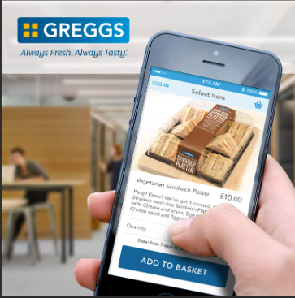
Fig. Greggs online shopping (Greggs, 2025).

Core Components of the Initiative
SmartServe comprises five interconnected modules:

Client Customisation and Recommendation System
This module converts the Greggs application and web ordering experience into a customised digital shopfront. Machine learning methods evaluate transaction history, temporal behaviour, geographic trends, product preferences, and seasonal variations to provide tailored menus for individual customers. The concept resembles individualised feeds found at major web merchants, although it is customised for food-to-go convenience.

The personalisation features would encompass:
- Contextual product recommendations (e.g., breakfast bun accompanied by coffee during morning hours)
- Impulse add-ons appeared throughout the checkout process (“you typically also purchase…”)
- Proximity-based, weather-related, or behavior-driven push alerts
- Customised promotions to enhance frequency and loyalty growth.
Retail data constantly indicates that customisation enhances basket size and transaction conversion rates, with digital-first companies seeing a gain of 10–20 percent (Econsultancy, 2023). For Greggs, even a slight increase would be significant on a national level.

Forecasting for Predictive Inventory and Production
The second module connects digital demand signals to operational decision-making at the shop level. Greggs shops presently bake and restock at regular intervals; nevertheless, the absence of in-depth predictive modelling at the local level renders product supply vulnerable to demand fluctuations. This results in two adverse outcomes noted in the present journey:
- Clients encountering unavailability of popular items during peak periods
- Excess generated from overproduction during periods of reduced activity.

SmartServe utilises time-series forecasting and machine learning to analyse variables such as:
Hhistorical hourly sales data at the shop level
- Weather influences the demand for hot beverages, pastries, and customer traffic.
- Day-of-the-week impacts
- Marketing events
- Community events, including academic calendars and athletic schedules.
The output is a recommended baking schedule that is "forward-projected" throughout the day and dynamically updated as real-time data becomes available. Demand forecasting systems implemented in prominent QSR chains have achieved double-digit decreases in waste and enhancements in product freshness (Euromonitor, 2024a). If Greggs decreased waste by 10–25 percent in experimental locations, the effect on margins would be substantial, considering its vertically integrated manufacturing approach.

Intelligent Pickup and Queue Administration
A significant challenge in the present customer journey is the predictability of wait times and the collecting experience, particularly during peak lunch hours on weekdays. Customers may encounter:
- Lines longer than anticipated,
- Personnel reallocating responsibilities under pressure, and
- Ambiguity between walk-in customers and Click & Collect customers.

SmartServe unveils multiple digital improvements:
- Guaranteed time-slot pickup reservations at the moment of ordering.
- Digital queue tickets displayed on the application, indicating expected wait time.
- Discretionary secure heated collection lockers located in high-traffic areas.
- Shop-floor dashboards displaying forthcoming orders and prioritising cues for personnel.
This enhances the customer experience by augmenting transparency and diminishing perceived wait times, a psychological element closely linked to satisfaction and NPS scores in food service studies. The strategy transitions operational labour from reactive queue management to proactive batch processing, hence enhancing throughput.

Coordinated Delivery Management
Greggs currently fulfils delivery requests through collaborations with platforms like Just Eat and Uber Eats. Although these channels have generated growth, the experience may fluctuate depending on rider availability, batching efficiency, and product cooling durations. The inconsistency of delivery undermines the perceived quality of Greggs' products, which are optimally enjoyed while hot and fresh.
SmartServe provides:
- synchronisation of delivery batch timing
- Integration of applications and aggregators to disseminate real-time kitchen readiness information
- Prioritisation of hot-hold items to decrease time out of the oven.
- Routing algorithm for the gathering of multiple orders by riders.
The technology is designed not to supplant delivery companies, but to augment Greggs' collaboration with them. This "closed-loop" methodology parallels optimisation methods employed in the restaurant industry, yielding documented enhancements in timeliness and a decrease in food temperature declines (Euromonitor, 2024b). For Greggs, the outcome would be a measurable enhancement in consumer happiness across rapidly expanding digital platforms.

Post-Purchase Evaluation and Learning System
Ultimately, SmartServe incorporates organised feedback mechanisms at the conclusion of each journey. Customers receive brief prompts star ratings or emojis through the app following collection or delivery. These responses directly inform operational metrics:
- Identifying Underperforming Stores
- Emphasising persistent operational challenges
- Associating product quality concerns with temporal data (e.g., the moment things exit the oven).
In high-volume retail chains, closed-loop feedback has demonstrated the capacity to enhance responsiveness and mitigate systemic quality failures by identifying concerns promptly. This session strengthens the emotional bond with clients by illustrating that feedback drives significant action.

How the Initiative Addresses Greggs’ Operational and Customer-Experience Challenges

3.3.1 Reducing Queuing and Friction
Greggs' outlets exhibit fluctuating demand patterns throughout the day, with peaks occurring in the mid-morning and mid-afternoon. The creation of queues during these periods affects both perceived service quality and real throughput. In contrast to table-service restaurants, Greggs functions in compact retail forms where inadequate line management may extend into doorways or street areas.
SmartServe alleviates this through:
- Increasing Digital Sales and Basket Size
- electronic ticketing
- order prioritisation methodology
- clear pickup signage or lockers.
This diminishes the psychological ambiguity associated with waiting—studies indicate that "uncertain waits seem prolonged compared to known waits," despite identical real waiting durations. By enhancing transparency, Greggs elevates perceived service quality without necessarily augmenting employment expenses.

3.3.2 Enhancing Product Availability
Food-to-go shoppers always complain about lack of availability. Unavailable best-sellers like vegan bangers at peak hours hurt customers and cost income. Predictive inventory scheduling reduces digital and physical sell-outs and protects product freshness.
Greggs' cost structure is protected during economic downturns by robust forecasting. Ingredient and energy costs have fluctuated recently (Greggs plc, 2024). A ten percent waste reduction across 2,300 stores might boost operating revenues.

3.3.3 Increasing Digital Sales and Basket Size
In-app personalisation, contextual enhancements, and cross-selling strategies frequently elevate digital revenues among analogous retail sectors (Econsultancy, 2023). Greggs has established the foundational platform, including the application, loyalty engine, and integrated payment systems; but, it has not yet achieved complete algorithmic maturity.
SmartServe facilitates:
- Increased spend per transaction
- More pertinent promotions
- Enhanced loyalty reinforcement
- Utilisation throughout many dayparts (e.g., marketing breakfast options for patrons who typically arrive during lunch).
If each digital transaction increased by £0.40 and digital penetration rose by several percentage points, the overall annual revenue boost would be significant on a national scale.

3.3.4 Enhancing Brand Positioning
Greggs has shown that disruptive product innovation, exemplified by the vegan banger roll, may position it within cultural discourse (The Guardian, 2019). Nevertheless, competitors have matched the adoption of fundamental digital ordering platforms. SmartServe provides Greggs with a novel differentiator:
- A truly rapid, reliable, data-optimized client experience.
This strategically promotes Greggs as not only "convenient and cost-effective" but also technologically advanced, accessible, and service-oriented, even within a low-price framework.

3.3.5 Advancing ESG and Sustainability Objectives
SmartServe is also consistent with Greggs' stated sustainability intentions. Mitigating overproduction directly diminishes food waste, a quantifiable ESG metric being monitored in annual reports. Simultaneously, enhanced routing efficiency in deliveries decreases rider miles and corresponding emissions. The initiative therefore endorses the ethical and environmental aspects of Greggs' corporate stance (Greggs plc, 2024).

3.4 Implementation Phasing
The initiative is designed for phased deployment, reducing financial and operational risk.
Fig. Table of the implementation Phasing.

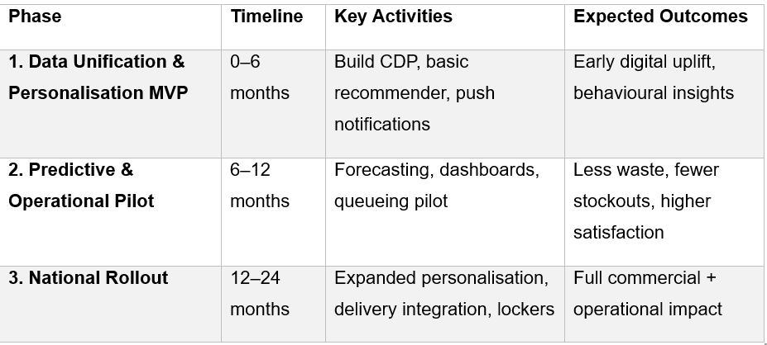
Phase 1 - Unifying Data and Developing a Personalisation Minimum Viable Product (0–6 months)
Essential steps:
- the integration of digital and point-of-sale data into a Customer Data Platform
- an overview of fundamental recommendation principles
- Push notifications activated by user behaviour and geographic location.
Expected outcomes:
- an observable increase in digital conversion
- the prominence of initial behavioural insights
- establishing the technical groundwork for the upcoming stages.

Phase 2 - Predictive and Operational Pilot (6 to 12 months)
Implemented in 50 to 100 stores that have shown a strong embrace of digital practices. This stage presents:
- models for predicting demand
- staff dashboards
- initial pilot for managing queues
- Optional early smart lockers are available in select urban stores.
Key Performance Indicators:
- minimising waste
- minimising stock shortages
- variation in fulfilment time
- the scores reflecting customer satisfaction.

Phase 3 - Expansion and Nationwide Implementation (12–24 months)
- Enhancement of predictive model
- The nationwide implementation of app customisation
- The collaboration of all delivery aggregator partners
- The enhancement of locker facilities and the implementation of digital queueing systems at locations with high traffic.

Results:
- The complete realisation of commercial and operational enhancement
- A significant improvement in Greggs’ digital impact.

3.5 Enhanced Customer Journey Map (Post-Transformation)
Awareness
- Messaging that is tailored to specific locations or weather conditions
- The app presents pertinent offers for breakfast or lunch.
- Enticing messages (“Delicious pastries just out of the oven – place your order for pickup in 10 minutes!”).
Consideration
- The application provides a real-time view of inventory for each store.
- Anticipated timeline for collection
- Tailored recommendations that take into account past interactions and the current time of day.
Order & Payment
- Deamless mobile checkout experience
- Designated time frame
- The visible reward balance allows for easy tracking, and the one-tap redemption simplifies the process.
Fulfilment & Pickup
- The app indicates that your order is currently being prepared.
- Retrieve from the heated locker or the priority pickup counter
- The sequence for riders or staff has been optimised.
Aftercare
- An easy way to express your feelings or provide feedback
- Immediate feedback transformed into actionable understanding
- Customised incentives tailored to individual sentiments.
This journey maintains a straightforward approach while enhancing Greggs' predictability, reliance on data, and focus on user needs.

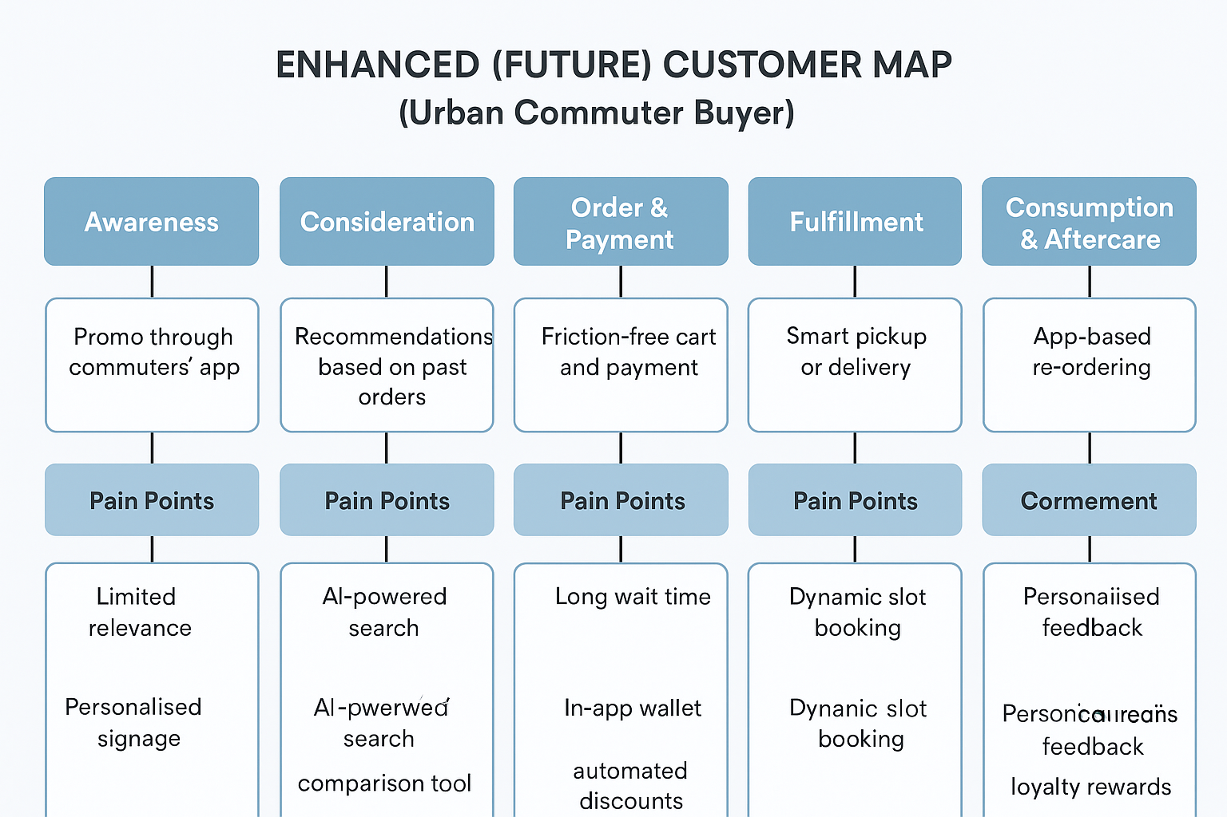
Fig. Enhanced Customer Mapping. Source. Own ownership

3.6 Key Performance Indicators (KPIs) and Measurement Plan
The transformation must be tracked with quantifiable, finance-linked KPIs. Measurements include
KPIs for Commercial Activities
- The proportion of total revenue generated through digital channels is expected to show a consistent increase over the next 12 to 24 months.
- The average order value for online transactions
- The frequency of visits for loyal customers
- Enhancing the Net Promoter Score and improving app store ratings.

KPIs for Operations
- The availability of products during high-demand times
- Typical fulfilment duration
- Variations in queue or locker pickup times
- The amount of waste generated by each store on a weekly basis.

Financial KPIs
An increase in digital revenue compared to control stores
Improvements in gross margin linked to forecasting
The duration required to recover the initial investment in capital expenditures and software.

Approach to measurement:
- Experimentation involving a control group
- Dashboards that provide real-time insights
- Quarterly assessment
- Optimising models through an iterative process.

2.7 Risks and Mitigations
- Operational Disruption
Store colleagues might find themselves facing a greater level of complexity at first. Implementing a gradual rollout alongside training and simplifying the user interface helps to reduce potential risks.

- Data Privacy
In accordance with GDPR requirements, it is essential that data processing upholds informed consent and ensures secure storage of information. Greggs currently manages customer data with care; however, there is a need to enhance governance, auditing, and transparency practices.

- Coordinating with Delivery Partners
Delivery optimisation requires the integration of APIs with various aggregators. By initially piloting with a single partner, we can mitigate technical risks before expanding the rollout to a broader audience.

- Acceptance by Customers
Customers who value spontaneity or face-to-face interaction should always have the option to walk in easily. SmartServe enriches options without eliminating current practices.

3.8 Assessing Viability and Strategic Alignment
SmartServe builds upon Greggs’ existing strengths, such as its mobile app usage, strong brand loyalty, quick product testing, and readiness for digital initiatives, instead of anticipating a complete overhaul of the organisation. Research and market insights indicate that retailers who combine operational data with personalisation and digital service channels often see lasting commercial benefits (Econsultancy, 2023; Euromonitor, 2024a). Greggs is well-positioned in terms of timing, scale, and maturity to significantly benefit from this shift.

SmartServe demonstrates financial credibility, aligns strategically with its goals, operates with practicality, and is firmly based on identifiable customer challenges. When implemented successfully, this strategy enhances Greggs' ability to stand out not only as a strong product innovator but also as a digitally advanced retail operator, ensuring continued growth in a challenging and cost-sensitive market.

Conclusion
Greggs stands out as a prominent retailer in the UK, known for its widespread recognition and appeal across various demographics. The brand has demonstrated its ability to innovate effectively while also expanding its presence in the digital landscape. The strategic decision to enhance digital channels and extend reach throughout the day is well-founded and backed by recent outcomes. Nonetheless, the main challenges faced by customers such as real-time availability, waiting times for pickup, and the quality of delivery can be significantly enhanced through a unified approach to digital transformation.

The Greggs SmartServe initiative presents a cohesive strategy that enhances personalisation, anticipates customer needs, and optimises the pickup experience.This approach not only leverages Greggs' existing strengths but also tackles current challenges, ultimately delivering tangible benefits both commercially and operationally. The approach utilises Greggs’ app, brand, and shop network, and its gradual implementation minimises risk while allowing for quick learning and optimisation.

When implemented with thoughtful consideration of data governance, change management, and partner integration, SmartServe offers a promising opportunity to enhance digital sales, lower costs, and bolster Greggs’ customer proposition for the future.

References
Econsultancy (2023) How Greggs balances tech with customer excellence. Available at: https://econsultancy.com/greggs-tony-taylor-digital-transformation-customer-excellence/
(Accessed: 15 November 2025).
Euromonitor International (2024a) Consumer Foodservice in the United Kingdom. Euromonitor. Available at: https://www.euromonitor.com/consumer-foodservice-in-the-united-kingdom/report
(Accessed: 15 November 2025).
Euromonitor International (2024b) Bakery Products in the United Kingdom: ISIC 1541. Euromonitor. Available at: https://www.euromonitor.com/bakery-products-in-the-united-kingdom-isic-1541/report
(Accessed: 16 November 2025).
Financial Times (2024) Greggs forecasts sales to double by 2026. Financial Times, 2024. Available at: https://www.ft.com/content/9090049f-0368-41b3-943b-25c8e833d54e
(Accessed: 15 November 2025).
Greggs plc (2024) Annual Report and Accounts 2024. Greggs plc. Available at: https://data.fca.org.uk/artefacts/NSM/Portal/NI-000118042/NI-000118042.pdf
(Accessed: 12 November 2025).
Greggs plc (2024) Annual Report and Accounts 2023. Greggs plc. Available at: https://a.storyblok.com/f/162306/x/6191f7066b/greggs-annual-report-and-accounts-2023.pdf
(Accessed: 16 November 2025).
Greggs corporate (2025) Our strategy — Digital channels. Greggs corporate website. Available at: https://corporate.greggs.co.uk/about-us/our-strategy
(Accessed: 16 November 2025).
Greggs (2025) Greggs App — Click + Collect and rewards. Available at: https://www.greggs.com/app
(Accessed: 15 November 2025).
MarketingWeek (2020) Why Greggs borrowed fashion’s ‘drop culture’ to launch its vegan steak bake. MarketingWeek. Available at: https://www.marketingweek.com/masters-awards-greggs-launch-vegan-steak-bake/
(Accessed: 16 November 2025).
Nature Humanities Research (2022) Sanford, M. Veganuary and the vegan sausage (t)rolls. Humanities & Social Sciences Communications, 2022. Available at: https://www.nature.com/articles/s41599-022-01464-2
(Accessed: 16 November 2025).
The Guardian (2019) Monaghan, A. Greggs struggles to keep up with demand for vegan sausage rolls, The Guardian, 9 January 2019. Available at: https://www.theguardian.com/business/2019/jan/09/greggs-unveils-extra-profit-vegan-sausage-roll
(Accessed: 12 November 2025).
Bakery Info (2025) Greggs named UK's strongest brand in 2025. BakeryInfo. Available at: https://bakeryinfo.co.uk/finance/greggs-named-uks-strongest-brand-in-2025/706979.article
(Accessed: 16 November 2025).
AnnualReports.com (2024) Greggs plc — Annual Reports collection. Available at: https://www.annualreports.com/Company/greggs-plc
(Accessed: 16 November 2025).

