
APPENDIX GA36a

LEVEL 4 ASSESSMENT SPECIFICATION

Student name: | Byron Grey | Student ID number: | 2221716
Programme: | HNC Electrical and Electronic Engineering
Module: | Design of Electrical Installations
Module code: | PCEE4007 | Contribution to Overall Module Assessment (%): | 50%
Lecturer: | Steven Evans | Internal Verifier: | Nigel Richards
Assignment Title: | Practical Installation Assessment | Word count (or equivalent): | 2000
Submission deadline: |  | Return date of provisional marks & written feedback:
Submission method: | All written assessments, where practical and possible, must be submitted via Turnitin unless otherwise instructed by the Lecturer. (Please DO NOT put this assessment specification into Turnitin or it will match many similarities with other students’ submissions.)  Alternative submission method (if applicable):  Late submission of the assessment will result in a late penalty mark. Penalties for late submission: Up to one week late, maximum mark of 40%. Over one week late, 0%. Only the Extenuating Circumstances Panel may approve a change to submission dates.
Academic honesty / referencing: | Academic honesty is required. In the main body of your submission you must give credit to authors on whose research and ideas your work is based. Append to your submission a reference list that indicates the books, articles, etc. that you have used, cited or quoted in order to complete this assessment.

Module Learning Outcomes
(from module syllabus)
LO1, LO2

TASK DESCRIPTION

Assignment 2 - 2023/ 2024

This assessment has been designed in TWO parts: Section A and Section B.

Answer all questions

Section A deals with the design, installation and testing of a Ring Final Circuit and requires the student to design and then construct the circuit using the accessories provided.

Section B requires the student to answer ALL the questions with detailed statements and fully labelled diagrams where possible.

Wiring with multicore cables
Multicore cables (commonly referred to as flat twin and earth (FTE) or PVC/PVC cables) used in standard circuit installations are three-core cables consisting of a line, a neutral and an earth conductor. Both the line and neutral conductors are copper insulated with coloured insulation; brown for line and blue for neutral. The earth being a non-insulated bare copper conductor sandwiched between the line and neutral and is known as the C.P.C. – Circuit Protective Conductor. The three conductors are encased in a PVC outer sheathing.
All cables used in electrical installations in the United Kingdom must be BASEC approved.

In this practical exercise you are requested to install and test a PVC/PVC wiring installation which shall comply with good codes of practice and the current IET Wiring Regulations.

The Layout diagram shows a Ring Final Circuit with spurs and a fused spur controlling a two-way switched lighting circuit. From the diagram, estimate the materials required and complete the requisition sheet. You will also need to complete the tools and equipment sheet.

Before carrying out the practical exercise you must complete a circuit diagram and a wiring diagram on the relevant sheets.

On completion of the practical exercise, carry out the required tests in the correct sequence according to the IET Wiring Regulations and record on the test sheet.

Section A

Time Allowed: 120 Minutes

Work Plan/ Method Statement

Tools List

Materials List

Test Results

Visual Inspection Pass / Fail

Continuity of CPC Test Lead Resistance = _____________

(R₁ + R₂₎ = _____________

Insulation Resistance Test Voltage Applied = ______________

Min. Acceptable Value = ______________

Line to Neutral Value = ______________

Line to CPC Value = ______________

Neutral to CPC Value = ______________

30mA RCD Test ½ x ______________

1 x ______________

Polarity Test Pass / Fail

Comments

Layout Diagram of a Ring Final Circuit with Spurs

and a Switched Fused Spur controlling a 3-way switched lighting circuit

Circuit Diagram of a Ring Final Circuit with Spurs

and a Switched Fused Spur controlling a 2-way switched lighting circuit

Wiring Diagram of a Final Ring Circuit with Spurs

and a Switched Fused Spur controlling a 2-way switched lighting circuit

Section B

1 a) The fuses in Figure 1 are BS88 Type 2.

- Explain why it is important to achieve discrimination between fuses A and B.

- By considering the time-current characteristics of fuses A and B, determine the disconnection times caused by a fault current of 300A and state if discrimination is achieved.

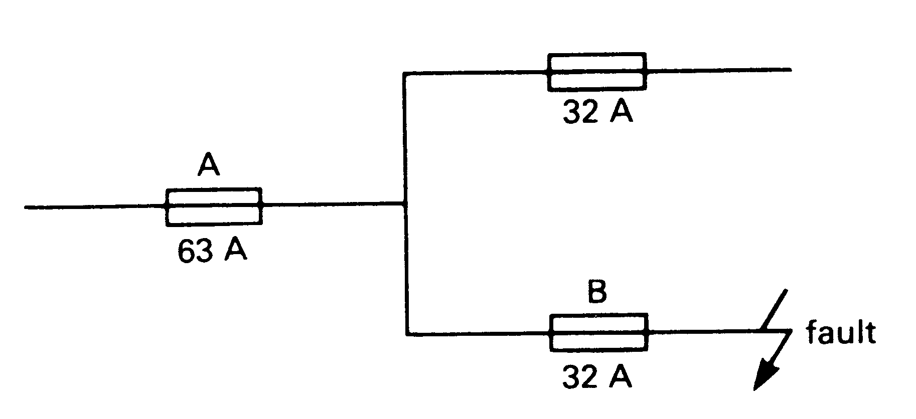

Figure 1

- Explain what is meant by thermal and magnetic tripping properties with regard to protective devices.

- The illustration below shows a line diagram that illustrates a typical lighting point controlled by a dimmer switch and protected by a fuse.
Create similar line diagrams for the following circuits:
  - Lighting point controlled by two-way switching.
  - Two lighting points switched together and controlled by two-way and intermediate switching.
  - Six x 1 gang 13A BS1363 switched socket outlets wired as a radial final circuit.
  - Thermostatically controlled heater wired from a double-pole switch.

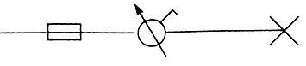

GUIDANCE FOR Students
IN THE COMPLETION OF TASKS

NOTE: The guidance offered below is linked to the five generic assessment criteria overleaf.

- Engagement with Literature Skills
Your work must be informed and supported by scholarly material that is relevant to and focused on the task(s) set. You should provide evidence that you have accessed an appropriate range of sources, which may be academic, governmental and industrial; these sources may include academic journal articles, textbooks, current news articles, organisational documents, and websites. You should consider the credibility of your sources; academic journals are normally highly credible sources while websites require careful consideration/selection and should be used sparingly. Any sources you use should be current and up-to-date, mostly published within the last five years or so, though seminal/important works in the field may be older. You must provide evidence of your research/own reading throughout your work, using a suitable referencing system, including in-text citations in the main body of your work and a reference list at the end of your work.

Guidance specific to this assessment: You must provide evidence of individual research with respect to the area of study and provide relevant referencing.

- Knowledge and Understanding Skills
At level 4, you should be able to demonstrate knowledge of the underlying concepts and principles associated with your area(s) of study. Knowledge relates to the facts, information and skills you have acquired through your learning. You demonstrate your understanding by interpreting the meaning of the facts and information (knowledge). This means that you need to select and include in your work the concepts, techniques, models, theories, etc. appropriate to the task(s) set. You should be able to explain the theories, concepts, etc. to show your understanding. Your mark/grade will also depend upon the extent to which you demonstrate your knowledge and understanding.

Guidance specific to this assessment: Your report and presentation should show you gained knowledge of the subject area.

- Cognitive and Intellectual Skills
You should be able to present, evaluate and interpret qualitative and quantitative data, in order to develop lines of argument and make sound judgements in accordance with basic theories and concepts of your subject(s) of study. You should be able to evaluate the appropriateness of different approaches to solving problems related to your area(s) of study and/or work. Your work must contain evidence of logical, analytical thinking. For example, to examine and break information down into parts, make inferences, compile, compare and contrast information. This means not just describing what! But also justifying: Why? How? When? Who? Where? At what cost? You should provide justification for your arguments and judgements using evidence that you have reflected upon the ideas of others within the subject area and that you are able to make sound judgements and arguments using data and concepts. Where relevant, alternative solutions and recommendations may be proposed.

Guidance specific to this assessment: Your report should show sound judgements and arguments related to the scenario and your responses to tasks.

- Practical Skills
At level 4, you should be able to apply the basic underlying concepts and principles to evaluate and interpret these within the context of your area of study. You should be able to demonstrate how the subject-related concepts and ideas relate to real world situations and/or a particular context. How do they work in practice? You will deploy models, methods, techniques, and/or theories, in that context, to assess current situations, perhaps to formulate plans or solutions to solve problems, or to create artefacts. This is likely to involve, for instance, the use of real world artefacts, examples and cases, the application of a model within an organisation and/or benchmarking one theory or organisation against others based on stated criteria.

Guidance specific to this assessment: Your report and presentation of practical work should indicate a level of research with respect to the application and deployment of the equipment, materials or processes that form the basis of the area of study.

- Transferable Skills for Life and Professional Practice
Your work must provide evidence of the qualities and transferable skills necessary for employment requiring the exercise of some personal responsibility. This includes demonstrating: that you can communicate the results of your study/work accurately and reliably, and with structured and coherent arguments; that you can initiate and complete tasks and procedures, whether individually and/or collaboratively; fluency of expression; clarity and effectiveness in presentation and organisation. Work should be coherent and well-structured in presentation and organisation.

Guidance specific to this assessment: Your work should be well organised and presented in a professional manner.

Student FEEDBACK FORM

This section details the extent to which the assessment criteria are demonstrated by you, which in turn determines your mark. The marks available for each category of skill are shown. Lecturers will use the space provided to comment on the achievement of the task(s), including those areas in which you have performed well and areas that would benefit from development/improvement.

Generic Assessment Criteria | Marks available | Marks  awarded
1. Engagement with Literature Skills
.
A clear and well-presented assignment. Well written and precise. |  | 20
 | 25 | 20
2. Knowledge and Understanding Skills

Excellent knowledge and understanding of electrical technology across the assignment. |  | 20
 | 25 | 20
3. Cognitive and Intellectual Skills

A well thought out and well-constructed assignment. |  | 18
A well thought out and well-constructed assignment. | 20 | 18
4. Practical Application Skills

Transferrable skills are clearly evident applied across the assignment work. |  | 18
 | 20 | 18
5. Transferable Skills for Life and Professional Practice

The learner has an excellent ‘working’ knowledge of his subject and can transfer his usable skills very well. |  | 8
 | 10 | 8

Assessment Mark (Assessment marks are subject to ratification at the Exam Board. These comments and marks are to give feedback on module work and are for guidance only until they are confirmed. ) | Late Submission Penalties (tick if appropriate) |  | 84 %
 | Up to 1 week late (40% Max) |  | 84 %
 | Over 1 week late (0%) |  | 84 %

GENERIC ASSESSMENT CRITERIA

Level 4
In accordance with the Framework for Higher Education Qualifications, at the end of Level 4 students will be expected to have demonstrated knowledge of the basic underlying concepts and principles of a subject, and an ability to evaluate and interpret these within the context of that area of study. They should be able to present, evaluate and interpret qualitative and quantitative data in order to develop lines of argument and make sound judgements in accordance with basic theories and concepts of their subject(s) of study. They will have learned how to evaluate different approaches to solving problems, and will be able to communicate the results of their study/work accurately and reliably, and with structured and coherent arguments. They will be able to undertake further training and develop new skills within a structured and managed environment and will have the qualities and transferable skills necessary for employment requiring the exercise of some personal responsibility.

Level 4 | FAIL | MARGINAL FAIL | SATISFACTORY  (3rd / Pass) | GOOD  (2.2 / Pass) | VERY GOOD  (2.1 / Merit) | EXCELLENT  (1st / Distinction) | EXCEPTIONAL  (1st / Distinction)
Category | 0-29% | 30-39% | 40-49% | 50-59% | 60-69% | 70-84% | 85-100%
Engagement with literature (including reading, referencing,  academic conventions and  academic honesty) | Little or no evidence of reading and/or reliance on inappropriate sources.  Views and findings mostly unsupported and non-authoritative.  Referencing conventions used incoherently or largely absent. | Poor engagement with essential reading. No evidence of wider reading. Reliance on inappropriate sources, and/or indiscriminate use of sources. Heavily reliant on information gained through class contact. Inconsistent and weak use of referencing. | Engagement with a limited range of mostly relevant and credible sources but with some reliance on information gained through class contact. Some omissions and minor errors.  Referencing conventions evident though not always applied accurately or consistently. | Engagement with an appropriate range of literature, including sources retrieved independently. Some over-reliance on texts rather than other sources. Referencing may show minor inaccuracies or inconsistencies. | Engagement with a wide range of literature, including sources retrieved independently.  Selection of relevant and credible sources. Generally sound referencing, with no/very few inaccuracies or inconsistencies. | Engagement with an extensive range of relevant and credible literature. Consistently accurate application of referencing. | Exceptional engagement with an extensive range of relevant and credible literature. High-level referencing skills consistently applied.
Knowledge and understanding (Knowledge of the basic underlying concepts and principles of a subject.) | Major gaps in knowledge and understanding of the basic underlying concepts and principles of the subject matter. Inclusion of irrelevant material. Substantial inaccuracies. | Gaps in knowledge of the basic underlying concepts and principles, with flawed or superficial understanding. Some significant inaccuracies and/or irrelevant material. | Limited knowledge and understanding of the basic underlying concepts and principles within the subject area. Some elements may be missing. | Knowledge of the basic underlying concepts and principles is accurate with a good understanding of the field of study but lacks depth and/or breadth. | Competent knowledge of the basic underlying concepts and principles. Exhibits very good understanding. | Excellent knowledge and understanding of the basic underlying concepts and principles of the subject. | Exceptional, detailed knowledge and understanding of the basic underlying concepts and principles
Cognitive and intellectual skills  (Evaluate underlying concepts and principles of a subject and interpret qualitative and quantitative data in order to develop lines of argument and make sound judgements.) | Wholly or almost wholly descriptive work. Little or no evaluation of the underlying concepts and principles.  Failure to develop arguments, leading to illogical or invalid judgements. Minimal or no use of  evidence to back up views. | Largely descriptive work, with superficial evaluation of the underlying concepts and principles. Weak interpretation of data, flawed development of arguments and judgements. Information accepted uncritically, uses generalised statements made with scant evidence and unsubstantiated opinions. Ideas sometimes illogical and contradictory. | Limited attempt at evaluation of the underlying concepts and principles, tending towards description.  Can interpret qualitative and quantitative data but with some errors. Some evidence to support emerging arguments and judgements but these may be underdeveloped or with a little inconsistency / mis-interpretation. | Good evaluation of the underlying concepts and principles. Can interpret qualitative and quantitative data, with minor errors.  An emerging ability to use evidence to support the argument.  Mostly valid arguments and logical judgements. | Sound evaluation of the underlying concepts and principles. Can interpret qualitative and quantitative data accurately. Ability to devise arguments using evidence to make mostly appropriate and valid judgements. | Excellent evaluation of the underlying concepts and principles. Can interpret qualitative and quantitative data accurately and with some insight. Excellent ability to devise arguments using evidence and make appropriate and valid judgements. | Exceptional evaluation of the underlying concepts and principles based evidence. Outstanding interpretation of qualitative and quantitative data.  Exceptional ability to devise arguments using evidence and make wholly appropriate and valid judgements.
Practical skills  (Different approaches to solving problems in particular contexts.) | Limited or no use of taught, basic methods, materials, tools and/or techniques.  Little or no appreciation of the context of the application.  Very weak evidence of different approaches to problem-solving in particular contexts. | Rudimentary application of taught, basic methods, materials, tools and/or techniques but without consideration and competence. Flawed appreciation of the context of the application.  Weak evidence of different approaches to problem-solving in particular contexts. | An adequate awareness and mostly appropriate application of basic methods, materials, tools and/or techniques.  Basic appreciation of the context of the application.  Can identify problems in particular contexts and propose basic alternative approaches or solutions though there may be errors. | A good and appropriate application of basic methods, materials, tools and/or techniques.  Clear appreciation of the context of the application.  Good evidence of different approaches to problem-solving in particular contexts and proposes mostly appropriate solutions. | A very good application of a range of basic methods, materials, tools and/or techniques.  Very good consideration of the context of the application. Very good evidence of different approaches to problem-solving in particular contexts and proposes appropriate solutions. | An advanced application of a range of taught, basic methods, materials, tools and/or techniques.  The context of the application is well considered, and insightful.  Excellent evidence of different approaches to problem-solving in particular contexts and proposes appropriate solutions. | Exceptional levels of application and deployment skills in particular practical contexts. Outstanding identification of problems in particular contexts and formulation of wholly appropriate, thoughtful solutions / different approaches.
Transferable skills for life and professional practice  (Communicate the results of their study/work accurately and reliably, and with structured and coherent arguments; the qualities needed for employment requiring the exercise of some personal responsibility within a structured and managed environment.) | Work is poorly structured, disorganised, inaccurate and/or confusingly expressed. Very weak use of language and/or very inappropriate style. Failure to work effectively individual or as part of a group. Little or no evidence of the skills for employment requiring the exercise of some personal responsibility. | Work is poorly presented in a disjointed manner. It is loosely, and at times incoherently, structured, with information and ideas often poorly expressed. Weak use of language and/or inappropriate style. Flawed approach to individual or group work, meeting only partial obligations to others. Limited evidence of the skills for employment requiring the exercise of some personal responsibility. | Mostly ordered presentation and structure in which relevant ideas / concepts are reasonably expressed. Work may lack coherence and/or accuracy in places. Can work as part of a group, meeting most obligations to others but perhaps with limited involvement in group activities.  Demonstrates the basic skills for employment requiring the exercise of some personal responsibility, with some areas of minor weakness. | Mostly coherent, organised and accurate work, in a suitable structure and is for the most part clearly expressed. Can work effectively independently and/or as part of a team, with clear contribution to group activities.  Demonstrates the skills for employment requiring the exercise of some personal responsibility, with some areas of strength and some of minor weakness. | Work is accurate, coherent, fluent, well-structured and organised.  Can work effectively independently and/or as part of a team, with very good contribution to group activities. Demonstrates very good skills for employment requiring the exercise of some personal responsibility, with just occasional minor weakness. | Work is coherent, very fluent and is presented professionally. Can work effectively independently and/or as part of a team, with an excellent contribution to group activities. Demonstrates excellent skills for employment requiring the exercise of some personal responsibility with an appetite for further development. | Work is accurate, exceptionally coherent, very fluent and presented well. Can work effectively independently and/or as part of a team, with an exceptional contribution to group activities. Demonstrates exceptional skills for employment requiring the exercise of some personal responsibility with an appetite for further development.

THIS DOCUMENT IS ALSO AVAILABLE IN WELSH



Electrical Installation

Assignment 2

HNC Electrical and Electronic Engineering

Byron Grey

Student Number- 2221716

Email- 173589@pembrokeshire.ac.uk

Table of Contents
Section A 17
Work Plan/ Method Statement 17
Tool List 18
Material List 18
Test Results 19
Layout Diagram 20
Circuit Diagram 20
Wiring Diagram 21
Completed Project 21
Section B 23
1a) 23
(i) 23
(ii) 23
1b) 24
2a) 26
2b) 26
2c) 27
2d) 27
References 27
Bibliography 27

Section A

Work Plan/ Method Statement
Before any work is to take place the work environment will need to be safe, and any hazards are identified, and the likelihood reduced. To manage this a risk assessment is completed and good housekeeping is to be carried out so that the work environment is clean and tidy, so nothing creates a trip hazard or a danger of cuts and injuries to personnel working in the area.

Once all hazards have been identified and reduced to create the safest work area possible, the layout of all components will be drawn onto the workspace where they are going to be secured. This will allow the clipping lines to be draw on to guide the installer further along the process.

The first installation will be the metal back boxes for the sockets and switches, which will be secured into their allocated positions outlined previously. From this the plastic backings of the junction box and ceiling roses can be installed and secured into position. Lastly the Consumer unit is to be secured into its allocated position, all fixtures will be secured using a suitable number of screws to be able to maintain a strong hold to the workspace.

Once all fixtures are secured the cable for the ring final circuit will need to be measured to size, then cut and fitted into position and secured into place with clippings. The cabling will follow the clipping lines so that it is fitted to specification of the planned design. Once the cable is fitted it can then be stripped and connected into the consumer unit, 4 sockets and the junction box as per the wiring diagram.

Next the cabling for the radial circuit that is fed off one of the sockets will need to be measured, cut, fitted and clipped follow the same process as spoken about before. All wiring and terminations need to be in accordance with BS7671 and follow good working practises.

Finally, the circuit will need to be tested, which include dead and live testing of the circuit and its components. All tests to be carried out will be as per the required testing sheet within the criteria.

Tool List
- Pencil
- Measuring tape
- Level
- Terminal screwdriver
- Philips screwdriver
- Wire strippers
- Hammer
- Wire cutters
- Fluke 1662 Multifunction Tester
- Test leads

Material List
- Consumer Unit
- 16A MCB Breaker
- 40A RCD
- Socket Outlets X4
- 30A Junction Box
- Fused Spur
- Ceiling Rose X2
- 2-way switch X2
- Intermediate switch
- $2.5{mm}^{2}$ 3 core PVC cable (Flat Twin and Earth)
- $1.0{mm}^{2}$ 3 core PVC cable (Flat Twin and Earth)
- $1.0{mm}^{2}$ 4 core cable (3 core and Earth)
- Earth sleeving
- $1.0 and 2.5{mm}^{2}$ wire clips

Test Results
Test Section | Test Type | Results
Visual | Visual Inspection | Pass
Continuity | Test Lead Resistance | Nulled
Continuity | $$R_{1}+R_{2}$$ | 0.01Ω
Insulation Resistance | Test Voltage Applied | 500V
Insulation Resistance | Min. Acceptable Value | 1MΩ
Insulation Resistance | Line to Neutral Value | >500MΩ
Insulation Resistance | Line to CPC Value | >500MΩ
Insulation Resistance | Neutral to CPC Value | >500MΩ
30mA RCD Test | ½ X | Fail
30mA RCD Test | 1 X | 17.2ms
30mA RCD Test | 5 X | 10.5ms
Polarity | Polarity Test | Pass

Comments

To Complete Continuity test link between the busbar and the earthing block installed to create the figure of 8 configuration as seen in figure 1.
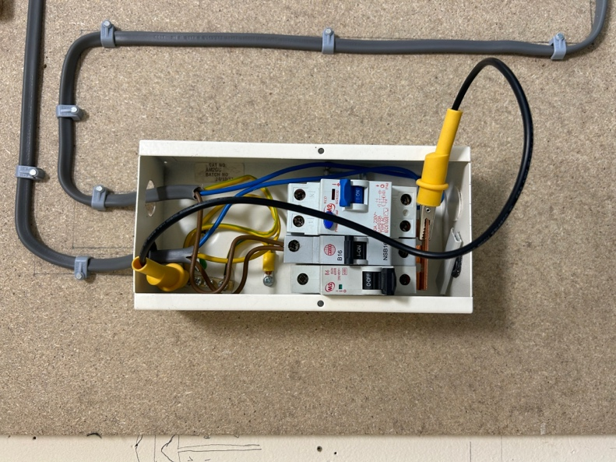
Figure 1- Link for testing continuity

Layout Diagram
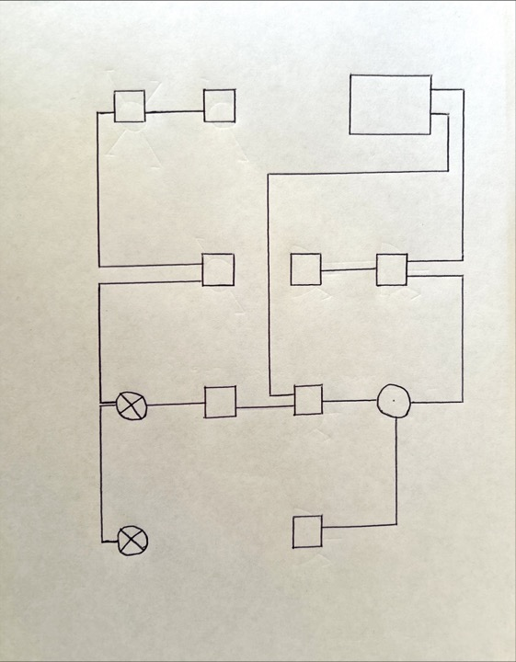
Figure 2- Layout Diagram

Circuit Diagram
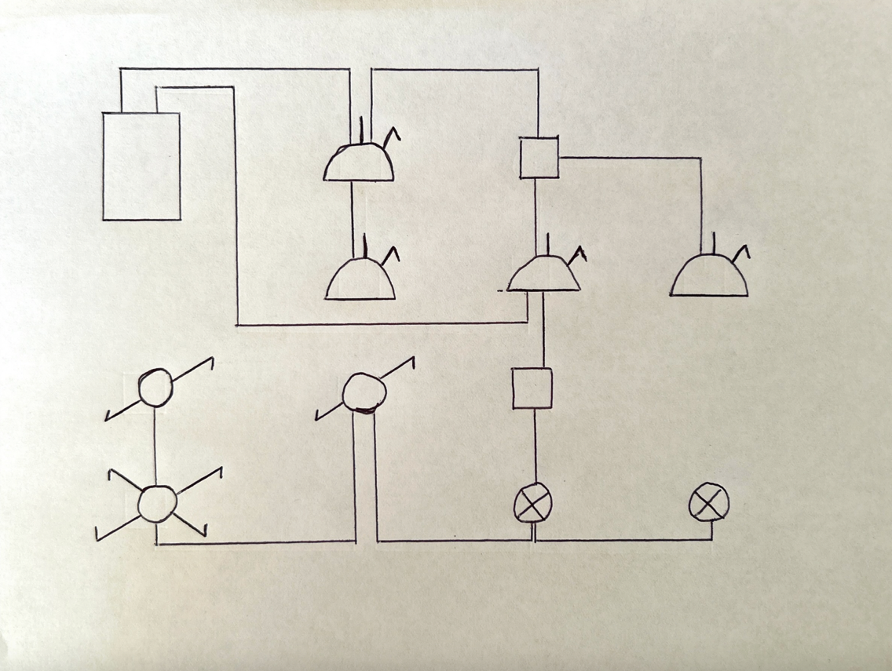
Figure 3- Circuit Diagram

Wiring Diagram
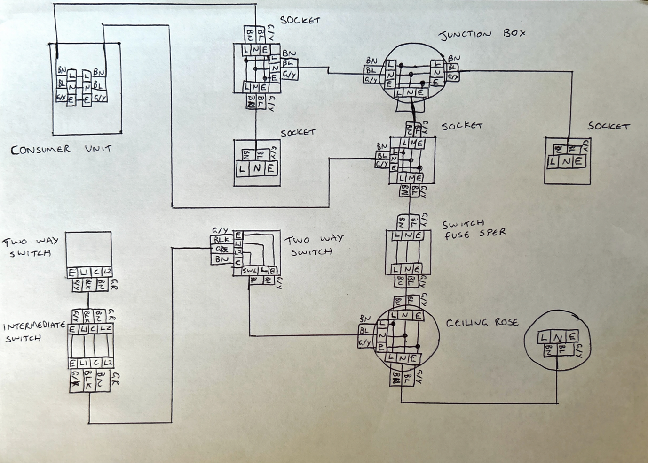
Figure 4- Wiring Diagram

Completed Project
Figures 5 to 8 demonstrates step by step of the project being completed.
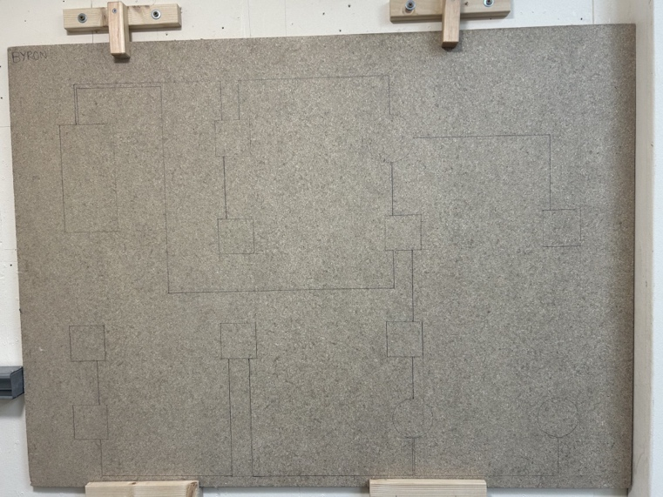
Figure 5- Layout and clipping lines drawn onto work area

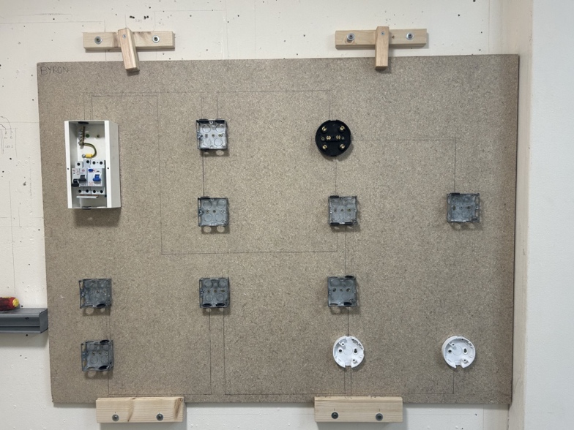
Figure 6- Back boxes and Consumer unit secured

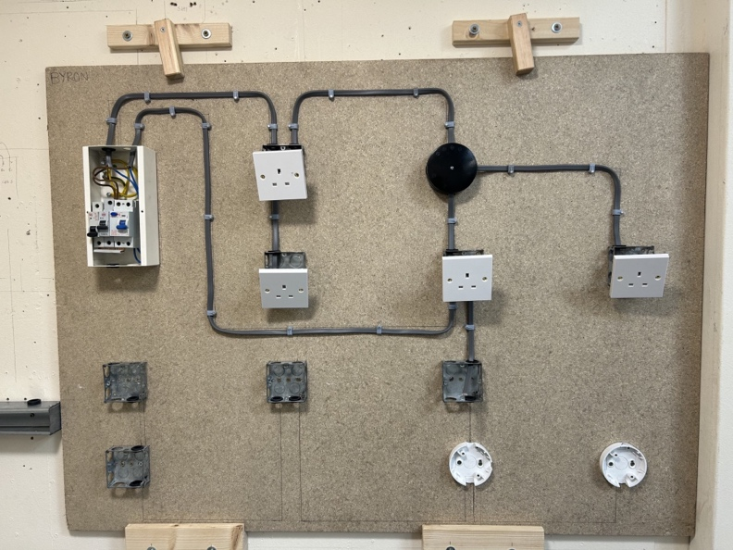
Figure 7- Ring Final circuit completed

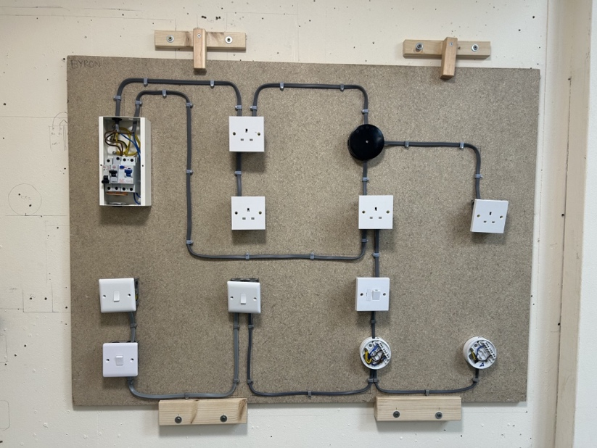
Figure 8- Completed project ready for testing

Section B

1a)
The fuses in figure 9 are BS88 Type 2.
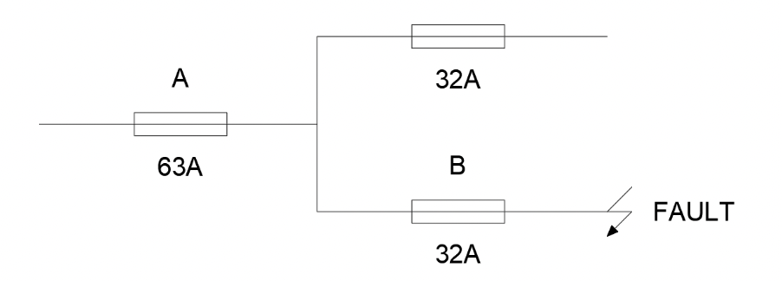
Figure 9- Question 1 circuit

(i)
Achieving discrimination is vital between fuses A and B as it will minimise the risk of unnecessary tripping of the circuit’s protective device, this will also reduce any unwanted interruptions to the circuit in the case of fault conditions. If a fault condition occurs downstream from fuse B, as demonstrated in figure 5 then the fuse must trip to make sure that no fault can cause fuse A to trip. If B fails to trip and results in fuse A tripping I will cause the full circuit to be off, which can lead to more significant issues, particularly if critical equipment is operating on other parts of the circuit. To summarise J. Whitfield states “Discrimination occurs when the protective device nearest to the fault operates, leaving all other circuits working normally.” (J.Whitfield,2015), this is why discrimination between both fuses are so important.

(ii)
To be able to gather the disconnection times for fuses A and B their time-current characteristics will need to be considered, the relevant graphs will need to be used out of Appendix 3 of BS7671:2018. The graphs in Appendix 3 offer the different disconnection times for BS88 Type 2 fuses at a range of fault current, as seen in figures 10 and 11 300V has been marked out to work out the times for a 32A and 63A fuse. Figure 10 shows the disconnection time for fuse A rated at 63A will operate within 4.0 seconds from when the fault current is applied. This is compared to fuse B rated at 32A will operate within 0.11 seconds from when the fault current is applied, seen in figure 11.
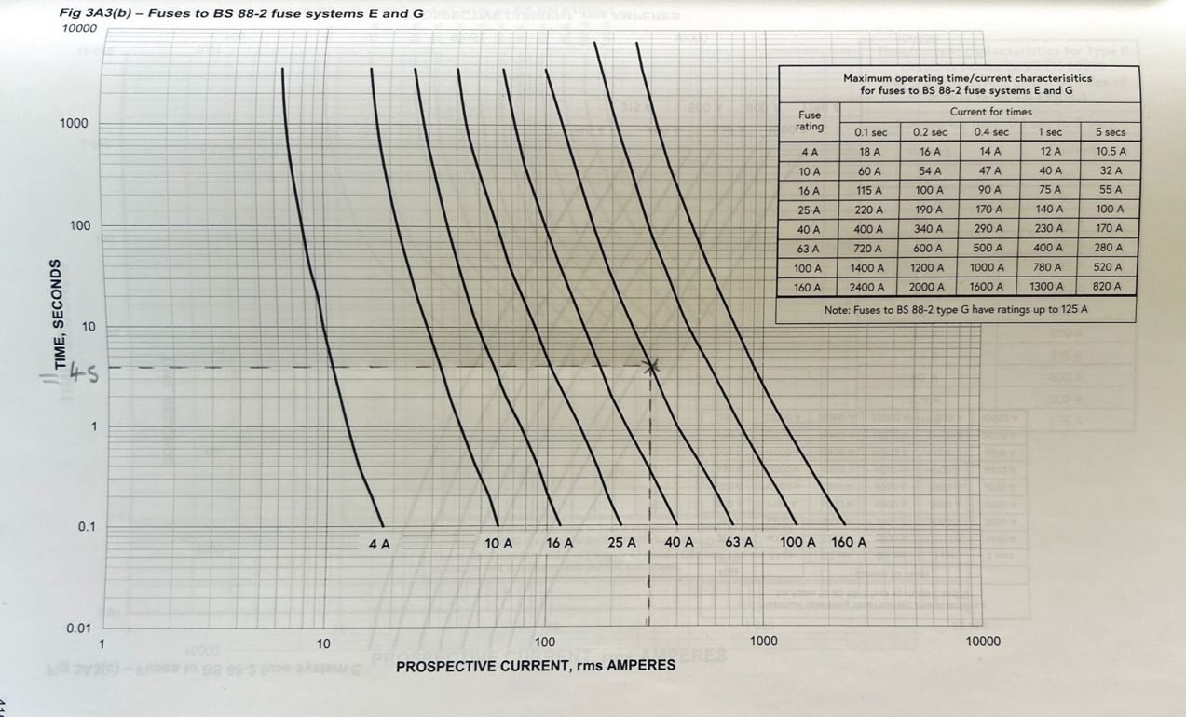
Figure 10- Fuse A time-current characteristic (IET, 2022, P.414)

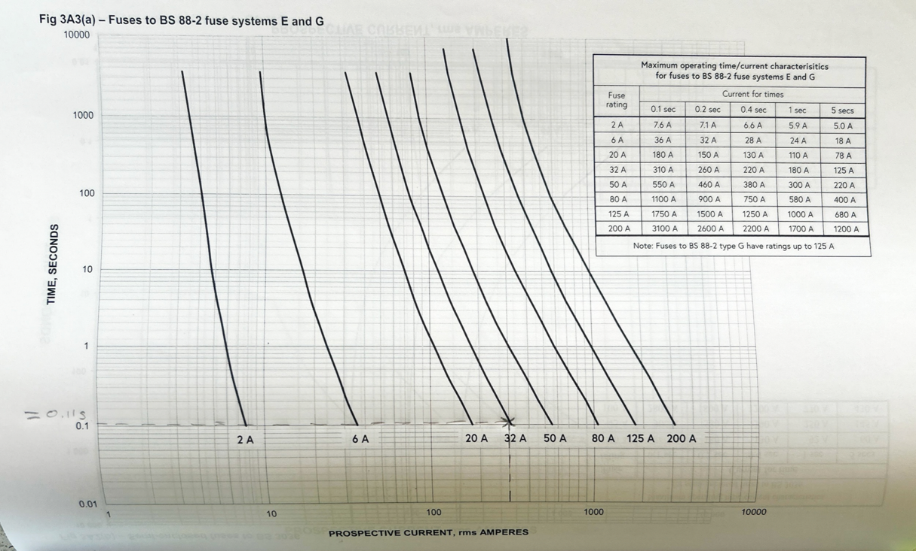
Figure 11- Fuse B time-current characteristic (IET, 2022, P.415)

1b)
Protective devices for circuits can work and operate in a range of methods, two common properties within these devices are thermal and magnetic tripping. These are put in place to protect the equipment and the circuit itself in the case of a fault.

Thermal tripping is one method used within a protective device to break the circuit in the case of a fault to stop anything worse from happening. Figure 12 shows the mechanism of a protective device that uses thermal tripping to operate. The protective device operates by the bimetal element being connected to the load in series and as the current passes through it, the element will heat up and cause it to bend. As the element bends due to an overload current in the circuit it will make contact with the latch, resulting in the latch opening the contact. This will cause the breaker to stay open until it is reset by the operator to comply with BS7671 Regulation 433.1.1 and to allow the element to cool down.

The element having a linear response of the thermal expansion allows the use of thermal tripping to be used in devices such as miniature circuit breakers as it can have a set limit for when to trip to minimise any unnecessary tripping from occurring. This happens as it will trip once it has exceeded the current rating that it has been set to and will not trip before the set limit. However thermal tripping devices can have disadvantages as it will not be suitable for use it hot environment as this could affect the bimetal element and how accurate it is.
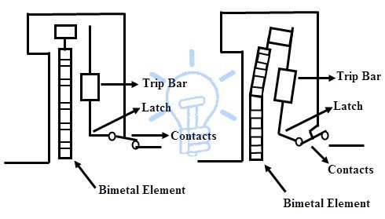
Figure 12- Thermal tripping protective device mechanism (Steemit, 2018)

The other form of operation protective devices can have been magnetic tripping, this is made up from a coil is wound around the iron core to produce an electromagnet, which is connected in series with the load. When a higher current is applied to the circuit the electromagnet will create a greater electromagnetic field, once the current is large enough it will cause the magnet and the tripping bar to attach and lift the latch, resulting in the contact opening and breaking the circuit.

This is demonstrated in figure 13, once the contact has been opened like the thermal tripping it is latched into place and will need to be reset by the operator. Similar to the thermal tripping the strength of the electromagnetic field will need to be equal or greater than the rating of the protective device for the device to operate, the time-current characteristic of the protective device will need to comply with BS 7671 to maintain the correct operation times.
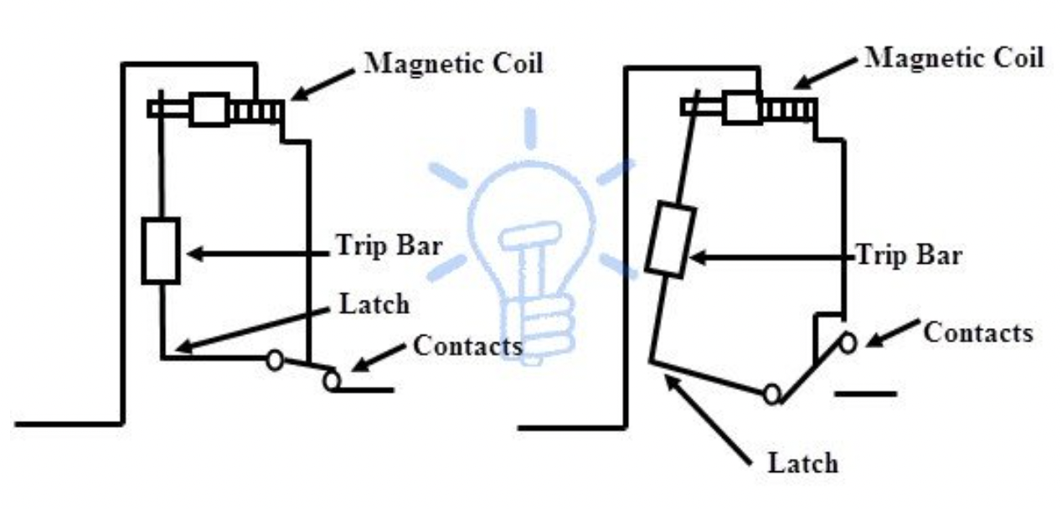
Figure 13- Magnetic tripping protective device mechanism (Steemit, 2018)

2a)
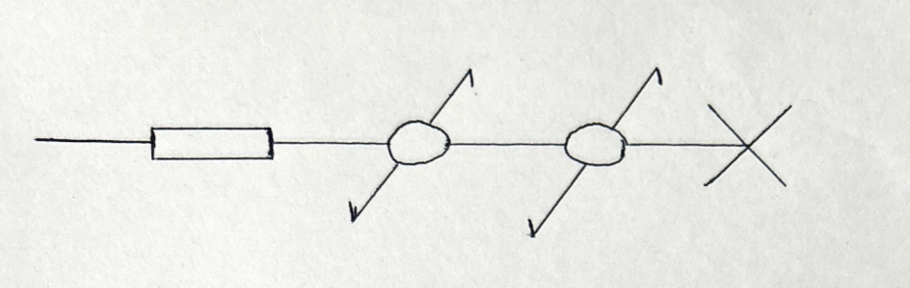
Figure 14- Light point controlled by two-way switching line diagram

2b)
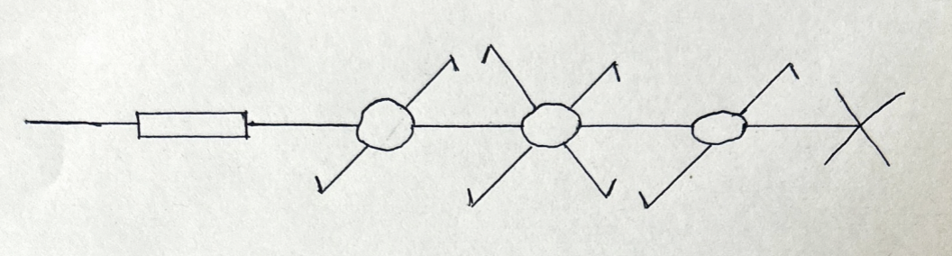
Figure 15- Two lighting points switched together and controlled by two-way and intermediate switching line diagram

2c)
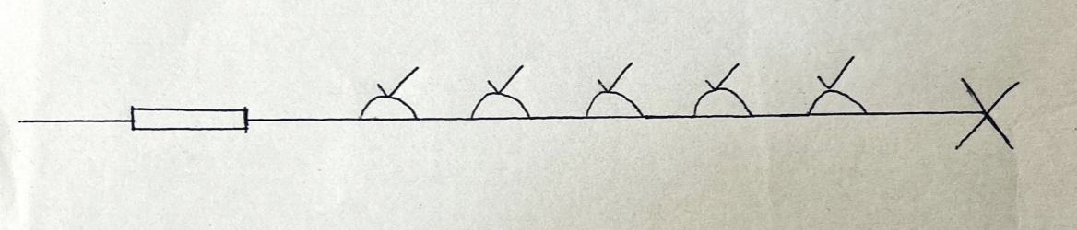
Figure 16- 6X one gang 13A BS1363 switched socket outlets wired as a radial final circuit line diagram

2d)
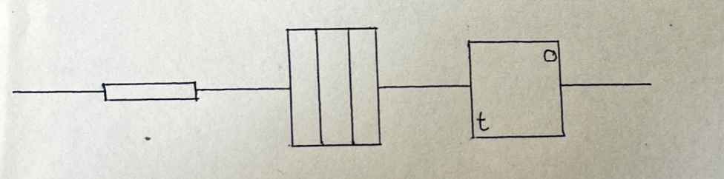
Figure 17- Thermostatically controlled heater wired from a double-pole switch line diagram

References

IET. (2022). Requirements for Electrical Installation. 18th ed. London: IET. Appendix 3.

John Whitfield. (2015). The Electricians Guide. 5th ed. London: EPA Press.

Steemit. (2018). What is MCB (Miniature Circuit Breaker), its Construction, Working, Types & How to select proper MCB for different loads. [Online]. Steemit. Available at: https://steemit.com/electrical/@luckyreddy/what-is-mcb-miniature-circuit-breaker-its-construction-wo [Accessed 5 May 2024].

Bibliography
Scaddan B. (2011). Electrical Installation Work. - 7th Edition. Routledge.

The Institution of Engineering and Technology. Requirements for Electrical Installations BS 7671:2018 (IET Wiring Regulations 18th Edition).

