2023
University of Wales Trinity Saint David
Mr Leighton Fernandes: 1915091
Lecturer: Maria Heffernan
30th June 2023
BMSW6104

Strategic Management Report
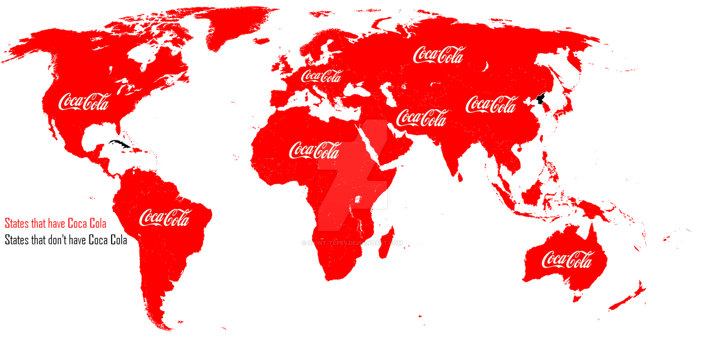
COCA COLA COMPANY
The Coca Cola Company

EXECUTIVE SUMMERY

TABLE OF CONTENTS

1.0 INTRODUCTION 3
2.0 MAIN FINDINGS 4
2.1 Overview - The Coca Cola Company 5
2.1.1 Vision/Mission 5
2.1.2 Major Stakeholders 6
2.1.3 Profit/Loss/Deficit/Market share 7
2.1.4 Business Operations/Strategic Business Units (SBU’s) 8
2.2 STRATEGIC MODELS AND THEORIES 8
2.2.1 Mintzberg’s Schools in Strategic Thinking 9
2.2.2 Boston Matrix 9
2.2.3 Porter’s 5 Forces 10
2.2.4 Porter’s Generic 11
2.2.5 SWOT Analysis 12
2.2.6 PESTLE Analysis 13
2.2.7 Stakeholder Analysis 14
3.0 PROS/CONS OF PURSUING THIS STRATEGY/MISSION/VISION. 15
4.0 CONCLUSION 16
5.0 APPENDICES 17
6.0 REFERENCE LIST 24

1.0 INTRODUCTION

This report was requested by the Inspector General of the Federal Trade Commission on the 23rd of April 2023, and was submitted on 30th June 2023. This paper was compiled by Leighton Fernandes, a research assistant at the Bureau of Economics. The focus is to provide a comprehensive strategic analysis and evaluation of the Coca Cola Company to critically discuss its strategic performance and assess its current strategic direction. To achieve this, the report will apply tools such as SWOT/PESTLE and stakeholder analysis to evaluate the company’s interaction with the internal/external environment and stakeholder expectations. This allows the company to formulate and verify new strategies for sustainable growth. Also, assessing whether the company’s current vision/mission is in line with their current strategy while analysing the benefits to the organisation and the major stakeholders of pursuing this strategy/vision/mission. In addition, the report will review the company’s development over the last five years, assessing if Coca-Cola operates as a whole or if it has strategic business units (SBU) and identifying its major financial stakeholders. Using strategic models and theories such as Boston Matrix, Porters 5 Forces and Porters Generic, the report will analyse the current strategy in operation within the organisation and discuss its advantages and disadvantages to the organisation and its major stakeholders. Finally, the paper will draw a conclusion based on the evidence researched and discussed, highlighting areas of the organisational strategy that is the most effective in today’s environment. Also, this discussion will outline the main areas within the organisational strategy that require further improvement.

To compile this report, sources of information were obtained by engaging in a wide range of strategic management concepts and situations using lectures, textbooks, journals, case studies, websites, and articles. The information in this paper is critically reviewed, supported with theoretical/organisational evidence and citations.

2.0 MAIN FINDINGS

(Porter, 1983) defines strategic management as the process of managing an organisations resource to achieve their goals and objectives. The process involves setting goals, analysing the competitive environment, analysing the internal organisation, evaluating strategies, and ensuring that management rolls out the strategies across the organisation. However, according to (Drucker, 2012) corporate strategy is a long-term plan that outlines an organisation’s objective and the actions they will take to achieve them. Drucker also emphasises the need for continuous review and adjustment to the corporate strategy in response to changes in the business environment. (Rumelt, 2011) states the organisations success relies on various interrelated factors including the organisations vision, mission, values, an internal and external environment analysis, strategic capabilities, competitive advantages, and strategic fit. (Hamel, 2007) suggests an effective corporate strategy ensures that the organisations resources are aligned with their objectives, helping them to create a competitive advantage and long-term success in the industry. These strategies include a range of approaches including market development, market penetration, product development and diversification. (Mullins, 2007) emphasises the importance of corporate strategy. Mullins explains that organisations will have to choose the most appropriate strategy which aligns with their vision and mission and has potential to reach the desired results. Mullins also highlights the importance of corporate strategy in guiding the organisations strategic direction and purpose. She explains that corporate strategy provides a framework for decision making, identify and priorities opportunities and threats, and to allocate their resources effectively to avoid a strategic drift – which is a gradual division between the organisational strategy and their environment, leading to a loss of competitive advantage and hindering long-term success. (Kachru, 2009) also argues it is important that the corporate strategy involves aligning their vision and mission with their goals and objectives and leveraging their strategic capabilities to develop effective strategies and business models, and making sure there is a strategic fit between their strategy and their environment.

2.1 Overview - The Coca Cola Company

The Coca Cola company is a leading global beverage corporation with a strong global presence that operates in over 200 countries, offering over 500 products including Coca Cola, Fanta, and Sprite (Investors, 2023). The company was established in 1892 by Asa Grigg Candler and purchased for $25 million in 1919 by an association led by Ernest Woodruff. It remained under the control of the Woodruff family for several decades. In 1982, the company was listed on the New York stock exchange. The Coca Cola company is a publicly traded corporation and has numerous investors and stakeholders worldwide, with no single owner (Coca-Cola, 2020). As of 2023, the Coca Cola company is run by a team of executives which are led by current CEO James Quincey, who has been in this job role since May 2017 (Coca-Cola, 2017). Under his leadership, the company has undergone numerous changes and initiatives in the last 5 years that as impacted their strategy. For example, the organisations strategic positioning has focused on product diversification, investing in sustainable initiatives, digital transformation, and strengthening distribution networks to reach a wider customer base (Coca-Cola, 2020). Their success is attributed to several strategies to help gain and maintain market share. For example, in 2018 the company acquired Costa Coffee for $5.1 billion, marking their entry into the coffee market (Mulier, 2018). This acquisition gave the Coca Cola company access to Costa Coffee’s enormous supply chain and retail network. According to (Weinbren, 2018), in the same year, the company introduced healthier options including Coke Zero sugar and launched a new line of premium organic fruit juice brands as part of their effort to unify their low-calorie products under one brand name to help communicate the Zero sugar message to consumer. In 2019, the company formed partnerships with e-commerce and digital platforms such as e-commerce leader Alibaba, in order to reach more customers effectively by expanding their online presence and enhancing their distribution networks (Mian, 2020).

In 2020, The company announced the acquisition of Tropico, a leading juice brand in Latin America (Longoria, 2018). This acquisition will help the company expand their presence in the juice market in Latin America. In the same year as this acquisition (Coca-Cola, 2020) state they responded to environmental concerns and developed a comprehensive sustainability plan that aims to achieve net zero carbon emissions across the organisations entire value chain by 2040. In addition to, investing in eco-friendly packaging, sourcing sustainable ingredients, and committing to making their packaging 100% recyclable by 2025. In 2021, Coca Cola announced a discontinuation of Tab soda, and other underperforming products. The company state they are discontinuing the famous line of Tab diet soda as well as other underperforming products in order to focus on core brands. This decision was part of the organisations effort to simplify their product portfolio and invest in more profitable brands (Friedman, 2020). The Company has historically followed a deliberate strategy focusing on brand recognition and maintaining a dominant market position. However, in recent years the company has implemented elements of emergent strategy, including diversifying their products range to appeal to the changing customer preferences, brand positioning, product differentiation, strategic partnerships, and acquisitions.

2.1.1 Vision/Mission

According to (Rebovich, 2016) aligning an organisations vision and mission with its corporate strategy is a significant element of success management. For example, when an organisations vision and mission are in line with their strategy it helps to create a clear sense of direction and purpose. In turn, helps to guild decision making and ensures everyone is working toward the same goals. (Forbes, 2023) states by aligning the company vision, mission, and corporate strategy an organisation can improve communication and collaboration, increase employee engagement, and build a strong brand identity. In turn leading to better financial performance and a more sustainable business model. This idea has been emphasised by numerous management theorists including Peter Drucker, Michael Porter, Jim Collins, and Steven Corvey. For example, Peter Drucker argues the importance of having a clear sense of purpose and direction, which helps to ensure that everyone is working towards the same vision (Drucker, 2012). Other theorists, including Steven Covey and Jim Collins also emphasised the significance of aligning an organisations vision, mission, and corporate strategy as key components of successful management (Covey, 2013). The Coca Cola company has seen some significant changes to their vision and mission over time. Initially, the company “vision” was to create refreshing drinks that everyone can enjoy, and their “mission” was to distribute their products to as many people as possible (Openrepository, 2021). However, as the organisation grew their focus shifted toward changing customer preferences, the competitive landscape, diversity, sustainability, and corporate social responsibility (FNM, 2022). For example, in response to the growing demand for low sugar and low-calorie drinks they introduced Coke zero sugar and their premium organic fruit brands to adapt to the changing customer preferences. In addition to expanding their product portfolio, as previously mentioned the company have entered partnerships and acquisitions to stay competitive (Weinbren, 2018). In 2020, the Company made a commitment that by 2030 they will increase the diversity of their leadership team by setting goals to increase the number of Black, Mixed Race, and Latino and Female leaders by 30%. Also, they have launched initiatives to promote diversity and inclusion throughout the organisation including the “Men as Allies” program (Gitnux, 2023). The company has adopted a comprehensive sustainability plan to address the growing environmental concerns.

The company’s vision and mission seem to reflect their long-term strategic goals and appear to be aligned with their corporate strategy. For example, they have demonstrated a commitment in regard to the changing customer preferences and competitive landscape, promoting diversity and inclusion, reducing their environmental impact, and supporting local communities. Additionally, the company has taken steps to achieve them in a sustainable and responsible manner.

2.1.2 Major Stakeholders

Stakeholders are individuals or groups who have significant interest or a stake in an organisation’s activities and outcomes. They may include investors, shareholders, employees’ customers, suppliers, government agencies, and communities (Investopedia, 2023). The importance of stakeholders can not be overemphasised as they play a vital role in the organisation’s corporate strategy, and they can significantly impact their success and failure as they provide the necessary capital and resources for them to achieve their strategic goals (Chinyio, 2009). Without them it would be difficult for organisations to operate effectively and achieve their goals. Stakeholders have a significant impact on the organisations corporate image and reputation (Freeman, 2010). For example, customers, suppliers, and employees are all stakeholders who can influence the public perception of an organisation so maintaining positive relationships with stakeholders is crucial for organisations to build a strong reputation. According to (Morgan, 2020) stakeholders can help organisations identify opportunities for improvement and growth. For example, by listening to the concerns and feedback of stakeholders, organisations can gain insights that can be applied to enhance their products and services. For example, Michael Porter who developed the concept of “shared value” argues that organisations should create value not only for their stakeholders but for society. Porter argues that by addressing social and environmental issues, organisations can create new opportunities for innovation, cost saving, and competitive advantage which benefits both stakeholders and society (Porter, 1983). Financial stakeholders including shareholders and investors expect a return on their investment and will often evaluate an organisations financial performance and prospects before deciding to invest or continue to invest in the company (Maverik, 2022). Therefore, an organisations corporate strategy must consider the wants, needs, and expectations of financial stakeholders and aim to deliver long term sustainable growth and profitability to ensure their continued support.

The Coca Cola company is a publicly traded corporation, and it has numerous investors and stakeholders worldwide include shareholders, employees, customers, suppliers, NGOs, communities, competitors, and industry groups who are affected by the Coca Cola company’s decisions and actions (Coca-Cola, 2022). The Company recognises the importance of engaging and managing with their stakeholders to achieve their business objectives and to maintain their reputation as a responsible and sustainable organisation. For example, the company has publicly stated their commitment to stakeholder engagement in their sustainability report and corporate social responsibility report. The company also established a dedicated department for stakeholder engagement and communicates regularly with them through several channels including meetings, surveys, social media, and feedback mechanisms (Colahellenic, 2021). Coca Cola has also implemented several initiatives and programs aimed at addressing stakeholders’ concerns including environmental sustainability and community development (Coca-Cola, 2022). These actions represent the company’s recognition of the importance of engaging with stakeholders to achieve their business objectives and maintain their reputation as a responsible and sustainable organisation.

2.1.3 Profit/Loss/Deficit/Market share

An organisations financial performance is closely watched by stakeholders, investors, and analysts as it provides an insight into the health of the organisation and their ability to generate profits and returns on investment (Calzon, 2023). The Coca Cola company reported a “net revenue” of $38.7 billion for the second quarter of 2021, up 17% over the same time in the previous year. The increase in revenue was due to the recovery of the global pandemic which resulted in an increased demand for Coca Cola products. The revenue growth was also due to the successful launch of new products and the expansion of their distribution networks (Investors, 2021). According to (Statista, 2023), the company had a global “market share” of 43.3% in 2020, compared to a market share of 42% of the soft drink segment in 2023. Making Coca Cola the leading global beverage corporation. These financial figures for the second quarter of 2021 demonstrate the recovery of the global economy from the pandemic (which has boosted the demand for their products) and the organisations resilience and ability to adapt to the changing market conditions. The financial figures are positive and indicate a healthy outlook for the company.

2.1.4 Business Operations/Strategic Business Units (SBU’s)

The Coca Cola company is a multinational corporation that operates as a single entity (Coca Cola, 2022). However, they have many different strategic business units (SBUs) and subsidiaries. These strategic business units (SBUs) and subsidiaries operate in various regions and countries around the globe. For example, some of the company’s subsidiaries include Coca Cola Hellenic which operates in Europe and Coca Cola FEMSA which operates in Latin America (Coca-Cola, 2023). The Coca Cola company headquarters is in Atlanta Georgia although the company operations are divided into several strategic business units (SBUs) including Europe, North America, Asian Pacific, Africa, and Latin America. Each of these strategic business units (SBUs) are responsible for different products and markets and have their own management teams who are responsible for their own operations including marketing, sales, and distribution in their respective region (Investors, 2023). The external environment of the company’s (SBUs) is shaped by various factors that impact their operations and performance. Some of the key external factors that impact on the company’s (SBUs) include economic factors, technological factors, social factors, political and legal factors, and the competitive environment (Cola Company, 2020)

2.2 STRATEGIC MODELS AND THEORIES

2.2.1 Mintzberg’s Schools in Strategic Thinking

Mintzberg Ten schools of thought in strategic thinking model can be used to identify a strategy currently being implemented within an organisation (Mintzberg, 2005). The model can be seen in (Appendix 1). The model shows different perspectives on how companies can develop and implement new strategies and provides managers with a framework for understanding different methods to strategy development (Hattangadi, 2019). Mintzberg explains by identifying the schools of thought being used managers can gain a better understanding of the organisations strategy and determine if it is aligned with the organisation’s goals and objectives (Mintzberg, 2005). The Coca Cola company’s strategic approach has elements of multiple schools of thought identified by Mintzberg. Although, based on their history and approach to strategy in the last five years it is possible that their strategic thinking aligns with ‘the positioning school of thought’ – which emphasises creating a unique brand identity and positioning the organisation as a market leader (Mintzberg, 2005). This strategy has been successful for Coca Cola as they have established a strong brand identity and a loyal customer base that are willing to pay a premium for their products. Also, the company has focused on positioning their brand as the market leader in the beverage industry (Patel, 2022). When evaluating other schools of strategic thinking against the company’s corporate strategy the ‘learning school of strategic thinking’ closely aligns with the company’s approach - which emphasises continuous learning, experimentation, and adaption to gain a competitive advantage (Mintzberg, 2005). For example, to meet customer preferences the company has experimented with new products and technologies to diversify their product portfolio and appeal to wider range of customers (Pereira, 2023). As previously mentioned, the company has acquired companies including Costa Coffee and Tropico to expand their product offerings and reach new markets. Also, formed partnerships with e-commerce leader Alibaba, in order to reach more customers effectively by expanding their online presence and enhancing their distribution networks. This demonstrates Coca Cola’s willingness to experiment and adapt to changing customer preferences and commitment to continuous learning and improvement. Also, the Resource Based View (RBV) is closely aligned with the company’s strategy as they leverage their internal resources and capabilities to gain a competitive advantage (Mintzberg, 2005). For example, one key internal resource is brand identity. The company has a strong brand identity that is recognised and trusted by customers worldwide. Therefore, brand equity is a valuable resource they have leveraged to differentiate themselves from competitors and maintain their market share (Faria, 2023). Coca Cola strategy likely incorporates elements from multiple schools of thought into their overall corporate strategy.

However, the positioning school is most closely aligned with the organisations strategy as their success is built on creating a unique brand identity and positioning themselves as a global market leader. However, the company must continue to innovate and adapt to the changing customer preferences as focusing on their market position may limit their ability to differentiate themselves from competitors and may make them vulnerable to disruption from new companies trying to enter the market with new products. The Mintzberg school of strategic thinking model offers a valuable framework. Although, it is important to recognise its limitations and use it as a tool to guild the strategic thinking process. Instead of as a systematic approach to strategy development.

2.2.2 Boston Matrix

The BCG Matrix, also known as the Boston Consulting Group Matrix, is a widely utilised method for portfolio analysis. Developed by BCG in 1970, it serves as a business planning tool to evaluate the strategic standing of a company's brand portfolio (BCG, 2023). Coca-Cola's BCG Matrix categorise its range of products into four distinct quadrants, namely Dogs, Stars, Cash Cows, and Question Marks, this model can be seen in (Appendix 1). Through this analysis, we can identify products with limited growth potential, products that are top sellers, products experiencing rapid growth, and products with uncertain growth prospects but high sales potential (Hayes, 2023).

Stars: Coca-Cola boasts several star products in its portfolio, each commanding a significant market share in rapidly growing industries (Forbes, 2018). Leading the way are Kinley and Dasani, two popular bottled water brands. Kinley has a strong presence in European and Asian countries, while Dasani dominates the US market (Openrepository, 2019). The US is the largest consumer market for bottled water, with sales volume reaching 13.85 billion gallons last year (Gelski, 2020). Dasani (Owed by Coca Cola) and Aquafina (Owned by rival PepsiCo), contribute over $2 billion in annual sales in the US market (Forbes, 2015). According to (Market Analysis Report, 2022) the global bottled water market is expected to grow at a compound annual growth rate of 6.7% by 2025. This growth is attributed to rising consumer demand for high-quality drinking water, concerns about tap water safety, and the convenience offered by bottled water (International Bottled Water Association, 2022). Coca-Cola's Sprite and Powerade are also considered star products, with Sprite holding a market share of 8% (Statista, 2022), and Powerade owning 14.1% of the US sports drink market (CNN, 2023). Sprite, known for its lemon-lime flavour and refreshing taste, has become a popular choice among consumers, particularly the younger demographic (Bedwell, 2023). Powerade, a leading sports drink, has successfully captured a significant market share in the highly competitive US sports drink industry. With its electrolyte-rich formula, Powerade appeals to athletes and active individuals looking for hydration and replenishment during physical activities (Fortune Business Insights, 2023).

Cash Cows: Coca-Cola Classic, Fanta, Diet Coke, and Coca-Cola Zero are cash cow products for the company. Coca-Cola Classic, the flagship brand, holds a 43% market share in the global carbonated soft drink category (Ridder, 2023). Despite growing concerns about sugar consumption and the introduction of healthier alternatives, Coca-Cola Classic remains a top choice for consumers worldwide (Cascade, 2023). Fanta, initially a star product, has transitioned into a cash cow due to its strong presence in markets like the US, Germany, Brazil, and China. Diet Coke and Coca-Cola Zero, both low-calorie and zero-sugar alternatives, have gained a loyal customer base and consistently contribute to Coca-Cola's revenue stream (Coca Cola, 2022). Diet Coke holds a notable market share of approximately 8% globally (Statista, 2022).

Question Marks: Coca-Cola Energy and Glacéau Smart Water started as question marks but have shown growth potential. Coca-Cola Energy, an energy drink, has gained traction in multiple geographical areas, including the US, Europe, and Australia (Coca-Cola Company, 2020). With its unique blend of ingredients and targeted marketing campaigns, Coca-Cola Energy aims to capture a share of the growing energy drink market (Fleming, 2019). According to (Polaris Market Research, 2020), the global energy drink market is projected to reach a value of $84.8 billion by 2026, presenting a significant growth opportunity for Coca-Cola Energy. Glacéau Smart Water, a premium bottled water brand by Coca Cola, has also shown promising growth potential. With its emphasis on hydration and purity, Smart Water has gained significant traction in markets like the US, Canada, and the UK (Expert Market Research, 2023). The global premium bottled water market is expected to witness substantial growth in the coming years, driven by increasing consumer awareness about health and wellness (Grand View Research, 2020). According to Coca Cola’s (Annual Reports, 2018), Smart Water aims to cater to this demand, positioning itself as a premium and quality hydration option with a focus on wellness.

Dogs: Tab Soda, once a star product, has declined due to changing customer preferences and increased competition (CNN Business, 2020). Tab Soda, introduced in the 1960s as a diet drink, faced challenges in recent years as more diet soda options entered the market (Miller, 2020). Consequently, Coca-Cola made the decision to discontinue Tab Soda in 2020, and focus resources on more profitable ventures (CNBC, 2020).

Coca-Cola manages a diverse portfolio of star products, cash cows, question marks, and dogs. The company strategically allocates resources based on the performance and potential of each product. The star products, such as Kinley, Dasani, Sprite, and Powerade, contribute significantly to the company's revenue and market share. Cash cows like Coca-Cola Classic, Fanta, Diet Coke, and Coca-Cola Zero generate consistent revenue and maintain strong market positions. Question marks like Coca-Cola Energy and Smart Water show promising growth potential. Dogs like Tab Soda are discontinued to optimise resource allocation. By effectively managing its product portfolio, Coca-Cola adapts to market dynamics and maximises profitability in the beverage industry.

Advantages of the Boston Matrix: it provides the visual representation of brand portfolio, identifying high and low growth products (Stern, 2006).

Limitations of this Model: It's a simplistic two-dimensional analysis that may oversimplify brand evaluation, overlooking complexities (MSG Management, 2022).

2.2.3 Porter’s 5 Forces

The strategic framework known as Porter's five forces assesses the competitive dynamics in an industry by analysing the threat of new entrants, bargaining power of suppliers and buyers, threats of substitutes, and intensity of competitive rivalry (Porter, 1975). When assessing Coca-Cola 's strategic choices, we will focus on two key forces within Porter's five forces framework: The intensity of competitive rivalry and the bargaining power of buyers.

The intensity of Competitive Rivalry: There's intense competition in the beverage industry. Coca Cola's main competitor, PepsiCo, has a vast product portfolio not only in beverages but also in the food sector. Dr Pepper, Snapple and Nestle are also strong competitors (Forbes, 2022). However, Coca Cola has a dominant position globally, with a market share of approximately 46.3% in the U.S soft drink market as of 2022 (Statista, 2022). Comparatively, PepsiCo, one of Coca Cola's main competitors, also made strategic adaptations during the pandemic. PepsiCo leveraged its diversified portfolio, especially its snacks division, to cater to increase at-home consumption (Access to Nutrition Initiative, 2020). They also accelerated their digital transformation efforts, partnering with Microsoft to improve consumer insights, data analytics, and supply chain management (Microsoft, 2021). While both Coca Cola and PepsiCo faced similar challenges, they took slightly different strategic approaches. Coca Cola focused on digital transformation, e-commerce, and product portfolio rationalisation (Forbes, 2020), while PepsiCo leveraged its diversified portfolio and prioritised digital transformation (Deloitte, 2017). These strategies were aligned with each organisation’s unique strengths and capabilities, demonstrating the importance of strategic fit in navigating uncertain market conditions.

Bargaining Power of Buyers: Buyers have considerable power in this industry, given the wide variety of alternative beverages available (Porter, 1983). Coca Cola has focused on product innovation to cater to changing consumer preferences such as low-sugar or sugar-free alternatives and functional beverages (Coca Cola, 2022). During the COVID-19 pandemic, Coca Cola, like many other businesses, had to make strategic adaptations to navigate the changing market conditions. The pandemic had various impacts on the dynamics of Porter's Five Forces, including the bargaining power of buyers and suppliers. For example, the pandemic-induced changes in consumer behavior increased the bargaining power of buyers, with more people staying at home, there was an increased demand for products suitable for home consumption (Gerlich, 2021). Coca Cola had to adapt its product offerings and sales channels to meet these changing preferences (Business Model Analyst, 2023), effectively raising the bargaining power of consumers. On the other hand, disruptions in the supply chain caused by the pandemic could have potentially increased the bargaining power of suppliers. Coca Cola, along with many other companies, faced challenges in sourcing raw materials and managing logistics due to restrictions and safety measures (Guardian, 2021), if suppliers were able to maintain operations during this time, their importance and thus their bargaining power may have increased.

During the pandemic, several factors steered Coca Cola towards a more emergent strategy. The COVID-19 pandemic had a significant impact on Coca Cola's business, with a 28% drop in sales in Q2 2020 due to lockdowns and reduced out-of-home consumption (Industry Reports, 2020). This necessitated a shift in strategy to adapt to the changing market conditions. Coca Cola responded to the changing consumer behavior by prioritising multipacks and larger package sizes for home consumption (Cola-Femsa, 2020). They also focused on strengthening their digital presence and e-commerce capabilities to cater to the shift towards online shopping. Coca Cola partnered with Alibaba in China to improve digital marketing, consumer analytics, and online distribution (Zhuoqiong, 2023). Furthermore, the company made the strategic decision to discontinue underperforming brands such as Tab Soda, Coca-Cola Life, Coca-Cola BlaK, OK Soda, Diet Coke Lime, Diet Coke Feisty Cherry, and New Coke, and focus on its strongest and most profitable ones (Yahoo, 2021). This allowed Coca Cola to allocate resources effectively and align with market demand.

These strategies allowed Coca Cola to cater to evolving consumer behaviors, optimise resource allocation, and maintain its market position. By understanding the implications of Porter's Five Forces, Coca Cola was able to navigate the challenges posed by the pandemic and emerge as a resilient and adaptable player in the beverage industry.
However, to ensure the success of their strategy, managers at Coca Cola should continuously monitor market trends, foster a culture of innovation, invest in research and development, strengthen digital capabilities, foster collaborative relationships, invest in employee development, monitor, and measure performance, stay customer-centric, communicate, and align, and promote adaptability and agility (HR Review, 2023). By implementing these steps, managers can enhance the chances of success for their strategic initiatives, ensuring the company's continued growth and market leadership. Another thing managers can do is identify through their analysis what these influences are, and then construct strategic plans that can counteract some of these areas of threat.

Advantages of Porters Five Forces Model: Porter's five forces provides a structured approach to analyse various aspects of industry competition, helping businesses gain a deeper understanding of the industry dynamics, competitive forces, and market structure (Investopedia, 2023).

Disadvantages of this Model: The framework may oversimplify the complexities of real-world business environments, as it focuses mainly on five key forces and may not capture all relevant factors (Researchgate, 2020).

2.2.4 Porter’s Generic

Porters generic strategies model is a strategic framework developed by Michael Porter that describes three generic strategies that companies can pursue to gain a competitive advantage in their industry.
Porters generic strategies model is a strategic framework developed by Michael Porter that describes three generic strategies that companies can pursue to gain a competitive advantage in their industry.
Porter's Generic Strategies model suggests that businesses can gain a competitive advantage by adopting one of three strategies: Cost Leadership, Differentiation, or Focus (Porter, 2009).

Cost Leadership: Companies adopting this strategy aim to become the lowest-cost producer in their industry. By operating with lower costs, they can offer products or services at competitive prices (Porter, 1983). While Coca Cola is a global leader in the beverage industry, it does not primarily focus on cost leadership (Business Model Analyst, 2023). The company's products are priced at a premium compared to generic or store-brand beverages. Coca Cola's emphasis is more on brand value and differentiation rather than competing solely on price (Coca, 2023). However, implementing this strategy poses the risk of price wars with competitors, potential compromise on product quality, vulnerable for changes in cost factors, and reduce the flexibility to respond to market shifts or customer preferences (Clark et al, 2022).

Differentiation: Differentiation involves offering unique and distinctive products or services that are perceived as superior by customers compared to competitors (Porter, 2009). Coca Cola has successfully implemented a differentiation strategy. Through its iconic brand, unique taste, and extensive marketing campaigns, Coca Cola has created a distinct image and brand identity. The company's strong emphasis on product innovation, such as introducing new flavors and packaging, further enhances its differentiation strategy (ICEMCI, 2021). For example, Coca Cola Zero Sugar was developed to cater to health-conscious consumers seeking a sugar-free alternative. This differentiation has helped Coca Cola maintain a loyal customer base and command a premium price (Kaplan, 2018). However, pursuing this strategy there are higher costs associated with research, potential difficulty in sustaining differentiation over time, and the risk of customer preferences shifting towards lower priced alternatives (Harvard Business Review, 1984)

Focus: The focus category involves targeting a specific market segment or niche and tailoring products or services to serve their specific needs (Porter, 1983). Coca Cola has also utilised a focus strategy by targeting specific market segments. For instance, the company has developed region-specific products and marketing campaigns to cater to local tastes and preferences. In India, Coca Cola introduced beverages like Thums Up and Maaza, which specifically target the Indian market (Research gate, 2018). This focus on specific markets allows Coca Cola to better understand and meet the unique demands of these segments, giving them a competitive advantage. However, this strategy could leave organisations vulnerable to changes in the chosen segment, difficulty in scaling up operations, and potential dependency on a narrow customer base (University of Cambridge, 1985).

While Coca Cola has successfully implemented aspects of differentiation and focus strategies, it does not primarily operate under a cost leadership approach. The company's focus on brand image, product innovation, and market segmentation has been instrumental in building a strong competitive position in the beverage industry (Coca Cola, 2022). Upon critical examination, Coca Cola primarily follows a differentiation strategy rather than cost leadership or focus. The company does not position itself as a low-cost provider, and its products are typically priced at a premium compared to generic or store-brand alternatives, and has consistently emphasised its brand image, unique taste, and extensive marketing campaigns to differentiate itself from competitors. For instance, Coca Cola's iconic red and white branding, along with its widely recognised logo, has become deeply ingrained in popular culture. This brand differentiation has contributed to Coca Cola's strong market presence and brand loyalty (Imperial College London, 2009). Additionally, Coca Cola's product innovation further supports its differentiation strategy. The company has introduced various flavors and packaging options to cater to diverse consumer preferences. For example, Coca Cola Zero Sugar was launched as a response to the growing demand for healthier beverage choices (Coca Cola, 2022). These product innovations help Coca Cola stand out in the market and attract customers seeking unique offerings.

2.2.5 SWOT Analysis

2.2.6 PESTLE Analysis

2.2.7 Stakeholder Analysis

3.0 PROS/CONS OF PURSUING THIS STRATEGY/MISSION/VISION.

4.0 CONCLUSION

5.0 APPENDICES

Appendix 1 – Mintzberg Schools of Strategic Thinking Model

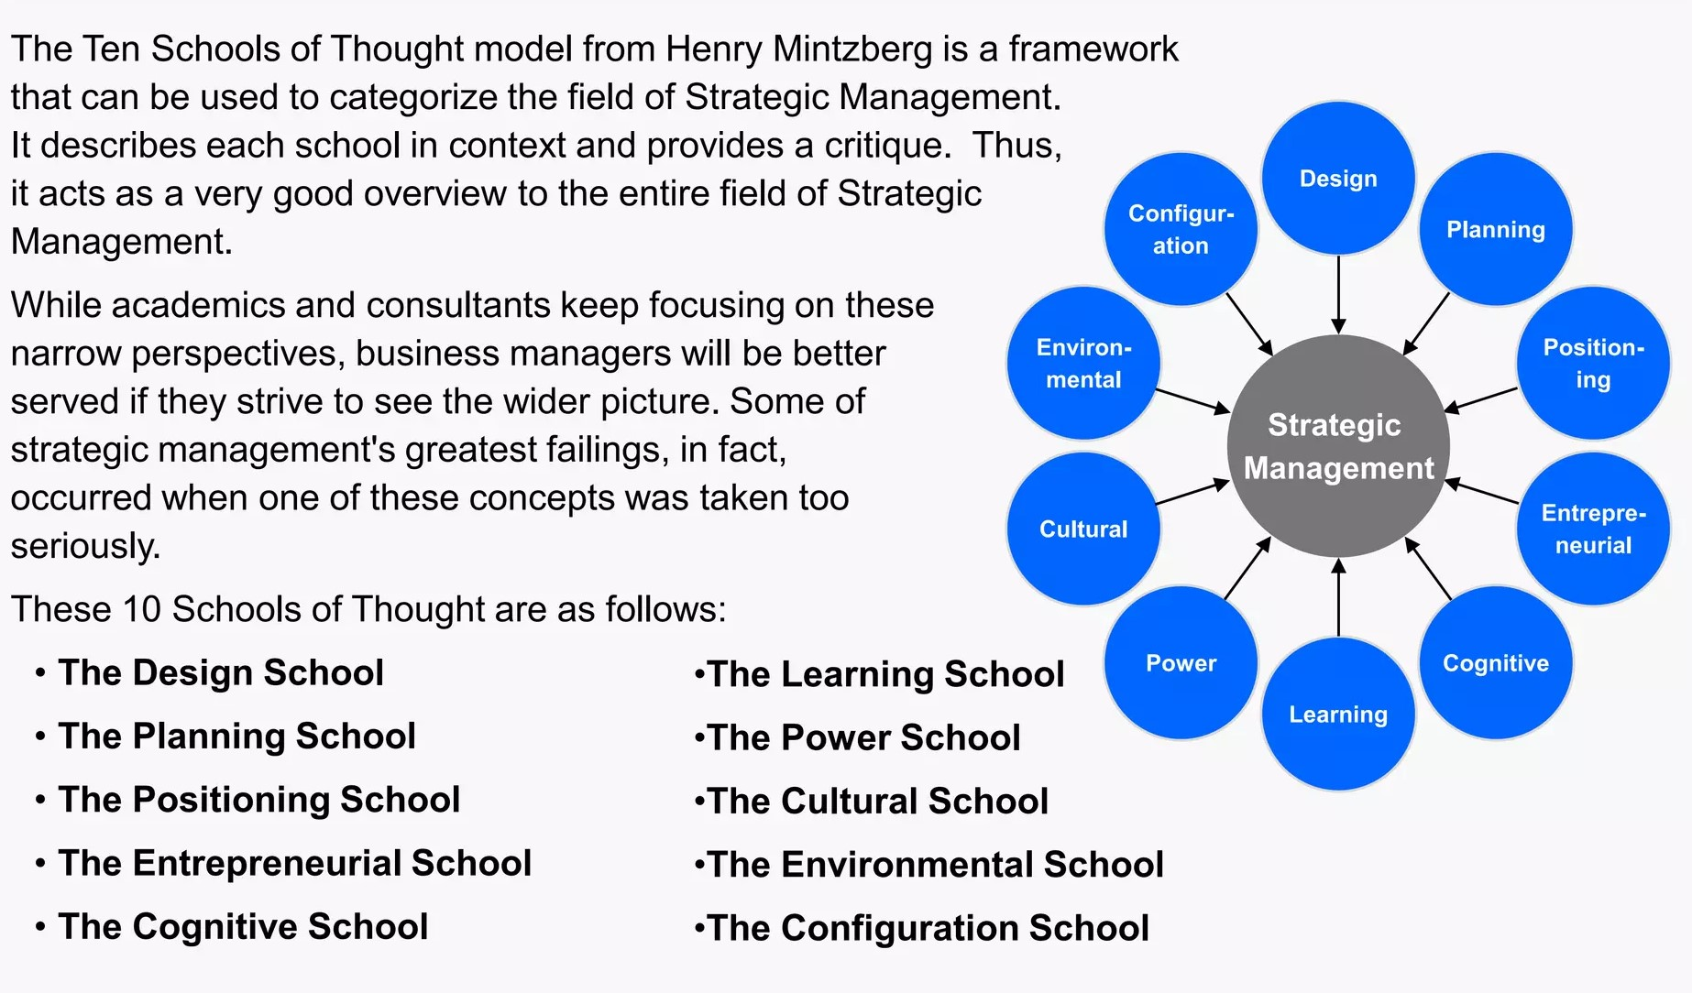 (Mintzberg, 2005).

Appendix 2 – Boston Matrix
STARS  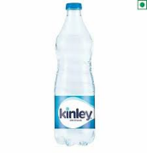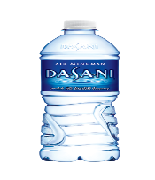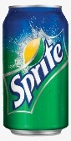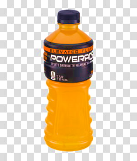 | QUESTION MARKS  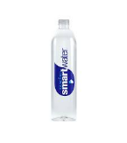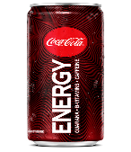
CASH COWS  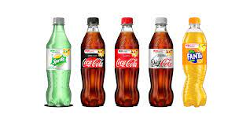 | DOGS  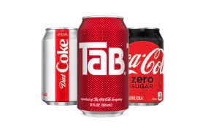

(BCG, 2023).

Appendix 3 - Porter’s 5 Forces
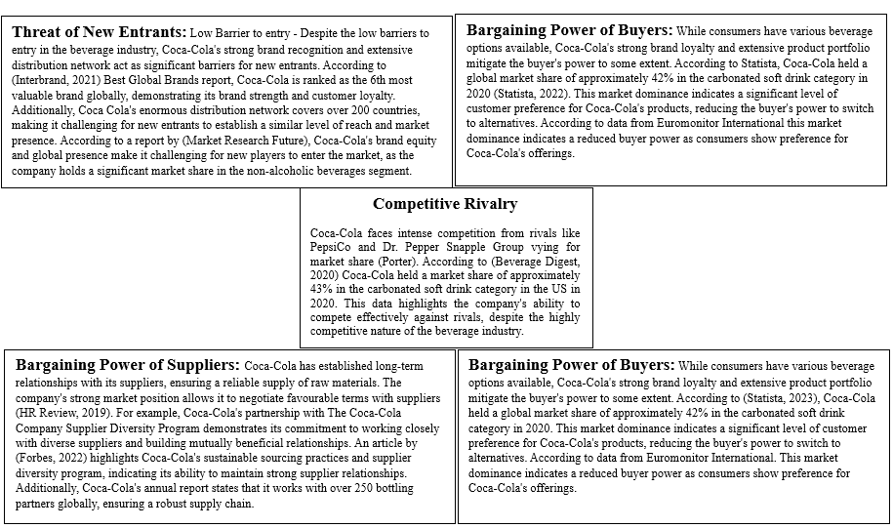
(Porter, 1975).

Appendix 4 - Porter’s Generic

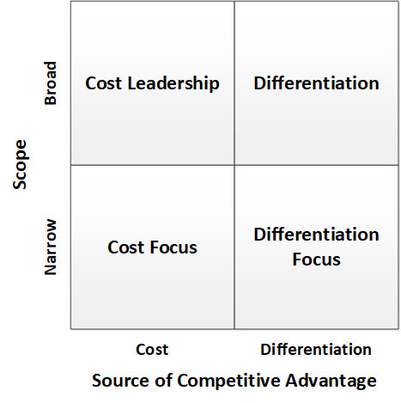(Porter, 2009).
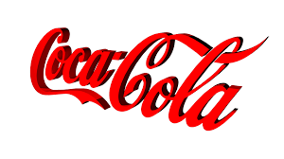

Appendix 5 - SWOT Analysis of Coca Cola’s Strategic Business Unit (SBU) in North America
Appendix 6 – PESTLE Analysis

Appendix 7 – Stakeholder Analysis: Power Attention Matrix

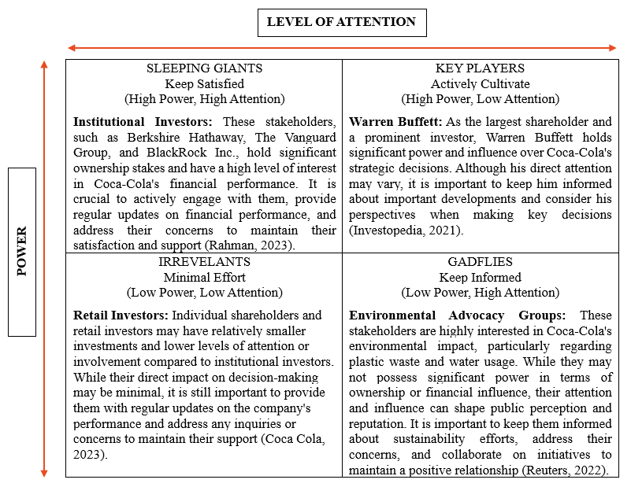
(Stakeholders Management, 2016).

6.0 REFERENCE LIST

Access to Nutrition Initiative. (2020). Nutrition responses from food and beverage companies to the Covid-19 pandemic. [Online]. accesstonutrition.org. Last Updated: October 2020. Available at: https://accesstonutrition.org/app/uploads/2020/10/Second-Covid-19-Quarterly-Report-Final-Version.pdf [Accessed 28 June 2023].

Annual Reports. (2018). In Good Company. [Online]. www.annualreports.com. Last Updated: 2018. Available at: https://www.annualreports.com/HostedData/AnnualReportArchive/c/LSE_CCH_2018.pdf [Accessed 24 June 2023].
BCG. (2023). What Is the Growth Share Matrix? [Online]. www.bcg.com. Last Updated: 2023. Available at: https://www.bcg.com/about/overview/our-history/growth-share-matrix [Accessed 15 June 2023].
Bedwell. (2023). Sprite relaunches with new recipe to appeal to young adults. [Online]. thegrocer.co.uk. Last Updated: 2 March 2023. Available at: https://www.thegrocer.co.uk/soft-drinks/sprite-relaunches-with-new-recipe-to-appeal-to-young-adults/676885.article [Accessed 20 June 2023].
Business Model Analyst. (2023). Coca-Cola Business Model. [Online]. businessmodelanalyst.com. Last Updated: 14 April 2023. Available at: https://businessmodelanalyst.com/coca-cola-business-model/ [Accessed 29 June 2023].

Business wire. (2021). Global Bottled Water Industry Analysis and Forecast 2020-2026 - Nestle, PepsiCo, and The Coca Cola Company are the Forerunners of the Market - ResearchAndMarkets.com. [Online]. businesswire.com. Last Updated: 07 April 2021. Available at https://www.businesswire.com/news/home/20210407005454/en/Global-Bottled-Water-Industry-Analysis-and-Forecast-2020-2026---Nestle-PepsiCo-and-The-Coca-Cola-Company-are-the-Forerunners-of-the-Market---ResearchAndMarkets.co [Accessed 04 July 2023].

Calzon, (2023). The Importance of Financial Reporting and Analysis: Your Essential Guide. [Online]. datapine.com. Last Updated: 1 Feb 2023. Available at: https://www.datapine.com/blog/financial-reporting-and-analysis/ [Accessed 08 May 2023].
Cascade. (2023). How Coca-Cola became one of the most successful brands in history. [Online]. www.cascade.app. Last Updated: 8 February 2023. Available at: https://www.cascade.app/studies/how-coca-cola-became-successful [Accessed 21 June 2023].
Chinyio, (2009). Construction Stakeholder Management. United Kingdom: Wiley. pp.112-129.
CIPD. (2017). The intangible workforce: do investors see the potential of people data?. [Online]. www.cipd.org. Last Updated: 2017. Available at: https://www.cipd.org/globalassets/media/knowledge/knowledge-hub/reports/do-investors-use-people-data [Accessed 05 July 2023].

CNBC. (2020). Coca-Cola to retire Tab, its first diet soda, as it trims its portfolio. [Online]. cnbc.com. Last Updated: 16 October 2020. Available at: https://www.cnbc.com/2020/10/16/coca-cola-to-retire-tab-as-it-trims-its-portfolio-.html [Accessed 24 June 2023].
CNN Business. (2020). Coca-Cola is discontinuing Tab after nearly 60 years. [Online]. edition.cnn.com. Last Updated: 16 October 2020. Available at: https://edition.cnn.com/2020/10/16/business/tab-soda-discontinued-coca-cola/index.html [Accessed 24 June 2023].
CNN, (2023). Coca-Cola’s Powerade is taking a jab at Gatorade with new formula and packaging. [Online]. edition.cnn.com. Last Updated: 1 February 2023. Available at: https://edition.cnn.com/2023/02/01/business/powerade-rebrand/index.html#:~:text=Today%2C%20Gatorade% [Accessed 19 June 2023].
Coca cola, (2020). When was The Coca‑Cola Company founded? [Online]. www.coca-cola.co.uk. Last Updated: 10 January 2020. Available at: https://www.coca-cola.co.uk/our-business/faqs/when-was-the-coca-cola-company-founded [Accessed 29 April 2023].
Coca Cola. (2022). Coca‑Cola Reports Third Quarter 2022 Results and Raises Full-Year Guidance. [Online]. www.coca-colacompany.com. Last Updated: 25 October 2022. Available at: https://www.coca-colacompany.com/media-center/coca-cola-reports-third-quarter-2022-results [Accessed 21 June 2023].
Coca Cola. (2022). Integrated Annual Report 2022. [Online]. www.coca-colahellenic.com. Last Updated: 2022. Available at: https://www.coca-colahellenic.com/content/dam/cch/us/documents/oar-2022/Coca-Cola-HBC-2022-IAR.pdf.downloadasset.pdf [Accessed 2 July 2023].

Coca Cola. (2022). More drinks, less sugar​. [Online]. coca-colacompany.com. Last Updated: 2022. Available at: https://www.coca-colacompany.com/sustainability/in-our-products/sugar-reduction [Accessed 28 June 2023].

Coca Cola. (2023). TRANSPARENCY IN PARTNERSHIPS: OUR APPROACH TO STAKEHOLDER ENGAGEMENT AND SCIENTIFIC RESEARCH. [Online]. coca-colacompany.com. Last Updated: 2023. Available at: https://www.coca-colacompany.com/policies-and-practices/transparency [Accessed 04 July 2023].

Coca Cola. (2023). WORLD WITHOUT WASTE - SUSTAINABLE PACKAGING. [Online]. coca-colacompany.com. Last Updated: 2023. Available at: https://www.coca-colacompany.com/sustainability/packaging-sustainability [Accessed 01 July 2023].

Coca, (2023). COCA-COLA SYSTEM. [Online]. Investors.coca-colacompany.com. Last Updated: 2023. Available at: https://investors.coca-colacompany.com/about/coca-cola-system [Accessed 09 May 2023].
Coca-Cola Company. (2020). A Classic with An Extra Kick. [Online]. www.coca-colacompany.com. Last Updated: 01 October 2019. Available at: https://www.coca-colacompany.com/media-center/coke-energy-drink-launches-in-2020 [Accessed 22 June 2023].
Coca-Cola company. (2021). 2021 Business & ESG Report. [Online]. www.coca-colacompany.com. Last Updated: 2021. Available at: https://www.coca-colacompany.com/content/dam/journey/us/en/reports/coca-cola-business-environmental [Accessed 03 July 2023].
Coca-Cola, (2020). Integrated Annual Report 2020. [Online]. Strategic-Report.pdf. Last Updated: 2020. Available at: file:///C:/Users/Mr%20L%20Fernandes/Downloads/2020-IAR-Strategic-Report.pdf [Accessed 1 May 2023].
Coca-Cola, (2020). Sustainability underpins every part of how we do business. [Online]. www.cocacolaep.com. Last Updated: 2020. Available at: https://www.cocacolaep.com/investors/our-proposition/esg/ [Accessed 04 April 2023].
Coca-Cola, (2022). Refresh the World. Make a Difference. [Online]. coca-colacompany.com. Last Updated: 2022. Available at: https://www.coca-colacompany.com/content/dam/journey/us/en/reports/coca-cola-business-and-sustainability-report-2022.pdf [Accessed 07 May 2023].
Coca-Cola, (2022). Transparency in partnerships: our approach to stakeholder engagement and scientific research. [Online]. Coca-Cola company.com. Last Updated: 2022. Available at: https://www.coca-colacompany.com/policies-and-practices/transparency.html [Accessed 07 May 2023].
Cola-company, (2017). James Quincey Chairman and Chief Executive Officer. [Online]. coca-colacompany.com. Last Updated: 2017. Available at: https://www.coca-colacompany.com/company/leadership/james-quincey#:~:text=Chief%20Executive%20Office [Accessed 29 April 2023].
Colacompany, (2020). 2020 Business & Environmental, Social and Governance Report. [Online]. Coca-colacompany.com. Last Updated: 2020. Available at: https://www.coca-colacompany.com/content/dam/journey/us/en/reports/coca-cola-business-environmental- [Accessed 10 May 2023].
Colafemsa. (2020). FUTURE- READY 2022 INTEGRATED REPORT COCA-COLA FEMSA. [Online]. coca-colafemsa.com. Last Updated: 2020. Available at: https://coca-colafemsa.com/wp-content/uploads/2023/04/KOF-2022-english-abr-4-11-00.pdf [Accessed 26 June 2023].

Colahellenic. (2021). Partnering with people, businesses and organisations that share our commitment to a sustainable future and have a stake. [Online]. Coca-colahellenic.com. Last Updated: 2021. Available at: https://www.coca-colahellenic.com/en/a-more-sustainable-future/our-approach/stakeholder-engagement [Accessed 07 May 2023].
Covey, (2013). The 8th Habit from Effectiveness to Greatness. United States: Simon & Schuster UK. pp.228-241.
Deloitte. (2017). Disruptions in Retail through Digital Transformation Reimagining the Store of the Future. [Online]. Deloitte.com. Last Updated: November 2017. Available at: https://www2.deloitte.com/content/dam/Deloitte/in/Documents/CIP/in-cip-disruptions-in-retail-noexp.p [Accessed 28 June 2023].

Department of Health and Social Care. (2021). Promotions of unhealthy foods restricted from October 2022. [Online]. www.gov.uk. Last Updated: 21 July 2021. Available at: https://www.gov.uk/government/news/promotions-of-unhealthy-foods-restricted-from-october-2022 [Accessed 03 July 2023].

Drucker, (2012). The Practice of Management. United Kingdom: Taylor & Francis. pp.64-81.
Drucker, (2012). The Practice of Management. United Kingdom: Taylor & Francis. pp.84-93.
Expert Market Research. (2023). Europe Smart Water Meter Market Outlook. [Online]. expertmarketresearch.com. Last Updated: 2023. Available at: https://www.expertmarketresearch.com/reports/europe-smart-water-meter-market#:~:text=Europe%20Smart% [Accessed 23 June 2023].
Faria, (2023). Coca-Cola: brand value 2006-2022. [Online]. Statista.com. Last Updated: 6 Jane 2023. Available at: https://www.statista.com/statistics/326065/coca-cola-brand-value/ [Accessed 14 May 2023].
Fleming. (2019). Coca-Cola launches first energy drink under the Coke brand. [Online]. marketingweek.com. Last Updated: 28 March 2019. Available at: https://www.marketingweek.com/coca-cola-launches-first-energy-drink-under-the-coke-brand/ [Accessed 22 June 2023].
FNM, (2022). Demand for Low Calorie, Organic, High-Quality, Performance Beverages Continue to Climb Along with Revenues. [Online]. prnewswire.co.uk. Last Updated: 16 May 2022. Available at: https://www.prnewswire.co.uk/news-releases/demand-for-low-calorie-organic-high-quality-performance [Accessed 06 May 2023].
Food Standards Industry. (2022). Packaging and labelling Legal requirements that you have to follow as a food business. [Online]. food.gov.uk. Last Updated: 4 November 2022. Available at: https://www.food.gov.uk/business-guidance/packaging-and-labelling [Accessed 05 July 2023].

Forbes. (2015). Bottled Water Is a Potential Growth Category That Can't Be Ignored. [Online]. www.forbes.com. Last Updated: 26 January 2015. Available at https://www.forbes.com/sites/greatspeculations/2015/06/26/bottled-water-is-a-potential-growth-category-that-cant-be-ignored/?sh=5e9605a3e352 [Accessed 18 June 2023].
Forbes. (2017). The Amazing Ways Coca Cola Uses Artificial Intelligence. [Online]. www.Forbes.com. Last Updated: 18 September 2017. Available at https://www.forbes.com/sites/bernardmarr/2017/09/18/the-amazing-ways-coca-cola-uses-artificial-intelligence-ai-and-big-data-to-drive-success/?sh=2d7b72b378d2 [Accessed 04 July 2023].

Forbes. (2018). Core Brands and Healthy Portfolio Drive Growth for Coca-Cola. [Online]. www.forbes.com. Last Updated: 26 April 2018. Available at: https://www.forbes.com/sites/greatspeculations/2018/04/26/core-brands-and-healthy-portfolio-drive-growth-for-coca-cola/?sh=6678a6ae380a [Accessed 15 June 2023].
Forbes. (2018). What's Driving Coca-Cola's Recent Acquisitions? [Online]. www.forbes.com. Last Updated: 4 Sep 2018. Available at: https://www.forbes.com/sites/garystern/2018/09/04/whats-driving-coca-colas-recent-acquisitions/?sh=1c107940202a [Accessed 3 July 2023].

Forbes. (2020). Coca-Cola's Brand-Business Rationalization. [Online]. Forbes.com. Last Updated: 4 August 2020. Available at: https://www.forbes.com/sites/larrylight/2020/08/04/coca-colas-brand-business-rationalization/?sh=219 [Accessed 28 June 2023].

Forbes. (2022). Food And Beverage Industry Trends: How to Benchmark Your Brand Against Competitors With 3 Strategies. [Online]. Forbes.com. Last Updated: 28 Jan 2022. Available at https://www.forbes.com/sites/sprinklr/2022/01/28/food-and-beverage-industry-trends-how-to-benchmark-your-brand-against-competitors-with-3-strategies/?sh=298f19751ff2 [Accessed 27 June 2023].
Forbes. (2023). 15 Key Strategies to Ensure Team Alignment with Your Mission and Values. [Online]. www.forbes.com. Last Updated: 12 April 2023. Available at: https://www.forbes.com/sites/forbesbusinesscouncil/2023/04/12/15-key-strategies-to-ensure-team-align [Accessed 05 May 2023].
Forbes. (2023). Embracing Sustainability: The Rise of Eco-Friendly Packaging Solutions. [Online]. Forbes.com. Last Updated: 23 June 2023. Available at https://www.forbes.com/sites/forbesbusinesscouncil/2023/06/23/embracing-sustainability-the-rise-of-eco-friendly-packaging-solutions/?sh=40c6604a271d [Accessed 04 July 2023].

Fortune Business Insights. (2023). Sports Drink Market Share and Trends [2023-2028] | Fortune Business Insights™. [Online]. globenewswire.com. Last Updated: 17 May 2023. Available at: https: https://www.globenewswire.com/news-release/2023/05/17/2670660/0/en/Sports-Drink-Market-Share-and-Trends-2023-2028-Fortune-Business-Insights.html [Accessed 20 June 2023].
Franek. K. (2023). Who Owns Coca-Cola: The Largest Shareholders Overview. [Online]. www.kamilfranek.com. Last Updated: 2023. Available at: https://www.kamilfranek.com/who-owns-coca-cola-largest-shareholders/?utm_content=cmp-true [Accessed 05 July 2023].

Freeman, (2010). Strategic Management A Stakeholder Approach. United Kingdom: Cambridge University Press. pp.113-125.
Friedman, (2020). Goodbye, Tab: Coca-Cola will discontinue the iconic diet soda. [Online]. The New York Times. Last Updated: 16 October 2020. Available at: https://www.nytimes.com/2020/10/16/business/coca-cola-tab.html [Accessed 04 April 2023].
Gaudenzi. B. Zsidisin. G. (2023). Mitigating foreign exchange risk exposure with supply chain flexibility: A real option analysis. [Online]. onlinelibrary.wiley.com. Last Updated: 10 February 2023. Available at: https://onlinelibrary.wiley.com/doi/full/10.1111/jbl.12338 [Accessed 01 July 2023].

Gelski. (2020). Top 10 Water Bottle Companies in the World 2020, Top Water Bottle Brands, Bottled Water Industry Factsheet. [Online]. www.foodbusinessnews.net. Last Updated: 20 May 2020. Available at: https://www.foodbusinessnews.net/articles/16071-bottled-water-volume-grows-52-globally [Accessed 17 June 2023].
Gerlich. M. (2021). COVID-19 Induced Changes in Consumer Behavior. [Online]. Scientific Research Publishing. Last Updated: 2021. Available at: https://www.scirp.org/pdf/ojbm_2021091715373546.pdf [Accessed 29 June 2023].

Gitnux, (2023). Coca-Cola’s Commitment to Diversity 2023: A Look at the Statistics. [Online]. blog.gitnux.com. Last Updated: March 16, 2023. Available at: https://blog.gitnux.com/coca-cola-diversity-statistics/ [Accessed 05 May 2023].
Global Data. (2023). Coca-Cola Company – Digital Transformation Strategies. [Online]. globaldata.com. Last Updated: 14 April 2023. Available at: https://www.globaldata.com/store/report/coca-cola-company-enterprise-tech-analysis/ [Accessed 04 July 2023].
Grand View Research. (2020). Bottled Water Market Size, Share & Trends Analysis Report. [Online]. grandviewresearch.com. Last Updated: 2020. Available at: https://www.grandviewresearch.com/industry-analysis/bottled-water-market [Accessed 23 June 2023].
Guardian. (2021). Coca-Cola’s supply chain under pressure due to shortage of cans. [Online]. theguardian.com. Last Updated: 02 September 2021. Available at: https://www.theguardian.com/business/2021/sep/02/coca-colas-supply-chain-under-pressure-due-to-short [Accessed 29 June 2023].

Guardian. (2022). Coca-Cola among brands greenwashing over packaging, report says. [Online]. www.theguardian.com. Last Updated: 01 July 2022. Available at: https://www.theguardian.com/environment/2022/jun/30/coca-cola-among-brands-greenwashing-over-packaging-report-says [Accessed 3 July 2023].

Hamel, (2007). The Future of Management. London: Harvard Business Review Press. pp.134-150.
Harvard Business Review. (1984). Strategies for Staying Cost Competitive. [Online]. hbr.org. Last Updated: 1984. Available at: https://hbr.org/1984/01/strategies-for-staying-cost-competitive [Accessed 1 July 2023].
Harvard Business Review. (1999). Stock or Cash? The Trade-Offs for Buyers and Sellers in Mergers and Acquisitions. [Online]. hbr.org. Last Updated: 1999. Available at: https://hbr.org/1999/11/stock-or-cash-the-trade-offs-for-buyers-and-sellers-in-mergers-and-acquisitin [Accessed 06 July 2023].

Harvard Business Review. (2019). The Elusive Green Consumer. [Online]. hbr.org. Last Updated: August 2019. Available at: https://hbr.org/2019/07/the-elusive-green-consumer [Accessed 05 July 2023].

Hattangadi, (2019). Evaluating Mintzberg’s 10 schools of thoughts for strategy formulation. [Online]. Financialexpress.com. Last Updated: 17 June 2019. Available at: https://www.financialexpress.com/opinion/evaluating-mintzbergs-10-schools-of-thoughts-for-strategy [Accessed 11 May 2023].
Hayes. A. (2023). Understanding the BCG Growth Share Matrix and How to Use It. [Online]. Investopedia.com. Last Updated: 24 May 2023. Available at: https://www.investopedia.com/terms/b/bcg.asp [Accessed 15 June 2023].
HBR. (2019). The Elusive Green Consumer. [Online]. Harvard Business Review. Last Updated: August 2019. Available at: https://hbr.org/2019/07/the-elusive-green-consumer [Accessed 01 July 2023].

HR Review. (2023). TALENT MANAGEMENT: THE DEFINITIVE GUIDE FOR HR MANAGERS. [Online]. hrreview.co.uk. Last Updated: 22 Feb 2023. Available at: https://www.hrreview.co.uk/guides/talent-management-the-definitive-guide-for-hr-managers/151101 [Accessed 29 June 2023].

ICEMCI. (2021). Research on Competitive Strategy of Coca-Cola Company. [Online]. International Conference on Economic Management and Cultural Industry. Last Updated: 2021. Available at: file:///C:/Users/Mr%20L%20Fernandes/Downloads/125965872.pdf [Accessed 1 July 2023].

Imperial College London. (2009). What Makes Brands Achieve Iconic Status? [Online]. www.researchgate.net. Last Updated: January 2009. Available at: https://www.researchgate.net/publication/46450972_What_makes_brands_achieve_iconic_status [Accessed 2 July 2023].

Industrial Marketing Management. (2021). Managing the supply chain during disruptions: Developing a framework for decision-making. [Online]. ncbi.nlm.nih.gov. Last Updated: 24 July 2021. Available at: https://www.ncbi.nlm.nih.gov/pmc/articles/PMC9750241/ [Accessed 03 July 2023].

Industry Reports. (2020). Coca-Cola’s Q2 revenues fall 28% as coronavirus disrupts Costa Coffee stores. [Online]. worldcoffeeportal.com. Last Updated: 24 July 2020. Available at: https://www.worldcoffeeportal.com/Latest/News/2020/July/Coca-Cola-s-Q2-revenues-fall-28-as-coronavirus [Accessed 26 June 2023].

International Bottled Water Association. (2022). Increased consumer demand for bottled water as a healthy alternative to other packaged drinks. [Online]. www.globenewswire.com. Last Updated: 31 May 2022. Available at https://www.globenewswire.com/en/news-release/2022/05/31/2453590/0/en/Increased-consumer-demand-for-bottled-water-as-a-healthy-alternative-to-other-packaged-drinks.html [Accessed 18 June 2023].
Investopedia, (2023). What Are Stakeholders: Definition, Types, and Examples. [Online]. Investopedia.com. Last Updated: 7 March 2023. Available at: https://www.investopedia.com/terms/s/stakeholder.asp [Accessed 05 May 2023].
Investopedia. (2021). Why Did Warren Buffett Invest Heavily in Coca-Cola in the Late 1980s? [Online]. www.investopedia.com. Last Updated: 21 December 2021. Available at: https://www.investopedia.com/ask/answers/052615/why-did-warren-buffett-invest-heavily-cocacola [Accessed 04 July 2023].

Investopedia. (2023). Porter's 5 Forces Explained and How to Use the Model. [Online]. www.investopedia.com. Last Updated: 19 June 2023. Available at: https://www.investopedia.com/terms/p/porter.asp [Accessed 30 June 2023].

Investors, (2021). The Coca-Cola Company "resists" to a 2021 of uncertainties. [Online]. EFA. Last Updated: 2021. Available at: https://www.efanews.eu/en/item/23445-the-coca-cola-company-resists-to-a-2021-of-uncertainties.html#: [Accessed 09 May 2023].
Investors, (2023). About the Coca-Cola company. [Online]. investors.coca-colacompany.com. Last Updated: 2023. Available at: https://investors.coca-colacompany.com/about [Accessed 29 April 2023].
Investors, (2023). Examples Of Strategic Business Units. [Online]. Investors.coca-colacompany.com. Last Updated: 2023. Available at: https://investors.coca-colacompany.com/about/segments [Accessed 09 May 2023].
Kachru, (2009). Strategic Management Concepts and Cases. New Delhi: Excel Books. pp.374-376.
Kaplan. J. (2018). Coca-Cola’s Focus on Healthier Drinks Pays Off. [Online]. bloomberg.com. Last Updated: 24 April 2018. Available at: https://www.bloomberg.com/news/articles/2018-04-24/coca-cola-s-focus-on-healthier-drinks-pays-off [Accessed 1 July 2023].

Leger. (2022). How Businesses Can Leverage Health-Conscious Consumer Behaviour. [Online]. legerusa.com. Last Updated: 18 Jan 2022. Available at: https://blog.legerusa.com/4-things-brands-need-to-know-to-effectively-engage-with-health-conscious-consumers [Accessed 01 July 2023].

LinkedIn. (2020). Energy Drinks Market Size to Reach USD 84.7 Billion by 2026. [Online]. www.linkedin.com. Last Updated: 10 January 2020. Available at https://www.linkedin.com/pulse/energy-drinks-market-size-reach-usd-847-billion-2026-olivia-thomas#:~:text=The%20global%20energy%20drinks%20market,published%20by%20Polaris%20Market%20Research. [Accessed 23 June 2023].
Longoria, (2018). Coca-Cola acquires French fruit-drink brand Tropico. [Online]. SPGlobal.com. Last Updated: 24 Sep 2018. Available at: https://www.spglobal.com/marketintelligence/en/news-insights/trending/trxkdhm4kntlh5rpp7o8oq2 [Accessed 03 April 2023].
Market Analysis Report. (2022). Bottled Water Market Size, Share & Trends Analysis Report. [Online]. grandviewresearch.com. Last Updated: 2022. Available at: https://www.grandviewresearch.com/industry-analysis/bottled-water-market [Accessed 18 June 2023].
Maverik, (2022). Why Do Shareholders Need Financial Statements? [Online]. Investopedia.com. Last Updated: 24 May 2022. Available at: https://www.investopedia.com/ask/answers/032615/why-do-shareholders-need-financial-statements.asp [Accessed 07 May 2023].
McKinsey. (2020). Perspectives on retail and consumer goods. [Online]. mckinsey.com. Last Updated: 08 August 2020. Available at: https://www.mckinsey.com/~/media/mckinsey/industries/retail/our%20insights/perspectives%20on%20retail%20and%20consumer%20goods%20number%208/perspectives-on-retail-and-consumer-goods_issue-8.pdf [Accessed 04 July 2023].

Mian, (2020). Top Research Reports for Alibaba, Berkshire Hathaway & Coca-Cola. [Online]. Finance.yahoo.com. Last Updated: 21 October 2020. Available at: https://finance.yahoo.com/news/top-research-reports-alibaba-berkshire-172505009.html?guccounter=1&gu [Accessed 03 April 2023].
Microsoft. (2021). PepsiCo uses Azure Machine Learning to identify consumer shopping trends and produce store-level actionable insights. [Online]. customers.microsoft.com. Last Updated: 28 January 2021. Available at: https://customers.microsoft.com/en-us/story/754571-pepsico-consumer-goods-azure-machine-learning [Accessed 28 June 2023].

Miller. (2020). A brief history of Tab, the iconic diet soda that’s headed to the graveyard. [Online]. fastcompany.com. Last Updated: 30 November 2020. Available at: https://www.fastcompany.com/90580210/a-brief-history-of-tab-the-iconic-diet-soda-thats-headed-to-the-graveyard [Accessed 24 June 2023].
Mintzberg, (2005). Strategy Safari a Guided Tour Through the Wilds of Strategic Management. United States: Free Press. pp.4-21.
Mintzberg, (2005). Strategy Safari a Guided Tour Through the Wilds of Strategic Management. United States: Free Press. pp.21-34
Mintzberg, (2005). Strategy Safari a Guided Tour Through the Wilds of Strategic Management. United States: Free Press. pp.37-45
Morgan, (2020). Stakeholder Research & Consultation: Keep Your Ears to The Ground. [Online]. b2binternational.com. Last Updated: 2020. Available at: https://www.b2binternational.com/publications/stakeholder-research/ [Accessed 06 May 2023].
MSG Management. (2022). BCG Matrix. [Online]. managementstudyguide.com. Last Updated: 2022. Available at: https://www.managementstudyguide.com/bcg-matrix.htm [Accessed 26 June 2023].
Mulier, (2018). Coke Makes $5.1 Billion Bet on Coffee Market with Costa Deal. [Online]. Bloomberg.com. Last Updated: 31 August 2018. Available at: https://www.bloomberg.com/news/articles/2018-08-31/coca-cola-to-buy-u-k-s-costa-coffee-chain-for-5-1 [Accessed 1 May 2023].
Mullins, (2007). Management and Organisational Behaviour. 8th ed. United Kingdom: Financial Times Prentice Hall. pp.529-542.
Munichiello. K. Clark. C. (2022). The Pros and Cons of Price Wars. [Online]. www.investopedia.com. Last Updated: 09 October 2022. Available at: https://www.investopedia.com/financial-edge/0810/the-pros-and-cons-of-price-wars.aspx [Accessed 1 July 2023].

National Institutes of Health. (2017). Effects of Soft Drink Consumption on Nutrition and Health: A Systematic Review and Meta-Analysis. [Online]. ncbi.nlm.nih.gov. Last Updated: 27. Available at: https://www.ncbi.nlm.nih.gov/pmc/articles/PMC1829363 [Accessed 3 July 2023].

National Library of Medicine. (2019). Labelling changes in response to a tax on sugar-sweetened beverages, United Kingdom of Great Britain, and Northern Ireland. [Online]. ncbi.nlm.nih.gov. Last Updated: 23 September 2019. Available at: https://www.ncbi.nlm.nih.gov/pmc/articles/PMC6883278/ [Accessed 05 July 2023].

Office National Statistics. (2017). Consumer Price Inflation (includes all 3 indices – CPIH, CPI and RPI) QMI. [Online]. Office of National Statistics. Last Updated: 20 December 2017. Available at file:///C:/Users/Mr%20L%20Fernandes/Downloads/Consumer%20Price%20Inflation%20(includes%20all%203%20indices%20%20%20CPIH,%20CPI%20and%20RPI)%20QMI.pdf [Accessed 03 July 2023].

Openrepository, (2021). Exploring the links between international business and poverty reduction. [Online]. Oxfamilibrary.openrepository.com. Last Updated: 2021. Available at: https://oxfamilibrary.openrepository.com/bitstream/handle/10546/266676/rr-exploring-links-coca-cola- [Accessed 06 May 2023].
Openrepository. (2019). The Coca-Cola/ SABMiller Value Chain. [Online]. oxfamilibrary.openrepository.com. Last Updated: 2019. Available at: https://oxfamilibrary.openrepository.com/bitstream/handle/10546/266676/rr-exploring-links-coca-cola- [Accessed 16 June 2023].
Patel, (2022). A Complete Guide to Successful Brand Positioning. [Online]. Hubspot.com. Last Updated: 28 September 2022. Available at: https://blog.hubspot.com/sales/brand-positioning-strategy [Accessed 11 May 2023].
Pereira, (2023). Coca-Cola Business Model. [Online]. Businessmodelanalyst.com. Last Updated: 14 April 2023. Available at: https://businessmodelanalyst.com/coca-cola-business-model/ [Accessed 12 May 2023].
Polaris Market Research. (2020). Energy Drinks Market Size to Reach USD 84.7 Billion by 2026. [Online]. polarismarketresearch.com. Last Updated: 2023. Available at: https://www.polarismarketresearch.com/press-releases/global-energy-drinks-market [Accessed 23 June 2023].
Porter, (1983). Cases in Competitive Strategy. United States: Free Press. pp.547-556.
Porter, (1983). Cases in Competitive Strategy. United States: Free Press. pp.103-114.
Porter. (1975). How Competitive Forces Shape Strategy. [Online]. link.springer.com. Last Updated: 1975. Available at: https://link.springer.com/chapter/10.1007/978-1-349-20317-8_10 [Accessed 26 June 2023].
Porter. M. (2009). Competitive Advantage Creating and Sustaining Superior Performance. United States: Free Press.

Rahman. (2023). Stakeholders of Coca-Cola. [Online]. BUSINESS ENVIRONMENT & STRATEGY. Last Updated: 2023. Available at: https://www.howandwhat.net/stakeholders-coca-cola/ [Accessed 04 July 2023].

Rebovich, (2016). Enterprise Systems Engineering Advances in the Theory and Practice. United States: CRC Press. pp.238-246.
Researchgate. (2018). Coca Cola: A study on the marketing strategies for millenniums focusing on India. [Online]. www.researchgate.net. Last Updated: 22 Nov 2018. Available at: https://www.researchgate.net/publication/330924745_Coca_Cola_A_study_on_the_marketing_strategies_for_millenniums_focusing_on_India [Accessed 2 July 2023].

Researchgate. (2020). A Critical Analysis of Porter’s 5 Forces Model of Competitive Advantage. [Online]. researchgate.net/. Last Updated: July 2020. Available at: https://www.researchgate.net/publication/348550277_A_Critical_Analysis_of_Porter%27s_5_Forces Model [Accessed 30 June 2023].
Reuters. (2022). Coca-Cola, criticised for plastic pollution, pledges 25% reusable packaging. [Online]. www.reuters.com. Last Updated: 15 Feb 2022. Available at: https://www.reuters.com/business/sustainable-business/coca-cola-criticised-plastic-pollution-pledges [Accessed 05 July 2023].

Ridder. (2023). Coca-Cola Company - statistics & facts. [Online]. www.statista.com. Last Updated: 18 April 2023. Available at: https://www.statista.com/topics/1392/coca-cola-company/#topicOverview [Accessed 21 June 2023].
Rodgers. W. Gago. S. (2011). Stakeholder Influence on Corporate Strategies Over Time. [Online]. core.ac.uk. Last Updated: 2011. Available at: https://core.ac.uk/download/pdf/29402522.pdf [Accessed 06 July 2023].

Rumelt, (2011). Good Strategy/Bad Strategy the Difference and why it Matters. London: Profile Books. pp.5-20.
Stakeholders Management. (2016). Stakeholders Analysis: Power/Influence-Interest Matrix. [Online]. projectizing.com/. Last Updated: 2016. Available at: https://projectizing.com/stakeholders-analysis-powerinfluence-interest-matrix/ [Accessed 06 July 2023].
Statista. (2022). Coca-Cola Company's market share in the United States from 2004 to 2021. [Online]. statista.com. Last Updated: 25 October 2022. Available at: https://www.statista.com/statistics/225388/us-market-share-of-the-coca-cola-company-since-2004/ [Accessed 27 June 2023].
Statista. (2022). Market share of the Diet Coke brand in the U.S. 2004-2021. [Online]. www.statista.com. Last Updated: 25 October 2022. Available at: https://www.statista.com/statistics/225478/us-market-share-of-the-diet-coke-brand-since-2004/#:~:tex [Accessed 21 June 2023].
Statista. (2022). Market share of the Diet Coke brand in the United States from 2004 to 2021. [Online]. statista.com. Last Updated: 25 October 2022. Available at: https://www.statista.com/statistics/225478/us-market-share-of-the-diet-coke-brand-since-2004/#:~:tex [Accessed 24 June 2023].
Statista. (2022). Market share of the Fanta brand in the United States from 2004 to 2021. [Online]. www.statista.com. Last Updated: 25 October 2022. Available at https://www.statista.com/statistics/225494/us-market-share-of-the-fanta-brand-since-2004/#:~:text=Compared%20to%20Fanta%2C%20the%20Sprite,adults%2C%20the%20colorless%20beverage%20was [Accessed 24 June 2023].
Statista. (2022). Market share of the Sprite brand in the United States from 2004 to 2021. [Online]. www.statista.com. Last Updated: May 2022. Available at: https://www.statista.com/statistics/225488/us-market-share-of-the-sprite-brand-since-2004/ [Accessed 19 June 2023].
Stern. C. (2006). Developing Professionals -The BCG Way (A). [Online]. Harvard Business School. Last Updated: 3 April 2006. Available at: https://faculty.washington.edu/pathaksd/BBUS549/Recommended%20Readings/Developing%20Professionals%20-%20The%20BCG%20Way.pdf [Accessed 26 June 2023].
Tearfund. (2019). THE BURNING QUESTION WILL COMPANIES REDUCE THEIR PLASTIC USE? [Online]. learn.tearfund.org. Last Updated: 2019. Available at: https://learn.tearfund.org/-/media/learn/resources/reports/2020-tearfund-the-burning-question-en.pdf [Accessed 03 July 2023].

Tutor2u, (2023). Why is Coca Cola so profitable? [Online]. Tutor2u.net. Last Updated: 19 March 2023. Available at: https://www.tutor2u.net/economics/reference/why-is-coca-cola-so-profitable#:~:text=Revenue%3A%20Coca [Accessed 08 May 2023].
University of Cambridge. (1985). Porter's Generic Competitive Strategies (ways of competing). [Online]. ifm.eng.cam.ac.uk/. Last Updated: 1985. Available at: https://www.ifm.eng.cam.ac.uk/research/dstools/porters-generic-competitive-strategies/ [Accessed 2 July 2023].

University of Law. (2023). Intellectual Property Law. [Online]. www.law.ac.uk. Last Updated: 2023. Available at: https://www.law.ac.uk/employability/legal-practice-areas/intellectual-property-law [Accessed 01 July 2023].

University of Pennsylvania. (2009). Buffett: Rock Star of American Capitalism. [Online]. knowledge.wharton.upenn.edu/. Last Updated: 15 July 2009. Available at: https://knowledge.wharton.upenn.edu/article/buffett-rock-star-of-american-capitalism/ [Accessed 05 July 2023].

Wall Street Zen. (2023). Coca Cola Co Stock Ownership - Who owns Coca Cola? [Online]. www.wallstreetzen.com/. Last Updated: 2023. Available at: https://www.wallstreetzen.com/stocks/us/nyse/ko/ownership [Accessed 05 July 2023].

Weinbren, (2018). Soft drinks: will new recipes have the halo effect? [Online]. thegrocer.co.uk. Last Updated: 25 April 2018. Available at: https://www.thegrocer.co.uk/consumer-trends/soft-drinks-will-new-recipes-have-the-halo-effect/565703 [Accessed 1 May 2023].
World Report. (2022). Coca-Cola is the Strongest Brand in the US, With a Brand Strength of 93.3. [Online]. www.thenewworldreport.com. Last Updated: 24 June 2022. Available at https://www.thenewworldreport.com/coca-cola-is-the-strongest-brand-in-the-us-with-a-brand-strength-of-93-3/ [Accessed 2 July 2023].

Yahoo. (2021). 10 Coca-Cola Products You Can’t Buy Anymore. [Online]. finance.yahoo.com/. Last Updated: 16 September 2021. Available at: https://finance.yahoo.com/news/10-coca-cola-products-t-130014684.html#:~:text=In%20October%202020% [Accessed 28 June 2023].

Zhuoqiong. (2023). Coca-Cola strengthens roots in Chinese market. [Online]. chinadaily.com. Last Updated: 15 Feb 2023. Available at: https://www.chinadaily.com.cn/a/202302/15/WS63eca223a31057c47ebaefa9.html [Accessed 28 June 2023].

