BMSK 4012
Enterprise and Intrapreneurship

Executive Summary
This business plan outlines the plan of a beauty salon called Sophie’s Beauty. A modern and welcoming beauty salon dedicated to helping clients look and feel their best. The mission is to offer a full range of high-quality beauty services from beauty treatments such as eyebrow treatments, eyelash extensions, nail gels and extensions as well as pedicures and facial treatments - all delivered with personalized care in a relaxing atmosphere.
Located in an easy accessible neighbourhood with strong foot traffic, Sophie’s Beauty aims to fill a gap in the market by combining expert services with a warm, community-focused approach. The team consists of experienced professionals passionate about staying up-to-date with the latest trends and techniques, ensuring every client leaves confident and satisfied.
With a focus on exceptional customer service, affordable pricing, and a loyalty program to build lasting relationships, Sophie’s Beauty positioned to quickly grow a dedicated clientele. The financial projections show steady revenue growth within the first year, supported by strategic marketing and partnerships with local businesses.
Ultimately, Sophie’s Beauty isn’t just about beauty - it’s about creating a space where people can relax, recharge, and leave feeling truly radiant inside and out.
Introduction
Starting a beauty salon is more than just opening a place where people get their eyebrows or nails done - it’s about creating a space where clients can feel confident and cared for. In today’s world, self-care and personal grooming have become essential parts of everyday life, making the beauty industry a thriving and exciting field to enter. However, success in this industry requires careful planning and a clear vision.
This assignment will walk through the key elements of creating a business plan for a beauty salon. From understanding the target market and choosing the right location, to defining services and setting competitive prices, each step is essential to building a salon that stands out and meets clients’ needs. By thoughtfully crafting a business plan, aspiring salon owners can turn their passion for beauty into a sustainable and rewarding venture.
The idea for this beauty salon was born out of a simple but powerful belief: everyone deserves to feel confident and beautiful in their own skin. With growing interest in self-care and wellness, the beauty industry continues to flourish, offering endless opportunities for creative entrepreneurs. Recognizing a need for a salon that blends professional expertise with a warm, welcoming atmosphere, the concept of Sophie’s Beauty was developed. From the beginning, the focus has been on providing high-quality services while fostering genuine connections with each client. This approach is what sets our salon apart and forms the foundation of our business idea.
Market and Competitors
Market overview
Globally, the beauty salon market is huge, it’s valued at tens of billions of dollars, with the nail care segment alone expected to grow consistently year over year. In many countries, the eyebrow and eyelash treatment has seen double digit growth rates.
Locally, depending on your region, salons offering these services typically see strong client loyalty and frequent repeat visits, which creates stable revenue. Nail services often bring clients back every 2–3 weeks, while eyebrow and eyelash treatments tend to be booked every 3–6 weeks.
According to a blog on GOV.UK by Jodie John, it says that ‘The beauty and health industry continues to grow rapidly, outpacing many other sectors in the retail industry, and is now set to be worth £26.7 billion by 2022.’
Current Trends
Personalization & Customization: Clients want treatments tailored to their individual style, whether it’s a unique nail art design or a particular eyelash curl style.
Sustainability: Eco-friendly and vegan products are trending, as customers become more conscious of environmental impact.
Health & Safety: Post-pandemic, salons emphasizing hygiene and using non-toxic, cruelty-free products have a competitive edge.
According to an article by Josh Howarth on ‘6 top beauty trends’ he says that ‘Continued Emphasis On Natural and Organic Ingredients’ is a huge trend. He also shows that ‘According to the Environmental Working Group, the average person applies nine personal care products to their body daily. One-quarter of women apply 15 or more products each day. In just nine products, there’s an average of 126 unique ingredients.’ He has also demonstrated a graph that shows the volume for sustainable skincare has increased 100% in the past 5 years.
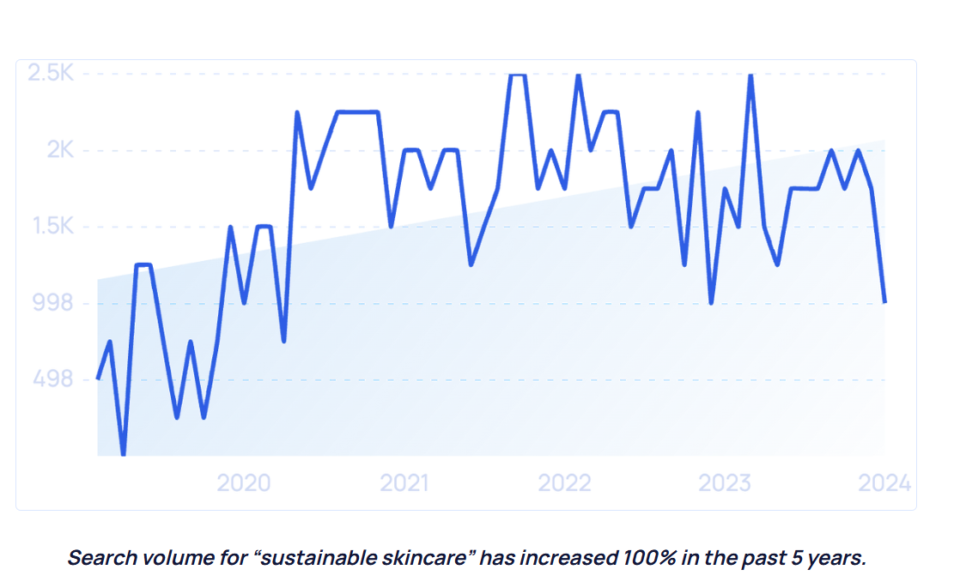
PEST(LE) Analysis
Political
Beauty salons often face regulations around hygiene, safety, and licensing, so staying compliant with local health codes is key.
Political stability in your area also affects customer confidence—when people feel safe, they’re more likely to spend on non-essential services like beauty treatments.
Economic
The salon industry can be sensitive to the economy. When people have more disposable income, they’re willing to spend on pampering and beauty. During economic downturns, some might cut back on luxury services, so it’s smart to offer a range of price points or packages to keep customers coming back.
Rising costs for supplies or rent can affect profit margins, so managing expenses carefully is important.
Social
There’s a growing trend toward self-care and wellness, making beauty salons more popular than ever.
Social media plays a huge role in influencing beauty trends and client expectations people want the latest looks they see on Instagram or TikTok.
Demographics matter: younger generations tend to try new trends more, while older clients might prefer classic styles or gentle treatments.
Increasing diversity in communities means offering a wide range of services that cater to different skin types, hair textures, and cultural beauty preferences.
Technological
New technologies in nail care (like gel or acrylic nails) and eyelash extensions (longer-lasting adhesives) make treatments better and more appealing.
Social media and digital marketing tools help salons reach more people and showcase their work effectively.
Legal
Compliance with health and safety regulations is critical, salons need to maintain clean tools, proper sterilization, and safe chemical use.
Employment laws around wages, working hours, and contracts affect how you manage staff.
Data protection laws mean you have to handle client information responsibly, especially if you use booking software or marketing databases.
Environmental
More customers care about eco-friendly and sustainable beauty—using cruelty-free, vegan, or biodegradable products can set your salon apart.
Waste management (like disposing of nail polish chemicals or single-use materials) must be handled responsibly to avoid environmental harm.
SWOT Analysis
Strengths
Personalized Services: Offering tailored treatments for nails, eyebrows, and eyelash extensions helps build strong customer relationships and loyalty.
Skilled Staff: Having trained, experienced beauticians means high-quality results that keep clients coming back.
Trendy & Popular Services: Nails, brows, and lashes are super popular right now, so there’s already a steady demand.
Relaxing Atmosphere: Creating a welcoming, cozy vibe makes clients feel pampered and happy to spend time (and money) there.
Weaknesses
High Competition: Beauty salons are everywhere, so standing out can be tough.
Seasonal Fluctuations: Some months may be slower (like post-holiday periods), which can affect steady cash flow.
Limited Services: Focusing only on nails, brows, and lashes might miss customers wanting a full beauty experience.
Opportunities
As the business grows, there may be opportunities to offer more beauty services.
Growing Beauty Trends: The rise in self-care culture and social media trends can attract new clients eager to try the latest looks.
Loyalty Programs: Creating rewards or memberships encourages repeat visits and steady income.
Threats
Economic Downturns: When money’s tight, people might skip beauty treatments.
Health & Safety Regulations: Stricter rules or unexpected closures (like during a pandemic) can disrupt business.
New Competitors: A new salon opening nearby with aggressive pricing or marketing can draw customers away.

Customers / Target Markets
For a beauty salon offering nails, eyebrows, and eyelash extension services, the ideal customers are people who value self-care and want to look and feel their best. Here’s a breakdown of the main groups:
Young Professionals (Ages 20-35)
These are busy people, often juggling work and social lives, who want quick but high-quality beauty treatments to keep them looking polished. They’re usually active on social media, love trying new trends.
Beauty Enthusiasts & Trendsetters
People who follow beauty trends closely and love experimenting with different nail art, eyebrow shapes, and lash styles. They often seek salons that offer the latest techniques and products. Social media influences this group a lot—they want to show off their looks and expect salons to be creative and up-to-date.
Brides and Special Occasion Clients
Weddings, parties, and special events drive demand for premium eyebrow shaping and eyelash extensions. These clients often book packages or repeat visits in the weeks leading up to a big day. Personalized attention and reliability are key to winning their loyalty.
Middle-aged Clients (Ages 36-55)
This group may prioritize natural-looking enhancements and more gentle treatments. They often prefer salons with experienced staff and a relaxing atmosphere. Many appreciate loyalty programs or subscription packages for regular maintenance.
Local Community and Repeat Customers
A solid base of nearby residents and workers who visit regularly for maintenance and relaxation. Building strong relationships here is important—word of mouth and repeat business often come from this group.
Competitor Analysis
When starting a beauty salon that specializes in nails, eyebrows, and eyelash extensions, it’s important to understand the competitive landscape. Here’s a look at the types of potential competitors:
Local Independent Salons - Many neighbourhoods have smaller, independently owned salons offering similar services. These salons often have loyal customers and flexible, personalized service.
Chain Salons and Franchises - Big brand salons tend to have established reputations, standardized services, and often attractive pricing or loyalty programs. They usually have the advantage of brand recognition and marketing power.
Mobile Beauty Services - Mobile technicians offering nails and lash extensions at clients’ homes are growing in popularity for convenience. While they’re flexible and can save clients travel time.
DIY and Retail Products - Some customers may try at-home kits for nails or lash care to save money. While convenient, these kits often don’t match the quality or longevity of professional services.
Sales and Marketing Strategy
Marketing Objectives
Increase brand awareness in the local area within the first 6 months.
Attract at least 100 new clients in the first quarter of operation.
Generate monthly sales revenue of $8,000 by the end of year one.
Marketing Strategies
Social Media Marketing: Regularly post high-quality photos and videos showcasing nail art, eyebrow shaping, and eyelash extensions. Use hashtags and local tags to reach nearby customers.
Referral Program: Encourage existing clients to bring friends by offering discounts or free add-ons.
Introductory Offers: Provide special discounts for first-time customers or bundle packages (e.g., nails + lashes combo) to increase trial.
Local Partnerships: Team up with gyms, spas, or fashion boutiques for cross-promotional events and flyer distribution.
Seasonal Promotions: Run themed specials for holidays or events to create urgency and excitement.
Target Market
Primary: Women aged 20-40, urban professionals who value beauty trends and convenience.
Secondary: Brides and special event clients looking for premium packages e.g. proms etc.
Also, any client that has desires to feel more beautiful, e.g. men can have eyebrow shaping, young girls wanting to have their nails done with their mother, etc.
Pricing Strategy
Use competitive pricing slightly below or on par with local mid-range salons to attract price-sensitive customers while maintaining quality.
provide discount packages and membership plans to encourage repeat visits (e.g., monthly lash extension maintenance plans).
Sales Forecast

Budget and Timeline

Operations
Location, Premises, and Equipment
Location: Home-Based Beauty Salon
Operating a beauty salon from home offers a great opportunity to start small while saving on rent and overhead costs. Choosing the right space within your home is essential to create a professional, comfortable, and hygienic environment for clients.
The salon would be based in an outhouse in a garden, so it will also still feel and resemble a salon.
The area will be designed with a clean, stylish aesthetic to reflect the salon’s brand — calming colors, neat furniture, and beauty-related décor to create a relaxing atmosphere.
Accessibility and parking are key considerations. If the home is in a residential neighbourhood, there should be safe parking nearby and easy entry for clients.
Equipment Needed:
For nails, eyebrows, and eyelash extension services, the following equipment and supplies will be essential:
Manicure and Pedicure Station: Adjustable chair and table with proper lighting and storage for tools.
Nail Care Tools: Nail files, buffers, cuticle pushers, nail clippers, UV/LED lamp for gel nails, nail polish, acrylic powders, and brushes.
Eyebrow Tools: Tweezers, eyebrow razors, waxing strips, brow pencils, and microblading kits (if applicable).
Eyelash Extension Supplies: Lash trays, adhesives, tweezers, lash brushes, eye pads, and sanitizing products.
Sanitation Equipment: UV sterilizer, disinfectants, gloves, masks, and disposable tools where necessary to maintain hygiene.
Comfort Items: Client chairs, footrests, a small waiting area or seating, and refreshments to enhance client experience.
Advantages of a Home-Based Salon:
Lower startup and operating costs due to no rent or commercial utility expenses.
Flexible working hours allowing better work-life balance.
A personalized and intimate atmosphere that can make clients feel at ease.
Challenges to Consider:
Maintaining a professional image despite being at home.
Complying with local zoning laws or regulations about running a home-based business.
Production and Distribution Processes
Booking and Scheduling:
Clients book appointments through an online system, phone, or social media messaging. Efficient scheduling ensures the salon runs smoothly and avoids overlap.
Preparation:
Before each appointment, the salon space is cleaned and sanitized thoroughly. Tools and equipment are prepared according to the service booked — for example, setting up nail polish colors, lash trays, or brow waxing supplies.
• Service Delivery:
Clients arrive at the garden outhouse, a dedicated space separate from the main home, providing privacy and a professional setting. The technician performs the selected treatments using sterilized tools and quality products. The environment is designed to be relaxing and welcoming.
Aftercare Guidance:
Once the service is complete, the client receives advice on maintaining their nails, brows, or lashes until the next visit. This helps build trust and encourages repeat business.
Cleanup:
After each client, the technician sanitizes all equipment, disposes of any single-use items responsibly, and refreshes the space for the next appointment.
People, Staff, and Suppliers
Starting a beauty salon at home requires thoughtful planning not only about services and location but also about the people who will make the business successful — including the owner, potential staff, and suppliers.
People and Staff
In a home-based beauty salon, the owner often starts as the primary service provider, handling nails, eyebrows, and eyelash extensions personally. This hands-on approach helps build strong connections with clients and ensures quality control. However, as the business grows, there may be a need to bring in additional staff, such as skilled technicians or a receptionist, to help manage increased demand.
Choosing the right staff means looking for licensed and experienced beauty professionals who share the salon’s values of hygiene, professionalism, and customer care. Friendly, approachable personalities are just as important as technical skills because positive client interactions encourage loyalty and word-of-mouth referrals. Training is crucial to keep everyone updated on the latest trends and safety standards.
Suppliers
For a home-based salon, establishing strong relationships with trustworthy suppliers is vital to ensure a steady supply of safe, professional-grade materials such as nail polishes, gels, eyelash adhesives, waxing strips, and sterilization products.
When choosing suppliers, factors like product quality, cost, delivery times, and customer service are important.
Most of the nail products would come from ‘Sally Beauty’ where the cost is more sufficient and high quality products.
Most of the eyebrow products would come from ‘Salon Services’ as the products are good value and high quality.
The eyelash products would come from Amazon as well as the other start up products needed such as a lighted mirror, nail lamp etc.
The beauty bed would be purchased from a seller on Tesco Marketplace.
The beauty chair would be purchased from a seller on B&Q.
Systems and Procedures
Appointments will be scheduled by phone or online to manage time efficiently and avoid overlap. Each client’s preferences and service history will be recorded to provide personalized care.
Customer feedback will be encouraged to improve services continuously. Clear communication and friendly service will create a welcoming atmosphere that keeps clients coming back.
Health & Safety, Quality Control, and Legal Compliance
Running a beauty salon at home means making sure both clients and the business stay safe and happy. Health and safety come first, all tools and equipment must be cleaned and disinfected after every use to prevent infections. The workspace should be tidy and well-ventilated to keep the environment fresh and comfortable.
Quality control is about delivering consistent, high-standard services. This means using good products, following proper techniques, and listening carefully to what each client wants. Checking client satisfaction regularly helps improve services and build trust.
Legal compliance involves following local laws and regulations. This includes getting any necessary permits or licenses, handling personal data responsibly, and ensuring proper insurance coverage. It’s also important to stay updated on health guidelines to protect everyone’s wellbeing.

Financial Information
Cashflow Forecast

- Price list -
- Eyelash & Eyebrow Tint £26.00 20 mins
- Eyelash Tint, Eyebrow Wax/Shape & Tint £38.00 30 mins
- LVL Lashes * £60.00 60 mins
- LVL Lashes & Fluffy Brows Combo * £84.00 60 mins
- Eyebrow Wax - Hot Wax £16.00 10 mins
- Eyebrow Tint £12.00 10 mins
- Eyebrow Wax/Shape & Tint £25.00 15 mins
https://www.thewaxbar.co.uk/treatments/eye-and-beauty-treatments
https://www.blushconwy.co.uk/treatments
Wax £12 / tint £12
Gel pedicurev - £ 42 – manicure - £37
💷 Average Costs for Eyebrow Wax & Tint in Wales
- Eyebrow Wax: Typically ranges from £6 to £10
- Eyebrow Tint: Generally between £8 and £15
- Combined Wax & Tint: Usually priced between £12 and £22
These prices can vary based on location, salon reputation, and the specific services offered.

📍 Examples from Welsh Salons
- Beauty Chepstow: Offers an Eyebrow Tint and Wax for £17.50
- Abbey Heywood Beauty Salon: Provides an Eyebrow Tint and Wax for £16
- Browbar Beautisun: Charges £15 for an Eyebrow Tint and Wax

Price list - https://www.nailsandlashesswansea.co.uk/price-list?category=20874c63-54f3-4778-8c24-101a427e9109

Price list -https://www.lotusnailsandbeautyswansea.co.uk/

Outgoings –
Beauty bed – amazon £162.90
Average Monthly Electricity Bill: Around £100 to £250 per month
This estimate includes usage of nail lamps (LED/UV), lighting, heating/cooling, and some small electrical equipment like sterilizers or fans.
• Simply Business UK mentions small beauty salons typically spend around £100 to £300 on energy per month, depending on size and equipment used.
Simply Business - Salon Startup Costs
• Business Energy UK provides general guidance on energy usage for small businesses, estimating small salons’ monthly electricity costs typically under £250.
Business Energy UK - Small Business Energy

