
Module: Accounting fundamentals
Module Code: LCBB4001
Assignment Title: Component 1 Essay
Student ID: 2242725
Student Name: Petronela Apetroaie

Introduction
According to Needles and Powers (2013), accounting, which is sometimes referred to as the language of business, plays a key role in causal the framework of international commerce and economic processes. The process of accounting has seen substantial development throughout the course of human history, progressing from the rudimentary methods used by ancient civilizations to the current, cutting-edge computerised methods utilised today. However, the overarching goal of this subject has remained the same over the years, and that is to give a thorough, clear, and accurate interpretation of the financial position and accomplishments of an organisation. Also, the foundation of modern accounting is founded on a number of fundamental principles, with the double-entry system being especially prominent (Weygandt, Kimmel, and Kieso, 2019). This collection of fundamental concepts forms the basis of current accounting. Also, the recording of financial transactions is ensured to be rigorous and fair with the help of this system. This essay explores the characteristic characteristics, practical implementation, and historical progression of these key principles in accounting. The importance of these principles in shaping corporate decisions, influencing economic strategies, and cultivating confidence among a variety of interested parties is emphasised throughout the course of this investigation.
Task 1
Coopers Grocery
Trial Balance
31st of August 2023

The first task is to handle the finances of 'Coopers Food,' a food business that may be found on New Street in Birmingham. The store's finance manager, Mr. Dennis, compiled a trial balance as of August 31, 2023. This document contained data on the store's assets, liabilities, owner's equity, and numerous other financial operations. A trial balance is a kind of financial statement that summarises the current values of all of the accounts in the general ledger at a predetermined point in time (Epstein and Jermakowicz, 2010). When all of the debits and credits in the ledger are equal to one another, the ledger is said to be balanced. This ensures that the entries in the ledger are correct and provides a snapshot of the store's financial activity. In addition to the statistics that were included in the first trial balance, there are a number of modifications that need to be taken into consideration. These include the management of closing inventory, the acknowledgment of accumulated pay, the accounting for prepaid rent, and the resolution of different financial factors. Adjustments of different kinds are made by businesses in order to bring their financial statements into conformity with accrual accounting rules. This involves managing bad debts and provisions, shutting out inventory, discussing accruals and prepayments, calculating asset depreciation, and discussing accruals and prepayments. According to Fisher and Taylor (2017), the prompt highlights how important it is to recognise costs and revenues at the time they are earned or incurred rather than when the corresponding monetary transactions take place. In addition, it examines the methodical distribution of the cost of a tangible asset over the course of its useful life, which represents the steady decline in value that occurs as a result of physical wear and tear as well as obsolescence.
To begin, the assignment requires the development of an income statement for the fiscal year that will end on August 31, 2023, considering the changes that were previously discussed. This income statement will illuminate the financial performance of 'Coopers Grocery' by outlining its sales, subtracting its costs and expenditures, and eventually determining whether the shop has earned a net profit or sustained a net loss for the fiscal year. Second, the assignment requires the creation of a balance sheet as of the particular date that has been given. According to Wild, Shaw, and Chiappetta (2020), the purpose of this balance sheet is to offer a thorough picture of the grocery store's assets, liabilities, and owner's equity, thus giving useful insights into the establishment's financial well-being and stability. Through its focus on the organisation of unstructured financial data into structured financial statements, Task 1 helps to increase the visibility of the financial situation and makes it easier to make decisions based on accurate information.
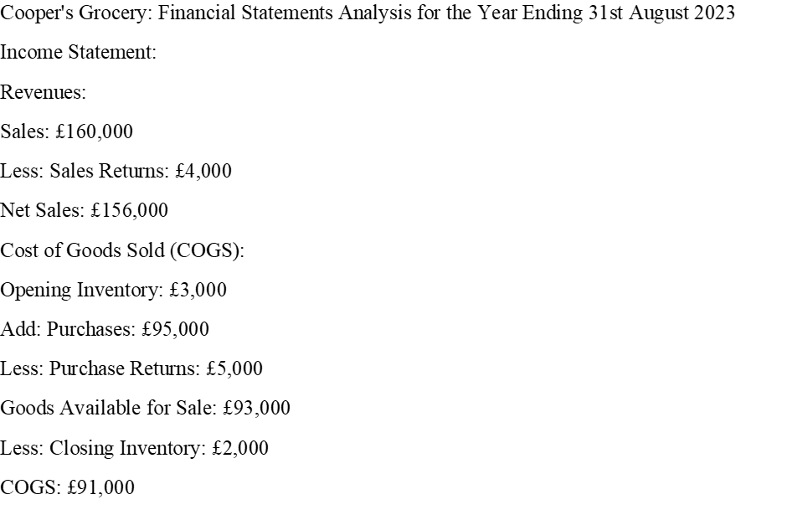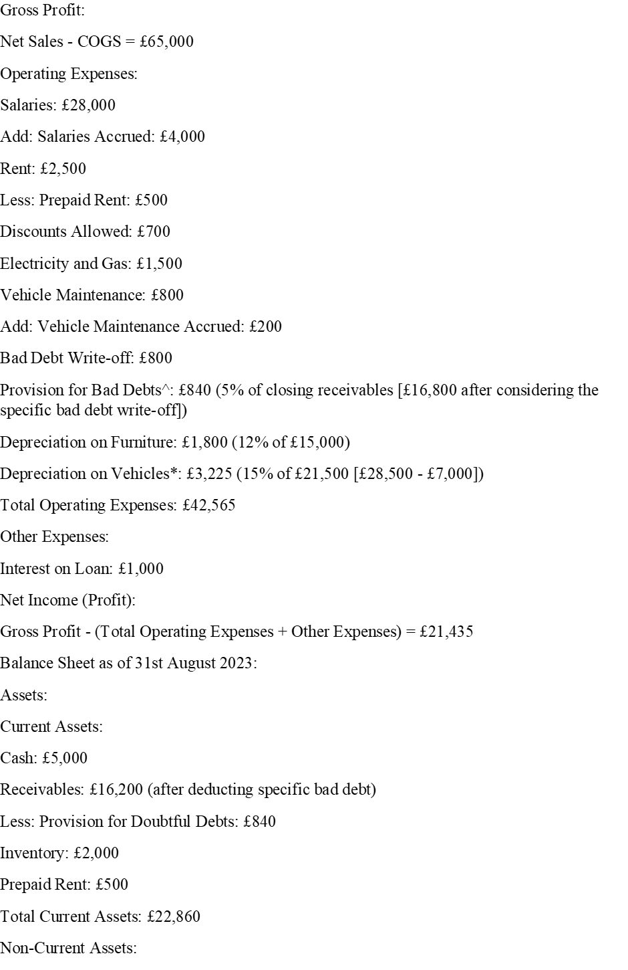

Task 2

The second task largely centres on the financial transactions pertaining to Sonia, who is the only owner of a tiny firm that is committed to selling pancakes to many cafés located inside Birmingham City. Hence, the preliminary financial data functions as a momentary representation of the organisation's fiscal condition as of September 1, 2023. The financial statement provides a comprehensive overview of the recorded balances in several accounts, such as capital, vehicle, bank, cash, receivables, and payables, along with other pertinent entries (Horngren, Sundem and Elliott, 2007). During the month of September, Sonia participates in a range of financial activities, including personal withdrawals, capital injections, asset purchases, outgoing and incoming payments, as well as outgoing and incoming receipts.
Comprehending the first balances: The first phase of this assignment is the presentation of the account balances for different accounts as of September 1st. The said starting balances serve as the basis for documenting future transactions. Within the framework of capital, it denotes the magnitude of an individual's equity stake in the organisation. Moreover, the firm's vehicle is documented as an asset in the financial records of the company. In order to assess the liquidity of the firm, an analysis of its bank and cash balances might be conducted. Furthermore, receivables and payables refer to the monetary obligations owed to the firm by its customers and suppliers, respectively (Warren, Reeve and Duchac, 2020).
Task 2 has been meticulously designed with the intention of attaining many significant objectives:
The main objective is to establish 'T' accounts inside the ledger in order to precisely document all transactions. The use of 'T' accounts is of utmost importance in the field of accounting since they provide a valuable means of visually illustrating the effect of individual transactions on particular accounts (Horngren, Sundem and Stratton, 2018). In accordance with the principles of double-entry accounting, each transaction gives rise to either a debit or credit entry in the corresponding accounts. The systematic methodology used guarantees the comprehensive recording, categorization, and meticulous verification of all financial transactions, hence ensuring correctness in a standardised fashion (Horngren, Sundem and Stratton, 2018).
The next phase in the accounting process, after the recording of all transactions in the ledgers, is the compilation of a trial balance. Also, this report provides a detailed overview of the closing balances for all accounts, therefore verifying the equivalence between the aggregate debits and credits. The verification procedure serves to validate the correctness of the recorded transactions.
By the end of September, those who demonstrate diligence will meticulously gather all pertinent data and create a trial balance after carefully documenting and reconciling 'T' accounts. However, this document provides confirmation of the equilibrium of the accounting equation by enumerating the final balances of all accounts and guaranteeing that the aggregate debits are equivalent to the aggregate credits, therefore sustaining the basic tenets of accounting. However, task 2 offers a valuable practical exercise for recording actual company transactions, so reinforcing the fundamental principles of double-entry bookkeeping and the process of compiling an initial financial statement, such as the trial balance.
Situation for Sonia's Pancake Business
Record Accounts and Trial Balance for September 2023
Ledger 'T' Accounts:
- Capital: 20,300 (1 Sept), 700 (2 Sept), 21,000
- Bank Balance: 7,000 (1 Sep), 800 (4 Sept), 700 (7 Sept), 3,000 (9 Sept), 350 (11 Sept) , 450 (18 Sept), 6,000 (28 Sept), 14,700
- Cash Balance: 300 (1 Sep), 700 (2 Sept), 1,000 (3 Sept), 2,600 (15 Sept), 800 (25 Sept), 500 (26 Sept), 2,000 (27 Sept), 1,200 (30 Sept) 100.
- Receivables: 5,000 (1 Sep), 3,000 (9 Sept), 2,600 (15 Sept), 2,400 (21 Sept), 5,800
- Payables: 2,000 (1 Sep), 800 (4 Sept), 1,200 (20 Sept), 3,400
- Van: 10,000 (1 Sep), 1,000 (27 Sept) .
- (Depreciation): 9,000
- Sales of Van (Gain on Sale): 1,000 (27 Sept), 1,000
- Expenses (Petrol, Insurance, Wages, Advertisement): 1,950 (Sum of transactions 6, 8, 11, 12). 1,950
- Drawings: 1,200 (30 Sept), 1,200
- Inventory (Products for resale): 700 (7 Sept), 1,200 (20 Sept), 1,900
Situation Trial Balance as of 30th September 2023:
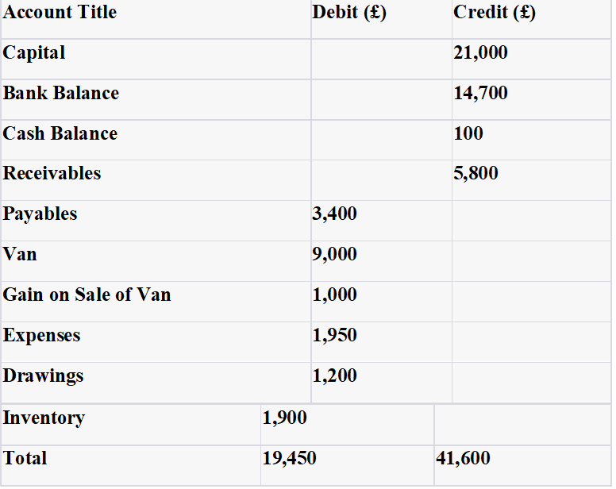

Task 3
The Conceptualization, Execution, and Historical Development of the Double Entry Accounting System
The foundation of contemporary accounting is the double-entry accounting system, which was developed to provide a mechanism that was both methodical and accurate for documenting monetary transactions. Also, this system is based on the basic idea that every single monetary transaction has two effects that are equal and opposite to one another. However, these effects are referred to as a debit and a credit, and they are both recorded in accounts that correspond to one another.
Conceptualization: The conceptual underpinning of double-entry accounting may be traced back to Luca Pacioli, an Italian mathematician and Franciscan friar, who wrote his landmark book "Summa de Arithmetical, Geometric, Proportioni et Proportionalità" in 1494. Pacioli's work is considered to be the founding document of double-entry accounting. In this work, Pacioli discussed the concepts of double-entry accounting, putting an emphasis on the function that it plays in ensuring accurate financial records are kept (Pacioli, 1494). The fundamental concept behind double-entry accounting is that for every transaction, there must be an entry that is equal to and opposite to its counterpart on the other side of the ledger. This is done to ensure that the accounting equation (Assets = Liabilities + Equity) is always in a state of balance. Therefore, this idea serves as the foundation for the process of producing financial statements and determining the overall financial health of a business.
Implementations: The process of implementing the double-entry system entails the establishment and maintenance of a collection of ledger accounts, each dedicated to recording a distinct financial facet of the enterprise. For example, within the realm of accounting, many categories are recognised, including assets, liabilities, equity, revenues, and costs. When a transaction takes place, it is documented in the relevant accounts via the process of debiting and crediting entries (Needles and Powers, 2013). Debits often signify augmentations in assets and costs, while credits indicate augmentations in liabilities, equity, and revenues. The use of this methodical technique guarantees that the financial records faithfully represent the true economic state of the organisation.
Historical Development: The double-entry accounting system has undergone a series of developments over the ages, in response to the evolving requirements of enterprises and the intricacies of contemporary trade. Pacioli's concepts continue to serve as the fundamental basis, although the progressions in technology, legislation, and financial reporting requirements have significantly influenced its evolution. One such instance is the introduction of computerised accounting software, which has enhanced the efficiency of the financial data recording and retrieval process. Furthermore, the implementation of International Financial Reporting Standards (IFRS) and Generally Accepted Accounting Principles (GAAP) has brought to a worldwide standardisation of accounting practises.
In summary, the double-entry accounting method, first conceived by Luca Pacioli during the 15th century, has significantly contributed to the advancement of contemporary accounting practises. The execution of this process entails the careful documentation of financial transactions, with a focus on achieving precision and promoting transparency (Needles and Powers, 2013).
Over the course of its existence, it has shown the ability to adapt to the dynamic nature of the business environment, therefore establishing itself as a fundamental component of financial reporting and analysis.
Conclusion
Because of its long history and continued relevance, the double-entry accounting system is an impressive example of how far we have come in terms of accurately recording and reporting financial transactions. It serves as a record of all monetary dealings, fostering trustworthiness, accuracy, and openness in the marketplace. Also, the system's underlying concepts are stable, allowing it to adapt to changing technical and economic conditions on a global scale and inside individual businesses. If you want to keep tabs on your finances, make sure the right people are held responsible, and keep your financial records accurate, double-entry accounting is the way to go. Despite developments in tools and methods, the essential concepts of double-entry accounting will continue to govern financial decision-making and emphasise its continuing relevance in corporate finance.
Recommendations
Financial management is crucial for the success of modern businesses. Sonia's Pancakes and Cooper's Grocery, two companies with high transactional activity, need to improve their accounting procedures. Utilizing software like QuickBooks, Xero, and Sage can reduce errors and speed up report generation. Automation is vital for maintaining a healthy financial routine and detecting irregularities. Consistent bank reconciliations are essential for sound financial management. Professional growth is crucial, with ongoing training programs aligning finance staff with current accounting standards. Advanced asset and debt management strategies are necessary. So, Cooper's Grocery should exercise caution in debt management, optimize debt arrangements, and explore refinancing opportunities. Improving financial management can be achieved through detailed credit checks, budgeting, and forecasting. Both companies can significantly improve their financial resilience through automation, ongoing learning, efficient asset and liability management, and proactive financial planning.

References
Epstein, B. J., & Jermakowicz, E. K. (2010). Interpretation and Application of International Financial Reporting Standards. Wiley.
Fisher, L., & Taylor, T. (2017). Accounting for Non-Accountants: The Fast and Easy Way to Learn the Basics. For Dummies.
Horngren, C. T., Sundem, G. L., & Elliott, J. A. (2007). Financial Accounting. Pearson/Prentice Hall.
Horngren, C. T., Sundem, G. L., & Stratton, W. O. (2018). Introduction to Financial Accounting. Pearson.
Needles, B. E., & Powers, M. (2013). Principles of Financial Accounting. Cengage Learning.
Needles, B. E., & Powers, M. (2013). Principles of Financial Accounting. Cengage Learning.
Pacioli, L. (1494). Summa de Arithmetica, Geometria, Proportioni et Proportionalità.
Spiceland, J. D., Thomas, W. B., & Herrmann, D. (2020). Financial Accounting. McGraw-Hill Education.
Weygandt, J. J., Kimmel, P. D., & Kieso, D. E. (2019). Financial Accounting. Wiley.
Wild, J. J., Shaw, K. W., & Chiappetta, B. (2020). Financial and Managerial Accounting. McGraw-Hill Education.
Warren, C. S., Reeve, J. M., & Duchac, J. (2018). Accounting. Cengage Learning.

