Name: Alice Samuel

Question:
“the best that has been thought and written in the world”—is in danger, or is indeed already “lost,” because of widespread popular education, popular communications systems, and what is often called “mass society.” On High and Popular Culture: Raymond Williams 1974
newrepublic.com/article/79269/high-and-popular-culture
Development of technology has spread all aspects of culture to a much wider audience. Are the terms high and low culture now redundant?

Student Number: P149875

Course Title: BA(Hons) Illustration

Word Count: 1989

Tutor(s): Louise Burston and Sarah Tombs

Title: The Growth of Low Culture

The concept of high and low culture has always existed. High culture refers to a classification of art that is held in high esteem; pieces that are rare and hold a sophisticated and aristocratic value. Many of these pieces are related to those who have received a higher education such as the middle-classes. Low culture however is a demeaning term that corresponds to objects that appeal to mass population. Both cultures have been encountered equally since the beginning of humanity, from cave paintings to Roman ceramics and architecture, but over the last three hundred years, low culture has grown immensely since the development of mass production.

One noteworthy societal group associated with high culture was the Pre-Raphaelites: a brotherhood established in 1848 by English painters John Everett Millais, William Holman Hunt and Dante Gabriel Rossetti. They defied the country’s growing corruption by studying artwork from the periods predating the Italian High Renaissance. They believed that paintings created during these time periods represented realistic views on civilization. [1]
As stated in John Piper’s book ‘British Romantic Artists’ [1942]:

Romantic art deals with the particular. The particularization of
Bewick about a bird’s wing, of Turner about a waterfall or a hill
town, or of Rossetti about Elizabeth Siddall, is the result of a
vision that can see in these things something significant
beyond ordinary significance : something that for a moment
seems to contain the whole world ; and, when the moment is
past, carries over some comment on life or experience besides
the comment on appearances.

Although their work challenged the idealisms of literature and art in society at that time, the Pre-Raphaelites still created aesthetic pieces much like many other artworks that appeared under the societal expectations of high culture. The brotherhood were held in high esteem among art academies and critics, producing works that paid close attention to nature, a high quality of detail, an opulence of colour and topics deriving from the medieval and most definitely, the literary, all of which are associated with the definition of high culture.
Their styles were reminiscent of gothic paintings, with their rich yellows and the harrowing realism. John Everett Millais’ ‘Ophelia’ [1851-2] is one such painting that truly encompasses the feeling of their opus, and such work would appeal to those of a higher status.

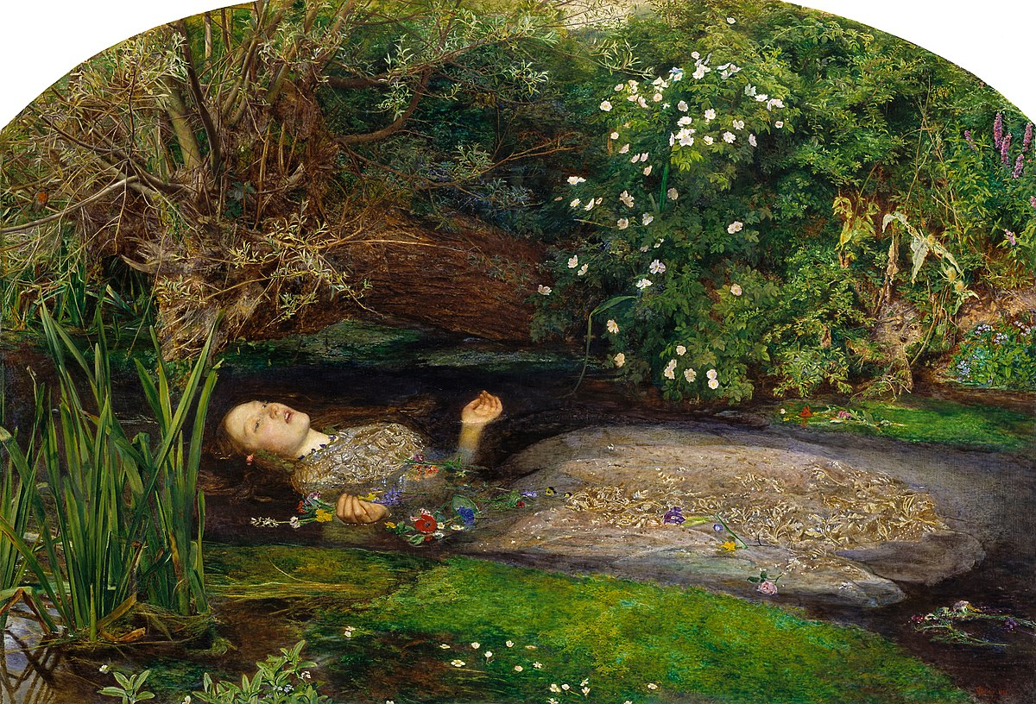
Everett Millais, J. (1851-2). Ophelia. [Oil paint on canvas]. London: The Tate Gallery.

A bewitching character, Ophelia is known as the innocent love interest from Hamlet, one of Shakespeare’s most famous plays. She has prompted many of the Pre-Raphaelites in their work, all of which have depicted her differently, but all portray the same sorrow of the heartfelt character.
After a series of horrific events, Ophelia becomes baffled by Hamlet’s dire need for revenge on his uncle. After the death of her own father (who is subsequently killed by Hamlet), she is also driven to insanity. This painting by Millais delineates her final moments.
Although painted in such an elegant fashion indistinguishable to that of Romanticism, the subject matter is anything but bright and beautiful. The juxtaposition of the bright colours to that of the metaphors hiding within the painting (the white flowers symbolizing death) still creates an element of peace. Even though she has drowned, the painting properly represents her character’s true innocence and romanticizes her death.

These paintings were unique, hung up in galleries, exhibited in Royal Academies and even purchased by merchants and industrialists to add to their private collections. The withholding of such artwork from a wider audience is one of the ways in which I believe that high culture began to diminish. The inability to teach those of a lower class about such works of art perhaps made it difficult for working class men and women to understand, but also not having the ability to view these works freely created a definitive cultural divide in society. By being biased as to whom they would show the paintings to, members of the public from a lower standing would have most likely shown very little interest, and ultimately the appeal of Romanticism would fade.

When looking at low culture, Realism had started to make an appearance in Britain after French artists painted works of art based on the Industrial Revolution. In 1850, British cities had become shrouded in smog with the pre-eminence of industries surpassing that of agricultural jobs. These paintings depicted the everyday lives of the working class, and although the PRB attempted to create their own works of modern realism, their paintings still showed an exemplified enchantment with “pseudo-medievalized semi-mythological worlds”. [2]
These representational images showed gritty modernism with relatable themes for those experiencing the harsh conditions of working in factories.

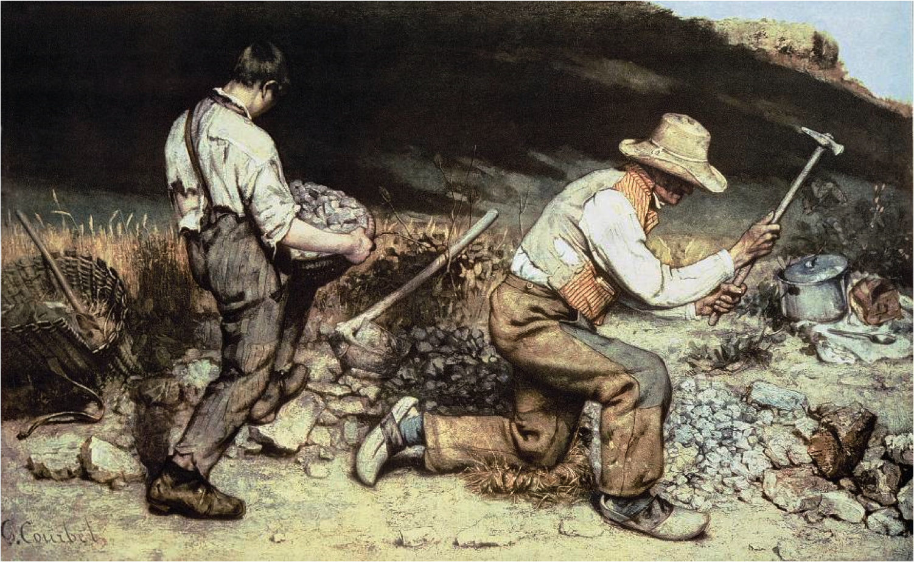
Courbet, G. (1849). The Stonebreakers [Oil on canvas]. Gemäldegalerie, Dresden (destroyed).

Gustave Courbet’s The Stonebreakers greatly symbolizes the spread of mechanical industry over the agricultural lifestyle, with the black shadows seeping in over the farmland behind the two figures. It’s a threatening presence, much like the evolution of the Industrial Revolution.

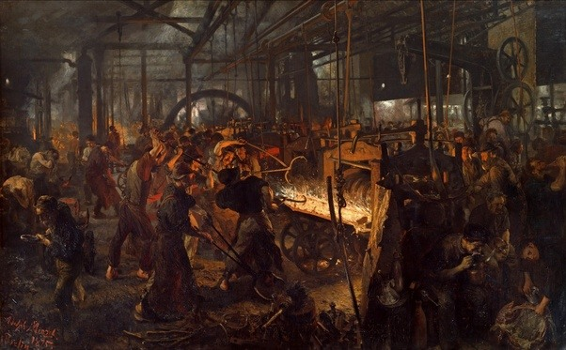
Menzel, A. (1875). The Iron Rolling Mill. [Oil paint on canvas]. Nationalgalerie, Staatliche Museen zu Berlin.

The Iron Rolling Mill, (painted by Adolph Menzel) is a perfect representation of the struggle between man and machine. Figures in the central section of the painting are in a demonstration of chaos, in contrast to the top of the painting being a calming, pale light showing the entanglement of the factory’s structure.
These were the realities for the working class, and great interest was drawn to the ugly symbols of the mechanics that show the harshness of the times. They also stood for hope and progress, and made large-scale manufacturing far quicker and easier for businesses to distribute.
The invention of the movable type press by Johannes Gutenberg in 1440 helped pave the way for many artists to distribute their work further afield, providing them a higher chance of being viewed all over the world and gaining more recognition. The development of printing materials such as the moveable type press “… were major steps in transforming the printing of books.” (Steven Kreis: Lecture on Modern European Intellectual History: The Printing Press, May 2, 2016). Printing processes like Aquatint, Lithography, Chromolithography and Photolithography allowed for books to be reproduced and distributed to the working classes. Penny Dreadfuls became extremely popular during the 19th century.
Originally called “Penny Bloods” in the 1830s, these illustrated, cheaply made comics became hugely popular amongst the working classes as new technologies made literacy more available. They depicted stories of pirates and highwaymen, and the gothic genre boomed, displaying ‘a world of dormant peerages, of murderous baronets, and ladies of title addicted to the study of toxicology [the study of poison], of gipsies and brigand-chiefs, men with masks and women with daggers, of stolen children, withered hags, heartless gamesters, nefarious roués, foreign princesses’. [3]
Despite these books being fictional thrills, there was a gritty realism to them; there were no dragons, knights and white steeds, but real lifelike characters that you could pass down the street. The story’s looked at the beasts within us rather than those from fairy tales.

The opposition of Neoclassic and Romantic art that exemplified escapism, continued from the mid 19th century into the beginning of the 20th century where artwork began to show larger societal issues. The women’s suffragette movement is a key example of this. Emerging in 1866, women fought for the right to vote after the proposal for women to have the same political rights as men were rejected. Led by Millicent Fawcett, the National Union of Women’s Suffrage Societies (NUWSS), believed in winning the right to vote by protesting peacefully via petitions and non-violent demonstrations. The progression of large-scale distribution enabled them to use printing machines to create leaflets and posters for their cause, and to gain help and create awareness for women of working class, (since many in the society were middle class property-owning women).

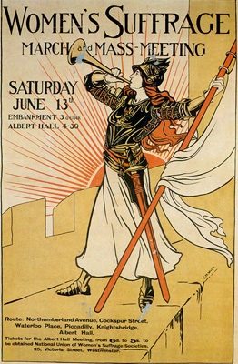
National Union of Women’s Suffrage Societies. (1908). The Allegorical Bugler. [Print]. Albert Hall , London.
Notable British cartoonists and organisations that worked on posters much the same as the one above were:
- Artists Suffrage League (ASL) and the Suffrage Atelier (workshop) (SA): these were groups of artists who organized specifically for the purpose of providing visual materials for the suffrage campaign.
- National Union of Women's Suffrage Societies (NUWSS)
- National League for Opposition to Women's Suffrage (NLOWS)
They fought to empower women, to create equality and fight the stereotypes that men had put on their gender. At the same time however, the Pre-Raphaelites were still influencing the works of many artists. John William Waterhouse (1849- ) is one example that painted pieces that portrayed the style of Millais, Hunt and Rossetti. ‘The Soul of the Rose’ is omnipotent with it’s style and detail, but the symbolism has much to be desired. It does not tell a story of woe through beauty, it is simply what you see: a beautiful woman smelling a rose. A complete contrast compared to the Suffragettes’ poster created in the same year. Waterhouse’s painting demeans the feminist values that women fought for.
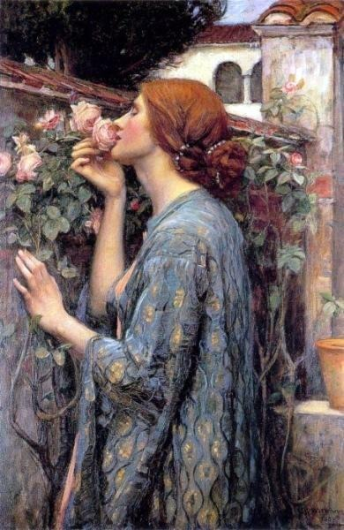
William Waterhouse, J. (1908). The Soul of the Rose. [Oil on canvas]. Private Collection.
A perfect sample of high culture art, yet it’s recognition is diminished by the growing popularity in the movements of the time. WWI recruitment posters followed the political statements made by the Suffragettes, consumerist propaganda in the 1920s and even the invention of films were making headway with classes associated with low culture.
Films became sensational hits in the Western World with a number of different cameras being invented to capture the perfect moving picture.
The construction of this new craft began in the 1830s with the creation of photographic lenses. Many inventors only wanted to discover how to capture a moving image for scientific purposes; looking at lighting and frames. It wasn’t until the 1890s that live action films would be attempted. Two men named Thomas A. Edison and William Dickson invented the Kinetoscope in 1891. It was publicly exhibited in 1894 on Broadway and became a huge hit. The Vitascope followed the year after in 1895 with an improved “Maltese cross” that permitted each frame to stop momentarily in front of the lens to provide a better flow between each transition. But it was the devising of the Cinématographe that began to pave the way for motion pictures. It was the first film camera and projector in one, invented by brothers Auguste and Louis Lumière who used it in part on the Théâtre Optique of Émile Reynaud in Paris. ‘La Charcuterie Mécanique’ [1895] was their first films, later followed by the well known ‘A Trip to the Moon’ [1902].
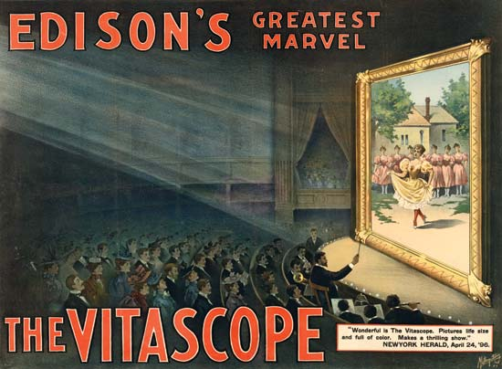
Advertisement for Thomas Alva Edison’s Vitascope.Metropolitan Print Company/Library of Congress, Washington, D.C.
To conclude, I don’t believe that both high and low cultures have become redundant, instead I think that one has simply taken over the other. Not only has technology helped to accommodate the interests of the mass population, but it is quite possibly also down to the popular interests and historical events of the time. If not for technology then maybe high culture and low culture would have been the same even now, but with the ability to administer numerous prints of the same piece of artwork to the populous, it was inevitable that low culture would overtake the other. The definition of high culture will never disappear; it still exists even today through private collections and galleries, but with modern technological advancements, it is very difficult not to be able to view artworks that were once considered rare masterpieces, and perhaps this lessens their original charming qualities.

[1] The Art Story Modern Art Insight. The Pre-Raphaelite Movement. [online] Available at: <http://www.theartstory.org/movement-pre-raphaelites.htm> [Accessed 2 November 2017].
[2] Lam, S. (2004). Defining Pre-Raphaelite Realism. [online]. victorianweb.org. Available at: http://www.victorianweb.org/authors/morris/lam2.html [Accessed 6 November 2017].
[3] George Augustus Sala, The Seven Sons of Mammon: a story, 3 vols. (London: Tinsley Brothers, 1862), ii, p. 22-3.
Bibliography:

Websites:

Graham Pina, S. (2008). Ophelia and the Pre-Raphaelites. [online]. Pre-Raphaelite Sisterhood. Available at: http://preraphaelitesisterhood.com/ophelia-and-the-pre-raphaelites/ [Accessed 3 November 2017].

Tate, (Date Unknown). Pre-Raphaelite. [online]. Available at: http://www.tate.org.uk/art/art-terms/p/pre-raphaelite [Accessed 3 November 2017].

Tate, (Date Unknown). Ophelia. [online]. Available at: http://www.tate.org.uk/art/artworks/millais-ophelia-n01506 [Accessed 6 November 2017].

Hoe, E. (2016). The Meaning Of 'Ophelia' By John Everett Millais. [online]. Culture Trip. Available at: https://theculturetrip.com/europe/united-kingdom/england/london/articles/the-meaning-of-ophelia-by-john-everett-millais/ [Accessed 7 November 2017].

The Editors of Encyclopædia Britannica, (Date Unknown). Romanticism. [online]. Encyclopedia Britannica. Available at: https://www.britannica.com/art/Romanticism [Accessed 10 November 2017].

The Art Story, (Date Unknown). Realism. [online]. Available at: http://www.theartstory.org/movement-realism.htm [Accessed 13 November 2017].

The Art Story, (Date Unknown). The Pre-Raphaelite Movement. [online]. Available at: http://www.theartstory.org/movement-pre-raphaelites.htm [Accessed 13 November 2017].

Encyclopedia, (2016). Pre-Raphaelites. [online]. Available at: http://www.encyclopedia.com/literature-and-arts/art-and-architecture/european-art-1600-present/pre-raphaelites [Accessed ].

Lam, S. (2004). Defining Pre-Raphaelite Realism. [online]. victorianweb.org. Available at: http://www.victorianweb.org/authors/morris/lam2.html [Accessed 6 November 2017].

National Museums Liverpool, (Date Unknown). The Pre-Raphaelites. [online]. Available at: http://www.liverpoolmuseums.org.uk/collections/preraphaelites/index.aspx [Accessed 17 November 2017].

Flanders, J (2014). Penny Dreadfuls. [online] bl.uk. Available at: https://www.bl.uk/romantics-and-victorians/articles/penny-dreadfuls# [Accessed 17 November 2017]

Artble, (Date Unknown). The Soul of the Rose. [online]. Available at: https://www.artble.com/artists/john_william_waterhouse/paintings/the_soul_of_the_rose [Accessed 18 November 2017].

BBC Bitesize, (2014). Women’s Suffrage Movement. [online]. Available at: http://www.bbc.co.uk/bitesize/higher/history/britsuff/suffrage/revision/2/ [Accessed 23 November 2017].

Radford, (Date Unknown). Art Responds to Women's Suffrage: Pro and Con. [online]. Available at: http://www.radford.edu/rbarris/Women%20and%20art/amerwom05/suffrageart.html [Accessed 26 November 2017].

Willette, J. (2010). Realism in England, France and America. [online]. Available at: http://arthistoryunstuffed.com/realism-england-france-america/ [Accessed 26 November 2017].

Grimes, E. (2014). What major influence did the Industrial Revolution have on art? [online]. Quora. Available at: https://www.quora.com/What-major-influence-did-the-Industrial-Revolution-have-on-art [Accessed 28 November 2017].

Dirks, T (Date Unknown). Voyage Dans La Lune (A Trip to the Moon) (1902). [online]. filmsite.org. Available at: http://www.filmsite.org/voya.html [Accessed 3 December 2017].

Sklar, R. and A. Cook, D. (2017). History of the motion picture. [online]. Avaibale at: https://www.britannica.com/art/history-of-the-motion-picture [Accessed 3 December 2017].

Brown, R. (2017). William Kennedy-Laurie Dickinson. [online]. Available at: http://www.victorian-cinema.net/dickson [Accessed 5 December 2017].

The Editors of Encyclopedia Britannica, (Date Unknown). Vitascope. [online]. Available at: https://www.britannica.com/technology/Vitascope [Accessed 8 December 2017].

The Editors of Encyclopedia Britannica, (Date Unknown). Kinetoscope. [online]. Available at: https://www.britannica.com/technology/Kinetoscope [Accessed 8 December 2017].

The Editors of Encyclopedia Britannica, (Date Unknown). Cinématographe. [online]. Available at: https://www.britannica.com/technology/Cinematographe [Accessed 8 December 2017].

Books:

George Augustus Sala, The Seven Sons of Mammon: a story, 3 vols. (London: Tinsley Brothers, 1862), ii, p. 22-3.

Piper, J. (1942). British Romantic Artists. London: William Collins, p. 7-15, 32-37.

Hilton, T. (1970). The Pre-Raphaelites. London: Thames and Hudson, p. 31-41, 64-89, 160.

Dearden, J. S. (Date Unknown). John Ruskin and Victorian Art. p.70-252.

Lord, P. (2013). Relationships with Pictures. Cardigan: Parthian, p.19-23, 29-52.

Zolberg, V. and Cherbo, J. (1997). Outsider Art: Contesting boundaries. Cambridge: Cambridge University Press.

Cherry, D. (1993). Painting Women: Victorian Women Artists. London: Routledge, p. 120-140, 187-211.

Caws, M. and Kuenzli, R. and Raaberg, G. (1991). Surrealism and Women. London: MIT Press.

Hobson, A. (1980). The Art and Life of JW WATERHOUSE RA 1849-1917. New York: Macmillan Publishing, p. 51-58, 69-108, 119-148.

