Contents
1. Introduction 2

1.2 Background and literature review 3

1.3 Rationale 4

1.4 Aims and objectives 5

2. Research and Methodology 6

Figure 2.1 Research Onion by Saunders 6

2.1 Paradigm 7

2.2 Sample 7

2.3 Data analysis and collection 7

2.3.1 Qualitative analysis 7

2.3.2 Collection Method 7

2.4 Limitations 7

2.5 Ethical Risks 7

3. Resources and Planning 8

3.1 Resources 8

3.2 Timescale 8

References 9

- Introduction

The purpose of this dissertation aims to investigate the “textile and apparel industry, which ranks among the world’s most polluting sectors” (Garcia-Torres, Rey-Garcia, Albareda-Vivo, 2017, p. 1) regarding the knowledge of consumers on their purchasing of fast fashion, furthermore analysing their knowledge regarding the ethical and sustainable effects that fast fashion purchases have. There is many previous researches regarding the buying behaviours and the overall effects of fast fashion compared to slow fashion that is generally perceived as a more sustainable option for clothing.

Furthermore evaluating if consumers would change purchasing at fast fashion retailers, in exchange for slow fashion and the positive effects it appears to have. This study aims to find the answer to the opposed question through a series of semi-structured interviews.

An investigation into consumers’ knowledge on fast fashion, and their ability to purchase more sustainable alternatives

1.2 Background and Literature Review

“Fashion is akin to art, which reflects the uniqueness of a time, place and culture” (Stefko and Steffek, 2018, p. 1), at least that’s what fashion was known for before it became fast and unpredictable. Moyo (2016) explains how the world of endless supplies of clothing now, rotates around the cheapest clothes, which is thrown away on a whim. Further explaining why fashion now relies on high flexibility from companies and production factories to bring a garment, from order to design within a fortnight.

Because retailers have been exposed for their unethical practices, due to the violations regarding their supply chains and how their garments are produced. Many researchers still express their concern for brands not taking control of their supply chains, as Moyo (2016) explains that “brands should be mapping their supply chains beyond their first sourcing tier to understand what is occurring and where”.

Its no surprise that retailers that take part in such productions are labelled as brands that have no regard for employees rights, way of life and sustainability. However the battle between, slow fashion and fast fashion has always been tough and on going. Whereas slow fashion retailers, design clothing “from recycled fabrics and never-thought-of materials” (Stefko and Steffek, 2018, p.1). Fast fashion retailers substitute quality for the cheaper alternatives such as polyester, resulting in almost all apparel using a mix of materials to produce their clothing. Thus making it more difficult to recycle due to the mixes in material compared to the materials used when producing quality garments in slow fashion. (The Economist, 2017).

Although some retailers such as Primark, H&M, Zara and Forever 21 fail to explain their efforts in producing clothing that is deemed as more ethical and more sustainable, and instead choose to focus on the quick delivery, inexpensive prices and that they display the most fashionable garments. They claim all of this but “do not make any efforts to highlight their sustainability efforts” (Moore and Birtwistle, 2004).

However there are retailers that identify as sustainable, as the focus on slow fashion. Whereas unsustainable clothing is everywhere in all styles; “sustainable products are often difficult to find and may have different levels of style, quality and price”. (Carrigan and Attalla, 2001)

With the European Union pushing companies to adhere to their regulations by making it known to organisations “that in order to fully meet their corporate social responsibility, enterprises should have in place a process to integrate social, environmental, ethical, human rights and consumer concerns into their business operations.” (European Commissions, 2018) Although these regulations could change drastically, due to the UK leaving the European Union.

Even though most the retailers discussed have been exposed by the media for the previous scandals that they have been a part of. Since the scandals taken place “H&M has eliminated toxic per- and polyfluorinated chemicals from its lines”. (The Economist, 2017) Although are these changes enough? Since the exposures seem to get worse and more intense especially within the production aspects of the clothing.

Furthermore, in a new generation where vegans, vegetarians and an inquisitive younger generation exists, will fast fashion be something that fades out, and a demand for quality materials be suddenly called to attention for the possibility of a more informed and socially aware generation.

1.3 Rationale
There are many studies that exist based on fast fashion, focusing on ethical perspectives, sustainability issues and consumer purchasing habits. However the other studies I have reviewed do not focus on the consumer’s ability to change their purchasing from fast fashion to the more alternative sustainable option of slow fashion.

Along with the reasons and motivation of as to why the change from fast fashion to sustainable fashion may happen, previous research focuses on the exposures and the issues with fast fashion and how sustainable fashion options are the way forward, although they fail to identify the opinions from customers on both fast fashion and slow fashion in identifying the influences that would encourage consumers to change to a more sustainable clothing option.

1.4 Aims and objectives

The overall aim of this study is to analyse the knowledge of consumers on their purchasing of fast and slow fashion, to identify if they would purchase more unsustainable or sustainable fashion in the future and what would have to happen for this change to take place.

- To analyse previous secondary research regarding ethics and sustainability associated with fast fashion in regards to the younger age groups, and their current consumer behaviour towards unethical and unsustainable fashion.

- To analyse previous secondary research regarding ethics and sustainability associated with slow fashion, related to the younger generation in terms of why they don’t purchase many garments associated with ethical and sustainable fashion.

- To identify consumers’ knowledge of fast and slow fashion through interviews, also analysing their future purchasing intentions of fast and slow fashion, and what can be done to change or help reduce fast fashion buying habits.

- Research Design and Methodology

“Research is a process that people undertake into a systematic way in order to find out things, thereby increasing their knowledge” (Saunders, Lewis and Thornhill 2016, pp. 5). Therefore the introduction of the research onion, a critical element when designing how the research is to be conducted and how this will be achieved.

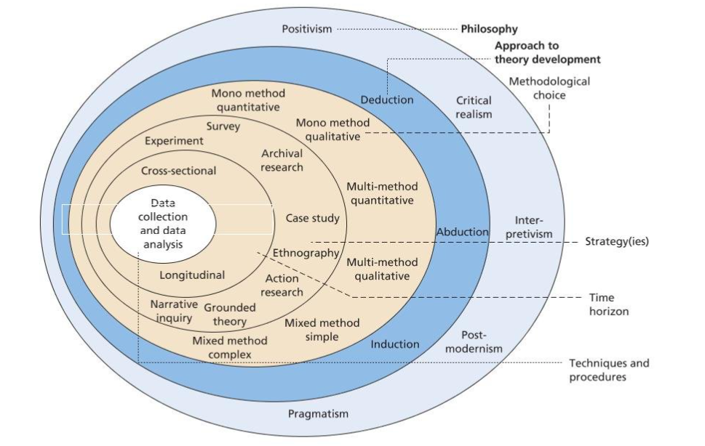
Figure 2.1: Research Onion By Saunders (2016, p. 124)

Techniques and strategies that are used to; obtain, analyse and represent the data and information collected affect the final overall design of the research. The researchers understanding and decisions affect the outer layers of the onion. These understandings and decisions determine how the researcher will decide which techniques to use to collect the data and how to best analyse the data collected. (Saunders and Tosey, 2012, p. 58)

The research onion forces researchers to question the way their research is to be presented, whether its through qualitative or quantative information, and how they present the type of data they have collected whether this be through deductive or inductive presentations.

The research onion forces researchers to identify the type of research conducted, regarding if the research will represent qualitative information that “tends to be concerned with words rather than numbers”. (Bryman and Bell, 2007, p. 402) Or if the research conducted will represent quantitative information that “is based on observations that are converted into discrete units that can be compared to other units by using statistical analysis” (Maykut and Morehouse, 2005)

The information collected will be qualitative, because this study will present information in a deductive manner, allowing theory to be analysed first which will then be linked to the findings (Bryman and Bell, 2007, p. 14) from the primary research conducted.

The primary research will be obtained by using semi-structured interviews where “the interviewee has a great deal of lee way in how to reply” (Bryman and Bell, 2007, p. 474) to the questions asked. Allowing a more personalised opinion from the participants, instead of them structuring an answer aimed to appease the researcher.
  - Paradigm

“The interpretivist researcher considers research is value bound,” explaining that this reflects “a function of a particular set of circumstances and individuals at a specific time” (Saunders and Tosey, 2012, p. 58). Interpretivist research philosophy focuses on the “way we as humans attempt to make sense of the world around us” (Saunders, Lewis and Thornhill, 2016, p. 134)
The interpretivist philosophy best suits this research because, it relates to the research being conducted, since the interviews are conducted about real life issues on sustainability and ethical issues, underpinning the statement made by Saunders regarding how the interpretivist philosophy that looks at how we attempt to understand the world that we live in and the effects our choices make.

  - Sample
The sampling process will consist of convenience sampling which “is one of the most commonly used sampling procedures” (Farrokhi and Mahmoudi-Hamidabad, 2012), allowing the researcher to choose the parts of interviews that relate to the study, and compare those selected.

  - Data Analysis and collection

    - Qualitative analysis

The results collected by the researcher will be used to create links with previous studies and hypotheses made and discussed throughout the study, allowing correlations with predications and possible discussions between previous research and the primary research conducted.

  - 2.3.2 Collection method

The research conducted will be obtained through detailed interviews, recorded safely on the researchers phone, and once the information has been noted from the interviews the recordings will be deleted from the phone. The researcher will prepare general questions, however the interview will be semi-structured to allow a broader comment from the interviewee. The information collected will be noted in paper form to e later used during the dissertation to refer to at convenient times.

2.4 Limitations
The sample size of the research is limited to 20 participants, 10 being from a younger age group while the other 10 are from an older age group, ensuring there is a equal amount of males and females from each of the age groups. This does not represent a large amount of information in terms of the general population, because it’s a small sample size, although the interview will allow a detailed answer process to best get the opinions of consumers in the now.

2.5 Ethical Risks
The ethical risks of the interviews are very low, as interviewees are going to be selected by the researcher, ensuring good participants are selected that fully consent and are happy to be used in the study, and are happy with the research proposed.
The recordings that are to be done for the interviews will be deleted when they have been recorded through written notes, the written notes will be kept safe at the researchers home and away from easy access from any visitors. Any information stored on the researchers laptop will be in particular files where only the researcher knows where they are kept, furthermore the researchers laptop is password protected for further security. The only times information from the dissertation study will be shared is when requested or needed to be seen by the supervisor overseeing the study.

- Resources and Planning

Many resources will be used during this study, these resources will underpin theories and enhance the study by presenting different view points throughout the dissertation, relating to ethics, sustainability and the types research undertaken.
Planning is the most important part of accessing resources and conducting research as it ensures that all resources are used efficiently and to the best knowledge presented, getting the planning right also allows apropiate time to integrate primary research findings with the secondary research collected.

  - Resources

The use of secondary research will be used in defining, explaining and theoretically underpinning the primary research being conducted. All literature reviews such as: journals, books and other types of articles will be accessed using the university online resources regarding the online lirary and also the library on campus.

  - Timescale

Gantt charts are great tools in setting timescale for which tasks should e competed by, and are used widely through academic writing and researching. A Gantt chart is a great way of organising tasks in order and all together in a table form to keep a close eye on the timescales tat are to e adhered to.

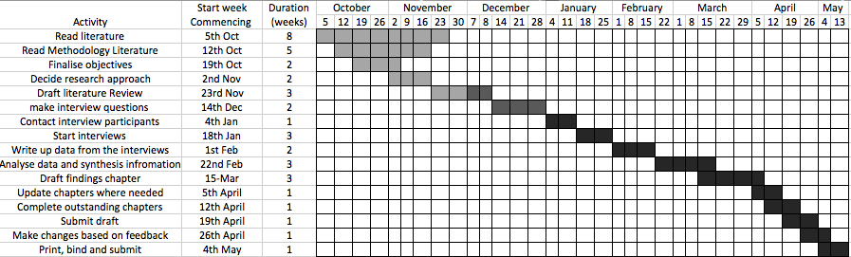

Stefko, R and Steffek, V (2018) ‘Key Issues in Slow Fashion: Current Challenges and Future Perspectives’, sustainability, 10, pp. 1 – 11.
DOI: 10.3390

Moyo, J, (2016) ‘Do you think fast fashion can ever be ethical?’, Ethical Trading Initiative [blog]. 16 September. Available at: https://www.ethicaltrade.org/blog/do-you-think-fast-fashion-can-ever-be-ethical (accessed 15 November 2018)

Moore, C.M and Birtwistle, G (2004), ‘The Burberry Business Model: Creating an International Luxury Fashion Brand’, International Journal of Retail and Distribution Management, Vol. 32 No. 8, pp. 412 – 422.

European Commissions (2018) Corporate Social Responsibility.
Available at: http://ec.europa.eu/growth/industry/corporate-social-responsibility_en
(Accessed: 18 November 2018)

Saunders. M, Lewis. P and Thornhill. A, (2016) Research Methods for Business Students 7th Edn. Pearson, pp. 2 – 134

Saunders, M. Tosey, P. (2012) ‘The Layers of Research Design’, Rapport, 30, pp. 58 – 59

Bryman. A, Bell. E, (2007) Business Research Methods 2 Edn. Oxford University Press Incorporated, New York, pp. 11 - 479

The Economist (2017) The environmental costs of creating clothes
Available at: https://www.economist.com/the-economist-explains/2017/04/11/the-environmental-costs-of-creating-clothes

Garcia-Torres, S. Rey-Garcia, M. Albaredo-Vivo, L. (2017) ‘Effective Disclosure in the Fast-Fashion Industry: from Sustainability Reporting to Action’ Sustainability, 9, pp. 1 – 23

Maykut, P. Richard, M. (2005) Beginning Qualitative research a Philosophic and Practical Guide. The Falmer Press

Farrokhi, F. Mahmoudi-Hamidabad, A. (2012) ‘Rethinking Convenience Sampling: Defining Quality Criteria’, Theory and Practise in Language Studies 2 (4), pp. 784 – 792

Carrigan, M. Attalla, A. (2001) ‘the myth of the ethical consumer – do ethics matter in purchase behaviour?’ The Journal of Consumer Marketing 18 (7) pp. 560 – 577

