

Student Name:
Student ID Number:
Programme: | Certificate of Higher Education Skills for the Workplace (Health and Social Care)
Module Title: | Professional Development within Health and Social Care
Module Code: | LCHS4009
Lecturer:

Table of Contents
Task 1: Curriculum Vitae (CV) .................................................................................................. 4
Task 2: Personal Statement ...................................................................................................... 6
Task 3a: SWOT Analysis ........................................................................................................... 7
Task 3b: Personal Development Plan (PDP) ........................................................................... 8
Task 4: Critical Reflection (Gibbs Model) ................................................................................ 9
References ............................................................................................................................... 12

Task 1: Curriculum Vitae (CV)

CHESSENEY
chesseny@gmail.com

PERSONAL PROFILE
Dedicated and reliable individual with extensive experience in food safety, hygiene compliance and high-pressure team environments, seeking to bring these transferable skills into a Health Care Assistant role. Demonstrates exceptional attention to detail and a professional attitude, with a strong track record of following strict health and safety procedures, safeguarding others, and maintaining calm, high standards of care under pressure. Currently studying towards a Level 4 Diploma in Health and Social Care, with a genuine commitment to promoting the dignity, wellbeing and safety of those in my care.
KEY SKILLS
• Health and safety compliance  • Attention to detail  • Calm under pressure  • Strong communication skills | • Team collaboration  • Time management  • Reliable and punctual  • Person-centred approach
WORK EXPERIENCE
Chef de Partie – Off to Work, Birmingham (Jan 2022 – Present)
• Followed strict health and safety and hygiene procedures at all times, ensuring full compliance with regulations
• Monitored conditions closely to reduce risk and protect the wellbeing of colleagues and customers
• Built and sustained positive, supportive working relationships across a busy team, fostering a harmonious environment
VOLUNTARY EXPERIENCE
Care Home Volunteer – Local Residential Care Home
• Assisted with mealtime support, ensuring food was prepared and served safely to residents with varying dietary needs
• Supported residents with daily activities and companionship, promoting dignity and wellbeing
EDUCATION
Level 4 Diploma in Health and Social Care (Jan 2024 – Present)
University of Wales, Birmingham
NVQ Level 3 Beauty Therapist (Jan 2013 – Jan 2015)
South and City College, Birmingham
ACHIEVEMENTS
• Successfully progressing through a Level 4 Diploma in Health and Social Care alongside full-time work
• Maintained a consistent, reliable record of attendance and punctuality across all roles
CERTIFICATIONS
• Food Hygiene Certificate
• Knowledge of Control of Substances Hazardous to Health (COSHH)
REFERENCES

Task 2: Personal statement
I am a dedicated, compassionate, and dependable person looking for the position of Health Care Assistant in which I will be able to use my practical experience, transferable skills and developing knowledge of health and social care to provide safe and person-centred care. In my long-term career objectives, I want to make my career in the healthcare industry by offering excellent care which ensures dignity, independence and wellbeing to people while making progress in my professional career.
At present, I am pursuing my diploma in Level 4 Health and Social Care at University of Wales, Birmingham. This course has provided me with enhanced knowledge related to concepts such as person-centered care, safeguarding, communication, equality, infection control, and professional duties in the health and social care environment. My studies have helped me gain the competence to relate theoretical knowledge with real-life experiences with the consideration of the need for evidence-based practice and continuous learning. Literature shows that continuing education and professional development lead to improved care provided by healthcare support workers (Boman et al., 2022).
In addition to my studies, I have been working as a Chef de Partie from January 2022. While not directly related to healthcare, this position has allowed me to gain some extremely useful transferable skills. My work in a challenging environment has helped me become much better at staying calm in such conditions, being able to prioritize tasks and perform efficiently as part of a multidisciplinary team. Adhering to stringent food hygiene, COSHH, and health and safety rules has made me pay more attention to details and be more concerned about the wellbeing of other people.
Moreover, my voluntary experience at the residential care home has enabled me to gain great insights into the care for older people in a dignified manner with compassion and respect. By offering assistance during meals to the residents has improved my interpersonal communication and empathy skills and increased my confidence in dealing with people with varying physical and emotional requirements. This has further affirmed my interest in joining the health and social care sector and helped me understand the significance of treating everyone with kindness and respect. Studies have shown that person-centered communication in a compassionate manner improves the quality of care (Kwame and Petrucka, 2021).
My personal strengths dependability, promptness, adaptability, perseverance, and a great desire to learn. I have always taken pride in offering myself as a dependable and professional person who works towards delivering great outcomes through adhering to the policies of the organisations where I work in collaboration with my colleagues for the well-being of those receiving health care services. I fully understand the need to maintain confidentiality, safeguarding, and respect the diversity in healthcare settings. I firmly believe that through my learning, experience, and dedication to improve myself, I can become a worthy member of your team.

Task 3A: SWOT Analysis
It will be my ambition to become an effective Health Care Assistant using my available transferable skills and also developing myself. A SWOT analysis of myself has enabled me to assess my suitability for this career and also areas that I need to improve on.
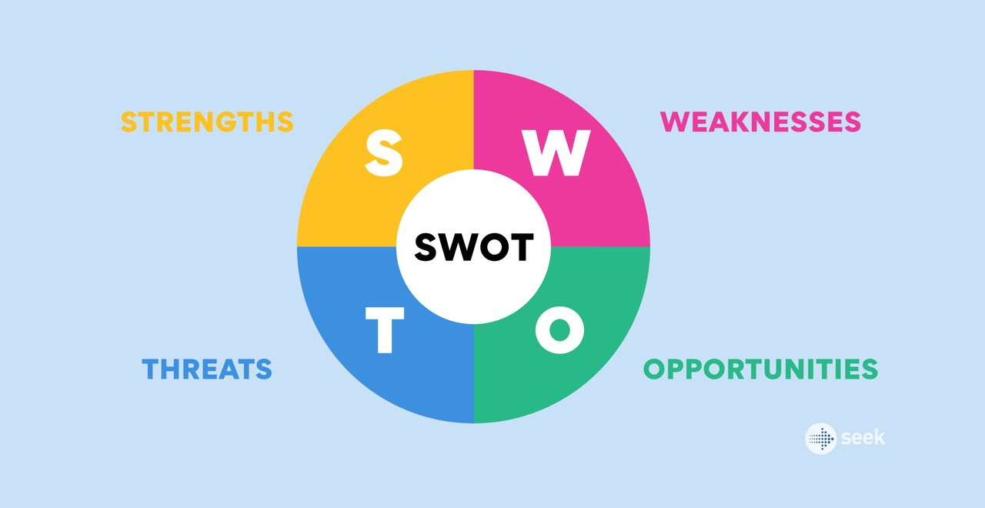
(Gunnai, 2024)
Strengths
My key strengths are those related to the knowledge of health and safety, food hygiene, and COSHH, all of which have been developed during my experience as a Chef de Partie. My fast-paced working environment has also improved my skills in staying calm, communicating well, and working as part of a team. Furthermore, undertaking studies for the Level 4 Diploma in Health and Social Care has helped me develop my skills in safeguarding, person-centred care, and professional practice.
Weakness
My primary weakness is that of not having any paid work experience in a health care environment. While working in a voluntary capacity at a residential care home was beneficial in improving my confidence in helping senior patients, I am well aware of the fact that my knowledge in providing care and using digital health records needs further improvement.
Opportunities
These include the completion of the Level 4 award, the achievement of the Care Certificate, employer training and learning from health care practitioners. Such opportunities will allow me to develop my practical skills and prepare myself for future progress in becoming a senior support worker.

Threats

These threats may be posed by the emotional stress associated with taking care of people who are at risk, stiff competition for the HCA job and keeping abreast of health care policies and practices. Nevertheless, I think that my resilience and desire to learn will allow me to overcome these hurdles and become a valuable person to the healthcare team by means of reflective practice and continuous learning (Rasheed, Younas and Sundus, 2021).

Task 3B: Personal Development Plan
To prepare for a successful career as a Health Care Assistant, I have developed the following Personal Development Plan (PDP) for the next two years.
Development Goal | Actions | Timeframe | Monitoring and Evaluation
Complete the Level 4 Diploma in Health and Social Care successfully. | Attend all lectures, complete assignments on time and seek tutor feedback. | Within 12 months | Monitor grades, assignment feedback and achievement of learning outcomes.
Improve practical healthcare and documentation skills. | Complete the Care Certificate, undertake additional volunteering or workplace training and practise accurate care recording under supervision. | Within 18 months | Review supervisor feedback, maintain a reflective diary and evaluate confidence in practical skills.
Strengthen communication and person-centred care skills. | Attend CPD training, observe experienced staff, practise active listening and communicate respectfully with service users and colleagues. | Within 24 months | Evaluate progress through mentor feedback, reflective practice and self-assessment against professional standards.

This development plan consists of objectives that are reasonable in accordance with the experience I have now and the career aims I have for the future. Reflective records kept by reviewing my academic progress and getting feedback from tutors and supervisors will allow me to assess my abilities and to see what else I need to learn. Assessing my progress every six months will make sure that the objectives are still reachable and appropriate in relation to the expectations of a Health Care Assistant. The literature shows that such professional development and reflection increase competence and improve quality of health care provided (WHO, 2022; NHS England, 2023).

Task 4: Critical Reflection Using Gibbs’ Reflective Cycle
The following reflection has used Gibbs’ Reflective Cycle (1988) to analyze the performance of my presentation on ‘Critical Thinking’ within LCHS4009 Component 1. This cycle provides an opportunity to reflect systematically on an event using six steps including description, feeling, evaluation, analysis, conclusion, and action plan. This reflective process has enabled me to realize my strengths and weaknesses.

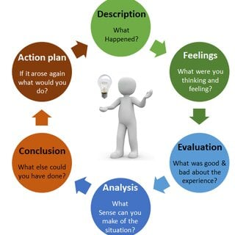
(Tsang, 2023)
Description
My presentation was delivered within five minutes on the theme of the significance of critical thinking for the practice of health and social care services. I was able to show how critical thinking helps in making decisions based on evidence, solving problems and providing safe and individualized care for people. I prepared my presentation through thorough research and organization of my presentation slides and rehearsals. My lecturer noted that I made eye contact and articulated well.
Feelings
Before delivering the presentation, I had some apprehension since I wanted to pass my message in a confident manner within the given time frame. I feared that my nerves would hinder my delivery or make me forget some important points. After introducing the subject matter and starting my explanation of the key ideas, my confidence started growing. The audience’s active participation motivated me to maintain focus and be able to communicate naturally. The successful completion of the presentation boosted my confidence and proved the importance of being prepared for presentations (Moloney-Harmon et al., 2022).
Evaluation
Overall, I feel that my presentation was a success because I managed to effectively communicate my key ideas within the given time limit. My lecturer provided me with constructive criticism pointing out my ability to maintain eye contact and explain things effectively which proves that I was successful at verbal and non-verbal communication. In addition, I managed to present information in an order that would make it easier to understand my arguments. I realized that I was nervous at the start of my presentation which affected my confidence and speech speed to some extent.
Analysis
In this experience, I learned that apart from having the knowledge of the topic, other things are required to give a good presentation. One requires skills in communication, confidence, and audience involvement. Critical thinking is one of the most important skills for the professionals as it allows healthcare workers to analyze, problem-solve and take good decisions that will benefit their patients. It was highlighted in my presentation that healthcare professionals can make use of critical thinking to provide quality and effective services. Studies have shown that reflective practice can help to develop critical thinking skills, clinical reasoning and professional development through self-evaluation of performance and improvements in learning process (Artioli et al., 2021). Moreover, communication and presentation skills help in building professional confidence.
Conclusion
Analyzing this presentation has helped me realize how much preparation and organization played an important role in my success. Even though I was somewhat anxious at first, I was able to speak well and got good comments about my eye contact and explanations.
Action Plan
In future presentation, I am going to continue practicing regularly to enhance my confidence and lessen any form of anxiety that may come up before I start presenting. More examples about the healthcare practices shall be included to create greater interaction with the audience. Feedback on my performance shall be sought from lecturers and fellow students. Also, I shall record myself while presenting and use reflective practice to evaluate my performance. This will aid my development in terms of professionalism (Artioli et al., 2021).
REFERENCES
Artioli, G., Foà, C., Turrini, M., Ferlito, S., Pavan, P. and Bisi, M.C. (2021) ‘The role of reflective practice in healthcare professions: A systematic review’, BMC Medical Education, 21(1), 394.
Boman, E., Glasberg, A.L., Levy-Malmberg, R. and Fagerström, L. (2022) ‘Thinking outside the box: Healthcare support workers’ perspectives on competence, development and quality of care in healthcare’, BMC Health Services Research, 22(1), 1416.
Gibbs, G. (1988) Learning by Doing: A Guide to Teaching and Learning Methods. Oxford: Oxford Polytechnic.
Kwame, A. and Petrucka, P.M. (2021) ‘Communication in nurse–patient interaction in healthcare settings: A scoping review’, International Journal of Environmental Research and Public Health, 18(22), 11743.
Labrague, L.J., McEnroe-Petitte, D.M. and Fronda, D.C. (2022) ‘Learning styles, reflective practice and professional competence among nursing students: A cross-sectional study’, BMC Nursing, 21(1), 82.
Moloney-Harmon, P.A., Deardorff, K., Schick, L. and Farris, C. (2022) ‘Strategies to reduce presentation anxiety and improve communication confidence in healthcare education’, Nurse Education Today, 118, 105518.
NHS England (2023) NHS Long Term Workforce Plan. London: NHS England.
Rasheed, S.P., Younas, A. and Sundus, A. (2021) ‘Self-awareness in nursing: A scoping review’, BMC Nursing, 20(1), 227.
World Health Organization (2022) Health and Care Workforce in Europe: Time to Act. Copenhagen: WHO Regional Office for Europe.

