Knowledge and information management skills for the workplace

Mohamed Kalam

(BMSW5106_LON)

Tsvetomila Metodieva
1808619



CONTENT

Executive Summary 1
Introduction 1
Evaluation the concept and importance of knowledge management 2
Relationship between data, information and knowledge 2
Relationship between individual and organization knowledge 5
Techniques and theory to identify knowledge 6
Evaluation of Amazon’s knowledge 7
Knowledge management process 9
Create, store and apply knowledge 9
Importance of intellectual property 11
A framework for establish a knowledge management culture 11
Contribution knowledge assets on Amazon 11
Knowledge requirements evaluation for Amazon 12
Amazon knowledge sharing evaluation 13
Recommendation for improvements of Amazon framework 13
Conclusion 15
References 15

Executive Summary

The main goal in this assignment is to be recognized and focus on the Amazon framework, where it will be shown the value of recognizing that the successful processing, distribution, storing and retention of information is an important prerequisite for the implementation of appropriate knowledge management performs. There will be five section including Introduction, first part, second part and third part of the main body and of the and conclusion. In the first part evaluation the concept and importance of knowledge management it will be covered Relationship between data, information and knowledge, Relationship between individual and organization knowledge, Techniques and theory to identify knowledge and Evaluation of Amazon’s knowledge. Second part is knowledge management process, where it will be explained how to create, store and use knowledge, together with importance of intellectual property. The third part is about a framework for establish a knowledge management culture including impact knowledge assets on Amazon, knowledge requirements evaluation for Amazon, Amazon knowledge sharing evaluation and recommendation for improvements of Amazon framework. There will be a conclusion of the end of this work. The chosen organization is Amazon as preferred platform to buy thigs from there.

Introduction

Knowledge has been the greatest source of creating wealth since the end of the 20th century. In corporate environments, it was believed that the key source of strategic advantages resides in what an company learns, how it applies its expertise and the capacity to discover new information (Barney, 1991). Awareness management is the application of common knowledge in order to accomplish the corporation's business targets. In order to be identified Amazon knowledge management awareness, how they create, share and store information it will be analyzed all tree part below.
Amazon.com has been supporting consumers globally over the past two decades. Amazon.com was created by Jeff Bezos back in 1995. The dream of the creators was to create a modern store for book lovers. Amazon.com takes the world's greatest online retailer to the doorstep of customers across the globe. What people need to do is check and pick the what they like. Amazon provides its offerings to four groups of clients, buyers, vendors, companies and content creators. Emerging as an American international E-Commerce Company, Amazon has proved to be the largest internet marketplace and supplier of cloud storage resources. Two innovations behind Amazon's success have been the incorporation of Consumer Experience Management and Data Management into the broader corporate approach. Linux has been a driving factor behind Amazon's technology, the organization's IT software has been designed in such a way that it can manage more than millions of purchases and even address requests and problems with more than half of the market value (Amazon, 2020).

Evaluation the concept and importance of knowledge management

Knowledge management (KM) often goes across the next phases: information development, knowledge acquisition, knowledge storing, knowledge distribution with other individuals, and knowledge deployment, thereby creating a life cycle of its own (Macintosh, 1995). Knowledge management definition provides the capability to obtain the needed info in the short term to insure that everyone can make the best decisions on market conditions, goods, facilities, competitive strategy or any other activity that is important to the success of the organization. (Shockley, 2000). Although, knowledge management is a mechanism in which the company creates knowledge-based principles in its intellectual properties (Santosus & Surmacz, 2012).

Relationship between data, information and knowledge

Company, in general, with the use of information management principles in practice, intention to accomplish two objectives: first, the formation of new knowledge for the advancement of growth and the benefit of modest benefit on the market; and, secondly, the diffusion of existing knowledge to increase the efficiency of the organization. The main drivers behind today's enhanced importance in and implementation of information management lie in four key areas: Company globalization,, leaner organizations, corporate amnesia, creating problems of consistency of information for the company, and technological advances (K, 2011).

Diagram 1: Relationships between Knowledge, Information, And Data

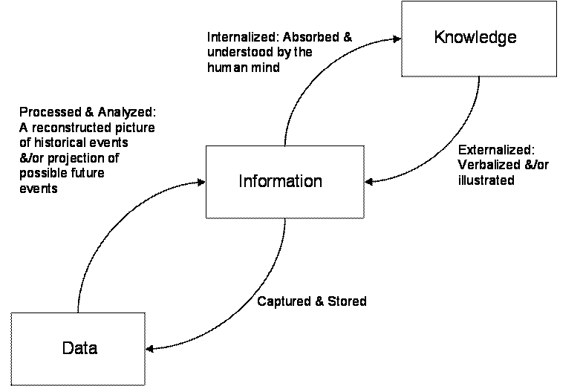

Source: http://www.tlainc.com/articl134.htm

In the Diagram above is shown the key to recognizing the connection between information and knowledge is to realize wherever the info is stored. Moreover, that knowledge is basically a message that is created by events and circumstances. However, information exists in the storage media (database, writing, video tapes, etc.) in the form of records, or in the human mind as intelligence. The difference between data and information vis-à-vis information and knowledge is evident, i.e. at the same moment they occupy different spaces. This additionally clarifies why many see data and details, as well as information and expertise, as synonymous. one man's data may be the information of another man, and vice versa, depending on the context" (Stewart, 2002).
Data management is the documentation, preservation, arrangement, processing, retrieval and review of data. It is the analysis of current or past experiences as sources for decision-making and/or problem-solving. Information management involves the interpretation of a description of historical events, the compilation of current or recent business data, together with the prediction of possible future developments (forecasting and scenario planning) and, of course, a decision-making and/or problem-solving process. Action can then be taken and then checked. Knowledge management, on the other side, is, in turn, the supervision of resources related to human capital, such as the client, manufacturer, strategic alliance, social capital and institutional capital, the origins and storage of knowledge; and the distribution of information, such as knowledge formation, exchange and deployment, to build and/or maintain corporate value and competitive advantage (Liew, 2007).
Amazon combines cloud storage and geoprocessing features to provide geoprocessing capabilities in a centralized network environment. Integration integrates geospatial modelling features with a scalable cloud computing framework to provide web-based geoprocessing capability. Amazon Cloud Computing Project is implemented to illustrate its application (Shao, et al., 2012).
Amazon Elastic Block Storage (EBS) is a database storage solution to use with AWS EC2, allowing customers to build system applications on demand and connect them to their AWS EC2 instances. Physalia is a proprietary database developed to perform this function in EBS and other related applications of Amazon Web Services. Physalia promises stability and maximum performance, including in the case of network partitions, as well as a reduced blast range of faults. This strives to struggle gracefully and partly, and to prevent large- errors (Brooker, et al., 2013).

Relationship between individual and organization knowledge

A variety of authors, such as Weick (1978) and Simon (1976), claimed that companies had little cognitive capacities (Weick, 1978), (H.A.Simon, 1976). It is more like people in companies that know. Nevertheless, a variety of experts, such as Starbuck (1983) and Nelson and Winter (1982), suggest that companies improve their absorbing capacities. Companies develop and gain information throughout their procedures and repertoires, which are part of a corporate context (Nelson & Winter, 1982), (Starbuck, 1983). Within an organization where the amount of contacts with group participants is held to a minimal, much information resides under the hands of people rather than the company. However, a significant part of the information is internalized within the organization by casual meetings and encounters between workers (Bhatt, 1998). Individual knowledge, if not communicated with everyone, would have especially small impact on the corporate knowledge base. Hence, some of the key tasks for management is to promote the cycle of contact between workers to render them receptive to environmental stimulation so that their individual information is reinforced to assumed to add to the organizational knowledge ground (Novaka, 1994). Person awareness is the result of social experiences that have been produced in a collectively developed society. Moreover, individual awareness is often conveyed by personal imagination and personality-expression. Organizational awareness is embodied in the services and goods that a company produces and markets to its clients. Individual competence in an organization is a resource, but if management does not carefully cultivate individual capability, personal self-expressions develop organizational assets. Management should consequently build an atmosphere that allows its workers to work together and share expertise. This outcomes in increased awareness of workers and the development of corporate information by human experiences (Bhatt, 2002).
Amazon understands its staff and clients, the kinds of products they like and what they need it. Amazon utilizes innovative information development (KM) methods. We in the eLearning area will learn a lot from how Amazon is handling the interaction between consumers and content. If Amazon's self-service FAQs or online boards cannot fix the issue, consumers should reach out to a real individual. Callers provide 24/7 assistance and are almost never put off. Amazon has also been impressed by a free customer support programmed named "Mayday." Owners of Amazon Fire phones will press the "Mayday" button and immediately link to a tech advisor via screen. The customer recognizes the advisor real, while the counsellor just sees what is on the phone frame. This is yet another illustration of how critical human contact will be to maintain consistent customer care (Rosenberg, 2014).

Techniques and theory to identify knowledge

There are different knowledge management models. Some of them are The Von Krogh & Ross model, Nonaka and Takeuchi model, Karl Wiig KM model.

Figure.1
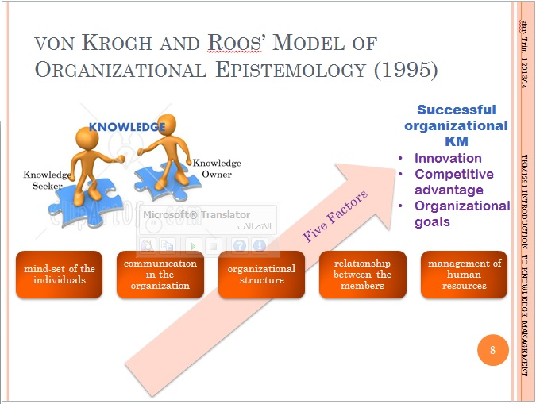
Source: The Von Krogh & Ross model (1995)
The von Krogh and Roos model of organizational epistemology (1995) is the first paradigm that specifically distinguishes between human information and collective awareness. This model analyses the following dimension of when and how information hits the workers of the corporation and enters the organization. What does awareness mean for employees, as well as for the organization, and what are the barriers. This model explores the essence of information management from the point of view of − Team leaders, connectivity and linking, organizational framework and architecture network between employees and human resources management.
Nonaka and Takeuchi (1995) analyzed the progress of Japanese firms in the area of imagination and innovation. They soon noticed that it was far from a mechanistic method of empirical understanding. They find that organizational creativity frequently derives from deeply abstract perspectives that can better be represented in the form of metaphors, phrases or symbols (Nonaka & Takeuchi, 1995).

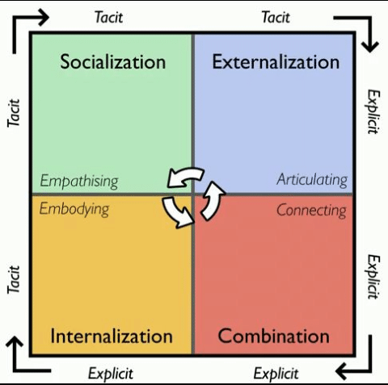
Figure. 2 Nonaka and Takeuchi model
Source: https://www.bing.com/images/search?view=detailV2&id=C36D108C6B81354F1FB967812FE135831F29F07D&thid=OIP.cW6um5cofphnP2-MsUH7FAHaHX&mediaurl=https%3A%2F%2Fwww.researchgate.net%2Fprofile%2FDania_Mohamad%2Fpublication%2F324502955%2Ffigure%2Fdownload%2Ffig1%2FAS%3A614944332603394%401523625562255%2FThe-SECI-Model-Nonaka-and-Takeuchi-1995.png&exph=477&expw=480&q=Nonaka+and+Takeuchi+++management+model&selectedindex=8&ajaxhist=0&vt=0&eim=0,6
Socialization is a process of implicit information exchange through study, emulation, experience and involvement in formal and informal societies and classes. Externalization is a method used to convey implicit information through specific terms. Combination is a method for incorporating ideas within an information structure. Internalization is the process of representation of concrete information tacit knowledge (Nonaka & Takeuchi, 1995).
Karl Wiig KM model (1993) is a fundamental theory that says that information must be structured and coordinated in order to be usable and efficient. Any of the critical dimensions of the WIIGS KM model are − completeness, accessibility, congruence and viewpoint and intent. Completion explains how much applicable information is accessible from a specific source. The more knowledge artefacts are linked to each other, the more the information base becomes related, the better the material becomes compatible and the stronger the meaning. Information base is congruent because all data, ideas, viewpoints, beliefs, decisions and relationships are congruent. The information base is coherent because all the data, ideas, viewpoints, beliefs, assumptions, and emotional relations and interactions between the artefacts are clear. This is a methodology in which we learn something except from a different point of view with a certain reason (Wiig, 1993).

Figure.3
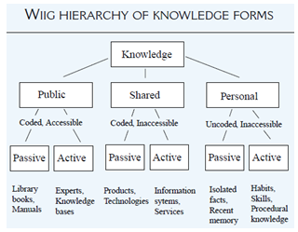
Source: https://www.bing.com/images/search?view=detailV2&id=ADCF44D7B419FAB2B75CE2F80E1173C8830FF2E9&thid=OIP.GXApQMBiZ2BI77kY36365QAAAA&mediaurl=https%3A%2F%2Fkmwiki.files.wordpress.com%2F2014%2F01%2Fwg.png&exph=249&expw=320&q=karl+wiig+km+model+1993&selectedindex=1&ajaxhist=0&vt=0&eim=0,6&ccid=GXApQMBi&simid=607988882820500303&sim=11
Having reviewed the above theory it can be stated that Amazon using Novaka and Takeuchi Model. The sign in Amazon method gathers the details of the current customer with the correct fields to be filled, which are specifically related to the Infomediary model. The next time a customer visits Amazon's platform, he / she will be given a selection of product reviews available in Amazon. Amazon utilizes cloud infrastructure in communications with consumers. The company's AWS software worked not only as a commodity but also as a tool for the efficient incorporation and maintenance of information systems (V.Helsing, 2011).

Evaluation of Amazon’s knowledge

According to a report by (Davenport, 1998), the majority of knowledge management (KM) initiatives have one of three objectives: (1) to render information accessible and to illustrate its position in the organization, primarily through charts, guides and hypertext tools; (2) to build a culture of appreciation through promoting and combining activities such as information sharing and actively searching and arranging knowledge; building knowledge substructure: a mesh of networks between people being assumed space, time, instruments, and inspiration to converse and cooperate (Hsia, et al., 2006).
Amazon is one of most popular platforms in allowing customers to have positive reviews. Customer input on material performance is one of the most important measures to evaluate KM efficacy. It is a lot more effective than website visits or updates, for example. This also allows consumers to easily differentiate relevant and valuable material based on input from peers (Rosenberg, 2014). Amazon employs knowledge management (KM) concepts and standards to bring tremendous value to its consumers in several respects. A unified platform and framework provide workers with a standard, recognizable and simple to use access to information at work in all ways. Courseware, eLearning, platform, photos, on - the-job tools — all exist in the same location. Involving manufactured goods explanations to ratings, specifics about each commodity is presented in the same manner and in the same sequence, whenever possible. Workers do not have to work out whether to translate or understand it if it presents it differently. Metaphors, flowcharts, and other organizational constructs have meaning, however if each location requires its own design approach, including its own learning curve, this interest dramatically reduces which can be disconcerting to consumers. They organize every website on Amazon in easy-to-read pages. This helps staff to easily view to the information they need and relieves them from spending hours searching complicated documentation or hints to locate everything they need (Amazon, 2020).

Knowledge management process

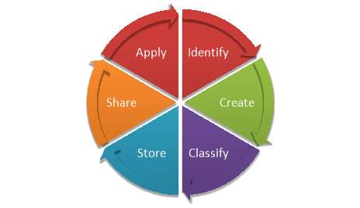
Create, store and apply knowledge
Figure.4

Source: https://www.google.co.uk/search?q=%E2%80%A2%09Create%2C+store%2C+apply+knowledge&tbm=isch&ved=2ahUKEwjXksHKx8zoAhXW_4UKHRmOBEkQ2-cCegQIABAA&oq=%E2%80%A2%09Create%2C+store%2C+apply+knowledge&gs_lcp=CgNpbWcQA1DxvQJYps4CYLvRAmgAcAB4AIABOogB1gKSAQE3mAEAoAEBqgELZ3dzLXdpei1pbWc&sclient=img&ei=g1SHXpfFEdb_lwSZnJLIBA&bih=614&biw=1366#imgrc=A9Z6B6QfspJuXM
Knowledge Management System (KMS) is an integrated set of individuals, processes, tools, databases and technologies developed to develop, maintain, exchange and access the knowledge and expertise of an entity. Explicit information is empirical, and it can be calculated and recorded. For example, by reviewing the initial budgets and real spending of a few programs, it is important to determine the categories of programs are more likely to move above the budget. Tacit information, on the other side, is not so easy to calculate and more challenging to formalize (Igbinovia & Ikenwe, 2017).
Knowledge management (KM) has been a necessity for corporate success and an asset due to the advantages it offers. The value of information management in organizations to promote creativity, facilitate free exchange of innovations, maximize sales and decrease costs, improve productivity and performance. KM increases the success of the enterprise by improved capacity, competitiveness, sustainability and creativity. Improves efficient decision-making, streamlines cycle time, eliminates rework, maintains strong data security and improved communication. KM often improves the interest or financial benefit of an entity by considering the expertise of the corporate leaders as an commodity equivalent to the capital plant (Igbinovia & Ikenwe, 2017).
Information is usually held in the form of an information archive that contains records, reports and databases. Specialized technological applications are required to arrange this content in a secure and functional way (Igbinovia & Ikenwe, 2017). Ikenwe and Igbinovia (2015) identified knowledge sharing as a core focus of knowledge management and characterized it as an act by which information, expertise, ideas, expertise and experience are transmitted and exchanged amongst individuals, organizations and organizations. Once information is exchanged by the people in the organizations, exchanged information can be used to solve the issue (Dhamdhere, 2015b).
Amazon shall include the name, address and, to our understanding, shareholding of each shareholder supporter after oral or written notification by the shareholder to Amazon.com, Inc., Corporate Secretary at Amazon.com. Amazon's managers have a legal duty to regularly analyze and assess the most suitable governance system for Amazon and its owners, taking into consideration our personalities or conditions at any given moment (Amazon, 2020).
Amazon has been at hazard of handling and protecting credit card and debit card records for more than 1000 consumers a day (Jordon, 2008). The business utilizes the Business Resource Management Consumer Experience Management System to store customized details and purchasing patterns for its clients and is combined into the publicity and advertisement strategy of the organization. Customers 'identifying records on their credit card history, spending record, order record, email, previous buying background is stored in the archive. The order processing system shall take control of the transaction record using the protected operation form and offer guidance to the distribution network for the execution of the shipment. Consumer suggestions, consumer preference, wish list, product reviews online page program gathers consumer details (Amazon, 2020).

Importance of intellectual property

Intellectual Property Rights (IPRs) are constitutionally recognized proprietary privileges of mind-creation. Within such privileges, as in any other type of traditional ownership, intellectual property can be purchased, leased, registered or shared. Under the statute on intellectual property, owners are given some proprietary rights to a range of intangible properties, such as cultural, literary and creative works; innovations and inventions; names, expressions, images and designs. In relation to real properties, intellectual property is a person's intangible possession. Intellectual Property Rights (IPR) are the sole protection of the authors of their works. Popular forms of intellectual property protection include licenses, trademarks, patents, product designs, regional markings, trade secrets, architectural designs for integrated circuits and even concepts. Rights are an opportunity for the author to create his or her work and share it with others for the benefit of society (Sharma, 2014).
Amazon provides a consistent shopping experience for its customers. When selling on Amazon, the buyer acknowledges that the sale of unauthorized goods is strictly forbidden, and that no items which are not lawful for sale, such as goods which have been unlawfully copied, recycled or imported, can ever be 2offered. There is a need to have evidence of the quality of the goods if the paperwork is demanded by Amazon. Copyrights for Amazon are legal safeguards for original works of authorship. Trademarks are legal provisions for a term, image, logo or variation of the same that a corporation uses to distinguish products and services (Amazon, 2020).

A framework for establish a knowledge management culture

Contribution knowledge assets on Amazon

Knowledge assets are the basis of the competencies and skills of an enterprise that are considered necessary for its success, strategic advantage and development of human. The most valuable expertise assets were defined as skilled professionals, technical capabilities, know-how, computer technologies, communication resources, media networking and networks, electronic journals and repositories, intellectual property rights, licensed prototypes, web material, copyrights, operational procedures (Kamasak & Ycelen, 2010).
Throughout the Amazon E2C program, S3 serves as a backup system for the usage of the Cloud. The gui allows end users to store, access, and use any amount of data from any place that is unrelated to time. Users continue searching to locate the items they want to purchase. Task Agent is the operating concept utilized at this juncture by Amazon. Amazon charges a price to end-users for the mode of usage. Auction brokers are also another method utilized by Amazon that provides details on bidding and completion. Amazon also issued a patent (U.S patent Feb 8, 2005) for providing customized products to the consumer with the aid of monitoring the behavior of customers during the surfing session. Amazon also developed a web-based social networking site that also provides more interactivity (Amazon, 2020).
The technology used by Amazon includes web service, middleware, group ware and, most importantly, networking. They are the foundations of knowledge technology programs. Logistics, payroll and human resources are the business structures connected with the Internet. Amazon infrastructure and business processes are interlinked with vivid hierarchical network management structures that are interdependent (Bryce, 2009).

Knowledge requirements evaluation for Amazon

At Amazon, people interact with knowledgeable, committed people who are creating innovative goods and services on behalf of their consumers every day. Amazons Leadership Values inspire them to be stakeholders and innovators while retaining consumer focus. We can take chances – creativity needs failure (Amazon, 2020). Amazon's strategy has been strategically crafted to compete faster than rivals and to gain a consistent strategic edge by leveraging its extremely qualified and knowledgeable C-Level, management and specialist staff as important and unique tools that are allowed and driven by the cloud and information technology stack. That's why Amazon.com also includes production management, inventory creation, R&D, marketing and HR departments that are organized in various areas and advances, instead of front office sales staff or cashiers that are like traditional stores (Amazon, 2020).
What makes Amazon great is not only how it handles content; other sites do that well (such as WebMD, Wikipedia, Flipboard, My Yahoo, and many more), but how it adapts to the needs and desires of customers, and how it links customers to knowledge given by others. The method, commodity, technological and strategic expertise of Amazon is available in an easy-to-use, transparent and reliable manner (Amazon, 2020).

Amazon knowledge sharing evaluation

Customer availability via the Amazon.com marketplace has given Amazon with an added gain to enhance its business. Amazon utilizes a broad variety of approaches to pick consumers by understanding their consumer actions. Amazon's early focus was persons who enjoy books. Yet the days of the target audience are long and demanding. Amazon's PR policy, via its app, is targeted at inspiring customers to use amazon.com. Each consumer who buys from amazon.com has his / her profile on the Amazon website. Amazon.com maintains a directory for your purchase, client records, credit / debit card. Via a consumer account, Amazon learns about the user, their personalities and, finally, they will accommodate them. Amazon also invites consumers to attach preferred things to the wish list. It allows Amazon to learn the consumer more. Amazon allows it easy to create links with the user, collaborate and interpret their desire and support Amazon achieve buyer trustworthiness and start the environment of the voice. During the first 3 months of 2000, Amazon gained 3 million additional buyers without any spending. Consumer amazon incorporates elements acquired from a customer archive, request list, etc. Amazon also introduced a range of tools to satisfy the user. 1-click shopping was an outstanding method, innovated by amazon, with sales of less than 20 sec to allow transactions (Amazon, 2020).

Recommendation for improvements of Amazon framework

Having reviewed strengths and weaknesses of some of the theory above it can be suggest some area where Amazon needs improvement. If customer experience management is concerned, Amazon must give consumers the possibility of selecting a given product based on recent items, ratings and scores provided by consumers. Technical problems are the most limiting factors for the introduction of modern technologies, Amazon has been increasingly plagued by phishing problems that challenge consumers for billing details from Amazon's current users. This must be tackled by robust anti-phishing measures that foster consumer understanding (Allen, 2009).
Amazon should improve the convergence that turned out to be the result of the incorporation of knowledge from ads, distribution and post selling facilities. Use enterprise supply development resources in social networking will help Amazon exchange comments and end-user feedback that would increase trust among consumers (Anderson, 2011).Although Amazon should build more consumer experience strategies and strengthen its distribution operations accordingly. It calls for further human capital distribution and extension to unexplored industries. Use evidence from consumer buying patterns, Amazon wants to evaluate the next big opportunity in terms of demographics. Providing consumers with personalized language expectations at the time of purchasing would improve their shopping experience. Analytics is a philosophy of knowledge technology for Amazon, because the organization wants to support not just customers but also corporate partners and companies who do corporate through Amazon (Goldsmith, 2011).
The usage of synthetic brainpower technologies as a method to improve consumer trust is also another suggestion that will succeed with Amazon throughout the future. The usage of smart computer agents will set the path for Amazon and its information systems. Further improvements need to be made to the way knowledge structures communicate with individuals. Amazon has to insure that continuous integration is the standard because Amazon's E approach has to be agile enough to satisfy evolving consumer expectations and desires (Goldsmith, 2011). The integration of intelligent software agents of all MIS structures requires to be conveyed to all stakeholders. Using avatars and identifying the avatar solely as an agent for Amazon's company will bring about a shift in the usage of Management Information Systems (Shanahan, 2011).
Supply Chain Management, Customer Experience Management, Project Management and Human Resources Planning in Amazon will be guided by the usage of clever computer agents. The usage of Intelligent Virtual Agents would allow the company to focus less on the Customer Service Center which may reduce high human resource expenses (Weber, 2010). Amazon's ad strategies ought to be better responsive to the desires of consumers. The usage of customer data belonging to a single group would encourage this trend by providing updates that are more relevant to the desires of the user population. Amazon's advice would not specify whether it should improve the technologies or framework, instead it should provide recommendations about comparisons and the better usage of usable knowledge (Bryce, 2009).
Employees should be given ways and means of monitoring the amount of consumer grievances and returned items via ERP bundles, which would boost pro-active offline customer support and enable Amazon to achieve more exciting affection among its consumers (Scott, 2009). With the rise of social networking in both virtual and non-web ways, Amazon would be able to further broaden its market, effectively giving Amazon's consumers a long-lasting emotional impact (Lewis, 2011).

Conclusion
In general, knowledge management is a systemic attempt to allow knowledge and information to evolve, move and create interest and has a role to play in ensuring that people should have the right knowledge in the right spot at the right moment (O'Dell & Hubert, 2011).
Having review and evaluate some of the theory and Amazon framework above, it can be concluded that the focus shown the value of acknowledging that the effective managing, sharing, storing and retention of information in this organization. Amazon understand the importance of well create, store and share information. Knowledge management is well managed between individual and an organization.

References

Allen, K., 2009. Viral Marketing 100 Success Secrets- Secret Strategies, Buzz Marketing Tips and Tricks, and Interactive Marketing. Volume 2nd, pp. 15-45.
Amazon, 2020. Amazon. [Online]
Available at: https://ir.aboutamazon.com/annual-reports-proxies-and-shareholder-letters/default.aspx
[Accessed 3 4 2020].
Amazon, 2020. Amazon culture. [Online]
Available at: https://www.aboutamazon.com/working-at-amazon/our-culture
[Accessed 04 04 2020].
Amazon, 2020. Amazon seller central. [Online]
Available at: https://sellercentral.amazon.com/gp/help/external/help.html?itemID=201165970&language=en_US&ref=efph_201165970_cont_201361070
[Accessed 28 3 2020].
Anderson, J., 2011. Planting Design Essentials. 8 ed. s.l.:The Crowood Press Ltd .
Barney, J., 1991. Firm resources and sustained competitive advantage. Journal of Management, Volume 17(1), pp. 99-120.
Bhatt, G., 1998. ``Managing knowledge through people’’, Knowledge and Process Management. Journal of Business Transformation, Volume 5, pp. 165-71.
Bhatt, G. D., 2002. Management strategies for individual knowledge and organizational knowledge. Journal of knowledge management, 6(1), pp. 31-39.
Brooker, M., Chen, T. & Ping, F., 2013. Millions of tiny databases. s.l.:s.n.
Bryce, M., 2009. Viral Marketing:Potential and Pitfalls. 4th ed. s.l.:VDM Verlag.
Bryce, M., 2009. Potential and Pitfalls. Viral Marketing:, 4th(VDM Verlag), pp. 78-89.
Davenport, T. a. L. P., 1998. How organizations work manage what they know. In: Working knowledge. Boston: Harvard Business Press School.
Dhamdhere, S. N., 2015b. Knowledge Management Strategies and Process in Traditional Colleges: A Study. International Journal of Information Library and Society. Dhamdhere, S.N. (2015b). Knowledge Management Strategies and Process in Traditional Co Journal of Information Library and Society, Volume 4, pp. 34-42.
Goldsmith, R., 2011. Viral marketing:get your audience to do your marketing for you. 1st(Prentice Hall Business), pp. 200-207.
H.A.Simon, 1976. Administrative Behavior: A Study of Decision-making Processes in Administrative Organization. 3rd ed. New York: Free Press.
Hsia, T., Lin, L., Wu , J. & Tsai, H., 2006. A framework for designing nursing knowledgemanagement systems. Interdisciplinary Journal of Information, Knowledge, and Management, Volume 1, pp. 13-22.
Igbinovia, M. O. & Ikenwe, J., 2017. Knowledge management: processes and systems. Journal of Information and Knowledge Managemen, Volume 5, pp. 26-38.
Jordon, M., 2008. The Secrets to Amazon Bookselling Success. 10thCreate space ed. s.l.:s.n.
Kamasak, R. & Ycelen, M., 2010. THE RELATIONSHIP BETWEEN KNOWLEDGE ASSETS AND ORGANIZATIONAL STRATEGY DEVELOPMENT.
K, D., 2011. Knowledege Management in Theory and Practice. Massachusetts: Massachusetts Institute of Technology..
Lewis, G. H., 2011. the complete guide to creating successful campaigns. Effective e-mail marketing, 1st(AMACOM Div American Mgmt Assn), pp. 235-238.
Liew, A., 2007. Understanding Data, Information, Knowledge And Their Inter-Relationships. Journal of Knowledge Management Practice, 8(2).
Macintosh, A., 1995. Position Paper on Knowledge Management. Artifical Intelligence Applications Institute. UK: University of Edinburg.
Nelson, R. R. & Winter, S., 1982. Nelson, R.R. and Winter, S.G. (1982), An Evolutionary Theory of Economic Change. Cambridge: Belknap Press of Harvard University.
Novaka, I., 1994. ``A dynamic theory of organizational knowledge creation’’. Organization Science, Volume 5 No1, pp. 14-37.
O'Dell, C. & Hubert, C., 2011. The New Edge in Knowledge: How Knowledge Management is Changing the Way we do Business. UK: APQC.
Rosenberg, M., 2014. The Knowledge Management Genius of Amazon.com. [Online]
Available at: https://learningsolutionsmag.com/articles/1480/the-knowledge-management-genius-of-amazoncom
[Accessed 27 03 2020].
Santosus, M. & Surmacz, ,. J., 2012. ABC of Knowledge Management. [Online]
Available at: www.cio.com/research/knowledge/edit/kmabc.html
[Accessed 09 03 2020].
Scott, M. D., 2009. how to use news releases, blogs, podcasting, viral marketing, & online media to reach buyers directly. The new rules of marketing and PR:, 2nd(John Wiley and Sons), pp. 02-0.
Shanahan, F., 2011. Amazon.com. 10(John Wiley & Sons), pp. 12-18.
Shao, Y., Liping , D., Bai , Y. & Bingxuan , G., 2012. Geoprocessing on the Amazon cloud computing platform — AWS. [Online]
Available at: https://ieeexplore.ieee.org/abstract/document/6311655
[Accessed 09 03 2020].
Sharma, D., 2014. INTELLECTUAL PROPERTY AND THE NEED TO PROTECT IT.
Shockley, W., 2000. Planning to Knowledge Management. s.l.: Quality Progress.
Starbuck, W., 1983. ``Organizations as action generators’’. American Sociological Review, Volume 48, pp. 91-102.
Stewart, T., 2002. The Wealth of Knowledge: Intellectual Capital and the Twenty-First Century Organization. London: Nicholas Brealey Publishing.
V.Helsing, 2011. E-marketing : the right customers at a lower cost. 2 ed. s.l.:Department of Trade and Industry.
Weber, S., 2010. Sell on Amazon: A Guide to Amazon's Marketplace, Seller Central, and Fulfillment by Amazon Programs. Sell on Amazon, 7(SAGE), pp. 33-37.
Weick, K., 1978. The Social Psychology of Organizing. MA ed. Reading: Addison-Wesley Publishing.

