

Student Name: Vishal Sapkal

Student ID: 2521152

Programme: Master of Business Administration
Module Name: International Business Concepts

Module code: LCMB7034

Report

Lecturer’s Name: Akshay Narayanan

Executive Summary
In this report, the potential expansion plan of ITC Limited in the UK FMCG market is critically examined by analyzing the company's international strategy, market attractiveness, environmental factors and suitability of the mode of entry and then providing recommendations. Analysis revealed that ITC had taken a transnational approach, with the focus on achieving global efficiencies and being locally responsive to enhance its international competitiveness. The UK market was proving to be very attractive due to the size of its FMCG industry, multicultural population, development of digital retail and consumer demand for sustainable products. The competition, regulations, retail control and operating expenses had, however, proved to be a big challenge. The report found that the potential success of expansion had been aided by ITC's ownership capabilities, the advantages of being based in the UK and the potential benefits of internalisation using Dunning's OLI Framework. The review of past international experience suggested that a gradual localisation model, driven by export, would have been better. So, a test-and-adapt market incubation strategy was recommended to minimise risk and promote sustainable growth of the UK market.

Table of Contents

Section 1 4
1. Organizational Classification and Global Strategy 4
2. Macro-Environmental Appraisal and Market Attractiveness 5
Host Country Analysis 5
Market Entry: Application of Dunning's Eclectic Paradigm (OLI Framework) 11
3. Entry Mode 13
Historical Pattern Recognition 13
Strategic Fit & Justification 14
Conclusion and Recommendations 14
Section 2 16
References 19

Section 1

Organizational Classification and Global Strategy
ITC Limited is a diversified Indian multinational company with a strong presence in the fast-moving consumer goods (FMCG), agribusiness, hotels, paperboards and packaging sectors. It has carved out a niche in the Indian market with its wide range of consumer brands, distribution network, sourcing and its product development skills. ITC has also got a long international track record with its products and exports being available in over 90 countries. Its FMCG portfolio consists of brands like Aashirvaad, Sunfeast and YiPPee! that can help it build upon in its international expansion. An international strategy allows for multinational firms to grow internationally and to be efficient while being responsive to the locals (Shenkar et al. 2021). It can effectively coordinate operations, knowledge sharing and competitive advantages across a variety of international market. According to Bartlett and Ghoshal's model (1989), international business strategies can be identified based on global integration and local responsivenes. The framework defines international, multidomestic, global and transnational approaches of multinational companies in their activity around the globe. Transnational Strategy is the key one adopted by ITC Limited and successfully blend in the required local market responsiveness with global efficiencies (Nambisan and Luo, 2022). This approach allows for innovation sharing, cost optimisations and adaptation to regional needs, thereby enhancing the competitiveness in international markets.
Coordination on a global scale and accommodating a variety of local requirements, however, adds up to a high level of organisation, managerial demands and implementation costs (Dako et al. 2021). ITC Limited has a diversified geographical presence with its business primarily held in India, with strategic plans in place for expanding business overseas. The company achieved gross revenue of ₹73,465 crore with net profit of ₹20,038 crore and exports worth ₹9,300 crore, catering to customers in over 90 countries, in FY2024–25 (timesofindia.indiatimes.com, 2026). While India continues to be its biggest market, overseas markets help to diversify revenues and help to stabilize against domestic economic cycles. For instance, wheat, rice, coffee, spices, and leaf tobacco are exported to Asia, Africa, Europe, the Middle East and North America from ITC's Agri Business, thus improving the utilisation of the supply chain. Additionally, the FMCG business, spread across a diverse portfolio, and the reverence achieved with the ITC brand assist in a broader market access and also in the business's long term competitive standing. The company's well-known brand portfolio in FMCG, backed by its wide sourcing, distribution and product development capabilities, allows it to meet various consumer needs in the domestic and international market (ITC Limited, 2026). It also helps to enhance its organisational resiliency by lessening dependence on a particular market and provides possibilities for diversifying income. Besides, they can also create valuable foreign exchange revenue and knowledge regarding the evolving tastes and trends for the international market which would boost ITC's brand image. These capabilities can enable long-term value creation by enhancing market reach, improving supply-chain efficiency and empower ITC to better adjust its response to industry and economic conditions, as well as to market fluctuations from a competitive point of view.

2. Macro-Environmental Appraisal and Market Attractiveness
The section will critically analyse ITC Limited's opportunity to enter the UK FMCG market, through assessing market attractive, macro-environmental factors and strategic considerations. It will use appropriate international business structures to recognise opportunities, threats and sustainable growth and expansion strategies.

Host Country Analysis
The FMCG market in the United Kingdom is worth £153bn, the grocery market is worth £240bn, the populations is 68.3 million (grocerygazette.co.uk, 2026). There is 97% penetration of the Internet into the population, meaning that the markets is an attractive opportunity for ITC Limited as it does support omnichannel retail. Many cities have large South Asian population which means a need for Aashirvaad, Sunfeast and YiPPee! products.
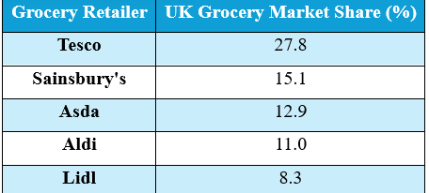
Table 1: UK Grocery Market Share (%)
(Source: Created by Author)
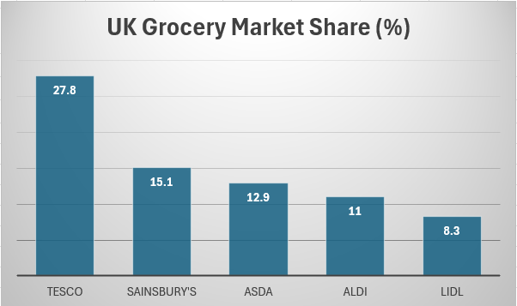
Figure 1: UK Grocery Market Share (%)
(Source: Created by Author)
However, the market is highly competitive, with Tesco (27.8%), Asda (12.9%), Aldi (11.0%), and Lidl (8.3%), and Sainsbury's (15.1%) dominating grocery sales (businesstats.com, 2026). On top of that, high marketing expenses, the strong private label competition and the strict regulations by the Food Standards Agency (FSA) pose a threat to market entry as consumers continue to demand healthier and more sustainable FMCG products. So, Political, Cultural, Economic, and Legal factors of the target country will be considered here.

Political Factors

Government Policies
A stable political environment with transparent governances and predictable policymaking, provided by a parliamentary democracy, is conducive to long-term foreign investments in the UK (oecd.org, 2026). The Worldwide Governance Indicator for government effectiveness indicate that the UK was 6th in the world in 2025. A consistent policy allows the FMCG industry to invest, plan the supply chain and expand retail outlets. In this way, ITC Limited will enjoy a business environment that is predictable, when launching branded packaged foods.
Tax Rules
Large companies in the UK are taxed at a corporation tax of 25% and most consumer good are taxed at a standard rate of 20% VAT (gov.uk, 2026). The pricing strategy of FMCGs, production costs, and the overall profitability are directly impacted by these tax policies within competitive retail markets. TCS could see declining profits and returns from investments due to increased corporate tax. In spite of this, the transparent tax regime help with financial planning and gives investors more confidence, ensuring the market can expand sustainably in the long runs with relatively high operating costs.
Trade Tariffs
The tariffs for processed food imports under the Global Tariff system in the UK range from 0% to 20% with tariff rates varying according to product category and country of origin (trade.gov, 2026). These tariffs have considerable impacts on import prices of FMCG, consumer prices, and the competitiveness of FMCG international supply chains. Future reduction in tariffs would make ITC more competitive to export to the UK as India is moving toward a Free Trade Agreement with the UK (m.economictimes.com, 2026). Until implementation, import taxes may create a higher cost of products than the cost of locally made FMCG products, and make the products less competitive.

Political Stability
The investment climates in the United Kingdom is relatively stable, with a score of 0.47 on the World Bank's indicator of Political Stabilities and Absence of Violence in 2024 (unstats.un.org, 2025). However, this has been impacted by recent policy change. Political stability boosts the confidence of consumers, the protection of business investments and efficient logistics throughout the FMCG sector. In ITC Limited's case, good governance will provide a conducive environment for long-term strategic investments and retail partnerships (itcportal.com, 2026). But, periodic uncertainties with regards to future trade deals and post-Brexit regulations could pose a continuing issue for operations and supply.

Economic Factors
GDP and Productivity
The UK economic activity rose by 0.6% in the first quarter of 2026 and productivity by 0.9% in a quarter and 0.4% in a year (cnbc.com, 2026).
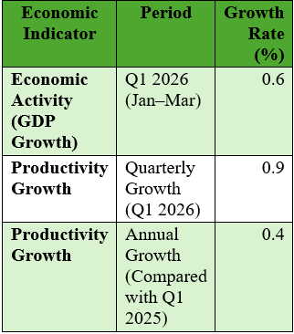
Table 2: Economic Growth Rate of UK ,2026
(Source: Created by Author; Referred to cnbc.com, 2026)
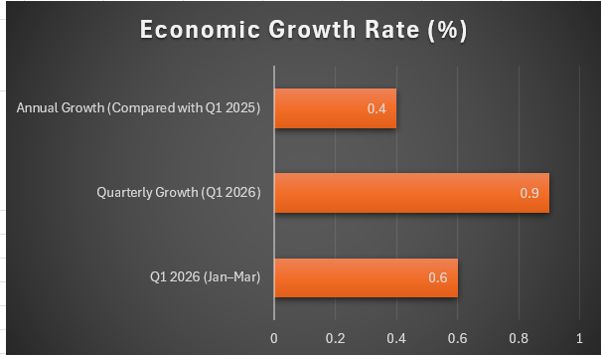
Figure 2: Economic Growth Rate of UK ,2026
(Source: Created by Author; Referred to cnbc.com, 2026)
Service output grew by 1.6% while manufacturing grew 0.5% (commonslibrary.parliament.uk, 2026). The strong economic growth strengthens FMCG demand via increased business activity and efficient production (Adewale et al. 2024). The growth in productivity has benefits for ITC Limited in terms of better distribution efficiency and market opportunities but the moderate growth in manufacturing may constrain ITC Limited's flexibility in its domestic supply chain.
Inflation, Interest Rates, Employment
CPI inflation continued at 2.8% in May 2026 and the Bank of England kept its interest rate at 3.75%. Average wages grew 3.4%, employment rose to 34.41 millions, unemployment increased to 4.9% and the employment rate slightly decreased to 75.0% (uk.finance.yahoo.com, 2026). The positive impact of rising income on FMCG consumption is offset by rising production, marketing and retailing costs due to inflation and borrowing costs. This meant that ITC experienced an increase in demand for consumers and an increase in operating cost.
Public Finances and Trade
The level of government borrowing rose to £46 billions and public debt climbed to 95.1% of GDP in May 2026. The trade balance was in deficit at £23.4 billions while the current account deficit was at £18.4 billions (2.4% of GDP) for the UK (tradingeconomics.com, 2026). Sterling was 0.8% higher than a year ago. The higher the deficit and volatility of the exchange rates, the higher the import cost are for FMCG companies. So, ITC could face currency risks, but a weak sterling may boost the competitiveness of exports.
Retail Sales & Retailer Confidence
During May 2026, the volume of retail sales grew by 0.4% on the quarter and 1.4% on the year. But, with economic growth, the GfK Consumer Confidence Index had slipped to minus 23, displaying the slow spending by households (census.gov, 2026). Growth in retail sale is helping FMCG growth as it drives up demand for products through both supermarkets and online sales. However, as confidence is low among consumers, they are looking for deals, and this allows supermarket private brands to gain a stronger foothold. As a result, ITC has to remains competitive and yet positioned as premium (itcportal.com, 2026). Thus, ITC has to find a balance where they are competitive but not too competitive to achieve the sustainable market penetrations.

Legal Factors
Labour Law
The Employment Rights Act 1996 gives employees the following protection: Redundancy payments, protection from unfair dismissal and statutory notice periods. The Equality Act 2010 prevents discrimination against employees on the basis of protected characteristics (legislation.gov.uk, 2026). In the case of ITC Limited, compliance will be a reinforcement of the goodwill of the employers and job retention. But higher employment requirements would result in higher recruitment, salary and HR costs, which would impact on operational flexibility and profitability.
Health and Safety Rules
Under the Health and Safety Act 1974, the UK has a main framework for the safety of the workplace (hse.gov.uk, 2026). It includes employers making sure that workplaces are safe, carrying out risk assessments and making sure they have proper safety equipment. These regulations minimize workplace accidents and create more reliable work practices when manufacturing and distributing FMCG products. Compliance will improve employee health, quality of products and reputation for ITC Limited. However, ongoing investment in safety systems, employee training and compliance monitoring leads to higher costs of operation.
Consumer Protection
Under the Consumer Rights Act 2015, goods must be of satisfactory quality, meet the purpose for which they were intended and must be adequately described. Moreover, under this law, the consumer can expect to be able to obtain a repair, replacement or refund for goods that are defective (nibusinessinfo.co.uk, 2026). The rules will enhance confidence among consumers and quality standards among products in the FMCG industry. The compliance for ITC Limited can lead to a gain in the credibility of the brand and customer loyalty. On the other hand, high financial losses and reputation damage may result from product recalls, refunds and product quality failures.
Data Privacy
The UK GDPR and Data Protection Act 2018 provide guidance on how organisations should collect; process and store consumers' personal information and the enforcement is through investigations by the ICO and financial sanctions for data breaches (Data Protection Act (2018), 2026). These rules promote responsible digital marketing and improve consumer confidence in FMCG companies. Good data management will enable ITC Limited to grow their business through customer relationship management and e-commerce.
Cultural Factors
Values and Beliefs
In the FMCG sector, the focus on health, sustainability, ethical sourcing, convenience and transparency of products has become a key factor in consumers' buying decisions, with increased focus from the UK consumers. In fact, the NielsenIQ Study (2025) shows that more than 70% of UK consumers are taking sustainability into account when buying FMCG products. Unilever UK has, for instance, consolidated their standing with consumers as a result of developing more eco-friendly packaging and sustainable product lines. If these preferences are not met, ITC Limited's consumers could be less enthusiastic about purchasing the UK, and the ability of the brand to be competitive in the long-term may be compromised.
Religious Demographics and Multiculturalism
The United Kingdom is a multifaith and very multicultural nation, with 37.2% of people identifying as Christian, 6.5% as Muslim, 1.7% as Hindu, 0.9% as Sikh, 0.5% as Jewish, 1.0% as other faith and none of them as religion (ons.gov.uk, 2021).
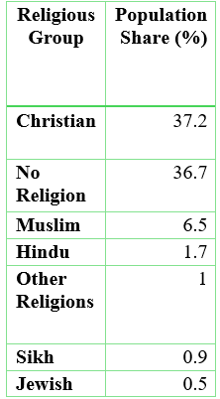
Table 3: Population Share in the UK
(Source: Created by Author; Referred to ons.gov.uk, 2021)
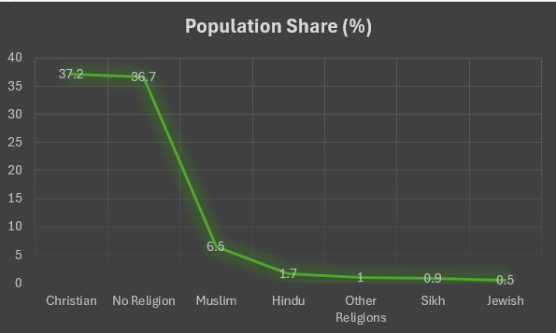
Figure 3: Population Share in the UK
(Source: Created by Author; Referred to ons.gov.uk, 2021)
This diversity has made a significant impact in the UK's FMCG market, driving up the demand for Halal, Vegetarian, Vegan and Authentic ethnic Food products (grocerytrader.co.uk, 2026). For instance, Tesco has increased its halal, Asian and world food lines to meet the demands of multicultural customers. For ITC Limited, this diversity is a great opportunity to promote the Indian food products such as Aashirvaad, Sunfeast, YiPPee! to the communities of South Asia and multicultural groups (indianretailer.com, 2026). The company must, however, tailor the product formulations, packaging, certification (for instance halal), and the marketing messages to suit religious preferences and cultural sensitivities and sensitivities, if they are not satisfied then consumer acceptance and brand reputation will be decreased.
Communication Styles
The UK business culture places much emphasis on concise, polite, professional and evidenced-based communication; marketing messages should be clear and fact-based. Digital engagement is also a huge part with more than 97% internet penetration and an omni channel communication system (Nambisan and Luo, 2022). For instance, Tesco is able to leverage the data from their customer loyalty scheme, Clubcard, to help them optimise product offerings. ITC limited needs to customize its marketing communication approach to be useful to the UK expectations of consumers.

Market Entry: Application of Dunning's Eclectic Paradigm (OLI Framework)
According to Dunning's Eclectic Paradigm, firms internationalise when they have Ownership, Location and Internalisation advantages which create a synergised advantage over exporting or licensing (Batschauer et al. 2022). The framework highlights ITC's advantages of a direct entry into the UK FMCG market, even when there are significant barriers for entering the market.
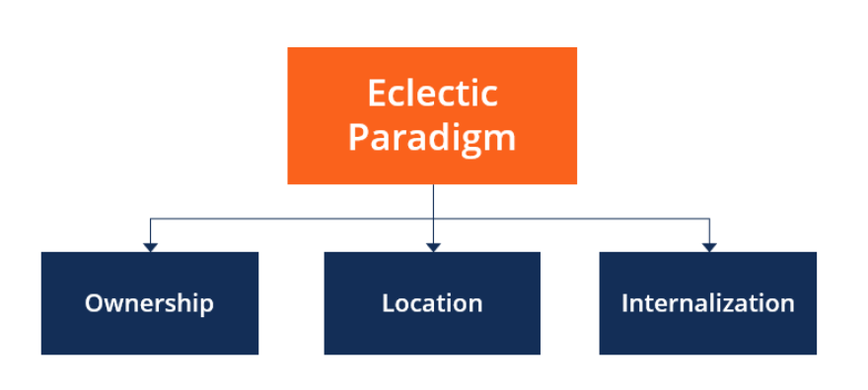
Figure 4: Dunning's Eclectic Paradigm (OLI Framework)
(Source: Batschauer et al. 2022)

Ownership Advantages (O) are not only indicates ITC products, but its unique intangible assets. The company's diversified FMCG portfolio, its innovation capability, its sustainability knowledge and expertise, its integrated sourcing network and its good brand equity can offer differentiation in the UK market (Li et al. 2025). For example, ITC's exports have already made it to over 90 countries, with an operational capability in the international domain. These product-specific resources could support the adaptation of products to the preferences of the UK consumer, and ensure consistency of quality and efficient operation of the product (Sen et al. 2024). Yet, the advantages of ownership will not guarantee the success of ITC Limited in the intensely competitive UK FMCG market. The company's brands, product knowledge and its broad sourcing capabilities and deep organisational resources are strong, but these need to be translated appropriately to local market conditions. Future innovation will be required to meet evolving UK consumer demands, especially for improved health, convenience and sustainably sourced food products. ITC needs to have in-depth knowledge of the purchasing habits, cultural diversity and price sensitivity of its local market in order to ensure that the products satisfy the consumer wants. Moreover, significant investment will be needed on brand building, digital marketing, and building relationships with retailers since ITC is dealing with well-known domestic and multinational players. Thus, the ownership benefits of ITC could keep the door open for market entry, but if they are to be successful, it depends mainly on the success of localisation, differentiation, and ongoing adaptation.
The United Kingdom is a strategically good place to locate an enterprise even though it is subject to competition (Location Advantages (L)) (Urfa et al. 2021). The market conditions are favourable due to the multicultural population, high retailing infrastructure, high level of digital maturity and transparency of regulatory institutions, coupled with increased awareness of healthier and more sustainable consumption. For instance, a high rate of Internet penetration (more than 97%) enables integration of an online and offline retailing strategy. Also, the idea of focusing on South Asian markets before entering the mainstream gives a foundation to the market acceptance. However, as per Zilberman et al. (2022), the need for regulation, bargaining power of retailers and high consumer expectations also necessitates a high degree of localisation and this is more crucial than market size in the long term.
Internalisation Advantages (I) indicate that it is more advantageous for ITC to keep critical business activities under its hands, rather than external parties (itcportal.com, 2026). Having the marketing, quality management, supply chain coordination, and customer relationships all internalized can help safeguard proprietary information, meet regulatory requirements and maintain a consistent brand positioning. Furthermore, direct control can help to respond quicker to the changing preferences of the consumers and the requirements of the retailers and can also help in protecting the intellectual property (Zilberman et al. 2022). While this approach will be demanding in terms of investment and management resources, it could lead to greater long-term value creation by increasing operating flexibility, strategic control, consumer trust and sustainable competitive advantage in the constantly changing UK FMCG sector.

3. Entry Mode
This section will critically explore the potential expansion of ITC Limited into the UK FMCG market in the context of various international strategies, market conditions and market entry decisions. It will explore the strengths and weaknesses and opportunities and threats of sustainable competitive advantage by adapting to the market effectively with strategic recommendations.

Historical Pattern Recognition
ITC Limited has always aimed to internationalise its business through low risk and export growth, rather than through high investment acquisitions or 100% subsidiaries, with the help of partnerships with distributors, local retail stores and progressive adaptation to the international markets (itc.ae, 2026). The gradual approach has helped the company establish its global footprint without risking its financial and operational situation in various countries.
In the United Arab Emirates, ITC successfully grew its packaged foods business by embracing the multi-cultural consumer base and high demand for high quality ethnic foods.
In 2025, the UAE retail food market hit US$38 billion, enabling ITC to consolidate their presence in the market via the existing retail chain with brands like Aashirvaad and YiPPee! (itc.ae, 2026). This is a testament to ITC's ability to launch differentiated products in high-end international stores.
Likewise, ITC has reinforced its business in Nepal by exporting to the market driven business with wide network of retail outlets (oec.world, 2026). India is the second biggest trade partner of Nepal and accounted for 69.8% of total merchandise imports in 2023, which indicates that India's products are very popular among consumers of Nepal and that there are good trade relations between the two countries. The experience indicates ITC's capabilities in building a robust network of distributors and localizing products in line with local market dynamics. These international experiences have improved ITC's knowledge and understanding of regulatory compliance, distribution management, product localisation and retailer partnership (Miller et al. 2024). Through these built-up competencies, ITC will be better equipped to mitigate the market entry risk and enhance the strategic implementation, which will enable them to create sustainable competitive positioning in the highly competitive UK FMCG market.

Strategic Fit & Justification
The export-led break into strategy of ITC Limited has proved effective in the past, but needs to be altered for the UK market because the UK's FMCG market is very developed and competitive (Reed, 2024). In the UAE, ITC (US$16 billion market for FMCG in 2025) was able to leverage export through the distributor channel, due to the presence of a significant expatriate Indian community (itc.ae, 2026). However, there are more difficulties in the UK where the grocery retail market is worth over £240bn in 2025 with dominant stores like Aldi, Sainsbury's and Tesco having strong bargaining power with suppliers. Thus, it may be possible to limit ITC's control over pricing, shelf positioning, and consumer involvement when placing its products on the shelves through distributors.
The US market is also useful to compare as ITC has built up a foothold via a limited selection of retail outlets and ethnic food providers to gain access to people who are familiar with Indian products (Grocery Gazette, 2026). However, direct duplication in the UK may be difficult due to differences in market and consumer expectations. The UK FMCG market must be more local, driven by the need for high food quality and labelling, competition from the supermarket private brands, and the consumers' preference for healthier and more sustainable products. Thus, ITC needs to revise its product formulas, packaging, price and promotions policies approach to meet the UK consumer expectations but preserve its unique Indian brand identity and product position.
The Nepal experience does show though the benefits of geographical proximity, with India providing 69.8% of Nepal's imports in 2023, making it easier with less logistics complexity (oec.world, 2026). But there are higher transport costs, more stringent sustainability criteria and tough food regulations involved with entering the UK. Growth in the UK has been possible for successful FMCG brands like Unilever's Dove and Nestlé's KitKat as a result of their strong localisation, innovation and consumer-based branding (Ojala, 2025). On the other hand, the Cadbury acquisition in the U.K. by Kraft Heinz in 2010 demonstrates the challenges of not getting the cultural and stakeholder aspects right.

Conclusion and Recommendations
The positive consumer demand, multicultural population, increased digital retail and preference for sustainability are areas that ITC Limited can leverage for entry into the UK FMCG market. But it’s a big challenge due to the intense competitions, regulatory requirements, retail dominance, and operational expenses. The successful expansion will rely on effective localisation, strategic partnerships and staying competitive in the UK market.
Before devoting substantial UK resources to ITC Limited should adopt a “test and adapt market incubation strategy” (Miller et al. 2024). For instance, Unilever has been able to build a stronger brand presence and impact in the UK, learning to continuously re-purpose its brands to meet evolving consumer expectations of sustainability and personal wellbeing instead of a one-size fits all global approach. Likewise, ITC can test marketing specific products, like healthy snacks, and high-quality Indian cuisine, in a small area of the city specifically multicultural London and Leicester before rolling them out nationwide (Piernas et al. 2022). ITC Limited can gain evidence, for use in decision-making on further expansion in the UK, from feedback from the consumer or sales performance and retailer responses. Feedback from consumers can be used to discover preferences concerning the quality of a product, its taste, packaging and pricing, while the sales data can be used to determine the market potential of products. Likewise, retailer reactions can offer ideas to product demands, shelf performance and distribution issues. This information will help ITC make necessary adjustments to its market approach prior to its large-scale investments in financial and operational resources. This testing and adapting route may help to minimise market-entry uncertainty, enhance fit and validate product-market, and foster a more solid and sustainable footprint within the competitive UK FMCG market.

Section 2
This is a reflective account that assesses my learning when researching, analysing and preparing the assessment on the possibility of ITC Limited entering the UK FMCG market. I apply Gibbs' Reflective Cycle to critically reflect on my research approach, theoretical application, challenges encountered and strategic insights gained during the assessment process (Sherwood et al. 2025).
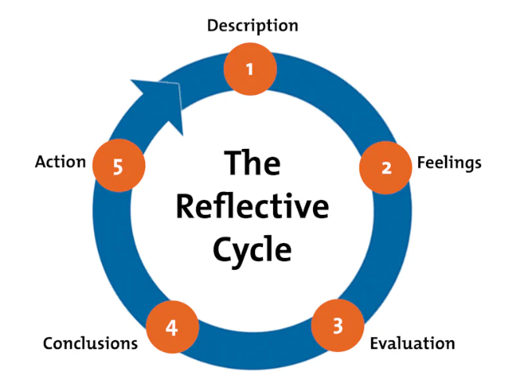
Figure 5: Gibbs’ Reflective Model
(Source: Sherwood et al. 2025)
Description
In developing the assessment of the potential success of ITC Limited's market entry to the UK FMCG market, I applied a structured approach to research, which included an analysis of ITC Limited's international strategy, host country environment and appropriate market entry approach (Sherwood et al. 2025). Theories related to the subject were identified first, which included Bartlett and Ghoshal's international strategy model, Dunning's Eclectic Paradigm (OLI Framework) and external environmental analysis. Secondary data was gathered from Annual Reports, Government sources, Academic Journals, Industry Reports, and Market Database (Ahmadpour et al. 2025). The study was undertaken to critically evaluate the market conditions in the UK where ITC Limited may expand operations. It looked at some important political, economic, legal and cultural aspects to ascertain the opportunities and impediments of working in the UK FMCG market. Also, previous cross-border expansion experiences were reviewed to grasp how existing capabilities of ITC, its market knowledge and internationalisation strategies could contribute to a successful entry, and continued growth into UK's competitive international market.
Feelings
It was difficult at first to relate theory with business analysis. Theories and concepts of international business as developed in the lecture were required to be critically used in the context of ITC Limited which I was aware (Aneeis et al. 2023). The choice of appropriate statistics and the reliability of data were also challenging. I am now more confident in using theories to real-world situations and in comprehending the impact of environmental factors on multinational expansion decisions, however, during the research process.
Evaluation
The best part of this evaluation was the incorporation of theory and research-based evidence. Lectures on internationalisation strategies gave deeper insights into the motives, risks, and control parameters when choosing entry modes, the involvement of business resources, and others (Ingham-Broomfield, 2021). Adopting the OLI framework of Dunning proved useful in assessing ITC's expansion strategy in a critical way. But at first, I had a bit of trouble breaking away from a descriptive analysis of environmental factors (Pieper et al. 2021). I conducted relevant academic reading and responded carefully to feedback received to enrich the quality and depth of my analysis. This was useful in helping to move beyond mere enumeration of political, economic, legal and cultural factors and consider how these factors affect ITC Limited specifically. I have gained an understanding of both the opportunities and potential challenges these external factors might present for the company. This process also helped develop my understanding of how theory can be applied to solve real world business and market entry decisions, on the international stage.
Analysis
This assessment enhanced my critical thinking, research skills and knowledge of international expansion strategies (Ocampo et al. 2025). I found that getting into a market successfully is not only important to have an attractive market, but also to be able to adjust business resources and strategies to fit local needs. ICFOT's experiences in the UAE, Nepal and the USA showed that what works well in one country is not necessarily what will work in another.
In addition, a study of the successful and unsuccessful FMCG brands in the UK emphasised the significance of localisation, consumer understanding and cultural adaptation (Bassot, 2024). This was an eye opener for me to see that in order to be competitively sustainable, multinational companies need to understand that they should match their global resources with local market expectations.
Conclusion
In general, this evaluation helped me to develop an understanding of the multi-national strategy and international market entry decisions. Theoretical frameworks and secondary research helped me gain a wider perspective in understanding the way companies view opportunities around the world. Acquired the skills and knowledge of critical evaluation and strategic alignment, as well as the need for reliable evidence, when working on developing recommendations for international expansion.
Action Plan
In the future, I will create a more formal research plan prior to gathering data and will recognize analytical frameworks in the initial phases of the assessment (Fagerholm et al. 2021). I will use academic sources and industry data to enhance the efficiency of my research and the depth of my analysis. In addition, I will analyse several further multinational business situations in order to build my understanding of theories of international business and how these could apply in real organisation-based context (Skivington et al., 2021). This will enable me to gain insight into various strategic approaches and an understanding of organisational reactions to variations in the international market. The experience gained from this assessment will help add to my future academic and professional development by helping me develop my critical thinking, research, analytical and decision abilities.

References
Adewale, T.T., Eyo-Udo, N.L., Toromade, A.S. and Ngochindo, A., 2024. Integrating sustainability and cost-effectiveness in food and FMCG supply chains: A comprehensive model. Unpublished manuscript. Https://crrjournals.com/crrj/sites/default/files/CRRJ-2024-0029.pdf
Ahmadpour, N., Shariati, A. And Moghadam, M.P., 2025. Effect of narrative writing based on Gibbs’ reflective model on the empathy and communication skills of nursing students. BMC Medical Education, 25(1), p.10. Https://link.springer.com/content/pdf/10.1186/s12909-024-06593-7.pdf
Aneeis Hashim, S.N., Yaacob, A., Suryani, I., Mohd Asraf, R., Bahador, Z. And Supian, N., 2023. Exploring the Use of Gibbs’ Reflective Model in enhancing in-Service ESL teachers’ reflective writing. Arab World English Journal (AWEJ) Volume, 14. Https://papers.ssrn.com/sol3/Delivery.cfm?Abstractid=4497558
Bassot, B., 2024. The reflective journal. Bloomsbury Publishing. Https://books.google.com/books?Hl=en&lr=&id=GAIZEQAAQBAJ&oi=fnd&pg=PP1&dq=Gibbs%27+Reflective+Cycle&ots=ayzimf7m2k&sig=1Gk4zTh5-2s2fjzo4uesstbytpm
Batschauer da Cruz, C.B., Eliete Floriani, D. And Amal, M., 2022. The OLI Paradigm as a comprehensive model of FDI determinants: a sub-national approach. International Journal of Emerging Markets, 17(1), pp.145-176. Https://www.researchgate.net/profile/Claudia-Cruz-7/publication/329151644_The_Eclectic_Paradigm_as_a_Comprehensive_Model_to_Analyze_Subnational_Determinants_of_FDI/links/5f76e322a6fdcc0086502bc6/The-Eclectic-Paradigm-as-a-Comprehensive-Model-to-Analyze-Subnational-Determinants-of-FDI.pdf
Businesstats.com, 2026 [Online] Available at https://businesstats.com/grocery-market-share-in-the-united-kingdom-uk/ [Accessed on July 27, 2026]
Census.gov, 2026 [Online] Available at https://www.census.gov/retail/sales.html [Accessed on July 27, 2026]
Cnbc.com, 2026 [Online] Available at https://www.cnbc.com/2026/05/14/uk-q1-gdp-2026.html [Accessed on July 27, 2026]
Commonslibrary.parliament.uk, 2026 [Online] Available at https://commonslibrary.parliament.uk/research-briefings/cbp-9040/ [Accessed on July 27, 2026]
Dako, O.F., Okafor, C.M., Adesanya, O.S. and Prisca, O., 2021. Industrial-scale transfer pricing operations: methods, toolchains, and quality assurance for high-volume filings. Quality Assurance, 8(9). Https://shisrrj.com/paper/SHISRRJ214264.pdf
Data Protection Act (2018), 2026 [Online] Available at https://www.gov.uk/data-protection [Accessed on July 27, 2026]
Fagerholm, N., Raymond, C.M., Olafsson, A.S., Brown, G., Rinne, T., Hasanzadeh, K., Broberg, A. And Kyttä, M., 2021. A methodological framework for analysis of participatory mapping data in research, planning, and management. International Journal of Geographical Information Science, 35(9), pp.1848-1875. Https://www.tandfonline.com/doi/pdf/10.1080/13658816.2020.1869747
Gov.uk, 2026 [Online] Available at https://www.gov.uk/government/publications/rates-and-allowances-corporation-tax/rates-and-allowances-corporation-tax [Accessed on July 27, 2026]
Grocerygazette.co.uk, 2026 [Online] Available at https://www.grocerygazette.co.uk/2026/06/26/uk-grocery-growth-to-hit-304bn-by-2031-but-weak-demand-clouds-outlook/ [Accessed on July 27, 2026]
Grocerytrader.co.uk, 2026 [Online] Available at https://grocerytrader.co.uk/world-food-goes-mainstream-consumers-are-seeking-more-authentic-flavours/ [Accessed on July 27, 2026]
Hse.gov.uk, 2026 [Online] Available at https://www.hse.gov.uk/legislation/hswa.htm [Accessed on July 27, 2026]
Indianretailer.com, 2026 [Online] Available at https://indianretailer.com/news/itc-adopting-disruptive-business-models-as-part-of-strategy-reset.n11333 [Accessed on July 27, 2026]
Ingham-Broomfield, B., 2021. A nurses' guide to using models of reflection. The Australian Journal of Advanced Nursing, 38(4), pp.62-67. Https://www.ajan.com.au/~ajancoma/index.php/AJAN/article/download/395/141
Itc.ae, 2026 [Online] Available at https://itc.ae/ [Accessed on July 27, 2026]
Itchotels.com, 2026 [Online] Available at https://www.itchotels.com/in/en/fortuneresortandwellnessspa-bhaktpur [Accessed on July 27, 2026]
Itcportal.com, 2026 [Online] Available at https://itcportal.com/about-itc/leadership-speaks/itc--building-a-competitive--future-tech--climate-positive-and-i.html [Accessed on July 27, 2026]
Itcportal.com, 2026 [Online] Available at https://itcportal.com/about-itc/leadership-speaks/itc-navigating-a-turn-to-reimagine-the-future.html [Accessed on July 27, 2026]
Itcportal.com, 2026 [Online] Available at https://itcportal.com/content/dam/itc-corporate/pdfs/sustainability-report/itc-sustainability-report-2026.pdf [Accessed on July 27, 2026]
Legislation.gov.uk, 2026 [Online] Available at https://www.legislation.gov.uk/ukpga/2010/15/contents [Accessed on July 27, 2026]
Li, H., Hilletofth, P., Eriksson, D. And Tate, W., 2025. Understanding the manufacturing reshoring decision-making content through the lens of the Eclectic Paradigm: a systematic literature review. European Business Review, 37(1), pp.16-48. Https://www.emerald.com/ebr/article-pdf/37/1/16/9695290/ebr-10-2023-0300.pdf
M.economictimes.com, 2026 [Online] Available at https://m.economictimes.com/small-biz/trade/exports/insights/india-uk-fta-takes-effect-on-july-15-but-the-real-test-lies-beyond-tariff-cuts/articleshow/132230710.cms [Accessed on July 27, 2026]
Miller, A., O’Mahony, S. And Cohen, S.L., 2024. Opening the aperture: Explaining the complementary roles of advice and testing when forming entrepreneurial strategy. Organization Science, 35(1), pp.1-26. Https://pubsonline.informs.org/doi/full/10.1287/orsc.2023.1656
Nambisan, S. And Luo, Y., 2022. The digital multinational: Navigating the new normal in global business. MIT Press. Https://books.google.com/books?Hl=en&lr=&id=mduteaaaqbaj&oi=fnd&pg=PR9&dq=Transnational+Strategy+is+the+key+one+adopted+by+ITC+Limited+and+successfully+blend+in+the+required+local+market+responsiveness+with+global+efficiencies+&ots=hykfgjjbr2&sig=eq7pwg6mbrtjt0mmbcg7pfwlc4u
Nibusinessinfo.co.uk, 2026 [Online] Available at https://www.nibusinessinfo.co.uk/content/consumer-rights-act [Accessed on July 27, 2026]
Nielseniq Study, 2025 [Online] Available at https://nielseniq.com/global/en/insights/report/2025/on-premise-channel-strategy-report-2025/ [Accessed on July 27, 2026]
Ocampo, F.A., mcintyre, B.G., Massey, D. And Saunders, R., 2025. Nursing student reflections on a research internship: A reflective discussion following the Gibbs' reflective cycle. Nurse education today, 145, p.106481. Https://www.sciencedirect.com/science/article/pii/S0260691724003915
Oec.world, 2026 [Online] Available at https://oec.world/en/profile/bilateral-country/ind/partner/npl [Accessed on July 27, 2026]
Oecd.org, 2026 [Online] Available at https://www.oecd.org/content/dam/oecd/en/publications/reports/2000/03/policy-competition-for-foreign-direct-investment_g1gh1387/9789264181083-en.pdf [Accessed on July 27, 2026]
Ojala, K., 2025. Consumer Perceptions of Diversity in Brands: Insights from the FMCG Industry. Https://www.utupub.fi/bitstream/handle/10024/181498/Ojala_Katariina_opinnayte.pdf?Sequence=1
Ons.gov.uk, 2021 [Online] Available at https://www.ons.gov.uk/census [Accessed on July 27, 2026]
Pieper, M., Roelle, J., vom Hofe, R., Salle, A. And Berthold, K., 2021. Feedback in reflective journals fosters reflection skills of student teachers. Psychology Learning & Teaching, 20(1), pp.107-127. Https://journals.sagepub.com/doi/pdf/10.1177/1475725720966190
Piernas, C., Harmer, G. And Jebb, S.A., 2022. Testing availability, positioning, promotions, and signage of healthier food options and purchasing behaviour within major UK supermarkets: Evaluation of 6 nonrandomised controlled intervention studies. Plos Medicine, 19(3), p.e1003952. Https://journals.plos.org/plosmedicine/article/file?Id=10.1371/journal.pmed.1003952&type=printable
Reed, T., 2024. Export-led industrial policy for developing countries: Is there a way to pick winners?. Journal of Economic Perspectives, 38(4), pp.3-26. Https://pubs.aeaweb.org/doi/pdf/10.1257/jep.38.4.3
Sen, B., Jain, R. And Srivastava, D.K., 2024. Revisiting the eclectic paradigm in the era of digital globalization: Past insights and future trends. Available at SSRN 5125344. Https://papers.ssrn.com/sol3/Delivery.cfm?Abstractid=5125344
Shenkar, O., Luo, Y. And Chi, T., 2021. International business. Routledge. Https://www.academia.edu/download/120629192/preview.pdf
Sherwood, G., Cherian, U.K., Horton-Deutsch, S., Kitzmiller, R. And Smith-Miller, C., 2025. Reflective practices: meaningful recognition for healthy work environments. Nursing Management, 32(6). Https://www.researchgate.net/profile/Cheryl-Smith-Miller/publication/323347750_Reflective_practices_Meaningful_recognition_for_healthy_work_environments/links/62b38ea089e4f1160c930d9a/Reflective-practices-Meaningful-recognition-for-healthy-work-environments.pdf
Skivington, K., Matthews, L., Simpson, S.A., Simpson, S., Craig, P., Baird, J., Blazeby, J.M., Blazeby, J., Boyd, K.A., Boyd, K. And Craig, N., 2021. Framework for the development and evaluation of complex interventions: gap analysis, workshop and consultation-informed update. Health technology assessment, 25(57), pp.1-132. Https://www.journalslibrary.nihr.ac.uk/hta/HTA25570
Timesofindia.indiatimes.com, 2026 [Online] Available at https://timesofindia.indiatimes.com/business/india-business/itc-is-now-2nd-largest-fmcg-co-by-revenue/articleshow/132594548.cms [Accessed on July 27, 2026]
Trade.gov, 2026 [Online] Available at https://www.trade.gov/country-commercial-guides/united-kingdom-import-tariffs [Accessed on July 27, 2026]
Tradingeconomics.com, 2026 [Online] Available at https://tradingeconomics.com/united-kingdom/current-account/news/537688 [Accessed on July 27, 2026]
Uk.finance.yahoo.com, 2026 [Online] Available at https://uk.finance.yahoo.com/news/uk-unemployment-climbs-4-9-065400111.html [Accessed on July 27, 2026]
Unstats.un.org, 2025 [Online] Available at https://unstats.un.org/sdgs/report/2024/The-Sustainable-Development-Goals-Report-2024.pdf [Accessed on July 27, 2026]
Urfa, A.M., Can, E., Beder, N. And Kavgacı, Y., 2021. A bibliometric analysis of the eclectic paradigm in Turkish Literature. Istanbul Management Journal, (91), pp.25-57. Https://dergipark.org.tr/en/download/article-file/1875266
Zilberman, D., Reardon, T., Silver, J., Lu, L. And Heiman, A., 2022. From the laboratory to the consumer: Innovation, supply chain, and adoption with applications to natural resources. Proceedings of the National Academy of Sciences, 119(23), p.e2115880119. Https://www.pnas.org/doi/pdf/10.1073/pnas.2115880119

