University of Wales Trinity Saint David
Wales Institute of Science and Art


Electronic Circuits Testing and Applications

Vehicle Electronics

Joel Gilby
2500756
19/04/26
Contents
1 Task 3 1
1.1 Scope Time Division Calculations (6) 1
1.2 Function Generator output square wave (6) 1
1.3 Capacitor charge and discharge wave marked at correct points. (6) 1
1.4 Basic Capacitor Calculations (6) 1
1.5 Capacitor discharge table (5) 1
1.6 Plot log(V) Gradient (5) 1
1.7 Gradient Calculations and Compare(8) 1
1.7.1 Gradient Calculations 1
1.7.2 Comparison table 1
1.8 Capacitor Uses (5) 1
1.9 Inaccuracies Question (4) 1
1.10 Risk Question (10) 1
2 References 2

Task 3

Scope Time Division Calculations (6)

Function Generator output square wave (6)
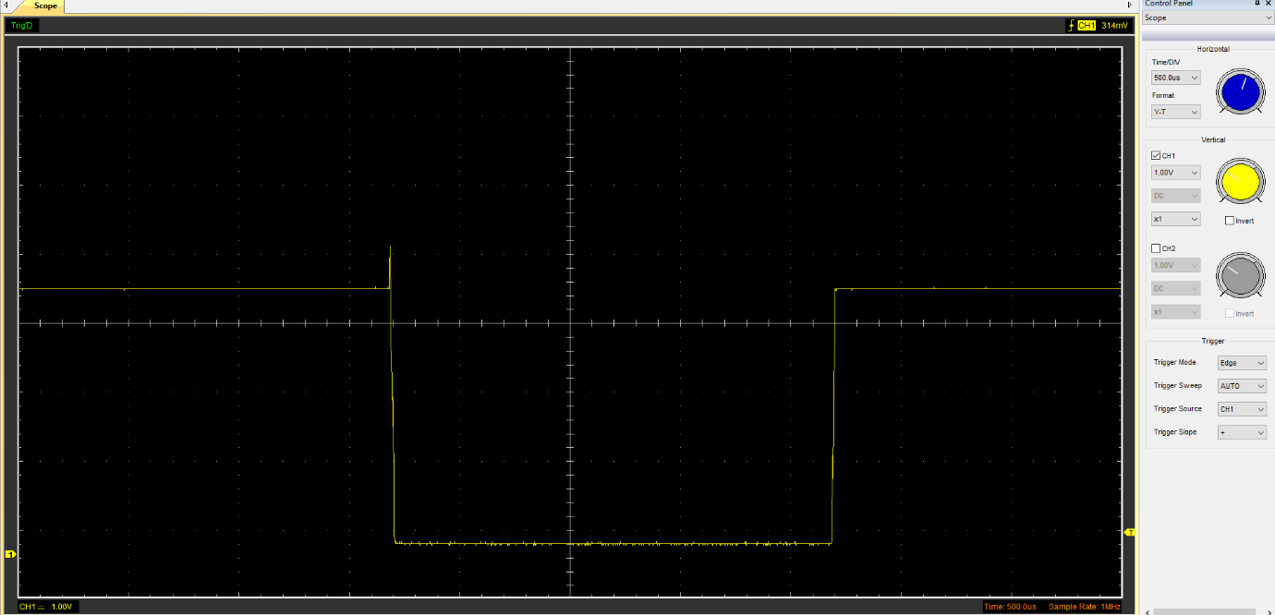

Capacitor charge and discharge wave marked at correct points. (6)
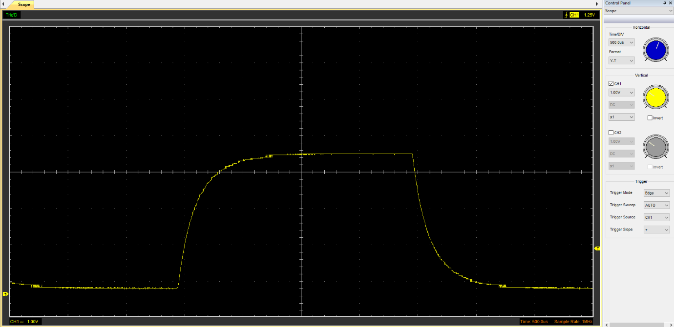

Basic Capacitor Calculations (6)

Capacitor discharge table (5)
Time (s) | Voltage (V) | ln (V) | dy = y2 – y1  dy = ln(V)2-ln(V)1 | dx = x2- x1  dx = Time2 – Time1 | dy/dx
 |  |  | x | x | x

Plot log(V) Gradient (5)

Gradient Calculations and Compare(8)

Gradient Calculations

Comparison table
 | Capacitance | Delta | Percentage difference
Actual | 1 µF | x | X
Marker Calculation
Gradient Calculation

Capacitor Uses (5)
In an automotive environment, capacitors are used to smooth voltage spikes in vehicle systems, such as ECUs, audio systems, regenerative braking systems, accelerometers, interior LCD displays and to stabilise signals from sensors such as ABS or EPAS.
Capacitors are also used to smooth power supplies, store energy in backup systems, for touch sensors and for timing circuits.

Inaccuracies Question (4)

Risk Question (10)
Due to the increase in cars with wireless connectivity (such as internet or Bluetooth) over recent years, modern vehicles are now vulnerable to cyberattacks. The CANBUS system that is widely used by electronic control units in vehicles was never initially designed with security in mind, as vehicles’ ECUs could rarely be accessed wirelessly. This means that they had no/limited forms of encryption or authentication in the messages that they sent between each other, as it would have needlessly complicated the systems.
The introduction of ISO/SAE 21434 is designed to encourage manufacturers to think about the cybersecurity threats towards a new vehicle throughout its entire life cycle and incorporate framework within a new vehicle’s systems in order to protect against threats. The standard means that all new vehicles are equally protected against vulnerabilities in their systems in the case of possible cyberattacks.
An example of where ISO/SAE 21434 enforces protection is with Vehicle to Everything (V2X) systems, where vehicles communicate data with many things around them, such as infrastructure, cloud services and even other vehicles. The standard provides secure framework through features such as cryptographic authentication to ensure that the data/messages that vehicles receive are legitimate, providing another layer of protection against malicious attacks.

References
atsnap.com. (2025). What Makes Capacitors Crucial in Automotive Electronics? [online] Available at: https://eureka.patsnap.com/article/what-makes-capacitors-crucial-in-automotive-electronics [Accessed 19 Apr. 2026]
YSEC. (n.d.). Overview of ISO/SAE 21434. [online] Available at: https://www.security-analyst.org/iso-sae-21434/
Konfirmity.com. (2026). ISO/SAE 21434: Definition, use cases, and compliance relevance (2026). [online] Available at: https://www.konfirmity.com/glossary/iso-sae-21434

