

University of Wales Trinity Saint David
School of Engineering
Factory Control 1
Faith Over
1904483
Manufacturing Systems Engineering
29/07/2022
ACMA6001 Control Technology

Contents Page

Contents
Contents Page ii
1.0 Introduction 1
2.0 Literature review of PLCs currently used in industry 1
3.0 Operational Flow Chart 1
4.0 Alarm & warning strategy and the operational parameters of each 1
5.0 Explanation of ladder logic used 2
5.1 HMI Screens 15
9. References 18
Works Cited 18

Introduction
Programmable logic controllers (PLC) have been widely used for many years in manufacturing systems (DU, et al., 2009). PLCs can automate processes, machine functions and entire production lines through receiving information from connected input devices, such as sensors, processes the data and then triggers outputs based in the programmed parameters (Unitronics, 2022). PLCs play an essential role in industries today, enabling higher levels of productivity due to the reliability and flexibility of PLC systems (Bolton, 2015).
This report will review different PLCs currently used in industry then will review the ladder logic written in Siemens TIA Portal v16 for a factory simulation in Factory I/O.
The task was to create a factory simulation in factory I/O which sorted an incoming stream of boxes into four different categories. The system is required to have counters for; number of boxes into the system, the number of boxes lost in the system and the number of boxes which reached the end of line (EOL) for each of the four box categories. Each of the counters were then to trigger either a warning or an alarm when they exceeded the set parameters which would be input by the user in the “Engineer Screen”.

Literature review of PLCs currently used in industry
PLCs in general are cheaper than other automation technology and is both flexible and the ladder logic commonly used to program these controllers is easier to understand than other conventional programming languages (Chaudhari, 2022).
The main function of a PLC in manufacturing is a simple controller, often paired with external processing units (Bolton, 2015)
There are two major types of PLC, Fixed input & output (I/O) PLC (also known as integrated or compact), and modular. Fixed I/O PLC has the input and output sections of the PLC integrated into the microcontroller itself meaning every type of input or output is determined by the manufacturer and the quantities available of each are fixed. (Phillips, 2019)
Figure 1: Model of a fixed PLC
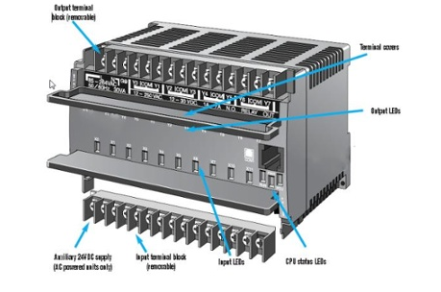
The modular PLC allows expansion through the addition of modules. These are often viewed as easier to use as the modular system means components are independent of each other; power supply, communications module and I/O module are separate from the actual microcontroller (Phillips, 2019). This modularity aids in scalability and expansion and additions to production lines can be added to the same controller.
Figure 2: Model of a modular PLC
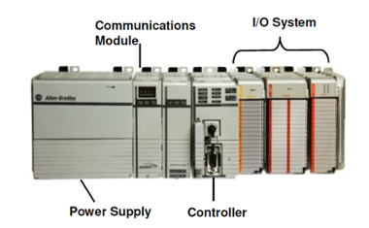

Table 1: Integrated vs Modular PLC

Type | Advantages | Disadvantages
Integrated PLC | Cheaper  Smaller | Limited inputs and outputs (fixed by manufacturer)  If one unit is broken, all modules are down  Can only hold so much information/ fewer memory & storage capabilities
Modular PLC | Flexibility for improvements- adding more inputs & outputs  Can replace only broken modules – repairs are faster and cheaper  More Memory and capacity | Larger in size – requires more space  More costly

Operational Flow Chart
The below flow chart visualises the operational flow sequence of the PLC logic:
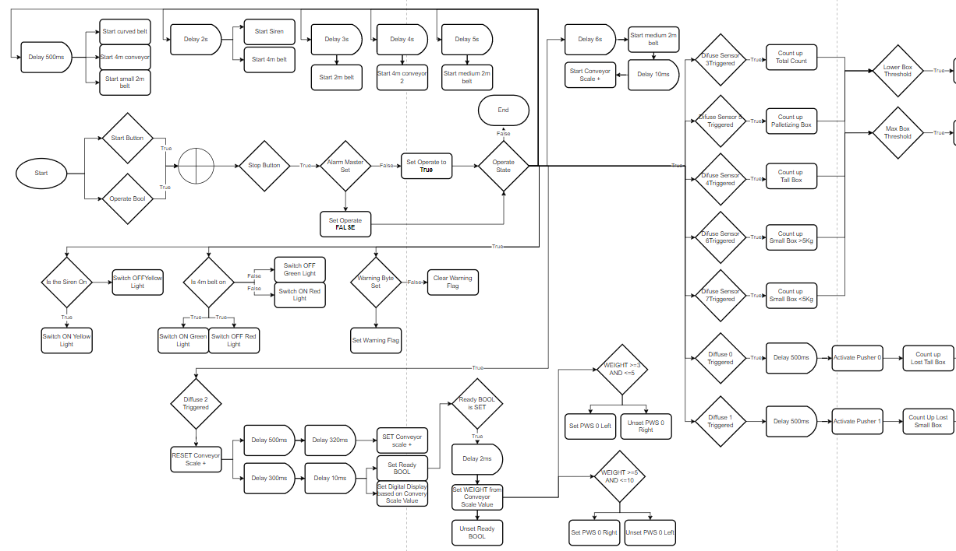
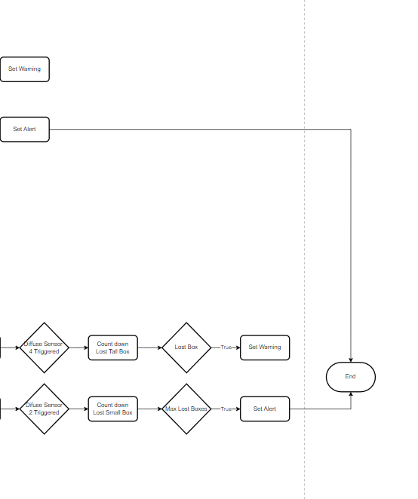

Alarm & warning strategy and the operational parameters of each
The alarm and warning strategies are set to the parameters input into the engineering screen. Thus, the parameters are variable. The warning strategy is designed to stay on until there is manual intervention to reset the counters. The alarm strategy is designed to stop the line, either to prevent a potential error from occurring or to prevent a potential error from worsening. Examples of these issues could be number of lost boxes increasing over the limit, indicating something is blocking the line, or boxes reaching end of line maximum has increased over the limit indicating it could e causing a blockage at the next step of the process/pallet/ offloading locations need to be changed.

Explanation of ladder logic used

. 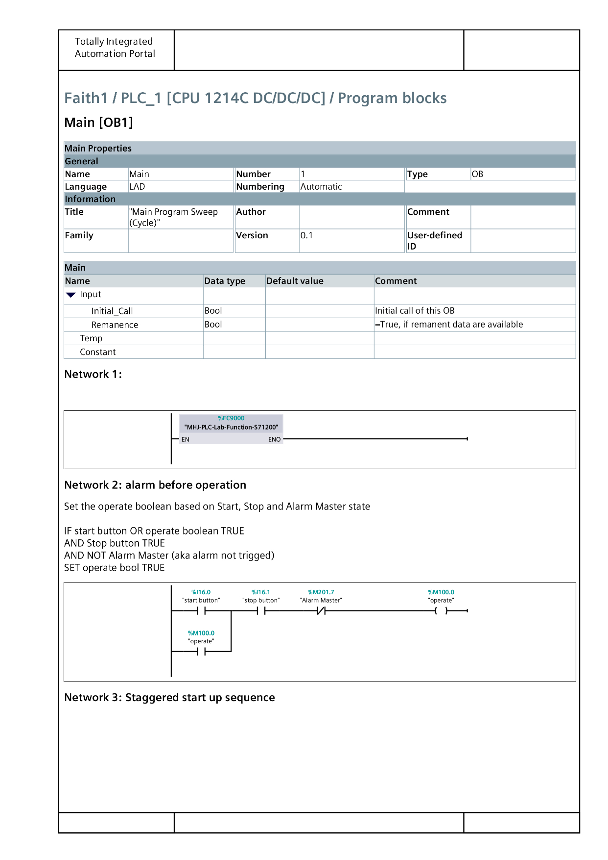
Network 2
Initiating the operating sequence if start or operate are set to on, stop set to off and alarm master is not set
Network 1
Initialise PLC to S71200

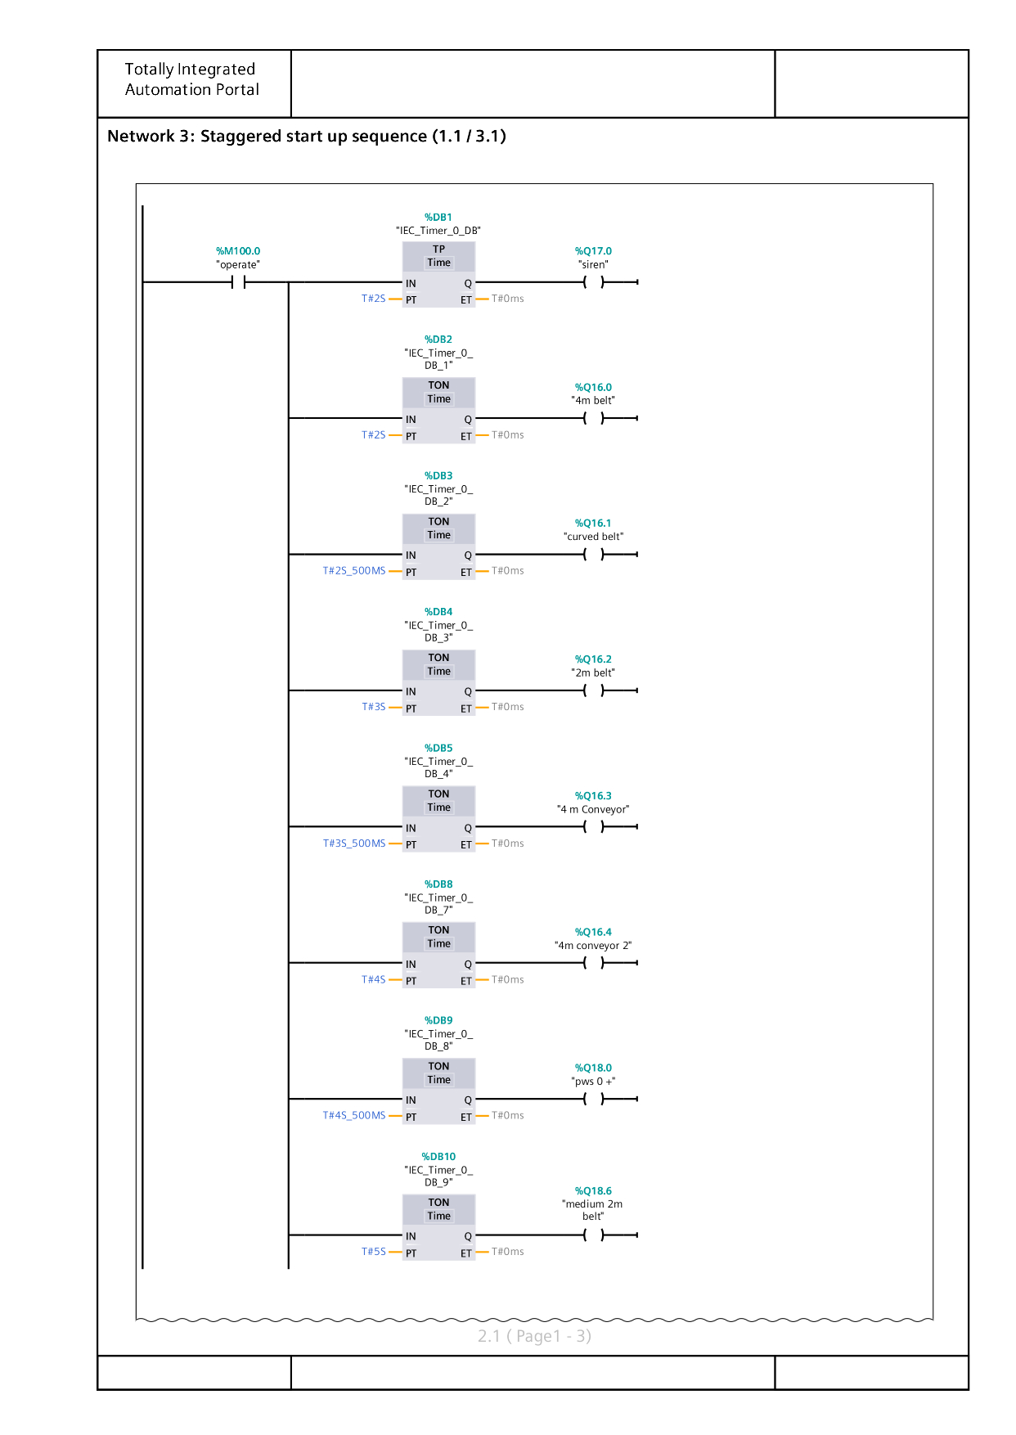
Network 3
The operate sequence triggers a timed start up as to not overload the system.
After 2 seconds (s) the siren is triggered. After a further 2s the 4m belt is triggered. Then after a further 0.5s the curved belt is triggered, after a further 3s the 2m belt is triggered. Then the 4m conveyor after a further 0.5s, then the second 4m conveyor after 4s, followed by the pop-up wheel sorter after a further 0.5s, the 2m belt after 5s, the next 2m belt after a further 0.5s and the conveyor scale after 6s.

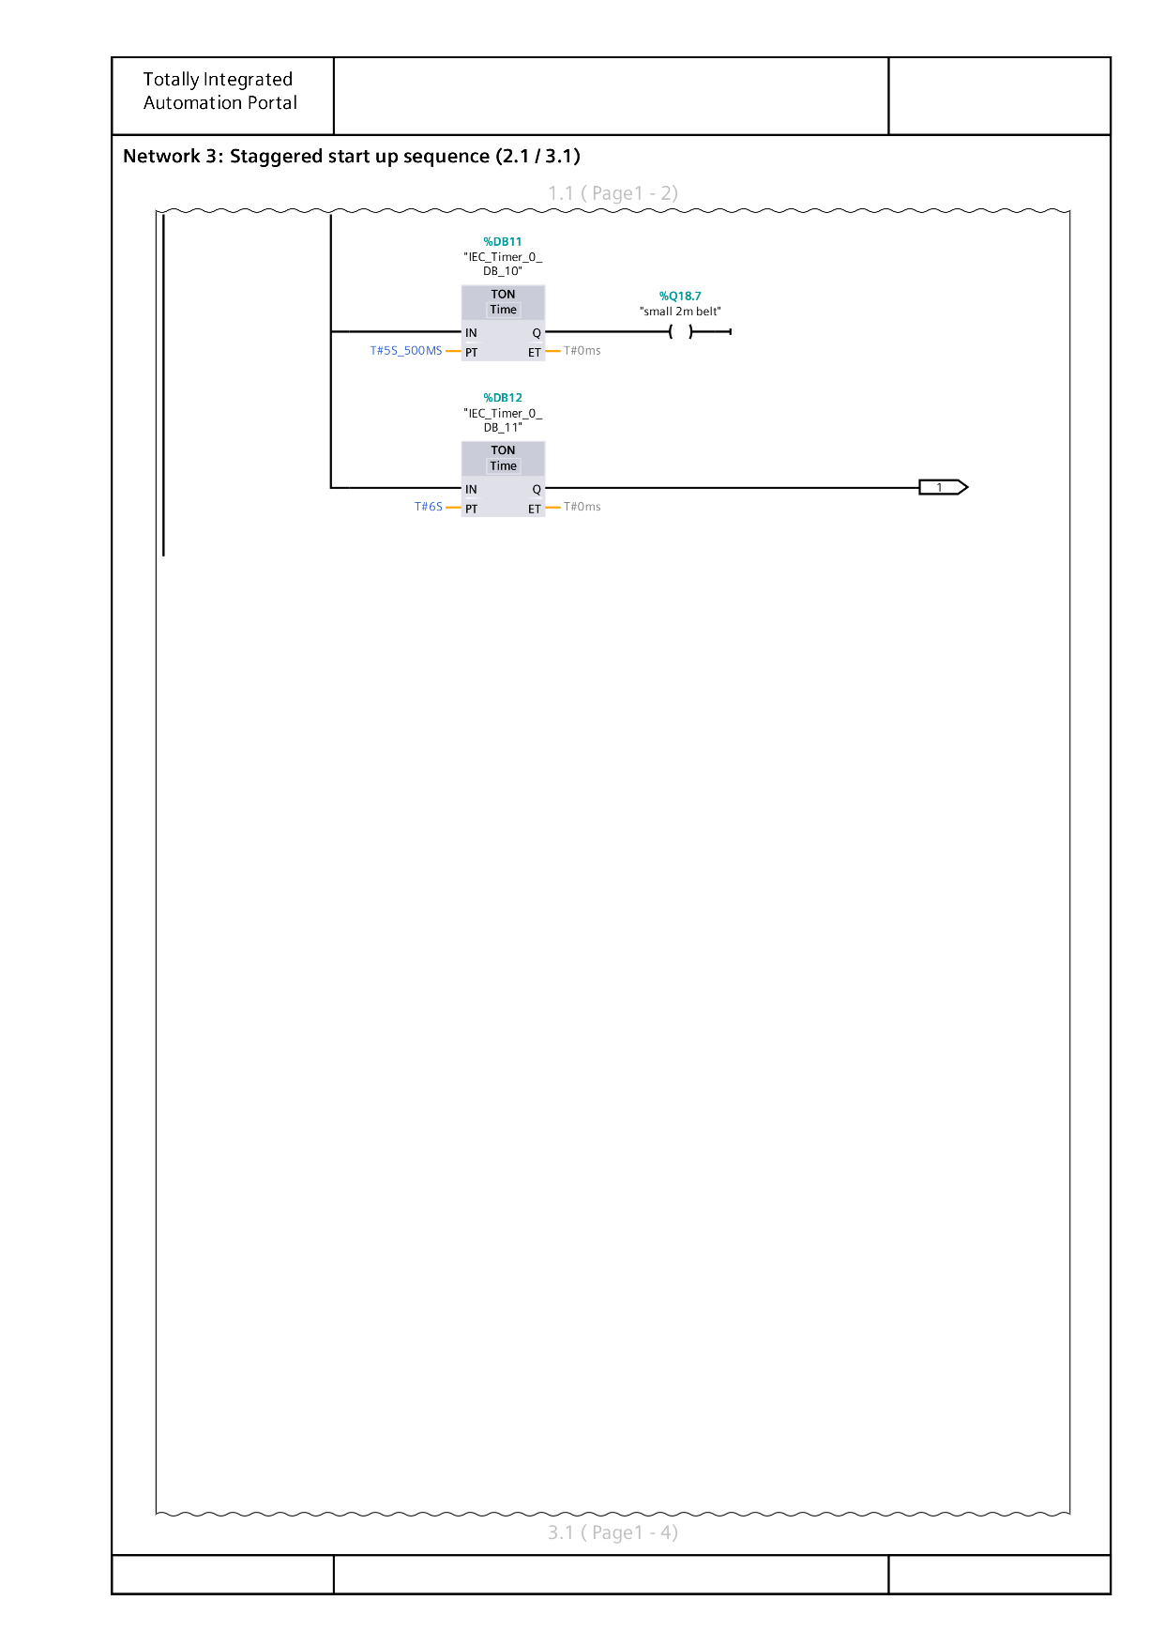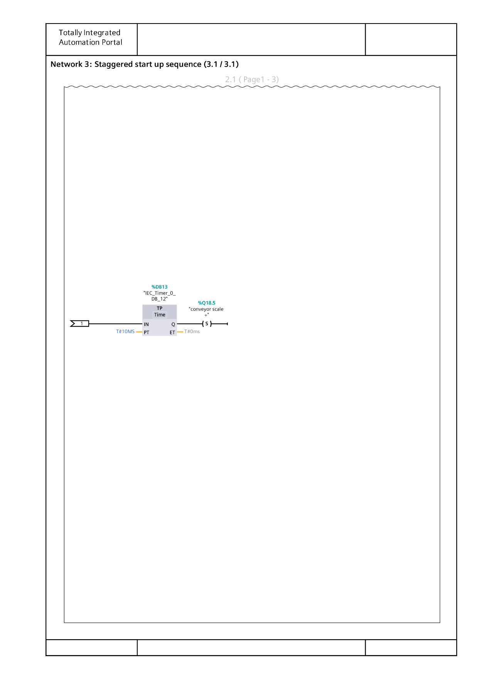
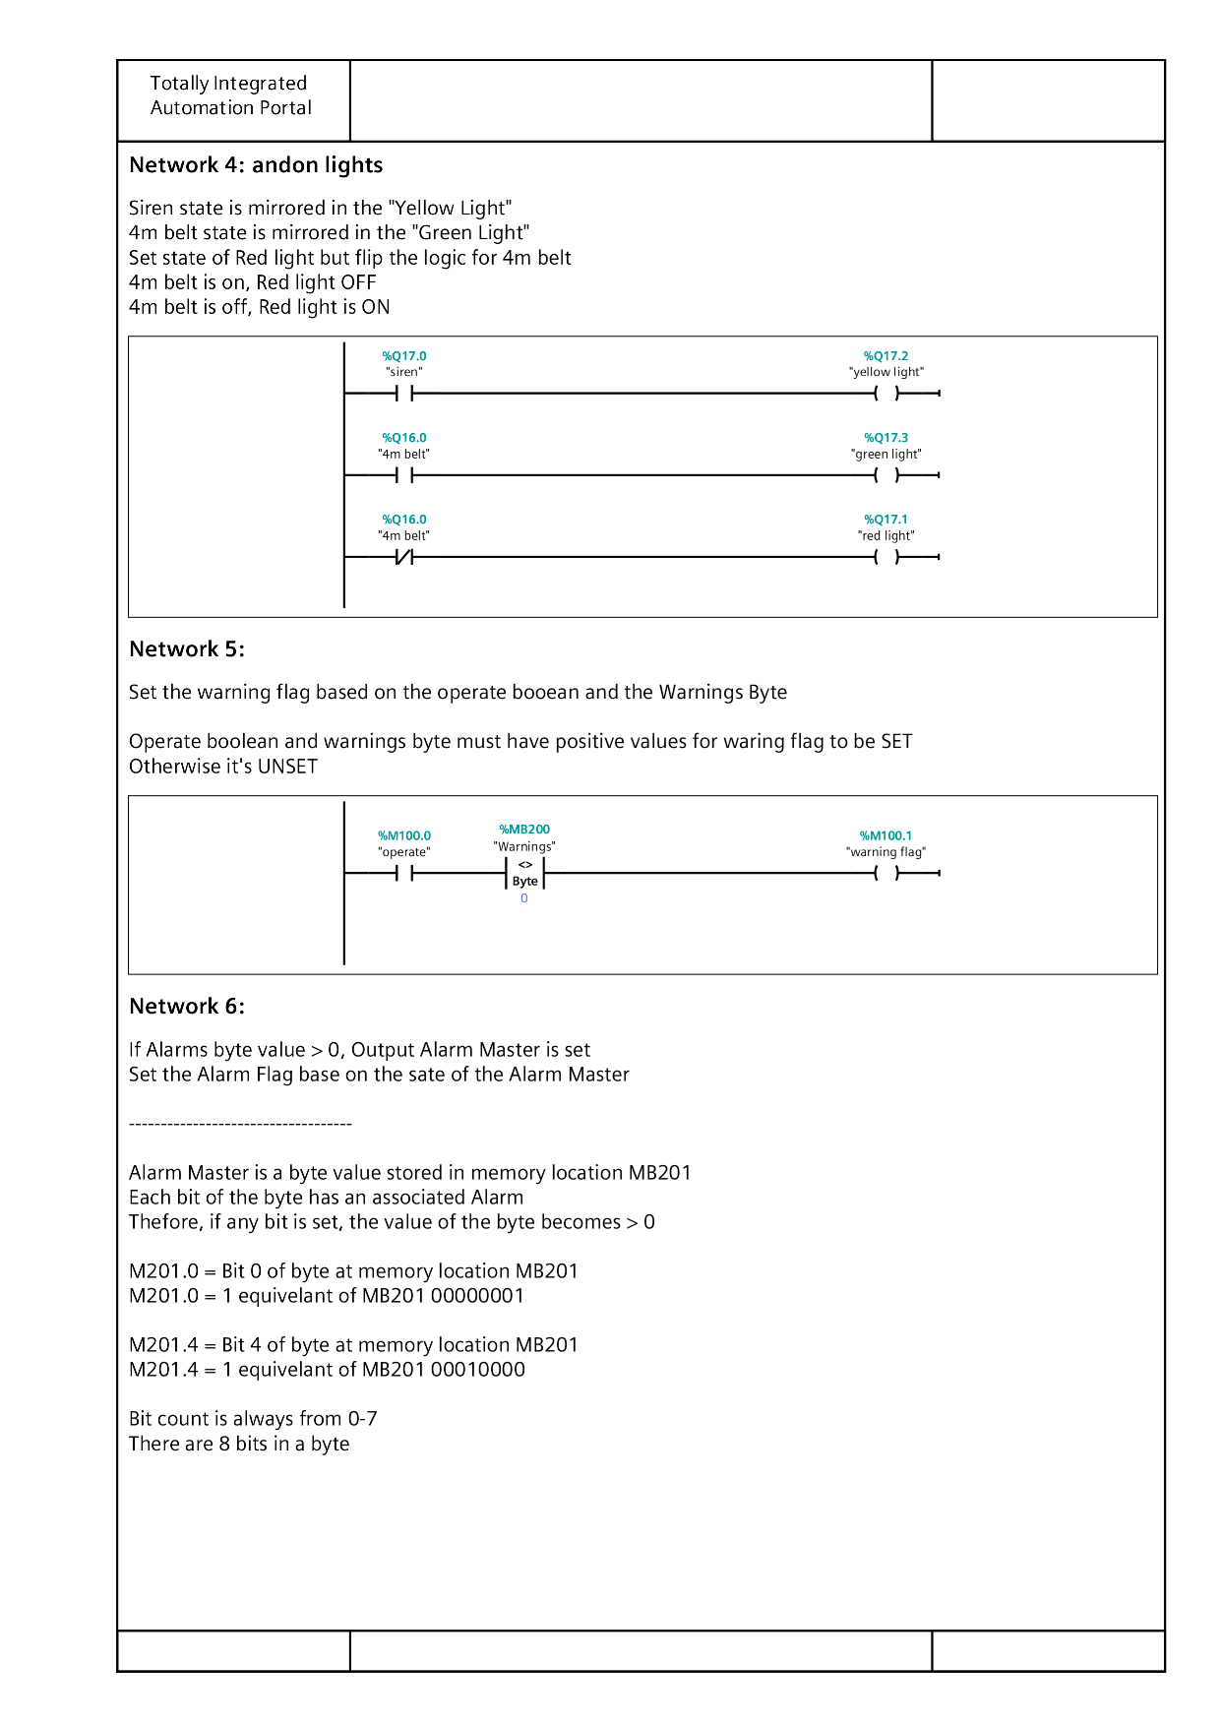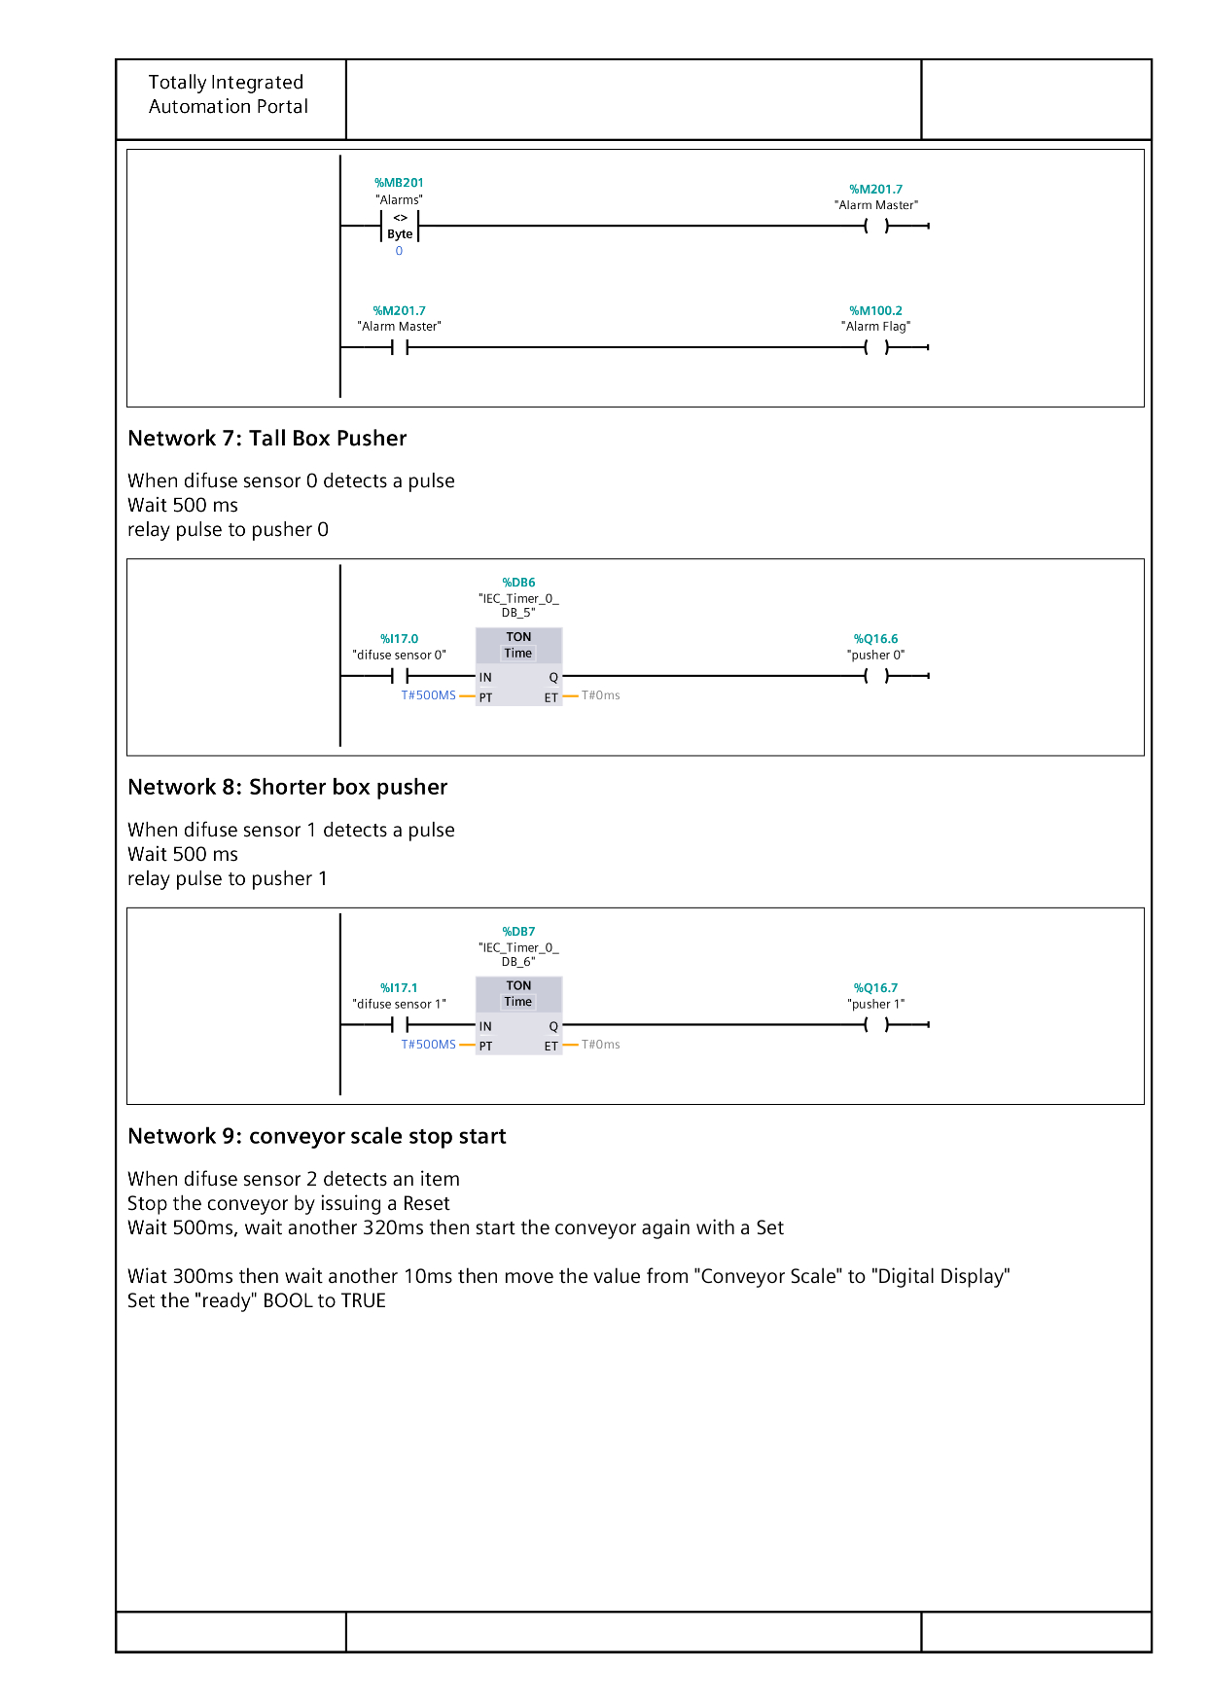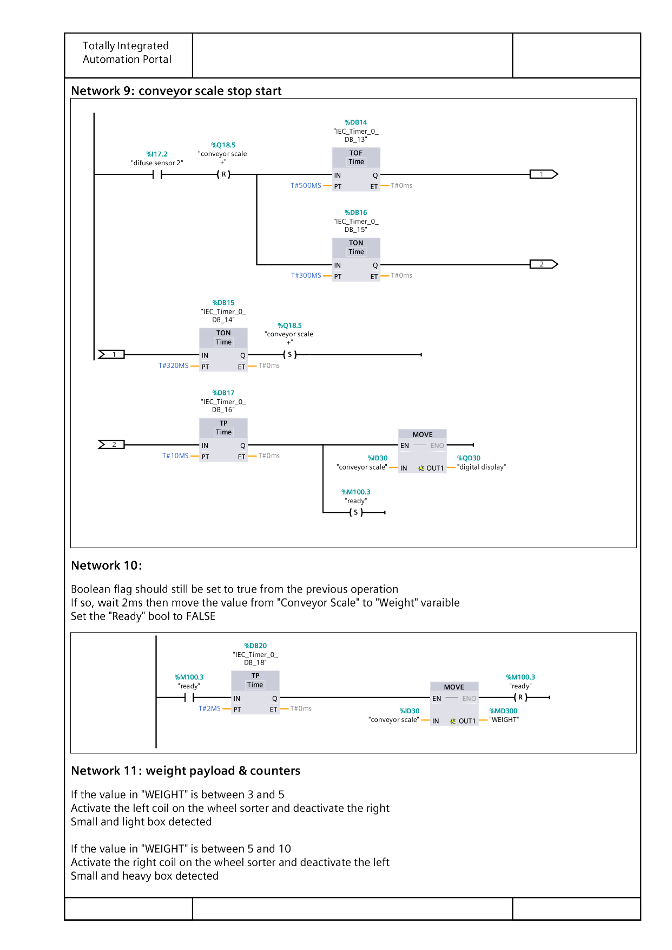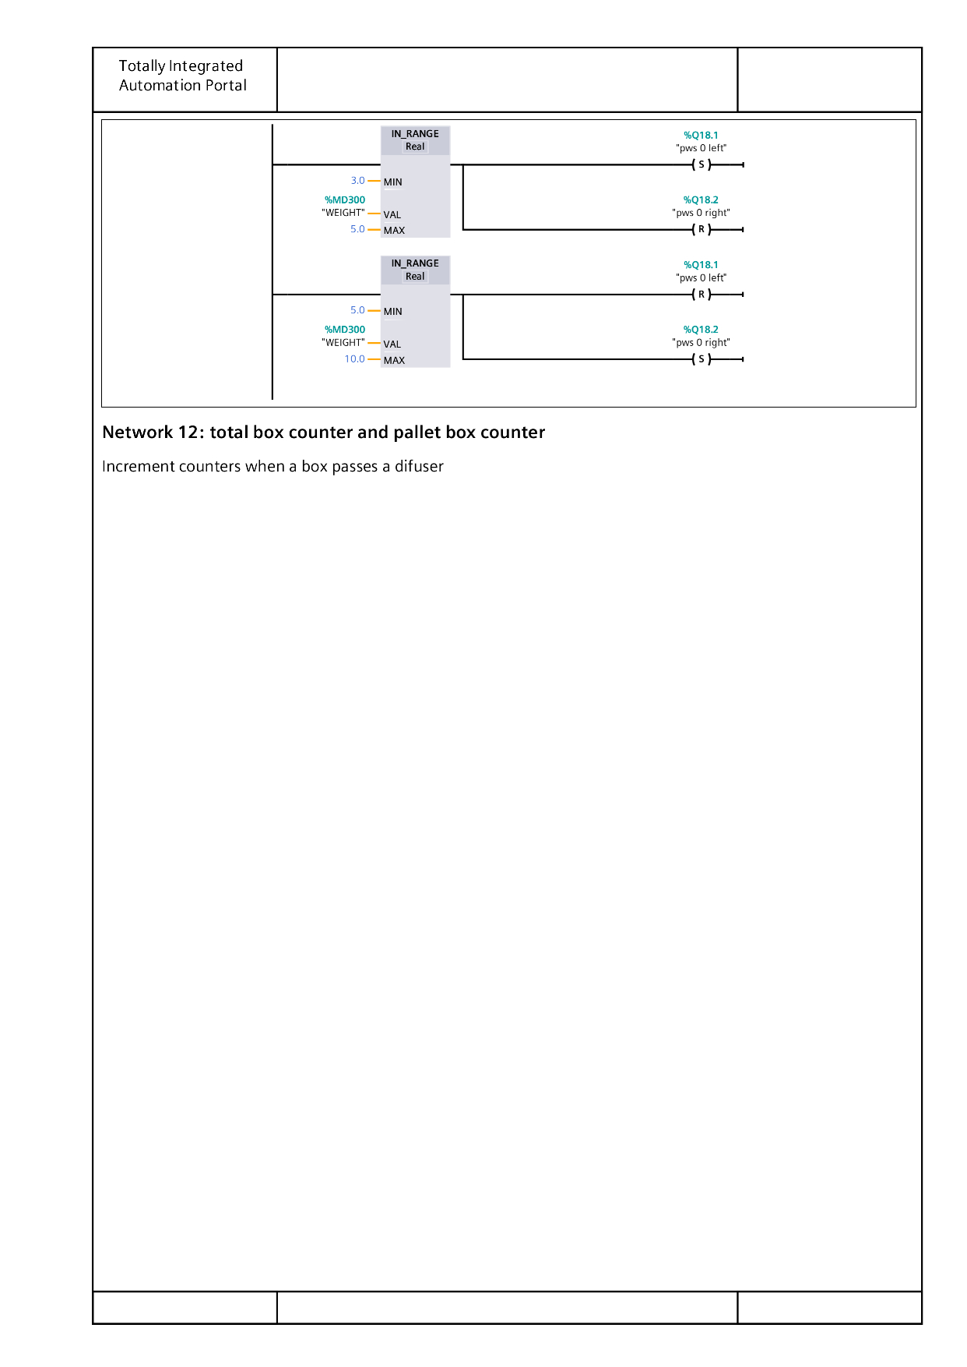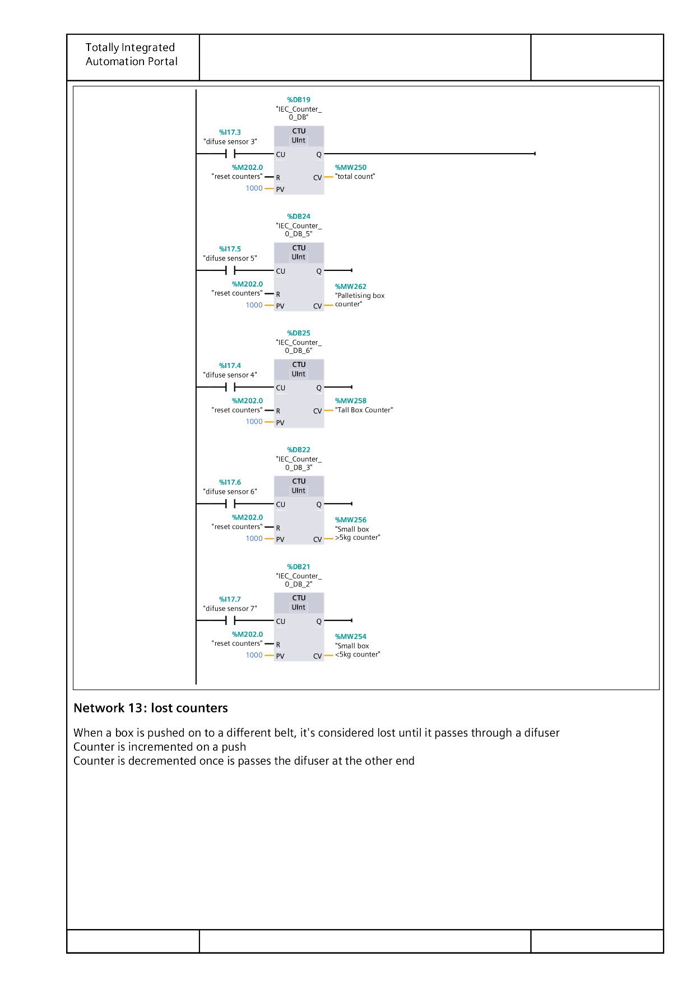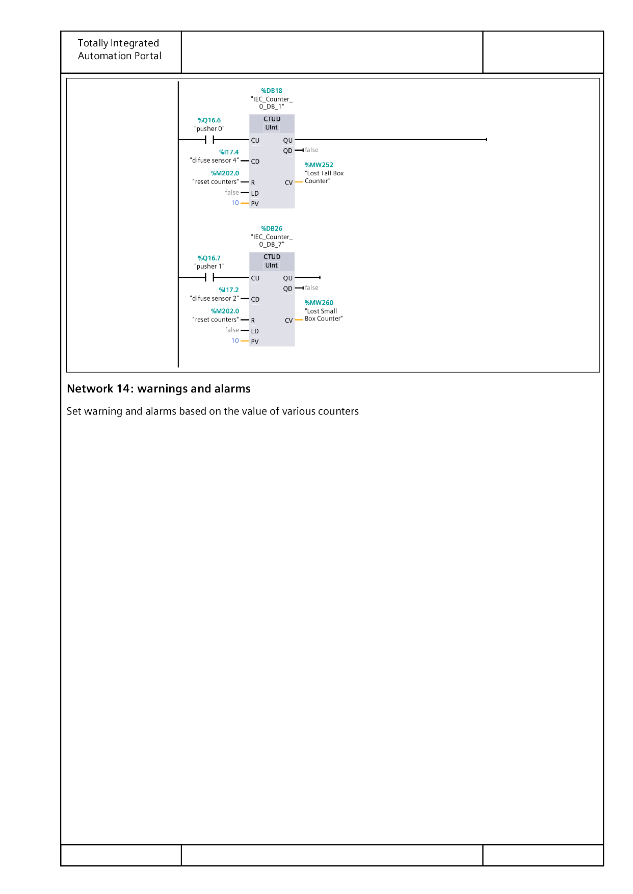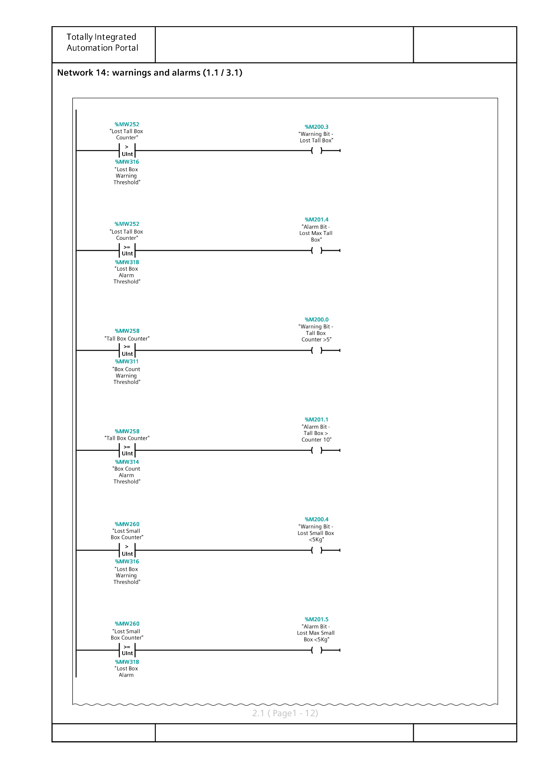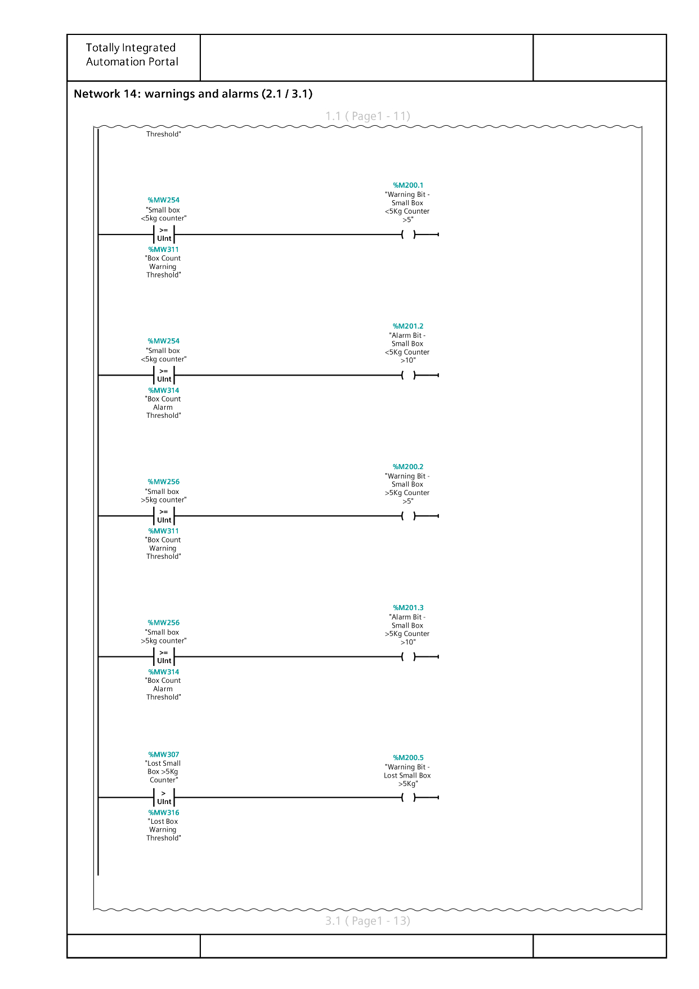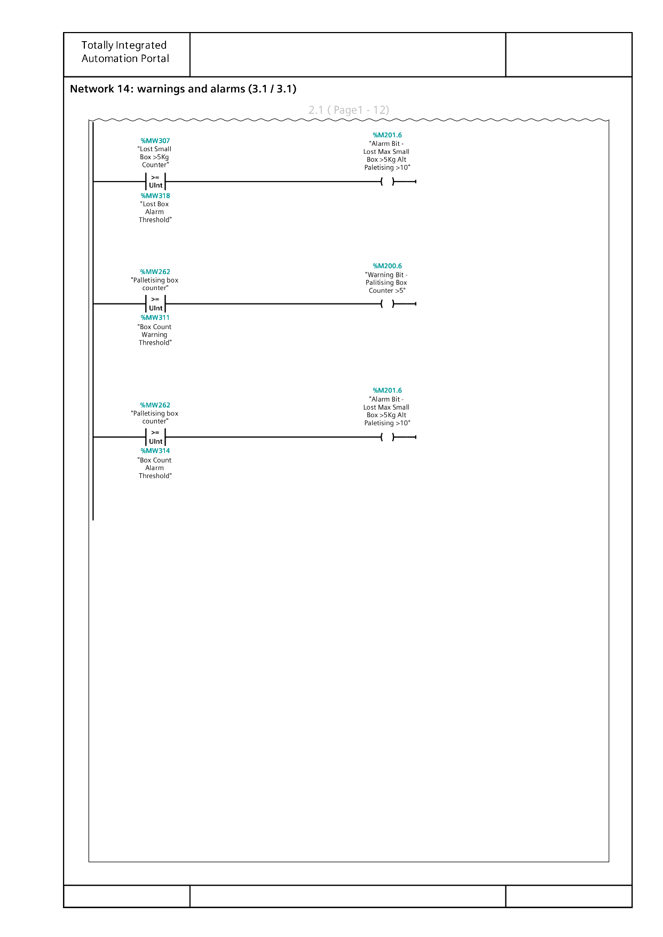
Network 6
If the “Alarms” byte is a non-zero value, then set the “Alarm Master" is in a TRUE state, then set the “Alarm Flag”
Network 5
This activates the warning flag. The system must both be in operate state (AKA on and running) and the “warnings” byte must be set to a non-zero value to start the activation of the warning flag.
aka:
IF Operate = ON
AND Warnings = 1 (00000001) THEN
Warning Flag = ON
IF Operate = ON
AND Warnings = 0 (00000000) THEN
Warning Flag = OFF
Network 4
This network links the Andon lighting system to the start sequence in network 3. The Yellow light will activate when the siren is activated, and the green light will activate when the main 4m belt is activated and the red light will be activated when the 4m belt is off.
Network 9
To prevent the weigher form weighing multiple packages at once, this network stops the feeding conveyor long enough for the scale and digital display to read and display a reading.
Network 7& 8
As the pushers are further along the conveyor to the sensors, there must be a delay to allow for the package to traverse to the pusher before it is activated
Network 10
Once the scales have sensed a package, wait 2ms and transfer the output into weight variable.
Copy the value measured on the conveyor to a memory location called WEIGHT.
Network 11
Based on the converted weight value from network 10 activates the left or right direction of the pop-up wheel sensor. Under 5kg goes left. Over 5kg goes right
Network 12
Diffuse sensors activate the counters for the warnings and alarm systems. These are the total count counter – the diffuse sensor at the very beginning of the system, and the sensors at the end of every output stream.
Network 13
The “lost box” counter – is incremented by the pushers for the tall and small boxes. All boxes are considered lost until they pass a diffuse sensor located at the end of the belt which decreases the counter. Therefore, every box in transit is added into the counter and deducted at the end of the conveyor
Network 14
This is the alarms and warnings system. The warnings will trigger the lights on the warning screen, the alarm will stop the line. The “lost box warning threshold”, “lost box alarm threshold”, “box count warning threshold” and “box count alarm threshold” are all variable parameters which are input via the Engineer HMI Screen.
The logic for each line is that if the counter is more than or equal to the set threshold, activate the relevant warning/alarm.

HMI Screens
Root Screen
The elements and descriptions of each are below:
- Start button – activates system
- Stop button – stops system
- Warnings button takes you to warnings screen
- Emergency stop button - stops system
- Lost tall box counter displays boxes that entered the tall box stream but did not come off the tall box stream
- Tall box counter displays the number of boxes passing diffuse sensor 4
- Lost small box counter displays boxes that entered the tall box stream but did not come off the small box stream
- Reset counters re sets all counters to 0
- Small box >5kg displays count of all boxes which pass diffuse sensor 6
- Small box <5kg displays count of all boxes which pass diffuse sensor 7
- Palletising box counter displays count of all boxes which pass diffuse sensor 5
- System status lights mirror the physical Andon light system on the conveyor
- Warnings and alarms LEDs activate when there are active warnings or alarms

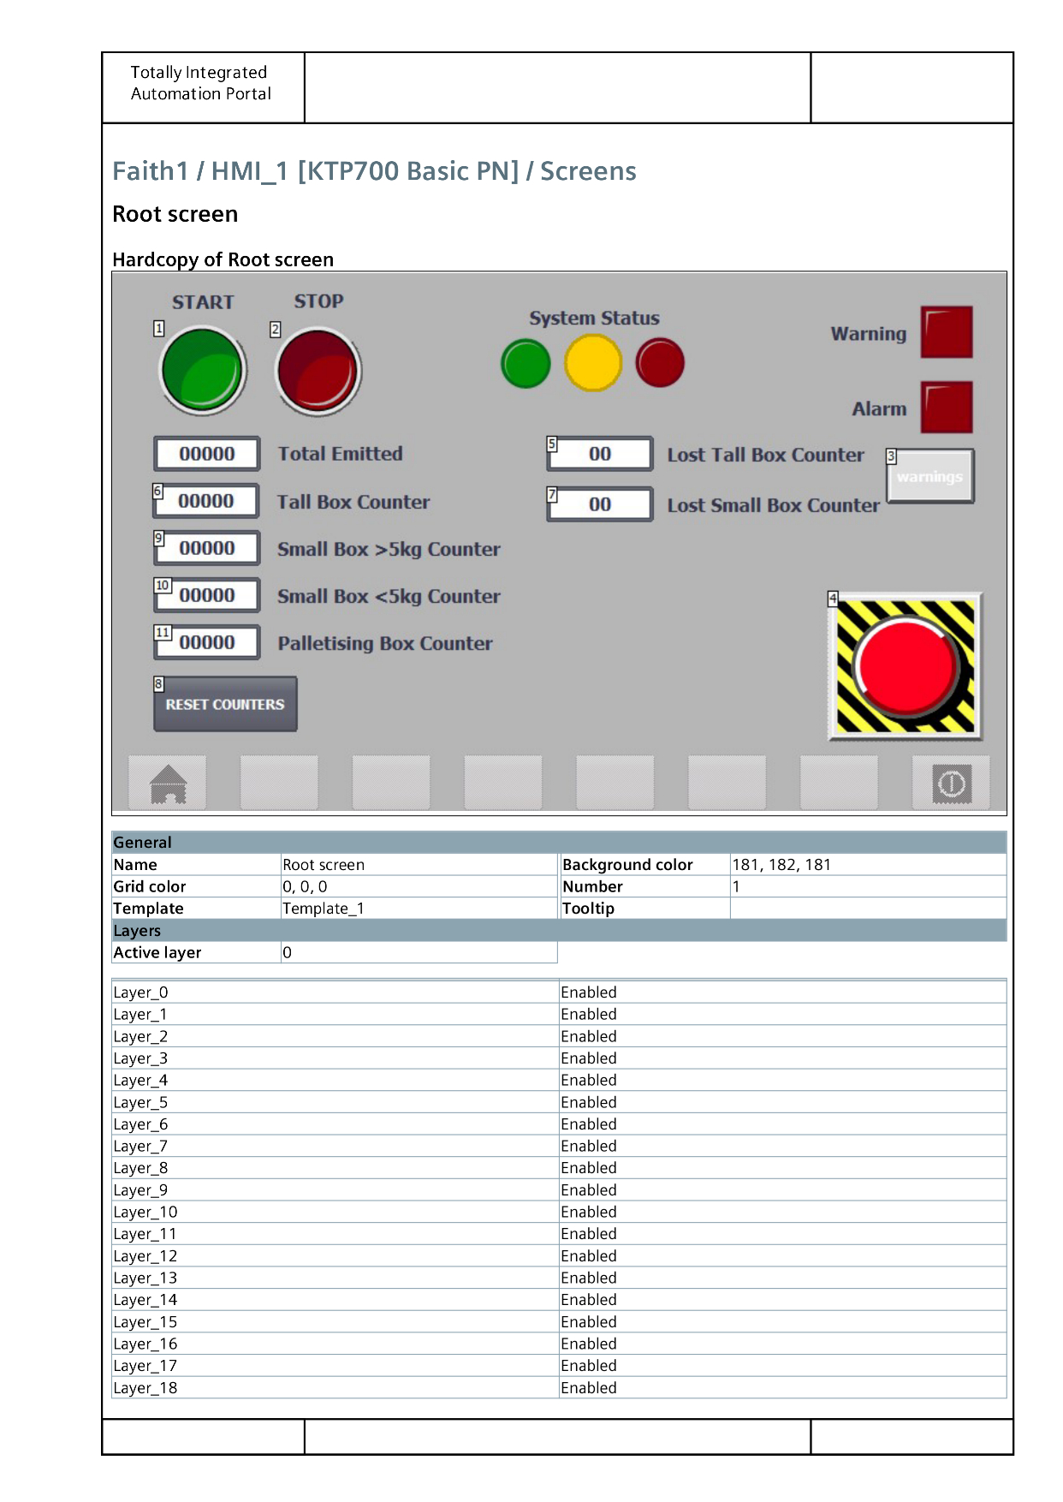

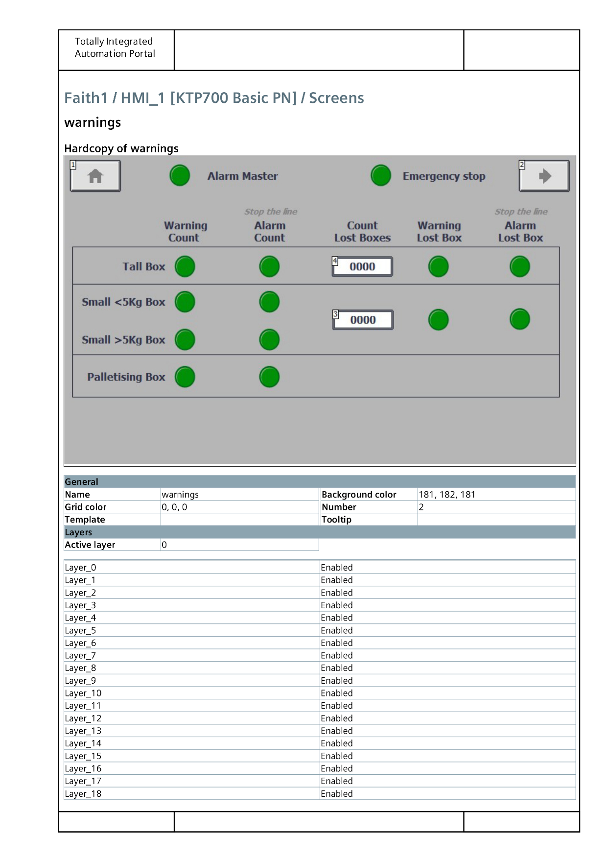
Warnings Screen
LED light is activated when the relevant counter for the corresponding column and row is above threshold.
Alarm master LED and Emergency Stop LED are triggered when the button is pressed, or alarm is triggered

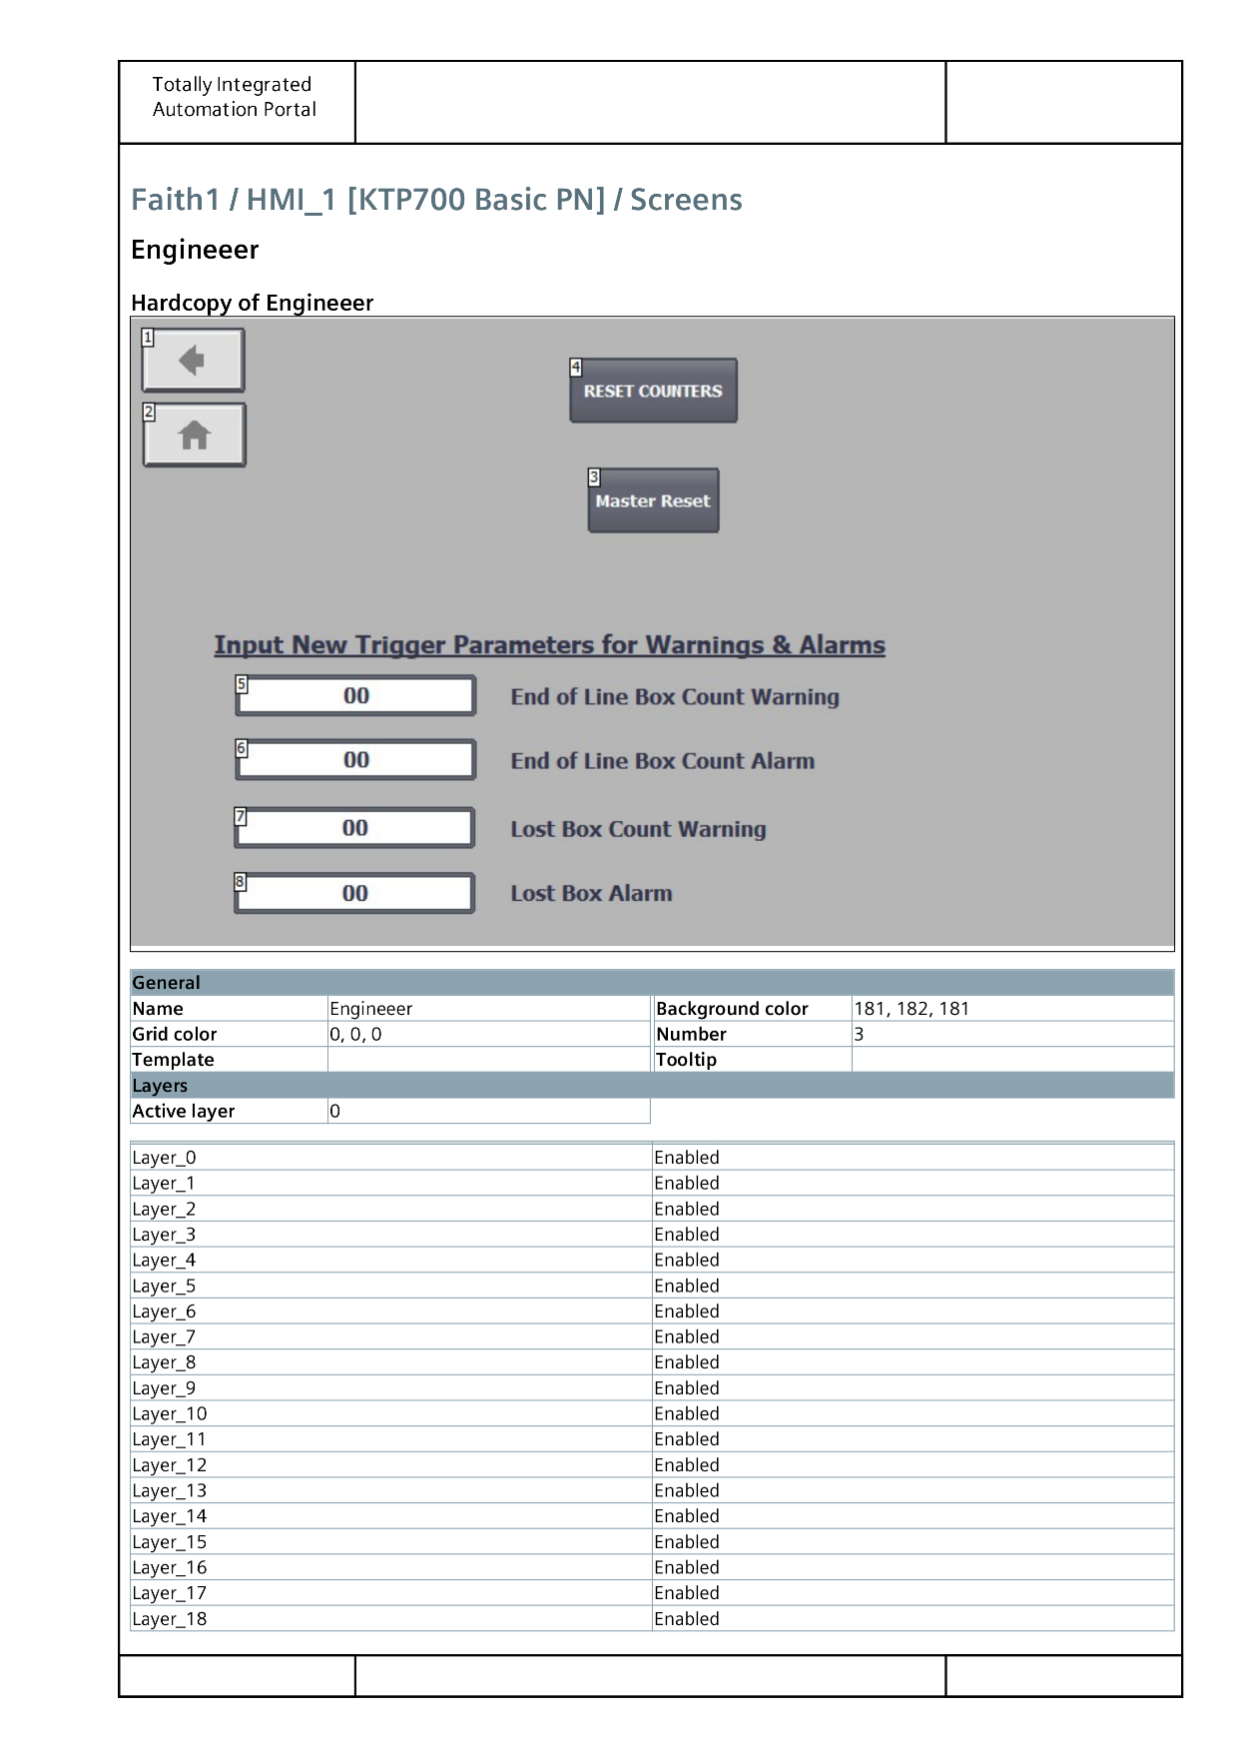
Engineer Screen
The following elements are on this screen
- Back button takes you back to warnings screen
- Home button takes you to root screen
- Master re set re sets all counters warnings and alarms
- Reset counters return all counters to the value of 0
Elements 5-8 are input elements, where an engineer is able to click into the field and enter the trigger parameters for the end of line warning and alarm system and the lost box warning and alarm systems

9. References

Works Cited
Bolton, W., 2015. Bolton, William. Programmable logic controllers. 6 ed. Oxford: Newness.
Chaudhari, D., 2022. Top 25 Advantages and Disadvantages of PLC | Pros and Cons. [Online]
Available at: https://dipslab.com/plc-advantages-disadvantages/
[Accessed 19 07 2022].
DU, D. et al., 2009. tudy on LD-VHDL conversion for FPGA-based PLC implementation. The International Journal of Advanced Manufacturing Technology, 40(11-12), pp. 1181-1190.
Phillips, R., 2019. What are the different types of PLC?. [Online]
Available at: https://basicplc.com/different-types-of-plc/
[Accessed 09 07 2022].
Swisslog Holding AG, 2022. Robot-based picking & palletizing for higher warehouse performance. [Online]
Available at: https://www.swisslog.com/en-gb/products-systems-solutions/picking-palletizing/robot-based
[Accessed 16 07 2022].
Unitronics, 2022. What is the definition of "PLC"?. [Online]
Available at: https://www.unitronicsplc.com/what-is-plc-programmable-logic-controller/
[Accessed 07 19 2022].
WDX, 2022. Offer. [Online]
Available at: https://wdx.eu/offer/conveyor-transport-and-automation/pallet-conveyor-systems/#offer
[Accessed 12 07 2022].

