DS 1 Template

My Screenshots/Photos
- Please add 4–6 screenshots or photos of your digital life.
- You can use your phone or laptop.
- For each screenshot, write one or two sentences explaining what it shows.

Screenshot/Photo 1
Moodle
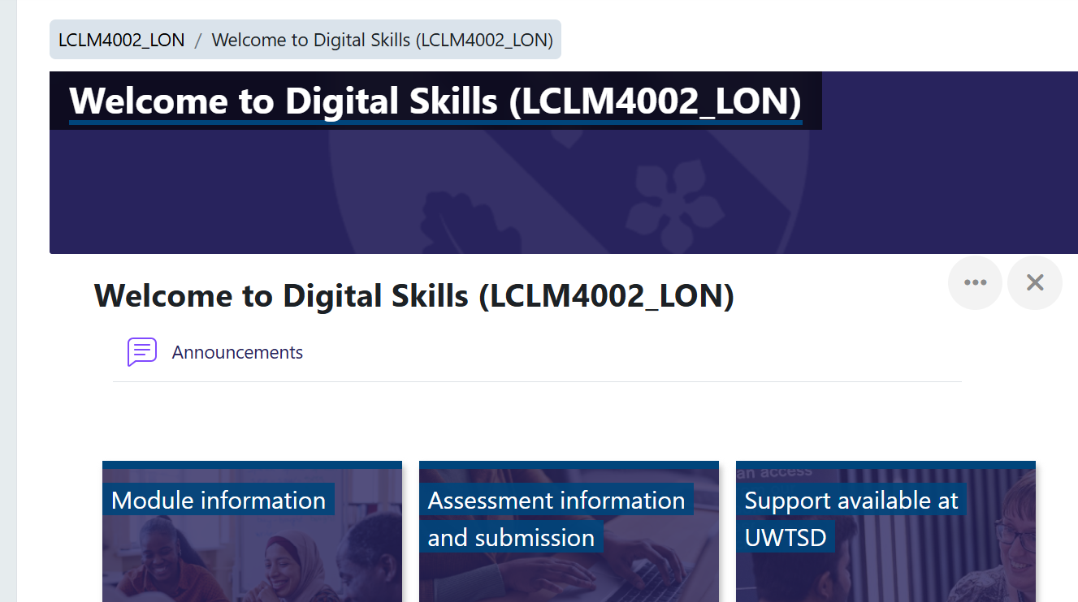
This is a screenshot of my university Moodle dashboard where I access my online courses. I use this platform every day to check my learning modules and study materials.

Screenshot/Photo 2
Library
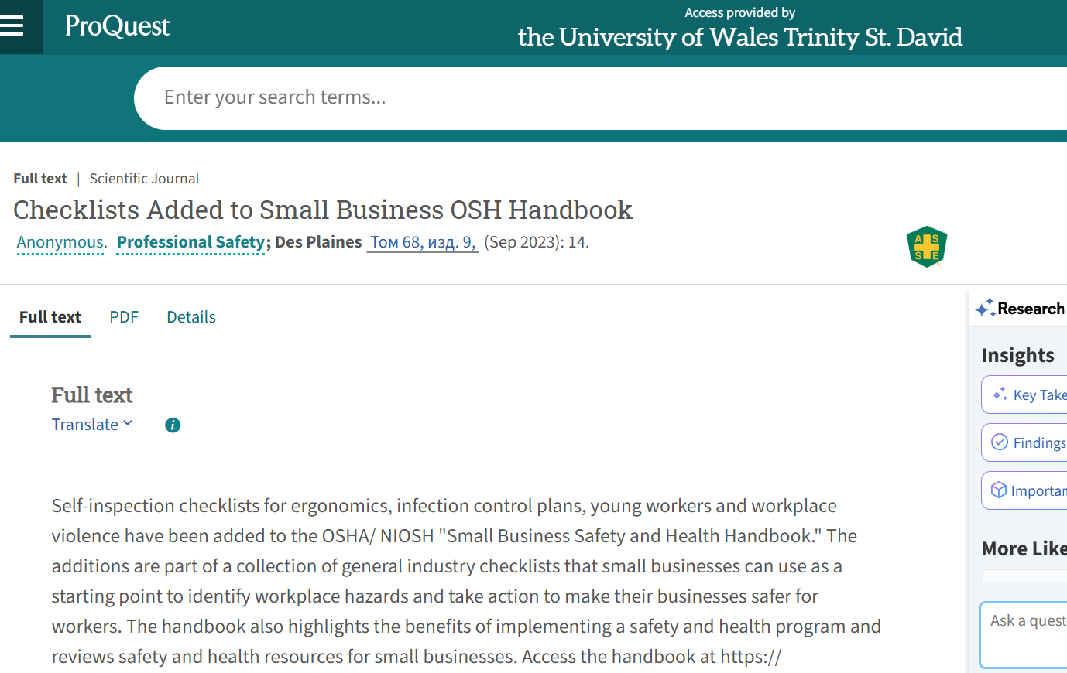
Here I am using the ProQuest library database through my university access to search for academic articles. This digital tool helps me find reliable information and safety handbooks for my studies.

Screenshot/Photo 3
Jisc
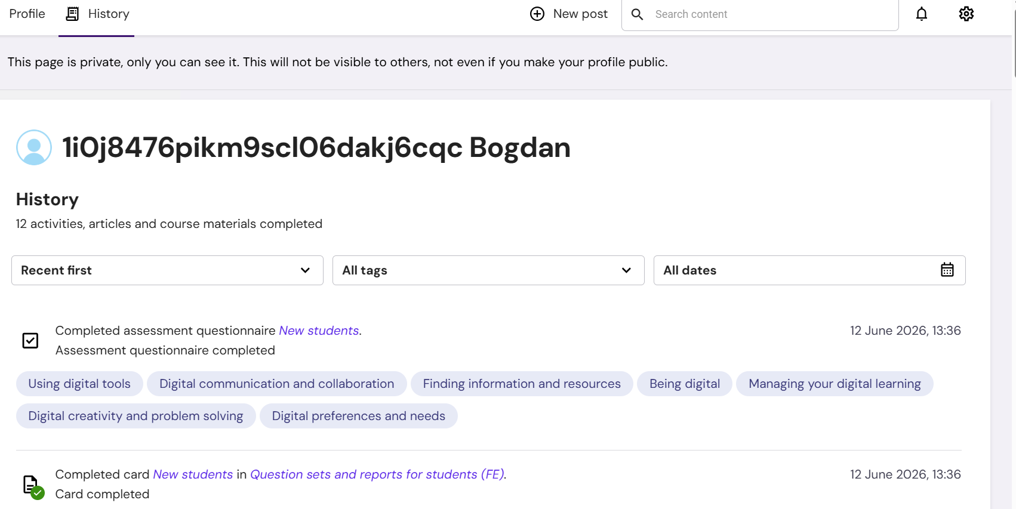
This is a screenshot of my Jisc digital capabilities report on the university portal. I used this discovery tool to complete an assessment questionnaire and review my strengths in digital learning.

Screenshot/Photo 4
Outlook
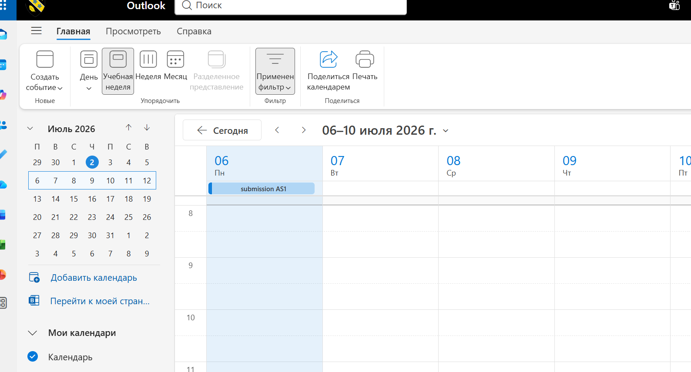
This is my digital Outlook calendar that I use to plan my academic week and organize task deadlines. It is an essential tool for my time management and tracking assignment submissions.

Screenshot/Photo 5
LinkedIn Learning
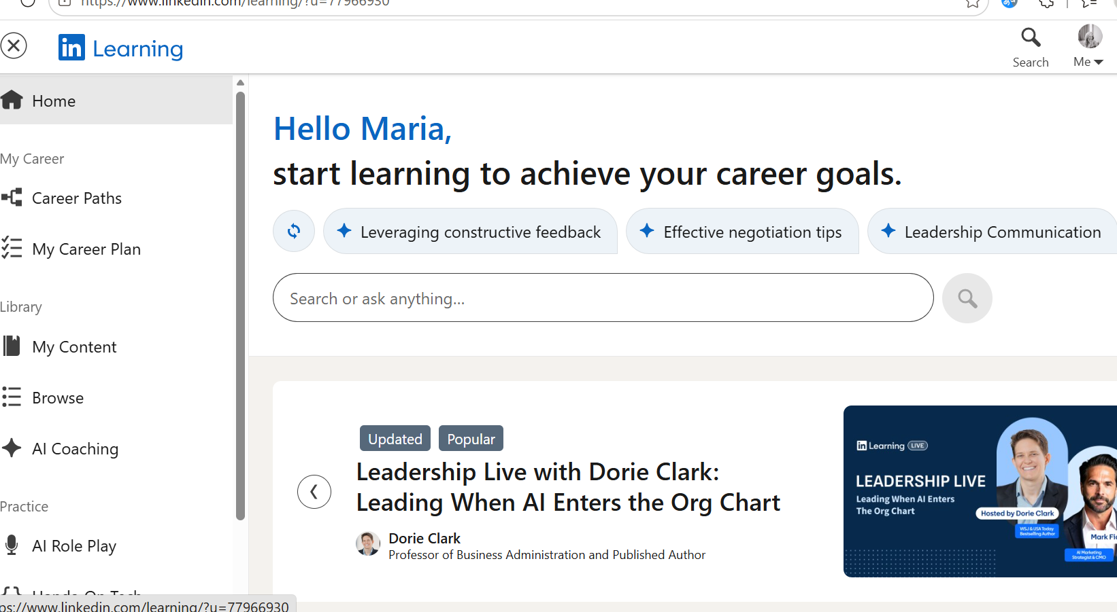
I use LinkedIn Learning to develop my professional leadership and communication skills. This online platform allows me to take extra courses and improve my workplace productivity.

Screenshot/Photo 6
NHS Learning Zone
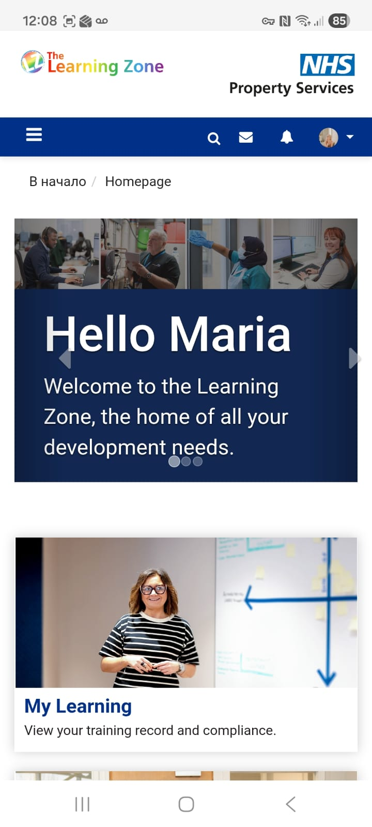
This is the NHS Learning Zone mobile application that I use on my phone. It helps me complete mandatory work training and keep my professional knowledge up to date.

My Short Reflection
- Write 5–8 simple sentences about your digital life.
- You can use the sentence starters below if helpful.
I use digital tools to study at university, find academic articles, and complete my training courses. I feel confident when I navigate the Moodle platform and use online databases like ProQuest. I want to improve my skills after reflecting on my Jisc capabilities report. I often use these tools on both my laptop and smartphone to stay organized. I sometimes feel nervous about technological updates, but I hope this module will help me work faster. Digital skills are important for me because they are necessary for my future career development.

Sentence starters
- I use digital tools to …
- I feel confident when I …
- I want to improve …
- I often use these tools: …
- I sometimes feel nervous about …
- I hope this module will help me …
- Digital skills are important for me because …
You can write more if you want.

Submission Checklist
Before you submit, please check:
​​​ ☒ I added 4–6 screenshots
☒ I wrote short sentences for each screenshot
☒ I wrote my short reflection
☒ My work is my own
☒ My file opens correctly
​​

