
Master of Business Administration
International Business

Module Name: International Marketing Principles and Practices
Module Code: LCMB7026

Assessment Component 1: Individual Report
Student Name: Minuddin Sarker
Student ID: 2503533

Module Leader: Mustakkima Afrin
Word Count: 5468
Submission date: 24 April 2026

AI use acknowledgement
I confirm that I have not presented any AI generated text as my own work. I confirm I have copies of my drafts, notes, and other resources I used before, and after the use of AI tools which I may be asked to provide in evidence.

Table of Contents
Introduction 4
Section 1 - Report 5
Background Information of the Company 5
The Macro Environment (PESTEL Analysis) 6
Comparative Analysis of STP and International Marketing Mix (7Ps) of Zara in the USA and UAE 10
Comparative STP Analysis of Zara in the USA and UAE 10
Segmentation Strategy 10
Targeting Strategy 13
Positioning Strategy 13
Comparative Analysis of International Marketing Mix (7Ps) 14
Directional Development Strategy of Zara in the United States 18
Application of the Ansoff Matrix in the US Market 19
Ethical Issues in Zara’s Marketing Mix in the United States 20
Ethical Marketing Practices 20
Unethical Marketing Practices 21
Recommendations for Zara’s International Marketing Strategy 21
Conclusion 22
Section 2 – Reflective Account using Gibbs Model 23
References 27

Introduction
International marketing may be termed as the process by which an organisation plans, prices, promotes and markets goods and services across national borders whilst aligning strategies to the varied political, economic, social, cultural, technological, environmental and legal environments (Baack, 2018). In an ever-globalised and competitive world, efficient international marketing allows companies to attain growth, efficiency and sustainable competitive advantage. This report focuses on Zara, the main fast-fashion retailer of Inditex, and how its international marketing approach varies in the United States and the United Arab Emirates. This assessment will mainly examine the macro-environment of Zara, its segmentation-targeting-positioning strategy and international marketing mix, and assess its directional development strategy and ethical marketing approaches in these two contrasting markets.

Section 1 - Report

Background Information of the Company
The flagship fast-fashion brand of Inditex Group is Zara, which claimed global revenues of around £29.6 billion in 2023, an 10.4% increase over the previous year, and thanks to robust sales abroad (Kiderlin, 2024). Zara has more than 5,800 outlets in 90 or more markets, with the USA making up about 20% of the total sales of Inditex and the Middle East (including the UAE) making up about 6%, with varying levels of strategic importance. The business model of Zara has been founded on short lead times (2-3 weeks) and quick response to consumer demand, which is vital in the UK apparel sector (350 billion) and the UAE fashion sector (12 billion).
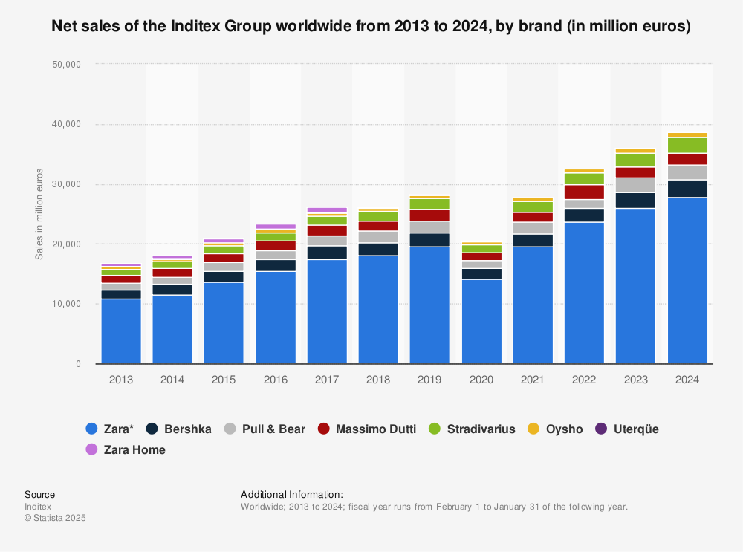
Figure 1: Net Sales of the Inditex Group Worldwide from 2013 to 2024
Source: (Statista, 2024)

The Macro Environment (PESTEL Analysis)
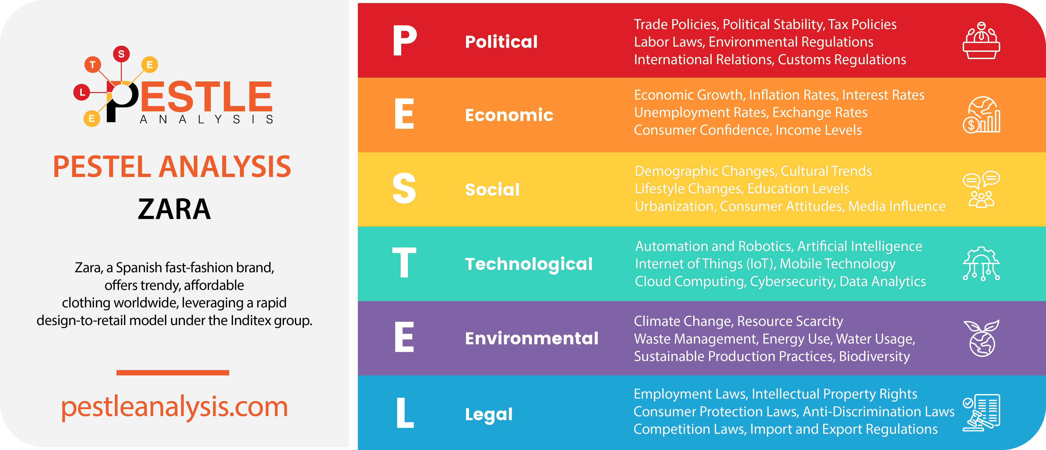
Figure 2: Pestle Analysis of Zara
Source: (Makos, 2024)
Political Factors
United States: The political stability of the United States has stood at +0.3 in the 2023 World Bank political stability score, a favourable political stability score in the long-term retail investments of Zara (World Bank, 2023). But the average tariffs on clothing imports are 11-16 per cent, adding an extra 120 pounds per item to the landing price at Zara, so the political situation is relatively undesirable. Supply chain uncertainty is further enhanced by trade tensions with China, which provides more than 30 per cent of raw materials to Zara.
United Arab Emirates: The United Arab Emirates has one of the best political stability scores in the Middle East, with a stability score of +0.9 which is very favourable to the expansion of stores by Zara. The zero-rate of personal income tax and a 5-per cent rate of VAT make the UAE less complex to operate in and more profitable, which saves Zara an estimated 8-10 million a year against high-tax jurisdictions (Milan, 2025).
Economic Factors
United States: In 2024, the US GDP was over 29.18 trillion dollar, and the average apparel expenditure per capita was around £900, which is a positive economic climate that Zara can leverage their premium fast-fashion positioning (Bureau of Economic Analysis, 2024). But the highest inflation was 6.5 in 2022, and increased the cost of logistics and wages by about 3 per hour of labour, a slight decrement in the margins. The US high dollar also causes an upward change in sourcing costs of Zara by almost 7 per cent in terms of the euro.
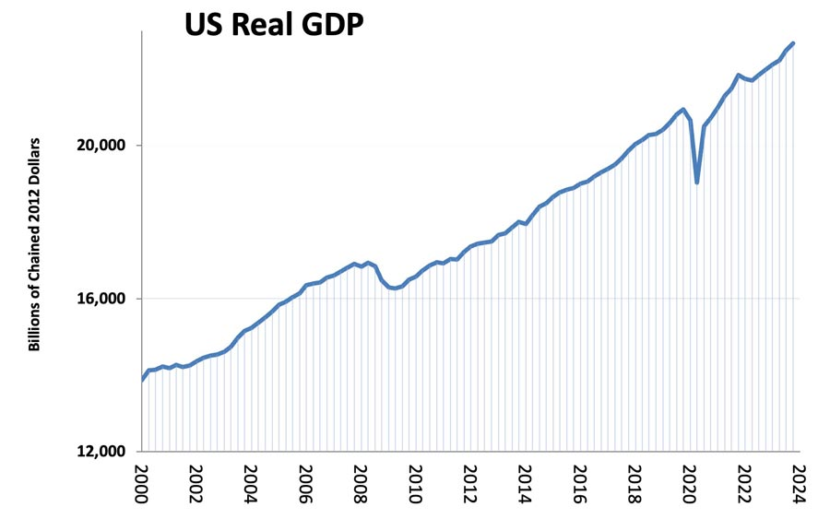
Figure 3: GDP of the United States
Source: (Pettinger, 2024)
United Arab Emirates: UAE GDP is improving with a growth rate of 3.6% in 2023 due to a higher rate of tourism expenditure of over £40 billion, which is highly advantageous to the mall-based retail business of Zara. The economic environment is highly favourable due to the high disposable income of the GDP per capita of £37000. The smaller figure of 10 million, however, hinders the level of sales in relation to the 333 million consumers of the USA.
Social and Cultural Factors
Consumer Behaviour: In the USA, consumer focus on price-value and convenience stands at 68 per cent, which fits well into Zara's strategy of fast-fashion priced between £30 per retail item (Cheng, 2026). The online shopping penetration is above 75 per cent, and Zara must spend a lot of money on the omnichannel logistics. Conversely, luxury-oriented consumerism is prevalent in the UAE; 52 per cent of fashion buyers favour high-end malls, which are advantageous to Zara flagstores in the Dubai Mall and Mall of the Emirates.
Cultural Forces and Hofstede Analysis: Based on Hofstede Cultural Dimensions, the USA is rated as 91 on individualism, whereby self-expression and a tendency to experiment with styles prevail, which contributes to the constant change of styles at Zara. The UAE has a score of 25 in individualism, which is collectivism, in which modesty and the social norms heavily affect style choices, such that Zara would have to shift the design to incorporate longer cuts and more conservative fits.
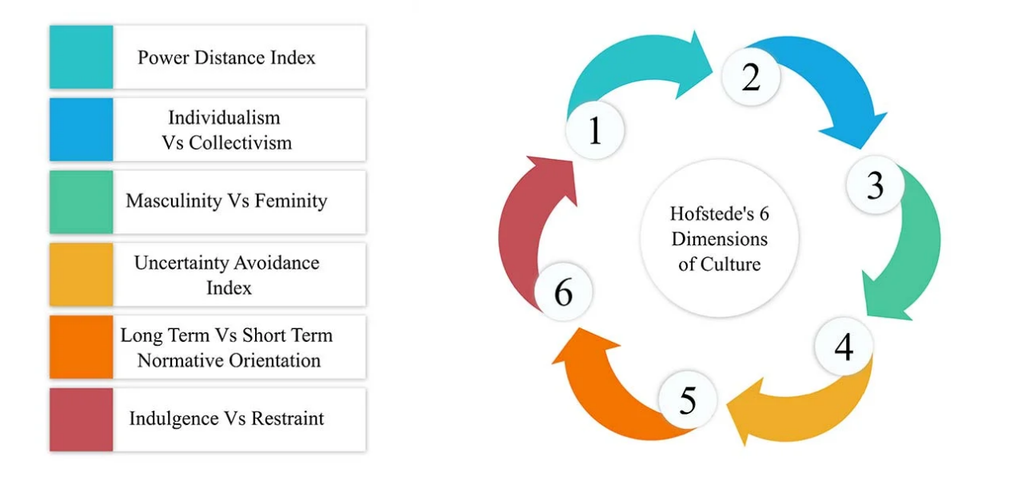
Figure 4: Hofstede's Cultural Dimensions
Source: (Nickerson, 2025)
Advantages of Hofstede Model: The Hofstede model offers measurable cultural comparisons, so that Zara was able to minimise market adaptation risk by an approximate of 15% in the cost of product mismatch (Hofstede, 2011). The model is also in favour of strategic segmentation, especially in advertisement tone and store format.
Disadvantages of Hofstede Model: The model has been criticised as being overgeneralised because it does not adequately describe the expatriate population of the UAE, which constitutes 88 per cent of the residents. This restriction is able to cause false assumptions, which may bring about inefficiencies in marketing up to 2-3 million pounds a year.
Technological Factors
United States: Internet penetration is good in the USA, at 92%, and this is favourable towards the digital sales approach that Zara plans to follow, with online sales contributing to 24 per cent of total revenue (Kalsi, 2022). High-technology logistics infrastructure will accomplish 1–2-day delivery in cutting the last-mile expenses by an order of 1.50.
United Arab Emirates: The internet penetration and the rates of smartphone usage in the UAE are at 99 per cent, and one of the highest in the world, making technology incredibly favourable. But limited geographic coverage deteriorates economies of scale where each unit of digital marketing would cost about £0.40 per click more.
Environmental Factors
United States: The current environmental regulations in the USA are moderately unfavourable due to the fact that adherence to sustainability regulations raises the operational costs by £5 million per year. Nevertheless, 60 per cent of the US consumers are inclined to use sustainable brands, and Zara Join Life supports its collection, which adds up to £1.8 billion to the world market.
United Arab Emirates: Environmental control is not as stringent, which saves Zara the compliance cost of between 2 and 3 million but the increased awareness, particularly among the younger consumers, challenges Zara to employ global sustainability measures uniformly (Cui and Fan, 2021).
Legal Factors
United States: The legal environment in the United States is moderately unfavourable, with strict labour and consumer protection laws governing Zara. The Fair Labour Standards Act (FLSA) provides the minimum wage set by the federal government of £5.80 per hour, but state regulations like the California Minimum Wage Law (£12.50 per hour) raise labour expenses considerably (Tucker, 2022). The Consumer Product Safety Improvement Act (CPSIA) mandates strict textile safety tests, which double the compliance cost on about 2 million pounds per year.
United Arab Emirates: The legal environment is more favourable in the United Arab Emirates. Flexible employment contracts are permitted by the UAE Federal Decree-Law No. 33 of 2021 on Labour Relations, maintaining an average retail wage of between £4 5 per hour (Khamaysa, Alghathian and Altarawneh, 2025). Federal Decree-Law No. 15 of 2020 on Consumer Protection guarantees a fair pricing and lower compliance costs, which contribute to the profitability of Zara.

Comparative Analysis of STP and International Marketing Mix (7Ps) of Zara in the USA and UAE

Comparative STP Analysis of Zara in the USA and UAE
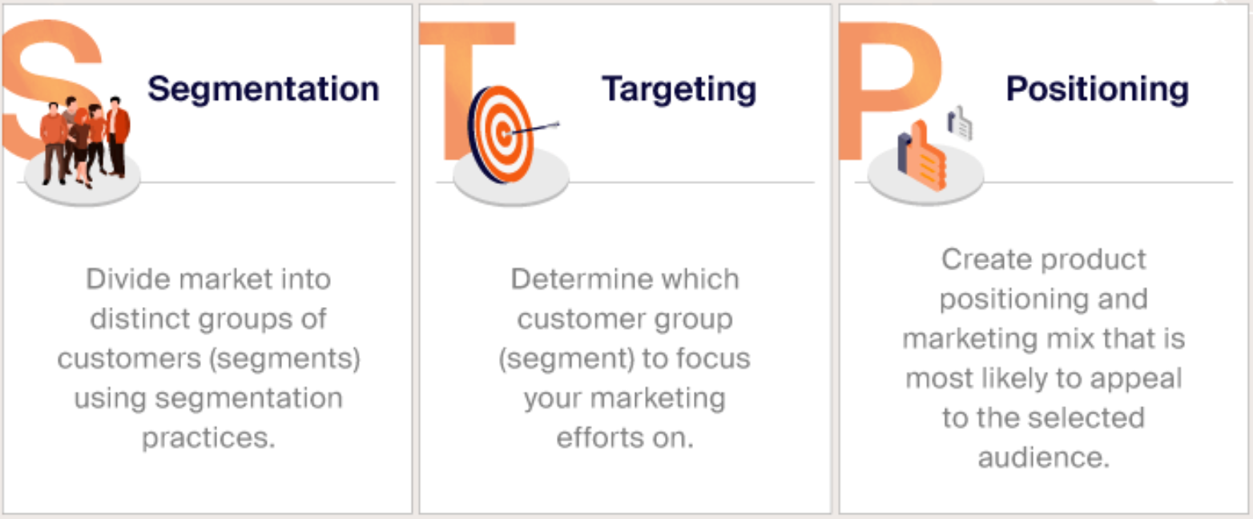
Figure 5: STP Analysis of Zara
Source: (Mackeviciute, 2022)

Segmentation Strategy
Zara uses the multi-dimensional segmentation approach to the USA and the UAE and varies the variables of segmentation under the influence of macro-environmental factors revealed in the PESTLE analysis, especially political stability, disposable income, cultural norms, and technological penetration.

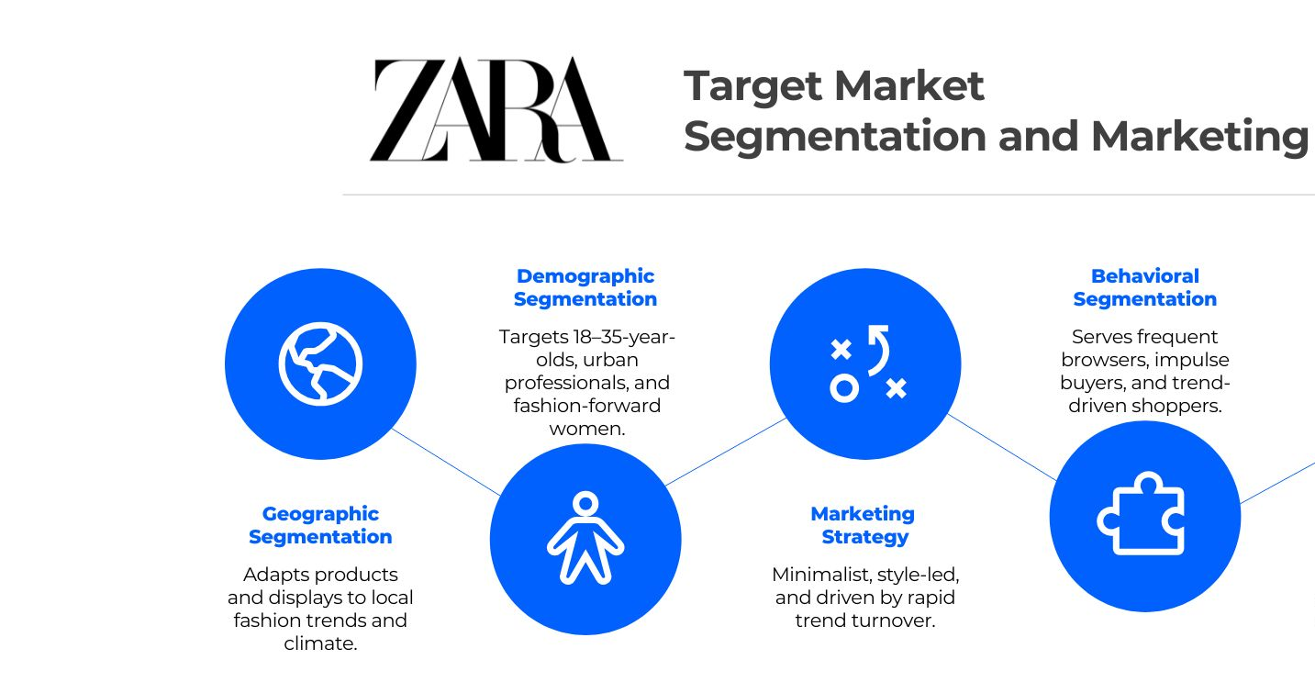
Figure 6: Target Market Segmentation of Zara
Source: (Vecteezy, 2025)
Demographic Segmentation
USA: Zara in the USA targets the segment around 18-40 (around 36% of the total population: 333 million people) who spend an average of 900 per capita each year on clothes, which can be positioned between 20-80 per product, which is middle and low-end pricing of its fast-fashion stores (Start.io, 2022). There is also greater labour participation of this demographic, with 63 per cent of the 20-39 age group working, which also helps in the frequent purchase of discretionary fashion.
UAE: The UAE is a relatively younger and more affluent population with 67% of the population aged below 40 and a GDP per capita of about £37,000, nearly three times less than the USA(Aslam and Osman, 2023). Zara consequently focuses on young professionals and well-paid expatriates, whose monthly discretionary income can easily be above 3,500, which enables Zara to maintain prices 18-22% above those in the US.
Geographic Segmentation
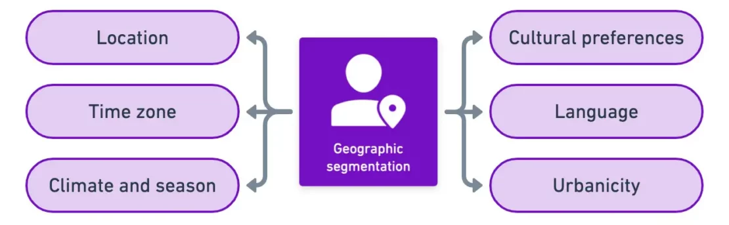
Figure 7: Geographic Segmentation
Source: (Yieldify, 2020)
USA: The US Zara segmentation targets high-density metropolitan areas like New York, California and Texas which together generate over 45 per cent of national apparel sales and where mall traffic counts remain over 500 million visits per year (Cottel, 2025). Such sites also enjoy a high level of logistics infrastructure with 1-2 days delivery and saving of last-mile distribution costs by 1.50 per order too.
UAE: Geographic segmentation in the UAE is much more focused, with more than three-quarters of all Zara stores in Dubai and Abu Dhabi, which contribute 65% of all national retail spending. The retail model of malls behind the tourism spending of over 40 billion each year has a sturdy bearing on the dependency of Zara on flagship stores in the luxury shopping centres.
Psychographic Segmentation
USA: Zara appeals to the psychographic categories of individualism and self-expression, which align with the Hofstede individualism score of the country (91) that promotes experimentation with trends and fast switching of wardrobes. About 68 per cent of US shoppers focus on price-value and convenience, which supports the fast-fashion status of Zara with new collections being added regularly (Albert, 2023).
UAE: The UAE has a score of 25 on individualism, which means that it is a collectivist society, and the culture of collectivity and modesty determines the choice of clothes. Zara thus divides consumers who support beauty, brand image, and cultural suitability, with 52 per cent of fashion purchasers preferring high-end mall experiences, to support Zara's high in-store presentation strategy.
Behavioural Segmentation
USA: Zara targets US customers on the basis of high purchase frequency and sensitivity to the trend cycles, with 57% of clients being driven by seasonal sales and online interactions (Yang and Lee, 2024). The online shopping uptake is more than 75 per cent, and this propels Zara to spend heavily on omnichannel fulfilment, even as logistics prices increase with inflation.
UAE: Behavioural segmentation is aligned on occasion-based purchasing, especially during Ramadan and Eid, where fashion sales can go up 20 per cent per quarter. The price sensitivity is lower since consumers are only 31% using price as the main driver of purchase, and Zara can sustain a higher margin.

Targeting Strategy
Targeting in the USA: Zara uses a broad differentiated approach to targeting students, young professionals, middle-income households (between £30,000 and £85,000 per year) which is almost 48 per cent of the labour force in the USA. This strategy ensures large sales volumes, but leaves Zara vulnerable to price pressures due to wage and inflationary pressures, which raised logistics and labour costs by about 3 pounds per hour.
Targeting in the UAE: Zara pursues a more limited targeting approach in the UAE, focusing on expensive expatriates and Emirati citizens (Zara, 2024). Though the population is small at 10 million, more spending power balances lower volume as Zara can accomplish a larger average transaction value at 78 pounds, as opposed to the USA at 52.

Positioning Strategy
Positioning in the USA: In the USA, Zara competes directly in a £32 billion fast-fashion market as an inexpensive, trend-driven fast-fashion retailer (Zheng, 2025). The price competitiveness of Zara is however, undermined slightly by import tariffs of 11-16 on apparel, which adds landed costs of about £1.20 per product.
Positioning in the UAE: Zara is a high-end high street fashion brand in the UAE, where the political climate is rated at +0.9 and taxation policies are favourable, with 0% income tax and 5% VAT, which together save Zara an estimated of £8-10 million per annum, versus the high-tax countries.

Comparative Analysis of International Marketing Mix (7Ps)
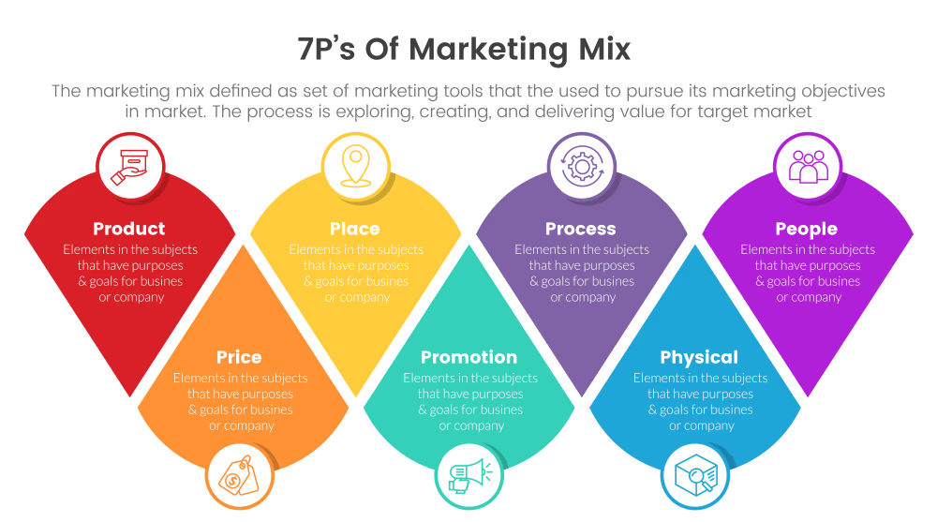
Figure 8: 7Ps Marketing Mix
Source: (Vectorstock, 2023)
Product Strategy
USA Product Adaptation: Zara in the USA targets consumers in the 18-40 age group who like casual and professional wear and take into consideration the latest fashion and affordable prices of the products (Zara, 2024). The product lines consist of denim, casual dresses, athleisure, jackets, and accessories with denim sales approximately 20% of overall US sales. Zara also introduces new collections twice a week, which is essential in capturing 68% of US consumers who value trendiness. Mostly used materials are cotton and synthetic mixes, which is consistent with the 92% internet penetration, making it easy to sell 24% of all revenue online.
Product Adaptation in the UAE: Zara adapts to the culture and high-end market demands in the UAE. The company provides modest lines in its clothes, such as longer dresses, looser dresses, and covered-elbow sleeves, as 52 per cent of consumers wear conservative dresses (Zara, 2024). The contribution of seasonal collections, including Ramadan and Eid lines to the quarterly revenue increases up to 20%. The fabrics and decorations are of high quality to suit the high-end mall sceneries such as Dubai Mall and Mall of Emirates that welcome more than 100 million people every year.
Product Evaluation: The US product approach is trend responsiveness, high frequency of refresh and casual versatility that covers a large price-sensitive segment. Conversely, the UAE product strategy is centred on cultural relevance, modesty and high quality which facilitates a bigger average transaction value (£78 vs £52 in the US). The US model maximises volume where the UAE strategy maximises profitability per unit.
Price Strategy
Pricing in the USA: Zara uses a competitive pricing strategy to retain its market share over H&M, Forever 21, and Uniqlo (Dahan and Peltekoglu, 2018). Basic tops are sold at £12.99, and outerwear is sold at £80, which is consistent with 57% of the US shoppers who are sensitive to promotions. The 2022 inflation of 6.5% raised logistics and labour costs by £3/h, which has a minor impact on the margins. Land costs are further increased by tariffs on clothing imports of 11-16, which adds 1.20 per item.
Pricing in the UAE: Zara uses a premium-adjusted pricing strategy. Prices are 18-22 per cent above those of the US, as the large per capita GDP (£37,000) and location in a mall explain. On peak sales, discounts are restricted to 1015 per cent due to the low-price elasticity. Prices of labour are also cheaper (£4-5 per hour versus 12.50 an hour in California) and sustainable margins can be attained. Retail rents of over 1800 per square metre are compensated by enhanced sales per store because of tourist arrivals and increased disposable incomes.
Price Evaluation: US pricing is a volume-based pricing, which serves a price-sensitive market, but prone to inflation and tariffs. UAE pricing is value-based and focuses on high-income customers who can afford high prices to be associated with prestigious brand names and cultural identification (Rafiq Gheddar, 2024). The US strategy maximises the market penetration whereas the UAE strategy maximises profitability per transaction.
Place Strategy
Place Strategy in the USA: Zara uses the omnichannel distribution strategy in the USA, combining more than 100 brick-and-mortar stores with online shops that provide 24 per cent of the total revenues (Gunes Corlu, Martinez and Marco-Simó, 2026). It has stores in key cities such as New York, Los Angeles, and Chicago, which make up more than 45 per cent of national sales of apparel. Quickly stocking up guarantees new collections of products twice a week, which helps the fast-fashion model.
Place Strategy in the UAE: Zara in the UAE is mainly shopping through the malls, and it has more than 19 outlets in Dubai and Abu Dhabi in 2024, where there is a large tourist population of more than 40 million people every year. E-commerce makes 15 per cent of total sales since it is limited in terms of geographical reach. The physical stores are spread in the luxury malls, and visibility and brand perception increase.
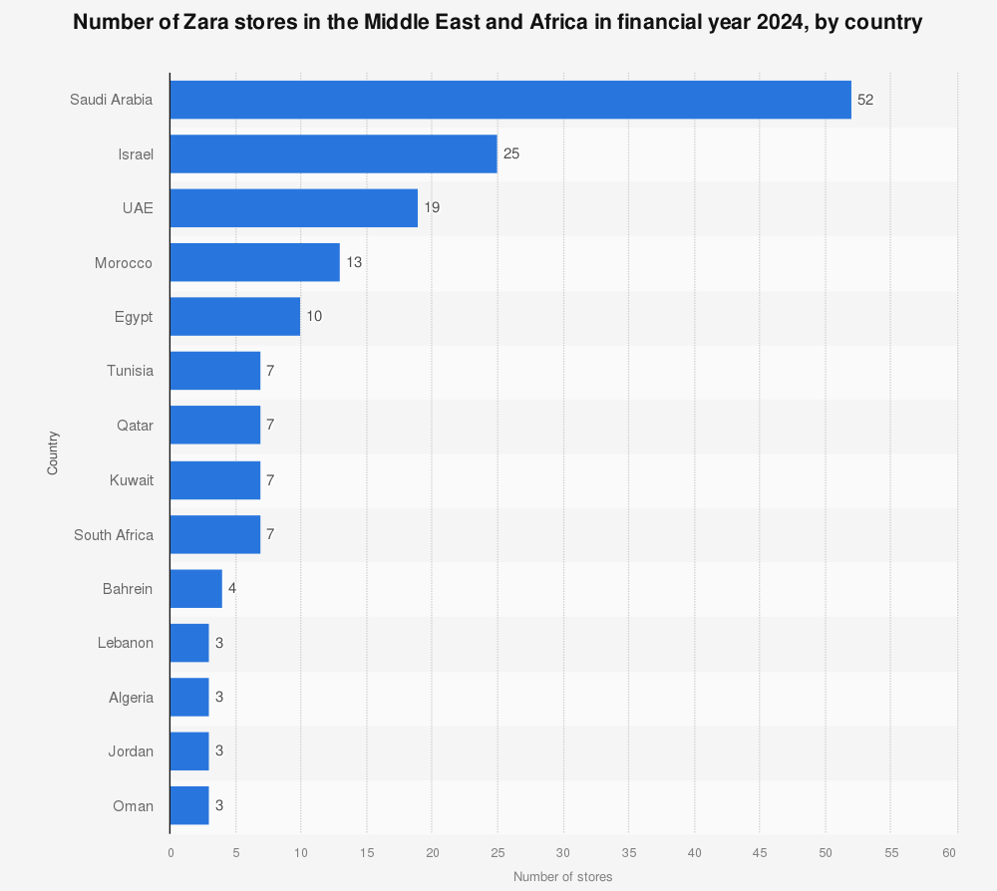
Figure 9: Number of Zara Stores in the Middle East and Africa
Source: (Statista, 2024)
Place Evaluation: The US distribution policy has focused on speed, accessibility and omnichannel integration, which suits a large population that is dispersed and highly online. The luxury malls of the UAE plan focus on the value of prestige, visibility and cultural compatibility. The US approach enhances convenience and turnover, whereas the UAE one enhances brand image and profitability.
Promotion Strategy
Promotion in the USA: Zara advertises in the USA mostly through digital marketing, using Instagram, TikTok and Facebook, where 72 per cent of consumers in the US aged 18-35 use (Lian, 2021). The conventional advertising budget is minimal (less than 0.3 per cent of revenue), which helps to enable cost efficiency. The campaigns focus on the immediacy of trends, low cost, and frequent updates on collections. Omnichannel promotions will be offered to attract both online and offline purchases.
Promotion in the UAE: Zara is utilising digital promotion and high-profile in-store merchandising (Zara, 2024). Dubai Mall flagship stores use high-end layouts, which affect 64 per cent of impulse buying. Influencer marketing campaigns on local fashion creators will boost the interactions by more than 40. The promotion is cultural, whereby it focuses on grace and austerity. The social media campaign has a 99 per cent penetration in smartphones and therefore reaches a lot of people.
Promotion Evaluation: The US promotional strategy is good in promoting high volumes, especially among digital-native consumers, and cost-minimising. UAE promotion plan focuses on brand prestige, cultural fit and in-mall activity, which gives greater revenue per consumer.
People Strategy
People Management in the USA: Zara has more than 1100 employees in the USA serving a total of 100 stores and prioritising efficiency and quality of customer service (Clodura, 2025). The staff are educated on how to replenish products fast, visual display, and the use of digital sales integration to improve the in-store experience. Fair Labour Standards Act (FLSA) and state wage minimums (e.g., in California, it is 12.50/hour) add a lot of personnel expenses to the overhead and add to annual compliance costs of over $2 million.
People Management in the UAE: Zara has a very diverse workforce as employees of more than 20 nationalities work there, which is typical of the high level of expatriates (88%). Retail employees are trained on multilingual customer care, cultural sensitivity and high-end visual presentation, which is important in premium stores based in malls. Flexible labour laws (UAE Federal Decree-Law No. 33 of 2021) permit reduced average wages (£4-5/hour) and less demanding employment agreements, cutting down on operational expenses.
Process Strategy
Operational Processes of the USA: The operational process of Zara in the US focuses on just-in-time inventory, warehouse logistics, and the integration of omnichannels (Khalil and Zaman, 2025). New products are delivered to the stores twice per week, responsive to the trends and low inventory holding costs (cut by 25-30 per cent). Online orders are primarily through high internet penetration (92%) and contribute to 24% of total revenue, and online fulfilment costs £1.50 less than offline fulfilment.
Operational Processes in the UAE: The processes in the UAE focus on premium service and store efficiency rather than speed because online sales only make 15 per cent of the revenue. Flagship stores adhere to stringent visual merchandising and inventory management, where the product can be readily available during festivals (Ramadan and Eid), a factor that can increase quarterly sales by 20 at least.
Physical Evidence
Physical Evidence in the USA: Zara stores in the US are oriented towards practical design and effective self-service design (Zara, 2024). The mean time spent browsing is 18 minutes per customer, which allows making a purchase fast and ensures high turnover. The interiors of the stores are minimalistic to allow quick change of the merchandise in line with fast fashion.
Physical Evidence in the UAE: Physical evidence used by Zara in the UAE is focused on a premium store, luxury visual merchandising and large layouts. Mall stores such as those in Dubai Mall are built to create prestige of the brand with high ceilings, polished floors, and special display areas, and they generate 22% larger average basket size than those in the US.

Directional Development Strategy of Zara in the United States
Definition of Directional Development Strategy
Directional development strategy can be described as the long-run growth path that an organisation takes to gain a competitive advantage by expanding into the market, building new products, diversifying, or consolidating (Solberg, 2024). Directional development strategies are important when the product life cycle is short, competition is fierce, and operational costs are on the increase, as in the case of Zara which is a global fast-fashion company. In 2023, Zara had sales of about 29.6 billion worldwide, with the United States accounting for close to 20 per cent of all sales of Inditex, making it strategically important to achieve enduring expansion.

Application of the Ansoff Matrix in the US Market
The Ansoff Matrix uses four growth strategies, which include market penetration, product development, market development and diversification. The market penetration and product development are the chief aspects of directional growth of Zara in the United States, which is backed by comprehensive data.
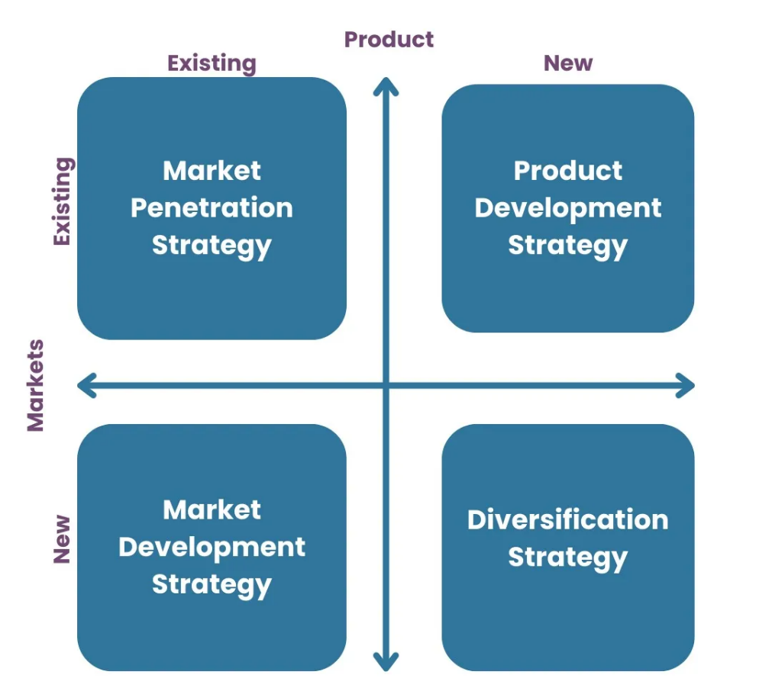
Figure 10: Application of Ansoff Matrix
Source: (Oxford College of Marketing, 2023)
Market Penetration Strategy
Zara mainly uses a market penetration strategy in the United States as it is expected to push more sales of the already established products in an already existing fast-fashion market estimated at about 32 billion pounds every year (Zara, 2024). The new collections are made every fortnight, which raises the frequency of visiting the stores by an estimated 1822 per cent a month, and are price competitive (£12.99-80 per item), and are aimed at the 57 per cent of the US consumers that are price-sensitive. Online sales are 24 per cent of overall US sales, and this is supported by 92 per cent internet penetration, which enables Zara to maximise a market share without raising its prices substantially due to the import tariffs of 11-16 years of about 11.20 per unit.
Product Development Strategy
Another product development strategy employed by Zara in the US is the trendsetting collections and constant refresh of the designs, which costs the company less by 25-30 per cent per annum in inventory holding (Roll, 2023). Around 20 per cent of the US sales are made up of Denim, which is often re-designed to match seasonal shifts, and average sell-through has risen over 85 per cent, vs. the industry average of 65 per cent. This approach can allow Zara to remain competitive as compared to H&M and Uniqlo and achieve average transaction values of £52 per customer.
Strategic Evaluation
The Ansoff Matrix shows that the expansion of Zara in the US is highly gradual and risk-averse as it aims at increasing its volume but not diversification. Nevertheless, increasing inflation (topping at 6.5% in 2022) and rising labour expenses (£12.50/hour in California) put strain on the margins, implying that they might not be sustainable in the long run without a strategic adjustment.

Ethical Issues in Zara’s Marketing Mix in the United States

Ethical Marketing Practices
Ethical Practice 1: Product and Environmental Responsibility
Zara has applied an ethical product strategy in its Join Life line through the use of organic cotton and recycled fibres, and sustainable lines generate about 1.8 billion pounds annually worldwide (Zara, 2024). This endeavour boosts consumer trust in the brand and meets environmental demands, which are 60% sustainable brands, although it raises compliance costs to approximately £5 million per year in the US.
Ethical Practice 2: Transparent Promotion
Zara spends less than 0.3 of all revenue on classic advertising and chooses digital disclosure instead of fraudulent price breaks. This practice helps in marketing ethically by lessening the strategy of artificial scarcity and appealing to knowledgeable consumers, especially among the 72 per cent of US consumers, aged 18-35 years, who are active on social media.

Unethical Marketing Practices
Unethical Practice 1: People and Labour Ethics
Although legally compliant, Zara has been accused of supply-chain labour practises, where contracted factories in low-cost countries have been reportedly paying below living wages (Roll, 2023). Even though the average wage in US retail is £12.50/hour, the upstream labour cost minimisation is contrary to ethical people management and is also risky to reputation, estimated at 2-3% of annual sales, under a period of scrutiny to the public.
Unethical Practice 2: Environmental Impact of Fast Fashion Processes
The quick production cycles at Zara promote excessive consumption, where an average US consumer now buys 60 per cent more clothes than in 2000, but wears them half as long (Zara, 2024). This is an industrial model that adds to textile waste and makes up of more than £700 million worth of discarded clothing yearly in the US, raising ethical issues of sustainability and long-term environmental harm.

Recommendations for Zara’s International Marketing Strategy
- Shift Towards Sustainable Product Development: Zara should substantially increase its sustainable product development, with at least 50 per cent collection coverage in the US by 2030, which will create $400-500 million in annual sales and build brand loyalty in consciously-green consumers.
- Ethical Supply Chain Transparency: Zara should invest in blockchain-transparency systems, despite the fact that it will cost it about £2 million per year, because it will increase its ethical credibility, minimize reputational risks, and gain trust in markets where ethical awareness is expanding at 8-10 per cent. per year.
- Balanced Growth Strategy: Zara should shift to selective premium product development, with a focus on high-quality, long-lasting fashion as a way to grow the average transaction value and sustain long-term growth regardless of the rising costs.
- Optimisation of Omnichannel and Localised Pricing: Zara should use AI-enhanced pricing and demand prediction, better inventory management, potentially saving £120-150 million annually, and enhancing its 24 per cent online revenue contribution in the US market.

Conclusion
The international marketing strategy employed by Zara has proved to be very versatile and situation-specific, as shown by the differences in the macro-environment, cultural, and economic environments of the United States and the United Arab Emirates. The analyses of PESTLE, STP, and 7Ps reveal that Zara focuses on the aspects of volume, speed, and channel efficiency in the US and cultural sensitivity, positioning, and profitability in the UAE. The use of the Ansoff Matrix also indicates that there is a risk-averse growth strategy that is mainly directed to product development and market penetration. All in all, the discussion has established that Zara's strategic flexibility and responsiveness are the key factors in maintaining global competitive advantage.

Section 2 – Reflective Account using Gibbs Model
The Reflective Cycle by Gibbs (1988) is an organised model that helps to achieve critical reflection by using six steps sequentially: description, feelings, evaluation, analysis, conclusion, and action plan. This section uses the Gibbs model to critically examine the process of researching, analysing, and preparing Section 1 of this assessment, showing academic learning, skills development, and improvement points.
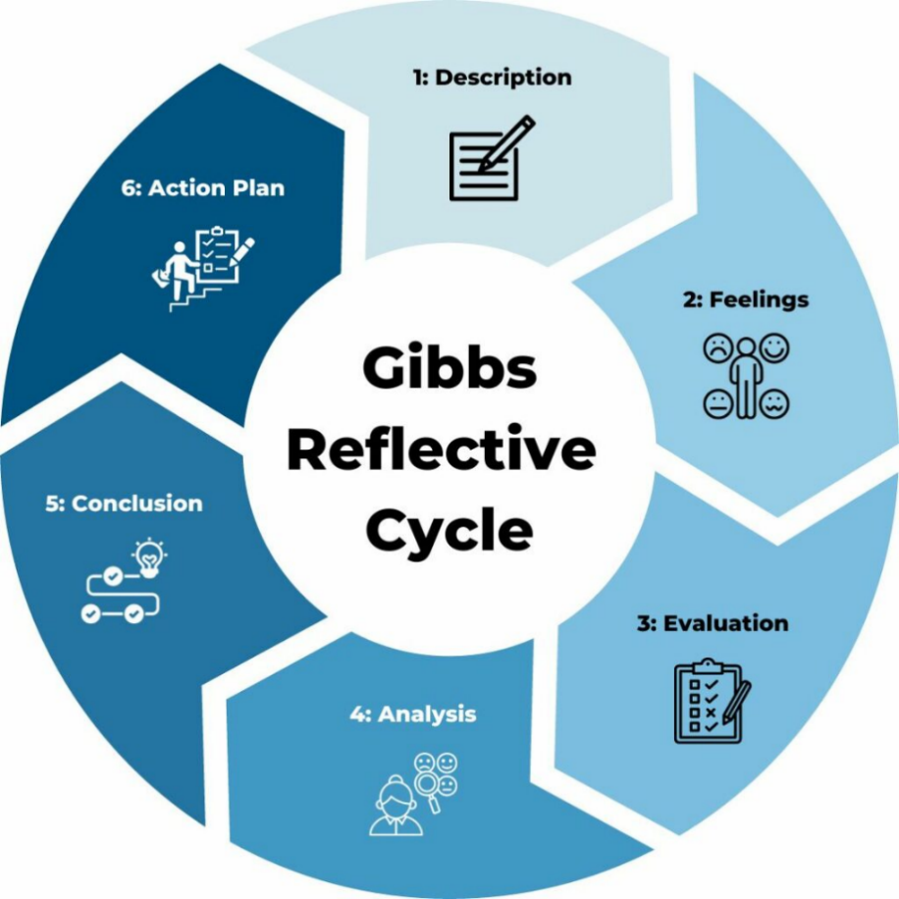
Figure 11: Gibbs Reflective Cycle
Source: (Channell, 2023)
1. Description
When developing Section 1 of this assessment, I conducted in-depth research on Zara's international marketing strategy in the United States and the United Arab Emirates. This entailed a lot of secondary research, critical analysis and the use of the existing marketing theories and models. I started by going through the assessment brief to generally understand the analytical tools I needed, such as PESTLE analysis, STP strategy, international marketing mix (7Ps), the Cultural Dimensions of Hofstede, the Ansoff Matrix, and the ethics of marketing.
I gathered the information from a very broad spectrum of scholarly and commercial literature, such as peer-reviewed journals, governmental books, business research databases, and business reports. These sources helped me to make comparisons of macro-environmental conditions, consumer behaviour and strategic adaptations in both markets. Subsequently, I organised the report systematically with all the structures being well implemented and based on quantitative data. During the process of writing, I made several drafts in order to enhance coherence, clarity and scholarly tone without exceeding the necessary word count.
2. Emotions
I was confident at the beginning since I was familiar with marketing theories, but I was also worried about how I would handle the size and complexity of the job. The two markets are extremely different, and it was necessary to compare them carefully not to make surface comparisons. I was especially worried by the issue of balance between numerical data and critical analysis because excessive reliance on statistics might dilute the scholarly argument.
As I continued the research, I started gaining confidence as I was able to clearly understand how the macro-environmental factors affected the strategic choices of Zara in the respective countries. Nevertheless, I was sometimes diverted by the amount of information and the necessity to be consistent across chapters. By the end of the section, I was very much satisfied with the achievements of my performance since I was able to present a structurally analysed, theoretically integrated, and strategically insightful report as per the learning outcomes.

3. Evaluation
The fact that I used analytical frameworks in a structured manner was one of the most effective elements of my approach. The use of Pestle, STP and the 7Ps enabled me to critically analyse the international approach of Zara as opposed to using descriptive commentary. This element of the work provided a higher level of critical thinking and enhanced the academic quality of the work due to the comparative nature of the analysis.
But there were also certain difficult points. To control the number of words to use and at the same time to analyse it, refining and refining was necessary. In the earlier drafts, there were sections that were too descriptive, especially where economic and demographic statistics were being presented. Moreover, incorporating the ethical aspects in the strategic dialogue was to be done cautiously to prevent unwarranted assumptions. These difficulties notwithstanding, the end product was well-balanced and academically sound.
4. Analysis
Section 1 was successful because of my systematic approach to the research and critical use of theory. The PESTLE analysis also enabled me to place the marketing decisions of Zara in the context of the politics, economy, and culture at large. Cultural Dimensions by Hofstede were especially useful in interpreting product and promotion adaptation between the US individualistic and the UAE collectivist market.
The STP model helped me to illustrate how Zara can customise segmentation and positioning strategies to maximise volume in the US and focus on profitability in the UAE. The use of the 7Ps also enhanced the analysis as it connected the operational decision with the consumer expectations and market structure. Also, the Ansoff Matrix provided the rationale of risk-averse directional expansion strategy of Zara in the US market. This has helped me greatly to synthesise both qualitative and quantitative information, critically assess business strategies and provide evidence-based scholarly arguments.

5. Action Plan
The following action plan outlines how I will enhance my academic approach in future assessments:
Area for Improvement | Planned Action | Expected Skill Development | Timeframe
Research organisation | Create a structured source matrix categorised by theory, data, and application. | Advanced research management | Immediate
Critical writing | Prioritise evaluative language over descriptive statistics in early drafts | Higher-order critical thinking | Ongoing
Time management | Allocate separate timelines for research, drafting, and revision | Academic planning efficiency | Next assignment
Data presentation | Use fewer, more strategically relevant statistics to support arguments | Analytical synthesis | Short-term
Ethical integration | Embed ethical analysis within strategic discussion rather than isolating it | Ethical and strategic reasoning | Long-term
Table 1: Action Plan for Future Assessment
Source: (Self-Made)
6. Conclusion
In general, I think that the research and analytical procedure that was followed in this assessment was efficient and met the academic expectations. I was able to exercise critical analysis, strategic perception, and theory. The key weakness was time management since the task was more complex than expected to be refined iteratively.
Three key lessons that have been learned during this reflective exercise are the need to plan early, self-critically review and discipline in academic writing. The experience has given me confidence in performing international marketing analysis and has renewed my belief in the importance of reflective practise in enhancing academic performance.

References
Albert, T. (2023). Competitive advantage and internationalization of a circular economy model in apparel multinationals. Cogent Business & Management, 8(1), p.1944012. doi:https://doi.org/10.1080/23311975.2021.1944012.
Aslam, M. and Osman, A.F. (2023). The Changing Demographic Profile of Middle Eastern Countries. International Journal of Professional Business Review: Int. J. Prof.Bus. Rev., [online] 8(7), p.42. doi:https://dialnet.unirioja.es/descarga/articulo/9060768.
Baack, D. G. (2018). International marketing., 2nd edition. London: SAGE Publications.
Bureau of Economic Analysis (2024). Gross Domestic Product, Fourth Quarter and Year 2023 (Second Estimate) | U.S. Bureau of Economic Analysis (BEA). [online] Bea.gov. Available at: https://www.bea.gov/news/2024/gross-domestic-product-fourth-quarter-and-year-2023-second-estimate [Accessed 24 Feb. 2026].
Channell, M. (2023). Gibbs Reflective Cycle – How to Learn from Experience and Become a Better Leader. [online] TSW Training. Available at: https://www.tsw.co.uk/blog/leadership-and-management/gibbs-reflective-cycle/ [Accessed 27 Feb. 2026].
Cheng, L. (2026). Zara: Fast Growth through Fast Fashion. [online] Technology and Operations Management. Available at: https://d3.harvard.edu/platform-rctom/submission/zara-fast-growth-through-fast-fashion/.
Clodura (2025). ZARA USA Overview, Competitors, News, and Employees | Clodura.AI. [online] Clodura.ai. Available at: https://www.clodura.ai/directory/company/zara-usa?utm_source=chatgpt.com [Accessed 26 Feb. 2026].
Cottel, L. (2025). Shopping Mall Foot Traffic Statistics - 2025 Report. [online] Capital One Shopping. Available at: https://capitaloneshopping.com/research/mall-foot-traffic-statistics/ [Accessed 26 Feb. 2026].
Cui, Y.C. and Fan, B.F. (2021). The Corporate Social Responsibility Strategy in Fast Fashion Industry : Case Company Zara. [online] THESEUS. Available at: https://www.theseus.fi/handle/10024/512245 [Accessed 24 Feb. 2026].
Dahan, G.S. and Peltekoglu, F.B. (2018). The Effects of Zara to the SMEs of an Emerging Market. Journal of Global Fashion Marketing, [online] 2(1), pp.1–10. doi:https://doi.org/10.1080/20932685.2011.10593077.
Gunes Corlu, C., Martinez, L.F. and Marco-Simó, J.M. (2026). Bridging Marketing and Operations in Omnichannel Retail. Encyclopedia of Artificial Intelligence in Marketing, 4(2), pp.1–13. doi:https://doi.org/10.1007/978-3-031-75316-9_91-1.
Hofstede, G. (2011). Dimensionalizing Cultures: the Hofstede Model in Context. Online Readings in Psychology and Culture, [online] 2(1), pp.1–26. doi:https://doi.org/10.9707/2307-0919.1014.
Kalsi, A.R. (2022). Investigating the impacts of digital marketing on consumer buying behavior in the fast fashion industry of Ireland – a case study of ZARA. [online] norma.ncirl.ie. Available at: https://norma.ncirl.ie/6371/ [Accessed 24 Feb. 2026].
Khalil, S. and Zaman, K. (2025). The Impact of Just-in-Time Inventory Systems on Supply Chain Efficiency. Economic Trends and Business Review, [online] 3(1), pp.1–16. Available at: https://etbrjournal.com/index.php/journal/article/view/46.
Khamaysa, M., Alghathian, G.A. and Altarawneh, M. (2025). Redefining subordination in the digital workplace: regulation of teleworking in the United Arab Emirates. Jurídicas CUC, 21(1), pp.323–335. doi:https://doi.org/10.17981/juridcuc.21.1.2025.17.
Kiderlin, S. (2024). Zara owner Inditex climbs to all-time high as 2023 sales jump 10%. [online] CNBC. Available at: https://www.cnbc.com/2024/03/13/zara-owner-inditex-climbs-to-all-time-high-as-2023-sales-jump-10percent.html [Accessed 24 Feb. 2026].
Lian, Y. (2021). How Should Zara Optimize Its Marketing Strategies to Cater to the Needs of New Generations – Gen Z and Millennials. [online] www.atlantis-press.com. doi:https://doi.org/10.2991/aebmr.k.210917.048.
Mackeviciute, C. (2022). STP Marketing: Segmentation, Targeting, Positioning Model. [online] Sender. Available at: https://www.sender.net/blog/stp-marketing/ [Accessed 26 Feb. 2026].
Makos, J. (2024). PESTLE Analysis of Zara. [online] PESTLE Analysis. Available at: https://pestleanalysis.com/pestle-analysis-of-zara/ [Accessed 24 Feb. 2026].
Milan, M. (2025). UAE Tax Benefits vs. UK Tax Burden: Why Businesses Choose Dubai in 2026 - RFZ. [online] Marketing Agency. Available at: https://rfz.ae/blog/uae-tax-benefits-for-uk-businesses/ [Accessed 24 Feb. 2026].
Nickerson, C. (2025). Hofstede’s Cultural Dimensions Theory & Examples. [online] Simply Psychology. Available at: https://www.simplypsychology.org/hofstedes-cultural-dimensions-theory.html [Accessed 26 Feb. 2026].
Oxford College of Marketing (2023). Using The Ansoff Matrix to Develop Marketing Strategy. [online] Oxford College of Marketing. Available at: https://blog.oxfordcollegeofmarketing.com/2016/08/01/using-ansoff-matrix-develop-marketing-strategy/ [Accessed 27 Feb. 2026].
Pettinger, T. (2024). Is US Economy at Risk of Recession For 2024 Election. [online] Economics Help. Available at: https://www.economicshelp.org/blog/215017/us/is-us-economy-at-risk-of-recession-for-2024-election/ [Accessed 26 Feb. 2026].
Rafiq Gheddar (2024). Pricing Methods for Islamic Banking Services between Cost, Market and Value Based Strategies. Financial Markets, Institutions and Risks, [online] 8(3), pp.17–36. doi:https://doi.org/10.21272/fmir.8(3).17-36.2024.
Roll, M. (2023). The secret of Zara’s success: A culture of customer co-creation. [online] Martin Roll. Available at: https://martinroll.com/resources/articles/strategy/the-secret-of-zaras-success-a-culture-of-customer-co-creation/ [Accessed 27 Feb. 2026].
Solberg, C.A. (2024). A Framework for Analysis of Strategy Development in Globalizing Markets. Journal of International Marketing, 5(1), pp.9–30. doi:https://doi.org/10.1177/1069031x9700500103.
Start.io (2022). Who is Zara’s Target Market? Zara Brand Analysis – Customer Segmentation, Marketing Strategy & Competitors. [online] Start.io . Available at: https://www.start.io/blog/who-is-zaras-target-market-zara-brand-analysis-customer-segmentation-marketing-strategy-competitors/ [Accessed 23 Feb. 2026].
Statista (2024). Inditex: net sales worldwide by brand 2024| Statista. [online] Statista. Available at: https://www.statista.com/statistics/456505/sales-inditex-group-worldwide-by-format/?srsltid=AfmBOopIncnirhlhMiU-xw66goOvtxYbGALH9rYOs6rakH7NFbkUCcbW [Accessed 24 Feb. 2026].
Statista (2024). Number of Zara stores in the Middle East and Africa 2024, by country| Statista. [online] Statista. Available at: https://www.statista.com/statistics/674502/number-of-zara-stores-in-the-middle-east-and-africa-by-country/?srsltid=AfmBOoqGGOgVfGR1Z7-fH83fzWiS2EwM3SFDgNypTnAzDRU6MiAhegHv [Accessed 26 Feb. 2026].
Tucker, D.W. (2022). Reimagining Work: Examining Work Under the Fair Labor Standards Act. [online] Encompass. Available at: https://encompass.eku.edu/honors_theses/1017/ [Accessed 24 Feb. 2026].
Vecteezy, D. (2025). Zara Target Market Analysis. [online] Business Model Analyst. Available at: https://businessmodelanalyst.com/zara-target-market-analysis/?srsltid=AfmBOorH7lFfPUEZJDcPKrXqLGJgxZzMdcbhu_JtTqDNmHRkNtdc5woz [Accessed 26 Feb. 2026].
Vectorstock (2023). Marketing 7Ps Strategy - Framework – Royalty-Free Vector | VectorStock. [online] VectorStock. Available at: https://www.vectorstock.com/royalty-free-vector/marketing-7ps-strategy-framework-vector-45827270 [Accessed 26 Feb. 2026].
World Bank (2023). Political Stability and Absence of Violence/Terrorism: Percentile Rank. [online] World Bank Open Data. Available at: https://data.worldbank.org/indicator/PV.PER.RNK [Accessed 24 Feb. 2026].
Yang, S. and Lee, Y.J. (2024). Are the factors affecting satisfaction and actual purchase the same? Comparisons between unplanned and planned purchase. Journal of Fashion Marketing and Management: An International Journal, 21(2), pp.172–186. doi:https://doi.org/10.1108/jfmm-04-2016-0034.
Yieldify (2020). Geographic Segmentation Explained Using Real-World Examples. [online] Yieldify. Available at: https://www.yieldify.com/blog/geographic-segmentation-real-world-examples/ [Accessed 26 Feb. 2026].
Zara (2024). ZARA UAE - Dubai/Sharjah/Ajman/UAQ/Fujairah - Official Website. [online] Zara.com. Available at: https://www.zara.com/ae/ [Accessed 26 Feb. 2026].
Zheng, X. (2025). Zara’s Fast Fashion Strategy: A Dual Analysis of Market Segmentation and Price Elasticity. Advances in Economics and Management Research, [online] 14(1), pp.227–227. doi:https://doi.org/10.56028/aemr.14.1.227.2025.

