
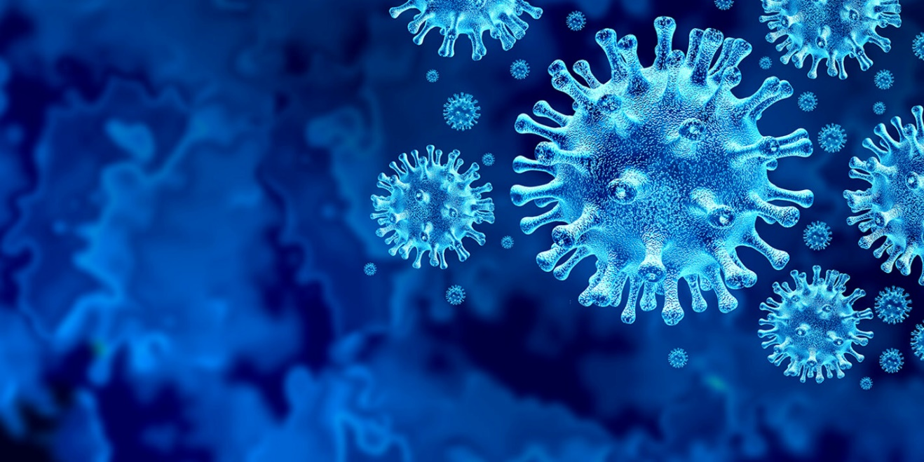

A Misinformation Pandemic: A Discourse Analysis on the Spread of Misinformation and Conspiracy Theories in Relation to and During the Coronavirus Pandemic (SARS-CoV 2/ Covid-19)

  - Module: Research project
  - Degree: ba law and criminology
  - Keely Sharpe, Student No.: 1805415

Table of Contents

- Chapter 1: Introduction………………………………………………………………………………..vi-ix
  - Introduction……………………………………………………………………………………………….vi
  - Background and Rationale…………………………………………………………………….vi-vii
  - Aims and Objectives………………………………………………………………………………….vii
  - Research Structure……………………………………………………………………………………viii
  - Conclusion………………………………………………..………………………………………………..ix
- Chapter 2: Literature Review………………………………………………………………………x-xvi
  - Introduction……………………………………………………………………….……………………….x
  - The Developing Coronavirus Pandemic………………….………………………………x-xi
  - Information and Misinformation………………….…………………………………………..xii
  - The Spreading of Misinformation on the Internet………………………………xiii-xv
  - Psychological Theories………………………………………………………………………………xv
  - Conclusion………………………………………………………………………………………………..xvi
- Chapter 3: Research Method……………………………………………………………….…xvii-xxix
  - Introduction……………………………………………………………………………………….xvii
  - Research Onion………………………………………………………………………………xvii-xviii
    - Philosophy…………………………………………………………………………..xviii-xix
    - Approach………………………………………………………………………………………xix
    - Strategy………………………………………………………………………………………….xx
    - Choice………………………………………………………………………………………xx-xxi
    - Time Horizon………………………………………………………………………………xxi
    - Techniques for Data Collection, Process and Analysis
      - Data Collection………………………………………………………………..xxi-xxii
      - Interview Design……………………………………………………………xxii-xxv
      - Analysis……………………………………………………………………….xxvi-xxvii
      - Quality: Reliability and Validity…………………………………………xxvii
      - Limitations…………………………………………………………………………xxviii
      - Ethical Considerations………………………………………………………..xxviii
3.2.7 Conclusion……………………………………………………………………………..…xxix
- Chapter 4: Data Analysis……………………………………………………………………xxx-xxxviii
  - Introduction…………………………………………………………………………………………….xxx
  - Data Analysis………………………………………………………………………………………….xxx
  - Participation Selection and Methods………………………………………………xxx-xxxii
  - Collected Data and Discussion………………….…………………………………xxxii-xxxvi
  - Conclusion………………………………………………………………………………xxxvii-xxxviii
- Chapter 5: Conclusions and Recommendations………………………………….xxxix-xlv
  - Introduction………………………………………………………………………………………….xxxix
  - Findings…………………………………………………………………………………………………xxxix
  - Implications………………………………………………………………………………………………..xl
  - Recommendations…………………………………………………………………………………xl-xli
  - Limitations………………………………………………………………………………………………..xli
  - Further Research……………………………………………………………………………………...xlii
  - The Achievement of Objectives………………………………………………………..xlii-xliii
  - Reflection…………………………………………………………………………………………………xliv
  - Conclusion………………….……………………………………………………………………..xliv-xlv
- References…………………………………………………………………………………………………..xlv-lii
- Evidence……………………………………………………………………………………………………...liii-lx

Impact of Covid-19

In light of the continuing impact of the global pandemic, it is important to include a statement at the start of my dissertation which outlines the effects that COVID-19 has had on the research that I have undertaken towards my undergraduate degree.

The University of Wales Trinity Saint David recognizes that the COVID-19 pandemic, and consequent closures of our campus (18th March 2020) and national and international lockdowns, has directly or indirectly impacted the work of many of our undergraduate researchers. Although the campus had periods of re-opening in 2020 and 2021, some research will have been disrupted and some personal circumstances difficult to manage. Teaching was arranged via suitable meeting software and documents shared electronically. All research data collection was designed to utilize digital data collection.

The inclusion of this statement is to facilitate the reader’s awareness, both now and in the future, that the pandemic may have had an effect on the scope, direction and presentation of the research.

The academic standards and quality threshold for the award remains unchanged. I wish to reassure readers that this statement is not evidencing a lack of original research or quality.

Acknowledgements

I dedicate this dissertation to my children, for whom I have worked towards my degree for, and for whom I try to better myself every day.
I would first like to thank my partner for his support, guidance and encouragement throughout my studies.
I would also like to give thanks to Bronwen Williams who has answered my endless questions during my time at university and for encouraging me and giving me advice when I needed it, as well as all of my lecturers for always checking in and providing support.
Finally, I would like to give thanks to the participants, Dr. Ana Santos Rutschman and Emma Quinn, who, in their busy lives in academia and research, took the time to answer my questions for this project.

1. Chapter One: Introduction

1.1 Introduction

The aim of this chapter is to provide a background and rationale for the project. The research purpose is to examine and discuss the spread of misinformation and conspiracy theories relating to the Coronavirus pandemic, otherwise known as SARS-Cov 2 or COVID-19, including how the existence of such may impact the behaviour of the population.

1.2 Background and Rationale

The current threat to global health is the ongoing outbreak of Coronavirus, to be referred to as COVID-19, an infectious disease defined as one which causes respiratory sickness, with the potential to greatly affect those who have ‘underlying conditions’, such as cardiovascular diseases, respiratory conditions or cancer (World Health Organization (WHO), 2021).
Various conspiracy theories have arisen about the nature of the pandemic, being that it is an artificially created virus (Desta & Mulugeta, 2020) and was spread through the population deliberately as a ‘bioweapon’ (Uscinski, et al., 2020), that it is being an exaggerated for political goals (Stein, et al., 2021), as a means to use vaccinations as a cover to insert microchips into the population (Ball & Maxmen, 2020), or beliefs that the pandemic was worsened by the use of 5G technology (Ahmed, et al., 2020).
Conspiracy theories do not stem only from what may be defined as extremist or paranoid individuals and groups; they flow throughout society through differences in demographics and politics (Uscinski & Parent, 2014) and can cause negative political and social consequences. In relation to the COVID-19 pandemic, (Imhoff & Lamberty, 2020) found that those holding beliefs about COVID-19 being exaggerated or false, self-reported a lack of preventative behaviours such as washing hands, wearing face masks and social distancing.
It has also been established that situations in which fear and uncertainty, for example in a crisis, increase the likelihood of conspiratorial ways of thinking (van Prooijen & Douglas, 2017). It is evident that the study of human behaviour, and behaviour in relation to conspiracy theories, or how they are formed and spread, is not a new topic. However, this topic specifically relating to COVID-19 is a new subject and the way in which it is approached will define the world in the following years.

1.3 Aims and Objectives

1.3.1 Aim:
The aim of the project is to engage in a discourse analysis of conspiracy theories relating to COVID-19 and the potential impact they may have on public health.

1.3.2 Objectives:

1. To critically analyse available academic literature on the formation and spreading of conspiracy theories with a focus on COVID-19 conspiracies.
2. To use a suitable method of research to explore professional views on ascertaining the impact of such conspiracies on public health.
3. To analyse the data collected to gain a well-rounded view on the subject.
4. To understand what, if any, practical implications of the research may arise in order to make appropriate suggestion for further research and analysis.
5. To investigate in what way this topic may be researched further.

1.4 Research Structure

In order to meet the objectives of the study, the research will take the form of various chapters to create distinct areas of topic and make for clear reading. Chapter one has made introduction of the research topic with reasoning as to why the research should take place. The research will make use of both primary and secondary research in the form of interviews and the literature review.
Chapter two is the literature review in which COVID-19 is discussed using available academic research, whilst also looking at research into the formation and spreading of conspiracy theories, and what impacts this may have on public health, as well as whether there is evidence that it has already had an impact.

Chapter three covers the methods and methodology of the research, investigating what the most appropriate ways of researching this topic are and how data will be collected effectively.

Chapter four will then analyse the collected data from the primary research and findings presented. Statistical analysis here is not necessary as the data will be collected in the form of interviews. This will then lead into final analysis and conclusions.

Chapter five will look at whether the aims and objectives of the research previously discussed have been met and whether there is potential in the future for further research, and if so, what recommendations might be made for this.

1.5 Conclusion

Chapter one has provided an introduction to the project, introduced the aims and objectives of the research, and outlined why this particular research is essential for the current health crisis facing the world. The chapter to follow will put forward a literature review, discussing the academic research that is available in this area.

Chapter Two: Literature Review

2.1 Introduction

The aim of this chapter is to review the current academic literature that is available on the topic of information and misinformation, and how the existence of such may impact the behaviour of the population.

The literature review is comprised of various academic and government sources that have been obtained from the online library of the University of Wales Trinity Saint David as well as Google Scholar, Google Books, the United Kingdom Government website (gov.uk), the United Kingdom Parliament website (parliament.uk), U.S government websites such as the FDA, as well as some news resources such as the BBC.

2.2 The Developing Coronavirus Pandemic

On December 31st, 2019, the China World Health Organisation Country Office was notified of cases of what was thought to be pneumonia, but of an ‘unknown etiology’. In January 2020, a new type of coronavirus was identified and isolated in order to test in China on the 7th, with the first confirmed cases outside of China (Japan, South Korea and Thailand) occurring by the 20th of January 2020 (World Health Organization, 2020).
The virus appeared to have originated in Wuhan, China, and this city was locked down on the 23^{rd of} January 2020, essentially being sealed away from the rest of the world with 11 million citizens confined to their homes, and this particular lockdown lasted for 76 days (BBC, 2021).
By March 2020, COVID-19 was a world-wide pandemic, and the UK began to introduce daily press briefings, at the time of which the death toll in the UK was 55, with more than 1,500 confirmed cases (BBC, 2020), though it is now believed that there were already 10,000 people in the UK that were infected by this time (Office for National Statistics, 2020).
As of April 2021, there has been 4.41 million confirmed cases and 127 thousand deaths across England, Wales, Scotland and Northern Ireland (John Hopkins University: JHU Education Research, 2021).
The UK has seen various types of lockdowns since the beginning of the pandemic; school closures and lockdowns, closure of services and non-essential stores, and instructions to the populace to not meet anyone who is not part of their household. Following the easing of restrictions, the rising of cases once again saw Wales enter a full lockdown for the third time following Christmas 2020.

In February 2021, the entirety of Wales was in a lockdown defined as alert-level-4 which means that all citizens must socially distance in public, wear face coverings (masks) in indoor public spaces, stay at home unless necessary and have contact with only their household (Welsh Government, 2021).
In England, ‘National Lockdown Rules’ were in place, similar to that of Wales where individuals could not leave home unless they are shopping for basic necessities or going to work, they could not meet with those who are not members of their household and must wear face coverings in public (UK Government, 2020).

2.3 Information and Misinformation

Thompson (2020) states that the toll on democracy, policing, civil liberties and freedoms, ethics in healthcare and human dignity may lead to a humanitarian crisis ‘no less devastating’ than the COVID-19 pandemic itself, in the long term.
In considering authoritarian leaders, the crisis of the coronavirus pandemic has provided an opportunity for ‘convenient pretext to silence critics and consolidate power’, seeing censorship in China and claims of such censorship in the United States to0- impacting the public’s ability to access true information and impacting the perception the public hold on the police as they enforce the regulations put in place by the government (Roth, 2020).
It was reported in February 2020 that a Chinese doctor, claimed to have been ‘silenced’ by the Chinese government, had died of COVID-19. Dr Li Wenliang had tried to warn the world about the cluster of viral infections in Wuhan potentially growing ‘out of control’ (Buckley, 2020).
On December 20th, 2019, Dr Li sent a message to his fellow doctors with a warning about a possible outbreak of a viral infection resembling that of SARS, or acute respiratory syndrome, in Wuhan, where he worked. Only days later, Dr Li was summoned to the Public Security Bureau in Wuhan where he was forced to sign a statement that he was making false statements which disturbed the public order. By February 2020 it had spread to 25 other countries and had a death toll of 1669 and 51,800 infections (Green, 2020).
Such incidents as this may encourage a distrust of information, whether it be accurate or inaccurate, when what is considered to be corrupt behaviour from a government is witnessed around the world.
Social media has developed extensively and its use much more widespread since the outbreak of SARS in 2003, with the first ‘glimpse’ of social media reaction to a pandemic and the spread of misinformation, which is defined as incorrect or misleading information (Merriam-Webster, 2021), seen during the Ebola outbreak in 2015.

2.4 The Spreading of Misinformation on the Internet

(Furedi, 2006) states that the formation of beliefs is influenced by the way in which groups of people or communities try to make sense of facts and events. This can be particularly evident when clusters of people try to process information on shared social media platforms, triggering a collective framing of narratives which are biased in self-confirmation (Zollo, et al., 2015; Bessi, et al., 2015).
Digital misinformation has been listed as one of the main threats to society by the World Economic Forum, citing the internet as being ‘uncharted, fast-evolving territory’ in which websites’ self-correcting methods to limit misinformation spreading are sometimes simply not enough (World Economic Forum, 2021). Studies have shown that users tend to look at and share content that fits their own specific narrative and ignore the rest, especially the content that directly contradicts their own beliefs (Del Vicario, et al., 2016). Research has also shown that people have a preference toward congenial information when given the choice to choose, including political information (Stroud, 2008; Iyengar & Hahn, 2009).
The fabrication of information is not by any means new, but social media platforms have created a base that is so effective in the spreading of such information that it has become what has been referred to as a “21st century information disorder” (Posetti & Matthews, 2018). There has been a rise of the use of the terms “fake news” and “fake media” to describe information and reporting that the person or community does not agree with, and the searching for the terms on Google was extensive during the latter half of 2016, the time of the US election (Wardle & Derakhshan, 2018). There are different motivations for the various types of misinformation that is spread online, and it has become easier to manipulate opinion with a widespread growth of distrust in experts and institutions, according to Morgan (2018).
The rise in the spread of misinformation shown in the United States from 2016 onwards, has become evident now across the globe with the spread of misinformation in relation to the Covid-19 pandemic- including conspiracy theories that the pandemic is a ‘plandemic’ and is either fake or deliberately started by governments (Frenkel, et al., 2020; Kearney, et al., 2020) and the beliefs that vaccines are not safe and will put nano-chips inside your skin to track you. Such ideas are not far-fetched for those already engaging in conspiracy theories such as the existence of ‘mass election fraud’ in the 2020 US election (leading to the Capitol Hill riot of early 2021 which claimed the lives of 5 people) (Levenson, et al., 2021), QAnon conspiracies (the idea that Hillary Clinton is involved in a group of powerful elites that are in control of the world and abusing children, and that an unnamed person known as ‘Q’ has inside information and is working with Donald Trump to expose the group of elites to the world, deriving from another conspiracy entitled ‘Pizzagate’, the QAnon conspiracies began on a website known as ‘4chan’) (Amarasingam & Argentino, 2020), and the idea that the Earth is flat and that climate change is not real (Olshanksy, 2018).
The rapid spread of misinformation relating to the Coronavirus pandemic lead to a group of public health scientists releasing a joint statement in which they stated they were deeply concerned about the virus and the sharing of misleading and false information (Calisher, et al., 2020) stating that scientists across the world having analysed the genomes of the causative agent and overwhelmingly concluding that the virus originated in wildlife is evidence in itself to dispute the conspiracy that Covid-19 is a lab-made virus that has been deliberately spread through the population, or that it is not real at all (Zhou, et al., 2020; Roujian, et al., 2020; Zhu, et al., 2020).
Mian & Khan (2020) state that the spreading of misinformation has drowned out credible information, with information from the World Health Organisation (WHO) and the US Center of Disease Control (CDC) having had several hundred thousand engagements cumulatively, where hoax and conspiracy theory websites have accumulated more than 52 million, with posts claiming that the virus was created in a lab by a government having more than 20 million engagements and continues to gain traction across the globe.
The most basic of information on how to reduce the transmission of the virus has been clouded by misinformation relating to homeopathic remedies and cures and medicinal cures that have little to no scientific backing- one example of which being former US president Donald Trump, during his presidency, stating that he was taking hydroxychloroquine, an anti-malaria drug, for Coronavirus, stating: “You’d be surprised…how many people are taking it, especially the front-line workers” (Lovelace Jr & Breeuninger, 2020). Trump also suggested injecting disinfectant to cure coronavirus at a press conference earlier in the pandemic (President Trump Suggests 'Injecting' Disinfectant as Coronavirus Cure, 2020). The mixing of sodium chlorite and citric acid to generate chlorine dioxide, which is a powerful bleaching agent, has been peddled online as a coronavirus remedy through physical consumption, such as drinking the agent, has been warned by the American Food Drug Administration to cause severe vomiting, potentially fatal low blood pressure and acute liver (U.S. Food & Drug Administration, 2019).
Furthermore, a study on Coronavirus misinformation estimated 1.1 million articles of false or misleading information that they looked at is likely to have significantly impacted public perceptions of the pandemic, and stated that the misinformation circulating during the HIV/AIDs outbreak and the effect such information had on policy decisions, is estimated to have caused an additional 300,000 deaths in just South Africa, and therefore the serious impact of misleading and false information during the current pandemic is of utmost importance to combat (Evanega, et al., 2020). This is backed by a further study that states that the social distribution networks used across social media platforms such as Facebook, Twitter and Reddit see ‘junk health news’ having a significant engagement (Bright, et al., 2020).

2.5 Psychological Theories

A meta-analysis on the correction of misinformation showed that correction does not eliminate entirely the effects of misinformation, and found that the corrective messages were more effective when they were coherent and consistent with the individual’s worldview, they were less successful if the misinformation was attributed to what would be considered a credible source, if the misinformation was reinforced multiple times prior to correction occurring, or where there was a lag in time between the misinformation and the correction (Walter & Tukachinksy, 2019). Other meta-analytic studies found that the correction of misinformation in the context of health and politics was more challenging than other topics (Walter & Murphy, 2018).

2.6 Conclusion

The literature review has shown that there is a serious issue of what the World Health Organisation (2020) refers to as an ‘infodemic’ or the spreading of misinformation. The extent of political conspiracies and misinformation has been seen to some degree in events such as the Capitol Hill riot, however, the extent of health conspiracies and misinformation relating to the Coronavirus pandemic is yet to be seen in its entirety, the aftermath of which is likely to be understood fully in years to come. There has been extensive research of the spread of misinformation online, but the number of studies which focus specifically on the Coronavirus is far less. Although this is large in part due to the fact that the pandemic is ongoing, and effects of the conspiracy theories and misinformation is not yet fully understood, it seems of great importance to attempt to understand it sooner rather than later in relation to preventing the spread of misinformation and limiting its effects in order to mitigate the effects of the pandemic itself while it is ongoing, this is to decrease the amount of individuals who could be severely and potentially fatally affected by the virus due to false and misleading information.

3. Chapter 3: Research Method

3.1 Introduction

Chapter 2 achieved the first objective of reviewing the current academic literature surrounding the topic of information and misinformation, critically analyzing literature on the formation and spreading of conspiracy theories, specifically the Covid-19 conspiracies.
This chapter aims to achieve the second objective: “To [select] a suitable method of research to explore professional views on ascertaining the impact of… [Covid-19] conspiracies on public health”.
To assist in the decision-making process of this project, the research onion, developed by Saunders, et al. (2007), will be used.

3.2 Research Onion

Salkind (2012, p. 3) states that research is “a process through which knowledge is discovered”.
Research methodology refers to the practical aspect of research, specifically, how the research will be undertaken (Goddard & Melville, 2004).
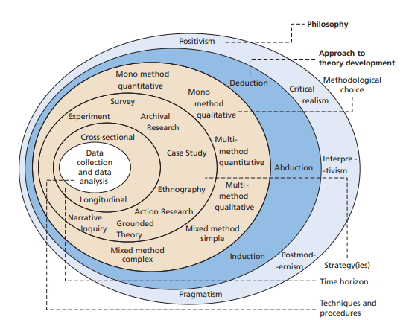The ‘Research Onion’ (Saunders, et al., 2007)

An exploratory approach is most suitable for the research, in that the aim is to contribute to the understanding of the topic and to open the avenues for further research, rather than seeking an immediate solution.

Exploratory research is a methodological approach to research that is concerned primarily with discovering, creating and building theories (SAGE, 2006). Elman, et al. (2020) state that the core of exploratory research is an attempt to discover something new, and that all good science is birthed by exploratory research.

3.2 Philosophy

Research philosophy is the belief of the way that research should be collected, analyzed and used- dealing with the source, nature and the development of the knowledge acquired (Bajpai, 2011).
The main research philosophies include pragmatism, positivism, realism and interpretivism. This research takes the form of interpretivism based on relative ontology, seeking to understand the topic at hand (Clarke, 2009): why do people believe what they believe? Can human behaviour be altered by controlling how people receive information and where they receive it from? Why and how are conspiracies formed? How has the formation and spreading of misinformation impacted public health during the pandemic? All of these topics relate to societal structures and human behaviour, and this research seeks to understand, not to reach a firm solution.
Ancient Greek philosopher and sociologist Epictetus stated the following:
“it is not actions that alarms or disturbs man, but it is their opinions and fancies about actions” (Chowdhury, 2014).
Interpretivism refers to the approach that emphasizes the nature of individuals’ character and their participation in their social and cultural life (Elster, 2012), looking to not only discover the presence or absence of a causal relationship, but the way in which such a thing manifested and the context in which it happened to occur (Lin, 2005).
Philosophical perspectives in research methodology are of importance in explaining how a researcher makes assumptions of their work, the choices made in respect of the purpose of the research, the design of the research as well as the methodology and methods of the research, and in the analysis and interpretation of the data findings (Novikov & Novikov, 2013). By understanding the philosophical basis upon which one has chosen to research, it can be ensured that the outcomes of the research are both meaningfully and appropriately interpreted (Kivunja & Kuyini, 2017).

3.2.2 Approach

An inductive approach to research is the applicable method for this project in order to observe the data collected and understand the theories that may arise from the data (Thomas, 2003). Inductive research is based upon the search for a pattern from observation to then develop explanations or theories for those patterns with a series of hypothesis (Bernard, 2006).

3.2.3 Strategy

There are a number of research strategies that a researcher may use, including what is known as ‘action research’, experiments, case studies, surveys and content analysis (Dyson & Brown, 2005). The strategy to be used for this research will be structured interviews in the form of email correspondence, due to the ongoing pandemic. The interviews will be structured in the sense that there are set questions for the individuals to answer, but there will be no back-and-forth or ‘probing’ in order to allow the individual to simply answer the question how they choose and explain as far as they wish to. This will be done by giving the individual a Word document of the questions where they have a space under each question to answer and may extend the answer box as far as they choose to. The purpose of this is to gain opinions and thoughts of individuals from a multitude of appropriate professions, such as immunology and behavioral science, in order to understand the topic at hand from various perspectives.

Structured interviews are the most prevalent amongst the interviewing techniques of social scientists, based on the idea of examining how one respondent may answer differently to another due to their varying social characteristics, age, race, gender or social class (Marvasti, 2003). In this context, it will be due to the varying professions and the various outlooks the individuals may have based on this information.

3.2.4 Choice

This research uses a qualitative method only, and so it uses a mono-method, or the use of one method, rather than both qualitative and quantitative (Azorin & Cameron, 2010).
The research seeks explanations, thoughts and opinions that can be analyzed for further discussion, rather than numbers and graphs. Seeking, as Silverman (2019) puts it, to treat interviews as providing direct access to the contents of people’s heads.

3.2.5 Time Horizon

Time horizon refers to time that is required in order to complete the project (Mishra & Alok, 2017). The most suitable time horizon for this research method, as shown in the ‘research onion’, is cross sectional, in that there is a specific time by which the research must be completed, and data must be collected.

3.2.6.1 Data Collection

Primary research, whether it be quantitative or qualitative, is a process of using a disciplined and systematic approach to collecting data to ‘find things out’ (Hancock, et al., 2009). Primary research for this project will entail obtaining data using interviews, with specifically selected individuals from appropriate professions.
Much of the disadvantages of conducting interviews as a form of research centers around the time-consuming element of face-to-face interviews, in which preparation can be expansive, travel time is taken into consideration, as well as potential transcribing of an interview that is perhaps recorded via video or a sound recording device (Gillham, 2004), however, the interviews for this research will be conducted utilizing the efficient format of email with pre-written questions that the interviewee can respond to in as much depth as they choose to.
This means that the most time-consuming elements for the interviewer are the writing of the questions and the analyzing of the answers provided, with no travel time or physical preparation that would be involved with face-to-face interviews.

3.2.6.2 Interview Design

Consideration was given as to how questions would be designed in order to ask the same questions to each interviewee and gain different answers, as each individual comes from a different profession, but all have undertaken research which is relevant to the study, whether it be from a psychology background or an immunology background.
The existence of misinformation and conspiracies surrounding the Covid-19 pandemic is established by the interviewer and interviewees, and so consideration as to the phrasing of questions so not to seem as if the questions were seeking answers desirable to the interviewer were not as extensive as it might be if the research were surveys or questionnaires to the general public. It was also made clear to the interviewees that they would be identified within the project and that they were asked to be interviewed based on the work they had already undertaken being of both relevance to the project and of an interesting nature in considering the purpose of the project being to ascertain the opinions and thoughts of professionals in order to pave the way for further discussion within the scientific community.
Demographic questions were not needed as the identities of the interviewees will be available, including their backgrounds, in order to establish the reliability of the individuals based on how they qualify to be interviewed.
Seven questions were written to be provided to each of the interviewees so that analysis could be based on how the interviewees answered each question from their own professional and personal perspective, and these questions are as follows:
- Various politicians in the UK and the US, as well as members of the public, have claimed that Covid-19 was/is ‘exaggerated’ or a ‘hoax’, to what extent do you feel that this kind of rhetoric in reference to Coronavirus is a threat to public health?

This question was to establish the interviewees’ opinions and thoughts as to how much of an issue they feel the Covid-19 conspiracies are and to set the precedent of understanding their answers to the questions that followed.

- In considering, for example, the Chinese doctor, Dr Li Wenliang, claiming to be ‘silenced’ by Chinese authorities prior to his death, do you believe that a distrust of authorities is a large contribution to how conspiracies are created and spread amongst the general population?

This question allowed for some explanation prior to the direct question, as this was an interview which was pre-written and conducted via email, in order to allow the interviewee time to think about their answer to the question at hand and ensure they understood the basis upon which the question was being asked.
This was considered reasonable given that the interviewees are all professionals and considered experts within their fields of work, and the questions were not being asked to unidentified members of the public in the form of a survey.
- What do you believe are the most significant reasons for individuals believing conspiracy theories or not questioning misinformation?
This question was asked to establish the individuals’ opinions and thoughts on the reasons why individuals may believe conspiracies and trust misinformation. Understanding this is imperative to finding a solution to have a better-informed society.
- It has been evidenced that social media is a great contributor to the spread of misinformation and conspiracies, but some have alleged that the removal of particular topics or accounts from social media as a breach of human rights, such as the freedom of speech. Do you think more should be done to prevent the spread of misinformation on social media platforms?
This question was asked to understand the interviewees feelings on what is referred to by some as ‘censoring’. There is great divide within the public on whether it is acceptable to remove posts on social media platforms that discuss conspiracies and misinformation about various topics and establishing the interviewees opinions on this was necessary in order to fulfill, the purpose of engaging in discussion of the topic for future research into the prevention and correction of misinformation.
- The simplest of information on reducing the transmission of Coronavirus has been clouded by misinformation relating to homeopathic and medicinal remedies and cures that have little to no scientific backing, such as the claim by former President of the United States Donald Trump, who stated during his presidency that hydroxychloroquine was an effective remedy/cure and claimed that injecting disinfectant could also be an effective cure for the virus. How dangerous is it, in your professional opinion, when such misinformation is spread by public figures, and what can we do to combat this when the misinformation originates from people with such influence?
This question sought to understand the interviewees opinion on the formulating and spreading of misinformation by those who have a significant degree of influence on members of the public.
To generate further discussion on this topic for future prevention, it must be understood from a medical standpoint how dangerous it is to have public figures spreading misinformation, but also from a social sciences perception of how members of the public may or may not be more likely to believe certain individuals based on their already established viewpoints and beliefs and how misinformation received by prominent figures can be corrected. It is one thing to provide the correct information to the general public, it is another thing entirely for them to believe the information they are being given.
- The extent of the effects of health conspiracies and misinformation specifically relating to Coronavirus is yet to be seen in its entirety, the aftermath of which will likely be seen and understood in years to come. How different do you think the course of the pandemic could have been had the spread of conspiracies and misinformation been a much smaller issue?
This question was to establish the interviewees thoughts on whether the pandemic could have been less impactful in terms of serious illness and deaths if misinformation and conspiracies had not been spread to the extent that they had. This is to provoke thought on how a future pandemic may be dealt with and to encourage research to better understand human behaviour in order to attempt to ensure any future health crisis may be less impactful (to reduce the death count and the impact economically).
- What do you think could be done, if anything, by the medical and scientific community, outside of the work they already undertake, to assist in preventing the spread of and correcting misinformation in any future health crisis that we may face?
The final question seeks to gain thought from professionals on how the scientific community could contribute to future prevention of the spread of misinformation. In order to do so in the most effective way, it is important to gain opinion from professionals from various backgrounds to piece together guidance both medically and in understanding social behaviour and the operation of society to have the best chance of reducing the spread of any future viruses.
Such guidance may also then be utilized to prevent misinformation in other areas, such as politics and climate change.
“The increasing prevalence of misinformation in society may adversely affect democratic decision making, which depends on a well-informed public” (Cook, et al., 2015).

3.2.6.3 Analysis

Analysis has been defined by Bazeley (2013, p. 4) as having a “close engagement with one’s [data]”. To effectively analyze the data received through the qualitative research undertaken for this project, the Miles and Huberman interactive model will be used for guidance:
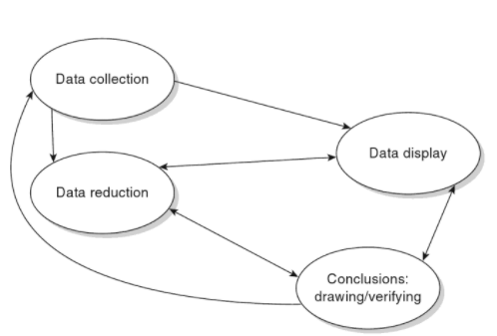
Miles & Huberman (1994) observed that qualitative analysis is comprised of three elements of activity: data reduction, data display and conclusion drawing. The model shows that the nature of work in analyzing qualitative data is cyclical.
Throughout the research, it will be reflected on to what extent the questions provoking the research are being answered, taking time to ‘absorb’ the data, before organizing the data in order to locate and label the thematic patterns which will become evident throughout analysis (Galletta, 2013).
Software for coding is not necessary for this research as there will not be large volumes of data, and, rather than using coding to discuss thematic relationships within the data, the analysis will discuss themes and ideas without the use of extensive coding to allow for a more “human approach” to the discussion of the data (Yavuz, 2012; Maykut & Morehouse, 1994) and to also allow for more accessible reading to those not within the research field.
There is also no transcribing taking place as the interviews are conducted by email, and so that eliminates much of the situation wherein coding would take place.

3.2.6.4 Quality: Reliability and Validity

In considering the reliability of data in quantitative data, it usually is reference to the replicability of the process to achieve the same results. Qualitative data reliability, on the other hand, is concerned with consistency but with a margin of variability in the results. Defining reliability within qualitative research is difficult and somewhat rationally counter-intuitive, in that the interpretivist research paradigm tends to focus on qualitative research methods that are usually considered to be flexible and mostly concerned with understanding complex issues (Cracary, 2009).
In the context of qualitative data, validity is concerned with how “appropriate” the tools, processes and data are. To specify, the validity of the question posed, the choice of the methodology being appropriate for the question that is posed, if the design is appropriate for the chosen methodology, the appropriateness of the data analysis and the results of the analysis and conclusions drawn being appropriate and valid for the context (Leung, 2015).
As the nature of knowledge within the qualitative paradigm and the quantitative paradigm is different, as a consequence, there must be paradigm-specific criteria in order to assess the trustworthiness, or rigor, of data collected. Verification strategies to be used to ensure reliable and valid results of qualitative data include ensuring methodological coherence and the dynamic relati0nship between the data collection and analysis, theoretical thinking and the development of theories (Morse, et al., 2001).
Interviews as a form of research have distinct advantages as a tool for qualitative research as they often gather unique information and opinions about the subject being discussed (Hannabuss, 1996).

3.2.6.5 Limitations

Limitations of interviews as qualitative research include the possibility that the interviewee may lean toward giving more ‘socially-acceptable’ answers to the questions (Fox, 2009) based on the fact that they are being identified in the paper. This is unlikely however, due to the interviewees being selected based on the idea that the existence of conspiracies and misinformation has been established in their prior work. This is the reason, in part, why individuals who may believe the misinformation and conspiracies of Covid-19 have not been selected.

3.2.6.6 Ethical Considerations

Research ethics refer to the way in which the researcher treats the participants of the research (Simelane-Mnisi, 2018). Ethical standards must be applied to selecting participants, designing the questions, and the use and storage of confidential data (Kaiser, 2009).
In this research, interviewees or participants are identified and therefore there is no confidential data collected and the contact information for the individuals being interviewed was obtained from public profiles on public websites, such as their places of work or studies they have published open access where their contact information is attached.
The research has been conducted in line with the ethical standards outlined by the University of Wales Trinity Saint David with approval via the Ethical Standards form. All interviewees are over the age of 18 with the capacity to consent to participation, have given informed consent as to the content of the research, purpose of the research, and have been informed that they will be identified within the research.
No possibility of psychological harm has been identified by the researcher.

3.2.7 Conclusion

This chapter has successfully met the second objective outlined:
“To [select] a suitable method of research to explore professional views on ascertaining the impact of… [Covid-19] conspiracies on public health”.
This has been achieved by identifying and outlining which method of research is most appropriate for this study, justifying the choice made to use an interpretivist qualitative approach by selecting interviews to obtain the data with the interviewees being carefully selected professionals in the science community. Chapter four will analyze and discuss the data that has been collected using the identified research methods.

4. Chapter 4: Data Analysis

4.1 Introduction

The previous chapter identified the methodology to be used in the course of conducting this researching. This chapter, chapter 4, aims to complete the third objective of the project:
“To analyse the data collected to gain a well-rounded view on the subject”.
This chapter will therefore present the data that has been collected in the form of interviews with two professionals in the relevant fields. The two individuals agreed to participate knowing that they will be identified in the project. The two individuals selected were Dr. Ana Santos Rutschman, S.J.D and Emma K. Quinn.

4.2 Data Analysis

Data, raw information, needs to be analysed in order to convert it to information, which is understandable and useable to draw conclusions from, of which there are various techniques to do so (Taylor & Cihon, 2004). This data was not analysed using specialized software given that there are not large volumes of data, and so the use of coding was not considered by the researcher to be necessary in this circumstance.

4.3 Participant Selection and Methods

The participants were selected based on their professions and previous work. Participants were not separated into categories based on age, gender or background. Both participants were over the age of 18 and gave informed consent to being interviewed knowing that they would be identified in the project. The project was explained to participants so they were aware of the purpose of the project and how their answers would be used. Both participants are female, and both are qualified within their fields.
Dr. Ana Santos Rutschman, to be identified as Dr. Rutschman, is an Assistant Professor at the Center for Health Law Studies and the Center for International and Comparative Law at the Saint Louis University School of Law in St. Louis, Missouri, U.S.A; teaching FDA Law and Policy, Emerging Health Technologies, Vaccines and the Law, Patent Law and Property Law.
Dr. Rutschman holds a Law degree, a Masters of Laws and a Doctor of Juridical Science. She has published various journal articles, including “The COVID-19 Vaccine Race: Intellectual Property, Collaboration(s), Nationalism and Misinformation”, “The Reemergence of Vaccine Nationalism”, and “IP Preparedness for Outbreak Diseases” (SSRN, 2021). Dr. Rutschman has been awarded with the Innovation, Business and Law Center Prize from the University of Iowa College of Law, the Beaumont Research Award and a Junior Faculty Non-Traditional Scholarly Works Award by Saint Louis University and is a member of the American Society of Law, Medicine and Ethics, the Global Pandemic Network and the American Bar Association (Saint Louis University School of Law, 2021).
The second participant is Emma Quinn, hereby referred to as Quinn, who is a student researcher with Alberta Health Services, the University of Calgary and CAREX Canada. Emma Quinn has a BHSc in Health Sciences from the University of Northern British Columbia (UNBC) and is currently undertaking an MSc in Occupational and Environmental Hygiene at The University of British Columbia (Linkedin, 2021). Quinn has published a joint paper entitled “The Instagram Infodemic: Cobranding of Conspiracy Theories, Coronavirus Disease 2019 and Authority-Questioning Beliefs”, which was of particular relevance to this study, as well as “Men and Women at work in Canada, 1991-2016” (Linkedin, 2021; Quinn, et al., 2020).
The email corresp0ndence and the questions in full will be attached at the end of the document.

4.4 Collected Data and Discussion

The study aimed to gain perspectives of professionals in appropriate fields on how and why misinformation and conspiracies are spread amongst the general population and how this may be combatted in the interest of public health, specifically looking at this topic within the context of the current global pandemic of COVID-19. All quotes in italics are quotes from the answers received by the participants.
Both participants expressed concern that anti-science rhetoric is a threat to public health in that it contributes to the distrust of professional science and health organisations as well as the decline in public confidence in vaccines.
Both participants also acknowledged that the spreading of other conspiracies are connected to global health conspiracies. Specifically, Dr. Rutschman expressed that there is evidence that suggests that beliefs in deep state conspiracies and other forms of misinformation and disinformation have been linked to the “polarization of discussions about vaccines, as well as…increased distrust in vaccines as instruments of public health”. And so, it could be said, that distrust in the state and authorities does appear to be linked to the increasing distrust in vaccines, “at least in areas like the United States”.

Quinn expresses that politicians are highly influential, especially during times which are considered to be stressful, and individuals are vulnerable. Some individuals may believe all of what a politician tells them, regardless of whether or not the information is factual and accurate. As such, politicians who choose to spread misinformation not only risk the health of their “followers”, but also influence policy and contribute the publics’ ‘rising up’ against measures which are safe and meant to protect them. The researcher notes examples of this as protests against restrictions and mask wearing, seen in both the United Kingdom and the United States (see: Figure. 1 and Figure 2).
Quinn also notes that individuals that already believe some conspiracies are more likely to believe others, and that lack of education may be a factor in why they believe misinformation, but “lack of transparency with political and public action may contribute to the distrust”. The researcher notes here that it may be of relevance that the ‘followers’ of former President Trump may be more likely to believe misinformation stated by Trump given that there are portions of his followers who identify themselves as ‘QAnon’ believers and state that Trump is not like other politicians in that he was not involved in politics prior to his presidential campaign, that he was a businessman who they can trust, unlike other politicians (BBC News, 2016) (see: Figure. 3).
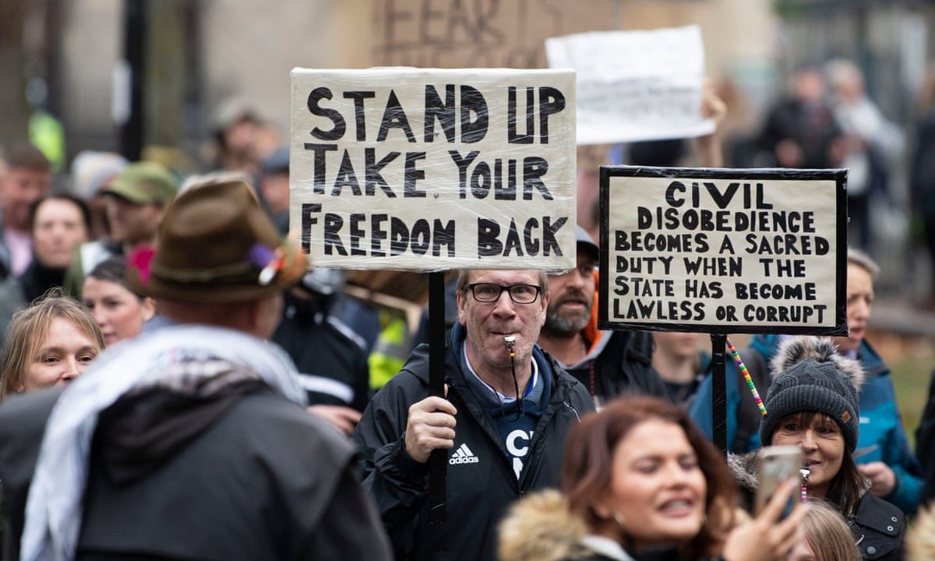
Figure 1: “Bristol police arrest 14 people at anti-lockdown protest” (Blackall, 2020).
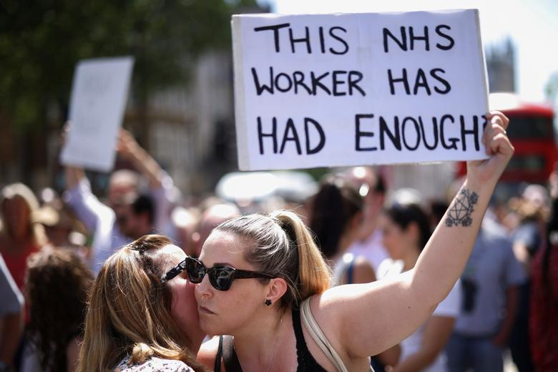
Figure 2: “Britons protest lockdown as UK delays lifting restrictions due to Delta variant” (Nicholls, 2021)
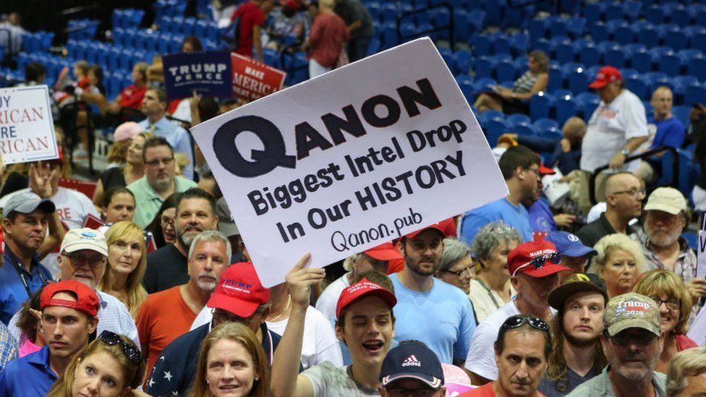
Figure 3: QAnon and Trump supporters at a rally (BBC News, 2019)
Participants were asked to identify what they thought were the most significant reasons for the spreading of misinformation and conspiracy theories: Dr. Rutschman stated “I have no personal beliefs in this area. The literature I know suggests that the reasons…are not yet fully understood, but seem to be rooted in causes ranging from lack of exposure to critical discourse…to misinformation or conspiracy theories about health/vaccines because of ancillary beliefs in certain political or social agendas”.
Quinn, however, expressed belief that the reasons are a lack of education or critical thinking ability, as well as the “constant bombardment” of opinions on social media. “Individuals who have a background in academia may be more likely to recognize how and why to seek evidence to support a claim they read on the internet, while others may figure that if the information is out there it must be accurate.”
Quinn also stated that it may be possible that as social media platforms have previously announced that they are trying to combat misinformation posts on their sites, that this may lead individuals to believe that if the inaccurate post is still on the website that it must be true, or that if the post was removed that it was removed in an attempt to cover up the “government’s ‘secret initiative’”. It should be noted that the belief of deep state conspiracies and cover ups have been particularly prevalent during events such as the incident at the Capitol, in the evidence collected from right-wing websites and footage taken at the incident itself.
Question 4 identified that both participants believe more could, and should, be done to combat misinformation on social media websites. Dr. Rutschman stated that regulation could be stringent and that it has been shown it is possible to filter misinformation and disinformation yourself, and so it should therefore be possible for the websites to do this for the users, especially given that speech inciting violence and other types of harm is often removed.
Quinn expressed that it is evident that misinformation is harmful and can occasionally result in death, and that misinformation should be removed, particularly if it risking the health and lives of those who read it; “while freedom of speech is a common concern for those choosing to post on various social media platforms, it would also be relatively straightforward to include a condition in the agreement a user must agree to when signing up for an account with the platform to not post untrue statements that may cause harm to others”.
Both participants agreed that public-figure speech is problematic when it comes to the spreading of misinformation and disinformation. Dr. Rutschman stated that this could be tackled by having news outlets and social media refrain from publishing and republishing such content. Quinn stated: “In the case of the former President of the United States Donald Trump, he used his position of power to spew health misinformation that quite literally did result in the death of some individuals who blindly followed the advice. An individual who is in a position of power and has influence over a large group of people should, in my opinion, be monitored by those supporting the political framework, in order to ensure that information being shared is accurate, safe and reliable”. Despite the COVID-19 pandemic being a unique circumstance, frameworks and protocols should already be in place within politics to ensure that such spreading of misinformation to such an extent is not possible from such influential figures, especially when it is harmful to public health.
It should be noted here that the statement about Trump causing the deaths of some of his ‘followers’ can be verified (Evelyn, 2021, Woolhandler, et al., 2021).
For question 6, Quinn answered that misinformation and conspiracies could potentially be linked to additional preventable cases and/or deaths, so decreasing misinformation would “likely” mean that more people will have accurate health information in order to decrease the transmission of COVID-19, whereas Dr. Rutschman answered “I do not know”.
For the final question, Dr. Rutschman stated: “These communities [the science and medicine communities] can become more literate in ways to communicate with people or groups that contest science-driven information. One thing we have observed during the pandemic is that misinformation groups tend to be much more tech-savvy and better at communication than public health organisations, and the medical community.”
Quinn answered: “Active anti-misinformation initiatives, particularly on social media, maybe useful to provide users with a toolkit to recognize misinformation and potentially debunk myths that are floating around. Some public health officials have taken this upon themselves to do their part in keeping the online community safe, but further action from public health from organisations or governments could assist in increasing the anti-misinformation presence on social media. Research in the area of misinformation has been growing, and more of an understanding to the degree to which misinformation influences individuals (and spreads) will be useful in creating effective and useful initiatives”.

4.5 Conclusion

This chapter achieved the third objective:
“To analyse the data collected to gain a well-rounded view on the subject.”
In conclusion, the project obtained data that suggested that some professionals in the field share the opinions that misinformation and conspiracy theories are a threat to public health, that individuals who believe in existing conspiracy theories are more likely to believe misinformation and further conspiracies, that a distrust in government is a factor in why an individual may believe misinformation and conspiracies, that social media is a tool to spread misinformation and that more can and should be done to address this, and finally, that further research and initiatives by the science and medicine community as well as the government is needed in order to assist in reducing the transmission of any further viruses.
The project found that the views of the participants matched views expressed previously by others in the field, suggesting that these views are not only held by the participants interviewed, of which the views were also what had been obtained in secondary research, for example, the World Health Organization stated that researchers estimate that at least 800 people died in the first 3 months of 2020 due to misinformation relating to COVID-19 (World Health Organization, 2021). A recent publication also made suggestions that medical professionals need to ‘urgently’ develop systems that will assist their patients in managing the waves of COVID-19 information and misinformation, guiding them to spot misinformation and recognize which information is correct (The Lancet: Rheumatology: Editorial, 2021).
This chapter has successfully analysed the data collected and explored the participants personal and professional views relating to the spread of misinformation and conspiracy theories, and what can be done to reduce the impact of this on public health in the context of a global pandemic. The final chapter will achieve the final objectives of understanding what, if any, practical implications of the research may arise in order to make appropriate suggestion for further research and analysis and to investigate in what way this topic may be researched further.

5. Chapter 5: Conclusions and Recommendations

5.1 Introduction

The previous chapter, Chapter 4, analysed the project data, highlighting the conclusions drawn from the participants answers and achieving the third objective. This chapter will achieve the fourth and fifth objectives of the project as follows:
“To understand what, if any, practical implications of the research may arise in order to make appropriate suggestion for further research and analysis”
and;
“To investigate in what way this topic may be researched further”.

5.2 Findings

The main findings from the participants answers are that conspiracies and misinformation are more likely to be believed by those who have pre-existing beliefs in conspiracies, such as the deep state conspiracies. The main findings were also that more could be done by social media platforms, the medical and science community, and the government to combat the spread of misinformation and conspiracies to protect public health.
Both participants believe that misinformation and conspiracies are a threat to public health, but to what extent this has affected the death toll and case numbers of COVID-19 are uncertain.
Further, the study found that the spreading of misinformation by politicians and other public figures is a serious issue which is recognized by those in the medicine and science communities and that this is something which needs to be addressed.

5.3 Implications

“Ever since the modern science of epidemiology emerged in the 19th century, misinformation has never been far behind” (Czyzewski, 2021).
The importance of discussing the spread of misinformation, disinformation and conspiracy theories with the purpose of understanding and the goal of finding solutions in order to protect public health cannot be understated.
False claims can spread and gain public traction incredibly fast, such claims often carrying the risk of public harm and sometimes even death, and this stresses the importance of evidence-based science. The evidence needs to be, however, accessible by the public, be deemed trustworthy by the public, and the public needs to be able to understand and utilize the information they are being provided.
The fact of public figures spreading and encouraging misinformation relating to a global pandemic, in turn causing illness, death and a negative impact on public health policy has been stressed by the participants in this project.
The implications here could be that there is not enough being done to combat misinformation and conspiracies, which may greatly impact public health and policy, and seep into more areas than one, and that further research and initiatives are needed to address this issue. The following part of the part will look at recommendations for doing so.

5.4 Recommendations

There are a number of recommendations which can be made following the completion of the current project. The importance of addressing the issues discussed must be further stressed to the government, in order to stress the importance of addressing the issue through government initiatives and through policy. This needs to be done in line with recommendations made by researchers in the field, such as those in psychology and social studies, who can identify more accurately why people are inclined to believe misinformation, and how this can be altered, as well as preventing the misinformation in the first place, for example, what can be done by social media platforms and the media, and whether enforcement of policy to control misinformation online needs to be considered if such platforms will not implement a successful strategy.
It would be beneficial to bring together communities from various fields to work together and bring together knowledge from various backgrounds in order to address this issue through a joint academic and government initiative.
Regulating against misinformation has been advised against previously, during the final report on misinformation ordered by the European Commission which gathered input from professionals from around the world in 2018 (European Commission High Level Expert Group on Fake News, 2018), however, it is evident that initiatives have not been entirely successful previously.
Although it may be impossible to eradicate misinformation altogether, slowing the spread and fighting against the ease at which groups quickly spread false information and conspiracies that are heavily influential on public behaviour, is an important issue which has clearly not been sufficiently addressed prior to the pandemic, and perhaps the pandemic itself and the events throughout it, relating to the pandemic and the political movements taking place during its course, have shown that it is still a very large issue.

5.5 Limitations

This project took place during the COVID-19 pandemic, and due to this, the researcher was restricted as to how the study could take place. Initial plans included more than one research method in order to gain a broader view, however, such plans had to be reevaluated given the circumstances. This may have impacted the study in terms of reducing the amount of data collected. Further information on this limitation was provided at the start of the paper by the University of Wales Trinity Saint David.

The second limitation would be the time constraints in place. The project was conducted as an Undergraduate dissertation project, and so the time was limited and further made difficult by the COVID-19 restrictions in place meaning the introduction of home learning for both university students and schools.
The final limitation worth noting is that the researcher reached out to many professionals to participate in the study, all of whom have their own research projects, studies, and classes to teach and/or take part in, and so some plans with researchers fell through due to this.

5.6 Further Research
It would be greatly beneficial in future research to use a mixed-methods approach, in utilizing surveys of the general public and analyzing using software to provide statistics as well as the methods used in this project. This would provide a broader understanding of the topic with the views of the general public as well as experts in the field, so that information could be compared to draw more accurate conclusions.
Further research could also investigate specific groups, specific conspiracies, or focus purely on one area of the topic, such as vaccinations. This could provide more detailed conclusions to be drawn from the data, which could be used in future initiatives to combat misinformation spreading.
It would also be beneficial to conduct the research over a larger span of time in order to speak with many more professionals as well as the above mixed-methods recommendation, which would provide a larger and more detailed amount of data which would be more useful for finding solutions.
Further research should also focus on not just preventing the spread, or slowing it, but also on how it can be corrected when it is already believed by groups of people.

5.7 Achievement of the Objectives
The project has completed the objectives set out by the researcher at the start of the study, as follows:

- To critically analyse available academic literature on the formation and spreading of conspiracy theories with a focus on COVID-19 conspiracies.
An in-depth literature review of the available resources and research has achieved this objective, showing that misinformation and conspiracy theories are not only prevalent and problematic in various areas of society, but particularly of relevance during the global COVID-19 pandemic, showing that such misinformation has impacted public health to an unknown extent and will continue to do so in any future health crisis without appropriate solution.
- To use a suitable method of research to explore professional views on ascertaining the impact of such conspiracies on public health.
This objective was achieved through interviews with two professionals who are knowledgeable in their field and have experience in this research area, both of whom shared views and also differed in some views, gaining a broader understanding of the topic through the opinions and thoughts of individuals who are educated in this subject.
- To analyse the data collected to gain a well-rounded view on the subject.
This objective was achieved through the means described above. This has shown in that the participants had opinions that both agreed on as well as differed, and the admittance to not knowing how they felt about something to not knowing to what extent the misinformation on COVID-19 has made an impact, as well as their views on why individuals may believe conspiracies: both participants had shared views as well as different points that the other may not have touched upon.
- To understand what, if any, practical implications of the research may arise in order to make appropriate suggestion for further research and analysis.
This objective was achieved by realizing the implications that could be drawn and making appropriate recommendations based on these implications for further research. For example, the implication that not enough has been done to combat the spread of misinformation and that it is a great problem in various areas of society, arguably impacting further misinformation in that individuals already convinced of one conspiracy are far more likely to believe another, and that the recommendation based on this realization is that a mixed-methods approach to researching this topic would be greatly beneficial.
- To investigate in what way this topic may be researched further.
This final objective was achieved by using the drawn conclusions from the data collected to recommend further research, what ways this research could take place and why such research may prove useful in this subject area.

5.8 Reflection

The aim of the researcher was to explore and analyze the opinions and thoughts of professionals in the relevant field in order to better understand how impactful misinformation and conspiracies are in the context of the COVID-19 pandemic as at the start of the project, there was little research in this specific area.
The researcher has interest in this area from a law perspective as well as a social studies perspective and how each intertwine with each other politically and in public health.
The researcher has improved social skills in interacting with professionals in the academic field as well as skills in overcoming ever-changing circumstances. COVID-19 has been disruptive to the entire world both from a health standpoint and also in that it has disrupted jobs, schooling, universities, childcare and social interaction. The ceasing of attending classes face-to-face and the disruption to study was particularly difficult, but the researcher has overcome this by reevaluating plans and working around the restrictions in place to the best of their ability.

Conclusion

This chapter achieved the final objectives: “to understand what, if any, practical implications of the research may arise in order to make appropriate suggestion for further research and analysis”, and “to investigate in what way this topic may be researched further”.
The project aimed to explore the thoughts and opinions of professionals in relevant fields in order to engage in a discourse analysis of this topic to better understand how and why people believe misinformation and conspiracy theories relating to COVID-19, how they spread and how this can be combatted. The project successfully achieved this by gaining the perspectives of individuals in the research and teaching field relating to epidemiology who have conducted relevant studies in this topic area, who were able to provide opinions stemming from academic expertise and who undoubtedly provided useful data to this study as well as in their own work which will continue to impact this subject area positively.
This research has highlighted the issue of misinformation and conspiracy theories in relation to the COVID-19 pandemic and concluded that misinformation and conspiracies impact society in many ways and require further research and initiatives to not only combat the spreading of misinformation and disinformation, but also in correcting already established beliefs which may negatively impact public health in any future health crises.
The study has also highlighted the importance of addressing particular topics in order to better understand the way in which society functions, so that solutions can be provided in the future to protect society from itself.

6. References

Ahmed, W., Vidal-Alaball, J., Downing, J. & Segui, F., 2020. COVID-19 and the 5G Conspiracy Theory: Social Network Analysis of Twitter Data. Journal of Medical Internet Research, 22(5).
Amarasingam, A. & Argentino, M.-A., 2020. The QAnon Conspiracy Theory: A Security Threat in the Making?. Combating Terrorism Center CTCSentinel, 13(7).
Azorin, M. J. & Cameron, R., 2010. The Application of Mixed Methods in Organisational Research: A Literature Review. Electronic Journal of Business Research Methods, 8(2), pp. 95-105.
Bajpai, N., 2011. Business Research Methods. Delhi: Pearson Education Ltd..
Ball, P. & Maxmen, A., 2020. The epic battle against coronavirus misinformation and conspiracy theories. nature, 581(7809), pp. 371-374.
Bazeley, P., 2013. Qualitative Data Analysis. London: SAGE.
BBC News, 2016. Why they love Trump: 'He's not a politician'. [Online]
Available at: https://www.bbc.co.uk/news/av/election-us-2016-36493676
[Accessed 1st June 2021].
BBC News, 2019. BBC. [Online]
Available at: https://www.bbc.co.uk/news/world-us-canada-48231708
[Accessed 1st June 2021].
BBC, 2020. Coronavirus: Boris Johnson delivers first daily update. [Online]
Available at: https://www.bbc.co.uk/news/uk-51901818
[Accessed 28th April 2021].
BBC, 2021. Wuhan lockdown: A year of China's fight against the Covid pandemic. [Online]
Available at: https://www.bbc.co.uk/news/world-asia-china-55628488
[Accessed 28th April 2021].
Bernard, R. H., 2006. Research Methods in Anthropology. 4th ed. Oxford: AltaMira Press (Rowman & Littlefield Publishers. Inc.).
Bessi, A., Zollo, F. D. V. M., Calderelli, G. & Quattrociocchi, W., 2015. Trend of Narratives in the Age of Misinformation. PLOS ONE.
Blackall, M., 2020. the Guardian. [Online]
Available at: https://www.theguardian.com/world/2020/nov/14/bristol-police-arrest-14-people-at-anti-lockdown-protest
[Accessed 19th May 2021].
Bright, J., Au, H. & Howard, N. P., 2020. Social Media Junk News on the Epidemic Status of Coronavirus, Oxford, UK: University of Oxford.
Buckley, C., 2020. Chinese Doctor, Silenced After Warning of Outbreak, Dies From Coronavirus. [Online]
Available at: https://www.nytimes.com/2020/02/06/world/asia/chinese-doctor-Li-Wenliang-coronavirus.html
[Accessed 28th April 2021].
Calisher, C. et al., 2020. Statement in support of the scientists, public health professionals, and medical professionals in China combatting COVID-19. The Lancet, 395(10226).
Chowdhury, F. M., 2014. Interpretivism in Aiding Our Understanding of the Contemporary Social World. Open Journal of Philosophy, 4(3).
Clarke, C., 2009. Paths between Positivism and Interpretivism: An Appraisal of Hay's Via Media. Political Studies Association, 29(1), pp. 28-36.
Cook, J., Ecker, U. & Lewandowsky, S., 2015. Misinformation and How to Correct It. Emerging Trends in the Social and Behavioural Sciences: An Interdisciplinary, Searchable, and Linkable Resource.
Cracary, M., 2009. The Research Audit Trial- Enhancing Trustworthiness in Qualitative Inquiry. Electronic Journal on Business Research Methods.
Czyzewski, A., 2021. Fighting an epidemic of misinformation. [Online]
Available at: https://www.imperial.ac.uk/stories/coronavirus-misinformation/
[Accessed 2nd June 2021].
Del Vicario, M. et al., 2016. The spreading of misinformation online. Proceedings of the National Academy of Sciences of the United States of America, 113(3), pp. 554-559.
Desta, T. & Mulugeta, T., 2020. Living with COVID-19-triggered pseudoscience and conspiracies. International Journal of Public Health, Issue 65, pp. 713-714.
Dyson, S. & Brown, B., 2005. Social Theory and Applied Health Research. New York: Open University Press.
Elman, C., Gerring, J. & Mahoney, J., 2020. The Production of Knowledge: Strategies for Social Inquiry. Cambridge: Cambridge University Press.
Elster, J., 2012. Explaining Social Behaviour: More Nuts and Bolts for the Social Sciences. Cambridge: Cambridge University Press.
European Commission High Level Expert Group on Fake News, 2018. A multi-dimensional approach to disinformation, s.l.: European Union.
Evanega, S., Lynas, M., Adams, J. & Smolenyak, K., 2020. Coronavirus misinformation: quantifying sources and themes in the COVID-19 'infodemic' (The Cornell Alliance for Science). [Online]
Available at: https://www.uncommonthought.com/mtblog/wp-content/uploads/2020/12/Evanega-et-al-Coronavirus-misinformation-submitted_07_23_20-1.pdf
[Accessed 10th February 2021].
Evelyn, K., 2021. Capitol attack: the five people who died. [Online]
Available at: https://www.theguardian.com/us-news/2021/jan/08/capitol-attack-police-officer-five-deaths
[Accessed 1st June 2021].
Fox, N., 2009. Using Interviews in a Research Project, Yorkshire: National Institute for Health Research.
Frenkel, S., Decker, B. & Alba, D., 2020. How the 'Plandemic' Movie and Its Falsehoods Spread Widely Online. [Online]
Available at: https://www.nytimes.com/2020/05/20/technology/plandemic-movie-youtube-facebook-coronavirus.html
[Accessed 11th May 2021].
Furedi, F., 2006. Culture of Fear Revisited. 4th ed. London & New York: Continuum Books.
Galletta, A., 2013. Mastering the Semi-Structured Interview and Beyond. New York: New York University Press.
Gillham, B., 2004. The Research Interview. 3rd ed. London: Continuum.
Goddard, W. & Melville, S., 2004. Research Methodology. 2nd ed. Lansdowne: Juta.
Green, A., 2020. Li Wenliang. The Lancet, 395(10225), p. P682.
Hancock, B., Ockleford, E. & Windridge, K., 2009. An Introduction to Qualitative Research, Yorkshire: The NI HR Reseach Design Service for the East Midlands.
Hannabuss, S., 1996. Research interviews. New Library World, 97(5), pp. 22-30.
Imhoff, R. & Lamberty, P., 2020. A Bioweapon or a Hoax? The Link Between Distinct Conspiracy Beliefs About the Coronavirus Disease (COVID-19) Outbreak and Pandemic Behaviour. Journal of Health Psychology, 11(8), pp. 1110-1118.
Iyengar, S. & Hahn, S. K., 2009. Red Media, Blue Media: Evidence of Ideological Selectivity in Media Use. Journal of Communication, 59(1), pp. 19-39.
John Hopkins University: JHU Education Research, 2021. COVID-19 Data. [Online]
Available at: https://github.com/CSSEGISandData/COVID-19
[Accessed 28th April 2021].
Kaiser, K., 2009. Protecting Respondent Confidentiality in Qualitative Research. Qual Health Res, 19(11), pp. 1632-1641.
Kearney, D. M., Chiang, C. S. & Massey, M. P., 2020. The Twitter origins and evolution of the COVID-19 "plandemic" conspiracy theory. Misinformation Review (Harvard Kennedy School).
Kivunja, C. & Kuyini, B. A., 2017. Understanding and Applying Research Paradigms in Educational Contexts. International Journal of Higher Education, 6(5), pp. 26-41.
Leung, L., 2015. Validity, Reliability and generalizability in qualitative research. Journal of Family Medicine and Primary Care, 4(3), pp. 324-327.
Levenson, E., Amir, V. & Kallingal, M., 2021. CNN: What we know about the 5 deaths in the pro-Trump mob that stormed the Capitol. [Online]
Available at: https://edition.cnn.com/2021/01/07/us/capitol-mob-deaths/index.htm
[Accessed 10th February 2021].
Lin, C. A., 2005. Bridging Positivist and Interpretivist Approaches to Qualitative Methods. Policy Studies Journal, 26(1), pp. 162-180.
Linkedin, 2021. Emma Quinn. [Online]
Available at: https://ca.linkedin.com/in/emma-quinn-22ab30189?trk=public_profile_browsemap_profile-result-card_result-card_full-click
[Accessed 19th May 2021].
Linkedin, 2021. Emma Quinn. [Online]
Available at: https://ca.linkedin.com/in/emma-quinn-22ab30189?trk=public_profile_browsemap_profile-result-card_result-card_full-click
[Accessed 19th May 2021].
Lovelace Jr, B. & Breeuninger, K., 2020. CNN: Trump says he takes hydroxychloroquine to prevent coronavirus infection even though it's an unproven treatment. [Online]
Available at: https://www.cnbc.com/2020/05/18/trump-says-he-takes-hydroxychloroquine-to-prevent-coronavirus-infection.html
[Accessed 10th February 2021].
Marvasti, B. A., 2003. Qualitative Research in Sociology. s.l.:SAGE Publications.
Maykut, P. & Morehouse, R., 1994. Beginning Qualitative Research: A Philosophical and Practical Guide. London: Routledge.
Merriam-Webster, 2021. Definitions for Misinformation. [Online]
Available at: https://www.merriam-webster.com/dictionary/misinformation#:~:text=%3A%20information%20that%20is%20not%20completely,from%20Merriam%2DWebster%20on%20misinformation
[Accessed 28th April 2021].
Mian, A. & Khan, S., 2020. Coronavirus: the spread of misinformation. BMC Medicine, 18(89).
Miles, B. M. & Huberman, M. A., 1994. Qualitative Data Analysis: An Expanded Sourcebook. 2nd ed. California: SAGE .
Mishra, B. S. & Alok, S., 2017. Handbook of Research Methodology: A Compendium for Scholars & Researchers. New Delhi: Educreation Publishing.
Morgan, S., 2018. Fake News, disinformation, manipulation and online tactics to undermine democracy. Journal of Cyber Policy, 3(1), pp. 39-43.
Morse, M. J., Barrett, M. & Mayan, M., 2001. Verification Strategies for Establishing Reliability and Validity in Qualitative Research. International Journal of Qualitative Methods, pp. 13-22.
Nicholls, H., 2021. Reuters. [Online]
Available at: https://www.reuters.com/news/picture/britons-protest-lockdown-as-uk-delays-li-idUSRTXD9QTK
[Accessed 14th June 2021].
Novikov, M. A. & Novikov, A. D., 2013. Research Methodology: From Philosophy of Science to Research Design. Boca Raton: CRC Press (Taylor & Francis Group).
Office for National Statistics, 2020. Coronavirus (COVID-19) Infection Surveyt pilot: England, Wales, and Northern Ireland, 16 October 2020, UK: ONS.
Olshanksy, A., 2018. Conspiracy Theorizing and Religious Motivated Reasoning: Why the Earth 'Must' Be Flat. Texas: Texas Tech University Libraries.
Posetti, J. & Matthews, A., 2018. International Center for Journalists: A short guide to the history of 'fake news' and disinformation. [Online]
Available at: https://www.icfj.org/sites/default/files/2018-
[Accessed 11th May 2021].
President Trump Suggests 'Injecting' Disinfectant as Coronavirus Cure. 2020. [Film] New York, USA: NBC New York.
Quinn, K. E., Fazel, S. S. & Peters, E. C., 2020. The Instagram Infodemic: Cobranding of Conspiracy Theories, Coronavirus Disease 2019 and Authority-Questioning Beliefs. Cyberpsychology, Behaviour, and Social Networking.
Roth, K., 2020. How Authoritarians Are Exploiting the COVID-19 Crisis to Grab Power. The New York Review of Books.
Roujian, L. et al., 2020. Genomic characterisation and epidemiology of 2019 novel coronavrius: implications for virus origins and receptor binding. The Lancet, 395(10224), pp. 565-574.
SAGE, 2006. The SAGE Dictionary of Social Research Methods. [Online]
Available at: https://dx.doi.org/10.4135/9780857020116.n75
[Accessed 11th May 2021].
Saint Louis University School of Law, 2021. Ana Santos Rutschman, S.J.D. [Online]
Available at: https://www.slu.edu/law/faculty/ana-santos-rutschman.php
[Accessed 19th May 2021].
Salkind, J. N., 2012. Exploring Research. 8th ed. Boston: Pearson Education Ltd..
Saunders, N. K. M., Lewis, P. & Thornhill, A., 2007. Research Methods for Business Students, Harlow, England: Pearson Education Ltd..
Silverman, D., 2019. Introducing Qualitative Research. In: D. Silverman, ed. Qualitative Research. 4th ed. London: SAGE Publications.
Simelane-Mnisi, S., 2018. Role and Importance of Ethics in Research. In: S. Sibinga, ed. Ensuring Research Integrity and the Ethical Management of Data. Pensylvania : IGI Global, pp. 1-14.
SSRN, 2021. Ana Santos Rutschman- Saint Louis University - School of Law. [Online]
Available at: https://papers.ssrn.com/sol3/cf_dev/AbsByAuth.cfm?per_id=2667484
[Accessed 19 May 2021].
Stein, R. et al., 2021. Conspiracy theories in the era of COVID-19: A tale of two pandemics. The International Journal of Clinical Practice, 75(2).
Stroud, J. N., 2008. Media Use and Political Predispositions. 30(3), pp. 341-366.
Taylor, K. J. & Cihon, C., 2004. Statistical Techniques dor Data Analysis. 2nd ed. London: CRC Press.
The Lancet: Rheumatology: Editorial, 2021. Going viral: misinformation in the time of COVID-19. The Lancet, 3(6).
Thomas, R. D., 2003. A general inductive approach for qualitative data analysis. American Journal of Evaluation, 27(2), pp. 237-246.
Thompson, S., 2020. COVID-19 emergency measures and the impending authoritarian pandemic. Journal of Law and the Biosciences, 7(1).
U.S. Food & Drug Administration, 2019. Danger: Don't Drink Miracle Mineral Solution or Similar Products. [Online]
Available at: https://www.fda.gov/consumers/consumer-updates/danger-dont-drink-miracle-mineral-solution-or-similar-products
[Accessed 10th February 2021].
UK Government, 2020. (COVID-19) Coronavirus Restrictions: what you can and cannot do. [Online]
Available at: https://www.gov.uk/guidance/covid-19-coronavirus-restrictions-what-you-can-and-cannot-do
[Accessed 28th April 2021].
Uscinski, J. et al., 2020. Why do people believe COVID-19 conspiracy theories?. Misinformation Review.
Uscinski, J. & Parent, J., 2014. American Conspiracy Theories. New York: Oxford University Press.
van Prooijen, J.-W. & Douglas, K., 2017. Conspiracy theories as part of history: The role of societal crisis situations. Memory Studies, 10(3), pp. 323-333.
Walter, N. & Murphy, T. S., 2018. How to unring the bell: A meta-analytic approach to correction of misinformation. Communication Monographs, 85(3).
Walter, N. & Tukachinksy, R., 2019. A Meta-Analytic Examination of the Continued Influence of Misinformation in the Face of Correction: How Powerful is it, Why Does it Happen and How to Stop it?. Communication Monographs, 47(2).
Wardle, C. & Derakhshan, H., 2018. Thinking about 'information disorder': formats of misinformation, disinformation, and mal-information. UNESCO.
Welsh Government, 2021. Coronavirus (COVID-19) guidance: Alert Level 4. [Online]
Available at: https://gov.wales/alert-level-4
[Accessed 28th April 2021].
Woolhandler, S. et al., 2021. Public policy and health in the Trump era. The Lancet, 397(10275), pp. 705-753.
World Economic Forum, 2021. World Economic Forum. [Online]
Available at: https://reports.weforum.org/global-risks-2013/risk-case-1/digital-wildfires-in-a-hyperconnected-world/?doing_wp_cron=1613040199.3015990257263183593750
[Accessed 11th May 2021].
World Health Organisation, 2020. Call for Action: Managing the Infodemic. [Online]
Available at: : https://www.who.int/news/item/11-12-2020-call-for-action-managing-the-infodemic
[Accessed 11th February 2021].
World Health Organization (WHO), 2021. Coronavirus. [Online]
Available at: https://www.who.int/health-topics/coronavirus#tab=tab_1
[Accessed 28th April 2021].
World Health Organization, 2020. Novel Coronavirus (2019-nCoV) Situation Report-1, s.l.: WHO.
World Health Organization, 2021. Fighting misinformation in the time of COVID-19, one click at a time. [Online]
Available at: https://www.who.int/news-room/feature-stories/detail/fighting-misinformation-in-the-time-of-covid-19-one-click-at-a-time
[Accessed 1st June 2021].
Yavuz, A., 2012. Competing Paradigms: The Dilemmas and Insights on an ELT Teacher Educator. International Education Studies, 5(1).
Zhou, P., Yang, Z.-L. & Shi, Z.-L., 2020. A pneumonia outbreak associated with a new coronavirus of probably bat origin. Nature, Volume 579, pp. 270-273.
Zhu, N. et al., 2020. A Novel Coronavirus from Patients with Pneumonia in China 2019. The New England Journal of Medicine, Volume 382, pp. 727-733.
Zollo, F. et al., 2015. Emotional Dynamics in the Age of Misinformation. PLOS Digital Health.

7. Evidence



