Programme | CertHE Skills for the Workplace
Module | Managing Enterprise in the 21st Century
Student’s ID | 2018315
Module code: | BMSW4006
Lecturers Name | Dr. Mushfiqur Rahman
Submission Date | 05 December 2022

Table of Contents

Introduction 1
Business Description and History 1
Aim and Objectives 3
Mission and Vision 4
Business Structure 4
Conclusion 4
Reference 5

Executive Summary
Black & White TM Clothing Line TM is both local and international clothing line situated in the eastern part of London United Kingdom. It is in a busy suburb of the town with a large space big enough for our products with the help of contributions from the founding four founding members.
Black & White TM Clothing Line TM will undertake all different types of clothes productions from kids to adults for casual wear to corporate and sports clothes of all genders. Our goal is to be one of the leading brands in cloth productions competing with the best in the business.
The company will be looking at hiring the best of talents in the cloth manufacturing company – they will undergo training that will make them function well in the clothing manufacturing industry Black & White – Clothing Line.
we have agreed with the best companies producing machines and equipment for cloth lining companies to purchase the best equipment and machines to help us produce high-quality clothing for our customers.
We will be looking at satisfying both the elite – high-end customers and the poor – low earn customers thereby putting everyone to have purchasing powers and not be left out from our brands of clothes. We will be looking beyond mass production by involving customized production where demand will be based on customer requests. They include sporting clubs, schools, and churches where they need clothes for specific purposes.
Black & White TM Clothing Line TM is co-founded by the President/Chief executive officer Elvis Uagbor a fashion guru, Maria Bahnari is experienced and respected in the fashion industry is the Chief operating officer. Cristina Vadana is a forward-looking, energetic enthusiast in the fashion industry is the Sales Executive officer while Desmond Wilson well-known fashion expert is the creative director.

Introduction
Black & white is a clothing line that will be located in East London. The Company will be involved in the production of clothes (casual, corporate, sports clothes et al) that will meet the needs of males, females, young adults, and children.
Our target is to become one of the leading brands in the world's fashion industry and we will ensure that every cloth that leaves our factory can favorably compete with the best brands in the industry.
Our clothing line will manufacture clothes for high-end customers and for low-income earners making sure it represents all the facets of the population. The business took off to meet the yarning of lack of quality trends in terms of clothing line fashion which will meet the ever-increasing demand for the populace in terms of fashion.
We have decided to make custom-made and manufactured clothing as deemed fit and needed by the customers. We will focus on a particular group of customers like the fire service, schools, and company workforce for the first year and build on our success from the outcome.
We decided to form this business because the clothing industry has been lacking a niche in quality and other accessories hence, we came up with an idea that will rival and overtake our competitors with an aggressive design and robust sales techniques.
Although we have been researching on different types of manufacturing and production of clothes for the past 3 years, we think this is the time to come and exhibit and showcase our findings through the research and again this is the festive period where customers are particularly going for new wardrobes and clothing thus making the most of it by entering the market at this time of the year.
The company brands will focus mainly on teeners and adults, but we will be producing in small quantities for children while we understudy the market and at the same time, we will form a bond with the on-demand customers – the customized customers like the military, schools, and hospitals and continue to research into the elderly for the future productions.
As a new business, we are targeting sales up to £30,000.00 for the first year and £90,000.00 in the second year. As it stands, we will be looking at the next three years for the profitable year as we must have broken even with the business capital spent in the business.

Business Description and History

The clothing business name will be called Black & WhiteTM Clothing LineTM with a registered trademark. It is registered with the company house in the UK having business registration numbers and co-founders’ names and appellations.
The clothing line is a limited company focusing on manufacturing and producing all sorts of clothes and wears for the populace which will be based in a business park in the East of London. There are four founding members and owners – Cristina Vadana, Maria Bahnari, Desmond Wilson, and Elvis Uagbor holding shares according to their status in the company.​
The business is a new company looking to serve different sizes and shapes of all ages. We recognize that most shops are into one type of design of clothes so we have come up with a decision that the clothing line can have different styles and colors targeting mostly children, teenagers, and adults. ​
The business hours will vary between departments – the production department will be open 24 hours a week, while the retail store will be open between 10:00 hrs – 18.00 hrs 5 days a week including bank holidays. During peak times the opening hours could vary depending on the collective agreements by the executives.
The business will not be seasonal, it will work round the clock producing and manufacturing clothes and other accessories all year round. Some clothes though might be seasonal e.g., Christmas and special occasions.
As earlier explained in the executive summary, the Black & White TM Clothing Line TM is co-founded by the President/Chief executive officer Elvis Uagbor a fashion guru, Maria Bahnari is experienced and respected in the fashion industry is the Chief operating officer. Cristina Vadana is a forward-looking, energetic enthusiast in the fashion industry is the Sales Executive officer while Desmond Wilson well-known fashion expert is the creative director. These are all professionals in their different capacities and hold to the high esteem in the fashion and clothing industry.
The business will be hiring experienced and inexperienced staff providing training and aligning them to the value and culture of the company. The experienced staff must have worked in a clothing company for at least 5 years and have a peccable character that suits the values of Black & white company. The inexperienced staff will be fresh graduates from the university, technical, or a recognized clothing academy in the country and will be made to undergo rigorous training matching the expectations of the Black & White company.
This business will be special in the sense that it will be doing what our competitors have not done before by visiting customers at their various homes and asking how they feel about our products. If customers come to shop in our retail stores and did not find their sizes or what they wanted, floor staff can take their measurements and send them to the factory to be produced for the said customers and the finished product delivered to the customer at their homes. The business will also be looking at hiring reputable distributors with wide range of customers and areas LaMarco N. (2019)
The business will take off from the contributions of the co-founders thereby putting the business on a good financial status by not borrowing or taking any loan from the financial companies. The profit will be shared amongst the founders on agreed percentages and still try to keep the floating capital in the business. the expenses the company made at its start-up in procuring and installing clothing were mainly the contributions from the founders.
The structure of the business is a flat structure – the CEO at the head of the pyramid and down to the bottom of the pyramid of laborers.

CEO/President

Chief Operating Manager
Creative Manager
Sales Executive Manager
Vacant Executive Chair

Tailor
designer
None
Sales Person

Figure 1: Organizational structure of Black & White Clothing Line Company

Aim and Objectives

The business aims are to identify consumer trends, this is going to be a long-term goal for the business and will be consistent at being on top of the business – the business will not only concern with what the customers want now but what they also want in the future. In other to keep abreast with the business, the company will be involved in attending fashion weeks and runaway shows thereby having good sense of the trends that are popping up in the fashion industry.
We also aim at remaining a profitable business making sure that the company revenue always be more than incurred costs. The money made in the peak times are saved up so that there will not be any issue with cash flow during off-peak.
The company will make every effort to make its brand recognizable, this is because most customers tend to shift towards known brands of high quality this will be done by extensive marketing and advertising strategies that exposes the masses to the company’s brand. By doing this it will evoke the right audience and associate the company will only quality, value, and security with familiarity.
According to White M. G. (2021) in her article “Examples of business objectives” stated that to achieve your goal you need to reach out to your objective as well. She reiterated to say that you create a survey to discover how the top 20% of our customer – Black & white found the firm and increase investment in the marketing strategy at a sorter date. We in Black & white would like to set the date in the first quarter of every year to boost up customer reliance. She went on to say creating loyalty is also a good business object which will include frequent buyer program to encourage repeat customer sales in every quarter of the year.
The third objective reason she gave was to create a client referral program to increase the company brand’s reach. We in Black & white have decided to do this in the last quarter yearly.
In other to achieve the company’s customer set goals, the company must set certain objectives to enable it to achieve them. In M. G. (2021), she mentioned three objectives we can apply to achieve our company’s goals – hire and fully train competent new customer service staff in the first quarter, install online help to further bring customers closer, and third to translate company’s most support documents into different languages considering our customers catch areas.

Mission and Vision

Keenan M. (2021) defined mission statement to be a part of business plan. He said it identifies company’s purpose and a way to share publicly why our company exists. He went on to say that typical mission statement should include – what a company does, how it does it, and why the company does what it does. He defined vision statement as providing a brief description of a company’s long-term goals, that it is typically ambitious and communicates how the company plans to make a difference in the world. That the vision should be seen as a roadmap for making decisions that align with a company’s philosophy and objectives. He went on to say that vision should include – inspire teams and keep them focus, connect with customers in niche markets, make smarter decisions, and attract top talents.

Business Structure
Businessdictionary.com defines a business structure as an organisation framework legally recognized in a particular jurisdiction for conduction commercial activities. But Finance + Legal (2017) defined it as a framework to make sure your business runs smoothly – in both financially and legally – because how you structure your business has a direct impact on tax returns. He went on to say that business structure should have common forms to consider which include the following – sole proprietorships, partnerships, corporations, small corporations, and limited liability company. Because we are just a startup company we are structured as a limited company see figure 1.

Conclusion
The competition in the clothing industry is tense in manufacturing different types of cloths for the society. The company Black and White clothing line is aware of this hence has prepared its operation to counter such competition it will come across. The company will use the SWOT analysis and seize the opportunity to maximize the strength and minimize the weakness and try to counter the threat that the company will face and seize the opportunity the company will undertake. The management of Black and White clothing line is ready to put all the resources needed to weather the storm during industrial imbalance in the market.

Reference

Finance + Legal (2017) How To Choose Your Business Structure available at: How To Choose Your Business Structure (startupfashion.com) (Accessed on 3 December 2021).
Keenan M. (2021) Find Your Purpose: 9 Best Vision and Mission. Available at:
https://www.shopify.com/blog/mission-statement (Accessed on 3 December 2021).
LaMarco N. (2019) Business Goals for a Clothing Line Available at: https://smallbusiness.chron.com/business-goals-clothing-line-20736.html (Accessed 3 December 2021).
Martins A. (2021). How to Write a Clothing Line Business Plan.
Available at: https://www.profitableventure.com/clothing-line-business-plan/ (Accessed on 22 November 2021)
M. G. (2021). Examples of Business Objectives Available at: https://business.lovetoknow.com/business-communications-sample-letters/examples-business-objectives (Accessed on 4 December 2021).
WORKPLACE HEALTH & SAFETY • Vol. 61, No. 1, 2013 Available at:
https://journals.sagepub.com/doi/pdf/10.1177/216507991306100104 (Accessed 2 December 2021).

Business Plan
Black & White clothing line

Student Name: Bahnari Maria
Student Number: 2026577
Programme: certHE Skills for the Workplace
Module: Managing Enterprise in the 21st century
Module code: BMSW4006
Lecturer: Mushfiqur Rahman

Table of Contents

- Introduction…………………………………………………………………………………...3
- Management and Organization…………………………………………………………….3
- Social Responsibility Sustainability………………………………………………………...4
3.1. Ideas of fashion sustainability…………………………………………………………5
- Development, Milestone, and Exit Plan…………………………………………..............6
- Conclusion……………………………………………………………………………………7
- Reference List………………………………………………………………………….…….8

Introduction
The aim of the business plan is to focus on showing the running steps the Black & White clothing line, key aspects of management and organization and the social responsibility and sustainability of owning a clothing brand. Opening a business is not an easy step and it involves a lot of work, knowledge, and patience. Nowadays there is a large range of clothing brands designed for everyone and having different quality apparels. Our clothing line Black & White has its mission to establish the right approach so that we can attract as many loyal customers as possible and make ourselves visible not only locally but also abroad in many other different countries. The management team will show their effort and contribution to a better functioning of the business and their skills will help to increase our company’s visibility to a sustainable development and creating the best customer service.
Management and Organization
Our clothing Company, Black & White represents the organization that is involved in the process of manufacturing and selling of garments. We are the company that produces many types of clothes designed for women, men, teenagers, and adults. To manage such a big organization, it is necessary that the company has a team to operate each task and contribute with the skills needed to succeed within the business. Our Company’s management philosophy is based upon responsibility, mutual respect, and profitability, and we believe that the company’s present and future growth will involve the following:
- Wonderful people
- Social responsibility
- Building customer service experience
- Excellence
- Respecting the core values
Black & White consists of eight main people having different roles and responsibilities to contribute to our business’ success:
Chief Executive Officer – Takes major decisions, delegates duties ( He / She will be the first person knowing what is happening within the business and if there is anything to be decided, a group meeting will be held to discuss the possible solution of that particular problem)
General Manager- builds the company’s image by collaborating with customers, other different types of organizations, and employees
Human Resources- responsible for interviewing people as well as other administrative skills (Analysing people’s skills will help us to have the most excellent people in our team)
Sales and Marketing Manager- makes sure to be up to date with the latest trends so that customers are interested in visiting the store
Accountant/Cashier- Receives payments on behalf of the organization
Fashion Designers – Designs clothes to meet the latest trend (being present at different fashion shows and show the knowledge in the latest fashion trends represent one of the main skills a designer should have so that the brand has the chance to become more successful)
Quality Control Officer- Ensures the quality of the product line before being introduced to the sale system
Tailors-Responsible for sewing clothes as instructed by the fashion designer
According to Lasher (1994) there are several reasons that a business may fail, some of them are the following: the location is not selected in a visible way, the capital is not sufficient, poor knowledge in terms of finance and accounting, the inventory process has poor management. After analysing many key factors about the failure in a small business, many studies have shown that a percentage of 98 is due to managerial functions and other 2% represent other factors that controls the running of the business.
Social Responsibility and Sustainability
The textile industry represents one of the largest industries in the world. Many countries are using them to create garments and contribute to the sustainability and protection of environment. The variety of materials and fibres represent a broad spectrum when it comes about choosing which one to use or which one is better or the best, for this reason, all the particularities and benefits of the fibres are collected by the owners so that they can decide whether they are safe for production of the apparels
Abrams (2010) stated, that there are 3 concepts, known as ‘‘triple bottom line’’ focusing on the performance of a company (p.240)
People – answers the question ‘’How do you affect other people (employees, community)
Planet – How do individuals’ actions affect the environment, not just in the present but also in the future?
Profit – How do owners achieve financial sustainability, as the company must be profitable to remain in business?
When the employees of a company are socially responsible and have the aim to become more sustainable, the benefits will come, and the customers will be attracted to buy from us and in this way, we will gain visibility. The below list has its goal to be achieved so that becoming more sustainable represents a future reality:
- Create sustainable materials like cotton
- Reduce virgin plastic by avoiding the consumption of plastic bags within stores
- Increase the amount of recycled polyester and natural fibres in products
- Invest in materials and machinery that allows to decrease the quantity of material waste.
By using natural materials and not plastic, gives the chance to the customers to bring the item worn back so that it can be reused and transformed into another apparel. In this way we make new garments from the material we reuse. Creating sustainable alternatives helps to reduce the negative environmental impact of synthetic materials. Coming up with solutions like increasing consumer awareness and changing their behavioural habits will help to prevent the pollution and encourage the reusing of textiles.
Ideas of Fashion Sustainability
International Year of Natural Fibres 2009 presented 15 types of materials divided into two categories: Plant fibres and animal fibres.
Plant fibres include seed seeds such as hemp, flax, coconut, cotton. Animal fibres include wool, alpaca, silk, cashmere, mohair. They are the most popular types of material well known by clothing business owners, and they tend to introduce in the luxurious textiles market.
In her article, Katie Roberts (2016) identifies 3 types of fibres: Natural, semi-synthetic, and synthetics, each of them having their own peculiarities. We can find cotton, linen, hemp, silk, leather, wool in natural fibres. These are the most common goals the clothing brands are aiming to achieve – using as more natural materials as possible. The main aim for Black & White clothing brand is also producing garments by using natural fibres to attract our customer’s interest. Synthetic fabrics, known as having raw ingredients include Nylon, acrylic, polyester, and vegan leather. Semi-synthetics are those breathable fabrics that gives the feeling of comfort while wearing, such as bamboo, viscose, rayon. There is just one negative aspect about them that they can easily shrink, and this causes the absence of natural effect of the garment.
Overall, the table below will show the difference between natural and synthetic fibres and ideas on how to make them more sustainable while using in creating the apparels according to hej-support.org:
Natural fibres  Are obtained from any vegetable sources | Synthetic fibres  Are obtained with the use of plant materials and minerals
Plant fibres included: cotton, flax and hemp seeds husk and coconut fibres  Animal fibres included: wool, silk | Include fibres as: viscose, acrylic, nylon, polyester (easy to maintain because of its smooth aspect)
Sustainability  - The materials such as linen, and seeds (hemp, flax) require the use of less water and chemicals  - Cotton is not treated using pesticides | Sustainability  - Less water usage  - The colour and shape last longer  - Gives the possibility to reuse/recycle  - Minimizes plastic waste

To prevent any negative aspect despite or efforts to contribute to sustainability, there is a list of tips our company is aiming to encourage the customers and we hope to succeed:
- Check the labels (for understanding which material best suits them and avoid negative feedback)
- Buy from local shops (support local)
- Wash less (helps to prevent the uncoloured effect)
- Encourage buying vintage (second hand)
- Introduce effective policies (categorize the difference of materials by using a different colour and how safe it is to wear it, or how many degrees it is good to be washed or if hand washing or dry cleaning is recommended)
Example: GREEN- safe for wearing, contains NO artificial or synthetic materials
RED- High risk of allergic reaction as the material is not recyclable and contains synthetic fibres
Yellow- Medium risk as containing synthetic materials and is not suitable for sustainability. (Adapted from: hej-support.org)

Development, Milestone, and Exit Plan
Our first list of milestones will be securing funds and setting up our business, this is our major focus. The following steps have as a goal to be achieved within 2-3 years after opening:
- Build a mailing list of loyal customers
- Open online payment platforms
- Generate capital from business partners/investors
- Purchase of sewing machines and equipment/tools
We would like to see the growth of our company with an increase of product lines, further development with online sales. The book ‘How to write the perfect business plan’ (Lasher, 1994) suggests ideas on how to make progress in achieving the goals proposed for the milestones and the development of the business. PERT, standing for Program Evaluation and Review Technique has the advantages to easier accomplish the stated goals, by enumerating them to their importance and urgency. This technique also helps to keep track of the progress so that the owner can manage on time within the stated period. As Black & White company has stated 4 main milestones to be achieved within 2-3 years after opening, the PERT diagram will be extremely helpful to succeed in accomplishing them. The following example is to show how PERT diagram looks like:

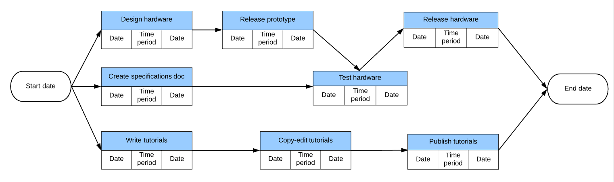
(Source: bing.com)

Deciding the starting date and working on each category step by step, play and important role when it comes about achieving goals and aspire with new ideas for creating new ones. The end date of a project, in our case ‘milestones’ has the role to encourage us as a team to work on our goals, contribute with necessary actions and support on how to easier succeed.
Conclusion
To get our business on the right track and keep it afloat, it is important that the business management is prudent with its finance and keeps the assets and liability in a moderate way that will not affect the company. To increase the expectations for a better future it is mandatory that our company sets a list of goals to be achieved such as contribution to sustainability by recycling the materials and consumption of plastic bags. Taking into consideration the factors that contribute to a sustainable future can lead into a successful development of the business and attraction of many interested customers and people willing to invest with a certain amount of money.

Reference List
Abrams, R.M. (2010) The successful business plan: Secrets & strategies. The Planning Shop. (p.240)
Course: Managing Enterprise in the 21st Century (BMSW4006_LON) (uwtsd.ac.uk)
Government UK (2021) Write a Business Plan. [Online]. 2021. Available from: https://www.gov.uk/write-business-plan. (Accessed: 03 January 2022)
Haag, A. B. (2013) ‘Writing a Successful Business Plan: An Overview’, Workplace Health & Safety, 61(1), pp. 19–29. Available at: doi: 10.1177/216507991306100104.
Henderson, S. (2018) Promoting Innovation in The Workplace │ How To Develop And Implement An Idea. [Online]. Available from: https://www.youtube.com/watch?v=Vrqbde3mSOE.
Ideas-of-fashion-sustainability-2.doc (live.com) available at: The Sustainability of Fashion: what role can consumers play? - HEJSupportHEJSupport (hej-support.org) (Accessed: 04 January 2022)
Lasher, W. (1994). The perfect business plan made simple. NY: Doubleday Dell
Pert diagram - Bing images
Perkins, G. (2019) How to Write a Business Plan - Entrepreneurship 101. [Online]. Available from: https://www.youtube.com/watch?v=ZEMbKzy7FD8&t=71s.
Roberts, K. (2016) ‘Synthetic and Natural: What’s the Diff?’ , Sustainability in Style, Available at: Synthetic and Natural: What’s the Diff? | Sustainability In Style (Accessed: 04 January 2022)
Valentin, E. (2014) Business Planning and Market Strategy, SAGE Publications, Thousand Oaks. Available from: ProQuest Ebook Central. [3 January 2022].
15 natural fibres | International Year of Natural Fibres 2009 (fao.org) (Accessed: 30 December 2021)

MANAGING ENTERPRISE IN THE 21st CENTURY
BMSW4006
Teacher: Mushfiqur Rahman
ID: 2028994
Student: Vadana Cristina Elena

Table of Contents
Introduction: 3
Prouduct and Service Description 3
Marketing Analysis and Trends 4
SWOT Analysis 5
Pestele Analysis: 6
Operation 6
Technology Plan 7
Conclusion: 7
References: 8

Introduction:
Black and White is clothing line that will be in East London. Black and white will be involved in the production of clothing (casual, corporate, sports, uniforms) that will be allocated to all the needs of men, women, young people, and children. Our goal is to become a well-known brand and make sure that every item of clothing that comes out of our workshop demonstrates quality and can compete with the biggest brands in the clothing industry. Our workshop will produce clothes for every pocket, from low prices to high prices. Depending on the customers' requirements, our workshop will open a line of personalized clothes in which each customer can order or customize their favourite clothes. Black and White is the brain of a young adults that they put their ideas into practice and built a new brand of clothes. While preparing a project for school they developed the idea of promoting and increasing revenues by selling clothes bearing the name, logo, and slogan of the group. The purpose of Blacke and White is to impress the client’s whit our fashion and casual pieces and to identify with uniqueness of each of our clients. We will make sure that we hire competent and professional employers that understand the industry and are also committed to helping us out in increasing productivity
Product and Service Description
Black and white is a workshop which one it was created for the purpose of producing quality clothes at reasonable prices and available for women, men, children, or older people. When we talk about clothes, each of us expects quality, so our company will make sure that every piece of clothing that it puts out for sale will be of good quality and our team will make sure that each clothes will exceed the customers' expectations. Black and White offers a full collection of clothing starting from classy to casual, this line includes uniforms, children clothing (from one month to up), winter clothing and robes. Our company will start adding logos and branding to premade items and carries a variety of products to suit the needs of every person, for any time of the day. We all love clothes and we all like to buy clothes for special occasions, work, school, or other events. When people talk about fashion everyone thinks of international brands, so our team has created a clothing brand to taste. and the price of each customer. Our company produces quality clothes at decent prices but also at the same time high for women, men, children, and older people. Our brand focuses on product quality and wants to offer a variety of clothes for different lifestyles. We hope to become one of the best brands. Some of our prices include:
- Jerseys (Men’s, women’s pullovers long or short)
- T-Shirts made from cotton 100% (long or short)
- Denim Jackets made from cotton 100%
- Denim pants made from cotton 100%

Marketing Analysis and Trends :
After the tragic event from September 11, 2001, which reduce consumer confidence, which led to declining sales in the apparel industry. The clothing market has always been one of the biggest strengths, which is why the clothing industry has a very wide range of customers because 99% of the world's population wears clothes and buys clothes every month from the occasional one for sports events or those for service or school. So, based on these statistics, our company has created strategies to reach people who go through different social classes, so that our workshop will produce clothes for adults, women, men, and children. Our company has ensured that the label we create will be accepted in the clothing industry market, so Black and White will produce quality clothing at affordable prices for every group of people. So, after some research, we found that 60% of people like to buy clothes every month, which will be a great benefit for our company and help us grow in the industry market.
The market Analysis table show the area by gender and age groups as well as potential sales:
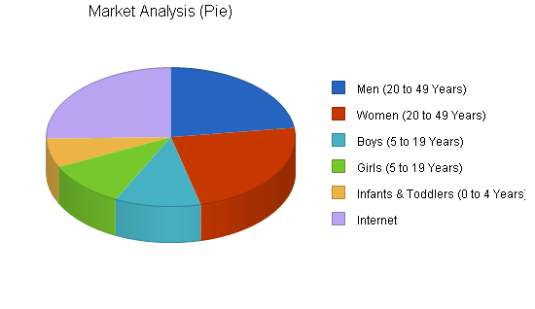

SWOT Analysis:
Because of the nature of business, we want to build a new brand of clothing and we decide to hire a service of HR and a consultant to help us about SWOT analysis to create a business model that will help our company to grow and achieve our goals and aims.
Strengths: One of our strongest points of strength is that we are working with skilled and knowledgeable team members with strong leadership and excellent communication skills.
Weakness: A major weakness is that we are new in this business, and we do not have enough money to compare to big brands like Hugo Boss, Gap, Mango.
Opportunities: One thing is certain that we goanna work more on strengths and weaknesses and find solutions to became better, we will start an internship program where we goanna open an online clothing store.
Threats: One of the big threats that our business will face like any other brands is that we will need to face an economic downturn and the problem of a new business who will want to adopt the same ideas like us.

Pestle Analysis
When we are talking about Pestle, six factors are coming in your mind:
Political: In UK, the government have the power to promote most of the companies to buy fabrics locality, especially when they import 35% of them in taxes in comparation with any other countries. In UK 75% of people buy clothing from companies who manufacture them in here. The fashion trends are 80% influence by social media, Celebes, actors.
Economic: After so many years of recession the people still find extra money to put in clothing and accessories. Most of the people are living with a low-income and they have a big rate of unemployment.
Social: Movies and music have a substantial role in any country. People like to adopt the ideas of clothing from movies or songs that is why many songs and movie have mention brand in the songs or showing the name of the brand in some of the movies.

Operation :
- On operation plan is start with
- Elvise Uagbor is the President and Founder of the Black and White, he will oversee supplying oversight of our design and distribution on our workhouse found in East of London. He coordinates each department and will manage the company's decisions and build the image of our company through new contracts and attract new potential customers, setting the clothing prices and discounts, recruiting employees and responsible for staff salaries.
- Myself (Cristina) I have decide to hire a manufacturing company to manufacture each piece of clothing. I believe by hiring a manufacturing company with their experience and their personal will be less for us to manage. Responsible for recruitment and question management positions to prepare new members and introduce them to the team, responsible for training and improving new employees
- Desmond Wilson Will be in charge with the tax obligation and money. He will receive payments and make the necessary payments; he will issue receipts for clients, and he will draw up a report at the end of each week where he will specify all the financial transactions and will manage the payment of taxes and invoices.
- Maria Bahnari will be focusing on showing the steps of running the business, key aspects of management and organization and the social responsibility and sustainability of owning a clothing brand​.She need to make sure that all our clothes meet the requirements of our customers, make sure that all production lines follow the rules of creating clothes, work on new ideas to improve the quality of our clothes and capitalize on the fact that our brand offers high quality clothes. be able to replace the general manager in case of emergency.

Technology Plan
When we are talking about our technology plan, we have six stages:
- Product analysis: we receive feedback on the quality and prices of our products
- Production: We prepare a variety of clothes for the needs of each client with an extremely high quality
- Marketing: We use social media to make ourselves known and to receive help from new customers.
- E-commerce: our customers currently have an online store where they can choose their clothes according to everyone's taste.
- Realization: We make sure that our customers will receive their order as soon as possible without any problems.
- Customer support: we differ from the competition because the relationships with customers in our company are open 24 hours a day, we are available by message, phone, or email

Conclusion:
Black and White will become a well-known brand in the clothing industry in addition to large competitors of manufacturers such as Tommy Hilfiger, Gucci, Polo, Gap. The management of the company is confident that Black and White can meet and meet the expectations of its customers in about 5 years. In addition, our management has carefully considered the market, the clothing industry, and potential customers, but also its ability to increase its sales rate. Our company has expectations to become a highly regarded brand in both national clothing markets as well as international. For Black and White to become the most famous clothing brand must exceed people's expectations. This will be possible by setting affordable prices and the quality of our clothes provided that the company meets its financing requirements, so our company should be able to achieve operational success for many years from now, so is no doubt the clothing industry has the widest range of customers, everyone wears clothes, but a major aspect is to assure their quality by using the right technologies and operations. ​To get our business on the right track and keep it afloat, it is important that the business management is prudent with its finance and keeps the assets and liability in a moderate way that will not affect the company. ​In this way, the balance sheet will reflect the financial data, as a result it will show the financial stability of the business thus keeping it from bankruptcy.​To increase the expectations for a better future it is mandatory that our company sets a list of goals to be achieved such as contribution to sustainability by recycling the materials and consumption of plastic bags. In the end, I can say that clothing is a necessary part of every human being and that it will continue to be the end and that our business will grow and expand all over the world, exceeding human expectations and creating quality clothing for every generation.

References:

Anon, (2018). [online] Available at: http://www.adidas-group.com/en/group/profile/ (Accessed 7th of November 2021).​
Abrams, R. M. (2010). The successful business plan: Secrets & strategies (5th ed.). Palo Alto, CA: The Planning Shop
. Arkebauer, J. B. (1994). The McGraw-Hill guide to writing a high-impact business plan: A proven blueprint for entrepreneurs. New York, NY: McGraw-Hill.
Bangs, D. H., Jr. (1995). The business planning guide: Creating a plan for success in your own business. Chicago, IL: Upstart Publishing
Byrne, R., June 2, 2005, A Netcentric Strategic Technical Plan (STP).​
Clothing Line Business Plan - Free Template for Retail Clothing Store (morebusiness.com)​
CC2SG Technology Planning Team, October 5, 2005, COCOM C2 Systems Group Technical Planning Process.​
Martins A. (2021). How to Write a Clothing Line Business Plan. Available at: https://www.profitableventure.com/clothing-line-business-plan/ (Accessed on 26 October 2021).​
MITRE Mission Planning Team, (November 2006), JMPS Strategic Technical Plan Ver. 3.0.​
PESTLE Analysis | Factsheets | CIPD​
ttps://www.profitableventure.com/clothing-line-business-plan/​
Retail Clothing Line Business Plan More business plan (2021). Available at: https://www.morebusiness.com/retail-clothing-business-plan/#11-company (Accessed on 28 October 2021).​
Steven D et al. (2021) Set Goals and Objectives in Your Business Plan Available at: https://www.dummies.com/business/start-a-business/business-plans/set-goals-and-objectives-in-your-business-plan/ (Accessed on 27 October 2021).​
Swarz, R. and J. DeRosa, 2006, A Framework for Enterprise Systems Engineering Processes, The MITRE Corporation.​
Essays. (2018). Social Responsibility of the Clothing Industry and the Sustainable Goals. [online]. Available from: https://www.ukessays.com/essays/fashion/social-responsibility-of-the-clothing-industry-and-the-sustainable-goals.php?vref=1 (Accessed 7 November 2021).

Module Name: managing enterprise in the 21st century
Student Name: Desmond Wilson

Student ID: 2026623

Module code: BMSW4006

Lecturer: Dr. Mushfiqur Rahman

Introduction
Financial data is a process for the business that allows you to manage your finances for long term or short-term business goals. Financial statement is key indicator of the where the business is heading. The company accounting year and on gong years will show you where the business is doing well by three main types of financial statement that is profit and loss, balance sheet and cash flow statement.

Financial data
Financial data is key to management as it helps to analyse the business performance, see what changes are needed and check whether the strategies and plans are working
Financial plan is providing the expansion of the business and taking the business to another level for new investments or loans or changing the strategies way to see that the company conducts business. The type of data and uses that are most importance to stakeholder and internal management.
Also mention by Richard Loth, The financial statements used in investment analysis are the balance sheet, the income statement, and the cash flow statement with additional analysis of a company's shareholders' equity and retained earnings. Although the income statement and the balance sheet typically receive the majority of the attention from investors and analysts, it's important to include in your analysis the often overlooked cash flow statement. I believe this is good for the company.
The elements to financial statement, assets anything the business owns or any past transactions. This could be real estate, personal property, tangible property that can be anything from equipment, furniture.
Liabilities can be sacrifices of economic benefits from present obligations to transfer asset. The company could owe money to other lenders or past debt. Sometimes it can be accounts payable which is money owed to suppliers for goods and service bought by the company. This come with wages pay, benefits and taxes that all be reported on the company balance sheet.
Expenses is the outflows of the asset being used or incurring liabilities that are ongoing from anything from delivering the product, providing services and producing goods.
Cash flow is the cash generated from the company which cash outflow that support the business to maintain assets so once in profit and have pay off expenses and capital expenditures.
Equity of the business is the owner's interest from the investment and re-investment in the business. So, the interest in the assets that you have made after the pay out to the liabilities.
Income loans is money agree and given to another party with term for repayment of the loan plus interest. Loan is given one time amount that come in many different forms including secured unsecured, commercial, and personal loans.
Also mention by Julia Kagan Here's how the loan process works. When someone needs money, they apply for a loan from a bank, corporation, government, or other entity. The borrower may be required to provide specific details such as the reason for the loan, their financial history, Social Security Number (SSN), and other information
Investment increases the net worth of the assets resulting from the transfers to it from other parties containing value to obtain and increase the business interest

Profit and loss account
This is referred to a financial report statement that provides a summary of the revenue company income or turnover, expense and profit. Profit and losses show if the business has the ability or inability to generate profit by the increasing revenue or reducing cost. if the business goes in profit, it gives investors and any other business or parties an insight into how the company is operating.
Jason Fernando also mention that the P&L statement is one of three financial statements every public company issues on a quarterly and annual basis, along with the balance sheet and the cash flow statement. It is often the most popular and common financial statement in a business plan as it shows how much profit or loss was generated by a business.

A profit and loss statement are calculated by what the company total revenue and subtracting the total expenses, including tax. Components of a profit and loss report will have revenue represents the net sales during accounting period earned from business. Cost of goods sold will be the product and service provide. Gross profit is the net revenue excluding cost of the sale made. Operating expenses are the general and selling expense which are related to running the business. Net profit is the total amount earned after deducting the expenses and all you do is subtract the total expenses from gross profit.
The structure for the profit and loss statement holds the following revenue like sales, cost of the goods sold. Selling, expenses, marketing and advertising, technology, interest, taxes and net income
The profit and loss are important to a business as it prepared by companies. It shows the company revenues and expenditure over a specified time period

Cost of sales
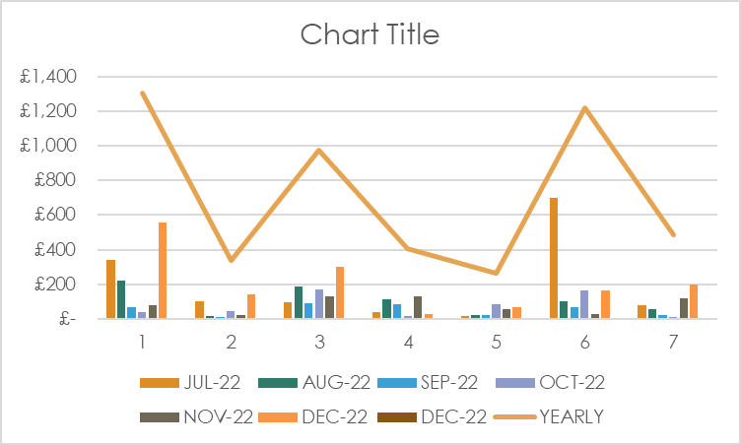
This graph shows where the company in the six-month period had made good sales. In the first month the sale was good hitting £1,300 because you want to be able to be going in the direction of a positive. The following two month was not so good because there was no sale coming in until the last couple month the sale manages to grow

Income sales
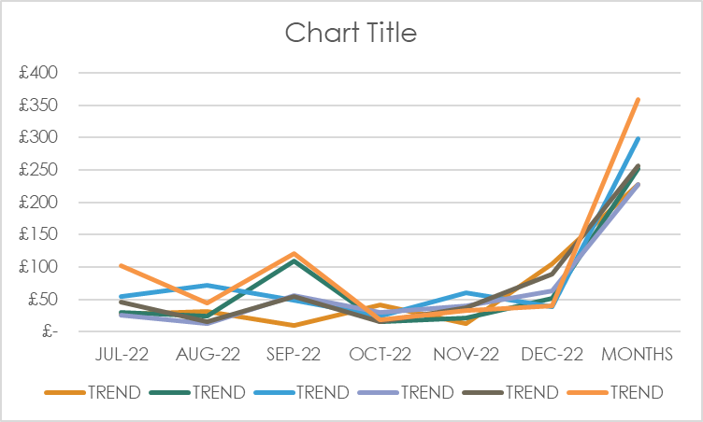
This the income scale graph showing what get sold as shown above in July was good then when quite for a while. Then during December made a lot of sale.

This the expense graph showing what was going out which where supplies for the shop and clothes, repairs and maintenance, advertising, rent, insurance

Expense
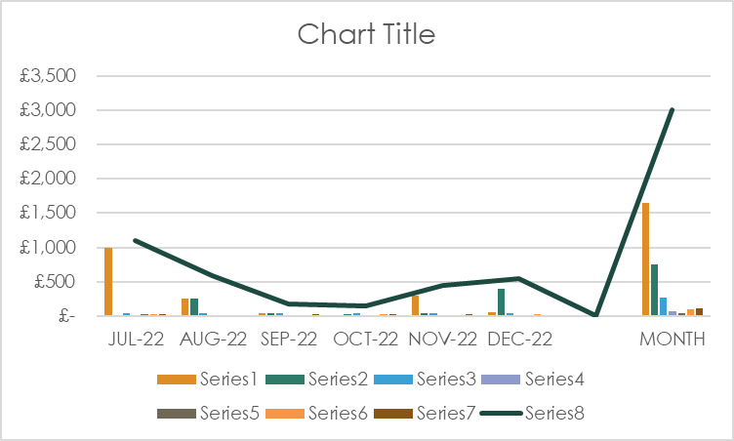
This graph shows the expense of
This the expense graph showing what was going out which where supplies for the shop and the clothes, advertising, rent, insurance. repairs and maintenance. As you can see on the first month was very a big pay out for the expenditures that came out.

Cash flow
This is a statement that shows physical money going in and out of the business in a particular time. When you have a good flow of money coming in that will be seen as positive cash flow. When it is the opposite the cash flow will be negative and make it harder for the business to pay its expense. This is because the cash flow affects the money available to fund your business day by day operation. When looking at the cash flow you must look at the sale and the balance sheet items with any other assumption.
Cash flow for the business is important to monitor outgoing bills, salaries, and property costs. When monitor well it give the business enough to pay the revenue and ensure the business has enough funds to make a profit. This will also direct the business to now take opportunities for investment that is good for the company.
Also mention by Chris b. murphy important measurement since it shows how efficient a company is at generating cash. Investors use free cash flow to measure whether a company might have enough cash for dividends or share buybacks. In addition, the more free cash flow a company has, the better it is placed to pay down debt and pursue opportunities that can enhance its business, making it an attractive choice for investors
Chris b. murphy, 2021

Cash receipt
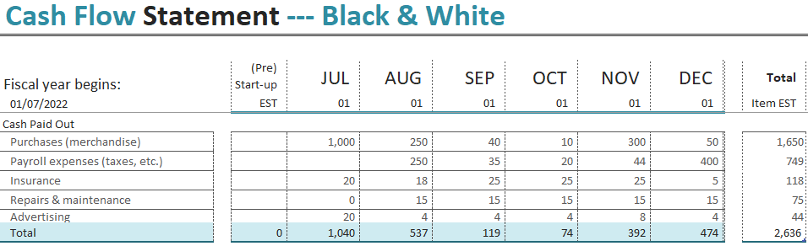
This the company receipt of cash paid out for the follow purchases merchandise, payroll expenses taxes, insurance, repairs and maintenance advertising for promotion all in total was a negative cash outflow of £2,636 for the period. In the next six month I want to try and lower the number to around £1,500 paid out.

Cash paid out
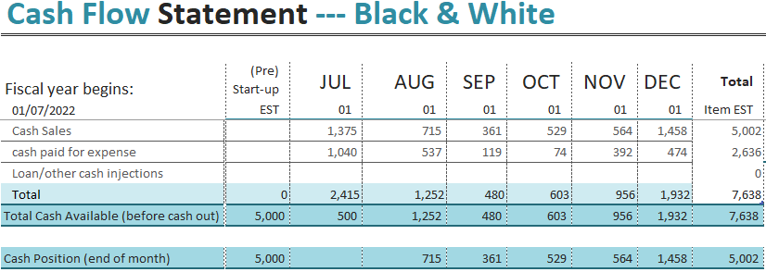
Cash pay out this show what we have paid out throughout the period of time. we hand enough money from the begin which gave the company an upper hand for when needed. We made a nice profit of £5,000 and cash paid out for expense was £2,636

Balance sheet
The balance sheet also refers to a financial statement that report the business assets, liabilities, and shareholders. Balance sheets provide the basic rates of return for the investors and evaluate the company capital structure. balance sheet is more of a financial statement that provides what the company owes and owns.
Its mention by Jason fernando The balance sheet provides an overview of the state of a company's finances at a moment in time. It cannot give a sense of the trends playing out over a longer period on its own. For this reason, the balance sheet should be compared with those of previous periods
A balance sheet come in four different section which are the current assets, current liabilities and shareholder's equity during the time with the business.
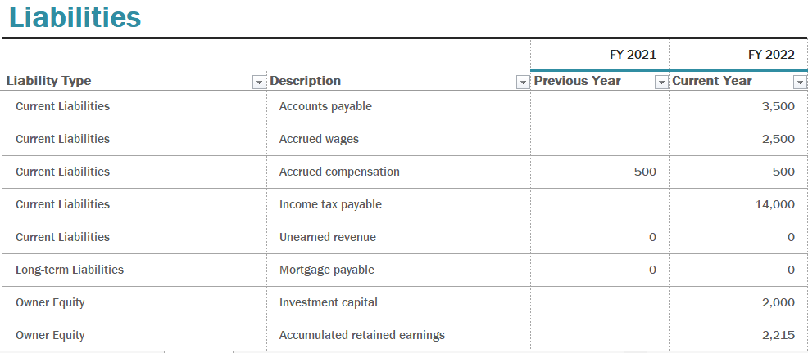
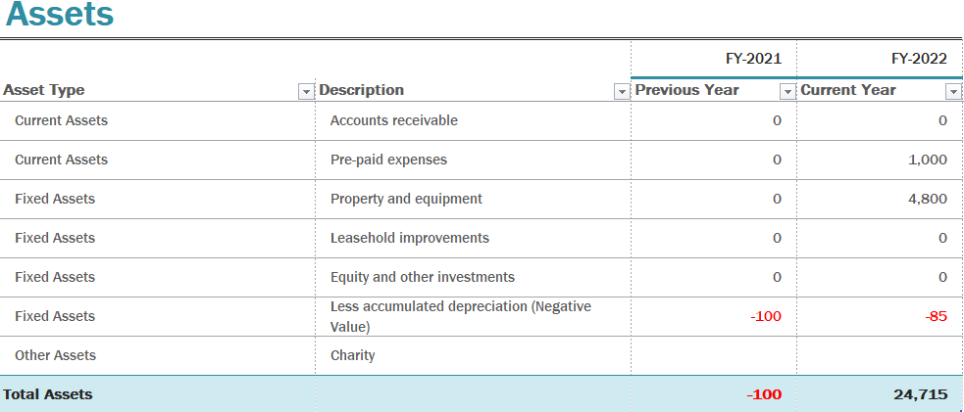

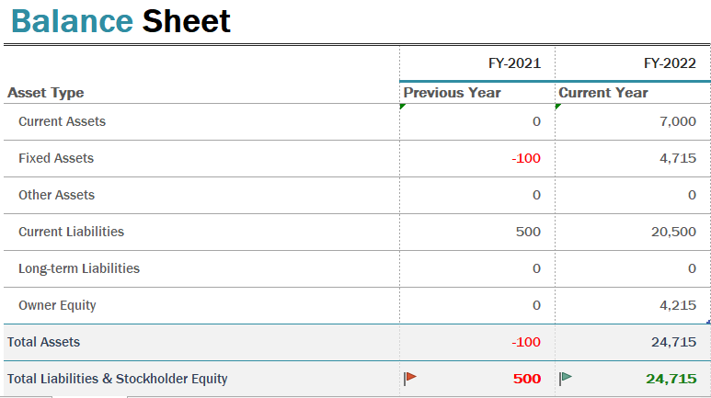
The balance sheet you see indicaties the liability that as a company need to pay for over a period of time. It shows the asset that we have all together so that we can sale good or property or land. Then the last one shows the whole summery of the balance sheet that is important because it show all the calcations of the profit and losses and cash flow. This points you in the right direction of the business.

Conclusions
I have analysis determine a company health and how long its stability is to provide an understanding of how the business and company is flowing during its period. It's important to understand that the financial statement analysis must be limitations as well. Different accounting methods also different firm and investor may want to get involved that can change the business profit margin and health of the business. When investor or other parties invloved the plan sometime don’t always go to plan. All and all financial statement are a good tool to have because you can see where your company is heading in term of financially and making investment deals. So you are able to see if you have break even or not.

Reference

Murphy C B. Investopedia. 2022. What Is the Formula for Calculating Free Cash Flow (FCF)?. [online] Available at: <https://www.investopedia.com/ask/answers/033015/what-formula-calculating-free-cash-flow.asp> [Accessed 6 January 2022].
KAGAN J Investopedia. 2022. Loan. [online] Available at: <https://www.investopedia.com/terms/l/loan.asp> [Accessed 5 January 2022].
Fernando J Investopedia. 2022. What Is a Balance Sheet?. [online] Available at: <https://www.investopedia.com/terms/b/balancesheet.asp> [Accessed 6 January 2022].
Fernando j Investopedia. 2022. Profit and Loss Statement (P&L) Definition. [online] Available at: <https://www.investopedia.com/terms/p/plstatement.asp> [Accessed 7 January 2022].
Loft R, Investopedia. 2022. 12 Things You Need to Know About Financial Statements. [online] Available at: <https://www.investopedia.com/articles/basics/06/financialreporting.asp> [Accessed 7 January 2022].

