Capitalism

noun
noun: capitalism
- an economic and political system in which a country's trade and industry are controlled by private owners for profit, rather than by the state.
"an era of free-market capitalism"
HEART OF CAPITALISM The thing called greed

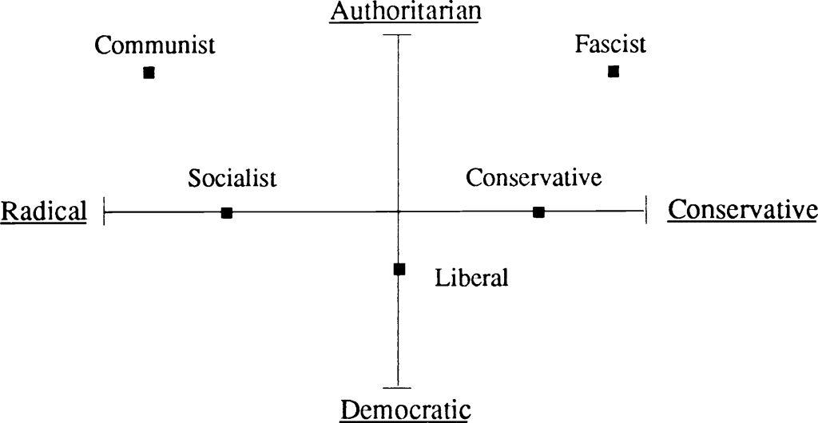
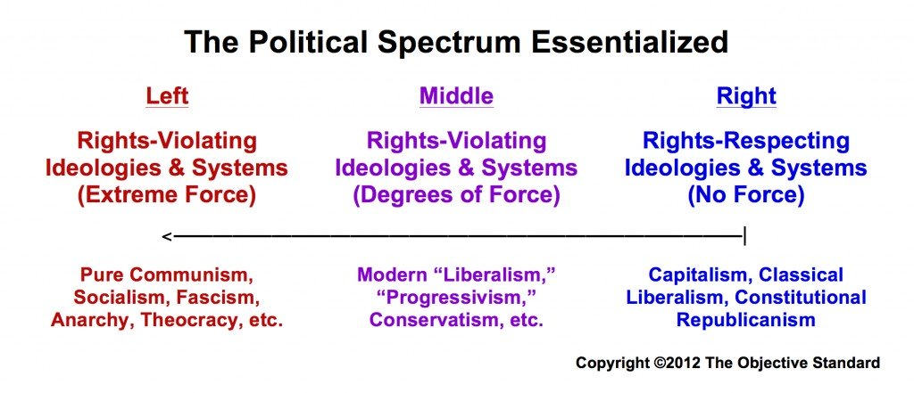
Occupy Wall Street

The protest movement began on September 17th 2011 in Zuccotti park located in wall streets financial district and lasted several months. The campaign was triggered by a Canadian non-profit organisation, Adbusters media foundation founded in 1989. The protest began with a small number of college students and progressed into a global movement which spread to 82 counties though Europe, Australia and parts of Asia and Africa. The movement is concerned with the financial inequality and the concentration of wealth among the 1%.
I want to study the injustice of consumerism throughout history posed by corporations and how they prey on our primitive brains.
Sapiens

I think considering the limited time we have been growing as a species we haven’t progressed cognitively since the cognitive revolution. Our primal instincts are more prevalent now than ever with access to social media and the news. We are now aware of all the fucked up and bullshit that is going on at any given moment. There has been no scientific evidence to prove modern humans have become more intelligent with time. I had recently read the book sapiens by Yuval Noah Harari; which addresses the discussion of evolution and how we have advanced since the dawn of our genus.
“Neanderthals were too familiar to ignore, but too different to tolerate.” I like this quote from the first chapter of sapiens as I think it shows as a species how little we have developed as I think this quote can link to a multitude of different issues, we still don’t like anything that different or unfamiliar. I like how ambiuas the phase is as I think it can address a diverse set of issues.
“Having recently been the underdogs on the savanna we are filled with fears and anxieties over our position which makes us doubly cruel and dangerous.”
George Santayana (late nineteenth and early twentieth century)Those who cannot remember the past are condemned to repeat it. Studying history is necessary to avoid repeating past mistakes.I thought this quote was relevant to my project as we as a species have had many immoral and unjust events and are bound to repeat them again.

Body worlds
“Gorillas generally walk on all fours, their spines differ from that of humans and makes standing up strenuous for them. The bones of their forearms, metacarpi and fingers are relatively long. Thus when standing the gorillas arm extends down below their knees.” When positioning my model for the first pose I considered the posture of a gorrlia as early homo sapiens shared a similar bone structure and got them to stand up and straighten their spine gradually and unhunch their shoulders to result in shorter arms.

Harvard university anthropologist Daniel Liberman in a telephone interview said; the transition to our genus didn’t occur rapidly, all of the sudden, in one great huge burst … instead, that transformation was more gradual.

Every day addictions (youtube)

I have been thinking about how we as humans have evolved too fast for our own good, I was troubled by my perceived lack of evolution. I have been disturbed by how our primal instincts seem to override common sense and rationale. I began to search videos regarding how underdeveloped our brains are.

Our primal instincts

• Survival instinct aka Self-preservation instinct.
• Killer instinct.
• Territorial instinct.
• Sexual instinct.
• Reproduction instinct (To want to reproduce and have children)
• (Possibly secondary) Tribal instinct.
• (Arguable) Social instinct.

These traits are still apparent in our daily life dr. Jud refers to some of these instincts as everyday addictions, the term addiction can be defined as ‘continued pattern of behaviour despite of adverse effects’. These addictions can include shopping, computer games, or daydreaming. For example we still feel the urge to gorge on high calorie foods, pre-cognitive revolution it was a necessity to eat as much food as possible, as fast as possible due to predators and the uncertainty of the scarcity of food. Similarly our fight flight or freeze response comes from our” old brain” much like the reward based behaviour learning system based on positive or negative stimuli. This instinct is so primal, scientists have discovered it in sea slugs with as few as 20000 neurons in their entire body. This is why we have a constant need for instant gratification, the two-minute click. The modern world is increasingly deigned for instant gratification, instant food, instant shoes. These corporations take advantage of anyone in any weak moment. Frustration, anger, boredom, loneliness or anyone in need of an emotional fix.

Evaluation

My idea stemmed from the sign created in the 2011 occupy wall street protest
against the corruption in wall street. I began to look at corruption throughout history such as the crash of wall street in 1929 I think how the human race has a constant desire for more whether it be money or property. I think the most fucked up bullshit stems from who we are as a genus. I researched our primal instincts which consisted of; survival, killer, territorial, sexual, reproduction, tribal and arguably social instinct. I wanted to show the growth of man from homo habilis to now and how we have matured physically but in the last 100 thousand years there has been almost no growth of our brain, which is pretty fucked up. I looked at Darwin’s theory of evolution and the diagram from ape to man, I observed how our bone structure metamorphized from homo habilis to homo sapiens as our spines developed and forearms, metacarpi and fingers shortened making standing up effortless and handling tools more convenient. I wanted to show the progression of evolution in a single exposure to demonstrate how seamlessly our bodies evolved. I used f-stop 7.1, ISO 200 and had a 50 second shutter speed. The problems I came across while shooting was the width of the paper as I found it too narrow to complete all 5 poses, to overcome this I positioned the two large white polystyrene boards to extent the frame. Consequentially I had to edit the poster heavily in photoshop, I mainly used the clone stamp tool to smooth out where the paper stopped, I also used the patch tool to keep the patterned texture. I was also wearing cool and groovy, patterned socks so I used the spot heal tool to remove the design. I think the photo on my poster was the most successful as I like how parts of the previous poses intertwine with the next leaving new ambiguous shapes linking them together. I think the photo looks better in black and white. It makes it more simplistic and gives the piece a more shadow like feel which I believe it makes the viewer focus more on composition and form opposed to the details. Additionally, it highlights the red text which increases its significance.

As I was reading sapiens I wanted to use the same typeface as the front cover as I felt it incorporated my research, I also liked the colour red on the front cover of sapiens as it has connotations of danger and I wanted my poster to have a similar air of impending doom. I was going to attempt to incorporate ink fingerprints in the final piece like the front cover but I like the simplicity of just a few words. I made the text layer slightly opaque as I feel like it blends with the image and looks part of the image and doesn’t look like the text is just placed there much the poster and babies? As the text there isn’t block colouring so it blends with the image as a whole. Both quotes trialled are an example of modern human brutality; the first is a quote from George Santayana, I liked this as I think throughout history humans have been ferocious and spiteful due to our primitive nature, I think it slips most people’s attention that we have only recently advanced past our chimp cousins so are bound to be just as barbaric. I positioned part of this text in the top left hand corner and the word condemned typed vertically down the right side of the image, although I liked how this filled the lighter negative space in the image I decided to opt for a quote from sapiens.
I preferred the quote “too similar to ignore, too different to tolerate” this quote is referring to the Neanderthals extinction or possibly the first genocide. I feel like this quote summarises my project and piece better as it is directly linking the first callous act of humanity.

