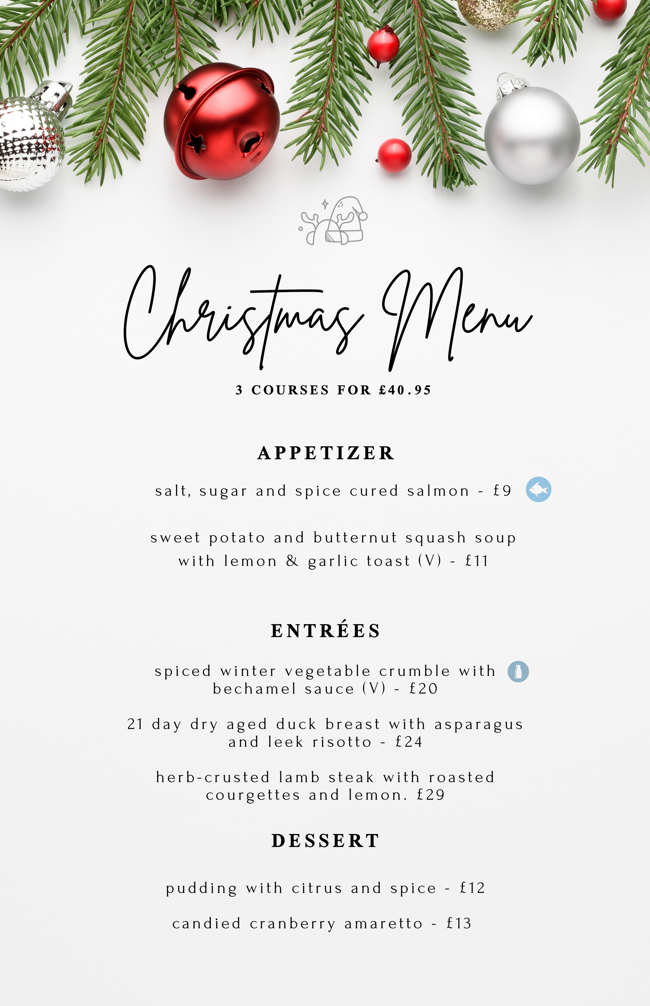
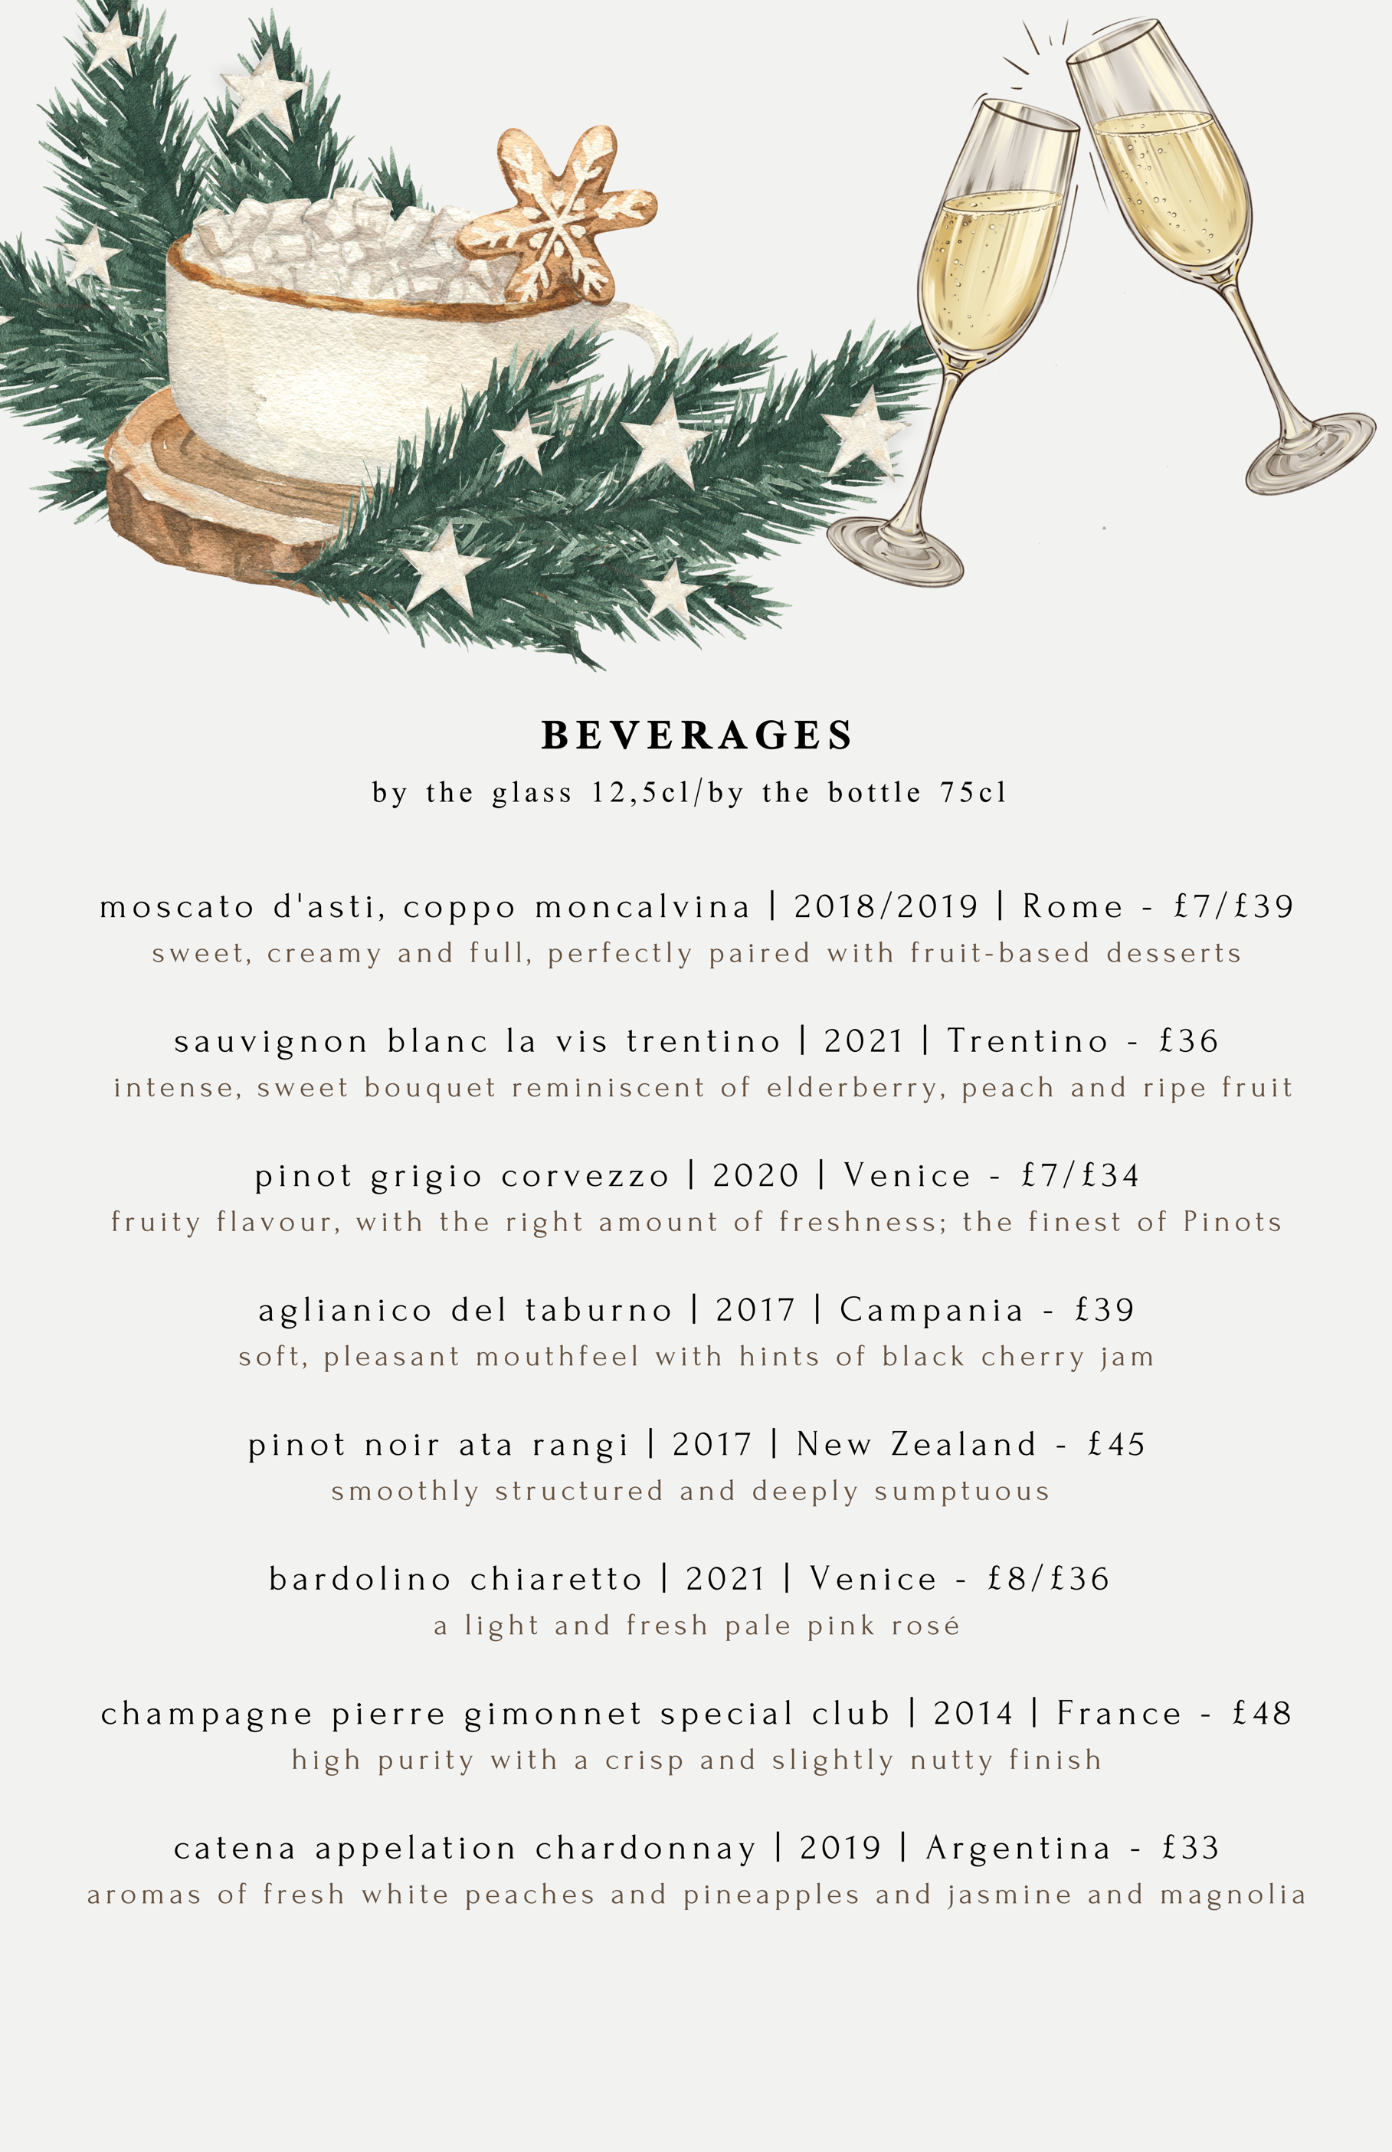
References

Boussard, S. (2021) “Chapter 5: Food and Beverage Cost Control,” Food and beverage management in the luxury hotel industry. New York: Business Expert Press (Accessed: November 16, 2022.

Brown, D.R., TotalBoox and TBX (2013) “Chapter 8: Profitable Menu Planning,” The Restaurant Manager’s Handbook : How to Set Up, Operate, and Manage a Financially Successful Food Service Operation 4th Edition. [N.p.]: Atlantic Publishing Group Inc. (Accessed: 16 November 2022).

Delicious. Team (2022) 75 seafood recipes for a lighter Christmas, delicious. Available at: https://amp.delicious.com.au/ (Accessed: November 17, 2022).

Donnell, E. (2022) 41 of the best Christmas dinners in London 2022, SquareMeal. SquareMeal. Available at: https://www.squaremeal.co.uk/restaurants/best-for/best-christmas-dinners-london_9488 (Accessed: November 16, 2022).

Foskett, D., Paskins, P. and Pennington, A. (2021) “Part 3: Food and Nutrition,”, The theory of hospitality and catering, 14th edition. Hodder Education Group (Accessed: 16 November 2022)..

Konstantinides, A. (2021) Michelin-Star Chefs Share 8 desserts they love making for holiday dinners, Insider. Insider. Available at: https://www.insider.com/michelin-star-chefs-favorite-christmas-desserts-holiday-desserts-2020-12#skip-the-pie-and-surprise-your-family-with-a-christmas-pudding-straight-from-the-kitchen-of-a-michelin-starred-chef-4 (Accessed: November 16, 2022).

