Developing workplace critical thinking

Module: BMSW 5001
Student: Georgiana Florentina Andronache (1711205)
Lecturer: Kenny Tang
Level 5: BA Leadership and Management (Skills for the Workplace)

Introduction:
The purpose of this assignment is to demonstrate why Critical thinking is crucial in a business. Critical thinking is important in every business is not just about the thinking it is about beliefs, values, attitudes and so on. However without the critical thinking a proper decision cannot be taken efficient when a problem arises. Within an area of the workplace there must always be present the principles of logic. In this paper will be discussed the principles of logic, how emotions, values and beliefs affect rational discourse, the value and the purpose of reflection in supporting learning. Also to choose the appropriate theories from; ‘’Scientific Management, Human Relations, Bureaucracy, Contingency or System theory’’.
According to Mandew, M. (2015) critical thinking is a range of decision making tools and techniques that support effective decisions. Critical thinking is based on logical relationships and principles. However critical thinking is also a tool and a technique which supports effective decisions by analysing the context of a problem. In many businesses the management when deal with a problem they follow the principal thinking theory before applying the solution to the problem. Usually the management have a meeting where is discussed the problem with all the members involved in the meeting and all of them generate and idea in order to solve the problem, as learned in previous course is called ‘’brainstorming’’. Brainstorming is a ‘’problem-solving technique that involves the spontaneous contribution of ideas from all members of the group.’’
Moreover the best idea is critically analysed by selecting all the ‘’good and bad’’ factors involved within the solution of the problem. It is for the best of the organisation and the staff to pick the right and logical decision, because it usually helps by having a good work relationship instead of picking the wrong and illogical solution for the problem by causing a disruptive relationship at the workplace among colleagues. In addition in this assessment I will be writing about my workplace, my job is ‘’Services Assistant’’ at Sainsbury’s.

Case study Sainsbury’s:

Sainsbury’s was established in the year of 1869 by John James Sainsbury and his wife Mary Ann with one store in London’s Drury Lane, flourishing in a short period of time.
Sainsbury’s had a big success opening more stores across UK and also having their own brand, until the First world war hit, when Sainsbury’s was left without male staff which made them recruit female colleagues also they had to employ female branch managers in order for the business to be up and running even with the shortage of staff. According to Mike Coupe the Sainsbury’s Group Chief Executive says “Customers are at the heart of our business and our success and future growth is based on being able to anticipate and then deliver what they need.” From here we can relate that the organisation is focused not only on profit-making but also on their customers, as they want their customers to have a great shopping experience each time.

The importance of critical thinking at the workplace:
According to Halpern (2007, p6), Critical thinking means that an individual is using their cognitive skills and strategies to increase the possibility of a positive outcome. “It is used to describe thinking that is purposeful, reasoned, and goal directed” - the kind of thinking involved in business for “solving problems, formulating inferences, calculating likelihoods, and making decisions when the thinker is using skills that are thoughtful and effective for the particular context and type of thinking task.” And according to Hart Research Associates (2015) ‘’Critical thinking is a consistently desired proficiency of employers when hiring college graduates ‘’
Moreover Keneipp, W. says that a critical-thinker is important within business in order for the organisation to prosper and managing the organisation in a way that helps the organisation in the ‘’competition’’ with other businesses. Keneipp also says that not everyone is made for this style in business and you have to have the skills to interpret information and to speak out loud. Having the critical thinkers in the team means that you have people who share their ideas, believes and attitudes, this type of people are cut out to be team leaders, sales people, etc.
Critical thinking in the business is important but more important is to have the people whom are doing the thinking otherwise the business may fall apart without the appropriate thinking skills. As an example when of critical thinking when I had my hiring interview I was asked many questions on my aspect of view on the job and the business and why I am good for this job, I was given a set of questions from real life within the retail business to answer how I would solve the issues. Problem solving is part of the critical thinking as is the creativity, decision making and many more.
After my interview I realised that the employer pushes in a good way the employee to develop their critical thinking, this is good for workflow and to improve the relationship between colleagues by coming together and brainstorm ideas and solutions.
Retailing is not a very easy workplace physically speaking, as it involves working with people. People as in customers, some of them are hard to be pleased with a product or services provided. Within the business the employee has to be able to balance with what the clients wants versus with what they actually desire.
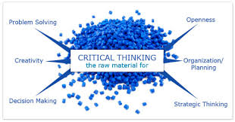
(figure from moodle, did not find source)

Principles of logic:
According to Farber, M. there is no general agreement regarding the meaning and the scope of logic. However is the purpose of logic to analyse methods of procedure enable to obtain valid judgements in any science or universe of discourse. The fundaments of logics are seen to be applied if interpreted properly to all system of knowledge. However logic cannot be falsified by anyone and it is built on a series of principles such as:
- Uniqueness- according to Harrington, D. is that the primary property distinguishes a uniqueness type of system that is called a subtype relation between the unique and non-unique version of each other.
- Existence- this has as principle that everything is someone or something in this world and also considers the existence of an object.
As example in a store the existence of different level of staff and their unique qualities, but also the objects in the store that make the store to be fully working, can be seen by anyone and be distinguished by their skills, necessities and their role in there.

Logic to establish a relationship:
According to Oner, T et all.’’ The logical consequence is undisputedly the central concept of logic. The main purpose of logic is to tell us what logically follows from what.’’ Moreover Copland and Knapp (2016) says that logical decisions and logic at the workplace can create a positive relationship between colleagues that is out of the box. For example the attributes that are being shared between the colleagues in accordance with their level and nature of job and also the payrate. As an example a manager can do the job of a Customer assistant (C.A.) while a C.A. cannot do the manager job without appropriate training and the permission to do the job. Also the logical payrate between a manager and a C.A. differentiate, this being logic and keeping a nicely and friendly relationship.

Value and purpose of reflection in supporting learning:
Reflection on an personal achievement at work or in live is important in order to add value on what you are learning, what you knew and know now. That’s why we should reflect more on our personal experience and learn how to add value on our achievements, on us.
‘’ Self-reflection should not be about beating yourself up. It should be a productive evaluation of what is working and not working well in your life based on core values and priorities’’ (Halloran, L., (2016).
‘’ The process of learning follows a pattern consisting of four stages ‘’ (Kolb, 1984)
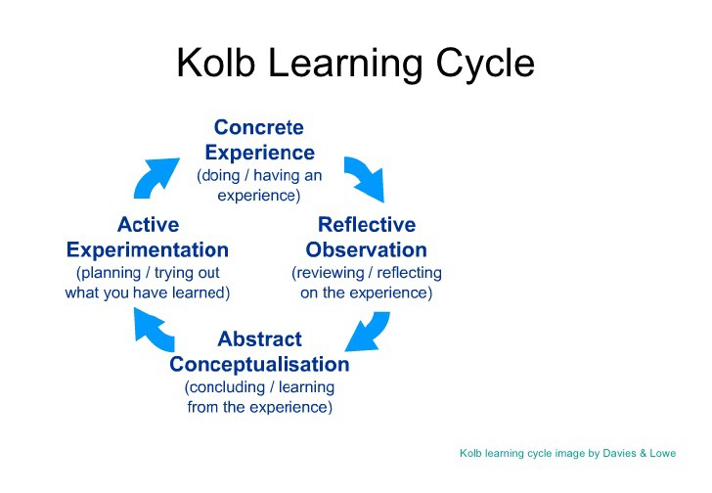
This Photo by Unknown Author is licensed under CC BY-NC
Sainsbury’s does focus on the staff’s personal reflection as important for them to feel safe and appreciated. The store will launch soon a new and easier way to shop, it is called ‘’smart shop’’, all the staff had to be trained. The objective of this new shopping application is to provide the customers with a new and easy way of shopping and also for the staff a new learning way and experience. Once the ‘’smart shop’’ will be launched the staff will be trained on the application also, not just theory but practice as well so they can reflect on what they have learned and to express their feelings and their opinion regarding the new technology.

Emotions, values and beliefs :
This three feeling; emotions, values and beliefs have different sense and meaning. The theories of emotions have been changing in the las three decades (Nico, H. et all, 2000). Moreover Lazarus (1991), has a theory that is called ‘’cognitive emotion theory’’, this lead to changing theories due to the keen interest of cognitive emotions on large scale.
However the cognitive theory the beliefs are seen as antecedent of emotions, this links to the ‘’appraisal theory’’ (Scherer, 1999).
In accordance with the appraisal theory the emotions are the result of an individual’s point of view on the world.
At Sainsbury’s you are encouraged to be yourself and to express your ideas, having this freedom is important for you as an individual to be able to express your emotions. Each individual have it’s own emotions, this enable them to take an efficient and qualitative decision at workplace in accordance with their feelings. That’s why at Sainsbury’s each members values, emotions and beliefs are important for while there is an important decision to be made.

How emotions, values and beliefs affect rational discourse:
All these feelings are important within any organisation, however they do not have the same meaning but they have an important role in critical and logical decision making.
Critical thinking plays an important role within the store as each decision taken is must be efficient, qualitative and problem solving. Critical thinking is based on logical thinking and logical relationships, it also has a range of tools that helps to support the right and effective decision. The decision makers can make an effective decision by critically analyse the problem. As an example at Sainsbury’s when it comes to a problem the duty managers gather in a meeting and arrange a brainstorming session to pick the most efficient ideas.
Rational discourse according to Habermas theory of communicative action and to his critical theory is fundamental in general. However when it comes to communicative action where validity claims of a given utterance are contested the participants prefer to arrive at a mutual understanding, in this case the rational discourse can ensue.
Moreover Habermas (1984, p.25) highlights the rational discourse assumption that ‘’ every competent speaker must presuppose are sufficiently satisfied in so far as he intends to enter argumentation at all’’.
However emotions, values and beliefs do play an important role in decision making, below in this paper will be a figure that shows how these three feelings are used in taking a decision.
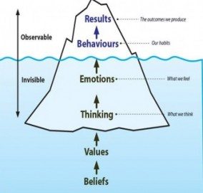

Relationship between emotions, values, beliefs and rational discourse:
The relationship between these feelings should always be a positive one, that’s why Sainsbury’s considers that our feelings are important for a highly qualitative service to be provided. As Roberts et al (2000) said that organisations try very hard to use the staff emotions for high performance.
Emotions, values and beliefs are at the centre of rational discourse, that’s why is important in each organisation. As example in the store I work recently was launched ‘’the sunflower lanyard’’, this is a service for customers with hidden disabilities. These customers may not want to share with everyone details of their disability, instead they can have a Sunflower Lanyard or ask for one in store, this means when we see a customer approaching us with the Sunflower Lanyard we have to be helpful, patient and understanding. However no everyone is prepared to help our customers with hidden disabilities as one of our colleagues may not feel comfortable or safe to help a customer. That’s why the management analyse each one’s personals values before we are given the Sunflower Lanyard. Also the staff that is able to help the customers use a Sunflower Lanyard also. These helps at improving the store’s relationship with the community and to provide a great customer service.

My role at the workplace:
At Sainsbury’s my role is as Customer Service Assistant, the role is about helping and engaging with customers in order for them to have a more pleasant shopping experience each time. Yet at Sainsbury’s the stakeholders aim that we all to be one, that’s why there are no more Team leaders or Supervisors, just colleagues and managers. As a colleague I have to be the ‘’face of the store’’, being approachable, friendly and helpful. Also in my department we had to have and be trained for at least three skills. I as customers assistant can do a trading assistant job also, a trading assistant is the one that’s on the shop floor dealing with the merchandise, making sure that all the shelves are impeccable and ready for the customers. I can also work in Kiosk, were is the customer services desk also, can do refunds, click and collect and dealing with complaints and not the last I am trained on Self-checkout. This job look easy enough from the outside, and even if we can be ourselves , it still is a very demanding job, where you have to be patient, confident and have people skills, we also have to treat each customer fair and professional no matter their attitude towards us.
According to Goodman, J., A., if the customer service is poor it will be bad for business. That’s why at Sainsbury’s they thrive for us to have all the training done by the due date and also each manager keeps an eye on their staff by ensuring that there are providing the best customer service they can.

Application of management theories:
According to Pirson, M., management theory effectiveness gain traction as is contributing to resolve societal problems by providing higher productivity and output of necessary goods. However at the management theory when it comes to application and interpretation differ according with the beliefs, values and emotions of the individual. The application of management theories will be discussed bellow:

Scientific management:
Scientific management is a science with workers with specific but different responsibilities. (Almasifard, M.,2017).
Sainsbury’s uses scientific management as well as many other organisations, this theory is used to enhance the capabilities of the staff. Taylor,(1911) argues that the organisations in their research are trying to gain the control and the efficiency endeavour by removing knowledge from the workers. Sainsbury’s as many others will search to implement the scientific and will look for scientific approach to perform any task. Also the stakeholders will not only focus just on the staff task also provide the appropriate training and motivate their employees so they can achieve a great performance. In addition the management monitor and supervise the performance of the employees in order to find an efficient way to perform the task. At Sainsbury’s the work is allocate between the management and the employees so they can see the performance of the staff and focus on their training, this enhances the the efficiency of the staff being part of the scientific management theory.

Human relation theory (HR):
Elton Mayo (1933), has provided the human relation theory with his experiment called Hawthorne in 1920. In his experiment he found out that the productivity of was related to the job satisfaction and the output of employees would be higher if someone respected by them will take high interest in them. Also within this experiment they have seen that the productivity increased by changing their facilities, hours of work and more. In addition Bowen and Ostroff (2004) and Kehoe and Wright (2013) agree that Human Relation system shapes the employees shared experience also supporting the performance by development their required capabilities and motivations.
At Sainsbury’s the HR plays an important role as is important for the employees to have a positive attitude towards their role and be more committed to the organisation. In addition in each Sainsbury’s store there is a HR policy where is explained; ‘’everyone to be valued, respected and treated fairly, everyone have to understand what is and not acceptable behaviour and that Sainsbuy’s will always take actions to stop discriminations and harassment’’

Contingency theory:
According to Heery. E. and Noon. M., the contingency theory is about the effectiveness of an organisation in accordance with the management taking into account the various factors that can have a positive or negative impact on the organisation. Moreover there are the most important contingent factors, as the environment, the employees, product diversity and the size and also the technology. However the contingency theory suggest that there is more than one best way to manage.
At Sainsbury’s the contingency theory plays an important role, as the management is always aware of their staff’s performance and closely supervising it, they have to make sure that their implemented strategies for good services is working. However if there are employees that are being negative and not willing to work and provide their best services the management then have to impose their superiority and help them become the best they can be by improving their performance.

Bureaucracy theory:
The definition of this theory is given by Max Webber, who is the first to write about bureaucracy sustains ‘’that working to the rules in a hierarchical office in which appointment and promotion went by merit was more rational than making appointments on other bases such as patronage.’’
At Sainsbury’s this theory is not necessary applicable, we do work by rules and policies yet we are allowed to be ourselves, to have beliefs, values and emotions. We are all equals even if we share different cultures, beliefs, religion, etc., at Sainsbury’s is more important for the employees to work in a place where they still can have their own opinions, thoughts and values.

System theory:
System theory is focusing on the relationship between the parts, instead of reducing an entity into parts and elements. (Chikere. C. C. and Nwoka. J., 2015).
As in the case of study ‘’Aldgate Congres Ltd.’’ The system theory is important at Sainsbury’s due to it’s efficiency to improve the flow of the communication by which the organisation is operated. Moreover this is important at Sainsbury’s as they want all of us to be equal and treated fairly, this is part from the diversity and inclusion policy which Sainsbury’s adopted by making the workplace safer, where everyone is respected, valued and understood. In addition to all this the management celebrate each and everyone’s success, like a positive feedback or wowing at workplace with their innovation and hard work, they will give to the nominated colleague a box of chocolates and thank you card also we can get a card with ‘’Love points’’ this is a thank you gift card with an amount of money on it that the colleagues can spend on whatever they wish.

Beliefs, attitudes and values:
While they look similar they are three different emotions and they feel different to each person and situation.
According to Anderson and DaSilva(2009), is that a belief is internal true even that there are no proofs or is irrational. They also gives us the definition of the value, they say that a value is about our attachment on something or someone, the value of our freedom and lives. Moreover DaSilva and Anderson agree that attitude is the link between the values and beliefs, the way a person express them.
Below is a figure by Su (2015), about personal beliefs, attitude and values
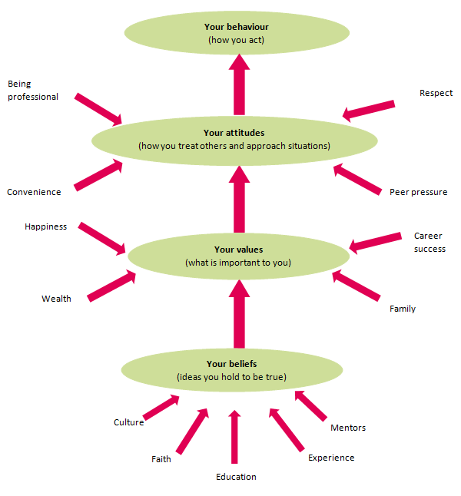
In addition according to Su (2015), these three establish a standards and principles of life creating the right and wrong dispute. However they grown from experience and learning outcomes applied at workplace, yet all of us have are own beliefs, values and attitudes which divides us from the rest.
At Sainsbury’s everyone is being respected and understood, we are all free to be ourselves, to have the freedom to speak for ourselves and if we do not feel confident enough there is always a representative colleague that can advice us what to do and not to do. Moreover as each individual have their own beliefs, attitudes and values at Sainsbury’ if they need to they can speak to each member of the management in a safe area where is privacy and no discrimination to be done.

Conclusion:
In conclusion to all this we can see that critical thinking at workplace and people with the skills are important in order for a business to succeed. However not just critical thinking plays an important role, also our beliefs, values, emotions and attitudes are important for us as individuals to achieve a greater performance and be at our best. Even if the critical thinking is based on a range of tools and technique decisions at Sainsbury’s is important to be fair and have a logic point when it comes to problem solving, the management likes to gather the employees with the critical thinking skills but also the ones with belies and values as they are important in taking a rational and logic decision. Moreover the management theories are very important within the organisation, they are there as rules to be followed to success and performance. However applying these theories may differ in accordance with each case. The training of the employees is very important at Sainsbury’s along with our safety. Sainsbury’s is a pleasant place to work, may not be in all the stores, but in the one I work they do appreciate you as an individual with your emotions, beliefs and values, not just you as a working tool and your skills. The skills are important but you as a human being with feelings are more important as skills can develop with the appropriate training. That’s why there is a regular training to be done by each individual in accordance with their position. Sainsbury’s do appreciate their staff’s beliefs, values and attitudes and allow us to be free to express our feelings and thoughts as long as we stay professional and polite, as they could see by doing that the performance is higher and the customers are pleased and they come back every time. The Sainsbury’s management likes to keep their employees happy by offering a safe place to work and have a good relationship where communications and privacy is important.

References:
Stanton, Angela D and Stanton,Wilbur W.(2017,p.32) Using journalism to enhance learning and critical thinking in a retailing course: Marketing Management Journal
Halpern D.F. (2007). The nature and nurture of critical thinking. In R.J. Sternberg, H.L. Roediger & D.F. Halpern (Eds.), Critical thinking in psychology, 1- 14. New York, NY: Cambridge University Press.
Hart Research Associates. (2015). Falling short? College learning and career success. Washington, DC: Author.
Keneipp, W (2019) Critical thinking separates advisers from mere sellers: Are you an insight-driven organization? If not you’re losing a tremendous opportunity: SourceMedia, Inc.
Mandew, M. (2015). A critical thinking process approach in the professional component of pre-service teacher education.
Farber, M., 1942. Logical system and the principle of logics. Philosophy of science, vol. 9, p. 40-54, The University of Chicago Press
Harrington, D., 2006. Uniqueness Logic. Theoretical Computer Science , vol. 354, p. 24-41, ScienceDirect(Elsevier B.V)
Oner, T. et all., 2008. Proprieties of the Logical Consequence Operation and it’s Relationship with the Independence of Propositional Logic: Ukrainian Mathematical Journal, vol. 70 p. 990-1000, Springer Science & Business Media B.V.
Copland, M. and Knapp, M. (2016). Connecting leadership with learning. Alexandria, Va.: Association for Supervision and Curriculum Development.
(online) Available at:
https://skillsforlearning.leedsbeckett.ac.uk/preview/content/models/02.shtml (accessed on 1st of August 2019).
Halloran, L (2016). The Values of Self-reflection: The Journal for Nurse Practitioners, November-December 2016, Vol. 12 p. 437-438. Elsevier.
(online) Available at: https://pdfs.semanticscholar.org/0544/3dd05b78a2a35a1abe7277735feae5449f0c.pdf (accessed on 10th of August 2019).
Lazarus, R. S.(1991) . Emotions and adaptation. New York, Oxford University Press.
Scherer, K. R. (1999), Appraisal theory, In T. Dalgleish and M. Power: Handbook of cognition and emotion (pp. 637-663.), Chichester, Wiley.
Hansen, S. et all. (2009), Wikipedia, Critical Social Theory and the Possibility of a Rational Discourse: Information Society, Vol. 2. P. 38-60. Taylor and Francis Ltd.
Habermas, J. 1984. The theory of communicative action: Reason and the rationalization of society. Boston: Beacon Press.
(online) Available at http://www.coaching.net.nz/wp-content/uploads/2013/06/Iceberg-for-blog-from-J-e1371521135440-284x269.jpg (accessed on 10th of August 2019)
ICSC Dictionary of Shopping Center Terms. 2005, p14-14. 1/9p. (available at the University online library)
Roberts, M., Welfare, H., Livermore, D. and Theadom, A. (2000). Context, visual salience, and inductive reasoning. Thinking & Reasoning,vol. 6(4), p.349-374. ,Department of Psychology University of Saskatchewan
Pirson, M., 2017, A Humanistic Perspective for Management Theory: Protecting Dignity and Promoting Well-Being, Journal of Business Ethics, Dec. 2017, p.1-19, ProQuest LLC.
Almasifard, M., 2017, Evolution of the Management Theory within 20 Century: A systemc overview of Paradigm Shifts in Management, International Review of Management and Marketing, 2017, Vol.7 (3). ProQuest LLC.
Paton. S., 2013, Introducing Taylor to the knowledge economy, Employee relations,Vol.35 (1),p. 20-38, ProQuest LLC.
Armstrong. M., Taylor. S., 2014, Armstrong’s handbook of Human Resource Management Practice, 13th Ed., Kogan Page.
Kehoe.R.R., Collins, C.J., 2017, Human resource management and unit performance in knowledge-intensive work., , Journal of Applied Psychology, Vol.102(8),p. 1222-1237., American Psychological Association
Goodman. J. A., 2009, Strategic customers service managing the customer experience to increase positive word of mouth, build loyalty, and maximise profits, New York.
Heery. E., Noon. M., 2008, A Dictionary of Human Management,2nd Ed., Oxford University Press
McLean. I., McMilian. A., 2009, The Concise Oxford Dictionary of Politics, 3rd Ed., Oxford University Press.
Chikere. C. C., Nwoka. J., 2015, The System Theory Of Management in Modern Day Organisations, A study of Aldgate Congress Resort Limited Port Harcourt, International Journal of Scientific and Research Publications, Vol. 5.
Su, Y. (2017). Taylor Scientific Management Theory Carding and Significance of Organization Management. Social Sciences, Vol. 6(4)
Unpublished, Sainsbury’s HR Colleague policies
Beliefs, attitudes and values, Moodle slides , DaSilva and Anderson (2009)

