Student name: Clare Joe Padilla
Student number: 1901439
Monday 9th December 2019

ECO BRICKS PROJECT DESIGN AND BUILD SCULPTURE STRUCTURE
(Reflective journal)

Eco Bricks can be used in architecture, along with using sustainable concepts and constructional materials/techniques, whilst transforming them into a shelter as a solution for the rapid increase of the homeless population. By using Eco bricks in sustainable building projects, makes them a great way to dispose of plastic waste. We were split into groups and was given a brief to create a shelter for the homeless using only Eco bricks and cardboard.

WEEK ONE – Introduction of brief
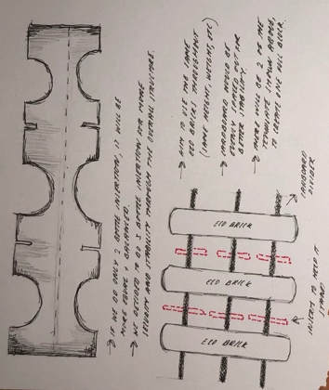
Our group contributed ideas until all agreed to create a shelter that will provide a safe and comfortable space. After sketching ideas, we all decided to go for a more challenging option of creating an igloo structure, whilst achieving a dome-like roof. Our first aim was to think of how to deconstruct, transport, and reconstruct the structure.

In order to use Eco bricks, it will need a stable structure, using recycled materials such as cardboard. We discussed about using dividers that will help hold the bottles securely. From the first image, we came up with this template, and by using this template, it will allow us to create one complete block full of Eco bricks, making it easier to deconstruct and reconstructed. We realised that there would be semicircle cut-outs to use for the stability in our structure.

WEEK TWO – Planning and Generating ideas

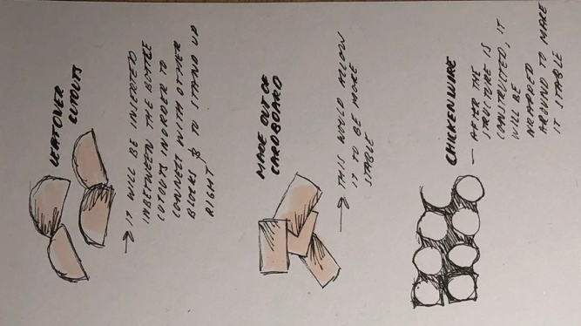
We adapted from our first meeting by sketching how the model will look like and discussed about the conditions of our shelter. By considering other building materials such as Eco bricks, which will benefit the environment as people will become more aware of the impact of plastic waste to the environment. We also discussed about the weather conditions, because when it rains the cardboard structure will not last. Waterproofing the cardboard structure means using natural substances such as beeswax or crayons as a coating for the whole structure.

WEEK THREE – Model making

As we were open to new ideas and adapting it into our previous idea of an igloo, we developed our structure into octagon framework, and a half geometric circle as a roof. Experimenting with the art of origami, to achieve the smooth curved roof. By cutting out the template onto cardboard, it was quite strong with the interlocking locks inserted and were able to hold the bottles weight.

While constructing this model at a scale of 1:100, we began to understand the importance of commodity (the space’s purpose), firmness (construction materials) and the delight (aesthetic pleasure), in order to create a well-built building. As all built structures have to withstand the forces and should provide a comfortable internal environment protected from external elements. The real-life structure is estimated to be two meters high. We then noticed that if we just used cardboard as our base, then it will easily be damaged. We then took action and decided to gather some wood crates as it is relatively resistant to different weather conditions and can be used as insulation by adding polystyrene.

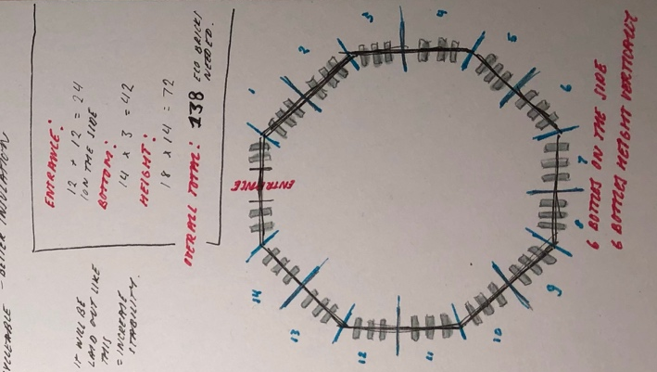
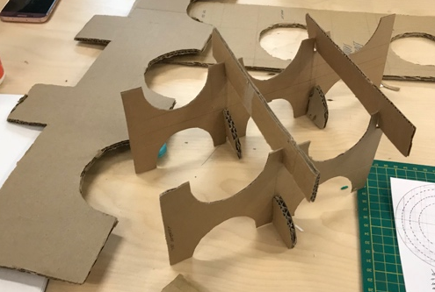
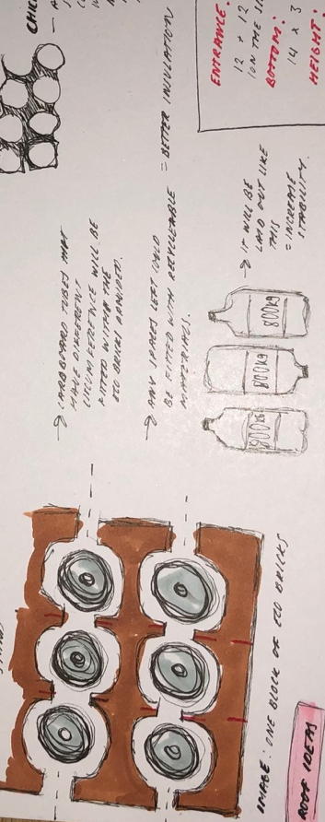
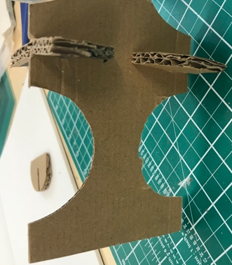
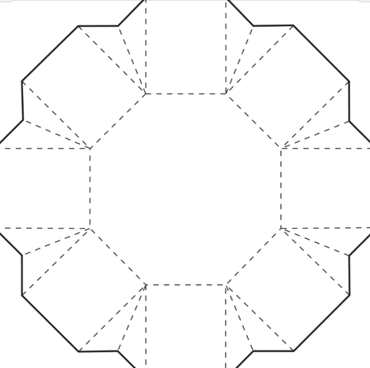
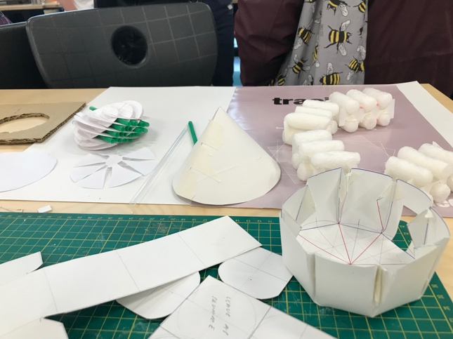
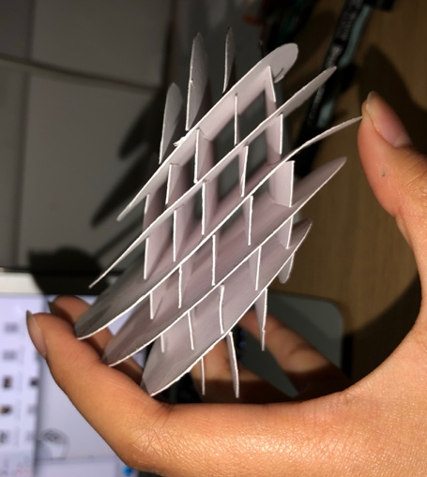
WEEK FOUR - Roof ideas and Development of ideas

It was quite difficult achieving a dome-like roof, especially with a strong density material such as cardboard. I then experimented with paper, giving me an unexpected result as it was not particularly a circle shape. However, it did give us a benefit that it would be easy to move from place to place as it can be folded. While constructing the geometric circle, I managed to obtain a smooth curve on the outer areas, which would be beneficial for all types of weather. There were many trial and errors before assembling it together, as I had to make sure each insertion was equal on both sides of the paper, of which I’ll need to improve on when proceeding with the final outcome.

Before deciding on our final roof design as the geometric circle, we first experimented with other shapes such as a basic dome, a cone or a slatted triangle roof. We came to an agreement as we can merge the material of using Eco bricks into the roof structure, as it would educate people the uses of plastic if it was recycled properly.

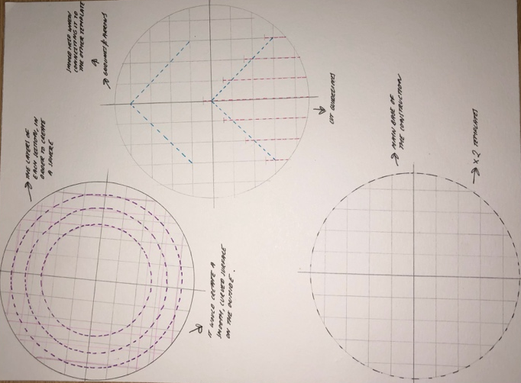
This geometric design was inspired interlocking of the Eco brick block that we designed in the beginning and will be put together only using cardboard. As this design looks similar to a globe, it would send a message including the issues in the world today in relation to climate change such as the overspreading fire in the Amazon rainforest.

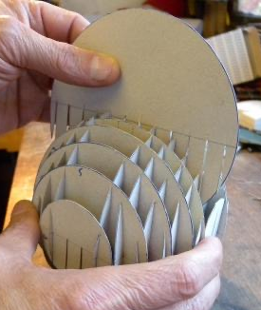
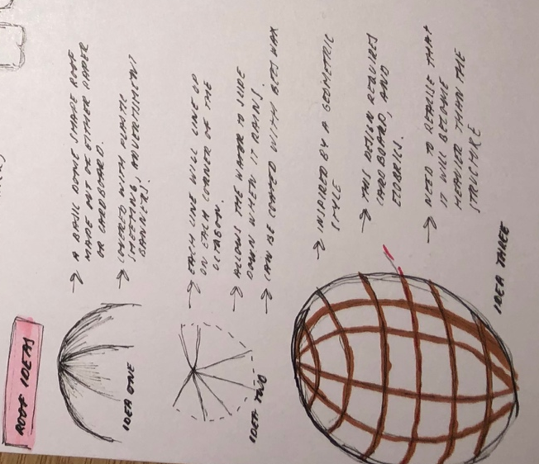

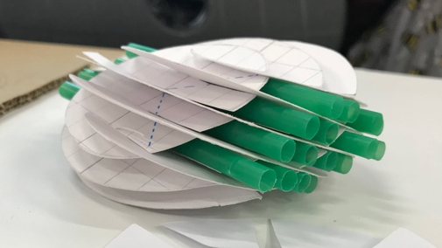

WEEK FIVE – Client Presentation of our Eco Brick shelter
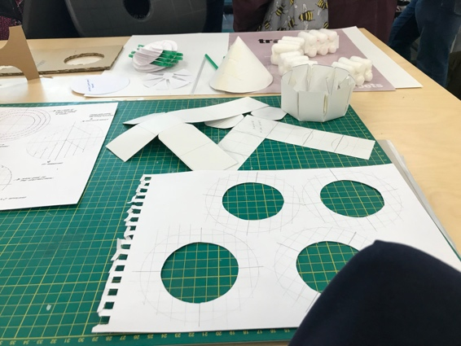
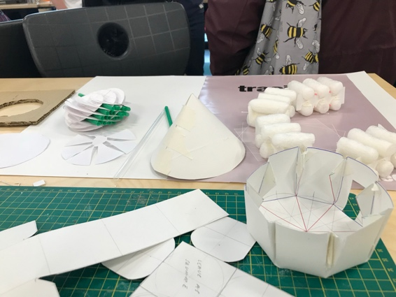
In terms of preparation, we finalised doing models to display our idea along with the discussion of the pros and cons of the structure. While also thinking about the conditions relating to the person and the weather, including our trials and errors throughout this project in order to see how our ideas have developed. Each one of us had a role to partake, mine being the model maker. From this role, I was able to explore the uses of the material alone without using anything else such as glue or tape.

After receiving good feedback from our design concept from our shelter especially the geometric circle and by using the straws, it gave the idea of doing a tree coming out of the circle.

WEEK SIX – Construction week

After seeing all the different designs each group displayed, we decided to merge all ideas into one sculpture. However, from our group the globe was the most impressive idea. In terms of constructing the sculpture, we were given the task to create the globe on a larger scale at 800mm. I then planned out that the circles will be cut down to 800mm, 600mm, 400mm and 200mm.

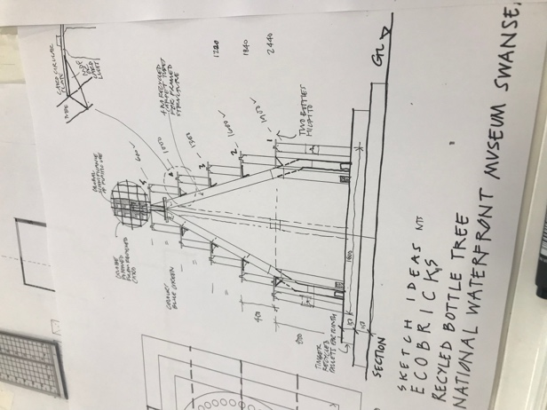
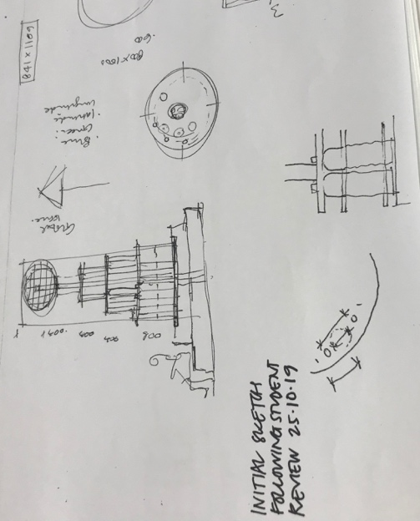
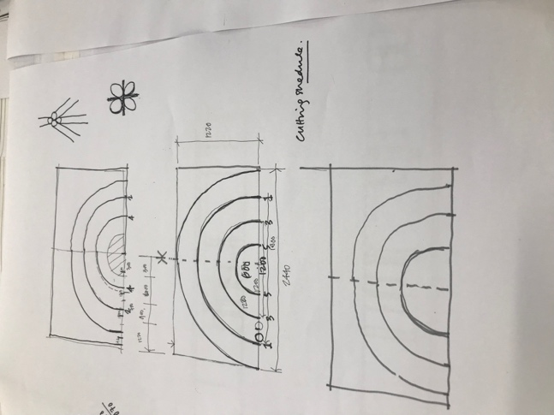
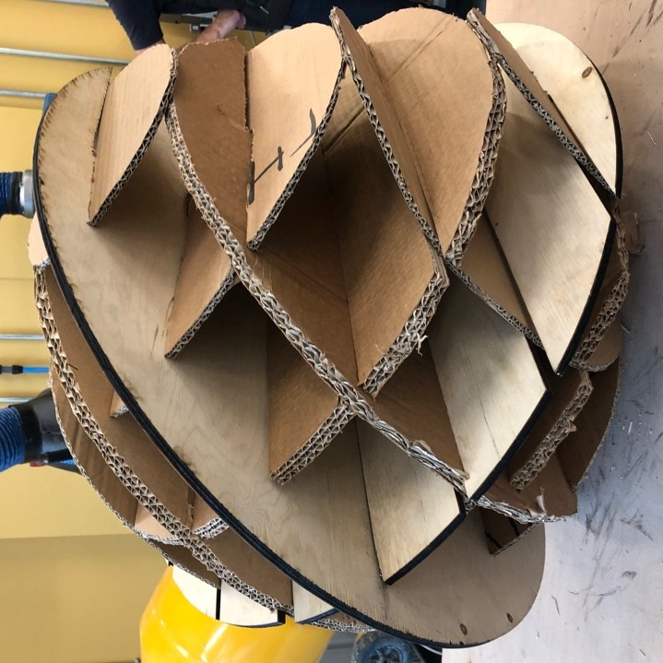
We first made the structure out of cardboard, and we received the same results as we got from previous works, meaning that it was not secure and stable structure. Our lecturer gave us the idea of using plywood for the foundation of the geometric circle, as cardboard has a different density. During this process, a cutting knife was used to cut out the circle and scissors to clean up the edges, which ended up being a difficult task as we used thicker cardboard. With a total of 14 circles cut out, we started to assemble. As we were putting it all together, we struggled with the cut sections as the cardboard was too thick, therefore we had to push it into the plywood base as it would naturally push it into the correct depth to interlock. However, seeing the final outcome of the global, the sturdy foundation of plywood helped to keep the shape of a circle, along with the cardboard circle securely placed inside.



