Masood Rana (2512874)
University of Wales Trinity Saint David
Analysing and Problem Solving
Written Paperwork

Contents
Introduction 2
1. Decomposition of the Problem 3
2. Proposed Solution 6
2.1 Flowchart 6
2.2 Solution Explanation 7
3. Reflection and Justification 8
References 9

Introduction

Group projects are an integral part of computer studies as they teach the students to collaborate and communicate. Organising the meetings may become challenging due to conflicting class schedules and working in part-time jobs.

In this report the problem of scheduling group project meetings will be analysed using structured problem-solving approach. The problem will be broken down into its components and evaluated using the MoSCoW prioritisation method [1]. After that a logical solution will be suggested using the flow chart and explaining how the meeting is going to be scheduled. The last part of the report will contain reflections about the problem-solving approaches applied and justification of the suggested solution along with its limitations. Academic references will be provided throughout the report [2].



1. Decomposition of the Problem

The first step to solving a scheduling problem is its decomposition into smaller, manageable elements. Decomposition is a method of problem solving which helps simplify the problem by breaking it into smaller parts, allowing for an easier analysis and finding a solution [3].

The major problem is that the schedules of the members of a student project group are different due to lectures, part-time job, and personal obligations. This leads to the problem of organizing meetings when everyone is present. Consequently, there are missed or delayed meetings that lead to a delay in performing tasks and to an unfair division of the workload.

The major stakeholders are the members of the student group who need a convenient meeting schedule. The lecturers are the secondary stakeholders since they are waiting for the completion and submission of projects. Thus, a scheduling system should help the students to organize the schedule and comply with their academic obligations.

The major requirements and constraints can be ranked using the MoSCoW technique which allows for dividing the requirements on their priority [4].
Must Have

Determine the meeting times that everyone in the group is free.
Schedule the meeting before the deadline of the project per week.
Do not clash the meeting time with lectures and other engagements.

Should Have

Reduce scheduling clashes.
Enable rescheduling of the meeting when there is a clash.

Could Have

Propose multiple meeting times.
Provide reminders before the meeting time.

Won’t Have

Automatically adjust the personal schedule and schedule of the college of the students.
Take care of project tasks and grading.

There are several factors that determine the scheduling of the meeting. Such factors include the availability of each student, lecture schedule, working hours, personal schedule, deadline of the project, duration of the meeting and the number of group members. The variables are used to compare the schedules and find the best time for everyone.

This solution takes into consideration the availability of all the students which is updated by all the students. The solution also assumes that all the members will be able to come for the meeting at the scheduled time. By defining the requirements, constraints and variables, the problem is easier to analyze.

2. Proposed Solution

2.1 Flowchart
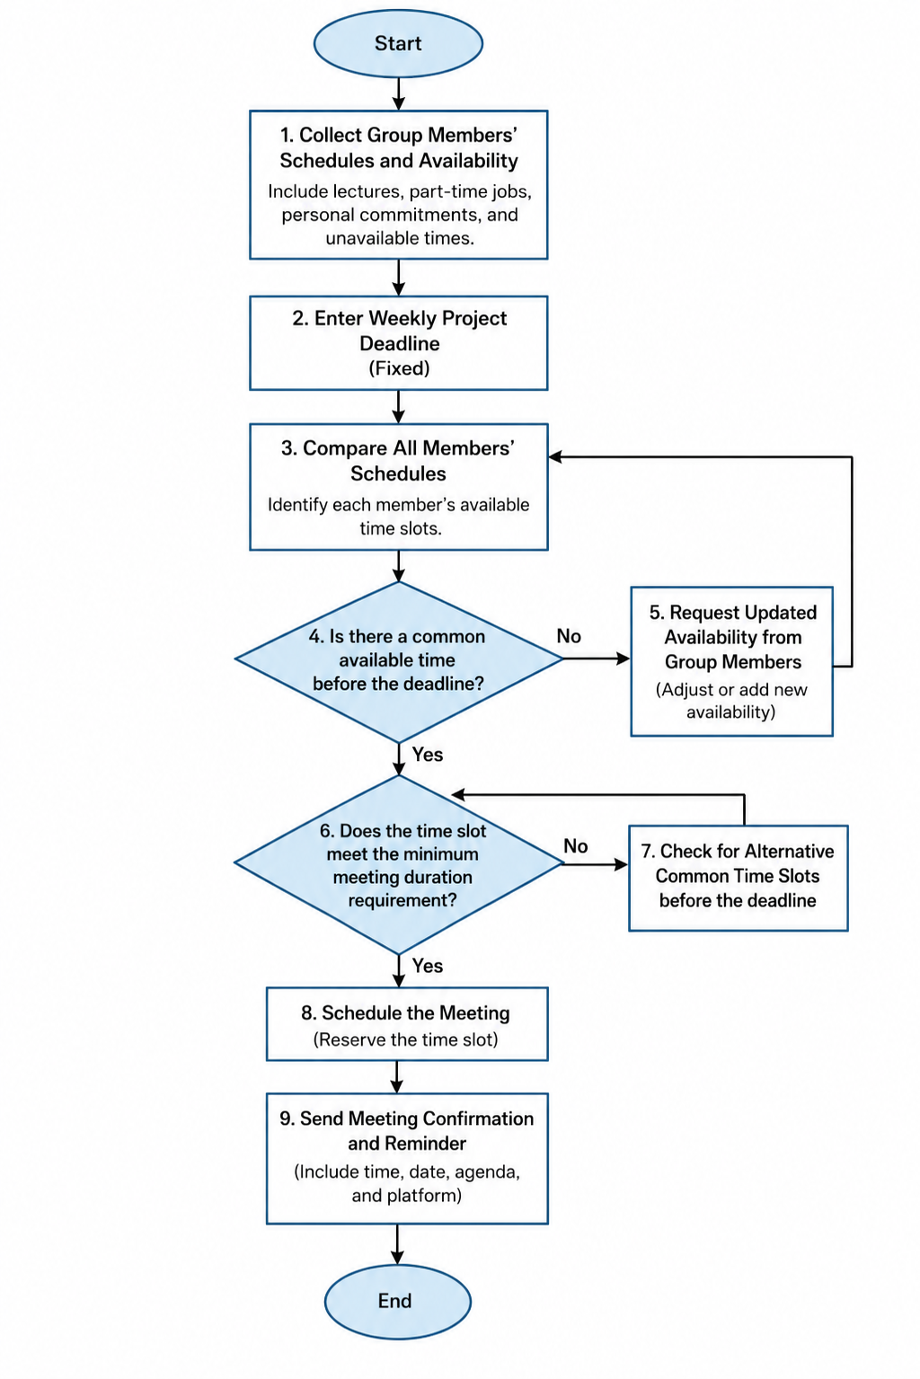

2.2 Solution Explanation

The solution consists of a systematic scheduling procedure that would help determine possible meeting times for all the group members, reduce timetable clashes and ensure that meetings occur before the deadline for the project per week. A systematized approach simplifies the process and improves its reliability [5].

The process starts with gathering data on each student’s schedule, which includes lecture timetables, work timetables and personal engagements. This data forms the input of the scheduling process. After that, the deadline for the project is determined, so that all meetings could be scheduled before it.

Then, the comparison between the schedules of all group members is done in order to determine a time when they all will be free. This is the point where the decision is made according to the flowchart. If there is no suitable time, the participants of the group have to change their timetables and compare them again until suitable time is identified.
If a common time is found, then the system determines whether the meeting will occur before the deadline. In case of a conflict with the deadline, a new time should be selected. When both requirements are satisfied, then the meeting is accepted, and notification is sent to all members of the group..

Thus, this approach allows solving the stated problem in an effective manner. First, it allows finding convenient time for all members by comparing their availability; second, it minimizes timetable collisions by checking schedule before scheduling a meeting; third, it ensures that all meetings will occur before the deadline. Additionally, this procedure can be considered as systems approach to problem solving, when the whole system of timetables is considered [7].

In conclusion, the presented solution is clear and efficient. It allows creating an objective schedule of meetings with the help of decision points and comparisons of members' timetables.

3. Reflection and Justification

Creation of the given solution required application of certain problem-solving methods like decomposition, abstraction and systems thinking. Decomposition was used to divide the general problem into its components like identification of availability of group members, checking of deadlines and confirmation of the meeting. This allowed for easy analysis and solving of the problem [8].

Abstraction was employed to limit processing to only necessary data like lecture schedules, work schedule, personal availability and deadlines of the project. Other data were neglected in order to keep the solution simple yet efficient enough to meet the project's requirements [9].

The proposed solution is reasonable since it provides for a sequence of logical steps which can be used again when a need arises to organize a new meeting. Application of decision points will make sure that only the meetings where all group members are available and occur prior to the weekly deadline are scheduled. This will help minimize conflicts in the timetable.
The solution offers the opportunity for great flexibility. In case there is no suitable time for all participants to meet, the process includes an option to change their availability and start the search once again.

Nevertheless, there are several drawbacks associated with the implementation of the proposed solution. It requires from the students to be always aware of their current availability. In case someone forgets to change his schedule and does not attend the scheduled meeting, the whole process may be inefficient. Moreover, the proposed solution assumes that all students will be ready to come to a compromise while selecting a meeting time.

In general, it should be stated that the proposed solution is rather efficient and simple. The use of recognised problem-solving techniques allows fulfilling all requirements put in the assignment. The application of the structured thinking helps the students collaborate and do their assignments on time.

References
[1] K. Wiegers and J. Beatty, Software Requirements, 3rd ed. Redmond, WA, USA: Microsoft Press, 2013.
[2] I. Sommerville, Software Engineering, 10th ed. Boston, MA, USA: Pearson, 2016.
[3] T. H. Cormen, C. E. Leiserson, R. L. Rivest, and C. Stein, Introduction to Algorithms, 4th ed. Cambridge, MA, USA: MIT Press, 2022.
[4] S. S. Skiena, The Algorithm Design Manual, 3rd ed. Cham, Switzerland: Springer, 2020.
[5] P. Checkland, Systems Thinking, Systems Practice. Chichester, U.K.: John Wiley & Sons, 1981.

