Charlotte Halls

How does police corruption effect public confidence?
2105544

Acknowledgements and Declarations:
Acknowledgments:
I would like to thank my supervisor Mike Durke for supporting me and providing guidance and feedback throughout this project. I would also like to thank my mum, dad, brother and boyfriend for their continued support and encouragement.

Declarations
This work has not previously been accepted in substance for any degree and is not being concurrently submitted in candidature for any degree.
STATEMENT 1
This dissertation is being submitted in partial fulfilment of the requirements for the degree of BA/BSc.
STATEMENT 2
This dissertation is the result of my own independent work/investigation, except where otherwise stated.
Other sources are acknowledged in the Reference Section.
STATEMENT 3
I hereby give consent for my dissertation, if accepted, to be available for photocopying and for interlibrary loan, and for the title and summary to be made available to outside organisations.
STATEMENT 4:
I hereby give consent for my dissertation, if accepted, to be available on the university’s IT system to those who have consent to use the system.

Student’s Name: Charlotte Halls
Signed: C.Halls
Date:3/5/2024

Abstract:

How does police corruption affect public confidence? This question is an interesting focal point because research suggests there have been many accounts of police officers acting as improper which poses the question of how this can impact public perception. The main focus of this dissertation was to define police corruption, examine the current public confidence in the police and the factors influencing it, assess whether trust in the police varies among different age demographics and explore the reasons behind any observed differences and provide recommendations on how police can increase public confidence. In order to achieve this there was a use of primary and secondary research. The reason for this research paper was to achieve a widespread of knowledge around police corruption and how this can influence public perception. The use of a questionnaire helped to provide reasons for lack of public confidence. Overall, the conclusion that can be drawn from this paper is that there is a higher amount of confidence in the police than expected. Despite the amount of personal encounters the participants had with the police, the majority of people said they felt confident in the police.

Table of Contents
Cover page 1
Acknowledgments and declarations 2
Abstract 3
Table of contents……………………………………………………………………………………………………………………………….4-5
1.0 Introduction (1269 words) 5
1.1 Background 5
1.2 Research focus 5-6
1.3 Aims and objectives 6
1.4 Research methods and timescales 6
1.5 Value of research 6-8
2.0 Literature review (2775 words)………………………………………………………………………………………………..8
2.1 Objective one 8-10
2.2 Objective two 10-14
2.3 Objective three 14-16
3.0 Methodology (1399 words) 16
3.1 Data collection 16
3.2 Data analysis 16-17
3.3 Research 17
3.3.1 The Research onion 17
3.3.2 Research philosophy 17
3.3.3 Research approach 18
3.3.4 Research strategy 18
3.4 Choices 18
3.5 Time Horizons 18-19
3.6 Techniques and procedures 19
3.7 Limitations 19-20
Data Analysis (2522 words) 20
4.1 Findings 20-30
5.0 Conclusion 31-32
Bibliography 33-47
Appendix 1:…………………………………………………………………………………………………………………………………45-47

1.0 Introduction

Police officers are not permitted to act against the law under Clause 25, which makes it an offence if an officer is to exercise the powers and privileges of a constable in a way which is corrupt or improper (House of Commons, 2014).
In recent years, there has been an increase in publicised cases surrounding improper police officers (Waiztman, 2022). This research project aims to understand the reasons for police corruption and who is most affected by this.

  - Background:
This dissertation will outline how police corruption effects public confidence, whilst identifying different ways an officer can be corrupt and how this ultimately affects the public perception in England and Wales. Police corruption is a current issue in society and the purpose of this research is to establish the view of the public and what impacts their views.

The police have a duty to maintain public order and safety, whilst ensuring they protect human rights (College of policing, 2013). Although these are the duties which should be abided by police officers, there have been many incidents of police corruption. Corruption can include offences such as taking drugs for personal use, sexual assault, fraud, murder, kidnap, torture, coercion, abuse of power. In 2021/2022 there were 75,020 complaint cases made about the police forces in England and Wales. Police Conduct (2022) found that on average it took six days for those complaints to be logged. This could suggest that complaints about police misconduct are not seen as a priority thus potentially impacting public confidence.
1.2 Research focus:
The purpose of this research is to identify which acts are responsible for the majority of corruption and identify why these occur. This will be researched alongside a questionnaire created to obtain a small sample of the general public’s perception of the police. The aim is to gain 100 responses to the survey and will be given to different age ranges to ensure a fair distribution of responses and more reflective analysis of the general public. The participants for the questionnaire will be fellow students, friends and family. The demographic of participants will vary from years 18-60 to compare how confidence changes and the potential reasons for why this is.

1.3 Aims and Objectives:

The main focus of this dissertation will be to define police corruption, examine the current of public confidence in the police and the factors influencing it, Assess whether trust in the police varies among different demographics and explore reasons behind any observed differences, and provide recommendations on how the police can increase public confidence.

1.4 Research methods and timescales:

The timescales for this paper will be eight months. This will allow enough time to gather different types of research and review literature. This also provides potential participants to take part in the questionnaire in their own time, offering the ability to answer honestly and ensuring they do not feel rushed. There may be new cases of corruption that come to light in this time, this will allow for more up-to-date research.

Within this research, there will be the use of research papers, journals, news articles, books, real-life case studies and reports. There will be a main focus on secondary research supported by primary research, in the form of a questionnaire. The secondary research will predominantly be focussing on the last ten years.
The goal is to gain qualitative and quantitative data from the questionnaire. This is to allow meaningful analysis of statistics in terms of understanding the facts as well as considering the thoughts of the general public.
1.5 Value of research
This research is vital in today’s society and police corruption is prominent. It is important to establish the reasons for why this is. This is especially relevant because the Baroness Casey Report regarding the corruption within the Metropolitan Police was released in March 2023. This report suggests that policing in general, attracts individuals who want to abuse their position of power (EVAW, 2023). Problems associated with police corruption are a lack of public confidence, underreporting of crimes, a potential increase in crimes due to the opinion that “if the police can do it then so can I” and many other issues. The police themselves, and the general public, will benefit from this research because it will hopefully offer some clarity to those worried about the police as it offers some reassurance. Police officers may benefit from this research due to them understanding how the public views them and how they can change perceptions.

This research will benefit both the police and the public by offering some clarity regarding the causes and hopefully some reassurance with respect to legitimate police officers. The police may especially benefit by understanding the public’s perceptions and how to improve them. Research will involve looking into real life cases to establish what makes a police officer corrupt and different case reports that highlight this. This research will also utilise statistics related to corrupt officers in different forces and a consideration of the factors impacting different gender’s opinions.

Problems associated with the research on this topic could be that there will be sensitive topics to discuss. Another issue could be that there may not be a definitive answer to the question why police corruption occurs, instead there might be many suggestions to make sure it doesn’t continue in the future. Having said this, there may not be any solution deemed adequate to entirely eliminate corruption within the police. This research could potentially help with reassuring the public that they can trust the police with the data concluding only a small percentage of officers have acted corruptly.

Victims of crime may benefit from this research; both those who have and have not reported crimes. It may encourage victims to speak out about their encounters. The general public could benefit from this research as they may have a better understanding of police corruption and the surrounding issues. However, the drawback of this could be that they are discouraged to report.

The value of using a questionnaire is it provides the chance to gain first-hand research. Utilising a questionnaire allows a more stream-lined analysis and an easier way of processing the data (Lindemann, 2023). Drawbacks of this method of research could be survey fatigue. This is when the participants are bored of the survey and often give up. Aswell as this, surveys which only allow closed-ended questions have lack validity (DeFranzo, 2017).

A way of mitigating these risks could be seen to contradict each other. To prevent survey fatigue, the answers could be solely made up of close-ended questions. However, by doing this, this would result in a lower validity rate. Therefore, the questionnaire will consist of both close and open-ended questions to ensure validity and minimise the risk of survey fatigue.

The value of using secondary research is it provides background knowledge and allows for improved comprehension. Also, it is easy to access and can present any gaps in the research (King, 2022). Drawbacks can include a lack of understanding and familiarity with data and no control over the quality of the data (The Open University, 2023).

2.0 Literature review

2.1 Define police corruption

In order to explore the nature of police corruption and the level of public confidence, it is vital to understand the term ‘Police corruption’. Corruption is any sort of behaviour from a public official which strays from accepted norms (Huntington, 1968). Police corruption is an act which includes an officer abusing their authority for personal gain or that of others (Kent police, 2022). Interactions with the police impacts public confidence and it is suggested that their perceptions of what the police do for communities, influences their confidence levels (College of Policing, 2008). While there have been many studies focusing on police corruption and public perception, there have been few recent ones.

Corruption can occur in different forms; using their authority and power for personal gain of money or sexual acts, stealing items when raiding a house for drugs, dealing or using drugs, domestic abuse etc (Crown Prosecution Service, 2022).To discuss and analyse what police corruption is thoroughly, it is vital to explore the reasons why police corruption occurs. For example, lack of accountability. National Police Chief’s Council highlight that on several occasions there are no consequences for police officers who have been known to abuse women, expressing that taking no accountability is normal for officers and is by no means an exception (End Violence Against Women, 2023). This was shown between October 2021 and March 2022, where 1,177 complaints were made against police officers acting violently towards women and girls. The NPCC say it is nearly certain that sexual conduct is the most common police-perpetrated crime. Furthermore, NPCC believe the number of instances of domestic abuse is larger than the data shows (Guy, 2023)

Another explanation for police corruption is affiliation with criminals and bribery (Newburn, 1999). In 2023, former police officer Frank Partridge was arrested for bribery. Partridge oversaw policing night clubs and Bars in London and ensuring safety. Frank Partridge acted as an improper officer in return for bribes of suits and shirts, family holidays and exclusive event tickets. Partridge plead guilty to three bribery instances and was convicted of four (CPS, 2023). This could be seen a less stringent instance of police corruption, but it could be argued that any form of corruption within the police is immoral due to it undermining the public’s confidence and disrespecting the law (Murphy, 1982 p.,2).

The Metropolitan Police (The Met) are said to have 161 currently serving officers who have criminal records. Some of these include sexual offences and serious violence cases. This is another example of the lack of consequences for police as perpetrators. The Metropolitan Commissioner, Sir Mark Rowley, suggested the Met has hundreds of people who should not be in the police but thousands of good officers (Sanders, 2023). In February 2023, two officers working at His Majesty’s Prison (HMP) Highpoint in Suffolk were arrested on suspicion of taking contraband into the wings. Detective Sergeant Steve Morrison stated that this has been part of an investigation into corruption (Reid, 2023). This is an example of how Police personnel can act in way deemed as corruptive.

Police corruption can happen due to abuse of power and authority. In November 2023, Nathan Collings, a previous police officer in Gwent was charged with three instances of controlling and coercive behaviour and two charges where he threatened a victim that he would disclose private sexual pictures or videos. Collings used tracking apps on the phones of two women, spying on their social media pages whilst also setting times the women were allowed to spend with friends and family. Collings was given a sentence of two years and six months (Gwent Police, 2023). This is an instance of corruption due to the officer using his power for personal gain.

In 1829, the first police officers of the Met were given nine general instructions, known as the Peelian principles of policing (Tudor, 2023). The existing police model in the UK is based on Policing by consent. Policing by consent is the idea that police officers rely on the support, trust and confidence of the public, and without it, policing cannot be effective (Desai, 2020). Sir Robert Peel expressed that the police are required to serve the public rather than the government (Brown, 2021). Peel’s nineth Principle of policing sates that the police are required to understand that, to identify the efficiency of the police, the focus is based on the absence of crime rather than the involvement of police in dealing with crime (Home Office, 2023). Furthermore, the less crimes the public see, the better the police are at dealing with crime (Brown and Hobbs, 2023). This could be seen to maintain public confidence. With an increase in cases of police corruption, there will be a rapid decline in public confidence and a desperate need for reform within police forces in England and Wales (Department for International development, 2015). The College of Policing (2023) stated that the police are yet to represent the communities surrounding them and hope to see an influx of different communities working within the police.

2.2 To analyse confidence levels in the police in England and Wales, it is important to research factors which can be seen to have an influence on public confidence.

Since the release of The Baroness Casey Review (2023), highlighting the corruption within The Metropolitan Police, there has been a decline in public confidence. Three quarters of those employed by the Met also think they have a poor reputation (Owen, 2023). With The Met’s own employees expressing their concerns for their reputation it could pose the question of how the public are supposed to feel confident if the majority of the Met themselves do not.

The Office for National Statistics (2020) found that 38% of people In England and Wales said they had very little or no confidence in the police, in 2023 this figure increased to 53%. This shows that more than half of the public do not feel confident in the police. Furthermore, 70% of people in England and Wales in 2020 believed the police were doing a good job compared to 47% of people in 2023. The institute for Government (2023) set out that the fall in positive views regarding policing could be associated with the increase in publicised cases involving police officers as criminals. These statistics highlight corruption has got worse.

In 2023, a survey revealed that 44% of women do not trust police officers and 51% of women do not trust the Met (Metropolitan Police, 2023). Furthermore, domestic abuse victims claim to have lost all confidence in the Met. Detective Superintendent Andrew Wadey notes that the Met have let down these victims but are working on rebuilding trust. The Met aim to ensure there are almost two-hundred detectives mainly focussing on domestic abuse cases (Sinmaz, 2023)

The College of Policing (2016) define stop and search powers as allowing a police officer to stop an individual and search them providing they have ‘reasonable grounds’ to believe they are carrying an unlawful item. Stop and search has been linked to racial stereotyping and affected confidence in the police and better handling of it could result in improved confidence (Home Office, 2023). In 2021, a fourteen-year-old black boy deemed the Metropolitan police as racist after stating he had been stopped and searched roughly thirty times in the space of two years. As a result of this, he has become fearful of the police and leaving his home (Taylor, 2021).

In March 2022, there were 516,684 recorded stop and searches (Stone and Pettigrew,2000) within England and Wales. For every 1,000 black people 27.2 stop and searches occurred whereas for every 1,000 white people there were only 5.6 perhaps suggesting that this is due to racism. Furthermore, it was found that 40% of all stop and searches occurred in London by the Metropolitan Police (Home office, 2023). Within 2020/2021, there were 584 complaints of racism made against The Metropolitan Police (Metropolitan police, 2021). This could be an explanation for the declined level of trust in the police.

It is important to note that although there has been a higher percentage of black people who were stopped and searched than white, this could be due to the demographic which makes up the population of the area. For example, in 2021 it was noted that London had the smallest amount of white people. It was recorded that London consisted of 20.7% of people from an Asian background, 13.5% were black, 36.8% were white, 17% of people from the category ‘white other’ and 6.3% of people from ‘other’. This research shows that only 36.8% of people living in London at this time were classed as white (Office for National Statistics, 2022). In 2020/2021,for every 1,000 people of each ethnic group, 8 white people were stopped and searched compared to 56 black people, 16 Asian people and 28 people with mixed ethnicity. Taking this into consideration, this could be considered as racism, because the majority of people living in London are considered ‘white’.

In 2021, Mohamud Hassan, a black man, died in his home hours after he had been released from Cardiff Bay Police Station. He was found with bodily injuries and bruising. It was implied these injuries were a result of police brutality. His family confirmed he did not have the wounds prior to the arrest. It was found that 8% of cases where Welsh police officers used force and a firearm was used, involved a black person, despite the fact that only 0.6% of the total population living in Wales are black (Syed, 2022).

In North Wales, a 2020 survey revealed that almost nine local residents out of ten said they have confidence in North Wales Police. Three people in ten said they are very confident in the police. 90% of people came to the consensus that their local police would treat them with respect if they needed to contact them, and 82% believe the police will treat everyone with equality no matter who they are (North Wales Police, 2020). Although 89% of these residents are said to have confidence in North Wales Police, 95% state that they would feel more inclined to say they have confidence in the police should they see Police officers and PCSOs (Police community support officer) policing their area. 95% of the population in North Wales
is made up of white people and 5% are made up of Asian, Black or are from mixed ethnic backgrounds (Home Office, 2022). It could be argued that the confidence in the police is so high due to the population being predominately made up of white people.

Rhett Wilson, a former police officer based in Shropshire was found guilty of perverting the course of justice. Wilson abused his power and level of authority as a police officer to start relationships for his own sexual gain. He did this by targeting women he knew were vulnerable and had been victims of domestic abuse and stalking. When Wilson became aware there was an investigation in place, he proceeded to delete all texts and calls, subsequently perverting the course of justice (West Mercia Police, 2023). This could alter public perception and make individuals question the legitimacy of the police.

In February 2023, Lewis Edwards, a former officer in South Wales Police, was sentenced to life imprisonment and convicted of 160 child sexual offences. Edwards pretended to be a 14-year-old boy in order to groom and get close to over 200 girls, the ages ranged between 10 and 16. Edwards asked for indecent pictures of these girls dressed in the school uniforms alongside blackmailing many others. He threatened to post these pictures online or hurt their families if they did not do as he said (South Wales Police, 2023). Judge Clarke found that the victims would express to Edwards that they were self-harming or felt suicidal and still Edwards would not stop. Judge Clarke stated that Edwards did not use his position of power to get close to the girls as they weren’t aware of his profession due to the fact, he masked himself as a 14-year-old (Judiciary, 2023).

Another found reason for lack of confidence in the police is sexism and use of brutal force. For example, Wayne Couzens. Couzens, a former Police Officer, kidnapped, raped and Murdered Sarah Everard. It is said that Couzens had a long plan to hunt down a female who is alone and then kidnap and rape her. This case caused an uproar and a fall in public confidence in the police, especially for women. It has been reported that 47% of women reported a decline in confidence (Geoghegan, 2021). One in ten women say they are less likely to report a sexual assault to the police after this case (End Violence Against Women, 2021).

2.3 In order to analyse the demographic with the least confidence in the police and why, it is crucial to identify how different groups are treated.

The Baroness Casey Review (2023) found that the Met are slipping away from their Peelian principles of policing by consent. The issue is, without public confidence, the effectiveness of the police could be further drawn into question. Resulting in a downward spiral of assurance and increasing mistrust.

The review concluded that in terms of race, individuals who are black or mixed ethnics backgrounds have the lowest confidence in the Met. This seems to be consistent compared to white Londoners who have the highest con (The Baroness Casey Review, 2023).

Crest Advisory (2022) conducted a survey which found that 46% of Black people in England and Wales have trust in the police compared to 64% of White people (Shemar, 2022). It’s possible that this lack of trust stems from the damaged relationships between Police and Black communities due to institutionalised racism.
During the first national COVID-19 lockdown, black people were almost twice as likely to have the lockdown measures enforced on them than white people (UK Parliament, 2021). In July 2020, Bianca Williams and Ricardo dos Santos were pulled over by the police and handcuffed whilst their car was searched for drugs and weapons. Officers stated this was because they smelt cannabis, this was later exposed to be a lie. The Officers were fired from their roles due to being found guilty of gross misconduct. The constables were accused of racial profiling (Jazeera, 2023). This case could be thought to be an example of institutionalised racism.

Whilst it is important to discuss different ethnicities and their trust in the police, it too is vital to compare confidence between genders. Misogyny within the police has often been dismissed as behaviour conducted by ‘bad apples’ (Pope-Wedieman, 2024). The Casey review revealed that there was an incident within the Met where a male officer sexually assaulted a female colleague while at work. The corrupt officer was said to have exposed himself and masturbated in front of her and forced her to sit on his lap. On another occasion, the same Officer undressed his colleague whilst on duty and eventually stopped when someone drove past them, these instances were reported to a Sergeant, and it was not followed up. These actions continued and the officers remain unnamed (Kingsley 2023).

Messages between officers were revealed and one officer was referred to as ’mcrapey raperson’, this was due to a rumour circling that he took women to the police station for sexual gain. Another officer wrote ‘I would happily rape you’. Officers brushed these messages off, explaining how it was just ‘banter’ (Holden, 2023). These are examples of milestone cases – there are many publicised cases of this nature, and this means they cannot be ignored as ‘banter’ or ‘one offs’. These cases highlight the severity and prominence of police corruption.

In 2020, a survey was released to establish trust in the police from 2017-2020 and how it differed between genders. The data suggested that 77% of women felt confident in their police compared to 75% of white men (Home Office, 2021). These statistics prove that women of all ethnicities did have more trust in the police than men. Contrastingly, as previously mentioned, 47% of women have less trust in the police after the case involving Wayne Couzens and Sarah Everard, compared to 40% of men who said the same (Smith, 2023). This suggests women’s confidence has declined since this case. These statistics came to light in October 2021, only months after Sarah Everard was murdered (Brown and Hobbs, 2023).

3.0 Methodology
The overarching goal is to gain more up-to-date information on police corruption and how it effects public confidence. It will be beneficial to gain first-hand examples of police interactions with the public and how this may have impacted confidence.

Due to the nature of the research question, there will be a requirement for both qualitative and quantitative data. The qualitative data will establish the thoughts and feelings individuals hold towards the police; this will make for a better understanding of public confidence. This type of data concentrates on open-ended questions whereas quantitative data focuses on statistics and close-ended questions and multiple choice (Streefkerk, 2019). The quantitative data will determine the overall percentage of those who do and do not have confidence in the police and qualitative data will verify this (Bhandari, 2022).

3.1 Data collection
The use of a questionnaire sent out to friends, family, fellow students and mutual friends on social media platforms will enable the highest possible response rates. The questionnaire will be given to different age ranges to determine how confidence in the police differs for different ages and genders; this will help to decipher individual experiences and how these can affect overall confidence in the police.

3.2 Data Analysis
In order to decipher trends in data the use of thematic analysis is required. This allows a close examination in order to recognise common themes seen through the respondents answers. There are different approaches within thematic analysis – inductive and deductive. Inductive allows obtained data govern any existing theme (Salomao, 2023). However, deductive involves looking into data with predetermined themes (Nisbet and Yale 2018). In this research, the above processes will be utilised. This will enable an adequate comprehension of the statistics and public sentiment.

3.3 Research

3.3.1 The research onion:
Saunders’ research onion (2019) makes reference to the different options and decisions required when creating research methodology. There are six layers to the research onion.

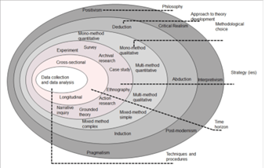
(Saunders et al., 2019)

3.3.2 The research philosophy
The research philosophy can be described from two different outlooks – ontological and epistemological. Ontology refers to ‘the what and how of what we know’ and epistemology touches on how knowledge is obtained and comprehended. The strategy that will be used throughout this dissertation is the ‘interpretivist’ idea. Interpretivism is the ideology that reality is subjective and socially constructed. One is only able to decipher someone’s reality through understanding their personal experiences. This approach relies on the use of questioning and can also include observation (University of Nottingham, 2023). This is the strategy which will be utilised in this dissertation due to the nature of the question requiring personal experiences of participants.

3.3.3 Research approach:
The second layer of the onion provides the option of using either inductive or deductive methods. An Inductive approach will be utilised throughout this research. This method will mean the creation of a theory based on what is obtained from the survey (Streefkerk, 2022). This will allow a thorough consideration of the responses provided and develop reasoning

3.3.4 Research strategy:
The third layer’s main focus is on the aims and goals of research. Grounded research may be seen as the most useful for the nature of this topic. This will allow the creation of a theory based on received answers from the questionnaire (Chun Tie et al, 2019). A survey will be utilised in this dissertation because it is a quick way of providing answers and data based on the research question.

3.4 Choices:
The fourth layer requires a decision on which type of data is desired. In this research there is an aim to gain mixed data, both qualitative and quantitative. The survey questions will necessitate both open and closed answers. These answers will generate statistics and opinion-based responses and therefore a focus on mixed data types will be needed.

3.5 Time Horizon:
Layer fives shows concern for the timeline regarding collection of data. The next step is to create the questionnaire and distribute it to participants. A cross-sectional study will take place. This is where data is collected from several different participants at one point in time (Cheng and Wang, 2020). Additionally, it will mean the data is all reviewed simultaneously once the questionnaire is no longer accepting participants. This will allow any correlations in the data to be found (Thomas, 2022).

3.6 Techniques and procedures:
The final layer to the research onion discusses techniques and procedures. The overall goal is to use both primary and secondary data for the research. Not only will this allow a comparison of statistics but it enables a better understanding of key issues surrounding public confidence and reasons for the lack of confidence. Furthermore, as mentioned, there will be a requirement for both qualitative and quantitative data to fully comprehend this topic. The questionnaire will consist of no
more than 15 questions to encourage the maximum number of respondents. The aim is to receive 100 responses to guarantee meaningful statistics. This will help to identify and therefore understand the reasons for these feelings. Google forms will be utilised to enable a quick response time and more efficient aid in analysis.

3.7 Limitations
The limitations of these strategies and methods of research could include lack of potential data. The aim is to retrieve data from people of different ages, sex and with different experiences with the police. However, there is no guarantee that people of varying ages will be willing to participate or will have had different experiences, if any at all. People may be unwilling to participate in the survey which could cause complications with the data analysis. There may be insufficient respondents for a robust conclusion.

Although there will be a chance for participants to explain any experiences they may have had with the police under ‘please explain’ sections, there is a risk of respondent fatigue due to the requirement of open and closed-answer questions. (O’Reilly et al, 2015). This could then question the validity and reliability of the responses due to the risk of participants not answering the question adequately – this could be done by putting ‘.’, or ‘N/A’ (not applicable) or any other variant of answering the question with symbols or irrelevant content.

Primary research is beneficial due it being reliable but there is a possible drawback of low response rates (Walker, 2021). Whilst secondary research is helpful in gaining access to credible sources, a downfall is the potential lack of key variables (The Open University, 2023). Another drawback could be lack of relevance – the research question may not be answered to its entirety (King, 2022). Limitations also include the lack of control over the study population (Smith et al., 2011).

4.0 Data analysis chapter:
Having used the techniques and methods described within the methodology chapter, the data analysis will allow for a thorough consideration for responses. Additionally, it enables a more concise understanding for why some members of the public either have confidence in the police or lack it.

The objectives of this research were as follows: define police corruption, examine the current public confidence in the police and the factors influencing it, assess whether trust in the police varies among different age demographics and explore the reasons behind any observed differences, and provide recommendations on how police can increase public confidence.

In this research paper, the main goal was to receive inductive data – drawing theories from the research (Thomas, 2006). The aim was also to obtain empirical data which includes both qualitative and quantitative data (Bullock, 2019). In order to analyse the data obtained from the questionnaire, the aim is to explain the answers given to each question and discuss how it links with the main objectives of this research.

4.1 Findings:

The outcome of the questionnaire provided evidence that 79.1% of the participants do trust the police, this equates to 34 people out of 43. Adding onto this, 54.5% of people selected ‘no’ when asked “Have real life instances of police corruption effected your confidence in the police?”, this is the equivalent of 23 people.

Question one: Do you consent to taking parking in this questionnaire?
100% (43 people) said yes.

Question two: Which age range are you in?
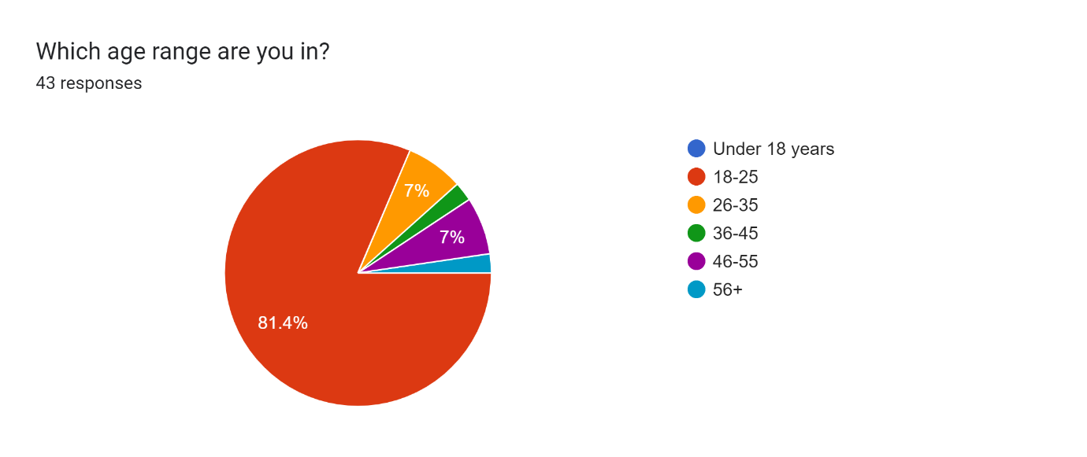
81.4% of participants are within the ages of 18-25, 7% are 26-35, 7% are 46-55, 1% are 36-45 and another 1% of people are 56+.

The majority of participants are 18-25, it could be likely that they are students. Assuming this, their views may influenced by potential lack of personal encounters with the police.

Question three: Which gender are you?
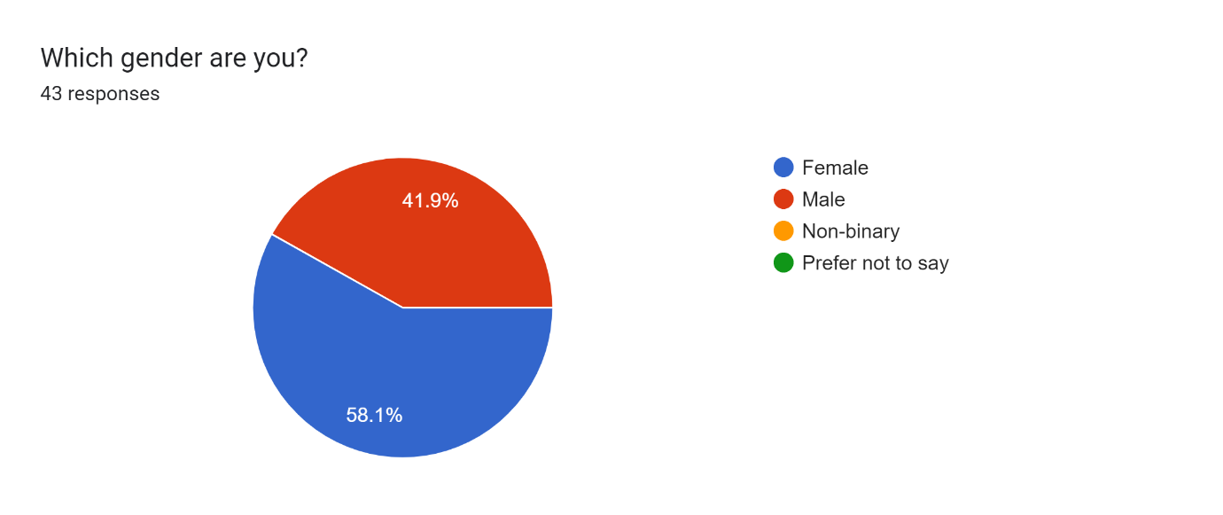
More than half of the participants (58.1%) equating to 25 people, are women and 41.9% (18 people) are men.

Question four: Have you ever had a personal encounter with the police which has increased or decreased your confidence in them?
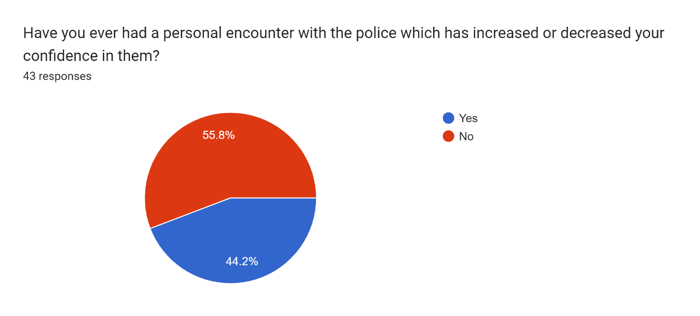55.8% of people said they have not ever had a personal encounter with the police which has resulted in either an increase of decrease in their confidence in them, whereas 44.2% of people said they had. Of those that said yes, 84% are between the ages 18-25, this equates to 16/25. 10.5% between 46-55 and 5.2% were 26-35.
Of those that said no, 79.1% (19 people) are aged 18-25, 8.3% (2 people) are 26-35, and 4.1% (1 person) are 56+, 4.1% are 46-55 and 4.1% are 36-45.

Question five: Please explain your answer.
This question received 33 responses. Three include either ‘N/A’ or ‘No’. It can be assumed that these answers are a reiteration of the previous question, stating ‘no’ the individual had not ever had an encounter with the police which effected their level of confidence.

Other answers included “An unneeded arrest as a result of an altercation with a bouncer in Cardiff” and “I was in the car with my family. We stopped at a red light and a police officer (not in uniform) was hitting a man to the ground. When we said we called the police he said he was the police so there was no need for them”.

There were only two positive responses which were “The British Transport Police were present at a station late at night and were looking out for me and my friends”, and “Every encounter I’ve had with the police has always seemed fair whichever side I’ve been on”. The majority of responses highlight negative encounters with the police.

These responses suggest officers have used excessive force and this can be backed up by secondary research. In 2022, PC Mary Smith was accused of gross misconduct after she beat Dalian Atkinson, who was dying on the floor, repeatedly (Dodd, 2023).

Question six: Would you say you have trust in the police?

The majority of people said they do have trust in the police – 79.1% (34 people).

Five people who had positive encounters went on to say they have trust in the police, four of these were male and one was female. However, fourteen people said they had negative encounters with the police, five were men and nine were women. Three of these women went on to say they do have trust in the police still, six said they did not.
Two of these men said they did still have trust in the police whereas three said they did not. The rest of the participants either hadn’t had personal encounters with the police and did trust them, or hadn’t had a personal encounter and did not trust them.

Research in the literature review section revealed that most people had trust in the police and only 38% did not. This is backed up in this questionnaire with 79.1% saying they trust the police.

In the literature review it was revealed that 77% of the women who took part in a survey regarding public confidence, said they trusted the police. 75% of men said they trusted the police. To compare with this questionnaire, 19/25 women said the same which equates to 76% of people. In this questionnaire, 15/18 of men said they trust the police which is the equivalent of 83% of men. Overall, this research slightly differed from the secondary research in the literature review, highlighting men had more confidence in the police. Due to the majority of participants being women, it presents the severity of the lack of trust. Three men said they did not trust the police and six women said they did not, suggesting men have double the trust women have.

Question seven: Please explain

Answers to this question varied: “Generally I have trust in the police, an increase in cases where officers have acted as criminals does change this”, “they’re supposed to help, not make us feel like we did anything wrong” this participant answered ‘no’ to the previous question, therefore this response could be seen to explain their lack of trust in the police by implying they have been made to feel like they are in the wrong when seeking help.

“They often treat women with great bias”, this participant is female aged 18-25. This participant answered ‘no’ when asked if they have confidence in the police and when asked if they believe the police to be homophobic/sexist/racist and why, they expressed “treat females differently. Racist with stop and searches”. It has proved difficult to decipher exactly what this participant means. It could imply the police are sexist, alas, acting more harshly towards men and more lenient towards woman.

Another response was “I don’t have trust in the police because of the way they respond to incidents not very effectively. Also, the case of Sarah Everard made me question the trust I had In the police!” this participant was a female. This response adds value to primary research used in the literature review, that states almost half of women have less trust in the police since this case (Greep, 2021).

“After the Adam Poven rape case, I would feel incredibly uncomfortable getting into a police car. And a couple of my neighbours work for the police and they are some of the most dodgy people on our estate and I’m pretty sure one of them has a criminal record. So, it makes me doubt the quality of the process someone has to go through to be in the police” this response also came from a female aged between 18-25. Assuming this person made a typing error and intended to write “Adam Provan”, who was an officer who raped a 16-year-old girl (France, 2023), the gender of this participant could be deemed as relevant.

Overall, most of these responses included respondents explaining that they have trust in the police to a certain degree – they trust they’d be there if required, but have doubts in they would handle a situation.

Question eight: Does the media impact your view on the police?

The vast majority said yes, equating to 83.7% and only 16.3% said no.
Of the seven people who stated no, 6 were within the ages 18-25 and one was within 36-45.

Question nine: If you were in a situation where you required the police, would you trust them to deal with the matter adequately?
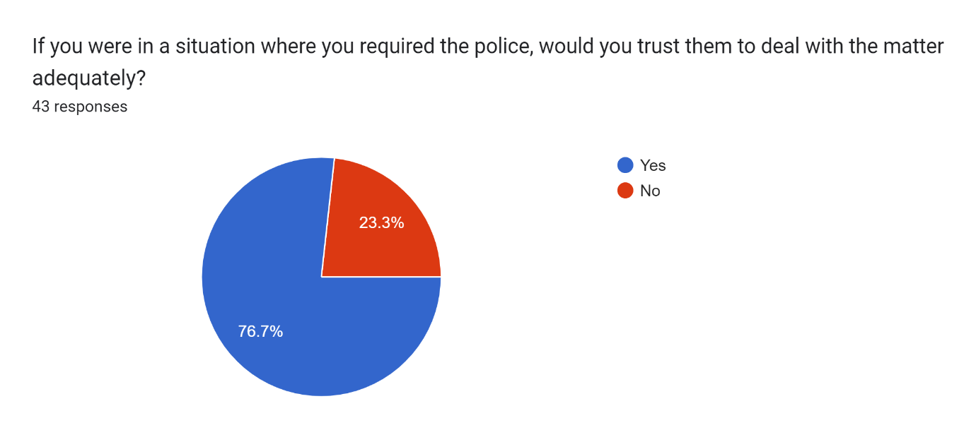

23.3% of people said no, this equates to 10 people. 76.7% of people said yes, equating to 33 people.

Question 10 asked those that said no, to explain:

Responses to this question were diverse:

Two answers made reference to race: “Yes as I am white” it can be assumed this person responded with ‘yes’ to the previous question. “To a point I will but if it involves a person of colour, I will remain sceptical”. These answers strengthen points discovered in secondary research suggesting the police are institutionally racist (Dodd, 2024).

“They make mistakes far too often and often go after the wrong people”, “I feel it will be a slow process and, in the end, not be affective”.
“I would still call them but I wonder if it would actually make a change in the matter”. Most of these responses showed doubt in the police’s ability to adequately handle a situation where their aid was required. These responses were unexpected due to lack of secondary research that could back this up.

Question eleven: Do you believe the police are homophobic, racist and/or sexist?
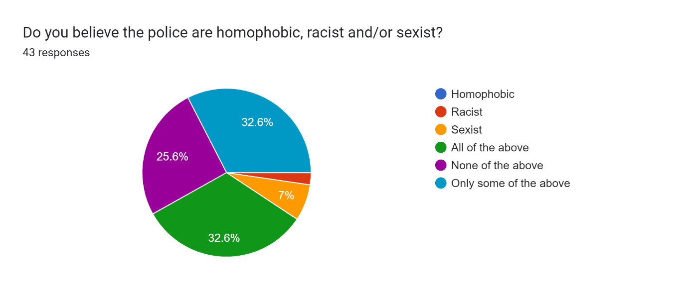
The responses to this question varied. 32.6% of respondants thought the police were ‘only some of the above’ and 32.6% also thought the police were ‘all of the above’. 25.% people thought the police were ‘none of the above’, 7% selected only ‘sexist’ and 2.3% selected only ‘racist”.

Question 12: Please explain (if you selected only some, please note and explain which ones).
“Racist – you only have to recall issues highlighted in the press regarding the ethnicity of people stopped and searched by the police to understand that the stats are skewed. Also, the proportion of ethnic minorities represented in the police force and the number of female officers show a degree of sexism still exists”.

“in my opinion, I feel some police treat men and women differently for various offences, some men may get away with some stuff, and some women may get away with others”.

“The Casey Review highlighted this that the Met police internally were all of these above. Additionally, the adversity towards Black people has been a major issue. This is highlighted in the case of Steven Lawrence and George Floyd”. There were two other answers which mentioned The Metropolitan police. This suggests that people have taken notice of the coverage highlighting the corruption within The Met.

One might think that these responses are surprising in light of the negative publicity over high level reports such as the Casey Review (2023). Although the Casey Review was mentioned three times, one might have expected the police to be viewed as more racist and sexist due to the revelations from this report.

Question 13: What can the police do to increase your confidence?
“Treat everyone fairly” and words to that effect were mentioned three times by males aged 18-25. “Ensure the level of corrupt officers comes down and you don’t see cases like the Sarah Everard case happening again” this participant was a female aged 18-25.

“Prove that they are making changes to how they train their officers and the tolerance they hold for unacceptable behaviour within the police”. This response can be seen to add value to the NPCC’s statement claiming the police’s lack of accountability is normal.

“Many times they took advantage of their power and never listen to reason” thus strengthening research discussing the prominence of police corruption. “Stop making so many crucial mistakes” was an answer given by a male aged 18-25, it could be suggested that the view of the police making ‘so many crucial mistakes’ stems from their personal experiences.

“Clearly fix the current problems and many levels of poor management internally. This will also be a long process to gain improved support and trust by the police” this comment was made by a male aged 56+ who had no personal experience with the police. This is relevant because it suggests that there is no guaranteed link between age and experience with police.

“Transparency” was an answer provided by a male aged 46-55 who had experienced a positive encounter with the police and trusts them. The relevance of this is it suggests there is not obvious link between lack of experience with the police and believing there is room for improvement. Also suggesting that media coverage does impact people’s views.

Question 14: Have real life instances of police corruption effected your confidence in the police?
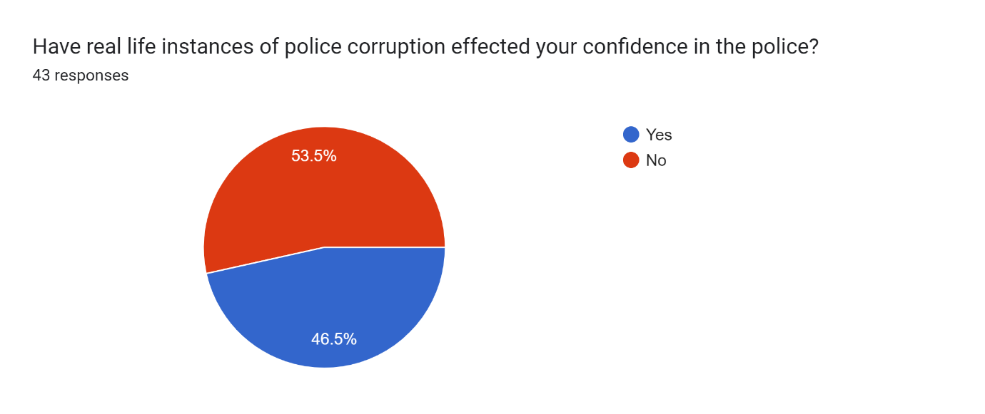
20 people said yes, 23 people said no.
Question 15: If so, which case(s)?
The case with Sarah Everard and Wayne Couzens were mentioned in 7/23 responses. “Met police”, “Their mistreatment of women in particular shown in many cases, including the corruption of covering up officer’s misconduct”, “Cases like the David Carrick and Sarah Everard case”, “The heavy-handed way they deal with social justice protests”

Question 16 was: If any, would you be more cautious of a female officer or a male officer?
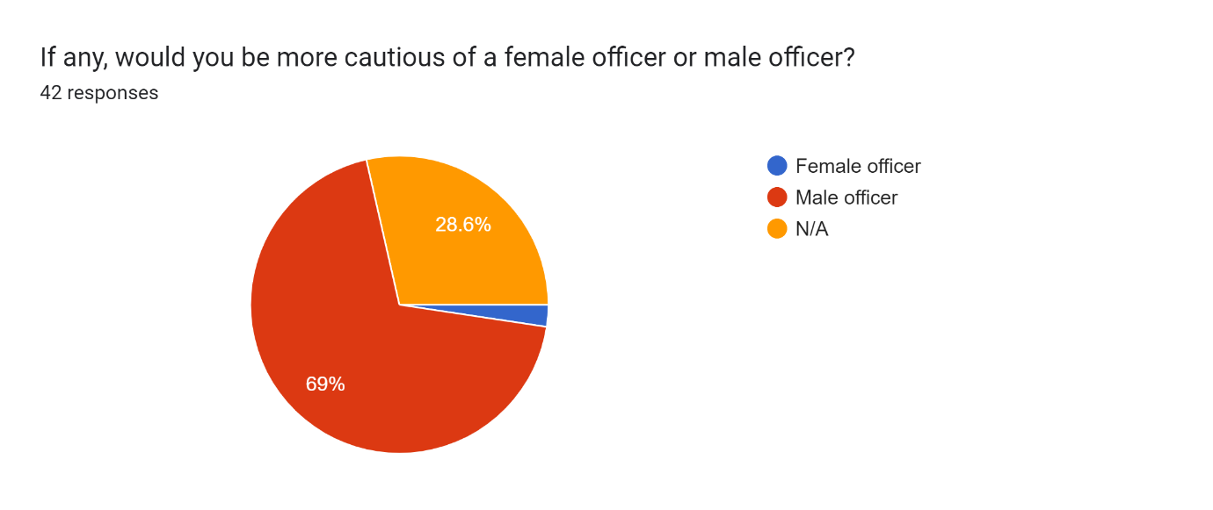
The majority of people (69%) said Male officer, 28.6% of people said N/A and 2.4% of people (one person) said Female officer.

The final question asked for an explanation to the previous question.
Answers included:
“Male officers are often seen abusing their powers”
“ I don’t believe I have seen any bad press concerning female officers apart from one very senior officer” this person responded with ‘Male officer’ to the question prior. This response is very similar to: “From the media stories, the ones that are reported are often male officers” highlighting the importance of the link between media coverage and public perception (Liao, 2023).

Some responses included “ I would feel safe with a female officer”, “ I have seen cases of police corruption and a lot of them involve male officers”. These responses prove that although some people are hesitant of both female and male officers and some are not hesitant of either, people tend to be more cautious of male officers.

Overall, the main findings of this research showed that there is a higher percentage of people who have trust in the police than one might have expected. Adding on to this, there has not been as much criticism for sexism and racism as one might have expected given the high-level reports about corruption especially in the Met. Additionally, the number of participants who would trust the police to deal with a matter adequately was higher than potentially expected. This could be due to the small number of participants, it Is important to note that had there been a higher response rate, these answers could have been entirely different. The research differed slightly and one may find some of the responses surprising.

5.0 Conclusion:

The aim of this research was to identify how police corruption effects public confidence. Based on primary research obtained through the questionnaire. It can be concluded that police corruption negatively effects public confidence.

The objectives of this research were: defining police corruption, examine the current public confidence in the police and analyse what effects this, analyse the demographic that have the least confidence and why, and provide recommendations on how police can increase public confidence.
Police corruption was defined by the use of primary research to ensure a consensus of the term, rather than using secondary research to discover what the public thought it meant. Utilising official police websites allowed for a clear understanding of the term. The Office for National Statistics (ONS) offered numerical data regarding the current level of public confidence. ONS provided details regarding the demographic which held the most confidence in the police as well as general statistics of the public as an entirety. The Casey Review (2023) aided in establishing demographic statistics, highlighting key areas of concern including a decline in public confidence.

This research clearly illustrates the lack of confidence the public have in the police. The main purpose of this research was to establish the current level of confidence the public have in the police and to decipher the reasons for this. The chosen methodology of this research paper could be deemed effective due to the nature of the question requiring a thematic analysis. Limitations of this research could include a lack of responses to the questionnaire. The initial aim was to receive 100 responses however the questionnaire only had 43 responses. Future researchers should consider this platform to create their questionnaires

Google Forms was used in this paper, this was a useful format to assess the correlation between the questions. For example, when asked ‘What gender are you?’ and then ‘Do you have trust in the police?’, there was a way of establishing the demographic who answered each question.

Responses varied to each question and some participants contradicted themselves. This caused difficulties in fully interpreting the data to meet the objective of ‘Analyse the demographic with the least amount of confidence in the police and why’. It was difficult to use primary research to establish this due to varied answers, therefore an over-reliance on secondary research was required.

Based on these conclusions, future researchers should ask more specific questions to fully determine the relationship between gender/age and levels of confidence in the police along with reasons for this. Future studies could address how police officers feel about police corruption and their personal experiences with the public after the revelation of cases, such as Wayne Couzens, and what they did to prove their legitimacy.

Recommendations for the police to increase public confidence could encompass more intense training revolving racism, sexism and homophobia, to demonstrate their competency and values adequately. Furthermore, implement more police officers to patrol the streets and show their presence. More positive publicity in the media addressing corruption and reassuring the public that the police are working towards making a safer service.

The literature review highlighted one main area of uncertainty – what can the police do to increase the levels of confidence. The utilisation of primary research helped to develop ideas based on what the participants said. For example, ‘Treat everyone fairly’. Overall, it could be said that this research has given strength to pre-existing research but has not changed the original perspective prior to beginning this research.

To conclude, this research has presented crucial issues within police forces. An unsurprising amount of the public lack confidence in the police due to personal experiences or negative media coverage regarding corruption. Policing is arguably under more pressure than ever before but there is evidence that it is taking an important curve towards a brighter future. With an increasing amount of positive media coverage such as “Policing Can Win” (Spencer, 2024), there is hope for an increased public confidence.

- Check to see if I have to add in the answers from the dissertation

Bibliography:
Aara Syed (2022). Racist Policing In Wales: ‘The Numbers And Stats Are There For Everyone To See’ -.Voice Wales . Available at: https://www.voice.wales/racist-policing-in-wales-the-numbers-and-stats-are-there-for-everyone-to-see/#:~:text=According%20to%20this%20data%2C%20in [Accessed 26 Nov. 2023].
Bhandari, P. (2022). An introduction to quantitative research. Scribbr. Available at: https://www.scribbr.co.uk/research-methods/introduction-to-quantitative-research/#:~:text=Quantitative%20research%20is%20the%20process [Accessed 3 Jan. 2024]
Brown, J. (2021). Policing in the UK Summary 1 Key Concepts 2 Key Actors 3 Police Forces 4 Performance. Available at: https://researchbriefings.files.parliament.uk/documents/CBP-8582/CBP-8582.pdf. [Accessed 3 Jan. 2024]

Brown, R. and Hobbs, A. (2023). Trust in the police. Available at: https://researchbriefings.files.parliament.uk/documents/POST-PN-0693/POST-PN-0693.pdf. [Accessed 3 Jan. 2024]

Bullock, M. (2019). Empirical Data: Definition & Example - Video & Lesson Transcript | Study.com. Study.com. Available at: https://study.com/academy/lesson/empirical-data-definition-example.html. [Accessed 3 Jan. 2024]

Casey, L. (2023a). An independent review into the standards of behaviour and internal culture of the Metropolitan Police Service. [Accessed 4 Jan. 2024]

Casey, L. (2023b). The Baroness Casey Review Final Report: March 2023. Metropolitan Police. Available at: https://www.met.police.uk/police-forces/metropolitan-police/areas/about-us/about-the-met/bcr/baroness-casey-review/. [Accessed 3 Feb. 2024]

Chun Tie, Y., Birks, M. and Francis, K. (2019). Grounded theory research: A design framework for novice researchers. SAGE Open Medicine, 7(1), pp.1–8. doi:https://doi.org/10.1177/2050312118822927. [Accessed 3 Jan. 2024]

College Of Policing (2023). Building trust and a fair culture.College of Policing. Available at: https://www.college.police.uk/about/corporate-strategy-2022-2026/building-trust-and-fair-culture. [Accessed 3 Mar. 2024]

College of Policing (2013). Legal framework. [online] College of Policing. Available at: https://www.college.police.uk/app/armed-policing/legal-framework. [Accessed 3 Feb. 2024]

College of Policing. (2016). Stop and search. Available at: https://www.college.police.uk/app/stop-and-search/stop-and-search#:~:text=If%20the%20officer%20has%20reasonable. [Accessed 11 Jan. 2024]
DeFranzo, S (2017) Advantages and Disadvantages of surveys available at: https://www.snapsurveys.com/blog/advantages-disadvantages-surveys/ [Accessed 29 Apr. 2024]
Department for International Development (2015). Why corruption matters: understanding causes, effects and how to address them. Available at: https://assets.publishing.service.gov.uk/media/5a7f86f2e5274a2e87db6625/corruption-evidence-paper-why-corruption-matters.pdf. [Accessed 23 Jan. 2024]

Desai, U. (2020). Policing with Consent. London City Hall. Available at: https://www.london.gov.uk/node/59395. [Accessed 3 Apr. 2024]

Dodd, V. (2024). Head of Britain’s police chiefs says force ‘institutionally racist’. The Guardian. 5 Jan. Available at: https://www.theguardian.com/uk-news/2024/jan/05/head-of-britains-police-chiefs-says-force-is-institutionally-racist-gavin-stephens. [Accessed 13 Apr. 2024]

Dodd, V., Police, V.D. and correspondent, crime (2023). Police officer guilty of using excessive force against Dalian Atkinson keeps job. The Guardian. 17 Mar. Available at: https://www.theguardian.com/uk-news/2023/mar/17/police-officer-faces-sack-excessive-force-dalian-atkinson. [Accessed 24 Feb. 2024]

End Violence Against Women (2021). Almost half of women have less trust in police following Sarah Everard murder. Available at: https://www.endviolenceagainstwomen.org.uk/almost-half-of-women-have-less-trust-in-police-following-sarah-everard-murder/.[Accessed 22 Feb. 2024]

EVAW (2023a). Casey review exposes an institution in crisis, as police powers increase. End Violence Against Women. Available at: https://www.endviolenceagainstwomen.org.uk/casey-review-exposes-an-institution-in-crisis-as-police-powers-increase/#:~:text=Baroness%20Casey. [Accessed 30 Jan. 2024]

EVAW (2023b). National Police Chiefs’ Council highlights lack of accountability for police-perpetrated VAWG. End Violence Against Women. Available at: https://www.endviolenceagainstwomen.org.uk/national-police-chiefs-council-highlights-lack-of-accountability-for-police-perpetrated-vawg/#:~:text=It [Accessed 1 Dec. 2023].
France, A. (2023). Serial rapist ex-Met officer Adam Provan jailed for 16 years. Evening Standard. Available at: https://www.standard.co.uk/news/crime/adam-provan-rapist-met-police-officer-sentenced-jailed-london-newmarket-suffolk-b1102271.html. [Accessed 13 Mar. 2024]

Geoghegan, S. (2021). Almost Half of Women Have Less Trust in Police following Sarah Everard Murder. End Violence against Women. Available at: https://www.endviolenceagainstwomen.org.uk/almost-half-of-women-have-less-trust-in-police-following-sarah-everard-murder/#:~:text=The%20End%20Violence%20Against%20Women. [Accessed 17 Feb. 2024]

Greep, M. (2021). Women reveal distrust in police after murder of Sarah Everard. Mail Online. Available at: https://www.dailymail.co.uk/femail/article-10049191/Women-reveal-distrust-police-Wayne-Couzens-abused-Covid-powers-murder-Sarah-Everard.html. [Accessed 18 Feb. 2024]

Guy, E. (2023). Police Accountability For Violence Against Women Is A National Issue. Each Other. Available at: https://eachother.org.uk/police-accountability-for-violence-against-women-is-a-national-issue/#:~:text=It [Accessed 25 Apr. 2024].
Gwent Police (2023). A former police officer has received a prison sentence of more than two years after admitting several domestic abuse offences. https://www.gwent.police.uk/news/gwent/news/news/2023/november/a-former-police-officer-has-received-a-prison-sentence-of-more-than-two-years-after-admitting-several-domestic-abuse-offences/. [Accessed 28 Feb. 2024]

Holden, M. (2023). British police face struggle to clean up sexist culture after scandals. Reuters. 22 Feb. Available at: https://www.reuters.com/world/uk/british-police-face-struggle-clean-up-sexist-culture-after-scandals-2023-02-22/. [Accessed 31 Jan. 2024]

Home Office (2021). Confidence in the local police. www.ethnicity-facts-figures.service.gov.uk. Available at: https://www.ethnicity-facts-figures.service.gov.uk/crime-justice-and-the-law/policing/confidence-in-the-local-police/latest/ [Accessed 6 Dec. 2023].
Home Office (2023a). Policing Productivity Review (accessible). GOV.UK. Available at: https://www.gov.uk/government/publications/policing-productivity-review/policing-productivity-review-accessible#:~:text=Robert%20Peel [Accessed 17 Apr. 2024].
Home Office (2023b). Stop and Search. Gov.uk. Available at: https://www.ethnicity-facts-figures.service.gov.uk/crime-justice-and-the-law/policing/stop-and-search/latest. [Accessed 23 Jan. 2024]
House of Commons (n.d.). Criminal Justice and Courts Bill New Offence of Police Corruption (clause 25) Background. Available at: https://assets.publishing.service.gov.uk/media/5a7ef43ee5274a2e8ab493f6/fact-sheet-police-corruption.pdf [Accessed 5 Nov. 2023].
Jazeera (2023). Two British police officers fired after stop and search of Black athletes. Al Jazeera. Available at: https://www.aljazeera.com/news/2023/10/25/two-british-police-officers-fired-after-stop-and-search-of-black-athletes. [Accessed 3 Jan. 2024]
Kent, P. (n.d.). Legal and Professional Standards Department - Wrongdoing: counter corruption procedure (P01b). [Accessed 13 Jan. 2024]

King, N. (2022). LibGuides: Research Methods: Secondary Research. libguides.tees.ac.uk. Available at: https://libguides.tees.ac.uk/researchmethods/secondary. [Accessed 23 Jan. 2024]
King, N (2022) Research Methods: Secondary Research Teeside University Available at: https://libguides.tees.ac.uk/researchmethods/secondary [Accessed 29 Apr. 2024)
Kingsley, T. (2023). ‘I’d happily rape you’: Shocking cases of Met Police misogyny and racism revealed. The Independent. Available at: https://www.independent.co.uk/news/uk/home-news/casey-report-met-police-racism-sexism-misogyny-b2304418.html. [Accessed 3 Jan. 2024]
Lindemann, N (2023) 12 advantages and disadvantages of questionnaires Available at: https://pointerpro.com/blog/questionnaire-pros-and-cons/#:~:text=Questionnaires%20provide%20structured%20and%20standardized,to%20process%20the%20data%20quickly. [Accessed 29 Apr. 2024]

Liao, C.-H. (2023). Exploring the Influence of Public Perception of Mass Media Usage and Attitudes towards Mass Media News on Altruistic Behavior. Behavioral sciences, 13(8), pp.1–22. doi:https://doi.org/10.3390/bs13080621. [Accessed 2 Jan. 2024]

March, J.O. and 2023 (2023). Met Police condemned for comms spin and culture of denial Available at: https://www.prweek.com/article/1817173/met-police-condemned-comms-spin-culture-denial [Accessed 6 Dec. 2023].
Metropolitan Police (2019). Home | The Met. Available at: https://www.met.police.uk/.[Accessed 27 Mar. 2024]
Murphy, P.V. (1982). Corruptive Influences (From Local Government Police Management Second Edition, P 52-73, 1982, Bernard L Garmire, ed. - See NCJ-88274) | Office of Justice Programs. www.ojp.gov. Available at: https://www.ojp.gov/ncjrs/virtual-library/abstracts/corruptive-influences-local-government-police-management-second#:~:text=The%20most%20common%20type%20of. [Accessed 14 Apr. 2024]

Myhill, A. and Beak, K. (2008). Public Confidence in the Police. Available at: https://library.college.police.uk/docs/npia/public-confidence-in-the-police.pdf. [Accessed 3 Jan. 2024]

Newburn, T. (1999). Understanding and Prevention Police Corruption: Lessons from the Literature. Tim Newburn. [Accessed 3 Dec. 2023]

Nisbet, R. and Yale, K. (2018). Deductive Approach - an overview | ScienceDirect Topics. Available at: https://www.sciencedirect.com/topics/mathematics/deductive-approach. [Accessed 31 Jan. 2024]

North Wales Police (2020). North Wales Police Confidence Survey 2019- 20. Available at: https://www.northwales.police.uk/SysSiteAssets/foi-media/north-wales/disclosure-2021/2021-499-public-perceptions-of-policing.pdf. [Accessed 13 Dec. 2023]

O’Reilly-Shah, V.N. (2017). Factors influencing healthcare provider respondent fatigue answering a globally administered in-app survey. PeerJ, 5, p.e3785. doi:https://doi.org/10.7717/peerj.3785. [Accessed 5 Apr. 2024]

Office for National Statistics (2019). Crime and Justice - Office for National Statistics Available at: https://www.ons.gov.uk/peoplepopulationandcommunity/crimeandjustice. [Accessed 23 Apr. 2024]

Office for National Statistics (2022). Regional Ethnic Diversity Available at: https://www.ethnicity-facts-figures.service.gov.uk/uk-population-by-ethnicity/national-and-regional-populations/regional-ethnic-diversity/latest/.[Accessed 27 Jan. 2024]
Police Conduct (2022). Police complaints statistics for England and Wales report - 2021/22 | Independent Office for Police Conduct (IOPC) Available at: https://www.policeconduct.gov.uk/publications/police-complaints-statistics-england-and-wales-report-202122. [Accessed 3 Feb. 2024]

Pope-Weidemann, M. (2024). The problem with British policing is not ‘just a few bad apples’ Available at: https://www.aljazeera.com/opinions/2024/3/26/the-problem-with-british-policing-is-not-just-a-few-bad-apples. [Accessed 9 Jan. 2024]

Rashid, M.H.A. (2023). Research Philosophy: Positivism, Interpretivism, and Pragmatism. Library & Information Management. Available at: https://limbd.org/research-philosophy-positivism-interpretivism-and-pragmatism/.[Accessed 23 Jan. 2024]

Reid, C. (2023). Prison officers arrested following corruption investigation, Suffolk News. Available at: https://www.suffolknews.co.uk/newmarket/news/prison-officers-arrested-following-corruption-investigation-9299699/ [Accessed 29 Nov. 2023].
Richards, G., Fright, M. and Davies, N. (2023). Performance Tracker 2022/23: Spring update – Police, Institute for Government. Available at: https://www.instituteforgovernment.org.uk/performance-tracker-2022-23/police. [Accessed 30 Jan. 2024]

Salomão, A. (2023). Inductive vs Deductive Research: Two Approaches to Data Analysis, Mind the Graph Blog. Available at: https://mindthegraph.com/blog/inductive-vs-deductive-research/.[Accessed 12 Apr. 2024]

Sanders, T. (2023). Met Police has 161 serving officers with criminal convictions in its ranks, Metro. Available at: https://metro.co.uk/2023/04/06/met-police-has-161-serving-officers-with-criminal-convictions-18566926/ [Accessed 1 Dec. 2023].
Shemar, J. (2022). Study reveals Black people have less trust in the police – The Justice Gap. The Justice Gap. Available at: https://www.thejusticegap.com/study-reveals-black-people-have-less-trust-in-the-police/.[Accessed 3 Mar. 2024]

Singh, D. (2022). The Causes of Police Corruption and Working towards Prevention in Conflict-Stricken States. Laws, 11(5), p.69. doi:https://doi.org/10.3390/laws11050069. [Accessed 3 Jan. 2024]

Sinmaz, E. (2023). Victims of domestic abuse have lost trust in Met police, says senior officer. The Guardian. Available at: https://www.theguardian.com/uk-news/2023/dec/27/victims-domestic-abuse-lost-trust-in-met-police-says-senior-officer. [Accessed 25 Apr. 2024]

Smith, M. (2023). By 51% to 42%, Londoners don’t trust the Metropolitan Police | YouGov. [online] yougov.co.uk. Available at: https://yougov.co.uk/politics/articles/45188-51-42-londoners-dont-trust-metropolitan-police [Accessed 6 Dec. 2023].
Spencer, D. (2024). The Metropolitan Police is utterly demoralised. The Telegraph. Available at: https://www.telegraph.co.uk/news/2024/01/17/metropolitan-police-utterly-demoralised/. [Accessed 5 May. 2024]

Stone, V. and Pettigrew, N. (2000). The Views of the Public on Stops and Searches. Home Office. Available at: https://www.politieacademie.nl/kennisenonderzoek/kennis/mediatheek/PDF/89415.PDF. [Accessed 20 Dec. 2023]

Streefkerk, R. (2019). Qualitative vs. Quantitative Research | Differences, Examples & Methods. Scribbr. Available at: https://www.scribbr.com/methodology/qualitative-quantitative-research/.[Accessed 3 Jan. 2024]

Streefkerk, R. (2022). Inductive vs Deductive Research Approach (with Examples) Scribbr. Available at: https://www.scribbr.co.uk/research-methods/inductive-vs-deductive-reasoning/#:~:text=The%20main%20difference%20between%20inductive. [Accessed 3 Jan. 2024]

Taylor, D. (2021). Black boy in stop and search ‘30 times’ accuses Met police of racist profiling. The Guardian. 15 Nov. Available at: https://www.theguardian.com/uk-news/2021/nov/15/black-boy-in-stop-and-search-30-times-accuses-met-police-of-racist-profiling#:~:text=2%20years%20old-.[Accessed 3 Feb. 2024]

The Open University (2023). Using data to aid organisational change OpenLearn. Available at: https://www.open.edu/openlearn/money-business/using-data-aid-organisational-change/content-section-6. [Accessed 26 Feb. 2024]
The Crown Prosecution Service (2022). Public Justice Offences incorporating the Charging Standard | The Crown Prosecution Service Available at: https://www.cps.gov.uk/legal-guidance/public-justice-offences-incorporating-charging-standard. [Accessed 1 Jan. 2024]

The Crown Prosecution Service (2023). UPDATED WITH SENTENCE: Former police officer jailed for bribery offences | The Crown Prosecution Service Available at: https://www.cps.gov.uk/cps/news/updated-sentence-former-police-officer-jailed-bribery-offences. [Accessed 26 Jan. 2024]

Thomas, D.R. (2006). A General Inductive Approach for Analyzing Qualitative Evaluation Data. American Journal of Evaluation, 27(2), pp.237–246 Available at: https://doi.org/10.1177/1098214005283748. [Accessed 5 Apr. 2024]

Thomas, L. (2022). Cross-Sectional Study | Definitions, Uses & Examples, Available at: https://www.scribbr.co.uk/research-methods/cross-sectional-design/.[Accessed 19 Jan. 2024]

Tudor, S. (2023). Police standards and culture: Restoring public trust Uk Parliament . Available at: https://lordslibrary.parliament.uk/police-standards-and-culture-restoring-public-trust/#:~:text=The%20policing%20model%20in%20the,service%20(MPS)%20in%201829. [Accessed 3 Jan. 2024]

UK Parliament (2021). Urgent action needed to tackle deep rooted and persistent racial disparities in policing, Committees. Available at: https://committees.parliament.uk/work/347/the-macpherson-report-twentytwo-years-on/news/157006/urgent-action-needed-to-tackle-deep-rooted-and-persistent-racial-disparities-in-policing. [Accessed 23 Jan. 2024]

University of Nottingham (2023). Understanding Pragmatic Research, University of Nottingham. Available at: https://www.nottingham.ac.uk/helmopen/rlos/research-evidence-based-practice/designing-research/types-of-study/understanding-pragmatic-research/section02.html#:~:text=Interpretivism%20is%20based%20on%20the. [Accessed 13 Jan. 2024]
Waitzman, F (2022) Crime and misconduct within the Metropolitan Police, House of Lords Library Available at: https://lordslibrary.parliament.uk/crime-and-misconduct-within-the-metropolitan-police/ [Accessed 29 Apr. 2024]

Walker, J. (2021). Disadvantages of Primary Research, Research Prospect. Available at: https://www.researchprospect.com/disadvantages-of-primary-research/. [Accessed 3 Feb. 2024]
Wang, X. and Cheng, Z. (2020). Cross-sectional studies: Strengths, weaknesses, and Recommendations. Chest, 158(1), pp.65–71. Available at: https://doi.org/10.1016/j.chest.2020.03.012. [Accessed 15 Jan. 2024]

Warren, M.E. (2004). What Does Corruption Mean in a Democracy? American Journal of Political Science, 48(2), pp.328–343 Available at:https://doi.org/10.2307/1519886. [Accessed 18 Jan. 2024]

Wickham, R. (2019). Secondary Analysis Research. Journal of the Advanced Practitioner in Oncology, 10(4), pp.395–400. Available at:https://doi.org/10.6004/jadpro.2019.10.4.7. [Accessed 19 Jan. 2024]

Appendix 1:






