Design and Implementation of Smart Home

Student Name – Gareth Evans
Student Number – 1810612
Module name – Smart & Connected Devices
Module code – ACDA5005

Contents
Introduction 1
1. The concept behind Internet of Things 2
1.1 Types of connections 2
1.2 IOT in the work place 3
2. Real Life Scenarios 4
2.1 Smart Home Assistants 4
2.2 Smart Security systems 5
2.3 Smart Heating Systems 5
3. Smart Home Implementation 6
Conclusion 7

Introduction

Internet of things (IOT) is a concept that has existed since the 1990’s. It may seem a vague phrase, however this indicates that the concept was prepared to allow for a massive expansion of networked objects being able to interact to their environment [1]. The idea behind IOT is to allow everyday items that are connected to the internet to interact, working towards a common purpose. Things refers to smart objects such as a smart car or even a smart home (a home containing various smart devices/objects that work together). These smart objects must be able to connect to the internet and can be part of a much larger scale network to try and have a positive impact on people’s lives. Billions of devices can be connected, making the possibilities for smart objects working together almost endless [2].
On a small scale, IOT means people can have a smart doorbell. These doorbells come can come with cameras and can connect to a user’s mobile phone. When the doorbell is ringing, a notification comes through to the user’s phone, who can then start a conversation from their phone to the person who rang the doorbell. This is just one of many examples that, due to the sharp increase of mobile phone usage, shows how IOT can contribute to people’s lives.
On a much larger scale, there are ideas in place to start creating smart cities. In 2015, the Government of India announced a mission to create Smart Cities across India. The idea being that devices and sensors across the city communicate with each other and without human interaction in an attempt to improve efficiency [3]. This plan is still in its infancy; however, its potential is massive. Figure 1 below shows the scale that the internet of things can reach.
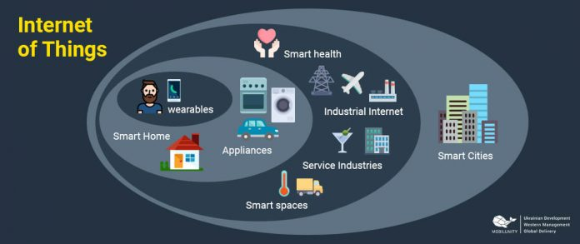
Figure 1 Scale of IOT [10]

This report will discuss current IOT technology available, the benefits it brings and the inevitable controversies that come with a system that relies so heavily on data usage. An example smart home implementation will also be referred to that has been created by the author.

The concept behind Internet of Things

There are currently billions of networked smart devices across the world. These devices can exist on a variety of networks, from a small Local Area Network (LAN) to Metropolitan Area Network (MAN). Thanks to current technology, common items such as doorknobs, thermometers and even cars can now work with these smart devices to help send, receive and create data [1]. These “things” can be controlled by smart devices through the internet by either an end user or through reacting to its environment through sensors. Devices will have built in sensors, such as GPS trackers or RFID, that are connected to the internet. These sensors gather data, potentially from an environmental change, and shares the information with the end application that can then act on it [4].

Types of connections

Not all connections require a human input, the main connection types are:
- People to People (P2P)
- Machines to people (M2P)
- Machines to Machines (M2M)

P2P connections consist of a device that communicates to a smart thing. A personal device can control the smart thing remotely using an internet connection [5]. For example, an app called Hive allows users to control their home heating through an app. Users can be at work and turn the heating on/off to their desired temperature.
M2P is the sending and receiving of data between a machine and a person, referred to as a transactional connection. This means that information flows in both directions. The most common and beneficial example of this connection can be seen in health care. Sensors and monitors can provide personal, round the clock data about a specific patient and their vital signs. [6]
M2M is the direct communication between devices without human intervention, allowing data flow between to machines. They must have a network connection [7]. A common example of an M2M connection is used in retail to have inventory visibility. A shelf can have a sensor, when an item is removed, the sensors reacts to this change and sends an update to a database to inform it that the item has been removed. The database then reflects that the item has been purchased, if there is a front end to the database, it will also update this [6].

IOT in the work place

In most cases, for smart systems to carry out their function, they will need access to vast amounts of personal data. Ranging from a person’s location or patient information, the data held in small or large smart systems carry the risk of a data leakage. Are the benefits that IOT brings worth the risk of losing such personal data? Table 1 below discusses the advantages and disadvantages of IOT in a workplace.

Advantages of IOT | Disadvantages of IOT
Faster and better decision making thanks to more data being available | Heavy reliance on wireless communications means signals can be wire tapped
Unites data that would normally be separated, allowing improved efficiency | Jobs otherwise carried out by people can now be automated, leading to unemployment
Ability to monitor behaviours in real time, whether that be an employee’s behaviour or a market pattern | Lack of knowledge about IOT can lead to data leaks
Safer work environment, sensors remove the need for humans to be in hazardous places | The set up of smart systems makes it harder to locate and track down criminals
Table 1 IOT in the work place [8] [9]

The above is a scenario that would affect organisations implementing smart systems. Large scale organisations have a lot to gain from smart systems, however they also have the most to lose. Table 1 implies that organisations can track patterns in employee’s efficiency. To monitor employees, there must be a constant transfer of data moving between devices. Whilst this may prove beneficial to the organisation, it relies on personal data being gathered by smart devices. Where personal data is being constantly transferred and stores, there is always the threat of it being intercepted.
The removal of human interaction can prove to be more efficient, especially in analysing data for patterns. However, the removal of human interaction means less job opportunities. This poses the moral question on whether its worth having a more efficient system that also leads to job losses and, in the bigger picture, a negative economic impact.
Data breaches are not inevitable in organisations. It is possible to have data transferring in a secure method, one that uses encryption for example. The largest cause of data leaks is human error. If a smart system is secure, there should be a lot smaller margin of error. Using smart systems should lead to less data losses provided that any staff who work for said organisation are trained and aware of how IOT works.
Based on this, there are more advantages to implementing smart systems. Human interaction often is the cause of less efficient work and data leaks. By using devices that connect to “things” through a network, data is constantly being transferred and processed by a smart system that make decisions faster and return better results. If a problem was to occur within a system, the lack of human interaction can make it harder to pinpoint the cause of the problem.

Real Life Scenarios

Smart homes are going to play a huge part in the future of most people’s lives. There are three views that indicate the concept of smart homes will appeal to the masses:
- Functional View – Smart homes help manage the demands of everyday life by using smart technology
- Instrumental View – Smart technology manages energy consumption at home in a bid to contribute to an overall lower carbon footprint
- Socio-Technical View – Smart homes are the next step in the digitalisation of everyday life [10]

The most common types of smart technology we see in smart homes is aimed to improve daily life. These can include virtual assistants, smart security systems and smart heating systems. Below are some examples of smart technology in the homes, what their purpose is and the risk they pose to their users.

Smart Home Assistants

Amazon’s Alexa is probably the most well-known example of a virtual assistant. As of April 2020, it is thought that more than 100,000,000 people own an Alexa-enabled device [11]. Once connected to the home Wi-Fi, it can communicate with other compatible smart devices and connected apps by using voice recognition. Users can set reminders, order shopping off Amazon and play music through connected apps such as Spotify. Recent advancements allow Alexa to also control garage doors and adjust home temperatures (if these are connected to the network). Alexa’s features make it appealing to both consumers and criminals. The data Alexa process can include personal or even financial information, making it appealing to cyber criminals. As Alexa uses third party apps, there in lies a vulnerability. Security researchers at SRLabs exploited this vulnerability, allowing Alexa to eavesdrop and, in some cases, phish users [12]. Fortunately, Alexa comes with an app that allows the user to customise their privacy settings to suit their needs. Features such as voice commands can be disabled, interactions with Alexa can be deleted and pin protection can be utilised to prevent unwanted purchases [11].

Smart Security systems

Blink security cameras are becoming a common site on the outside of homes. Consider the Blink XT2 model, this includes a doorbell with a built-in camera and another camera to be set up around the house. These cameras have built in motion sensors, meaning they begin filming as soon as they detect motion. The camera also has infrared vision so it can film at night. It allows for 2 way audio, so if there was to be someone at the door, as long as the user as the Blink app on their mobile phone, they are able to have a conversation with those at the door. Blink automatically records footage and saves it to a memory card, however it also has the ability to save to a cloud storage (this comes at an additional cost) [13]. It is clear why the Blink systems are so appealing, allowing users to give instructions to delivery drivers, check in on kids or pets and rewind footage. To those not to IT literate however, using Blink can lead to a security breach in the home. There do exist flaws in Blink that could lead to attackers viewing stores camera footage, listening into conversations and even hijacking the camera. Man in the middle attacks seem to be particularly effective when trying to access these smart systems. This should not discourage users from using smart systems as the risks are relatively low, providing the user ensures the devices and software on the latest version as regular patches are pushed out [14].

2.3 Smart Heating Systems

One of the most popular smart heating systems is the Hive heating system. The most attractive feature is the accompanying app that allows for remote control, allowing users to set schedules and different modes when away from home. It also accesses the users GPS location. Using GPS, it can detect when the user is far from home, if the heating has been left off it can turn it off itself or send a notification to the user to do so. Additional functionalities allow for Hive to control smart things such as smart lights, plugs and windows [15]. As with the previous products, Hive is susceptible to a data breach. Whilst Hive does not store as sensitive data as Alexa or Blink, it can still be exploited by cyber criminals who can intercept the location of the user to find out when they are not home.

Smart Home Implementation

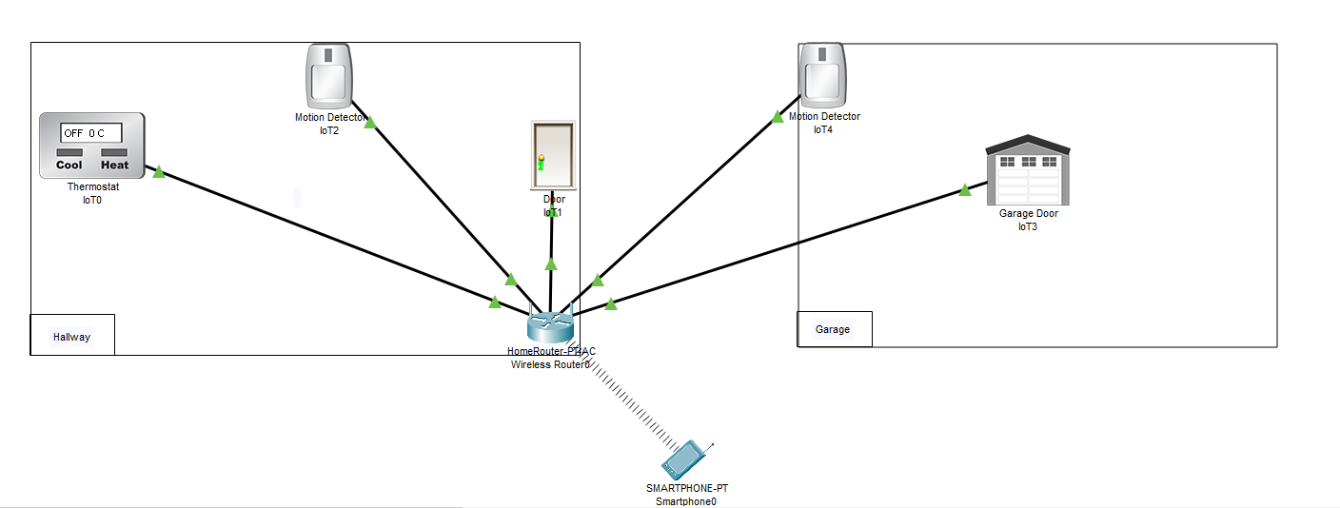
Figure 2 below is an example implementation of a smart home. It shows how one connection can allow for multiple devices to talk to each other and react based on the surrounding environment.
Figure 2 Smart Home system

Figure 2 shows a home wireless router found in a hallway. Connected to this router are eight smart devices, one of these being a smart phone. The smart phone can act as a remote control for the other smart devices; however, the smart things can also react to an environmental change. Below are the examples of scenarios where the smart devices interact with each other to contribute to home living.

- A person returns home from work and pulls ups to the garage door. This triggers the motion sensor and causes the garage door to open so the person can drive into their garage
- A person has gone on holiday and has forgotten to turn their home heating off. Their motion sensor has detected no movement for a long period of time (set by the user) and turns the heating off
- A delivery driver rings the doorbell at the front door but there is no answer. The doorbell triggers a notification to the smart phone. The homeowner can perform a two-way audio conversation to inform the delivery driver what to do next
These smart devices can work together to make life easier for the homeowner, but also reduce energy consumption in the short term and give some reassuring security for the home.

Conclusion

Smart systems can bring a great number of benefits to homes, workplaces and cities. Whilst it can be argued that they pose a security risk, using smart systems pose no more a risk than using any IT systems. Providing those implementing the smart systems are aware of the threats they are at risk to, they should do everything they can do prevent any data loss. What is most important in smart systems is that they are simple enough for everyone to use whilst staying safe. Protocols such as pin protection seen in Alexa and keeping software/firmware up to date can keep users safe whilst using smart systems. It is inevitable that smart systems will be seen more in the future, only then will people see the great improvements they bring with them.

Bibliography

[1] | F. Lacerda, M. Lima-Marques and A. Resmini, “An Information Architecture Framework for the Internet of Things,” Philos Technol, vol. 32, pp. 727-744, 2019.
[2] | J. Morgan, “Simple explanation of internet of things,” Forbes, 13 May 2014. [Online]. Available: https://www.forbes.com/sites/jacobmorgan/2014/05/13/simple-explanation-internet-things-that-anyone-can-understand/#6939ffad1d09. [Accessed May 2020].
[3] | A. K. K. M. G. Sheshadri Chatterjee, “Success of IoT in Smart Cities of India: An empirical analysis,” Government Information Quarterly, vol. 35, no. 3, pp. 349-261, 2018.
[4] | J. Clark, “What is Internet of Things?,” IBM, 17 November 2016. [Online]. Available: https://www.ibm.com/blogs/internet-of-things/what-is-the-iot/. [Accessed 06 2020].
[5] | “P2P IoT explainer,” Nabto, [Online]. Available: https://www.nabto.com/p2p-explainer/. [Accessed 06 2020].
[6] | O. University, “Internet of Everything,” [Online]. Available: https://www.open.edu/openlearn/ocw/mod/oucontent/view.php?id=48822&section=1.2. [Accessed 06 2020].
[7] | M. A. F. P. C. H.C. Chen, “Security and privacy challenges in IOT-based machine to machine collaborative scenarios,” in Internatioanl Conference on Hardware/Software Codesign and System Synthesis, 2016.
[8] | L. L. W. Xi, “Research on IoT Privacy Security Risks,” in 2016 International conference on Industrial Informatics, Wuhan, 2016.
[9] | N. Dyess, “Top six benefits of the IOT,” Control Eng, vol. 65, no. 7, pp. 50-51, 2018.
[10] | H. T. H.-B. R. Wilson. Charles, “Smart homes and their users: a systematic analysis and key challenges,” 1 August 2014.
[11] | S. team, “10 quick tips for Amazon Echo Safety & Privacy,” Safety.com, 17 April 2020. [Online]. Available: https://www.safety.com/amazon-echo-safety/#:~:text=So%20whether%20connecting%20your%20Amazon,Echo%20remain%20safe%20and%20secure.&text=Always%20keep%20your%20Echo%20updated,app%20requires%20updating%2C%20do%20it.. [Accessed June 2020].
[12] | J. Porter, “Security Researchers expose new Alexa vulnerability,” The Verge, 21 Oct 2019. [Online]. Available: https://www.theverge.com/2019/10/21/20924886/alexa-google-home-security-vulnerability-srlabs-phishing-eavesdropping. [Accessed June 2020].
[13] | “Blink For home,” Blink, [Online]. Available: https://blinkforhome.co.uk/collections/all?locale=en. [Accessed June 2020].
[14] | L. O'Donell, “Amazon blink smart camera flaws,” Threat Post, 10 December 2019. [Online]. Available: https://threatpost.com/amazon-blink-smart-camera-flaws/150962/#:~:text=Overall%2C%20seven%20CVEs%20were%20disclosed,devices%20or%20obtaining%20network%20information.. [Accessed June 2020].
[15] | “Hive Active heating review,” Expert reviews, 3 December 2019. [Online]. Available: https://www.expertreviews.co.uk/home/1408780/hive-active-heating-2-review. [Accessed June 2020].
[16] | “Biggest security issues IOT Devices face,” Internet of things wiki, [Online]. Available: https://internetofthingswiki.com/biggest-security-issues-iot-devices-face/1344/. [Accessed 06 2020].

