04/05/2025
Zakriya Fathi 2003845

Introduction to Web and Database Concepts
Design and Implementation of a Relational Database System
Contents
1. Introduction 1
2. Functional Requirements 2
2.1 Menu-Driven Interface 2
2.2 Inventory Management 2
2.3 Order Tracking 2
2.4 Query and Reporting Capabilities 2
2.5 Data Validation and Integrity 3
3. Entity Relationship Diagram (ERD) 3
3.1 Entities and Attributes 3
3.2 Relationships Between Entities 4
ERD diagram 4
Customer to Order 4
Order to OrderDetails 4
Inventory to OrderDetails 4
Data Dictionary 4
4. Logical Design 5
4.1 Table Structures 5
Customer Table: 5
Inventory Table: 5
Order Table: 6
OrderDetails Table: 6
4.2 Normalisation Process 6
5. Microsoft Access Implementation 7
5.1 Forms and Reports 7
5.2 Reports 9
5.4 Relationships 10
6. Conclusion 10
References 11
Bibliography 12

Introduction
CraftGem is a small, independent business that specialising in creating and selling handmade jewellery. Presently, the business relies heavily on manual processes to manage daily operations such as tracking inventory, recording customer orders, and maintaining customer records. As the business grows, this manual approach has become increasingly inefficient, prone to human error, and difficult to scale [1]. In response to these challenges, the director of CraftGem has commissioned the design and implementation of a database solution using Microsoft Access. The primary objective is to automate key business functions to improve efficiency, ensure data accuracy, and support decision-making through timely access to information.
This report presents a robust database system developed to meet the specific operational needs of CraftGem. The proposed system captures essential inventory, customer details, and order processing data. Furthermore, it supports querying and reporting functions to provide real-time insights into stock levels, customer activities, and sales performance. A menu-driven interface has also been designed to simplify user navigation and make the system accessible to non-technical users. The creation of this database uses organisational design methods, like entity relationship modelling and logical database design rules, to ensure it is normalised to the third normal form (3NF), which improves data consistency and integrity.
This document outlines the practical development of the database design and the rationale behind its key features. Screenshots of the implementations in Microsoft Access, along with justifications for design choices, are included to provide a comprehensive view of the project. The work is supported by academic and industry sources relevant to database design and small business information systems.

Functional Requirements
To effectively replace CraftGem’s current manual processes, the database system must fulfil several functional requirements. We identified them through a hypothetical analysis of the business's workflow and categorised them as follows:

2.1 Menu-Driven Interface
The system must include a start-up menu that presents users with straightforward navigation options. This interface allows users to perform key operations such as adding, editing, or deleting data entries related to inventory, customers, and orders. The main menu should be the default view upon launching the database, enabling even new users to access core features without requiring deep technical understanding.

2.2 Inventory Management
The database must provide a centralised structure to track all jewellery items available for sale. This includes details such as product ID, items (e.g., earrings, bracelets), quantity in stock, and unit cost. The system should also be capable of generating reports on low stock levels and notifying the business when replenishment is required.

2.3 Order Tracking
The database must support order tracking from initial placement through to fulfilment. Each order should be linked to a customer and contain one or more products. The system should track the order status (e.g., ordered, processing, shipped, delivered) and the date of each update. This ensures accurate records and enables the business to provide timely updates to customers.

2.4 Query and Reporting Capabilities
To support strategic decisions, the database must include a series of queries and reports. These should include stock availability reports and order histories for customers. Calculations such as total sales, average order value, and stock turnover should be implemented where possible. Reports must be easy to read and generated automatically via queries linked to underlying tables.

2.5 Data Validation and Integrity
All fields within the database must enforce appropriate validation rules (e.g., numeric values for quantities and prices and mandatory fields for customer contact details) to ensure that data entry errors are minimised. Relationships between tables must be enforced through the use of primary and foreign keys, with referential integrity maintained throughout the database.

3. Entity Relationship Diagram (ERD)

3.1 Entities and Attributes
An Entity Relationship Diagram (ERD) is a visual representation of the data entities and their relationships within a system. The CraftGem relational database identifies four primary entities: Customer, Inventory, Order, and OrderDetails. Below is a brief description of each entity and its associated attributes:
Customer Entity
This entity represents the customers who place orders with CraftGem. The key attributes for the customer are:
- CustomerID (Primary Key): A unique identifier for each customer.
- FirstName: This will be the customer’s first name.
- LastName: This variable will be the customer’s last name.
- Address: This will be the customer's address.
- Email: This will be the customer's email address.
- PhoneNumber: This will be the phone number of the customer.
Inventory Entity
This entity contains details about jewellery items that are on sale. The attributes for the inventory entity are:
- ItemID (Primary Key): A unique identifier for each item.
- ItemName: This variable will be the name of the item.
- Price: This will identify the item of the price.
- StockQuantity: The number of units of the item in stock.
Order Entity
This entity contains information about customer orders. The attributes for the order entity include:
- OrderID (Primary Key): A unique identifier for each order.
- CustomerID (Foreign Key): The unique identifier of the customer who placed the order.
- Order Date: We placed the order on the specified day.
- TotalAmount: The order of the total cost.
- Status: The current status of the order (e.g., “Ordered", "Processing", "Shipped”, “Delivered).
OrderDetails Entity
This entity tracks the specific items within an order. The attributes for the order details are:
- OrderDetailID (Primary Key): A unique identifier for each order detail entry.
- OrderID (Foreign Key): The identifier for the order to which the item belongs.
- ItemID (Foreign Key): This field is the order's unique identifier.
- Quantity: The number of units of the item ordered.
- PriceEach: The price of a single unit of the item at the time of order.

3.2 Relationships Between Entities

ERD diagram

Customer to Order
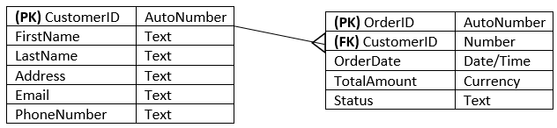
A customer can place many orders, but each order is linked to only one customer. This scenario is represented by a one-to-many relationship between the Customer and Order entities.

Order to OrderDetails
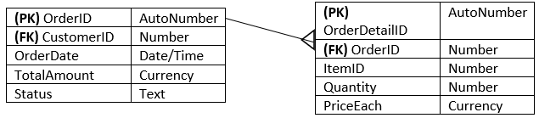

An order can contain multiple items, but each entry in the OrderDetails entity corresponds to only one order. This attribute defines the one-to-many relationship between the Order and OrderDetails entities.

Inventory to OrderDetails
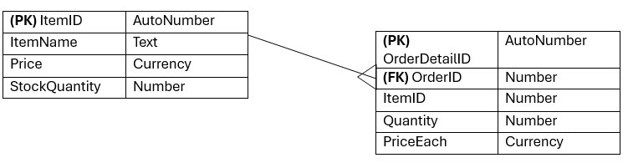

An item in the inventory can be part of many different orders, but each order detail links to a single inventory item. The result is a one-to-many relationship between the Inventory and OrderDetails entities.

Data Dictionary
Table | Column | Data Type | References | List of Values | Default | Not Null
Customer | CustomerID (PK) | Integer |  |  | Auto Increment | Y
 | FirstName | Text |  |  |  | Y
 | LastName | Text |  |  |  | Y
 | Address | Text |  |  |  | N
 | Email | Text |  |  |  | Y
 | PhoneNumber | Text |  |  |  | Y
 | PostCode | Text |  |  |  | Y
 | City | Text |  |  |  | Y
Inventory | ItemID (PK) | Integer |  |  | Auto Increment | Y
 | ItemName | Text |  |  |  | Y
 | Price | Currency |  |  | 0 | Y
 | StockQuantity | Integer |  |  | 0 | Y
Order | OrderID (PK) | Integer |  |  | Auto Increment | Y
 | CustomerID (FK) | Integer | Customer |  |  | Y
 | OrderDate | Date/Time |  |  | Current Date | Y
 | Status | Text |  | "Ordered", "Processing", "Shipped”, “Delivered" | Pending | Y
OrderDetails | OrderDetailID (PK) | Integer |  |  | Auto Increment | Y
 | OrderID (FK) | Integer | Order |  |  | Y
 | ItemID (FK) | Integer | Inventory |  |  | Y
 | Quantity | Integer |  |  | 1 | Y
 | PriceEach | Currency |  |  | 0 | Y

4. Logical Design

4.1 Table Structures

Customer Table:
Fields: CustomerID (AutoNumber), FirstName (Text), LastName (Text), Address (Text), Email (Text), PhoneNumber (Text).
(PK) CustomerID | AutoNumber
FirstName | Text
LastName | Text
Address | Text
Email | Text
PhoneNumber | Text
PostCode | Text
City | Text

Inventory Table:
Fields: ItemID (AutoNumber), ItemName (Text), Price (Currency), StockQuantity (Number).
(PK) ItemID | AutoNumber
ItemName | Text
Price | Currency
StockQuantity | Number

Order Table:
Fields: OrderID (AutoNumber), CustomerID (Number), OrderDate (Date/Time), TotalAmount (Currency), Status (Text).
(PK) OrderID | AutoNumber
(FK) CustomerID | Number
OrderDate | Date/Time
TotalAmount | Currency
Status | Text

OrderDetails Table:
Fields: OrderDetailID (AutoNumber), OrderID (Number), ItemID (Number), Quantity (Number), PriceEach (Currency).
(PK) OrderDetailID | AutoNumber
(FK) OrderID | Number
ItemID | Number
Quantity | Number
PriceEach | Currency

4.2 Normalisation Process
Normalisation is a step-by-step guide that organises data in a database. The process involves creating tables and establishing relationships between them based on a set of rules designed to protect data, enhance flexibility, and eliminate redundancy and inconsistent dependencies [2]. When designing a database, normalisation plays a crucial role by ensuring efficient and redundancy-free data storage. The database design I created for CraftGem uses the principles of 3NF (the third normal form), which involves the following normalisations:
First Normal Form (1NF)
The first normal form is the first level of normalisation. The first normal form will need each column from the table to contain an individual atomic value [3]. A different column in a table has atomic values, which means it doesn’t have any repeating groups, and each row is unique and can be identified through the primary key.
Second Normal Form (2NF)
The second normal form establishes a unique concept within a fully functional dependency. This is a way to organise database tables and reduces any redundancy that occurs, ensuring
That has data consistency [4]. The tables from the database are in the first normal form, and each non-key attribute will be fully dependent on the primary key (PK). For instance, in the OrderDetails table, the fields are fully dependent on the OrderDetailID.
Third Normal Form (3NF)
Finally, the Third Normal Form is a crucial part of the database design; it removes any unwanted dependencies [5]. In the CraftGem database, there aren't any transitive dependencies. For example, the Customer table contains only attributes that directly describe the customer, and the Order table contains only attributes that are specifically related to the order itself.

5. Microsoft Access Implementation

5.1 Forms and Reports
Login form
The screenshot below is a login form this is when users enter in their credentials. The username is Test, and the password is Test. Once we enter the credentials correctly, a pop-up message will appear, displaying a welcome message.
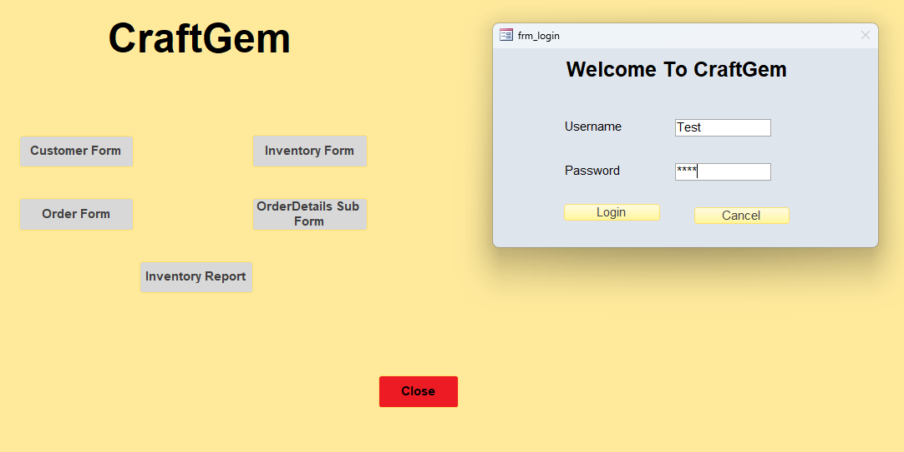
Customer form
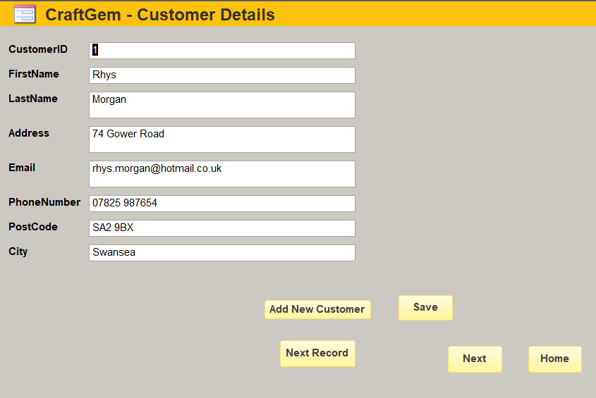
The above screenshot shows the name of a default customer who wants to order from the CraftGem database. Users can click on the “Add New Customer” button, which will direct them to a blank form to add their credentials, such as their first name, last name, address, email address, phone number, postcode, and city, as shown below.
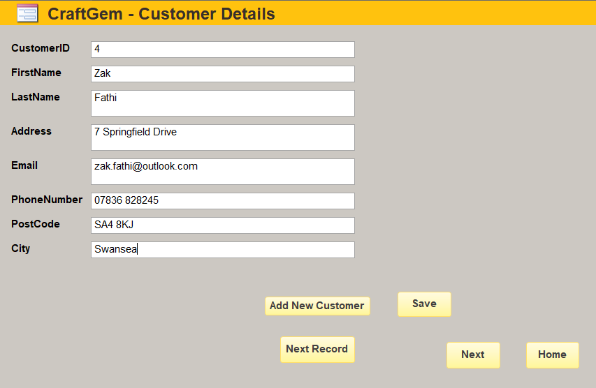
Inventory Form
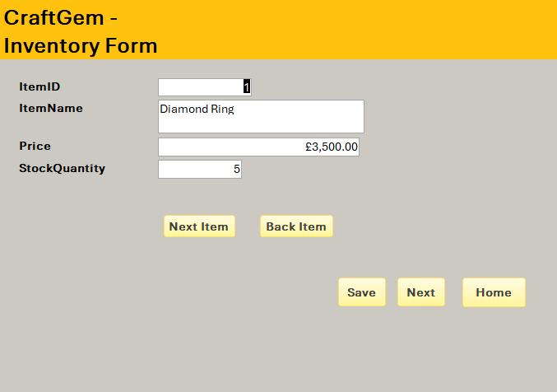
The above screenshot shows the inventory form; here it displays different items users can pick and choose from with their appropriate pricing. The item consists of a “Diamond Ring”, “Gold Necklace”, “Pearl Earrings”, “Ruby Pendant”, “Emerald Bracelet”, “Platinum Wedding Ring”, “Opal Ring”, and “Amber Necklace”. All can be selected by clicking on the “Next Item” button, or if the user wants to go back, they can simply click on the “Back Item” button.

Order form
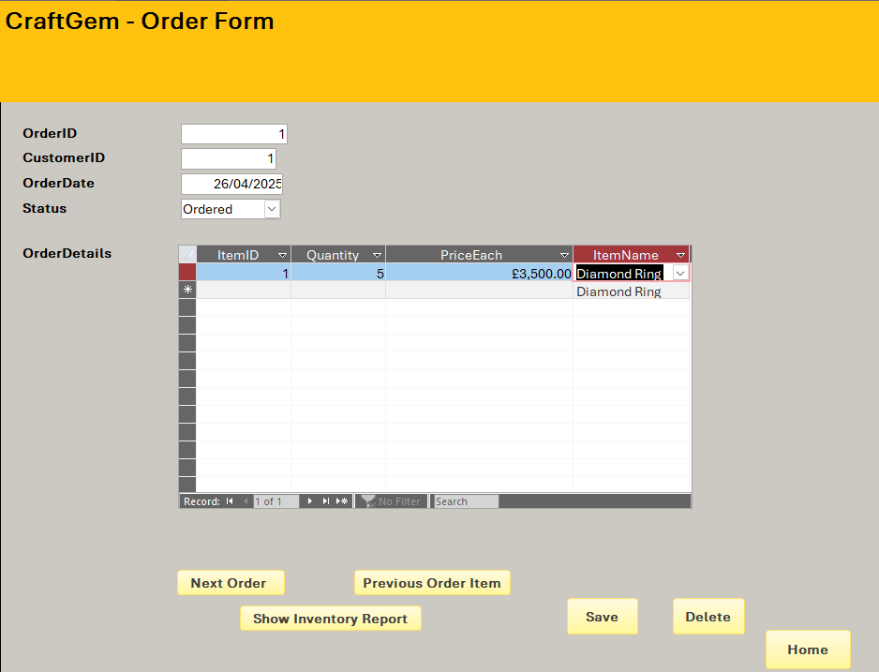
The above screenshot shows the order form, where the customer has selected what they ordered from the CraftGem. The status indicates that the first customer placed their order on the 26th of April. They have gone for the diamond ring, which costs £3500.

5.2 Reports
Inventory report
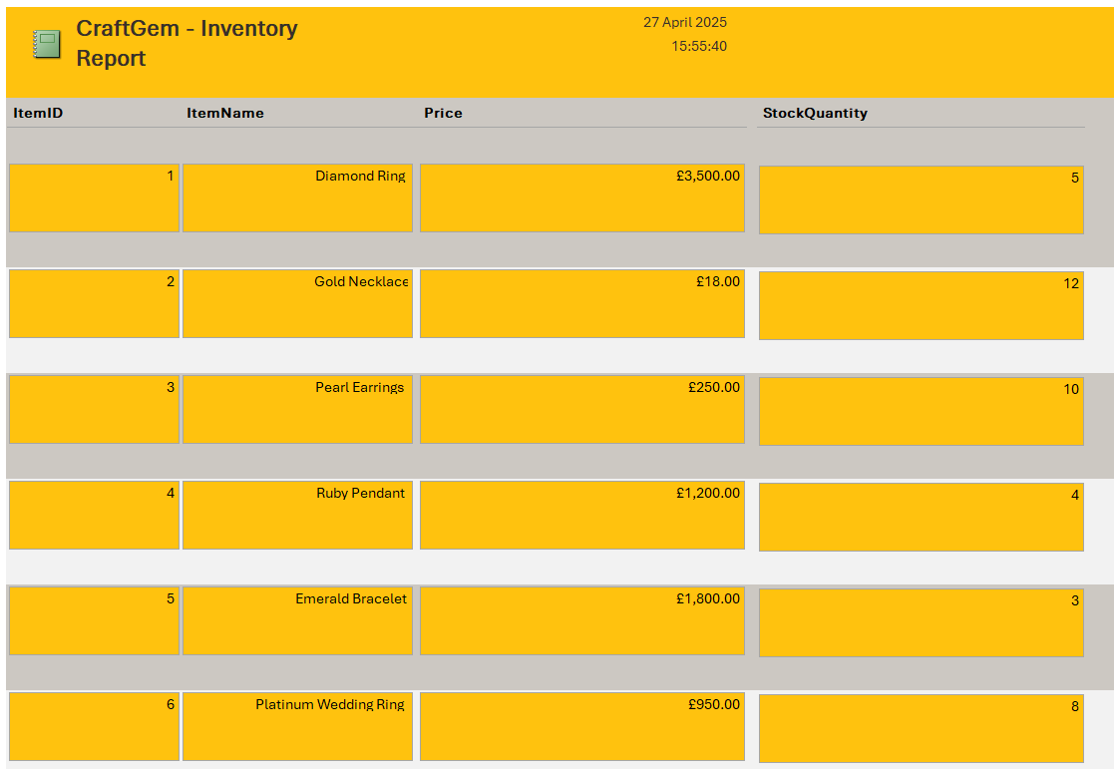
This report displays various item IDs along with their corresponding item names from the inventory form. Overall, the Microsoft Access report is a tool used to display and share data in a clear, organised way. It helps us take information from our database, like tables or queries, and format it into something professional and easy to understand. Reports are excellent for creating documents such as invoices, summaries, or charts that we might want to print or present to others.
With reports, we can sort and group our data, add titles or headers, and even include totals or calculations. We can also customise the layout to focus on the information that matters most. Whether we need a quick overview or a detailed analysis, reports make it simple to turn our data into something useful and visually appealing.

5.4 Relationships
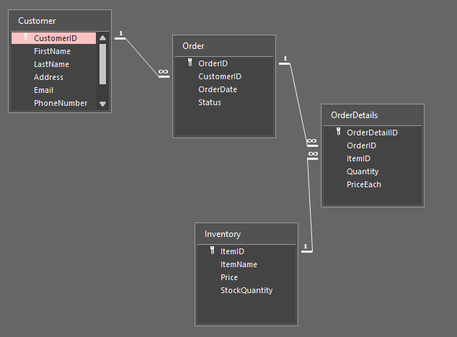
In my Microsoft Access database for CraftGem, I set up a one-to-many relationship between key tables to help manage customer orders and inventory. The customer table stores customers details like the ID of the customers, their name, address, email and phone number. I link this customer table to the order table, which houses order information like order ID, customer ID, order date, and order status.
The order table is connected to the OrderDetails table through the Order ID. This table contains details about the ordered items, such as the OrderDetailID, Item ID, Quantity, and price. The Inventory table, which tracks product details like Item ID, item name, price, and the available stock quantity, links to the Item ID.
This structure ensures that a customer can have multiple orders, each with multiple items. It also makes it easier to track stock levels in real time and keep things organised. With this setup, managing customer orders and inventory is more efficient.

6. Conclusion
This report outlines the design, development, and implementation of a relational database for CraftGem using Microsoft Access. The system provides a practical solution to streamline inventory, orders, and customer data, thereby eliminating manual inefficiencies. Through the careful application of ER modelling, 3NF normalisation, and query and report generation, CraftGem has the capacity to grow to meet increased demand and is an efficient and user-friendly database system that meets modern information system standards.

References
[1] DI Infotech, “Inventory Management Made Easy: Solutions for Small Business Owners,” DI Infotech. Admin, Dec 2, 2024 [Online]. Available: https://diinfotech.in/blog/inventory-management-made-easy-solutions-for-small-business-owners/. [Accessed: May. 03, 2025].
[2] Toxigon, “Database Normalization,” Toxigon. [Online]. Available: https://toxigon.com/database-normalization?utm_source. [Accessed: May. 01, 2025].
[3] Codecademy, “First Normal Form (1NF) in DBMS,” Codecademy. [Online]. Available: https://www.codecademy.com/article/first-normal-form-1nf-in-dbms?utm_source. [Accessed: May. 01, 2025].
[4] GeeksforGeeks, “Second Normal Form (2NF),” GeeksforGeeks. [Online]. Available: https://www.geeksforgeeks.org/second-normal-form-2nf/. [Accessed: May. 01, 2025].
[5] DataCamp, “Third Normal Form,” DataCamp. [Online]. Available: https://www.datacamp.com/tutorial/third-normal-form. [Accessed: May. 01, 2025].

Bibliography
[1] Here is when I used how to make validation rules for my database design:
Microsoft, “Restrict data input by using validation rules,” Microsoft Support, [Online], Available: https://support.microsoft.com/en-gb/office/restrict-data-input-by-using-validation-rules-b91c6b15-bcd3-42c1-90bf-e3a0272e988d [Accessed Apr. 27, 2025]
[2] Here is when I used how to make validation text for my database design:
Microsoft, “Restrict data input by using validation rules,” Microsoft Support, [Online], Available: https://support.microsoft.com/en-gb/office/restrict-data-input-by-using-validation-rules-b91c6b15-bcd3-42c1-90bf-e3a0272e988d [Accessed Apr. 27, 2025]
[3] Here is when I used how to make primary key for my database design:
Microsoft, “Add a primary key to a table in Access,” Microsoft Support, [Online]. Available: https://support.microsoft.com/en-gb/office/add-a-primary-key-to-a-table-in-access-c6055b7f-4dfe-4516-901c-95272d74a6ff#:~:text=In%20the%20Navigation%20Pane%2C%20right,Select%20Design%20%3E%20Primary%20Key. [Accessed Apr. 27, 2025]
[4] Here is when I used how to make date and time field for my database design:
Microsoft, “Format a date and time field,“ Microsoft Support, [Online], Available: https://support.microsoft.com/en-gb/office/format-a-date-and-time-field-47fbbdc1-52fa-416a-b8d5-ba24d881b698 [Accessed Apr. 27, 2025]
[5] Here is when I used how to create a relationship for my database design:
Microsoft, “Create, edit or delete a relationship,” Microsoft Support, [Online], Available: https://support.microsoft.com/en-gb/office/create-edit-or-delete-a-relationship-dfa453a7-0b6d-4c34-a128-fdebc7e686af#:~:text=in%20Datasheet%20view.-,When%20you%20drag%20a%20field%20from%20an%20%22other%22%20(unrelated,enforce%20referential%20integrity%20by%20default. [Accessed Apr. 27, 2025]
[6] Here is when I used how to create a query for my database design:
Microsoft, “Create a simple select query,” Microsoft Support, [Online]. Available: https://support.microsoft.com/en-gb/office/create-a-simple-select-query-de8b1c8d-14e9-4b25-8e22-70888d54de59 [Accessed Apr. 27, 2025]
[7] Here is when I used how to make command button for my database design:
Microsoft, “Use a command button to start an action or a series of actions,” Microsoft Support, [Online]. Available: https://support.microsoft.com/en-gb/office/use-a-command-button-to-start-an-action-or-a-series-of-actions-c7bf2827-2f3e-42b8-83d6-6c4f0de78990#:~:text=On%20the%20Form%20Design%20tab,The%20Command%20Button%20Wizard%20starts. [Accessed Apr. 27, 2025]
[8] Here is when I used how to insert next record button for my database design:
Education with Mr Hambury, “MS ACCESS | How to Insert Action Buttons in Forms”, YouTube, Feb 17, 2024. [Online] Available: https://www.youtube.com/watch?v=epItmkeJMzY&t=6s [Accessed Apr. 27, 2025]
[9] Here is when I used how to insert previous record button for my database design:
Education with Mr Hambury, “MS ACCESS | How to Insert Action Buttons in Forms”, YouTube, Feb 17, 2024. [Online] Available: https://www.youtube.com/watch?v=epItmkeJMzY&t=6s [Accessed Apr. 27, 2025]
[10] Here is when I used how to create a save button for my database design:
Computer Learning Zone, “How To Add a Save Button to Your Microsoft Access Forms”, YouTube, May 4, 2022. [Online] Available: https://www.youtube.com/watch?v=dXEmf7X4_4M [Accessed Apr. 27, 2025]
[11] Here is when I used how to create a close button for my database design:
JonAWF, “Creating a close Form button in Microsoft Access”, YouTube, May 31, 2011. [Online] Available: https://www.youtube.com/watch?v=kzzPAgvKPaQ [Accessed Apr. 27, 2025]
[12] Here is when I used how to create a drop down button for my database design:
Excel, Word and PowerPoint Tutorials from Howtech, “How to Create Drop Down List in Access”, YouTube, Jun 12, 2013. [Online] Available: https://www.youtube.com/watch?v=H_qAOGQduO4 [Accessed Apr. 27, 2025]
[13] Here is when I used how to create a subform for my database design:
Microsoft, “Create a form that contains a subform (a one-to-many form),” Microsoft Support, [Online], Available https://support.microsoft.com/en-gb/office/create-a-form-that-contains-a-subform-a-one-to-many-form-ddf3822f-8aba-49cb-831a-1e74d6f5f06b [Accessed Apr. 27, 2025]

